Information Curation Process (ICP) Standard Project

Purpose and Scope Status
The purpose of this recommendation is to provide a standard method structured as a complete process to formally define the steps and associated activities required to preserve information objects in order than these data objects are usable for the designated community. The process thus defined along with the activities, is linked with the data lifecycle and its Data Management Plan.
It is thus important to consider preservation not as a separate and costly activity to be considered at the end of an information production project, but as a set of actions that have to be conducted along the data lifecycle and integrated in the data specification, production and sustainability, in order than the data be usable according to the project objectives (including the long term ones). This point of view highlights the fact that preservation begins at the definition point.

Main Input References
- Long Term Preservation of Earth Observation Space Data, Preservation Workflow, CEOS/WGISS/DSIG/PW, December 2014 (under review)
- Data Lifecycles
  - Data Lifecycle Models and Concepts, September 2011, http://ceos.org/ourwork/workinggroups/wgiss/documents/
  - http://blogs.loc.gov/digitalpreservation/2012/02/life-cycle-models-for-digital-stewardship/
  - https://dl.dropboxusercontent.com/u/6959356/ICP/Many%20models.pptx
- Several other input materials are available and will likely contribute to additional models and mapping of processes to models as the standard.

Expected Benefits
- a consistent approach for existing and future projects/missions,
- a checklist of concerns that should be considered at each step of the data lifecycle
- decreased costs for archiving due to capture of needed metadata at the most efficient time
- decreased costs for archiving due to consistent structure and governance of digital information
- easier sharing of and access to digital information
- more authentic and reliable digital information which can more easily be made available to a wider audience if desired

Key technical features
- Will be applicable to all space missions
- Will address needed action from early planning to disposition of data
- Will address actions/processes that are desired at each phase of a data lifecycle
- Will provide a checklist of concerns at each phase.
- Will likely be providing links to other existing standards that should be applied at various points
- Will likely propose future standards

Terminology
An important part of this standard will be coming to an agreement on terminology that will be acceptable to the current space, science, library and archival communities. The OAIS Reference Model provides a starting point. Inputs from the EU LTDP project glossary provides proposals for additional terms although in a number of they will need to be adjusted to use current OAIS terminology.
At this time it seems as if the most important terms to get agreement on are the need for and definition of the following terms (or another equivalent term for the concept):
- Data Management Plan (Wikipedia): A data management plan or DMP is a formal document that outlines how you will handle your data both during your research, and after the project is completed. The goal of a data management plan is to consider the many aspects of data management, metadata generation, data preservation, and analysis before the project begins; this ensures that data are well-managed in the present, and prepared for preservation in the future.
- Preservation
- Curation
- Stewardship

- Data
- Metadata

- Data Record
- Preserved Data Set Content (PDSC)

Framework: Main Stages, Actors

Identification of the main high level chronological steps, loops between them, transversal activities, and milestones (taking into account that there are plenty of examples of lifecycle models, see references). Actors and responsibilities have to be addressed at the same level.

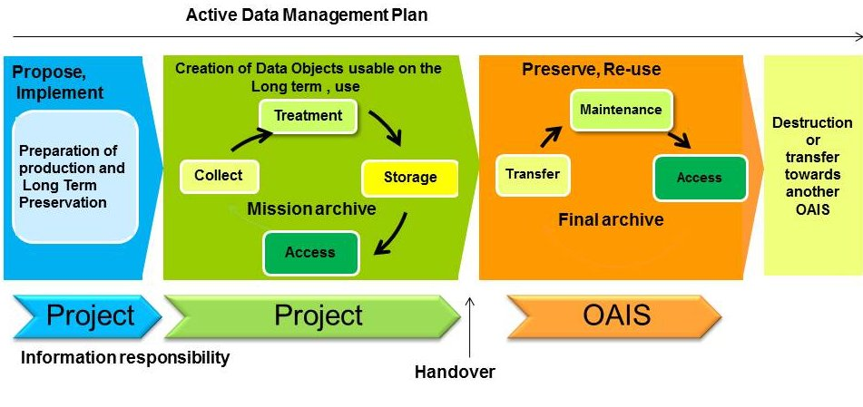
1Propose, implement => LTDP initialization
  - Preparation of Data production (design, formats, …)
  - Preparation of Long Term Preservation (PAIMAS feasibility and formal definition check list)
  - Implement tools, prepare mission archive, …
- Production => LTDP consolidation
- Archiving: Long term preservation, Re-use -> LTDP implementation + Operations
Adding value -> more than OAIS current responsibilities?
- Disposition

Within each of these steps, a checklist of processes or concerns will be provided and issues addressed. This may include making links towards existing standards, and we give recommendations on how and when the concerns can best be addressed.

Actors:
- Producer (Project)
- OAIS
- Consumers/Designated Community
- Management -> stewardship

