

Technical Area Internal Draft Recommendation for  
Space Data System Practices

|  |
| --- |
| Functional Resource model |

Technical Area Internal Draft Recommended Practice

AUTHORITY

|  |  |  |  |
| --- | --- | --- | --- |
|  |  |  |  |
|  | Issue: | White Book, |  |
|  | Date: |  |  |
|  | Location: | Not Applicable |  |
|  |  |  |  |

**(WHEN THIS RECOMMENDED PRACTICE IS FINALIZED, IT WILL CONTAIN THE FOLLOWING STATEMENT OF AUTHORITY:)**

This document has been approved for publication by the Management Council of the Consultative Committee for Space Data Systems (CCSDS) and represents the consensus technical agreement of the participating CCSDS Member Agencies. The procedure for review and authorization of CCSDS documents is detailed in *Organization and Processes for the Consultative Committee for Space Data Systems* (CCSDS A02.1-Y-4), and the record of Agency participation in the authorization of this document can be obtained from the CCSDS Secretariat at the e-mail address below.

This document is published and maintained by:

CCSDS Secretariat

National Aeronautics and Space Administration

Washington, DC, USA

E-mail: secretariat@mailman.ccsds.org

STATEMENT OF INTENT

**(WHEN THIS RECOMMENDED PRACTICE IS FINALIZED, IT WILL CONTAIN THE FOLLOWING STATEMENT OF INTENT:)**

The Consultative Committee for Space Data Systems (CCSDS) is an organization officially established by the management of its members. The Committee meets periodically to address data systems problems that are common to all participants, and to formulate sound technical solutions to these problems. Inasmuch as participation in the CCSDS is completely voluntary, the results of Committee actions are termed **Recommendations** and are not in themselves considered binding on any Agency.

CCSDS Recommendations take two forms: **Recommended Standards** that are prescriptive and are the formal vehicles by which CCSDS Agencies create the standards that specify how elements of their space mission support infrastructure shall operate and interoperate with others; and **Recommended Practices** that are more descriptive in nature and are intended to provide general guidance about how to approach a particular problem associated with space mission support. This **Recommended Practice** is issued by, and represents the consensus of, the CCSDS members.  Endorsement of this **Recommended Practice** is entirely voluntary and does not imply a commitment by any Agency or organization to implement its recommendations in a prescriptive sense.

No later than five years from its date of issuance, this **Recommended Practice** will be reviewed by the CCSDS to determine whether it should: (1) remain in effect without change; (2) be changed to reflect the impact of new technologies, new requirements, or new directions; or (3) be retired or canceled.

In those instances when a new version of a **Recommended Practice** is issued, existing CCSDS-related member Practices and implementations are not negated or deemed to be non-CCSDS compatible. It is the responsibility of each member to determine when such Practices or implementations are to be modified.  Each member is, however, strongly encouraged to direct planning for its new Practices and implementations towards the later version of the Recommended Practice.

FOREWORD

Through the process of normal evolution, it is expected that expansion, deletion, or modification of this document may occur. This Recommended Practice is therefore subject to CCSDS document management and change control procedures, which are defined in the *Organization and Processes for the Consultative Committee for Space Data Systems* (CCSDS A02.1-Y-4). Current versions of CCSDS documents are maintained at the CCSDS Web site:

http://www.ccsds.org/

Questions relating to the contents or status of this document should be sent to the CCSDS Secretariat at the e-mail address indicated on page i.

At time of publication, the active Member and Observer Agencies of the CCSDS were:

Member Agencies

* Agenzia Spaziale Italiana (ASI)/Italy.
* Canadian Space Agency (CSA)/Canada.
* Centre National d’Etudes Spatiales (CNES)/France.
* China National Space Administration (CNSA)/People’s Republic of China.
* Deutsches Zentrum für Luft- und Raumfahrt (DLR)/Germany.
* European Space Agency (ESA)/Europe.
* Federal Space Agency (FSA)/Russian Federation.
* Instituto Nacional de Pesquisas Espaciais (INPE)/Brazil.
* Japan Aerospace Exploration Agency (JAXA)/Japan.
* National Aeronautics and Space Administration (NASA)/USA.
* UK Space Agency/United Kingdom.

Observer Agencies

* Austrian Space Agency (ASA)/Austria.
* Belgian Federal Science Policy Office (BFSPO)/Belgium.
* Central Research Institute of Machine Building (TsNIIMash)/Russian Federation.
* China Satellite Launch and Tracking Control General, Beijing Institute of Tracking and Telecommunications Technology (CLTC/BITTT)/China.
* Chinese Academy of Sciences (CAS)/China.
* China Academy of Space Technology (CAST)/China.
* Commonwealth Scientific and Industrial Research Organization (CSIRO)/Australia.
* Danish National Space Center (DNSC)/Denmark.
* Departamento de Ciência e Tecnologia Aeroespacial (DCTA)/Brazil.
* Electronics and Telecommunications Research Institute (ETRI)/Korea.
* European Organization for the Exploitation of Meteorological Satellites (EUMETSAT)/Europe.
* European Telecommunications Satellite Organization (EUTELSAT)/Europe.
* Geo-Informatics and Space Technology Development Agency (GISTDA)/Thailand.
* Hellenic National Space Committee (HNSC)/Greece.
* Hellenic Space Agency (HSA)/Greece.
* Indian Space Research Organization (ISRO)/India.
* Institute of Space Research (IKI)/Russian Federation.
* Korea Aerospace Research Institute (KARI)/Korea.
* Ministry of Communications (MOC)/Israel.
* Mohammed Bin Rashid Space Centre (MBRSC)/United Arab Emirates.
* National Institute of Information and Communications Technology (NICT)/Japan.
* National Oceanic and Atmospheric Administration (NOAA)/USA.
* National Space Agency of the Republic of Kazakhstan (NSARK)/Kazakhstan.
* National Space Organization (NSPO)/Chinese Taipei.
* Naval Center for Space Technology (NCST)/USA.
* Research Institute for Particle & Nuclear Physics (KFKI)/Hungary.
* Scientific and Technological Research Council of Turkey (TUBITAK)/Turkey.
* South African National Space Agency (SANSA)/Republic of South Africa.
* Space and Upper Atmosphere Research Commission (SUPARCO)/Pakistan.
* Swedish Space Corporation (SSC)/Sweden.
* Swiss Space Office (SSO)/Switzerland.
* United States Geological Survey (USGS)/USA.

PREFACE

This document is a Technical Area-internal draft CCSDS Recommended Practice. Its ‘White Book’ status indicates that the CCSDS Cross Support Services Area is using it as the basis for the development of a future Recommended Practice.

When the Technical Area believes the document to be technically mature, it will request the CCSDS Secretariat to release a Draft Recommended Practice (Red Book) for formal review by appropriate technical organizations.

As a White Book, its technical contents are not stable, and multiple iterations of it are expected to occur within the Area and in response to comments received during the review process of one or more Red Book versions.

Implementers are cautioned **not** to fabricate any final equipment in accordance with this document’s technical content.

Recipients of this Area-level draft are invited to submit, with their comments, notification of any relevant patent rights of which they are aware and to provide supporting documentation.

DOCUMENT CONTROL

|  |  |  |  |
| --- | --- | --- | --- |
| **Document** | **Title and Issue** | **Date** | **Status** |
| CSSA-CSS_FRs-TN-0.1 | Functional Resources in Cross Support Services, Issue 0.1 | April 2013 | first draft. Integrates FR material from multiple sources. |
| CSSA 1-TN-0.2 | Functional Resources in Cross Support Services, Issue 0.2 | May 2013 | - Combines All Frames Reception with Return Sync and Decoding  - Changes cardinality of symbol streams per subcarrier.  - Changes Section to be a description of additional Function Resource Concepts, deletes the concept of Functional Resources Class.  - Includes a new section 3, which describes Space Communication Cross Support Functional Groups.  - Defines the FR Types needed for IOAG SC1 services, organized by Functional Group (section 4).  - Includes a new section 5 that describes service templates and service profiles. |
| CSSA 1-TN-0.3 | Functional Resources in Cross Support Services, Issue 0.3 | March 2014 | - Fixes various diagram errors  - Responds to W. Hell comments on sections 1 through 4, and discussions at the San Antonio meetings. |
| CSSA 1-TN-0.4 | Functional Resources in Cross Support Services, Issue 0.4 | August 2014 | - Updates in response to comments at Noordwijkerhout meetings  - Functional Resource adjustments in response to comments from W. Hell and A. Crowson  - Terminology adjustments in response to ESCCS-SM Concept Green Book CESG review.  - Abstract Service Component adjustments in response to ESCCS-SM Concept Green Book CESG review |
| CSSA 1-TN-0.5 | Functional Resources in Cross Support Services, Issue 0.5 | March 2015 | - Updated master Functional Resource diagram concerning interactions of CFDP Entities with each other and other FRs  - Changes names of SCs and FRs associated with Validated RM data service for clarity  - Updated master FR diagram to properly identify sources of CLCWs.  - Updated master FR diagram to adjust cardinalities  - Split IOAG services into sub-services that align with the 3 service configurations: SLS, retrieval, and forward offline.  - Removed the FRs in Service Management section to a separate Tech Note. |
| CSSA 1-TN-0.6 | Functional Resources in Cross Support Services, Issue 0.6 | April 2015 | 1. Applied normative FR type OIDs to all FR types. 2. Fixes numerous naming errors and inconsistencies. |
| CSSA 1-TN-0.7 | Functional Resource and Service Component Reference Model, Issue 0.7 | September 2015 | 1. Changed name reflect extended scope 2. Combined material from the *Service Components in Service Profiles* Tech Note 3. Re-organized and consolidated material to eliminate redundancies and provide a progressively-detailed exposure of the elements of the Reference Model. 4. Updated the details of the Functional Resources to reflect the latest concepts for and definitions of them. |
| CSSA 1-TN-0.8 | Functional Resource and Service Component Reference Model, Issue 0.8 | September 2015 | 1. Adds annex with future SCs. |
| CSSA 1-TN-0.9 | Functional Resource and Service Component Reference Model, Issue 0.9 | October 2015 | 1. Typo fixes 2. -Adds ports for frequency coherence and frequency offset relationships between forward and return space link carriers |
| CSSA 1-TN-0.10 | Functional Resource Reference Model, Issue 0.10 | July 2016 | 1. Drops “and Service Component” from the title 2. Downgrades the Abstract Service Components and Service Components from pseudo-operational entities (e.g., ones that have their own instances) to a concept for packaging sets of functional resources 3. Divides the previous “port” concept into two new concepts: SAP/Accessors and provided/required interfaces. 4. Move Service Agreement and Configuration Profile models here. |
| CSSA 1-TN-0.11 | Functional Resource Reference Model, Issue 0.11 | July 2016 | 1. Modifies master functional resource diagram (figure 2-2) to move Forward Frames CSTS Provider to right side of diagram for consistency as a TS provider. |
| CSSA 1-TN-0.12 | Functional Resource Reference Model, Issue 0.12 | August 2016 | 1. Updated figures 2-3 and 2-4. |
| CSSA 1-TN-0.13 | Functional Resource Reference Model, Issue 0.13 | March 2018 | 1. Updates functional resource definitions to reflect current concepts. 2. Replaces “Abstract Service Component/Service Component” concepts with the more-lightweight “Functional Resource strata/Functional Resource Set” concepts. 3. Consolidates several highly-redundant “views” of the same material. 4. Deletes the detailed Service Agreement/ Configuration Profile sections, which are either redundant to, or in some cases contradictory to, current concepts. The current concepts are instead now documented in the *Requirements for Simple Configuration Profiles and Service Agreements* Technical Note. 5. Points to the SANA Functional Resource Registry for specific OID assignments and parameter/event/ directive definitions. |
| CSSA 1-TN-0.14 | Functional Resource Reference Model, Issue 0.14 | July 2018 | 1. Introduces the notion that FRs can be used internal to a Provider CSSS/ESLT as well as an external view for cross support. (section 2) 2. Adds explanation the derivation of the SAP/Accessor and provided/required interface icons. (section 3) 3. Deletes the TDM Sink FR type for consistency with the Tracking Data CSTS specification (deleted from section 3.6.1 and the functional resource types diagram. 4. Fleshed out the specification of the TDM Segment Generation FR type. 5. Fleshed out the specification of the Tracking Data CSTS Provider FR type. 6. Fleshed out the specification of the TDM Recording Buffer FR type. 7. Deleted the TDM Sink FR type. 8. Updated Fig 2-2 to reflect deletion of TDM Sink. |
| CSSA 1-TN-0.15 | Functional Resource Reference Model, Issue 0.15 | March 2019 | 1. Adds information about how functional resources are represented in the SANA Functional Resource Registry (section 2.21.1). 2. Adds directions for accessing current draft specifications of the FR parameters, events, and directives that will eventually be specified in the online SANA Functional Resource Registry (section 2.21.1). 3. Updates the “Forward AOS Sync and Channel Encoding” functional resource to reflect comments received on the Forward Frame CSTS Red Book regarding the associated functionality and to account for USLP as well as AOS usage of the FR. The resultant FR has been renamed “Forward Fixed Length Frame (FLF) Sync, Channel Encoding, and OID Generation”. 4. Adds specifications of the FRs that will be used to provide the Forward Frame CSTS. This material was previously documented in the White Paper *Functional Resources for the Forward Frame CSTS* 5. Updates the specifications of the functional resources that comprise the Return TM/AOS Space Link Protocol Reception Functional Resource Set. 6. Changes “Terrestrial File Transfer Service Provider” to “TGFT Host” for better alignment with TGFT terminology. 7. Replaces replication of the definitions of the FR parameters, events, and directives (PEDs) that are normatively defined in the SANA FR Registry with references to the locations of those PED specifications in the SANA FR Registry. 8. Repairs numerous typos and other editorial errors. |
| CSSA 1-TN-0.16 | Functional Resource Reference Model, Issue 0.16 | September 2019 | 1. Deletes figure 2-2. 2. Adds overview of SANA FR Registry to section 2: PEDs, concept of shared configuration information, internal consistency checking not needed. 3. Splits USLP FRs into FLF and VLF sets 4. Splits Rtn TM/AOS SDLP FR Set into TM and AOS FR sets 5. Shows mapping from CCSDS Blue Book managed parameters to FR configuration parameters. 6. Adds discussion about xxxResourceStat being defined as read-only for cross support but controllable by EM directives 7. Adds discussion about parameter type definitions not including qualifiers when parameter values are reported 8. Adds discussion about how TC repetition is handled in FRs that process variable-length frames. 9. Identifies the FRs that are planned for the initial release to the SANA FR Registry on 1 January 2020. |
| CCSDS 000.0-W-0.1 (was R-0.1) | Functional Resource Reference Model, Workiong Group Draft Issue 0.1 | December 2019 | 1. First draft as a Magenta Book 2. Scope of current issue Reference Model limited to ESLTs, but potential future expansion to cover other node types addressed. 3. Figures 2-3, 2-4, 2-5, and 2-6 have been updated 4. A new figure 2-7 has been added to show the connectivity of the Functional Resource Sets. It replaces the old diagram that showed the connectivity among the individual functional resources, which became too unwieldy. 5. The following FR descriptions have been updated: -- TC PLOP, Synchronization, and Channel Encoding -- FLF Synchronization, Channel Encoding, and OID Generation -- FLF Synchronization and Channel Decoding -- TC MC Mux (partial) -- TC VC Mux -- AOS MC Mux -- AOS VC Mux -- Frame Data Sink -- Offline Frame Buffer -- Forward Frame CSTS Provider -- Monitored Data CSTS Provider |
| CCSDS 000.0-W-0.2 (was R-0.2) | Functional Resource Reference Model, Working Group Draft Issue 0.2 | February 2020 | 1. Updated (completely or partially) a number of FR definitions while working with the FRM definitions. 2. Attempted to respond to as many comments from W. Hell as possible. |
| CCSDS 000.0-W-0.2 –WH (was W-0.2-WH) | Functional Resource Reference Model, Working Group Draft Issue 0.2 | 9 March 2020 | 1. Includes WH comments and edits on the Feb 2020 version |
| CCSDS 000.0-W-0.3 (was R-0.3) | Functional Resource Reference Model, Working Group Draft Issue 0.3 | April 2020 | 1. Updated the FLF USLP VC Mux FR 2. An initial draft set of term definitions (1.5.1) has been included. Note that not all referenced terms used in this Magenta Book or thae various referenced documents are included, and some terms continaed in this section may not actually be used in this Magenta Book and will be removed in a future draft. 3. Updated the SANA Functional Resource Registry section (2.6) 4. Added a new section, “Conceptual Model of Functionsl Resource Interactions” (2.7) 5. Reorganized the Forward File Data Delivery Production and Return File Data Delivery Production FR Sets into the CFDP File Data Production, Packets File Data Transmission Production, and Packets File Data Reception Production FR Sets to more closely suppor the current IOAG definitions of the related services and to conform to SCCS-SM configuration profile structuring constraints. 6. Updated the TDM Segment Generation FR description. 7. Updated the TDM Recording Buffer FR description. 8. Updated the TD-CSTS Provider FR description. 9. Updated the FF-CSTS Provider description. 10. Updated diagrams for multiple other FRs. 11. Added a new annex, Object Identifier Offsets for Functional Resource Sets |
| CCSDS 902.x-W-0.4 | Functional Resource Reference Model, Working Group Draft Issue 0.4 | June 2020 | 1. Responses to WH review comments on W-0.3 2. Put in individual; sections for FR strata; 3. Update all diagrams for sections corresponding to tier-1 FRs; 4. Updated SAP/ancillary interface sections for all tier-1 FRs; 5. Focussed the scope on the tier-1 FRs. |
| CCSDS 902.x-W-0.5 | Functional Resource Model, Working Group Draft Issue 0.5 | October 2020 | 1. Change name of document to *Functional Resource Model* 2. Populates Acronyms annex 3. Updates Terms section 4. Updates the description of the content and organization of the SANA Functional Resource registry 5. Adds a new Ageny-Defined Functional Resource Registration section 6. Updates the Antenna FR to input and output IF signals, to better support the definition of D-DOR and Open Loop FRs 7. Respecifices the SAPs accessed by the Ccsds401SpaceLinkCarrierXmit and Ccsds401SpaceLinkCarrierRcpt FRs as carrying IF Signals 8. Updates TC PLOP, Synchronization and Channel Encoding FR definition to reflect upcoming BB revision 9. Clarifies the content of certain TDM Segments whe suppressed modulation and GMSK mosdumation are used (TDM Segment Generation FR) 10. Simplifies the TDM Buffer to use a simple FIFO retention policy if recorded segments exceed the allocated storage capacity 11. Clarifies that the ROCF TS Provider FR assumes that offline input is transfer frames ansd not individual OCFs, consistent with extant implementations. 12. Updates Open Loop Receiver/Formatter and Delta-DOR Receiver/Formatter FR Sets |

CONTENTS

Section Page

DOCUMENT CONTROL i

CONTENTS xv

1 Introduction 1-1

1.1 Purpose OF THIS Recommended Practice 1-1

1.2 Background 1-1

1.3 Scope 1-2

1.4 Applicability 1-4

1.5 Rationale 1-4

1.6 Document Organization 1-4

1.7 Definitions 1-5

1.7.1 Terms 1-5

1.8 Conventions 1-8

1.8.1 components of Functional resource definitions 1-8

1.9 References 1-10

2 Reference Model Concepts 2-1

2.1 Functional ResourceS 2-1

2.1.1 Functional Resources aS abstractions of real resources 2-1

2.1.2 Core Functional Resource Types 2-3

2.2 Functional Resource Stratified Model 2-4

2.3 Functional Resource Sets 2-10

2.4 Service Configuration Categories 2-13

2.4.1 SLS Configuration Category 2-13

2.4.2 Retrieval Configuration Category 2-16

2.4.3 Forward Offline Data Delivery Configuration 2-16

2.4.4 Functional Resource Set Connectivity 2-17

2.5 Relationships Among and within Functional Resource Sets 2-19

2.5.1 Service Access Points and Accessors 2-19

2.5.2 Required and Provided Ancillary Interfaces 2-20

2.6 SANA Functional Resources Registry 2-21

2.6.3 Functional Resource parameters 2-22

2.6.4 Functional Resource events 2-23

2.6.5 Functional Resource Directives 2-24

2.6.6 Functional Resource Status 2-25

2.6.7 Transfer Service Provider Functional ReSource Production Status 2-26

2.6.8 CSTS Provider Functional Resource Configuration change 2-26

2.6.9 Candidate and Approved SANA Functional Resource Registries 2-26

2.7 Conceptual Model of Functional Resource Interactions 2-27

3 Aperture Functional Resource Stratum 3-1

3.1 General 3-1

3.2 RF Aperture Functional Resource Set of the Aperture Functional Resource Stratum 3-1

3.2.1 Antenna 3-1

3.3 Antenna Array Functional Resource Set of the Aperture Functional Resource Stratum 3-2

4 Physical Channel Functional Resource Stratum 4-1

4.1 General 4-1

4.2 CCSDS 401 Physical Channel Transmission Functional Resource Set of the Physical Channel Abstract Stratum 4-1

4.2.1 CCSDS401 Space Link Carrier Transmission 4-2

4.2.2 Ranging Transmission 4-2

4.3 CCSDS 401 Physical Channel Reception Functional Resource Set of the Return Physical Channel Reception Functional Resource Stratum 4-3

4.3.1 CCSDS 401 Space Link Carrier Reception 4-4

4.3.2 Range and Doppler Extraction 4-5

4.4 CCSDS 415 Physical Channel Transmission Functional Resource Set of the Physical Channel Abstract Stratum 4-6

4.5 CCSDS 415 Physical Channel Reception Functional Resource Set of the Physical Channel Abstract Stratum 4-7

5 Synchronization and Channel Coding Functional Resource Stratum 5-1

5.1 General 5-1

5.2 TC Synchronization and Channel Encoding Functional Resource Set Of the Synchronization and Channel Coding FR Stratum 5-1

5.2.1 TC PLOP, Synchronization and Channel Encoding FR 5-1

5.3 Fixed Length Frame (FLF) Synchronization, Channel Encoding, and OID Generation Functional Resource Set Of the Synchronization and Channel Coding FR Stratum 5-5

5.3.1 FLF Synchronization, Channel Encoding, and OID Generation FR 5-6

5.4 Fixed-Length Frame Synchronization and Channel DeCoding Functional Resource Set Of the Synchronization and Channel Coding Functional Resource Stratum 5-11

5.4.1 FLF Synchronization and Channel Decoding 5-11

6 Space Link Protocol Functional Resource StratUM 6-1

6.1 General 6-1

6.2 TC Space Link Protocol Transmission Functional Resource Set of the Space Link Protocol Functional Resource Stratum 6-1

6.2.1 TC Master Channel (MC) Multiplexing FR 6-2

6.2.2 TC Virtual Channel (VC) Multiplexing FR 6-7

6.2.3 TC Encapsulation, VC Packet Processing and VC Generation FR 6-9

6.2.4 TC MAP Multiplexing FR 6-12

6.2.5 TC Encapsulation and MAP Packet Processing 6-13

6.3 AOS Space Link Protocol Transmission Functional Resource Set of the Space Link Protocol Transmission Functional Resource Stratum 6-14

6.3.1 AOS MC Multiplexing 6-15

6.3.2 AOS VC Multiplexing 6-18

6.3.3 AOS Encapsulation, Packet Processing and VC Generation 6-20

6.4 Variable Length Frame Unified Space Data Link Protocol Transmission Functional Resource Set of the Space Link Protocol Functional Resource Stratum 6-22

6.4.1 VLF USLP Master Channel (MC) Multiplexing FR 6-23

6.4.2 VLF USLP Virtual Channel (VC) Multiplexing FR 6-26

6.4.3 VLF USLP VC Generation FR 6-26

6.4.4 VLF USLP Multiplexer Access Point (MAP) Multiplexing FR 6-27

6.4.5 VLF USLP Encapsulation and MAP Packet Processing FR 6-27

6.5 Fixed Length Frame Unified Space Data Link Protocol Transmission Functional Resource Set of the Space Link Protocol Functional Resource Stratum 6-27

6.5.1 FLF USLP Master Channel (MC) Multiplexing FR 6-28

6.5.2 FLF USLP VC Multiplexing 6-32

6.5.3 FLF USLP VC Generation FR 6-35

6.5.4 FLF USLP Multiplexer Access Point (MAP) Multiplexing FR 6-35

6.5.5 FLF USLP Encapsulation and MAP Packet Processing FR 6-35

6.6 TM/AOS Space Link Protocol Reception Functional Resource Set of the Space Link Protocol Functional Resource Stratum 6-35

6.6.1 TM/AOS MC Demultiplexing 6-37

6.6.2 TM/AOS VC Demultiplexing 6-39

6.6.3 TM/AOS Packet Extraction and De-encapsulation 6-41

6.7 VAriable Length Frame Unified Space Data Link Protocol Reception Functional Resource Set of the Space Link Protocol Functional Resource Stratum 6-41

6.8 Return Fixed Length Frame Unified Space Data Link Protocol Reception Functional Resource Set of the Space Link Protocol Functional Resource Stratum 6-41

7 SLS Data Delivery Production Functional Resource StratUM 7-1

7.1 General 7-1

7.2 Frame Data Sink Functional Resource Set of the SLS Data Delivery Production Functional Resource Stratum 7-1

7.2.1 Frame Data Sink 7-1

7.3 CFDP File Data Production Functional Resource Set of the SLS Data Delivery Production Functional Resource Stratum 7-2

7.3.1 CFDP Entity 7-3

7.3.2 CFDP File Transmission Processing 7-3

7.3.3 CFDP File Reception Processing 7-4

7.4 Packets File Data Transmission Production Functional Resource Set of the SLS Data Delivery Production Functional Resource Stratum 7-5

7.4.1 Packets File Transmission Processing 7-5

7.5 Packets File Data Reception Production Functional Resource Set of the SLS Data Delivery Production Functional Resource Stratum 7-6

7.5.1 Packets File Reception Processing 7-7

8 SLS Radiometric Data Production Functional Resource Stratum 8-1

8.1 General 8-1

8.2 Real-Time Radiometric Data Collection Functional Resource Set of the SLS Radiometric Data Production Functional Resource Stratum 8-1

8.2.1 TDM Segment Generation 8-1

8.3 Non-Validated Radiometric Data Functional Resource Set of the SLS Radiometric Data Production Functional Resource Stratum 8-28

8.3.1 Non-validated Radio Metric Data Collection 8-28

8.4 Delta-DOR Raw Data Collection Functional Resource Set of the SLS Radiometric Data Production Functional Resource Stratum 8-29

8.4.1 D-DOR Raw Data Collection 8-29

8.5 Open Loop Receiver/Formatter Functional Resource Set of the SLS Radio Metric Data Production Functional Resource Stratum 8-29

8.5.1 Open Loop Receiver/Formatter 8-30

9 Offline Data Storage Functional Resource Stratum 9-1

9.1 General 9-1

9.2 Offline Frame Buffer Functional Resource Set of the Offline Data Delivery Production Functional Resource Stratum 9-1

9.2.1 Offline Frame Buffer 9-2

9.3 Tracking Data Message (TDM) Recording Buffer Functional Resource Set of the Offline Data Storage Functional Resource Stratum 9-3

9.3.1 TDM Recording Buffer 9-3

9.4 Non-validated radiometric Data Store Functional Resource Set of the Offline Data Storage Functional Resource Stratum 9-4

9.4.1 Non-validated Radiometric Data Store 9-5

9.5 Validated radiometric Data Store Functional Resource Set of the Offline Data Storage Functional Resource Stratum 9-5

9.5.1 Validated Radiometric Data Store 9-6

9.6 D-DOR Raw Data Store Functional Resource Set of the Offline Data Storage Functional Resource Stratum 9-6

9.6.1 D-DOR Raw Data Store 9-7

9.7 OpeN Loop Data Store Functional Resource Set of the Offline Data Storage Functional Resource Stratum 9-7

9.7.1 Open Loop Data Store 9-8

9.8 Return File Data Store Functional Resource Set of the Offline Data Storage Functional Resource Stratum 9-8

9.8.1 Return File Data Store 9-9

9.9 Forward File Data Store Functional Resource Set of the Offline Data Storage Functional Resource Stratum 9-9

9.9.1 Forward File Data Store 9-10

10 Data Transfer ServiceS Functional Resources Stratum 10-1

10.1 General 10-1

10.2 SLE Forward Space Packet Functional Resource Set of the Data transfer ServiceS Stratum 10-1

10.2.1 F-SP Transfer Service Provider 10-2

10.3 SLE Forward CLTU Functional Resource Set of the Data Transfer ServiceS Stratum 10-2

10.3.1 F-CLTU Transfer Service Provider 10-3

10.4 Forward Frame CSTS Functional resource Set of the Data Transfer ServiceS Spectrum 10-4

10.4.1 Forward Frame CSTS Provider 10-4

10.5 SLE Return All Frames Functional Resource Set of the Data Transfer ServiceS Functional Resource Stratum 10-5

10.5.1 RAF TS Provider 10-5

10.6 SLE Return Channel Frames Functional Resource Set of the Data Transfer ServiceS Functional Resource Stratum 10-6

10.6.1 RCF TS Provider 10-6

10.7 SLE Return Operational Control Fields Functional Resource Set of the Data Transfer Services Functional Resource Stratum 10-7

10.7.1 ROCF Transfer Service Provider 10-8

10.8 Tracking Data CSTS Functional Resource Set of the Data Transfer Services Functional Resource Stratum 10-8

10.8.1 Tracking Data CSTS Provider 10-8

10.9 Terrestrial Generic File Transfer (TGFT) Host Functional Resource Set of the Data Transfer ServiceS Functional Resource Stratum 10-9

10.9.1 TGFT Host 10-10

11 Service Management Functions Functional Resource Stratum 11-1

11.1 General 11-1

11.2 Monitored Data Functional Resource Set of the Service Management Funcitons Functional Resource Stratum 11-1

11.2.1 Monitored Data CSTS Provider 11-1

11.3 Service Control Functional Resource Set of the Service Management Functions Functional Resource Stratum 11-2

11.3.1 Service Control CSTS Provider 11-2

11.3.2 Service Control Production 11-3

12 Space Internetworking Functional Resource Stratum 12-1

12.1 General 12-1

12.1.1 Delay Tolerant Networking Functional Resource Set Of the Space Internetworking Functional Resource Stratum (Candidate) 12-1

Figure Page

**Figure 2‑1: Notional Interfaces of the Generic Functional Resource Type** 2-1

**Figure 2‑2**: **Functional Resource Strata for Earth-Space Link Terminals** 2-8

**Figure 2‑3: Functional Resources Sets within the Strata** 2-12

**Figure 2‑4: Functional Resource Strata Used in SLS Configurations** 2-15

**Figure 2‑5: Functional Resource Strata and FR Sets Used in Retrieval Configurations** 2-16

**Figure 2‑6: Functional Resource Strata Used in Forward Offline Data Delivery Configurations** 2-17

**Figure 2‑7: Functional Resource Set Connectivity** 2-18

**Figure 2‑8: Functional Resource Conceptual Model of Interaction** 2-28

**Figure 2‑9: Functional Resource Mixed Architecture Example** 2-30

**Figure 3‑1: Member Functional Resource of the RF Aperture Functional Resource Set** 3-1

**Figure 4‑1: Member Functional Resources of the CCSDS 401 Physical Channel Transmission Functional Resource Set** 4-1

**Figure 4‑2: Member Functional Resources of the CCSDS 401 Physical Channel Reception Functional Resource Set** 4-4

**Figure 5‑1: Member Functional Resource of the TC Synchronization and Channel Encoding Functional Resource Set** 5-1

**Figure 5‑2: Internal Structure of the TC PLOP, Synchronization and Channel Encoding Functional Resource** 5-3

**Figure 5‑3: Member Functional Resource of the FLF Synchronization, Channel Encoding, and OID Generation Functional Resource Set** 5-6

**Figure 5‑4: Internal Structure of the FLF Synchronization, Channel Encoding, and OID Generation Functional Resource** 5-8

**Figure 5‑5: Member Functional Resource of the FLF Synchronization and Channel Decoding** **Functional Resource Set** 5-11

**Figure 5‑6: Internal Structure of the FLF Synchronization and Channel Decoding Functional Resource** 5-13

**Figure 6‑1: Member Functional Resources of the TC Space Link Protocol** **Transmission** **Functional Resource Set** 6-2

**Figure 6‑2: Internal Structure of the TC MC Multiplexing Functional Resource** 6-5

**Figure 6‑3: Internal Structure of the TC Encapsulation, VC Packet Processing and VC Generation Functional Resource** 6-11

**Figure 6‑4: Internal Structure of the TC Encapsulation and MAP Packet Processing Functional Resource** 6-14

**Figure 6‑5: Members of the AOS Space Link Protocol Transmission Functional Resource Set** 6-15

**Figure 6‑6: Internal Structure of the AOS MC Multiplexing Functional Resource** 6-17

**Figure 6‑7: Internal Structure of the AOS Encapsulation, Packet Processing and VC Generation Functional Resource** 6-21

**Figure 6‑8: Member Functional Resources of the VLF Unified Space Link Protocol** **Transmission** **Functional Resource Set** 6-23

**Figure 6‑9: Internal Structure of the VLF USLP MC Multiplexing Functional Resource** 6-24

**Figure 6‑10: Member Functional Resources of the FLF Unified Space Link Protocol** **Transmission** **Functional Resource Set** 6-28

**Figure 6‑11: Internal Structure of the FLF USLP MC Multiplexing Functional Resource** 6-31

**Figure 6‑12: Member Functional Resources of the TM/AOS Space Link Protocol Reception Functional Resource Set** 6-37

**Figure 6‑13: Internal Structure of the** **TM/AOS MC Demultiplexing FR** 6-38

**Figure 6‑14: Internal Structure of the** **TM/AOS VC Demultiplexing FR** 6-40

**Figure 7‑1: Member Functional Resource of the Frame Data Sink** **Member Functional Resource Set** 7-1

**Figure 7‑2: Member Functional Resources of the CFDP File Data** **Production** **Functional Resource Set** 7-3

**Figure 7‑3: Member Functional Resources of the Packets File Data** **Delivery Transmission** **Functional Resource Set** 7-5

**Figure 7‑4: Member Functional Resources of the Packets File Data** **Reception Production** **Functional Resource Set** 7-7

**Figure 8‑1: Member Functional Resources of the Real-Time Radiometric Data Collection** **Functional Resource Set** 8-1

**Figure 8‑2: Contents of the Carrier Power Atomic Segment** 8-4

**Figure 8‑3: Contents of the Pc/No Atomic Segment** 8-5

**Figure 8‑4: Contents of the Pr/No Atomic Segment** 8-7

**Figure 8‑5: Contents of the One-Way Doppler (instantaneous) Atomic Segment** 8-9

**Figure 8‑6: Contents of the Two-Way Doppler (instantaneous) Atomic Segment** 8-10

**Figure 8‑7: Contents of the Three-Way Doppler (instantaneous) Atomic Segment** 8-11

**Figure 8‑8: Contents of the One-Way Doppler (integrated) Atomic Segment** 8-14

**Figure 8‑9: Contents of the Two-Way Doppler (integrated) Atomic Segment** 8-15

**Figure 8‑10: Contents of the Three-Way Doppler (integrated) Atomic Segment** 8-16

**Figure 8‑11: Contents of the Two-Way Range Atomic Segment** 8-18

**Figure 8‑12: Contents of the Three-Way Range Atomic Segment** 8-20

**Figure 8‑13: Contents of the Receive Frequency Atomic Segment** 8-22

**Figure 8‑14: Contents of the Transmit Frequency Atomic Segment** 8-23

**Figure 8‑15: Contents of the Transmit Frequency Rate Atomic Segment** 8-25

**Figure 8‑16: Contents of the Antenna Angles Atomic Segment** 8-26

**Figure 8‑17: Member Functional Resource of the Non-validated Radiometric Data Collection** **Functional Resource Stratum** 8-28

**Figure 8‑18: Member Functional Resource of the Delta-DOR Raw Data Collection** **Functional Resource Set** 8-29

**Figure 8‑19: Member Functional Resources of the Open Loop Receiver/Formatter** **Functional Resource Set** 8-30

**Figure 9‑1: Member Functional Resource of the Offline Frame Buffer Functional Resource Set** 9-2

**Figure 9‑2: Internal Composition of the TDM Recording Functional Resource Set** 9-3

**Figure 9‑3: Member Functional Resource of the Non-validated Radiometric Data Store Functional Resource Set** 9-5

**Figure 9‑4: Member Functional Resource of the Validated Radiometric Data Store Functional Resource Set** 9-6

**Figure 9‑5: Member Functional Resource of the D-DOR Raw Data Store** **Functional Resource Set** 9-7

**Figure 9‑6: Member Functional Resource of the Open Loop Data Store** **Functional Resource Set** 9-8

**Figure 9‑7: Member Functional Resource of the Return File Data Store** **Functional Resource Set** 9-9

**Figure 9‑8: Member Functional Resource of the Forward File Data Store** **Functional Resource Set** 9-10

**Figure 10‑1: Member Functional Resource of the SLE Forward Space Packet** **Functional Resource Set** 10-1

**Figure 10‑2: Member Functional Resource of the SLE Forward CLTU** **Functional Resource Set** 10-3

**Figure 10‑3: Member of the Forward Frame CSTS** **Functional Resource Set** 10-4

**Figure 10‑4: Member Functional Resource of the Return All Frames Functional Resource Set** 10-5

**Figure 10‑5: Member Functional Resource of the Return Channel Frames Functional Resource Set** 10-6

**Figure 10‑6: Member Functional Resource of the Return Operational Control Fields Functional Resource Set** 10-7

**Figure 10‑7: Member Functional Resource of the Tracking Data CSTS Functional Resource Set** 10-8

**Figure 10‑8: Member Functional Resource of the TGFT Host Functional Resource Set** 10-10

**Figure 11‑1: Member Functional Resource of the Monitored Data Functional Resource Set** 11-1

**Figure 11‑2: Member Functional Resources of the Service Control Functional Resource Set** 11-2

Table Page

5-1 Resource Status as a Function of Space Link Availability and Bit Lock 5-4

6-1 Managed Parameters of the Master Channel Multiplexing and All Frames Generation Functions of the TC Space Data Link Protocol Recommended Standard that are Not in the Configuration Parameters of the TC MC Multiplexing Functional Resource 6-4

6-2 Managed Parameters of the Virtual Channel Multiplexing Function of the TC Space Data Link Protocol Recommended Standard that are Not in the Configuration Parameters of the TC VC Multiplexing Functional Resource 6-7

6-3 Managed Parameters of the Master Channel Multiplexing and All Frames Generation Functions of the AOS Space Data Link Protocol Recommended Standard that are Not in the Configuration Parameters of the AOS MC Multiplexing Functional Resource 6-16

6-4 Managed Parameters of the Virtual Channel Multiplexing Function of the AOS Space Data Link Protocol Recommended Standard that are Not in the Configuration Parameters of the AOS VC Multiplexing Functional Resource 6-19

6-5 Managed Parameters of the Master Channel Multiplexing and All Frames Generation Functions of the Unified Space Data Link Protocol Recommended Standard that are Not in the Configuration Parameters of the FLF USLP MC Multiplexing Functional Resource 6-30

6-6 Managed Parameters of the Virtual Channel Multiplexing Function of the AOS Space Data Link Protocol Recommended Standard that are Not in the Configuration Parameters of the FLF USLP VC Multiplexing Functional Resource 6-33

# Introduction

## Purpose OF THIS Recommended Practice

This Recommended Practice defines the Functional Resource Model. It defines the concepts and organizing principles of functional resources, identifies functional resources needed to model the functions of an Earth Space Link Terminal (ESLT), and specifies the behavior of each of the functional resources.

## Background

The Functional Resource concept was originally developed as a way to provide unique qualifiers for monitored parameter names in cases where multiple instances of those parameters could be reported simultaneously through the Monitored Data CSTS (MD-CSTS). A strawman set of Functional Resource Types was developed for the MD-CSTS (see reference [10]). The strawman Functional Resource Types were subsequently used (with modifications) to generate a proposed standard set of monitored parameters for each functional resource type.

Fundamental to the concept of Functional Resources is that each one represents a cohesive, atomic set of space communication functionality with which can be associated single instances of management parameters, monitored parameters, real-time control parameters, and event notifications.

Functional Resources are not the physical resources (e.g., transmitters and receivers) that comprise real systems. Rather, they represent the functions or capabilities that are provided by those physical resources. A Functional Resource may be realized by several physical entities that work cooperatively to perform that function. Alternatively, for some types of functional resources, a single physical resource may be designed such that it instantiates several functional resources.

The concept has subsequently been adopted as a core concept of the *CSTS Specification Framework* (CSTS SFW) (see reference [4]), with standard parameter names being defined as having a functional resource identifier component. The CSTS SFW also defines a registration subtree for functional resource type Object Identifiers (OIDs) under the CCSDS registration tree. The Technical Note “Operational Scenario Implementation” (reference [11]) applied the functional resource type and monitored parameter OID structure to the proposed standard set of monitored parameters. Besides monitored parameters, the Functional Resource registration tree defined in the CSTS SFW is used to register OIDs for *notifiable events* and *directives* associated with each Functional Resource type. *Notifiable events* are also reported by the MD-CSTS. A *directive* is a control action that is invoked in real time. The directives are intended for use by a future Service Control CSTS (and possible other CSTSes).

The Functional Resource concept has been adopted as the method for organizing the management information associated with the services to be managed via the planned *Space Communication Cross Support Service Management – Service Agreement and Configuration Profile Data Formats* Recommended Standard (also see reference [12]). However, for purposes of Service Management, Functional Resources are *too* granular – the prospect of managing all possible combinations at the individual Functional Resource level is overwhelming. Fortunately, from a real-world perspective, in many cases multiple Functional Resources are used to represent the functionality of a single technical specification (e.g., a CCSDS Recommended Standard) such that the associated set of Functional Resources can be treated as a unit. Such units are called *Functional Resource Sets*.

## Scope

WHITE BOOK NOTE - This Working Group Draft Recommended Practice (White Book) contains all of the working notes that have been accumulated regarding the Functional Resource Model. Some of this information is tentatively normative, other parts are simply placeholders, and some material lies somewhere in-between. The process is as follows: as certain functional resources are defined to a sufficient level of correctness and specificity, their parameters, events, and directives (PEDs) are defined in a SANA Candidate Functional Resource registry, and the subset of this White Book that focusses on those candidate FRs will be made available to the subject matter experts of the FRs in that candidate registry as a pre-Red (Pink) companion review document. At the completion of each such review cycle, those FRs that are approved (either as-is or after having been updated as a result of the review) will be transferred to the SANA (approved) Functional Resource registry (reference [34]), and the associated Red/Pink draft FR Model (with modifcations resulting from the review, as necessary) will be submitted for CCSDS Agency Red/Pink book review and subsequent publication as a CCSDS Recommended Practice (Magenta Book). When a subsequent group of FRs is developed, the corresponding defintions will be added to the SANA Candidate FR registry and the corresponding material from this White Book will be added to a pre-Pink update of the existing Magenta Book. These new candidate FRs and the corresponding new sections of the pre-Pink book are reviewed by subject matter experts as described above, resulting in new FRs being added to the SANA approved FR registry and new version of the FR Model Magenta Book. The process iterates as long as new FRs are identified and added to the FR Model and SANA FR registry. For each issue of the Magenta Book, the scope section will identify which functional resources are covered. THIS NOTE WILL NOT BE INCLUDED IN THE PRE-PINK, PINK, AND MAGENTA VERSIONS OF THIS RECOMMENDED PRACTICE.

This Recommended Practice specifies the behavior of each of the functional resources in terms of the functionality of the CCSDS Recommended Standard that the functional resource represents. This Recommended Practice **does not** define the individual configuration parameters, monitorable parameters, notifiable events, or directives of the functional resources. Those details are defined in the SANA Functional Resource Registry (reference [34]).

WHITE BOOK NOTE - The following three paragraphs will be adjusted as appropriate for every issue of the Magenta Book. THIS NOTE WILL NOT BE INCLUDED IN THE PRE-PINK, PINK, AND MAGENTA VERSIONS OF THIS RECOMMENDED PRACTICE.

**The scope of** **this issue** of this Recommended Practice is limited to CCSDS-standard cross support functional resources that are (a) used to provide the services specified in IOAG Service Catalog #1 (reference [9]), plus the Forward Frame service of the Interagency Operations Advisory Group (IOAG) Service Catalog #2 (reference [16]), and (b) associated with what are called *Earth Space Link Terminals* (ESLTs) in the SCCS Architecture (reference [13]). As its name implies, an ESLT provides an Earth-side termination of a space-ground link to a *Space User Node* (spacecraft, rover, etc.). A typical ESLT is a ground station, but in the case of a relay satellite system in which both the ground terminal and the relay satellite belong to the same operational organization such that the operation of the links between the ground terminal and the relay satellite are not exposed to the user mission (such as the NASA Space Network), the ESLT represents the functionality of both the ground terminal *and* the relay satellite.

NOTE - CCSDS Cross Support Transfer Services and Service Management are also capable of operating with Agency-defined functional resources, as long as the definitions of those Agency-specific functional resources meet certain minimal requirements as discussed in 2.6.12. Any consideration of Agency-specific functional resources beyond the discussion in 2.6.12 is outside the scope of this Recommneded Practice. Unless explicitly identified as an Agency-specific Functional Resource, any discussion of a Functional Resource in this Recommended Practice should be assumed to be with respect to a CCSDS-standard cross support Functional Resource.

Specifically, this issue of this Recommended Practice specifies the following candidate functional resources:

1. Antenna;
2. CCSDS 401 Space Link Carrier Transmission;
3. Ranging Transmission;
4. CCSDS 401 Space Link Carrier Reception;
5. Range and Doppler Extraction;
6. TC PLOP, Synchronization, and Channel Encoding;
7. Fixed Length Frame Synchronization, Channel Encoding, and Only-Idle-Data Generation:
8. Fixed Length Frame Synchronization and Channel Decoding;
9. TC Master Channel Multiplexing;
10. TC Virtual Channel Multiplexing;
11. AOS Master Channel Multiplexing;
12. AOS Virtual Channel Multiplexing;
13. Fixed Length Frame USLP Master Channel Multiplexing;
14. Fixed Length Frame USLP Virtual Channel Multiplexing;
15. TM/AOS Master Channel Demultiplexing;
16. TM/AOSVirtual Channel Demultiplexing;
17. Frame Data Sink;
18. CFDP Entity;
19. TDM Segment Generation;
20. Offline Frame Buffer;
21. TDM Recording Buffer;
22. F-CLTU Transfer Service Provider;
23. Forward Frame CSTS Provider;
24. RAF Transfer Service Provider;
25. RCF Transfer Service Provider;
26. ROCF Transfer Service Provider;
27. Tracking Data CSTS Provider; and
28. Monitored Data CSTS Provider.

The functional resources in this Functional Resource Model are potentially applicable to other entities in the SCCS Architecture (e.g, Space User Nodes and Earth User Nodes). As the applicability of functional resources to other entity types are better defined, future issues of this Recommended Practice will address those use cases. Such expanded use cases may include the definition of new functional resource types, the addition of new functionality to existing functional resource types, the addition of new Functional Resource Strata (see 2.2), and/or the addition of new Service Configuration Catgoeries (see 2.4).

## Applicability

This Recommended Practice is applicable to ESLT-provided cross support services that are based on CCSDS Cross Support Transfer Services and Cross Support Service Management that model functionality in terms of Functional Resources.

The concepts and specifications of Functional Resources, Functional Resource Sets, and Functional Resource Strata may by applicable to other node types, but such applicability must be determined on an implementation basis

## Rationale

Multiple CCSDS cross support services use Functional Resources as a core organizing paradigm for representing – in a uniform and implementation-independent way - the functionality of the numerous and various CCSDS Recommended Standards. This Functional Resource Model Recommended Practice and the SANA FR Registry (reference [34]) define the collection of CCSDS-standard cross support functional resources in an organized and consistent manner.

## Document Organization

Section 2 provides an overview of the various conceptual building blocks of the Functional Resource Model.

Section 2 describes the various concepts around which the Functional Resource Refernce Model is organized. In particular, it describes the concept of functional resources and the Functional Resource stratified model and Functional Resource Sets as vehicles for organizing those functional resources.

Section 3 identifies and defines the Functional Resource Sets of the Aperture Functional Resource Stratum.

Section 4 identifies and defines the Functional Resource Sets of the Physical Channel Functional Resource Stratum.

Section 5 identifies and defines the Functional Resource Sets of the Synchronization and Channel Coding Functional Resource Stratum.

Section 6 identifies and defines the Functional Resource Sets of the Space Link Protocol Functional Resource Stratum.

Section 7 identifies and defines the Functional Resource Sets of the Space Link Session Data Delivery Production Functional Resource Stratum.

Section 8 identifies and defines the Functional Resource Sets of the Space Link Session Radiometric Data Production Functional Resource Stratum.

Section 9 identifies and defines the Functional Resource Sets of the Offline Data Storage Functional Resource Stratum.

Section 10 identifies and defines the Functional Resource Sets of the Data Transfer Services Functional Resource Stratum.

Section 11 identifies and defines the Functional Resource Sets of the Service Management Functions Functional Resource Stratum.

Section 12 identifies and defines the Functional Resource Sets of the Space Internetworking Functional Resource Stratum.

Annex A lists the Object Identifier Offsets for the Functional Resource Strata and Functional Resource Sets

ANNEX B **Error! Reference source not found.**addresses the security, SANA, and patent considerations that are applicable to this Recommended Practice.

Annex C lists the Acronyms and Abbreviations used in this Recommended Practice (this annex is currently just a placeholder).

Annex D identifies existing, in-progress, and planned CCSDS Recommended Standards that will likely result in the specification of additional Functional Resources and Functional Resource Sets.

## Definitions

### Terms

#### Terms Defined in the Cross Support Transfer Services Specification Framework, reference [4]

1. Association Control procedure;
2. blocking [operation];
3. Buffered Data Processing procedure;
4. complete [transfer mode];
5. CSTS;
6. functional resource;
7. latency-limit;
8. procedure configuration parameter;
9. ProcessDataInvocation;
10. qualified parameter;
11. Sequence Controlled Data Processing procedure;
12. service instance provision period;
13. service management parameter;
14. service-user-responding-timer;
15. timely [transfer mode].

#### Terms Defined in the Cross Support Reference Model, reference [1]

1. Mission User Entity (MUE);
2. Service Package;
3. space link session.

#### Terms Defined in the Space Communications Cross Support Architecture Description Document, Reference [13]

1. Cross Support Service System (CSSS);
2. ESLT;
3. Earth User CSSS;
4. Earth User Node;
5. Element Management (EM);
6. Provider CSSS;
7. Provision Management (PM);
8. Service Management;
9. Space User Node;
10. Utilization Management (UM).

#### Terms Defined in Abstract Syntax Notation One, Reference [43]

1. Abstract Syntax Notation One (ASN.1);
2. Object Identifier.

#### Terms Defined in the TC, AOS, and Unified Space Data Link Protocols, References [17], [18][18], and [35], Respectively

1. Communications Operation Procedure (COP) (reference [17] only);
2. Global Virtual Channel Identifier (GVCID);
3. Only Idle Data Frame (references [18] and [35] only);
4. Master Channel (MC);
5. Master Channel Identifier (MCID);
6. Spacecraft Identifier (SCID);
7. Transfer Frame (the format is specific to each space data link protocol);
8. Transfer Frame Primary Header;
9. Transfer Frame Version Number (TFVN);
10. Virtual Channel (VC); and
11. Virtual Channel Identifier (VCID).

#### Terms Defined in the TM Synchronization and Channel Coding Recommended Standard, Reference [6][6]

1. Attached Synchronization Marker (ASM);
2. Channel Access Data Unit (CADU);
3. Low-Density Parity-Check (LDPC);
4. Low-Density Parity-Check coding of a stream of Sync-Marked Transfer Frames;
5. Sync-Marked Transfer Frame (SMTF).

#### Terms Defined in the COP-1 Recommended Standard, Reference [21]

1. AD;
2. BC.

#### Terms Defined in this Recommended Practice

1. functional resource;
2. functional resource set;
3. functional resource strata/stratum;
4. only-idle-data (OID) data unit;
5. Space Link Protocol Data Unit (SL-PDU).

## Conventions

### components of Functional resource definitions

Sections 3 through 12 identify and define the functional resources that comprise the Functional Resource Model. These definitions are organized by FR Strata (where each section corresponds to an FR Stratum) and by FR Set within those strata.

For each Functional Resource type that is defined in this Recommended Practice, the following information is specified:

1. the corresponding Functional Resource Type classifier is listed. The FR Type classifier is label of the unique Object Identifier (OID) for that FR type. The FR Type OIDs are specified in the SANA Functional Resources Registry (reference [34]) and the classifier serves as the key into that registry;

NOTE - The Functional Resource Type OIDs are registered under the crossSupportFunctionalities branch of the CCSDS Object Identifier Tree, which is specified in reference [4] as:

{ iso(1) identified-organization(3) standards-producing-organization(112) ccsds(4) css(4) crossSupportResources(2) crossSupportFunctionalities(1)}

The FR Type OID for a given FR is therefore designated in the SANA FR Registry by

{ iso(1) identified-organization(3) standards-producing-organization(112) ccsds(4) css(4) crossSupportResources(2) crossSupportFunctionalities(1)   
<Functional Resource Type classifier>…<FR Type OID bit>}

where *FR Type OID* bit is the distinguishing number of the that FR’s OID.

1. the status of the SANA Functional Resource Registry information for the functional resource as of the current version of this Recommended Practice. The status can be one of:
2. Approved – the FR has be registered in the SANA Approved FR registry and can be used by operational systems;
3. Candidate - the FR has been posted to the SANA Candidate FR registry with a projected date for registration in the Approved FR registry. It is assumed that the FR is under review.
4. the specific functions of the pertinent CCSDS Recommended Standard(s) is(are) identified.
5. For each Recommended Standard cited as a source of FR functionality, (a) the FR definition addresses whether the Recommended Standard specifies the managed parameters associated with that functionality, (b) if it does specify the managed parameters, the FR definition identifies any of those managed parameters that are NOT mapped to the configuration parameters of the FR, and specifies how those managed parameters are set instead;

NOTE – Due to the application of information sharing (see 2.6.5), parameters that are defined in a Recommneded Standard may have their values specified in an FR that is different from the FR that implements the functionality of that Recommended Standard, either directly or by derivation.

1. If the FR performs multiple functions of the source Recommended Standard(s), a diagram of the internal structure of the FR is provided;
2. relationships of the functional resource with other functional resources outside the Functional Resource Set are identified in terms of
3. SAPs that are accessible by external FRs;
4. SAPs of external FRs that are accessed by the functional resource;
5. ancillary interfaces that are provided by the FR; and
6. ancillary interfaces that are required by the FR (and if the ancillary interfaces are optionally required, the conditions under which they are required);

This Recommended Practice uses graphical conventions based on Unified Modeling Language (UML, reference [44]) concepts and graphical notation to represent relationships among Functional Resources. In particular, the UML concepts of composition, provided interfaces, and required interfaces, and their respective graphical notations, are used. The application of these UML concepts and graphical notations is described in 2.3 and 2.5.

## References

The following documents are referenced in this Recommended Practice. At the time of publication, the editions indicated were valid. All documents are subject to revision, and users of this Recommended Practice are encouraged to investigate the possibility of applying the most recent editions of the documents indicated below. The CCSDS Secretariat maintains a register of currently valid CCSDS documents.

[] *Cross Support Reference Model—Part 1: Space Link Extension Services*. Recommendation for Space Data System Standards, CCSDS 910.4-B-2. Blue Book. Issue 2. Washington, D.C.: CCSDS, October 2005.

[] *Space Link Extension—Return All Frames Service Specification*. Recommendation for Space Data System Standards, CCSDS 911.1-B-4. Blue Book. Issue 4. Washington, D.C.: CCSDS, August 2016.

[] *Space Link Extension—Return Channel Frames Service Specification*. Recommendation for Space Data System Standards, CCSDS 911.2-B-3. Blue Book. Issue 3. Washington, D.C.: CCSDS, August 2016.

[] *Cross Support Transfer Service - Specification Framework*, Recommendation for Space Data System Standards, CCSDS 921.1-B-1. Blue Book. Issue 1. Washington, D.C.: CCSDS, April 2017.

[] *TC Synchronization and Channel Coding*. Recommendation for Space Data System Standards, CCSDS 231.0-B-3. Blue Book. Issue 3. Washington, D.C.: CCSDS, September 2017.

[] *TM Synchronization and Channel Coding*. Recommendation for Space Data System Standards, CCSDS 131.0-B-3. Blue Book. Issue 3. Washington, D.C.: CCSDS, September 2017.

[] *Requirements for Simple Configuration Profiles and Service Agreements*. Cross Support Services Area Draft Technical Note. CSSA 902.5-TN-1.4. June 2019.

[] *Cross Support Transfer Services - Tracking Data Service*. Draft Recommendation for Space Data System Standards, CCSDS 922.2-R-1. August 2017.

[] *IOAG Service Catalog #1*. Issue 2, Revision 1. Interagency Operations Advisory Group. February 2017.

[] *Cross Support Transfer Services- Monitored Data Service*. Recommendation for Space Data System Standards, CCSDS 922.1-B-1. Issue 3. Washington, D.C.: CCSDS, April 2017.

[] Doat, Yves, “Operational Scenario Implementation”, CSTSWG Technical Note. 20 May 2012.

[] *Extensible Space Communication Cross Support Service Management Concept*. Informational Report. CCSDS-902.0-G-1. Green Book. Issue 1. Washington, D.C.: CCSDS, November 2013.

[] *Space Communications Cross Support Architecture Description Document*. Report Concerning Space Data System Standards, CCSDS 901.0-G-1. Green Book. Issue 1. Washington, D.C.: CCSDS, November 2013.

[] *Space Communication Cross Support - Service Management – Service Specification*. Historical Recommendation for Space Data System Standards, CCSDS 910.11-B-1-S. Silver Book. Issue 1. Washington, D.C.: CCSDS, September 2009.

[] *Space Communication Cross Support Service Management – Service Agreement and Configuration Profile Data Formats*. Recommendation for Space Data System Standards, CCSDS 902.5. Future Recommended Standard.

[] *IOAG Service Catalog #2*. Issue 1, Revision 3. Interagency Operations Advisory Group. June 2019.

[17] *TC Space Data Link Protocol*. Recommendation for Space Data System Standards, CCSDS 232.0-B-3. Blue Book. Issue 3. Washington, D.C.: CCSDS, September 2015.

[18] *AOS Space Data Link Protocol*. Recommendation for Space Data System Standards, CCSDS 732.0-B-2. Blue Book. Issue 3. Washington, D.C.: CCSDS, September 2015.

[19] *TM Space Data Link Protocol*. Recommendation for Space Data System Standards, CCSDS 132.0-B-2. Blue Book. Issue 2. Washington, D.C.: CCSDS, September 2015.

[] *Space Packet Protocol*. Recommendation for Space Data System Standards, CCSDS 133.0-B-2. Blue Book. Issue 2. Washington, D.C.: CCSDS, June 2020.

[] *Communications Operation Procedure-1*. Recommendation for Space Data System Standards, CCSDS 232.1-B-2. Blue Book. Issue 2. Washington, D.C.: CCSDS, September 2010.

[] *Encapsulation Packet Protocol*. Recommendation for Space Data System Standards, CCSDS 133.1-B-3. Blue Book. Issue 3. Washington, D.C.: CCSDS, May 2020.

[] *Radio Frequency and Modulation Systems—Part 1: Earth Stations and Spacecraft*. Recommendation for Space Data System Standards, CCSDS 401.0-B-29. Blue Book. Issue 29. Washington, D.C.: CCSDS, March 2019.

[] *Pseudo-Noise (PN) Ranging Systems*. Recommendation for Space Data System Standards, CCSDS 414.1-B-2. Blue Book. Issue 2. Washington, D.C.: CCSDS, February 2014.

[] *Data Transmission and PN Ranging for 2 GHz CDMA Link via Data Relay Satellite*. Recommendation for Space Data System Standards, CCSDS 415.1-B-1. Blue Book. Issue 1. Washington, D.C.: CCSDS, September 2011.

[] *CCSDS File Delivery Protocol (CFDP)*. Recommendation for Space Data System Standards, CCSDS 727.0-B-4. Blue Book. Issue 4. Washington, D.C.: CCSDS, January 2007.

[] *Space Link Extension—Forward CLTU Service Specification*. Recommendation for Space Data System Standards, CCSDS 912.1-B-4. Blue Book. Issue 4. Washington, D.C.: CCSDS, August 2016.

[] *Space Link Extension—Forward Space Packet Service Specification* Recommendation for Space Data System Standards, CCSDS 912.3-B-3. Blue Book. Issue 3. Washington, D.C.: CCSDS, August 2016.

[] *Space Link Extension—Return Operational Control Fields Service Specification*. Recommendation for Space Data System Standards, CCSDS 911.5-B-3. Blue Book. Issue 3. Washington, D.C.: CCSDS, Augsut 2016.

[] *Rationale, Scenarios, and Requirements for DTN in Space*. Report Concerning Space Data System Standards, CCSDS 734.0-G-1. Green Book. Issue 1. Washington, D.C.: CCSDS, August 2010.

[] *IP Over CCSDS Space Links*. Recommendation for Space Data System Standards, CCSDS 702.1-B-1. Blue Book. Issue 1. Washington, D.C.: CCSDS, September 2012.

[32] *Delta-DOR Raw Data Exchange Format*. Recommendation for Space Data System Standards, CCSDS 506.1-B-1. Blue Book. Issue 1. Washington, D.C.: CCSDS, June 2013.

[] *Cross Support Transfer Services – Forward Frame Service*. Draft Recommendation for Space Data System Standards, CCSDS 922.3-R-1. Red Book. Issue 1. Washington, D.C.: CCSDS, February 2019.

[] “Functional Resources.” Space Assigned Number Authority. <https://sanaregistry.org/r/functional_resources>.

[35] *Unified Space Data Link Protocol*. Recommendation for Space Data System Standards, CCSDS 732.1-B-1. Blue Book. Issue 1. Washington, D.C.: CCSDS, October 2018.

[] *Tracking Data Message*. Recommendation for Space Data System Standards, CCSDS 503.0-B-2. Blue Book. Issue 2. Washington, D.C.: CCSDS, June 2020.

[] *Terrestrial Generic File Transfer*. Proposed Draft Recommendation for Space Data System Standards, CCSDS 927.1-W-0.9-jvp. White Book. Issue 0.9-jvp. Washington, D.C.: CCSDS, January 2019.

[38] *Service Package Data Format. Proposed Draft Recommendation for Space Data System Standards,* CCSDS 902.4-W-0.02*.* White Book. Issue 0.02. Washington, D.C.: CCSDS, November 2018.

[] “Service Sites and Apertures.” Space Assigned Number Authority. <https://sanaregistry.org/r/service_sites_apertures>.

[] “Spacecraft”. Space Assigned Number Authority. [www.sanaregistry.org/r/spacecraft](http://www.sanaregistry.org/r/spacecraft).

[] Stallings, William. *SNMP, SNMPv2, and CMIP: The Practical Guide to Network-Management Standards*.Reading, Massachusetts: Addison-Wesley Publishing Co., 1993.

[] *CCSDS Spacecraft Identification Field Code Assignment Control Procedures.* Issue 7. Recommendation for Space Data System Practices (Magenta Book), CCSDS 320.0-M-7. Washington, D.C.: CCSDS, November 2017.

[43] *Information Technology—Abstract Syntax Notation One (ASN.1): Specification of Basic Notation*. 4th ed. International Standard, ISO/IEC 8824-1:2008. Geneva: ISO, 2008.

[44] *OMG Unified Modeling Language (OMG UML)*. Version 2.5.1. OMG formal/2017/2017-12-05. <https://www.omg.org/spec/UML/2.5.1/PDF>: Object Management Group, December 2017.

[45] *Ranging and Doppler tracking*. ECSS-E-ST-50-02C. Second issue. Noordwijk, The Netherlands: ESA-ESTEC. July 2008.

[46] Sequential Ranging. DSN No. 810-005, 203, Rev. D. Pasadena, California: Jet Propulsion Laboratory. July, 2019.

# Functional Resource Model Concepts

The Functional Resource Model is built upon the concepts of:

* functional resources;
* functional resource stratified model;
* functional resource set;
* relationships among functional resource sets; and
* service configuration categories.

These conceptual building blocks are combined and refined in various combinations to create the Service Management functional resource-based Service Agreement and Configuration Profile Information Entities that are the subject of reference [7] and future CCSDS Recommended Standards.

This section describes the conceptual building blocks listed above.

## Functional ResourceS

### Functional Resources aS abstractions of real resources

Functional Resources are abstract representations of the functionality needed to provide space communication and navigation services, defined at a level of granularity sufficient to specify the configuration parameters, monitored parameters, and notifiable events associated with that functionality. Functional Resources exist to represent such information as it applies to a cross support interface – if a processing function does not have unique monitored parameters, notifiable events, or any configuration parameters that need to be set (possibly through configuration profiles), queried, or reconfigured (via real-time control directives), then it does not have a Functional Resource to represent it. Note that only one of these facets needs to be present in order for a function to need to be represented by a Functional Resource.

Figure 2‑1 depicts a generic Functional Resource type and its notional interfaces.



**Figure 2‑1: Notional Interfaces of the Generic Functional Resource Type**

The horizontal interfaces represent the flow of data or a signal through an instance of the FR – the “function” of the FR is the process that it performs on this signal/data. Such processing can involve converting one type of signal to another type of signal, manipulating data to produce another type of data, generating signals from data, or extracting data from signals (e.g., space communication data modulated onto an electromagnetic carrier signal, or Doppler data derived from an electromagnetic carrier signal). An FR instance is configured via the setting of the configuration parameters for its FR type. When the FR instance is active, it emits measurements of whatever monitored parameters are defined for that FR type. The FR instance also emits event notifications if any of the notifiable events that are defined for its FR type occur. Finally, the behavior of an FR instance may be modified via the real-time control directives that are defined for its FR type (if any).

Because FRs are abstractions, their relationships to the real physical resources that perform those functions are not specified, and will vary from ESLT to ESLT. Also, the “interfaces” by which the configurations are initially set and subsequently reconfigured, and by which parameters are monitored and events notified, are also abstract. The Element Management function(s) of any given ESLT have the (conceptual) responsibility for translating operations involving the parameters, events, and directives (PEDs) of abstract functions resources into the actual interfaces of the real physical resources that implement those functional resources within that ESLT.

Whereas the identification of the Functional Resources and their behavior are within the purview of this Recommended Practice, the Space Assigned Numbers Authority (SANA) Functional Resource Registry (reference [34]) is the official repository of (a) the identification and formal definitions of the PEDs of the functional resources, and (b) the specifications of the various object identifiers (OIDs) that are associated with those FRs and their PEDs. The contents of, and concepts that apply to, the SANA FR Registry are described in 2.6.

The values of most of the configuration parameters are set through the use of *configuration profiles*. The requirements for configurations profiles will eventually be formally standardized in the CCSDS Recommended Standard *Space Communication Cross Support Service Management – Service Agreement and Configuration Profile Data Formats* (reference [15]). Configuration profiles are lists of configuration parameters and their values that are pre-agreed between the Provider CSSS and the User Mission. When a configuration parameter in a configuration profile is the same as a configuration parameter of a functional resource instance, the value of that parameter in the configuration profile is the initial value of the corresponding FR parameter at the start of execution of the Service Package.

Configuration profiles specify the values of configuration parameters that do not depend on things such as the specific ESLT that is scheduled to execute a given Service Package or the trajectory of the Space User Node for the duration of the Service Package. However, some FR configuration parameters do depend on such dynamic considerations and their values can only be determined when the Service package has been scheduled for a specific ESLT for a specific period. Such configuration parameters are outside the scope of configuration profiles. Their initial values are set by Element Management (EM) as a product of the scheduling of the Service Package.

NOTE – When the value of a configuration parameter of an FR is determined by EM as a result of the scheduling process, the Utilization Management (UM) function of the User Mission is informed of the values through the Service Package information entity defined in reference [38]. This process is described in greater detail in reference [7].

Many configuration parameter values of an FR may also be changed during the execution of the Service Package by invoking the ‘set control parameters’ directive for that functional rescource. Invocation of the ‘set control paramters’ directive on any given configuration parameter is subject to the guard conditions that are defined for that parameter. These guard conditions define the prerequisites for being able to change the value of the configuration parameter, and if those conditions are not present the directive will fail.

Directives provide the mechanism by which the User Mission may alter the behavior of functional resources during the execution of a Service Package, subject to guard conditions. The CCSDS-standard directives may also be invoked by EM for purposes of local control within the Provider CSSS. There may also be additional, locally-defined directives that are available only to EM. The specification of such EM-only directives is outside the scope of this Recommended Practice and the SANA FR Registry.

Finally, in addition to the guard conditions and restrictions to dynamic re-configuration defined as part of the CCSDS-standard definitions of the parameters, each Provider CSSS (e.g., Agency) may impose its own further restrictions on which parameters may have their values dynamically changed by UM through invocation of the ‘set control parameters’ directive, and on which other directives may be invoked by UM.

### Functional Resource Types

For the IOAG Service Catalog #1 services performed by an Earth Space Link Terminal (which is the current scope of SCCS-SM), the composite functionality includes:

1. the transmission/reception of the signal on the space link with the Space User Node;
2. the channel synchronization and coding/decoding of the data on that space link;
3. the execution of the space link protocols; and
4. the provision of the cross support services by which the User missions submit data destined for their Space User Node and receive data from their Space User Node.

This functionality nominally conforms to the specifications provided by CCSDS Recommended Standards for space link modulation (reference [23]), synchronization and channel coding (references [5] and [6]), space data link protocols (references [17] - [22] and [35]), terrestrial cross support services e.g., (references [2], [3], and [10]), and space internetworking services (references [30] and [31]).

The services provided in a Service Package can contain multiple instances of *Functional Resource types* (FR types). Each FR type is assigned an ISO object identifier (OID), which is referred to as the *Functional Resource Type*. The FR Type is used to construct unique identifiers for functional resource instances and for the monitored parameters, configuration parameters, notifiable events, and real-time control directives that those functional resources expose. A Functional Resource instance is identified by its Functional Resource Name, which is the combination of the Functional Resource Type with a Functional Resource Instance Number (see the *Cross Support Transfer Service Specification Framework* (reference [4]) for additional details on the formal syntax of Functional Resource identifiers).

## Functional Resource Strata

NOTE – Parts of this section are adapted from material in the *Extensible Space Communication Cross Support Concept* Green Book (reference [12]). That Green Book uses the modeling and terminology of the SCCS Architecture Description Document Green Book (reference [13]). That SCCS ADD terminology is also used in this section. The ADD terms that are applicable to the Functional Resource Model are:

* *Earth Space Link Terminal* (ESLT) is the ADD term for ground station. It also applies to the combination of ground stations and relay satellite in bent-pipe relay satellite systems, i.e., in which the relay satellite is the aperture of the ground station from the perspective of the Space User Node;
* *Space User Node* is the ADD term for the user Mission element in space, e.g., mission spacecraft, planetary rover;
* *Earth User Node* is the ADD term for a terrestrial facility of the user Mission, and in particular one that hosts users of ESLT services; and
* *Provider* *Cross Support Service System* (CSSS) is the ADD term for a Tracking, Telemetry, and Command (TT&C) network.

Functional Resource Types represent specific space communication technologies and specific terrestrial cross support services. As space communication technologies evolve and new terrestrial cross support services are added over time, the FR Types that are used to represent them may need to be augmented or replaced by different FR Types. In cases where multiple FR Types are closely bound to a particular space communication technology (e.g., space link signal modulation), the replacement/addition of such a technology could involve the replacement/addition of multiple FR Types. Similarly, a terrestrial cross support service may need multiple FR Types to represent the total functionality associated with that cross support service. For example, a return offline SLE transfer services has an FR type for the service provision functions of the SLE service, and also an FR type for the offline buffer that stores the data for subsequent retrieval by the SLE service provider.

To categorize the types of functionality that the various functional resources perform, and to help clarify what categories of functions are need to perform a given service, this Functional Resource Model establishes the *Functional Resource stratified model*. The FR stratified model is similar to the layered models for ISO Open System Interconnection (seven layers) and TCP/IP (four layers), in which each layer is defined abstractly so that multiple specific protocols can be plugged as long as they meet the definition of that layer. In the case of the Functional Resource stratified model, the “lowest” stratum provides the physical link (in this case, an electromagnetic carrier signal) between the ESLT and a Space User Node and the “higher” strata perform the intermediate processing of data that is exchanged between the ESLT and an Earth User Node that is associated with that Space User Node. The FR stratified model has the following strata:

1. aperture, which is the physical interface to the space medium. On the “ground side”, the aperture receives and/or transmits an electromagnetic carrier signal;
2. physical channel, which transfers a stream of channel bits through the aperture across the physical medium (in this case, space). In addition to the transfer of a stream of bits, the physical channel may also carry non-binary signals, e.g. for the purpose of range measurements. The space physical channel has traditionally been provided at radio frequencies using RF modulation techniques, but the use of optical physical channels is expected to increase;

NOTE – In any realization of a space link, the technology used by the aperture must be compatible with the technology used by the physical channel. However, the possibility for multiple aperture technologies being applicable to the same physical channel technology (e.g., a single-feed steerable antenna, an array of geographically-separated steerable antennas, an array of fixed antenna elements that “point” by adjusting the phase differences among those antenna elements) justifies treating apertures separately from physical channels for the purposes of FR strata definition.

1. channel synchronization and coding, which consists of the error coding, randomization, and synchronization functions that are performed to convert space data link transfer frames to the bit streams that are transferred across the space physical channel, and vice versa;
2. space data link protocols that insert/extract space-optimized protocol data units (PDUs) into/from space data link transfer frames and in some cases control the flow of those transfer frames across the space link;
3. data delivery transfer services that allow remote user mission entities to interface with the ESLT for the purpose of exchanging data with their respective Space User Node via the space links provided by the ESLT. These services include SLE Transfer Services, CSTSes, and application-level services that transform data on the way to or from the Space User Node;
4. offline data storage, used to hold data when the transfer of data to or from the Space User Node cannot occur at the same time (or at the same data rate) as that of the space link over which the data is to be transported;
5. internetworking protocols that provide end-to-end connectivity across multiple kinds of data links, including space links.

NOTE – Space Internetworking is part of IOAG Service Catalog #2 capabilities.

For the IOAG Service Catalog #1 services performed by an ESLT (which is the current scope of this Functional Resource Model), the composite functionality of these abstract strata conforms to the specifications provided by CCSDS Recommended Standards for space link modulation (reference [23]), synchronization and channel coding (references [5] and [6]), space data link protocols (references [17], [19], [18], and [35]), and terrestrial cross support transfer services (references [27], [2] , [3], [29], [33], [10], and [8]). Over time, these Recommended Standards will be augmented to accommodate new space communications and tracking technologies (e.g., radio frequency vs. optical technologies at the aperture and physical channel layers). Each space communications technology may have its own set of management parameters that must be used when that technology is employed in the configuration of an ESLT.

Figure 2‑2 depicts the set of Functional Resource Strata for the ESLT, and the possible data flows through them. As illustrated in the figure, many combinations of FR strata are possible, although most services will each use only a single flow through the strata.

NOTES

1. The possible flows shown in Figure 2‑2 are the space communications and radiometric service data flows through these FR strata. They do not include the flows by which the resources within these strata are configured and controlled in real time and by which monitored parameter values and event notifications are collected from the resources in these various strata for reporting to the Earth User Node. Such data flows can be considered to occur in a separate management dimension (see the paragraph describing the Service Management Functions stratum below).
2. Figure 2‑2 includes a Space Internetworking stratum, even though space internetworking is an IOAG Service Catalog #2 capability and outside the current scope of this Informational Report. This stratum is included to illustrate how space internetworking can be accommodated within the FR stratified model.
3. Although the set of strata identified in this Recommended Practice encompass all services of IOAG Service Catalogs 1 and 2, new SCCS services may be introduced in the future that do not easily fit into the strata defined herein. If that happens, new strata will be defined in a way that provides the same kinds of extensibility as the strata described in this Recommended Practice.

The IOAG services are distributed across multiple strata to align with the IOAG service categories defined in Service Catalogs #1 and #2 (references [9] and [16], respectively). IOAG services are categorized into *data delivery services* (forward and return), *radiometric services*, and *service management functions*. The data delivery and radiometric service groups are further divided into the *space link interfaces* and *ground link interfaces* of which they are composed.

The set of strata that correspond to the Space Link Interface Standards are the Aperture, Physical Channel, Synchronization and Channel Coding, and Space Link Protocol FR strata. By definition, these strata are present only in SLS configurations (see 2.4.1).

* The Aperture stratum represents the general class of apertures through which forward space link signals are transmitted and return space link signals are received as part of SLS Service Packages. Some apertures can be used by multiple forward and/or return space links simultaneously, although specific types may be limited in directionality and/or number of simultaneous links.
* The Physical Channel Reception stratum represents the RF modulation, (future) optical modulation, and radiometric measurement functions that are performed as part of SLS Service Packages.
* The Synchronization and Channel Coding stratum represents the coding/decoding and synchronization functions that are performed as part of SLS Service Packages.
* The Space link Protocol stratum represents the space link protocol processing functions that are performed as part of SLS Service Packages.

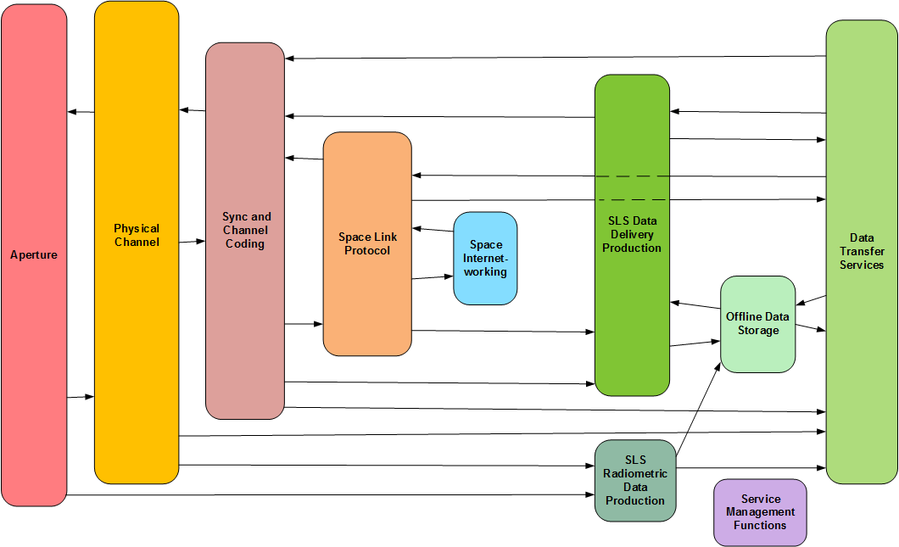**Figure 2‑2**: **Functional Resource Strata for Earth-Space Link Terminals**

The strata that correspond to the ground link interfaces of the IOAG data delivery and radiometric services are the SLS Data Delivery Production stratum, the SLS Radiometric Data Production stratum, the Offline Data Storage stratum, the Data Transfer Services stratum, and the Space Internetworking stratum.

* The SLS Data Delivery Production stratum represents the additional production functions beyond those provided by the Aperture, Physical Channel, Synchronization and Channel Coding, and/or Space Link Protocol strata that are performed as part of SLS Service Packages. For forward link data, the SLS Data Delivery Production stratum functions provide the additional processing needed to transmit data that is either transferred in real time via a Data Delivery transfer service or extracted from intermediate storage. For return link data, the SLS Data Delivery Production stratum functions provide the additional processing needed to prepare the data for either intermediate storage and/or real-time delivery via a Data Transfer service.
* The SLS Radiometric Data Production stratum represents the additional production functions (beyond the Aperture and Physical Channel strata radiometric measurement functions) that are performed as part of SLS Service Packages in order to prepare radiometric data for intermediate storage and/or real-time delivery via a Radiometric Data transfer service.
* The Offline Data Storage stratum represents the production functions that are performed as part of Retrieval Service Packages (for return link communication and radiometric data) or a Store and Forward Service Package (for forward link communication data). For return link data, these functions include (but are not necessarily limited to) the data stores and recording buffers that hold data awaiting subsequent retrieval. For forward link data, these functions include (but are not necessarily limited to) the data stores that hold data awaiting subsequent transmission during a space link session.
* The Data Transfer Services stratum represents the various cross-support transfer services that are used to transfer space link communication data and radiometric data across terrestrial networks between an Earth User Node and an ESLT. These services include the SLE transfer services, CSTSes that transfer communication data to be sent or that has been received through the space link, services that transfer radiometric data from the ESLT to the Earth User Node, as well as services that transfer files of communication data that is to be sent or that has been received through the space link.
* The Space Internetworking stratum represents functions performed to transfer internetwork data across the space link as part of an end-to-end internetwork data transfer. IOAG Service Catalog #1 (reference [9]) does not include internetwork services; those are covered by Service Catalog #2 (reference [16]). This stratum is included in the set of ESLT strata for accommodation of Space Internetworking services in CSSM in the future.

The Service Management Functions stratum corresponds to the IOAG service management functions. There are two transfer services that belong to the Service Management Functions stratum: the MD-CSTS and the future SC-CSTS. As noted above, the Service Management Functions interface with functions in all of the other strata via connections that exist in a management dimension that is not illustrated in Figure 2‑2.

The FR strata do not have specific management parameters, monitored parameters, notifiable events and real-time control directives. It is the specific Functional Resource types within concrete *Functional Resource Sets* within the strata for which parameters, events, and directives are defined.

## Functional Resource Sets

As described previously, the Functional Resource Stratified model is similar to the ISO Open System Interconnection (OSI) seven-layered reference model: by itself it is abstract and incapable of being implemented, but it provides a framework for organizing the various functional resource types. A set of functional resource types that collectively perform the functions that are ascribed to a Functional Resource stratum are a *Functional Resource Set*.

Figure 2‑3 depicts the Functional Resource Sets that support the service configurations in IOAG Service Catalogs #1 (reference [9]) and #2 (reference [16]). Each of these FR Sets corresponds to a CCSDS Recommended Standard. Within the rounded box for each stratum, the FR Sets of that stratum are depicted as dashed-border rounded boxes. In two cases (SLS Radiometric Data Production and Offline Data Storage) the strata boxes are not large enough for all of the FR Sets. In these cases, the FR Sets are shown in separate boxes at the bottom of the diagram.

NOTES

1 In Figure 2‑3 and subsequent figures that depict the FR Sets that specialze the FR Strata, the placement of the FR Set icons within the FR Strata icons is not related to the postion of the arrows entering and leaving the containing parent icons. The figures merely indicate that the FR Sets belong to their parent FR Strata. However, for those FR Strata that have both transmission and reception FR Sets, the transmission FR Sets are shown in the upper part of the FR Strata icons, and the reception FR Sets are shown in the lower part of the FR Strata icons.

2 The functionalities of the CCSDS 401 FR Sets of the Forward Physical Channel Transmission and Return Physical Channel Reception ASCs conform to the CCSDS 401 Recommended Standards for radio frequency and modulation (reference [23]) and optionally to the CCSDS Recommended Standard for pseudo-noise (PN) ranging (reference [24]) where Code Division Multiple Access (CDMA) is not employed. These are the two physical channel-layer Recommended Standards that are explicitly called out in IOAG Service Catalogs #1 (reference [9]) and #2 (reference [16]). IOAG services could also be performed over links that use CDMA in accordance with reference [25], for which different FR Sets of Physical Channel Transmission and Physical Channel Reception FR Strata will exist.

The functionality of a Functional Resource Set is provided by the Functional Resource(s) that comprise that Functional Resource Set. The functional resource types that comprise each of the Functional Resource Sets are identified in subsequent chapters of this Recommended Practice.

When a Functional Resource Set contains two or more functional resource types, the relationships among the functional resources in the same Functional Resource Set are expressed as UML *containment* relationships. These containment relationships represent the flow of data or information among the functional resources within the Functional Resource Set. By convention, the containment relationships flow *away from the space link*, regardless of the direction of the data flow between among) those functional resources. This convention is driven by the multiplexing and demultiplexing nature of space link communications, where multiple user data flows are multiplexed across the space link. For example, a master channel multiplexer FR instance contains multiple virtual channel multiplexer FR instances, and a master channel demultiplexer FR instance contains multiple virtual channel demultiplexer FR instances.

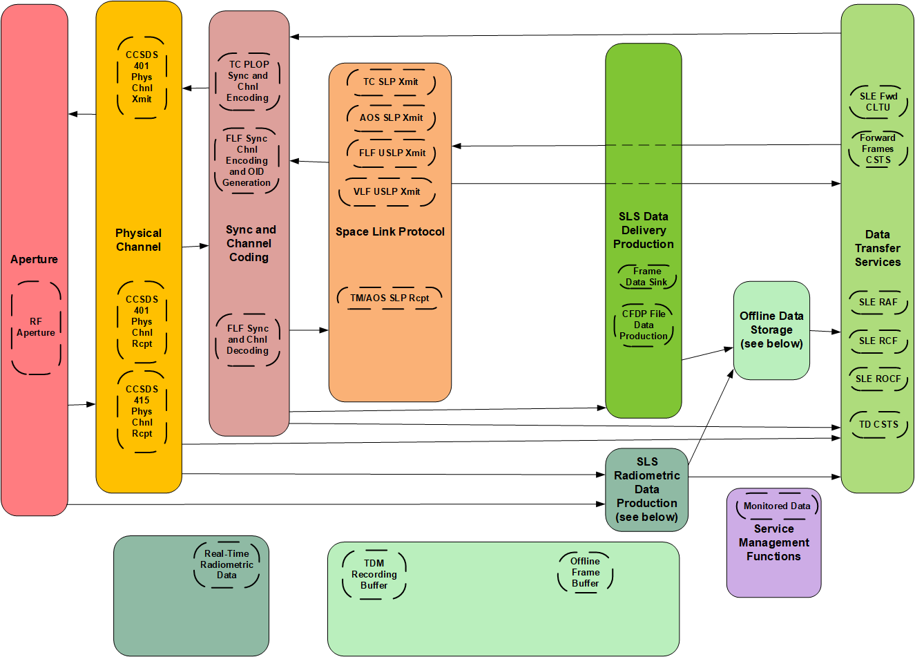

**Figure 2‑3: Functional Resources Sets within the Strata**

## Service Configuration Categories

For Service Management purposes (e.g., service agreements, configuration profile definition, and scheduling), the FR Sets (and the FRs that comprise them) are used in three categories of configurations:

1. the Space Link Session (SLS) configuration category, which comprises the functions of the ESLT that:
2. transfer data to or from one or more Space User Nodes across one or more space links during an SLS;
3. provide forward and/or return data transfer services during an executing SLS so that one or more Earth User Nodes communicate with the Space User Node(s) with end-to-end connectivity in “real time”; and
4. extract radiometric measurements from space links of an active SLS and deliver those measurements to the destination Earth User Node in “real time”.
5. the retrieval configuration category, which comprises the functions or the ESLT that:
6. deliver data that was received from a Space User Node to an Earth User Node, but not necessarily during the execution of the SLS by which the data was received; and
7. deliver radiometric measurements to the Earth User Node, but not necessarily during the execution of the SLS during which the radiometric measurements were extracted;
8. the forward offline data delivery configuration, in which the ESLT receives and stores data from an Earth User Node destined for a Space User Node, before the execution of the SLS by which the data is transmitted to the Space User Node.

These configuration categories are reflected in the service agreements, space link service profiles, and configuration profiles described in reference [7].

### SLS Configuration Category

Figure 2‑4 illustrates the FR strata and FR Sets that are used in the SLS configurations, including the Space Internetworking FR Set for Service Catalog #2 services. The SLS configuration category involve all of the FR strata for ESLTs, but only part of the functionality of the following strata is used for the provision of services during an SLS:

1. the Data Transfer Services stratum is limited to those services that allow Earth User Nodes to interface with the ESLT for the purpose of (1) exchanging data with their respective Space User Nodes in real time via the space links provided by the ESLT, and (2) receiving radio metric data in real time. These SLS cross support transfer services include online SLE Transfer Services (see reference [1] ) and real time CSTSes (see reference [4]);
2. the Offline Data Storage stratum is constrained to those functions associated with (1) transferring to Space User Nodes data that had been received by the ESLT prior to the SLS, (2) receiving and storing data from Space User Nodes for subsequent transfer to Earth User Nodes, and (3) storing radiometric data for subsequent transfer to Earth User Nodes.

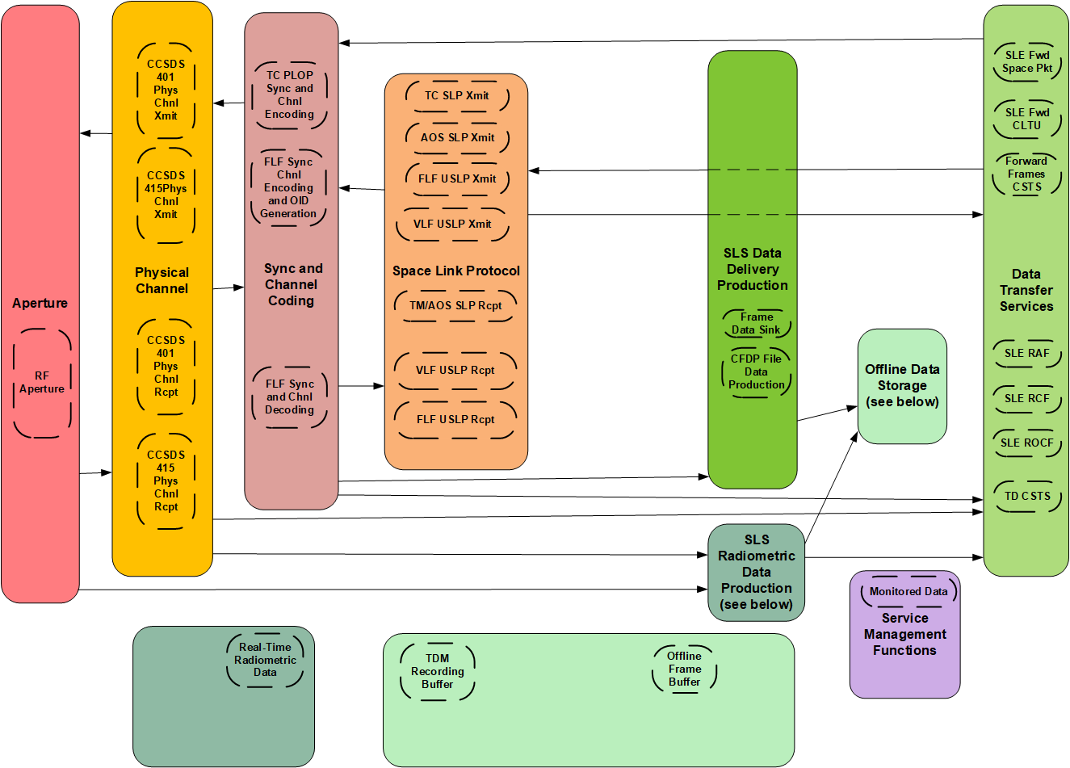

**Figure 2‑4: Functional Resource Strata Used in SLS Configurations**

### Retrieval Configuration Category

The retrieval configuration category does not require the above space link communications stack, although in some cases the space link stack may be present. The minimal retrieval configuration is composed of an Offline Data Storage FR set and a Data Transfer Services FR set. The data transfer services that are included in the retrieval configuration category include *offline* SLE Transfer Services (see reference [1] ), *complete* CSTSes (see reference [4]), the Terrestrial Generic File Transfer (TGFT) Host, and the offline retrieval of space data files captured by the ESLT.

Figure 2‑5 shows the FR Sets within the FR strata used in the retrieval data delivery and retrieval radiometric data configurations and the connectivity among the FR Sets within those strata.

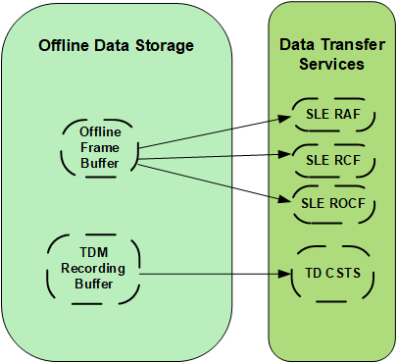

**Figure 2‑5: Functional Resource Strata and FR Sets Used in Retrieval Configurations**

### Forward Offline Data Delivery Configuration

The forward offline data delivery configuration does not involve the space link communications stack – it is composed of a forward offline cross support transfer service and a forward space link data store.

There is only one IOAG Service Catalog 1 service that operates using the forward offline data delivery configuration, the Forward File service. Figure 2‑6 shows the FR Sets within the FR strata used in the forward offline data delivery configuration.

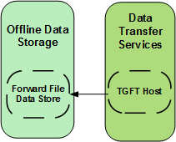

**Figure 2‑6: Functional Resource Strata Used in Forward Offline Data Delivery Configurations**

### Functional Resource Set Connectivity

Figure 2‑7 shows the connectivity among the Functional Resource Sets.

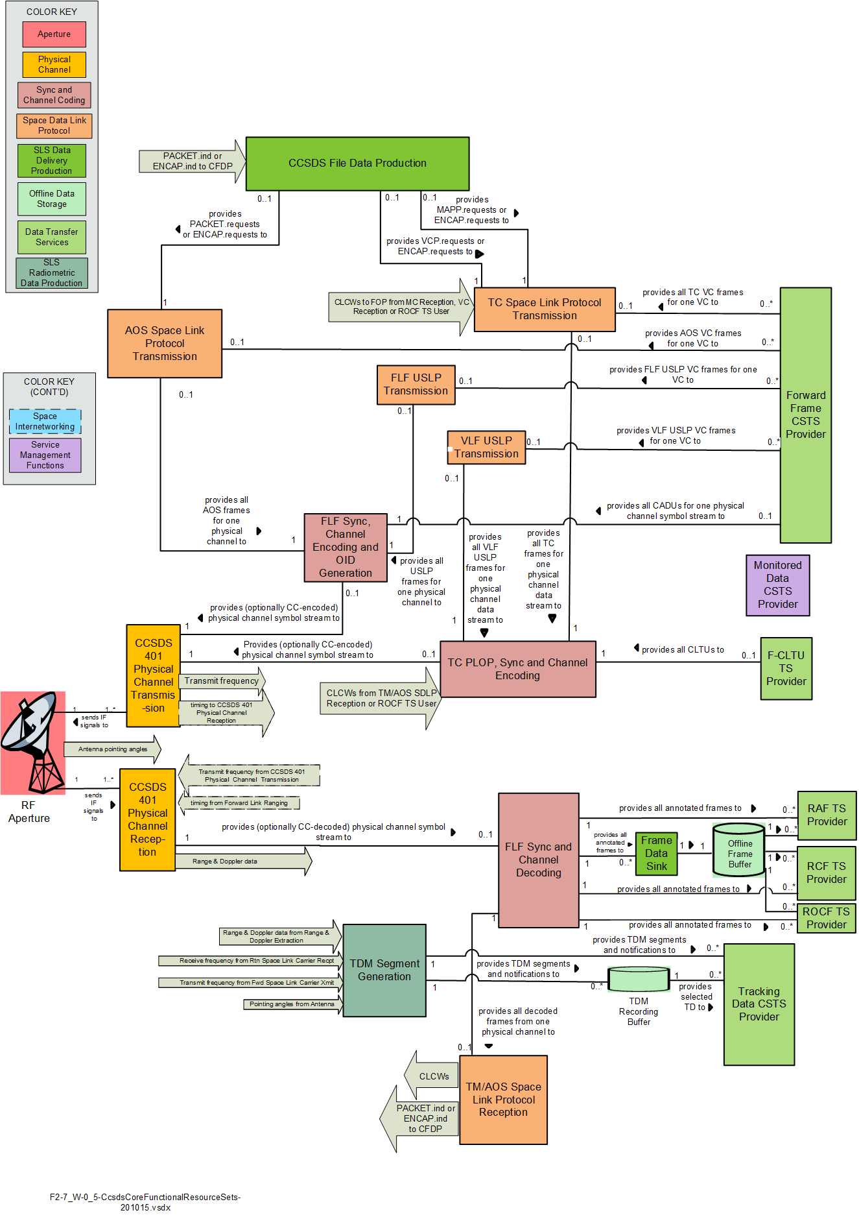

**Figure 2‑7: Functional Resource Set Connectivity**

## Relationships Among and within Functional Resource Sets

There are two kinds of relationships between functional resources within and among FR Sets: relationships in which a functional resource provides a Service Access Point that is accessed by another functional resource, and relationships in which a functional resource provides an ancillary interface that is required by another functional resource. The principal use of Service Access Point relationships and provided/required interfaces is to establish the necessary “wiring” among FR instances in Configuration Profiles and Service Packages.

### Service Access Points and Accessors

The FR stratified model allows different FR sets of a given FR stratum to substitute for each other in service configurations. The key characteristic of FR strata that enables this substitution is the use of standard interfaces between the strata: as long as an FR Set implements the essential interfaces of a given stratum, it can substitute for other FR sets that belong to that stratum. In this relationship between the FR Sets in two interacting strata, we borrow from ISO/OSI terminology and say that the FR Set in the lower stratum (i.e., the one that is “closer to” the space physical medium) provides a *Service Access Point* (SAP), and other FR Set is the *Accessor* of that SAP.

NOTE – In the SAP/Accessor context, “service” refers to the service that a stratum provides to the stratum above it. It is not to be confused with “service” in the sense of SLE or Cross Support “transfer services” or “space link services” such as telemetry, command, and tracking.

The SAP/Accessor relationships are the essential relationships among FR Sets and between functional resources within any FR Set that contains multiple functional resources. Usually, the associations between a SAP and its Accessors is used to identify a relationship in which user data flows from one functional resource to the other within the ESLT.

However, SAP/Accessor associations may also represent other kinds of relationships among functional resources, For example, a functional resource whose sole purpose is to extract directives from a metadata file in order to issue those directives to another functional resource for the purpose of controlling the behavior of that other functional resource. The first functional resource has an existential dependency on the second functional resource – the only reason that the first functional resource exists is because the second functionsl resource exists. The first functionl resource therefore has a SAP/Accessor relationship with the second functional resource. Note that in this example there may also be other essential relationships, e.g., the relationships between the second functional resource and other functional resources that represent the user data flow through for which the processing performed by the second functional resource is being shaped by the directives invoked by the first sunctional resource.

Sections 3 through 12 define the functional resources in each FR Set within each FR Stratum. FR For each FR Set, a diagram is provided that represents the functional resources that comprise that FR set and the SAP and Accessor roles of each FR (as appropriate). The diagrams use the following graphical notion to depict the SAP and Accessor roles in the essential relationships among functional resource instances.



This is the graphical notation used in the Unified Modeling Language (UML, reference [44]) to represent *composition*, where the filled diamond end represents the composite class or object, and the arrow end represents a component class/entity of that composite class/entity. For purposes of this Functional Resource Model, use of composition to express these relationships represents the essential, existential relationship between the FRs – the Accessor FR exists only when the SAP FR exists. The semantics of UML composition specify that if the compound object is not present, neither are its component objects. In terms of space communication and radiometric services, if one layer of the protocol stack is missing, then all layers that exist above that layer are also missing[1]. The composition begins with the FRs at the space link and “move” toward the ground interface with the user. A forward space link carrier must have an aperture in a viable space link service profile. However, the opposite is not necessarily true: an aperture can function in a space link service profile without a forward space link carrier, as in the cases of receive-only data and/or tracking operations.

### Required and Provided Ancillary Interfaces

In addition to the primary SAP/Accessor relationships, functional resources may also have ancillary relationships provide information that facilitates the proper functioning of those functional resources. For example, the provision of transmission frequency information by a functional resource that generates the forward carrier on one FR Set to the functional resource that receives the return carrier when the return carrier is coherent to the forward carrier is an instance of an ancillary interface between functional resources. Another example is the relationship by which CLCWs are extracted from return link transfer frames and used on the forward link to regulate the Physical Layer Operations Procedure (PLOP) on the forward link. These ancillary relationships are represented as *provided* and *required interfaces*. The functional resource that generates the information has the provided interface, and the functional resource that consumes the information has the required interface. For the first example above, The functional resource that generates the forward carrier has the provided interface for transmit frequency information and the functional resource that transmits the return carrier has the required interface for transmit frequency information. For the second example above, the functional resource that extracts CLCWs from return link transfer frames has the provided interface for CLCWs and the forward link functional resource that uses the CLCWs to regulate the PLOP has the required interface.

Provided/required interfaces are also use to represent relationships in which there is no existential dependency of one functional resource on a single other functional resource. For example, The Tracking Data Cross Support Transfer Service (TD-CSTS, reference [8]) is capable of reporting multiple types of radiometric data from multiple functional resources concurrently. At least one of these functional resources must be present to provide its type of radiometric data to the functional resource that combines the data into the Tracking Data Messages (TDMs) that are delivered by the TD-CSTS, but there is no single radiometric data source functional resource type that is essential to the existence of the TD service: any one (or more) of several such functional resource types is sufficient. The relationships between the individual radiometric data source functional resources and the functional resource that combines the data into the TDMs are therefore represented by provided/required interfaces, where IF the TDM generation function is configured to report a given type of radiometric data THEN it requires an interface with a functional resources that provided that radiometric data type.

The FR Set diagrams use the following graphical notation to represent the Provided Interfaces and Required Interfaces:



This representation is derived from the UML “ball and socket” icons for provided/required interfaces, where the ball represents the provided interface and the socket represents the required interface. However, the graphical tools available to the author of this Recommended Practice are unable to generate the proper ball-and-socket icons, so instead this Recommended Practice substitutes the double arrow end for the socket as the representation of the required interface.

## SANA Functional Resources Registry

The SANA Functional Resource Registry (reference [34]) is the official repository of: the object identifiers (OIDs) that are assigned to the CCSDS standard cross support functional resources; the semantic definitions of those fnctional resources; the identification and formal definitions of the parameers, events and directive (PEDs) of those functional resources; and the OIDs that are associated with those PEDs.

NOTE - The semantic definitions of the functional resources given in the SANA Functional Resource Registry are high-level defintions that do not have sufficient detail to prescribe interoperable implemetation. The defintions of the functional resources that are supplied in sections X through Y of this Recommended Practice do provide sufficient specification, by way of references to specific standards and specifications, to provide interperable implementations.

The SANA FR Registry populates the crossSupportFunctionalities node of the CCSDS OID registration tree: { iso(1) identified-organization(3) standards-producing-organization(112) ccsds(4) css(4) crossSupportResources(2) crossSupportFunctionalities(1)}.

NOTE - In addition to the CCSDS-standard cross support functional resources that are registered under the crossSupportFunctionalities node of the CCSDS OID registration tree, Agency-specific functional resources may be registered unde the agenciesFunctionalities node: { iso(1) identified-organization(3) standards-producing-organization(112) ccsds(4) css(4) crossSupportResources(2) agenciesFunctionalities(2)}. Section 2.6.12 addresses the contents of the agenciesFunctionalities node.

The SANA FR Registry is organized by Functional Resource Type, that is, by the OIDs assigned to the functional resources (see 2.1.2). However the OIDs under the crossSupportFunctionalities node contain an internal structuring by Functional Resource Strata (see 2.2) and then by Functional Resource Sets (see 2.3) within those strata, and finally by functions resource within those FR Sets. This internal structuring is accomplished by giving the OID digits under the crossSupportFunctionalities node FR Strata *OID offsets* that begin with 10000 (for the Apeture FR Stratum) and increment by 10000 for each subsequent stratum (e.g, the Physical Channel Stratum has the OID offset 20000). Within each FR Stratum, the FR Sets are given OID offsets that begin with 100 and increment by 100; e.g., the RF Antenna FR Set within the Aperture FR Stratum has the OID offset 10100. ANNEX A lists the OID offsets for the functional resources that are contained under the crossSupportFunctionalities node. Within each FR Set, the component FRs are assigned OIDs, with the OID of the root FR being set to the OID of the FR Set itself and subsequent FRs within the FR Set assigned OIDs that increment by 1. Thus the Antenna FR, which is the only FR within the RF Antenna FR Set (and is therefore also the root FR of that FR Set) has the OID digit 10100, which results in the full OID for the Antenna FR being

{ iso(1) identified-organization(3) standards-producing-organization(112) ccsds(4) css(4) crossSupportResources(2) agenciesFunctionalities (2) Antenna(10100)}.

This scheme allows for the possibility of future definition of FR Strata with up to 99 FR Sets within each stratum, and up to 100 FRs within each FR Set. The presence of the FR Strata and FR Set structure is implicit in the OID of each functional resource even thogh they do not appear explicitly in the registration tree.

For each FR, the following are specified:

1. the OID of the FR;
2. the *semantic definition* of the FR;
3. the *classifier* of the FR (i.e., the “short name” of the FR, e.g., Ccsds401SpaceLinkCarrierXmit);
4. the *string identifier* of the FR (i.e., the “long name” of the FR, e.g., ccsds-401-space- link-carrier-xmit);
5. the *version* of the FR definition;
6. the *creation date* of the FR definition;
7. the *authorizing entity* of the FR definition;
8. the parameters of the FR;
9. the events of the FR; and
10. the directives of the FR.

### Functional Resource parameters

For each parameter of an FR, the SANA FR Registry specifies the following:

1. the OID of the parameter;
2. the *semantic definition* of the parameter;
3. the *classifier* of the parameter;
4. the *string identifier* of the parameter;
5. the *version* of the parameter definition;
6. the *creation date* of the parameter definition;
7. the *authorizing entity* of the parameter definition, which must be the same as the authorizing authority for the functional resource definition that contains the parameter (see 2.6.2 g));
8. the *type definition* of the parameter, expressed in ASN.1;
9. the *engineering unit(s)* of the parameter;
10. whether or not the parameter is *configured*; and
11. *guard condition(s)* (if any) on the configuration (setting) of the parameter value (applicable only when configured = true).

The *configuration parameters* input in Figure 2‑1 corresponds to SANA Registry parameters that are designated as configured = true. By definition, all parameters of a functional resource are monitorable, and so the *monitored parameters* output in Figure 2‑1 corresponds to all parameters, whether they are configured or not.

NOTE – When a cross aupport transfer service such as the Monitored Data Cross Support Transfer Service (reference [10] reports FR parameter values, each parameter value is encapsulated within a *qualified parameter* (see annex C of reference [4]) that not only reports the parameter value but a qualifier for that value: ‘valid’, ‘unavailable’, ‘undefined’, or ‘error’. The type definition of the FR parameter that is specified in the SANA FR Registry is the data type that applies to the parameter when the qualifier is ‘valid’.

Several concepts apply to the identification and definition of FR configuration parameters. The first is the concept of information sharing among FRs in the same operarional configuration. Often, a parameter value will be applicable to multiple FRs in an operational configuration, for example, the VC multiplexer FR, MC multiplexer FR, and synchronization and channel encoder FR for a given fixed-length-frame-carrying physical channel must all operate with frames of the same length. One approach might be to require that each of these FR instances has its own individual frame length configuration parameter. However, in such an approach, each of these frame length parameters would have to be set to the same value in the configuration profile that represents the chain of functionality associated with that physical channel, which introduces redundancy and the possibility of inconsistent settings. Under the concept of information sharing, only one FR instance contains the common parameter, and the other FRs in the same configuration profile share that common parameter value as necessary. The common configuration parameter is allocated to the lowest-common FR type where the parameter is always applicable. In some cases, a configuration parameter is derived from other configuration parameters, either within the same FR or within other FRs in the same configuration profile. In the example of frame length, the (fixed or maximum) frame length that is used by the FRs that generate and multiplex frames can be derived from the Channel Acces Data Unit (CADU) or Communication Link Transmission Unit (CLTU) size parameter plus the coding options that are configured in the synchronization and coding FR that is associated with those other FRs.

Such shared configuration parameter values are propagated throughout an operational configuration as necessary to ensure that all functionality is configured in accordance with those values. Returning to the fixed frame length example, the shared frame length parameter value is specified as a configuration parameter of an instance of the Fixed Length Frame Synchronizaton, Channel Encoding, and Only-Idle-Data Generation (FlfSyncChnlEncodeAndOidGen) FR. If there are any Forward Frame CSTS instances associated with that FlfSyncChnlEncodeAndOidGen FR instance, that shared frame length value is used to validate incoming frames by all of those Forward Frame CSTS instances. If there are any frame generation FR instances associated with that FlfSyncChnlEncodeAndOidGen FR instance, that shared frame length value is used to set the length of the frames generated by all of those frame generation FR instances.

A consequence of the information sharing approach for FR configuration information is that it is assumed that all FRs in a configuration will be consistent with each other and therefore no exception-handling behavior needs to be specified for FRs regarding consistency errors (such as frames of different lengths being input to the same fixed-length-frame multiplexer).

### Functional Resource events

For each event of an FR, the SANA FR Registry specifies the following:

1. the OID of the event;
2. the *semantic definition* of the event;
3. the *classifier* of the event;
4. the *string identifier* of the event;
5. the *version* of the event definition;
6. the *creation date* of the event definition;
7. the *authorizing entity* of the event definition, which must be the same as the authorizing authority for the functional resource definition that contains the event (see 2.6.2 g)); and
8. the *value* of the event, which is comprised of:
9. the *semantic definition* of the event value;
10. the *classifier* of the event value;
11. the *string identifier* of the event value;
12. the *version* of the event value definition;
13. the *creation date* of the event value definition;
14. the *authorizing entity* of the event value definition, which must be the same as the authorizing authority for the functional resource definition that contains the event value (see 2.6.2 g));
15. the *type definition* of the event value, expressed in ASN.1; and
16. the *engineering unit(s)* of the event value.

In general, the event values are the values of existing parameters. For example, the value of the *resourceStatusChange* event is the new value of the *resourceStatus* parameter for that FR. In these cases, the type definition of the event value and the source parameter value are the same (e.g., ResourceStat).

### Functional Resource Directives

For each directive of an FR, the SANA FR Registry specifies the following:

1. the OID of the directive;
2. the *semantic definition* of the directive;
3. the *classifier* of the directive;
4. the *string identifier* of the directive;
5. the *version* of the directive definition;
6. the *creation date* of the directive definition;
7. the *authorizing entity* of the directive definition, which must be the same as the authorizing authority for the functional resource definition that contains the directive (see 2.6.2 g)); and
8. the *qualifier* of the direcitve, which is comprised of:
9. the *semantic definition* of the directive qualifier;
10. the *classifier* of the directive qualifier;
11. the *string identifier* of the directive qualifier;
12. the *version* of the directive qualifier definition;
13. the *creation date* of the directive qualifier definition;
14. the *authorizing entity* of the directive qualifier definition, which must be the same as the authorizing authority for the functional resource definition that contains the directive qualifier (see 2.6.2g));
15. the *type definition* of the directive qualifier, expressed in ASN.1; and
16. the *engineering unit(s)* of the directive qualifier.

Every functional resource has a set control parameters directive (xxxSetContrParams) that allows the User Mission to reset the value of configuration parameters during the execution of the Service Package. The directive qualifier of the xxxSetContrParams directive contains the identification of the parameters that are to be modified and their new values. The set of configuration parameters that are eligible to be modified using this directive is under control of the individual Provider CSSS and identified as such in service offering information and service agreements.

### Functional Resource Status

Every functional resource (except SLE Transfer Service Provider and CSTS Provider FRs) has a *resource status* parameter (xxxResourceStat) that reports the operational status of the resource(s) represented by that FR instance. The values of the resource status are:

* 'configured': the resource has been configured, but is not yet operational;
* 'operational': the resource is performing its function(s);
* 'interrupted': a failure has been detected that prevents the resource from performing its function(s);
* 'halted': the resource has been taken out of service by local management (i.e., by EM).

From the perspective of the User Mission, the resource status of an FR is a read-only parameter. However, stimuli that cause an FR’s resource status to change may include directives from the Provider CSSS’s EM, e.g, a directive to transition the resource from ‘operational’ to ‘halted’. Any EM directives that relate to the resource status are within the purview of the individual EM and outside the scope of CCSDS standardization.

In addition to the xxxResourceStat parameter, each FR has the notifiable event xxxResourceStatChange, which is emited upon the change of the resource status. The event- value of the xxxResourceStatChange event is the status of the resource following the change.

### Transfer Service Provider Functional ReSource Production Status

Each SLE Transfer Service Provider and CSTS Provider FR has a *production status* parameter that represents the collective resource status of the FRs that support that data transfer service instance. While the semantics of the production status are particular to each transfer service type, in general if all FRs that support a transfer service instance are operational then the production status is ‘operational’, if any support FR is halted then the production status is ‘halted’, etc. As with the resource status of the individual FRs, the production status of a transfer service is read-only from the perspective of the User Mission.

### CSTS Provider Functional Resource Configuration change

Every CSTS Provider FR has a ‘production configuration change’ event that is emitted when a configuration parameter of any of the FRs that support that CSTS instance changes value that applies to the production of that service instance. Such configuration changes can occur as a result of an invocation of the EXECUTE-DIRECTIVE operation (for CSTSes with EXECUTE-DIRECTIVE capability), a parameter change caused by the future Service Control CSTS; and a parameter change directed by a Sequence of Events. The ‘production configuration change’ event carries no event-value.

### Candidate and Approved SANA CCSDS-Standard Cross Support Functional Resource Registries

As of this version of this Recommended Practice, the SANA FR Registry that is available online at <https://sanaregistry.org/r/functional_resources> contains only Candidate (not Approved) specifications for the subset of the functional resources that are identified in this Recommended Practice. After the candidate set has been reviewed, the SANA FR registry will be reclassified from being a ‘candidate’ registry to an ‘approved’ registry.

As new FR registry specifications are created, they will first be added to a new SANA Candidate FR registry for review and comment. As each FR registry specification is deemed to be valid, it will be moved to the Approved SANA FR registry. The status of each FR registry specification is identified in its corresponding FR definition in this Recommended Practice.

NOTE – When the URL has been assigned to the new Candidate registry, this section will be updated.

### SANA Agency-defined Functional Resource Registration

As noted earlier in this document, the functional resources that are defined herein are the CCSDS-standard cross support FRs that are registered under the crossSupportFunctionalities node of the CCSDS OID registration tree: { iso(1) identified-organization(3) standards-producing-organization(112) ccsds(4) css(4) crossSupportResources(2) crossSupportFunctionalities(1)}.

Individual Agencies may wish to create and register their own fuctional resources and associated PEDs, such that the real resources represented by those FRs can take advantage of the cross support service infrastructure that relies on the functional resource concept (e.g., the Monitored Data, Tracking Data, and Service Control CSTSes, and Space Communication Cross Support Service Management). For example, an Agency may provide a legacy service that is not based on CCSD Recommended Standards and that has no reason to become a CCSDS-standard service. Such a service – with appropriate instrumentation - could be monitored using the Monitored Data CSTS.

The CCSDS OID registration tree accommodates the registration of Agency-defined FRs and their respective PEDs under the agenciesFunctionalities node: { iso(1) identified-organization(3) standards-producing-organization(112) ccsds(4) css(4) crossSupportResources(2) agenciesFunctionalities(2)}.

Under the agenciesFunctionalities node, each Agency may be allocated its own node by first requesting designated control authority over such a node. Once the Agency has received the designated control authority, that Agency may define additional functional resources and associated PEDs, for which the object identifiers OIDs are allocated in accordance with D6.3 of reference [4].

Although each Agency is responsible for creating the defintions of their FRs, as specified in H2.4 of reference [4] the Cross Support Services Area serves as the Review Authority for Agency-defined FRs. As such, the CSSA reviews proposed FRs prior to registration to ensure consistency and non-overlap with existing FR defintions. Once approved by the Review Authority, the Agency-defined FRs are published by SANA.

Although the only formal requirements on the definition of Agency-defined functional resources are specified in D6.3 of reference [4]. Agencies are encouraged to follow the structure and information content of the CCSDS-standard cross support functional resources described in 2.6.4 through 2,6,8 to the greatest extent reasonable.

## Conceptual Model of Functional Resource Interactions

As described earlier, the functional resource is an abstraction that allows the physical resources of a node to be represented in a standard and uniform way. The functional resource concepts are inspired by the concepts of ISO Open Systems Interconnection (OSI) Systems Management (see reference [41]). In the OSI systems management model, the real resources of an enterprise are represented by a collection of standardized *managed object*s. Managed objects are abstractions that represent idealized groups of functions that are performed by the real resource of the enterprise. Each managed object has a standardized set of controllable and monitorable attributes (i.e., parameters), events emitted by the managed object, and operations that can be invoked on the managed object. By definition, this standard set is of interest to management. Depending on the implementations of a real resource, it may be represented by a single managed object or several managed objects, or its functionality may be combined with that of other resources and the combined functionality represented by a single managed object. The *management agent* (or simply *agent*) of a managed object marshalls the resource or resources that perform the functionality ascribed to the managed object such that it appears to management as though the managed object encapsulates the resources that perform that functionality. Each *managed object class* has a standardized set of attributes, event, and operations. The collection of attributes, events, and operations for all managed object classes for all managed object classes used by an enterprise constitutes the *management information base* (MIB) for that enterprise. If a real resource has been designed and implemented to support the standard MIB for the managed object functions that it performs, the agent functionality is embedded in the real resource and the resource interacts directly with management. However, if a real resource does not map easily into a managed object, and/or if the real resource has its own, non-standard set of parameters, events, and operations, then a *proxy agent* is needed to perform the translations/transformations necessary between the standardized set and the resource-specific attributes, events, and operations.

The CCSDS functional resource is analogous to the OSI managed object, in that it is an abstract representation of the real resources used to accomplish space data communincations and navigation. The SANA Functional Resource registry is essentially the MIB for the functional resources.

As with the OSI Systems Management model, the represetation of functional resources as having one-to-one relationships with real space data system resources is an idealization. In a real implementation, the functionality that is represented by a functional resource may be performed by a real physical resource that performs the functions of multiple functional resources, the functionality may be performed by multiple real physical resources, or some combination thereof. It is also possible (and likely if there is not a one-to-one relationship between functional resource and physical resource) that the physical resource(s) do(es) not natively support the functional resource PEDs that are defined for its associated functional resource(s), but instead have non-CCSDS-standard (possibly implementation-specific) PEDs that can be translated and/or transformed into the CCSDS-standard PEDs. In such a case, a proxy agent will be needed to mediate the interface between the affected resources and Element Management. The proxy agent may be collocated (physically or logically) with the physical resources that it represents, or it may reside remotely from the represented physical resource(s) - in either case the interface(s) between the proxy agent and the physical resource(s) that it represents are implementation specific and outside the scope of this Recommended Practice.

Figure 2‑8 illustrates the conceptual model for an ESLT that is executing a Service Package that is transmitting TC frames using the Forward Frame CSTS (reference [33]). The example also includes an instance of the MD-CSTS (reference [10]) and the future Service Control CSTS.

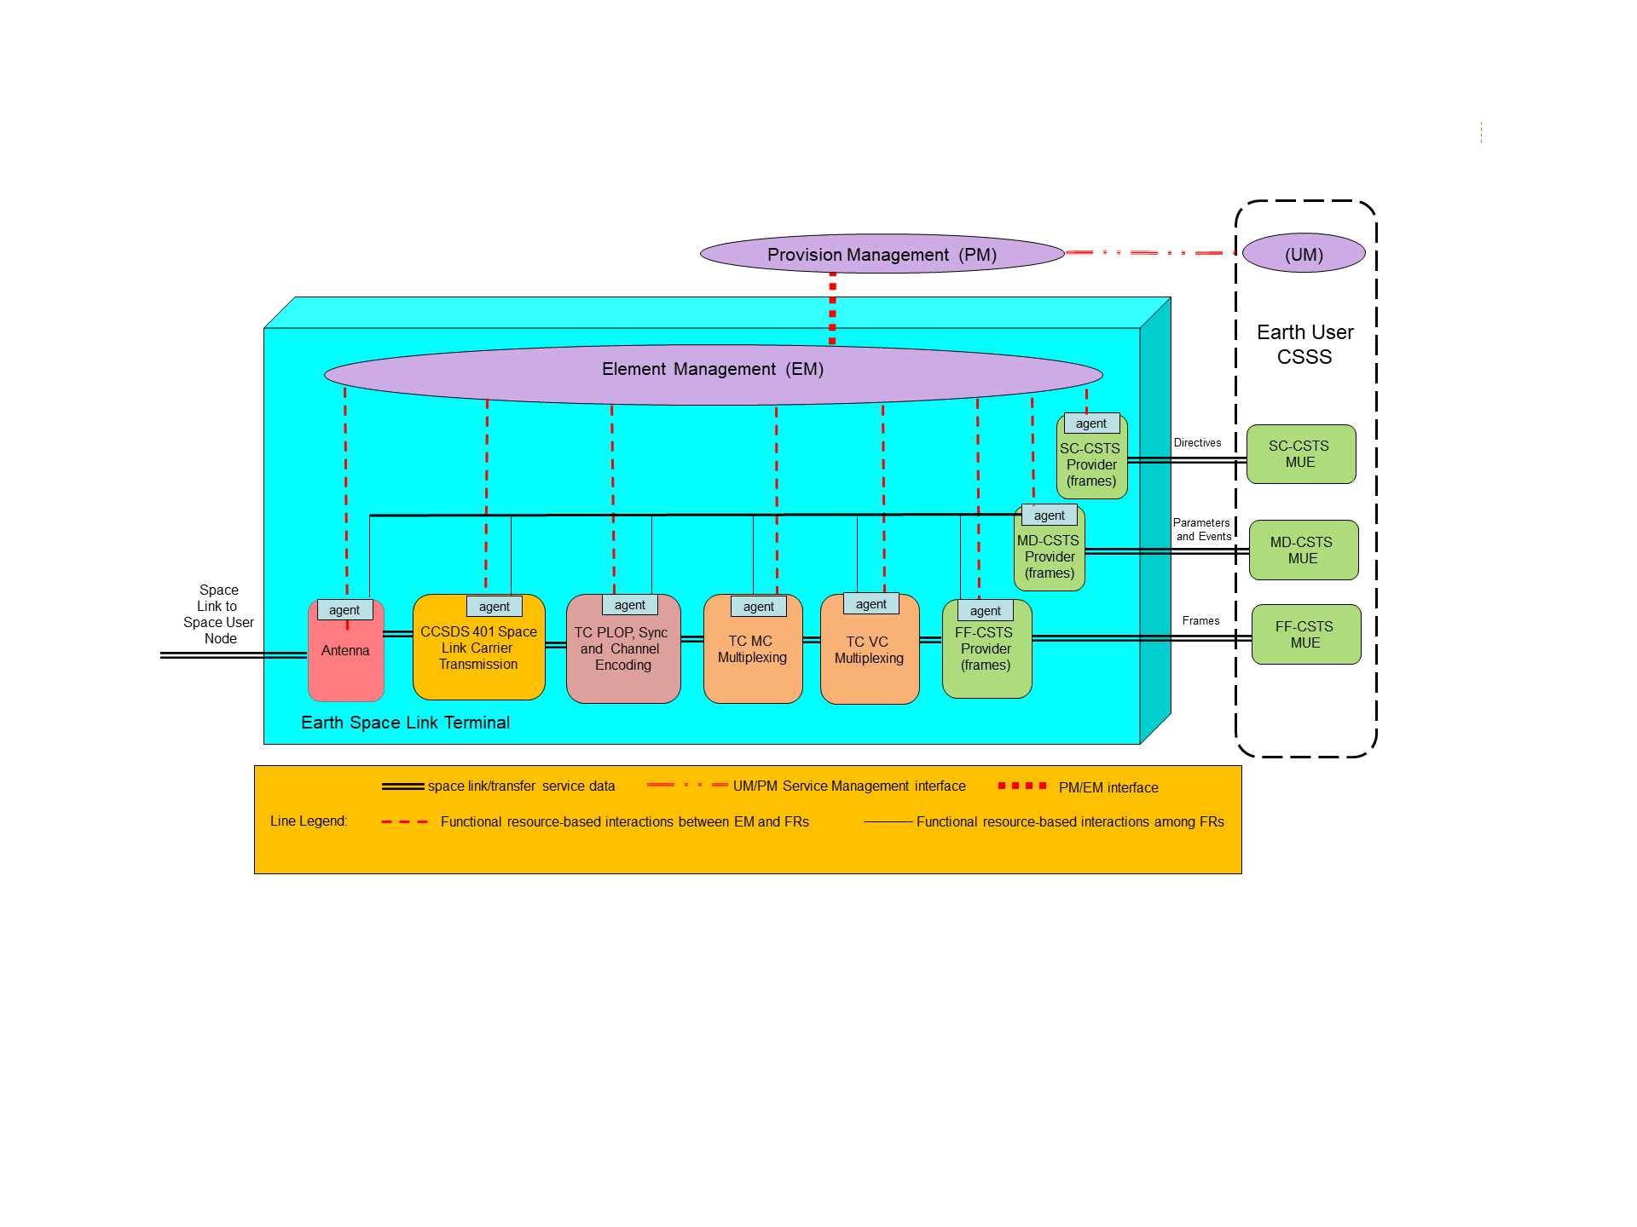

**Figure 2‑8: Functional Resource Conceptual Model of Interaction**

In this conceptual model, each managed system has a one-to-one mapping to a functional resource type, and each has an embedded agent. The Mission’s Configuration Management (CM) function interacts with the Provider CSSS’s Provision Management (PM) function to schedule a Service Packge that executes the configuration profile that transmits the TC frames received by the ESLT through the FF service. PM transfers the Service Package information to the EM function of the ESLT that is to execute the Service Package using interface(s) and protocol(s) that are locally-defined by the Provider CSSS and outside the scope of this Recommended Practice.

EM selects the managed systems that will be used to host the functional resources in the configuration and configures those FRs through the embedded FR agents. The interface(s) used between EM and the embedded FR agents are standardized to the extent that they are expressed in terms of CCSDS-standard PEDs, but are otherwise implementation-specific and outside the scope of this Recommend Standard.

When Service Package execution begins and the FF-CSTS instance is bound and active, the user of the FF service is able to query the values of parameters of not only the FF-CSTS Provider instance itself but also the values of the parameters of the FR instances that form the production chain for that FF service instance. The supporting production FRs also emit event notifications (such as the ‘data processing complete’ event tha is emitted by the TC PLOP, Synchronization and Channel Encoding FR to indicate that the frame has been transmitted) that either moderate the functions of the FF-CSTS Provider or are relayed to the service user. In the conceptual mode, these parameter values and event notifications are exchanged directly among the agents of the FF-CSTS Provider FR and the supporting production FRs, as represented by the virtual network represented by the *functional resource-based interactions among FRs* lines in the diagram. The implementation of such a virtual network is outside the scope of this Recommended Practice.

The FF-CSTS may also issue directives to underlying production FRs, triggerd either by directives from the service user or by the processes performed by the FF-CSTS Provider FR itself. However, because directives must in general be checked against guard conditions that may involve multiple FR instances in the production chain, all directives are sent to EM for guard condition validation, and valid directives are sent from EM to the affected FR instances.

When the MD-CSTS instance is bound and active, the user of the MD service is nominally able to query the values of the parameters of all of FR instances in the Service Package, subject to Service Agreement constraints. As with the exchange of prarameter values and event notification with the FF-CSTS Provider FR, in the conceptual mode the parameter values and event notifications are exchanged directly among the agents of the MD-CSTS Provider instance and the FRs, including the FF-CSTS Provider FR.

When the SC-CSTS instance is bound and active, the user of the SC service is nominally able to issue directives to trigger actions and change the values of the configuration parameters of all FR instances in the Service Package, subject to Service Agreement constraints. As with the invocation of directives by the FF-CSTS Provider FR, all directives are sent to EM for guard condition validation, and valid directives are sent from EM to the affected FR instances.

Now consider a non-ideal (and probably more realistic in the near term) implementation/deployment in which the physical resources do not necessarily relate one-to-one to their FR types and not all managed systems have resident FR agents. Figure 2‑9 is an example of such an implement/deployment, which implements the proxy agents as part of EM.

In this example, only the CSTS Provider FRs have built-in FR agents – the other FRs are implemented by managed systems that have management interfaces that are native to their design. Also, the TC MC Multiplexing and TC VC Multiplexing FRs are implemented by the same physical resource, which has one native management interface that configureas and controls the functions of both FRs.

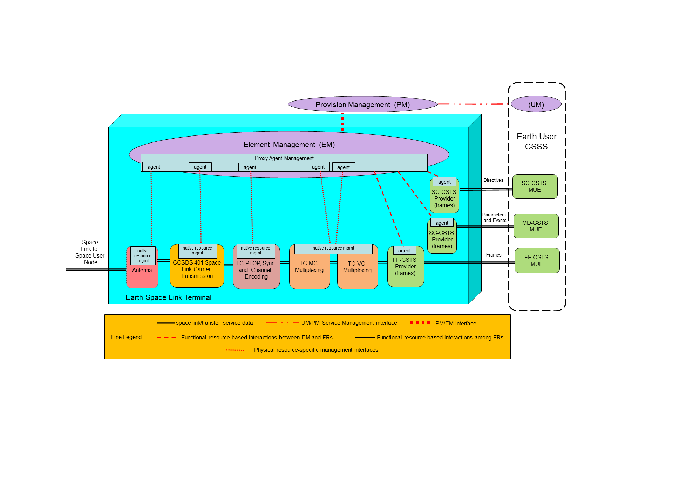

**Figure 2‑9: Functional Resource Mixed Architecture Example**

In this example, EM performs various proxy agent management functions that collectively make the managed resources appear and act as functional resources. Thes proxy functions include instantiating proxy agents for each of the managed systems that do not have embedded FR agents. Each proxy agent translates/transforms between the CCSDS-standard FR PEDs and the PEDs that are native to the managed system for which it is acting as a proxy. The proxy agent management functions also interface with the FR agents of those managed systems that have embedded FR agents. And finally, the proxy agent management functions provide the virtual interconnection network among the agents and proxy agents that allow for the exchange of parameters and events among the FRs, and for the invocation and guard-condition validation of directives.

# Aperture Functional Resource Stratum

## General

The Aperture FR stratum has one candidate and one future Functional Resource Set:

* RF Aperture (approved); and
* Antenna Array (future).

## RF Aperture Functional Resource Set of the Aperture Functional Resource Stratum

The RF Aperture Functional Resource Set of the Aperture stratum consists of the Antenna FR. Figure 3‑1 illustrates the composition of the RF Aperture FR Set.

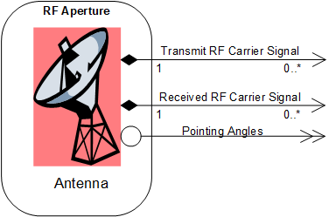

**Figure 3‑1: Member Functional Resource of the RF Aperture Functional Resource Set**

### Antenna

The classifier of the Antenna FR Type is Antenna.

In transmitting signals, the Antenna FR accepts as input the RF carrier signal from an FR in the Physical Channel FR stratum, and either radiates that signal either into space or into a water load, provided the given Antenna FR instance has the transmit capability.

In receiving signals, the Antenna FR provides as output the RF carrier signal received from space to one or more signal reception FRs in the Physical Channel FR stratum, provided the given Antenna FR instance has the receive capability.

The azimuth and elevation pointing angles are forwarded to one or more FRs of the SLS Radiometric Data Production FR stratum. The pointing angles are provided only while the antenna is in some form of 'closedLoop' pointing mode.

For the correction of radiometric observables weather data are required which should be collected close to the antenna used to obtain the radiometric observables. Therefore the Antenna FR is regarded as the source of the weather data provided to FRs in the SLS Radiometric Data Production FR stratum.

Note: An Antenna FR may be limited to 'transmit-only' or 'receive-only'.

The Antenna provides as output the carrier signal of which the nominal frequency is specified by the applicable FR of the Physical Channel stratum downconverted to the IF used by the local implementation. This IF signal is forwarded to the Ccsds401SpaceLinkCarrierRcpt FR or the Ccsds415SpaceLinkCarrierRcpt FR.

NOTES

1. In many real TT&C networks, the interface between the transmitter or receiver and the aperture is at IF and not at RF as formally represented in the Functional Resource Model. The nature of such IF interfaces is dependent on local implementation details. Formally modeling the interface as being at RF consolidates the radio-related parameters in one logical place in the Functional Resource Model. The Functional Resource Model, being an abstract logical model, does not prescribe or constrain the deployment of functionality to real physical systems.
2. If multiple instances of signal reception FRs in the Physical Chanel FR stratum (e.g., CCSDS 401 Space Link Carrier Reception FR, Delta-DOR Receiver/Formatter FR, and/or or Open Loop Receiver/Formatter FR) share the received RF carrier signal output by the Antenna FR, the RF-related configuration parameters of all of those Physical Channel FR spectrum FRs must be set to mutually-consistent values.

One antenna can be used by multiple forward and/or return space links simultaneously. The Antenna FR also encompasses the tracking receiver used to lock onto the RF signal for the purposes of autotracking.

The parameters, events, and directives of this functional resource registered in the SANA FR Registry (reference [34]).

There are no CCSDS Recommended Standards that specify the behavior or managed parameters of the resources represented by the Antenna FR.

#### Service Access Points (SAPs) and Ancillary Interfaces Used by this Functional Resource

##### SAPs Accessed by this Functional Resource

None.

##### SAPs Hosted by this Functional Resource

The Antenna FR has a Transmit RF Carrier Signal SAP that can be accessed by multiple Accessors (if it is a multi-band antenna).

The Antenna FR has a Received RF Carrier Signal SAP that can be accessed by multiple Accessors (if it is a multi-band antenna).

##### Ancillary Interfaces Required by this Functional Resource

None.

##### Ancillary Interfaces Provided by this Functional Resource

The Antenna FR provides a Pointing Angles ancillary interface.

## Antenna Array Functional Resource Set of the Aperture Functional Resource Stratum

NOTE- This FR will not be included in the draft Red-0.4 version of this book that will be made available for subject matter expert review.

This FR Set definition is TBD.

# Physical Channel Functional Resource Stratum

## General

The Physical Channel FR stratum has two candidate and two future Functional Resource Sets:

* the CCSDS 401 Physical Channel Transmission Functional Resource Set (approved);
* ;
* the CCSDS 401 Physical Channel Reception Functional Resource Set (approved);
* the CCSDS 415 Physical Channel Transmission Functional Resource Set (future);
* the CCSDS 415 Physical Channel Reception Functional Resource Set (future);
* the Delta-Differential One-way Ranging (DOR) Receiver Functional Resource Set (future); and
* the Open Loop Receiver Functional Resource Set (future).

## CCSDS 401 Physical Channel Transmission Functional Resource Set of the Physical Channel Abstract Stratum

The CCSDS 401 Physical Channel Transmission Functional Resource Set of the Physical Channel stratum comprises the following FR types:

1. CCSDS 401 Space Link Carrier Transmission; and
2. Ranging Transmission.

Figure 4‑1 illustrates the functional resource types that constitute the CCSDS 401 Physical Channel Transmission Functional Resource Set.

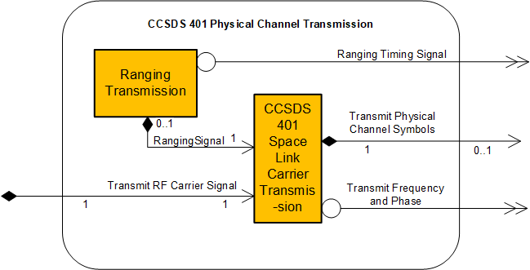

**Figure 4‑1: Member Functional Resources of the CCSDS 401 Physical Channel Transmission Functional Resource Set**

### CCSDS401 Space Link Carrier Transmission

The functional resource classifier of the CCSDS 401 Space Link Carrier Transmission FR Type is Ccsds401SpaceLinkCarrierXmit.

The CCSDS 401 Space Link Carrier Transmission FR accepts as input the optionally convolutionally encoded physical channel symbol stream from a functional resource in the Synchronization and Channel Coding FR stratum. It also accepts from the Ranging Transmission FR the ranging signal for modulation of the carrier. The CCSDS 401 Space Link Carrier Transmission FR provides the resultant modulated RF carrier signal to an FR in the Aperture FR stratum and the actual carrier frequency and phase to one or more FRs in the SLS Radiometric Data Production FR stratum.

NOTE - In many real TT&C networks, the interface between the transmitter and the aperture is at intermediate frequency (IF) and not at RF as formally represented in the Functional Resource Model. The nature of such IF interfaces is dependent on local implementation details. Formally modeling the interface as being at RF consolidates the radio-related parameters in one logical place in the Functional Resource Model. The Functional Resource Model, being an abstract logical model, does not prescribe or constrain the deployment of functionality to real physical systems.

The parameters, events, and directives of this functional resource are registered in the SANA FR Registry (reference [34]).

The CCSDS 401 Space Link Carrier Transmission FR corresponds to the radio frequency modulation and transmission functions up to the point of intermediate frequency (IF) generation, as specified in the CCSDS *Radio Frequency and Modulation Systems: Part 1 – Earth Stations and Spacecraft* Recommended Standard (reference [23]). That Recommended Standard does not explicitly specify the managed parameters of the functions specified therein.

#### Service Access Points (SAPs) and Ancillary Interfaces Used by this Functional Resource

##### SAPs Accessed by this Functional Resource

The CCSDS 401 Space Link Carrier Transmission FR accesses a TransmitRF Carrier Signal SAP that can be accessed by multiple Accessors (if it is a multi-band antenna).

##### SAPs Hosted by this Functional Resource

The CCSDS 401 Space Link Carrier Transmission FR has a Transmit Physical Channel Symbols SAP that is accessed by zero or one Accessor.

NOTE – When the space link is used only for ranging, there is no Accessor for the Transmit Physical Channel Symbols SAP.

The CCSDS 401 Space Link Carrier Transmission FR has a Ranging Signal SAP that is accessed by zero or one Ranging Transmission FR.

NOTE – When the space link is used only for data transmission, there is no Accessor for the Ranging Signal SAP.

##### Ancillary Interfaces Required by this Functional Resource

None.

##### Ancillary Interfaces Provided by this Functional Resource

The CCSDS 401 Space Link Carrier Transmission FR provides a Transmit Frequency and Phase ancillary interface.

### Ranging Transmission

The Functional Resource classifier of the Ranging Transmission FR Type is RngXmit.

The Ranging Transmission FR provides the to be radiated ranging signal to the spacecraft to the CCSDS 401 Space Link Carrier Transmission for modulation onto the forward carrier. It provides the timing information needed by the Range and Doppler Extraction FR of the CCSDS 401 Physical Channel Reception FR Set.

The parameters, events, and directives of this functional resource are registered in the SANA FR Registry (reference [34]).

There are no CCSDS, European Cooperation for Space Standardization (ECSS), or DSN standards that specify the managed parameters of the resources represented by the Ranging Transmission FR.

The Ranging Transmission FR generates the ranging signal that is applied to the forward physical channel. Depending on the ranging technology used, the ranging signal takes the form of:

1. ranging tones as defined in the ECSS Ranging and Doppler tracking standard(reference [45]) and the DSN sequential ranging standard (reference [46]); or
2. a pseudo-noise (PN) sequence as defined in CCSDS 414 (reference [24]).

The time of radiation of the ranging signal is provided to the Range and Doppler Extraction FR so that on reception of the ranging signal replica the round-trip delay can be determined.

#### Service Access Points (SAPs) and Ancillary Interfaces Used by this Functional Resource

##### SAPs Accessed by this Functional Resource

The Ranging Transmission FR accesses a Ranging Signal SAP.

##### SAPs Hosted by this Functional Resource

None.

##### Ancillary Interfaces Required by this Functional Resource

None.

##### Ancillary Interfaces Provided by this Functional Resource

The Ranging Transmission FR provides a Ranging Timing Signal ancillary interface.

## CCSDS 401 Physical Channel Reception Functional Resource Set of the Return Physical Channel Reception Functional Resource Stratum

The CCSDS 401 Physical Channel Reception Functional Resource Set of the Physical Channel Reception Functional Resource stratum consists of the following FR types:

1. CCSDS 401 Space Link Carrier Reception; and
2. Range and Doppler Extraction.

Figure 4‑2 illustrates the internal composition of the CCSDS 401 Physical Channel Reception Functional Resource Set.

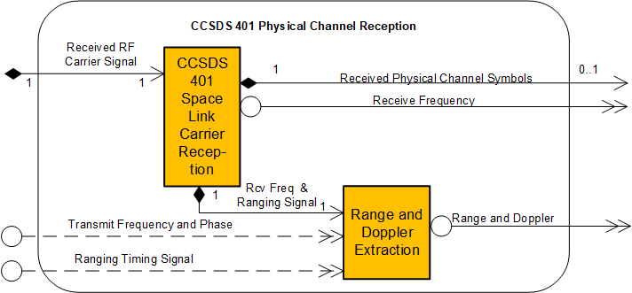

**Figure 4‑2: Member Functional Resources of the CCSDS 401 Physical Channel Reception Functional Resource Set**

### CCSDS 401 Space Link Carrier Reception

The Functional Resource classifier of the CCSDS 401 Space Link Carrier Reception FR Type is Ccsds401SpaceLinkCarrierRcpt.

The CCSDS 401 Space Link Carrier Reception FR accepts as input the RF carrier signal from an FR in the Aperture FR stratum. It provides the symbol stream demodulated from the carrier channel to an FR in the Synchronization and Channel Coding FR stratum. It provides observables needed for the creation of radiometric data to the Range and Doppler Extraction FR.

NOTES

1. In many real TT&C networks, the interface between the receiver and the aperture is at IF and not at RF as formally represented in the Functional Resource Model. The nature of such IF interfaces is dependent on local implementation details. Formally modeling the interface as being at RF consolidates the radio-related parameters in one logical place in the Functional Resource Model. The Functional Resource Model, being an abstract logical model, does not prescribe or constrain the deployment of functionality to real physical systems.
2. If an instance of the CCSDS 401 Space Link Carrier Reception FR shares a return RF carrier signal with another receiver (e.g., such as a Delta-DOR Receiver/Formatter or Open Loop Receiver/Formatter), the RF-related configuration parameters of the CCSDS 401 Space Link Carrier Reception FR and the FRs representing those other receiver types must be set to mutually-consistent values.
3. If the frequency of the carrier received by the CCSDS 401 Space Link Carrier Reception FR is to be coherently related to the transmitted frequency of an instance of the CCSDS 401 Space Link Carrier Transmission FR, the identiy of the coherently-paired CCSDS 401 Space Link Carrier Transmission FR is indirectly indicated by the value of the CCSDS 401 Space Link Carrier Reception FR ccsds401CarrierRcptTransponderRatio parameter, as defined in the SANA FR Registry.

The parameters, events, and directives of this functional resource are registered in the SANA FR Registry (reference [34]).

The CCSDS 401 Space Link Carrier Reception FR demodulates one stream of return physical channel symbols and/or extracts ranging and/or Doppler data from a return modulated electromagnetic waveform.

The CCSDS 401 Space Link Carrier Reception FR corresponds to the radio frequency reception and demodulation functions from the IF signal, as specified in the CCSDS *Radio Frequency and Modulation Systems: Part 1 – Earth Stations and Spacecraft* Recommended Standard (reference [23]). That Recommneded Standard does not explicitly specify the managed parameters of the functions specified therein.

NOTE – Although CCSDS 401 theoretically permits separate data streams to be modulated on the I and Q channels when QPSK modulation is used, no existing Provider CSSS supports such a capability and none are expected to do so. So the CCSDS 401 Space Link Carrier Reception FR as documented in the SANA Functional Resource Registry only represents systems that produce a single data stream.

#### Service Access Points (SAPs) and Ancillary Interfaces Used by this Functional Resource

##### SAPs Accessed by this Functional Resource

The CCSDS 401 Space Link Carrier Reception FR accesses the Received RF Carrier SignalSAP.

##### SAPs Hosted by this Functional Resource

The CCSDS 401 Space Link Carrier Reception FR has a Received Physical Channel Symbols SAP that can be accessed by zero or more Accessors.

NOTE – When the space link is used only for ranging, there is no Accessor for the Received Physical Channel Symbols SAP.

The CCSDS 401 Space Link Carrier Reception FR has a Receive Frequency and Ranging Signal SAP that is accessed by zero or one Range and Doppler Extraction FR.

NOTE – When the space link is used only for data reception, there is no Accessor for the Range and Doppler Extraction SAP.

##### Ancillary Interfaces Required by this Functional Resource

None.

##### Ancillary Interfaces Provided by this Functional Resource

The CCSDS 401 Space Link Carrier Reception FR provides a Receive Frequency ancillary interface.

### Range and Doppler Extraction

The Functional Resource classifier for the Range and Doppler Extraction FR Type is RangeAndDopplerExtraction.

The Range and Doppler Extraction FR accepts as input the timing information from the Ranging Transmission FR of the CCSDS 401 Physical Channel Reception Transmission FR Set and the range and Doppler data from the CCSDS 401 Space Link Carrier Reception FR. It provides range and Doppler observables to on or more FRs in the SLS Radiometric Data Production FR stratum.

The parameters, events, and directives of this functional resource are registered in the SANA FR Registry (reference [34]).

There are no CCSDS, ECSS, or DSN standards that specify the managed parameters of the resources represented by the Range and Doppler Extraction FR.

The Range and Doppler Extraction FR extracts the ranging signal that is applied to the forward physical channel by the Ranging Transmission FR. Depending on the ranging technology used, the ranging signal takes the form of:

1. ranging tones as defined in the ECSS Ranging and Doppler tracking standard(reference [45]) and the DSN sequential ranging standard (reference [46]); or
2. a pseudo-noise (PN) sequence as defined in CCSDS 414 (reference [24]).

The time of radiation of the ranging signal is provided by the Ranging Transmission FR so that on reception of the ranging signal replica the round-trip delay can be determined.

#### Service Access Points (SAPs) and Ancillary Interfaces Used by this Functional Resource

##### SAPs Accessed by this Functional Resource

The Range and Doppler Extraction FR accesses a Receive Frequency and Ranging Signal SAP.

##### SAPs Hosted by this Functional Resource

None.

##### Ancillary Interfaces Required by this Functional Resource

The Range and Doppler Extraction FR optionally requires a Ranging Timing Signal ancillary interface.

The Range and Doppler Extraction FR optionally requires a Transmit Frequency and Phase ancillary interface.

##### Ancillary Interfaces Provided by this Functional Resource

The Range and Doppler Extraction FR provides a Range and Doppler ancillary interface.

## CCSDS 415 Physical Channel Transmission Functional Resource Set of the Physical Channel Abstract Stratum

NOTE- This FR will not be included in the draft Red-0.4 version of this book that will be made available for subject matter expert review.

The composition of the CCSDS 415 Physical Channel Transmission Functional Resource Set of the Physical Channel stratum is To Be Specified.

NOTE – This FR set corresponds to the functionality specified for a Code Division Multiple Access (CDMA) spread spectrum forward link as defined in CCSDS 415 (reference [25]). This functionality includes both data transfer and ranging. Whether this functionality is to be represented by a single FR type or multiple FR types is TBD.

**The remainder of this section is To Be Specified.**

## CCSDS 415 Physical Channel Reception Functional Resource Set of the Physical Channel Abstract Stratum

NOTE- This FR will not be included in the draft Red-0.4 version of this book that will be made available for subject matter expert review.

The composition of the CCSDS 415 Physical Channel Reception Functional Resource Set of the Physical Channel stratum is To Be Specified.

# Synchronization and Channel Coding Functional Resource Stratum

## General

This section identifies and defines the Functional Resource Sets of the Synchronization and Channel Coding FR stratum.

The Synchronization and Channel Coding FR stratum has three candidate Functional Resource Sets:

* the TC Synchronization and Channel Encoding Functional Resource Set,
* the Fixed Length Frame Synchronization, Channel Encoding, and OID Generation Functional Resource Set, and
* the Fixed Length Frame Synchronization and Channel Decoding Functional Resource Set.

## TC Synchronization and Channel Encoding Functional Resource Set Of the Synchronization and Channel Coding FR Stratum

The TC Synchronization and Channel Encoding Functional Resource Set of the Synchronization and Channel Coding FR Stratum consists of the TC PLOP, Synchronization and Channel Encoding FR. Figure 5‑1 illustrates the functional resource type that constitutes the TC Synchronization and Channel Encoding Functional Resource Set.

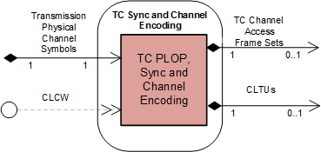

**Figure 5‑1: Member Functional Resource of the TC Synchronization and Channel Encoding Functional Resource Set**

### TC PLOP, Synchronization and Channel Encoding FR

The Functional Resource classifier of the TC Synchronization and Channel Encoding FR Type is TcPlopSyncAndChnlEncode.

The parameters, events, and directives of this functional resource are registered in the SANA Candidate FR Registry (reference [34]).

The TC PLOP, Synchronization and Channel Encoding FR corresponds to the following functions:

1. the Random Sequence Generation function of the TC Synchronization and Channel Coding Recommended Standard (reference [5]);
2. the BCH Encoding function of the TC Synchronization and Channel Coding Recommended Standard;
3. the LDPC Encoding function of the TC Synchronization and Channel Coding Recommended Standard;
4. the CLTU Generation functions of the TC Synchronization and Channel Coding Recommended Standard;
5. the Physical Layer Operations Procedure (PLOP) of the TC Synchronization and Channel Coding Recommended Standard;
6. the emission of ‘data unit processing complete’ CSTS event notifications, as required by the CSTS Data Processing procedure, Buffered Data Processing procedure, or Sequence Controlled Data Processing procedure (4.6.3.4 of reference [4]); and
7. the discarding of all data units with specified service-instance-id upon receipt of a CSTS ‘discard all data units’ request, as required by the CSTS Data Processing procedure, Buffered Data Processing procedure, or Sequence Controlled Data Processing procedure (4.6.3.4 of reference [4]).

Section 8 of the TC Synchronization and Channel Coding Recommended Standard (reference [5]) specifies the set of managed parameters that are pertinent to the functions specified in that Recommended Standard. All managed parameters from that Recommended Standard are reflected in the configuration parameters of the TC PLOP, Synchronization and Channel Encoding FR as defined in the SANA FR Registry, **except for the *Decoding Mode* managed parameter**, which applies only to the receiving end.

NOTE – The configuration parameters of the TC PLOP, Synchronization and Channel Encoding FR also include parameters that are not explicitly identified as managed parameters in the Recommended Standard.

An instance of the TC PLOP, Synchronization and Channel Encoding FR is configured to process either TC channel access frame sets (groups of transfer frames) or CLTUs.

When configured to support TC channel access frame sets, the FR performs: Random Sequence Generation ((a) above (optional for BCH, mandatory for LDPC)); either BCH Encoding ((b) above) or LDPC Encoding ((c) above); the CLTU Generation ((d) above); and the PLOP ((e) above). When configured to process CLTUs, the FR performs only the PLOP ((e) above).

Figure 5‑2 illustrates the sublayers of the TC PLOP, Synchronization and Channel Encoding FR.

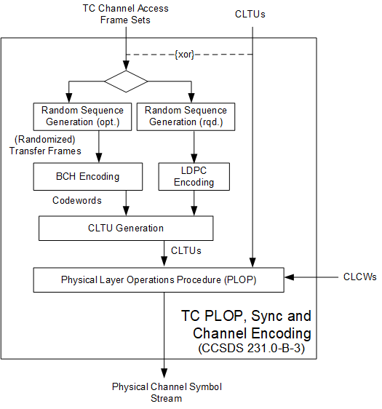

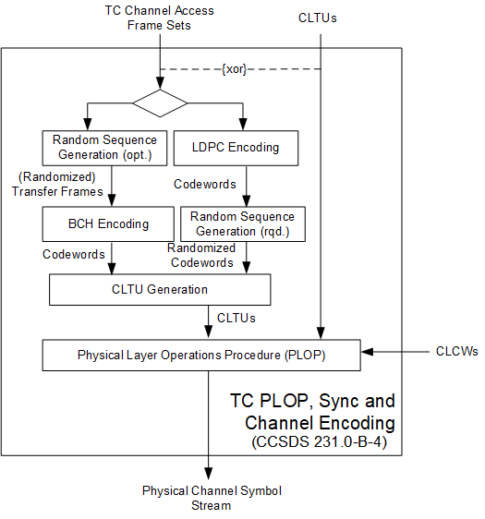

**Figure 5‑2: Internal Structure of the TC PLOP, Synchronization and Channel Encoding Functional Resource**

#### Support for Systematic Retransmission

The TC Synchronization and Channel Coding Recommended Standard (reference [5]) specifies a mechanism for the systematic retransmission of CLTUs. As formally specified in reference [5], the TC Synchronization and Channel Coding sublayer provides a Channel Access service interface through which the space data link protocol above it submits a set of frames, optionally accompanied by a Repetitions parameter. The set of frames – referred to as a TC channel access frame set in this Recommended Practice – constitutes the set of frames from which the TC Sync and Channel Coding sublayer forms the CLTU. If the Repetitions parameter has a value greater than one, then the TC Sync and Channel Coding sublayer transmits that CLTU Repetitions number of times.

However, the specifcations of the SLE Forward CLTU (reference [27]) and Forward Space Packet (reference [28]) service do not use the Repetitions parameter to implement systematic retransmission. In the case of Forward CLTU service, it is the responsibility of the service user to transfer the same CLTU multiple times to cause that CLTU to be repeated across the space link. In the case of Forward Space Packet service, the space data link protocol layer generates repeated copies of the same TC channel access frame set, based on configuration parameters set by Service Management that specify how many times Sequence-Controlled (type AD) and COP Control Command (type BC) Telecommand frames for each virtual channel are to be repeated, and whether the specific group-of-frames data unit contains any AD or BC frames that are specified to be repeated.

For consistency with the Forward CLTU and Forward Space Packet services, the TC PLOP, Synchronization and Channel Encoding FR does not support the Repetitions parameter. Any repetitions of CLTUs must be accomplished by having the space data link protocol layer submit the same TC channel access frame set multiple times. The net effect “on the space link” is the same as if the Repetitions parameter were used, and so interoperability across the space link is preserved.

NOTE – The term *TC channel access frame set* is not formally defined in any CCSDS Recommended Standard. The *TC Synchronization and Channel Coding* Recommended Standard does, however, define the ChannelAccess.request service primitive as the mechanism by which the TC coding sublayer receives a “data unit” of TC frames that is optionally accompanied by a Repetitions parameter. Each data unit of frames is transformed into a single CLTU, and the Repetitions parameter specifies how many times the resulting CLTU shall be transmitted. This Recommended Practice uses the term *TC channel access frame set* to refer to the data unit of frames of the ChannelAccess.request service primitive. Note that a TC channel access frame set is not to be confused with an TM/AOS *Channel Access Data Unit* (CADU). Whereas the TC channel access frame set exists at the interface between the space link protocol and coding layers, the TM/AOS CADU exists at the interface between the coding and physical layers.

#### Regulation of the resource status by bit lock and RF availability status of the forward space link

The resource status of the TC PLOP, Synchronization and Channel Encoding FR can be made to depend upon the bit lock and/or RF availability status of a corresponding forward space link through the tcPlopSyncClcwEvaluation configuration parameter. If either of these indicators are configured to be required, then the CLCW ancillary interface is required. When the CLCW ancillary interface is used, the resource status of the FR instance transitions between ‘operational’ and ‘interrupted’ depending on the No Bit Lock and/or No RF Available flags of the CLCWs received through that interface, as defined in Table 5‑1.

NOTE – The dependency on the CLCW flags only affects the resource status when the FR instance would otherwise be in ‘operational’. The CLCW flags have no effect when the resource status is either ‘configured’ or ‘halted’.

Table ‑1 : Resource Status as a Function of Space Link Availability and Bit Lock

|  |  |  |  |  |
| --- | --- | --- | --- | --- |
|  | **CLCW Flag Settings** | | | |
| **tcPlopSyncClcwEvaluation Configuration Parameter  Settings** | No Bit Lock = true | No Bit Lock = false | No RF Available = true | No RF Available = false |
| noEvaluation | operational | operational | operational | operational |
| evaluation: linkCondition = noEvaluation | operational | operational | operational | operational |
| evaluation: linkCondition = rfAvailableVerified | operational | operational | interrupted | operational |
| evaluation: linkCondition = bitLockVerified | interrupted | operational | operational | operational |
| evaluation: linkCondition = rfAvailableAndBitLockVerified | interrupted | operational | interrupted | operational |

##### Relationships with external Functional Resource Sets

The TC PLOP, Synchronization and Channel Encoding FR accesses the Transmission Physical Channel Symbols SAP.

The TC PLOP, Synchronization and Channel Encoding FR has a TC Channel Access Frame Set SAP that can be accessed by a single Accessor.

The TC PLOP, Synchronization and Channel Encoding FR has a CLTU SAP that can be accessed by a single Accessor.

The TC PLOP, Synchronization and Channel Encoding FR requires a CLCW ancillary interface when the resource status of the FR instance is configured to be regulated by the No Bit Lock and/or No RF Available flags of the CLCW.

## Fixed Length Frame (FLF) Synchronization, Channel Encoding, and OID Generation Functional Resource Set Of the Synchronization and Channel Coding FR Stratum

The Fixed Length Frame (FLF) Synchronization, Channel Encoding, and OID Generation Functional Resource Set of the Synchronization and Channel Coding FR Stratum consists of the FLF Synchronization, Channel Encoding, and OID Generation FR.

Figure 5‑3 illustrates the functional resource type that constitutes the FLF Synchronization, Channel Encoding, and OID Generation Functional Resource Set.

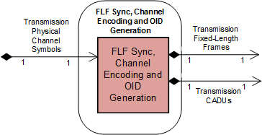

**Figure 5‑3: Member Functional Resource of the FLF Synchronization, Channel Encoding, and OID Generation Functional Resource Set**

### FLF Synchronization, Channel Encoding, and OID Generation FR

The FLF Synchronization, Channel Encoding, and OID Generation FR is used to support space data link protocols (SDLPs) that use fixed-length frames on the transmitted link. As of this issue of this Recommended Practice, there are two CCSDS SDLPs that use fixed-length frames on the transmission link, the AOS SDLP (reference [18]) and the Unified SDLP (reference [35]).

The FLF Synchronization, Channel Encoding, and OID Generation FR is also used to support the synchronization and optional convolutional encoding of already-formed Channel Access Data Units (CADUs). Although the CADUs are nominally formatted in accordance with the TM Synchronization and Channel Coding Recommended Standard (reference [6]), they can actually be any fixed-length data unit, which allows synchronization (and optional convolutional encoding) of non-CCSDS-standard fixed-length-data-units to be supported.

The functional resource classifier of the FLF Synchronization, Channel Encoding, and OID Generation FR Type is FlfFrameSyncChnEncodeAndOidGen.

The parameters, events, and directives of this functional resource are registered in the SANA Candidate FR Registry (reference [34]).

The FLF Synchronization, Channel Encoding, and OID Generation FR corresponds to the following functions:

1. the Reed-Solomon Encoding function specified in the TM Synchronization and Channel Coding Recommended Standard (reference [6]);
2. the (transfer frame) LDPC Encoding function specified in the TM Synchronization and Channel Coding Recommended Standard;
3. the Pseudo-Random Sequence Generation function specified in the TM Synchronization and Channel Coding Recommended Standard;
4. the Attachment of Sync Markers function specified in the TM Synchronization and Channel Coding Recommended Standard;
5. the Convolutional Encoding function specified in the TM Synchronization and Channel Coding Recommended Standard;
6. the (sync-markered transfer frame) LDPC Encoding function specified in the TM Synchronization and Channel Coding Recommended Standard;
7. the Only Idle Data (OID) Generation function, as described in 5.3.1.1;
8. the emission of ‘data unit processing completed’ CSTS event notifications, as required by the CSTS Data Processing procedure, Buffered Data Processing procedure, or Sequence Controlled Data Processing procedure (4.6.7.4 of reference [4]) ; and
9. the discarding of all data units with specified service-instance-id upon receipt of a CSTS ‘discard all data units’ request, as require by the CSTS Data Processing procedure, Buffered Data Processing procedure, or Sequence Controlled Data Processing procedure (4.6.7.3 of reference [4]).

Section 12 of the TM Synchronization and Channel Coding Recommended Standard (reference [6]) specifies a set of managed parameters. All managed parameters from that Recommended Standard for the functions implemented by the Functional Resource are reflected in the configuration parameters of the FLF Synchronization, Channel Encoding, and OID Generation FR as defined in the SANA FR Registry.

NOTES

1 The TM Synchronization and Channel Coding Recommended Standard has multiple scalar configuration parameters, many of which are applicable to only one of the available encoding schemes and are therefore “not applicable” when any other coding scheme is used. The FLF Synchronization, Channel Encoding, and OID Generation FR uses the complex-structured configuration parameter flfSyncEncCodingSelection to represent the configuration parameters of the supported coding schemes in such a way that only the applicable parameter values for the selected coding scheme are specified.

2 The TM Synchronization and Channel Coding Recommended Standard managed parameter *Transfer Frame Length* is represented by the FLF Synchronization, Channel Encoding, and OID Generation FR configuration parameter flfSyncSlpduLength, which specifies the transfer frame length when transfer frames are being encoded and synchronized, and specifies the CADU length when CADUs are being encoded and synchronized..

3 The configuration parameters of the FLF Synchronization, Channel Encoding, and OID Generation FR also include parameters that are not explicitly identified as managed parameters in the TM Synchronization and Channel Coding Recommended Standard.

Figure 5‑4 illustrates the component functions of the FLF Synchronization and Channel Encoding FR.

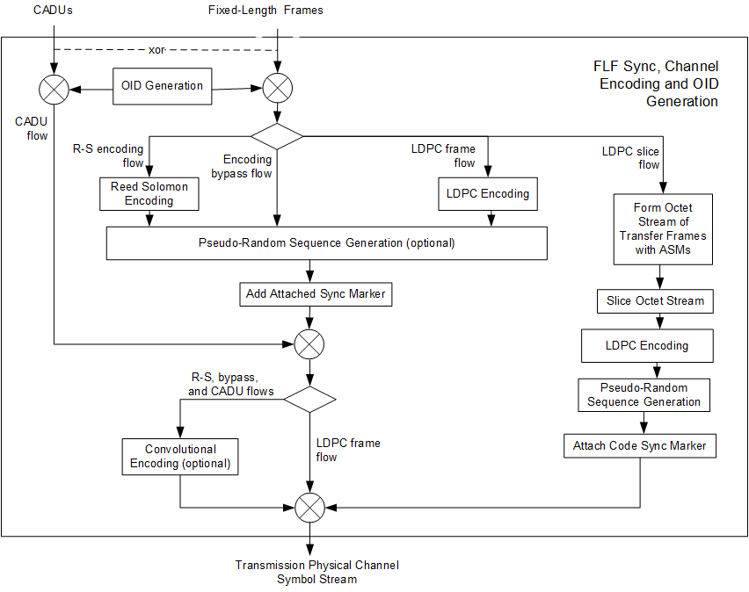

**Figure 5‑4: Internal Structure of the FLF Synchronization, Channel Encoding, and OID Generation Functional Resource**

#### OID Generation Function

The AOS Space Data Link Protocol Recommended Standard (reference [18]) and Unified Space Data Link Protocol (USLP) Recommended Standard (reference [35]) allocate the injection of Only Idle Data to the Master Channel Multiplexing function, which is represented in this Functional Resource model by the Forward AOS MC Multiplexing FR (6.3.1). As defined in the AOS and USLP SDLPs, the Master Channel Multiplexing function generates uncoded, fixed-length OID Frames that conform to the respective transfer frame format whenever frames containing user data are not available.

However, there are cases in which the input to the FLF Synchronization, Channel Encoding, and OID Generation FR comes directly from a Forward Frame CSTS Provider FR instance, bypassing the AOS/USLP VC and MC Multiplexing functions and any OID frame generations that they might perform. In order to support FF-CSTS production configurations in which the AOS/USLP multiplexing functions are bypassed, the FLF Synchronization, Channel Encoding, and OID Generation FR must generate OID data units when user-generated data units are not available. The OID Generation function serves this purpose.

NOTE – Although the allocation of the OID generation function to the FLF Synchronization, Channel Encoding, and OID Generation FR is not formally consistent with AOS and USLP Space Data Link Protocol Recommended Standards (references [18] and [35], respectively), the net effect on the data as it appears on space link is the same as if the function had been performed by the Master Channel Multiplexing function of the AOS or USLP Space Data Link Protocol in those cases where the AOS or USLP Space Data Link Protocol is applicable.

The OID Generation function of the FLF Synchronization, Channel Encoding, and OID Generation FR generates OID data units that match the coding that has already been applied to the input SL-PDUs. For example, if the incoming SL-PDUs being transferred by the Forward Frame CSTS instance are transfer frames that have already been Reed-Solomon encoded, randomized, and had the sync markers attached, such that they only require the FLF Synchronization, Channel Encoding, and OID Generation FR to convolutionally encode them (see the CADU flow, 5.3.1.2.5 below), the OID data unit itself must be a Reed-Solomon encoded, randomized, and sync-marker-attached OID Frame. In this Recommended Practice, the name *OID Data Unit* is used for an OID data unit that has the appropriate transformations applied to match the incoming SL-PDUs.

As noted above, the Forward Frame CSTS may even be used to transfer opaque blocks of octets – that is, SL-PDUs that are not necessarily based on the CCSDS AOS or USLP Transfer Frame format, and OID Data Units based on CCSDS OID Frames may not be appropriate. In order to support all possible combinations of prior encoding and private formatting, the OID Data Unit is itself an opaque block of octets that is set as a configuration parameter of the OID Generation function.

NOTE – The content of the OID Data Unit is static, and can therefore be set as a configuration parameter. If CCSDS were to ever specify a service for placing data inside the Insert Zone, the OID Data Unit would no longer have fixed content, and therefore the method for configuring the content of the OID Data Unit would need to be changed. However, at the time of this writing, there are no plans to implement a cross-supported Insert service.

#### Encoding and Channel Synchronization Flows

There are five possible flows through the functions of the Forward FLF Synchronization, Channel Encoding, and OID Generation FR, each of which constitutes a set of encoding functions. All five flows include the OID Generation function. The following subsections describe the remaining functions that constitute each flow. Note that for the flows that process frames (the first four flows below), the “frames” do not necessarily conform to the CCSDS AOS or USLP Transfer Frame specifications – they can be any data units conforming to the same (possibly Mission specific) fixed length format.

Encoding Bypass Flow. This flow is used for frames that do not require Reed-Solomon or LDPC encoding to be performed by the service provider, either because the SL-PDUs do not require any encoding or because they have already been encoded by the Mission prior to being transferred to the service provider using CCSDS-standard or Mission-specific encoding techniques. In this flow, the FLF Synchronization, Channel Encoding and OID Generation FR optionally pseudo-randomizes each data unit, adds the Attached Synchronization Marker (ASM), and optionally convolutionally encodes the resultant CADUs.

Reed-Solomon Encoding Flow. This flow is used for frames that require CCSDS-standard Reed-Solomon encoding to be performed by the service provider. In this flow, the FLF Synchronization, Channel Encoding and OID Generation FR applies Reed-Solomon encoding to each data unit, optionally pseudo-randomizes each data unit, adds the ASM, and optionally convolutionally encodes the resultant CADUs.

LDPC Frame Flow. This flow is used for frames that require CCSDS-standard LDPC encoding to be performed by the service provider. In this flow, the FLF Synchronization, Channel Encoding and OID Generation FR applies LDPC encoding to each data unit, optionally pseudo-randomizes each data unit, and adds the ASM.

LDPC Slice Flow. This flow is used for frames that require slicing and LDPC encoding to be performed by the service provider. In this flow, the Forward FLF Synchronization, Channel Encoding and OID Generation FR adds the ASM to each frame to form a Sync-Marked Transfer Frame (SMTF). Then the FR performs what is called LDPC coding of a stream of SMTFs in reference [6]: a process of slicing the SMTFs into Information Blocks, LDPC-encoding each of the the resultant Information Blocks into an *LDPC codeword*, aggregating a specified number of codewords into an *LDPC codeblock*, pseudo-randomizing each LDPC codeblock, and adding the Sync Code Marker to each LDPC codeblock.

CADU Flow. This flow is used for fully-formatted CADUs that require at most convolutional encoding to be performed by the service provider. In this flow, the FLF Synchronization, Channel Encoding and OID Generation FR optionally convolutionally encodes the CADUs. Note that in this flow, the “CADUs” do not necessarily conform to the CCSDS CADU specification in reference [6] – they can be any data units conforming to the same (possibly Mission specific) fixed length format.

#### Relationships with external Functional Resource Sets

The FLF Synchronization, Channel Encoding and OID Generation FR accesses the Transmission Physical Channel Symbols SAP.

The FLF Synchronization, Channel Encoding and OID Generation has two SAPs that are mutually exclusive: the Transmission Fixed Length Frame SAP and the Transmission CADU SAP. A single Accessor can access one and only one of these SAPs.

## Fixed-Length Frame Synchronization and Channel DeCoding Functional Resource Set Of the Synchronization and Channel Coding Functional Resource Stratum

The Fixed Length Frame (FLF) Synchronization and Channel Decoding Functional Resource Set of the Synchronization and Channel Coding Functional Resource stratum consists of the FLF Synchronization and Decoding FR. Figure 5‑5 illustrates the functional resources of the TM Synchronization and Channel Decoding Functional Resource Set.

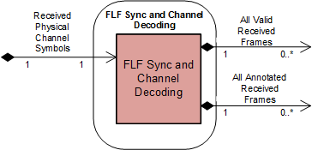

**Figure 5‑5: Member Functional Resource of the FLF Synchronization and Channel Decoding** **Functional Resource Set**

### FLF Synchronization and Channel Decoding

The Functional Resource classifier of the FLF Synchronization and Channel Decoding FR Type is FlfSyncAndChnlDecode.

The parameters, events, and directives of this functional resource are registered in the SANA Candidate FR Registry (reference [34]).

The FLF Synchronization and Decoding FR corresponds to the following functions:

1. the Convolutional Decoding function specified in the TM Synchronization and Channel Coding Recommended Standard (reference [6]);
2. the (sync-marked transfer frame) LDPC Decoding function specified in the TM Synchronization and Channel Coding Recommended Standard;
3. the Frame Synchronization function specified in the TM Synchronization and Channel Coding Recommended Standard;
4. the Pseudo-Random Sequence Removal function specified in the TM Synchronization and Channel Coding Recommended Standard;
5. the (transfer frame) LDPC Decoding function specified in the TM Synchronization and Channel Coding Recommended Standard;
6. the Turbo Decoding function specified in the TM Synchronization and Channel Coding Recommended Standard;
7. the Reed-Solomon Decoding function specified in the TM Synchronization and Channel Coding Recommended Standard;
8. the All Frames Reception function (which performs Frame Error Control decoding) of the TM Space Data Link Protocol (reference [19]), AOS Space Data Link Protocol (reference [18]), and Unified Space Data Link Protocol (reference [35]) Recommended Standards; and

NOTE – The All Frames Reception function is formally defined as part of the space data link protocol. However, its functionality is included in the TM Synchronization and Channel Decoding FR so that the resultant annotated transfer frames reflect all error detection and/or correction performed on those frames.

1. the Frame Annotation function, which is described in 5.4.1.1.

Section 12 of the TM Synchronization and Channel Coding Recommended Standard (reference [6]) specifies a set of managed parameters. All managed parameters from that Recommended Standard are reflected in the configuration parameters of the FLF Synchronization and Channel Decoding FR as defined in the SANA FR Registry.

Figure 5‑6 illustrates the component functions of the FLF Synchronization and Channel Decoding FR.

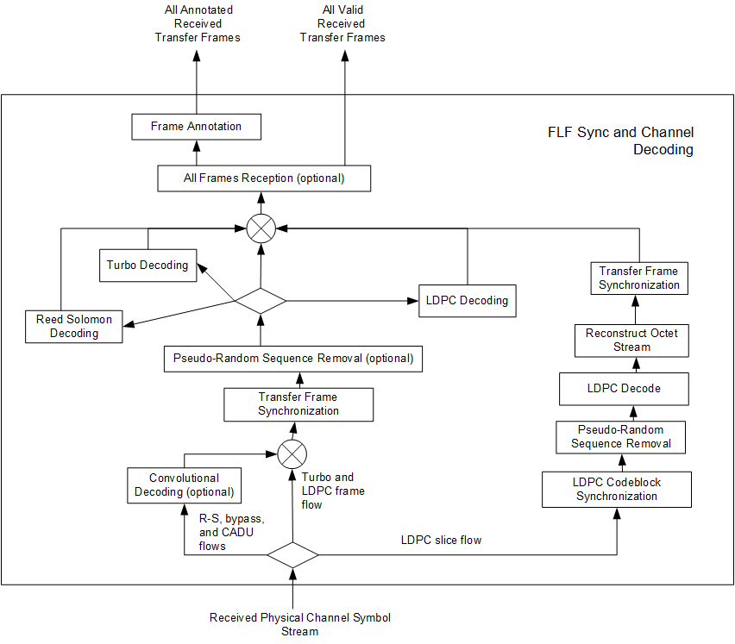

**Figure 5‑6: Internal Structure of the FLF Synchronization and Channel Decoding Functional Resource**

NOTE - Although Figure 5‑6 formally depicts the performance of convolutional decoding before transfer frame synchronization, implementations that perform frame sychronization on the convolutionally-encoded symbol stream have been shown to exhibit marginally better frame identification performance. Such implementations are conformant with the pertient CCSDS Recommendations in that the net effect on the processed frames is the same.

#### Frame Annotation function

The Frame Annotation function annotates each frame with information that is reported as part of the TRANSFER-DATA PDUs of the return SLE Transfer Services (references [2] , [3], and [29]). This information is:

* earth-receive-time of the frame;
* antenna-id of the aperture through which the frame was received;
* data-link-continuity;
* delivered-frame-quality (set only for RAF); and
* any private annotation that is optionally bilaterally agreed between the Provider CSSS and the Mission.

#### Service Access Points (SAPs) and Ancillary Interfaces Used by this Functional Resource

##### SAPs Accessed by this Functional Resource

FLF Synchronization and Channel Decoding FR accesses the Received Physical Channel Symbols SAP.

##### SAPs Hosted by this Functional Resource

The FLF Synchronization and Channel Decoding FR has a Return All Valid Frames SAP that can be accessed by multiple Accessors. The All Valid Received Frames SAP carries only those frames that are valid with respect to the decoding schemes configured for the FR instance. The Accessors of this SAP are nominally the return space data link protocols, for which only the contents of valid frames are acceptable.

The FLF Synchronization and Channel Decoding FR has a All Annotated Received Frames SAP that can be accessed by a multiple Accessors. The All Annotated Received Frames SAP carries both valid and errored frames. The Accessors of this SAP are nominally return transfer services (in particular SLE transfer services) that require the per-data-unit annotation information.

##### Ancillary Interfaces Required by this Functional Resource

None.

##### Ancillary Interfaces Provided by this Functional Resource

None.

# Space Link Protocol Functional Resource StratUM

## General

This section identifies and defines the Functional Resource Sets of the Space Link Protocol FR stratum.

The Space Link Protocol FR stratum has four candidate and three future Functional Resource Sets:

* the TC Space Link Protocol Transmission Functional Resource Set (candidate);
* the AOS Space Link Protocol Transmission Functional Resource Set (candidate);
* the Variable Length Frame (VLF) Unified Space Data Link Protocol Transmission Functional Resource Set (future);
* the Fixed Length Frame (FLF) Unified Space Data Link Protocol Transmission Functional Resource Set (candidate);
* the TM/AOS Space Link Protocol Reception Functional Resource Set (candidate);
* the VLF Unified Space Data Link Protocol Reception Functional Resource Set (future); and
* the FLF Unified Space Data Link Protocol Reception Functional Resource Set (future).

## TC Space Link Protocol Transmission Functional Resource Set of the Space Link Protocol Functional Resource Stratum

The FR types that comprise the TC Space Link Protocol Transmission Functional Resource Set of the Space Link Protocol Functional Resource stratum are:

1. TC Master Channel (MC) Multiplexing;
2. TC Virtual Channel (VC) Multiplexing;
3. TC Encapsulation, VC Packet Processing and VC Generation;
4. TC Multiplexer Access Point (MAP) Multiplexing; and
5. TC Encapsulation and MAP Packet Processing.

Figure 6‑1 illustrates the functional resource types that constitute the TC Space Link Protocol Transmission Functional Resource Set.

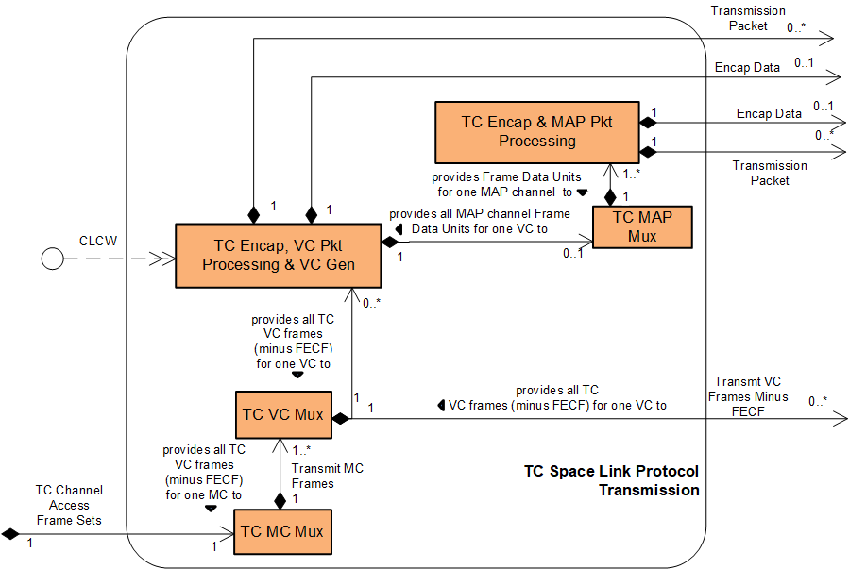

**Figure 6‑1: Member Functional Resources of the TC Space Link Protocol** **Transmission** **Functional Resource Set**

### TC Master Channel (MC) Multiplexing FR

The functional resource classifier of the TC MC Multiplexing FR Type is TcMcMux.

The parameters, events, and directives of this functional resource are registered in the SANA Candidate FR Registry (reference [34]).

The TC MC Multiplexing FR corresponds to the following functions:

1. the Master Channel Multiplexing function of the TC Space Data Link Protocol Recommended Standard (reference [17]), which multiplexes the transfer frames from one or more Master Channels into a single stream of transfer frames. The TC MC Multiplexing FR implements the three multiplexing schemes required by the Forward Frame Cross Support Transfer Service (reference [33]): absolute priority, polling vector, and FIFO; and
2. the All Frames Generation function of the TC Space Data Link Protocol Recommended Standard, which optionally adds a Frame Error Control Field (FECF) to the trailer of each frame, groups transfer frames into *TC channel access frame sets*, and sends those TC channel access frame sets to the underlying synchroniziation and coding sublayer one or more times based on the repetition parameters specified for the virtual channels and frame types of the frames contained in those frame sets (see 6.2.1.1).

NOTE – *TC channel access frame set* is the term used in this Recommended Practice to refer to the groups of TC frames created by the *TC Space Data Link Protocol* All Frames Generation function. The *TC Space Data Link Protocol* Recommended Standard refers to the groups simply as “data units”. The *TC Synchronization and Channel Coding* Recommended Standard, however, defines the ChannelAcess.request service primitive, through which the coding sublayer receives the groups of frames and associated optional repetitions parameters. The term TC channel access frame set is derived from the name of that TC Sync and Channel Coding primitive.

Tables 5-1 and 5-2 of section 5 of the TC Space Data Link Protocol Recommended Standard (reference [17]) specify a set of managed parameters for the Phyiscal Channels and Master Channels. All managed parameters from that Recommended Standard are reflected in the configuration parameters of the TC MC Multiplexing FR as defined in the SANA FR Registry except for the managed parameters identified in Table 6‑1.

Table 6‑1 : Managed Parameters of the Master Channel Multiplexing and All Frames Generation Functions of the TC Space Data Link Protocol Recommended Standard that are Not in the Configuration Parameters of the TC MC Multiplexing Functional Resource

| **Excluded Recommended Standard Managed Parameter** | **Comment** |
| --- | --- |
| Physical Channel Name | The Physical Channel Name is specified in the xxxPhysChnlName parameters of the Physical Channel stratum FRs. The TC MC Multiplexing FR inherits the value of this parameter from the Physical Channel stratum FR with which it is associated in the operational configuration. |
| Transfer Frame Version Number | For Telecommand, this value is fixed to version 1 (‘00’ binary) and is not configurable. |
| Valid Spacecraft IDs | The spacecraft IDs of the frames are either set as part of the configuration of FRs that generate frames from user inputs, or are included in the validation parameters of FRs that receive frames from user inputs (i.e., the Forward Frame CSTS). Thus the configuration profile as a whole defines the set of valid SCIDs. |
| Maximum Length of Data Unit Given to the Coding Sublayer | This value is derived from the tcPlopSyncMaxCltuLength parameter and coding options specified for the TC PLOP, Sync and Channel Encoding FR instance that is associated with the TC MC Multiplexing FR instance. |
| Maximum Bit Rate Accepted by the Coding Sublayer | This value is derived from the xxxCarrierXmitSymbolRate parameter of the Physical Channel stratum-level FR and the coding options specified for the TC PLOP, Sync and Channel Encoding FR instance that is associated with the TC MC Multiplexing FR instance. |
| Maximum value for the Repetitions parameter for the Coding Sublayer | The annotation of frames with the desired number of repetitions is part of the configuration of the TcVcMux FR type and is assumed to be correct with respect to any limits regarding the max number of repetitions. Therefore there is no need to specify the permissible max number of repetitions as a parameter of the TcMcMux FR. |

NOTE – The configuration parameters of the TC MC Multiplexing FR also include parameters that are not explicitly identified as managed parameters in the Recommended Standard.

Figure 6‑2 illustrates the sublayers of the TC MC Multiplexing FR.

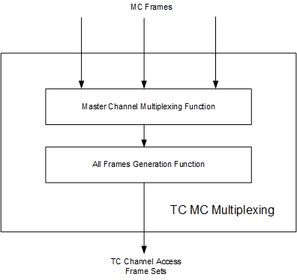

**Figure 6‑2: Internal Structure of the TC MC Multiplexing Functional Resource**

#### Support for Systematic Retransmission

The Master Channel Multiplexing and All Frames Generation functions of the TC Space Data Link Protocol Recommended Standard (reference [17]) use the Synchronizationa Channel Coding sublayer functions of the TC Synchronization and Channel Coding Recommended Standard (reference [5]). The TC Sync and Channel Coding Recommended Standard specifies a mechanism for the systematic retransmission of CLTUs. As formally specified in reference [5], the TC Synchronization and Channel Coding sublayer provides a Channel Access service interface through which the space data link protocol above it submits a set of frames, optionally accompanied by a Repetitions parameter. The set of frames – referred to as a *TC channel access frame set* in this Recommended Practice – constitutes the set of frames from which the TC Sync and Channel Coding sublayer forms the CLTU. If the Repetitions parameter has a value greater than one, then the TC Sync and Channel Coding sublayer transmits that CLTU Repetitions number of times. As formally specified in the TC Space Data Link Protocol Recommended Standard, the TC space data link protocol generates the TC channel access frame sets and an accompanying Repetitions parameter values to form the ServiceAcess.Request primitives.

As described in 5.2.1.1, the Forward CLTU and Forward Space Packet services and the TC PLOP, Synchronization and Channel Encoding FR do not support the Repetitions parameter. Any repetitions of CLTUs must be accomplished by having the space data link protocol layer submit the same TC channel access frame set multiple times. The number of times that the same TC channel access frame set is submitted to the underlying TC Sync and Channel Coding sublayer is determined by the virtual channel and type (AD or BC) of the frames contained within that TC channel access frame set. Each TC VC Multiplexer FR (see 6.2.2) instance has tcVcMuxAdFrameRepetitions and tcVcMuxBcFrameRepetitions managed tables that specify the repetitions that are to be applied for the VCs that are handled by that multiplexer instance.

The net effect “on the space link” is the same as if the Repetitions parameter were used, and so interoperability across the space link is preserved.

#### Service Access Points (SAPs) and Ancillary Interfaces Used by this Functional Resource

##### SAPs Accessed by this Functional Resource

The TC MC Multiplexing FR accesses the TC Channel Access Frame Sets SAP.

##### SAPs Hosted by this Functional Resource

The TC MC Multiplexing FR has a Transmit MC Frames SAP that can be accessed by multiple instances of the TC VC Multiplexing FR.

##### Ancillary Interfaces Required by this Functional Resource

None.

##### Ancillary Interfaces Provided by this Functional Resource

None.

### TC Virtual Channel (VC) Multiplexing FR

The functional resource classifier of the TC VC Multiplexing FR Type is TcVcMux.

The parameters, events, and directives of this functional resource are registered in the SANA Candidate FR Registry (reference [34]).

The TC VC Multiplexing FR corresponds to the Virtual Channel Multiplexing function of the TC Space Data Link Protocol Recommended Standard (reference [17]), which multiplexes the transfer frames from one or more Virtual Channels into a Master Channel.

The TC VC Multiplexing FR also implements the three multiplexing schemes required by the Forward Frame Cross Support Transfer Service (reference [33]): absolute priority, polling vector, and FIFO.

Tables 5-2 and 5-3 of section 5 of the TC Space Data Link Protocol Recommended Standard (reference [18]) specify a set of managed parameters for Master Channels and Virtual Channels. All managed parameters from that Recommended Standard are reflected in the configuration parameters of the TC VC Multiplexing FR as defined in the SANA FR Registry except for the managed parameters identified in Table 6‑2.

Table 6‑2 : Managed Parameters of the Virtual Channel Multiplexing Function of the TC Space Data Link Protocol Recommended Standard that are Not in the Configuration Parameters of the TC VC Multiplexing Functional Resource

| **Excluded Recommended Standard Managed Parameter** | **Comment** |
| --- | --- |
| Spacecraft ID | The spacecraft IDs of the frames are either set as part of the configuration of FRs that generate frames from user inputs, or are included in the validation parameters of FRs that receive frames from user inputs (i.e., the Forward Frame CSTS). Thus the configuration profile as a whole defines the set of valid SCIDs. |
| Valid VCIDs (per Master Channel) | The VC IDs of the frames are either set as part of the configuration of FRs that generate frames from user inputs, or are included in the validation parameters of FRs that receive frames from user inputs (i.e., the Forward Frame CSTS). Thus the configuration profile as a whole defines the set of valid VCIDs. |
| VCID (per Virtual Channel) | The VC IDs of the frames are either set as part of the configuration of FRs that generate frames from user inputs, or are included in the validation parameters of FRs that receive frames from user inputs (i.e., the Forward Frame CSTS). |
| COP In Effect | This parameter is not applicable to the VC Multiplexing function. It applies to functions performed by the TC Encapsulation, VC Packet Processing and VC Generation FR. |
| CLCW Version Number | This parameter is not applicable to the VC Multiplexing function. It applies to functions performed by the TC Encapsulation, VC Packet Processing and VC Generation FR. |
| CLCW Reporting Rate | This parameter is not applicable to the VC Multiplexing function. It applies to functions performed by the TC Encapsulation, VC Packet Processing and VC Generation FR. |
| Presence of Segment Header | This parameter is not applicable to the VC Multiplexing function. It applies to functions performed by the TC Encapsulation, VC Packet Processing and VC Generation FR. |
| Data Field Content | This parameter is not applicable to the VC Multiplexing function. It applies to functions performed by the TC Encapsulation, VC Packet Processing and VC Generation FR. |
| Valid MAP IDs | This parameter is not applicable to the VC Multiplexing function. It applies to functions performed by the TC Encapsulation, VC Packet Processing and VC Generation FR. |
| MAP Multiplexing Scheme | This parameter is not applicable to the VC Multiplexing function. It applies to functions performed by the TC Encapsulation, VC Packet Processing and VC Generation FR. |
| Blocking | This parameter is not applicable to the VC Multiplexing function. It applies to functions performed by the TC Encapsulation, VC Packet Processing and VC Generation FR. |

NOTE – The configuration parameters of the TC VC Multiplexing FR also include parameters that are not explicitly identified as managed parameters in the Recommended Standard.

#### Support for Systematic Retransmission

Each TC VC Multiplexing FR (see 6.2.2) instance has tcVcMuxAdFrameRepetitions and tcVcMuxBcFrameRepetitions managed tables that specify the repetitions that are to be applied for the VCs and frame types (AD or BC) that are handled by that multiplexer instance. The TC VC Multiplexing FR annotates the frames submitted to the TC MC Multiplexing FR with these repetition values to allow the TC MC Multiplexing FR to determine how many times the TC channel access frame sets are to be submitted to underlying TC Sync and Channel Coding sublayer.

#### Service Access Points (SAPs) and Ancillary Interfaces Used by this Functional Resource

##### SAPs Accessed by this Functional Resource

The TC VC Multiplexing FR accesses the Transmit MC Frames SAP of a TC MC Multiplexing FR.

##### Resource SAPs Hosted by this Functional

The TC VC Multiplexing FR has a Ttransmit VC Frames Minus FECF SAP that can be accessed by multiple Accessors. The SAP uses the GVCID of the frame to determine the VC into which the frame is to be multiplexed.

### TC Encapsulation, VC Packet Processing and VC Generation FR

NOTE - This FR will not be included in the draft Red-0.4 version of this book that will be made available for subject matter expert review.

The functional resource classifier of the TC Encapsulation, VC Packet Processing and VC Generation FR Type is TcEncapVcPktProcVcGen.

The TC Encapsulation, VC Packet Processing and VC Generation FR corresponds to the following functions:

1. the Encapsulation function of the Encapsulation Packet Protocol Recommended Standard (reference [22]), which encapsulates data into Encapsulation Packets destined for the same virtual channel;
2. The Packet Transfer function of the Space Packet Protocol Recommended Standard (reference [20]), which multiplexes space packets from different sources destined for the same virtual channel;
3. the VC Packet Processing function of the TC Space Data Link Protocol Recommended Standard (reference [17]), which multiplexes Space Packets and Encapsulation Packets into Frame Data Units for a single virtual channel;
4. the Virtual Channel Generation function of the TC Space Data Link Protocol Recommended Standard, which comprises:
5. the Frame Operation Procedure-1 (FOP-1) of the Communications Operation Procedure-1 Recommended Standard (reference [21]), which executes the Frame Operation Procedure on the Frame Data Units; and
6. the Frame Generation procedure of the TC Space Data Link Protocol Recommended Standard, which generates transfer frames from the Frame Data Units.

Section 5 of the Encapsulation Packet Protocol Recommended Standard (reference [22]) specifies a set of managed parameters for the Encapsulation Service. Section 5 of the Space Packet Protocol Recommended Standard (reference [20]) specifies a set of managed parameters for the Space Packet Service. Tables 5-3 and 5-5 of section 5 of the TC Space Data Link Protocol Recommended Standard (reference [17]) specifies a set of managed parameters for Virtual Channels and Packet Transfer. How the managed parameters of those Recommended Standards are represented in the configuration parameters of the TC Encapsulation, VC Packet Processing and VC Generation FR is To Be Specified.

Figure 6‑3 illustrates the sublayers of the TC Encapsulation, VC Packet Processing and VC Generation FR.

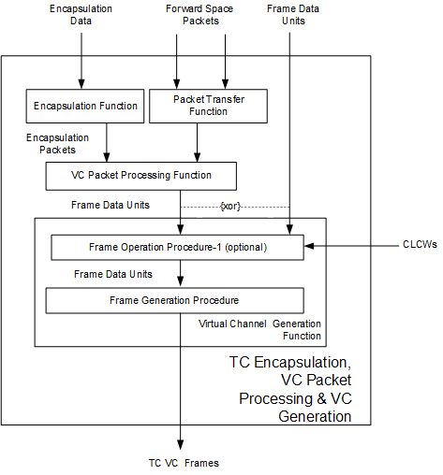

**Figure 6‑3: Internal Structure of the TC Encapsulation, VC Packet Processing and VC Generation Functional Resource**

#### Service Access Points (SAPs) and Ancillary Interfaces Used by this Functional Resource

##### SAPs Accessed by this Functional Resource

The TC Encapsulation, VC Packet Processing and VC Generation FR accesses the Transmit VC Frames Minus FECF SAP of a TC VC Multiplexing FR.

##### SAPs Hosted by this Functional Resource

The TC Encapsulation, VC Packet Processing and VC Generation FR has an Encapsulation SAP that can be accessed by a single Accessor. The Encapsulation SAP is available when the Encapsulation function and the VC Packet Processing function are configured.

The TC Encapsulation, VC Packet Processing and VC Generation FR has a Transmit Space Packets SAP that can be accessed by multiple Accessors. The Transmit Space Packets SAP is available when the Packet Transfer function and the VC Packet Processing function are configured.

The TC Encapsulation, VC Packet Processing and VC Generation FR has a Transmit Frame Data Units SAP that can be accessed by zero or more TC MAP Multiplexing FRs. The Transmit Frame Data Unit SAP is available when the VC Packet Processing function **is not** configured.

##### Ancillary Interfaces Required by this Functional Resource

The TC Encapsulation, VC Packet Processing and VC Generation FR requires a CLCW ancillary interface when the Frame Operation Procedure is configured to execute.

##### Ancillary Interfaces Provided by this Functional Resource

None.

### TC MAP Multiplexing FR

NOTE - This FR will not be included in the draft Red-0.4 version of this book that will be made available for subject matter expert review.

The functional resource classifier of the TC MAP Multiplexing FR Type is TcMapMux.

The TC MAP Multiplexing FR corresponds to the MAP Multiplexing function of the TC Space Data Link Protocol Recommended Standard.

Table 5-4 of section 5 of the TC Space Data Link Protocol Recommended Standard (reference [17]) specifies a set of managed parameters for MAP Channels. How the managed parameters of those Recommended Standards are represented in the configuration parameters of the Forward Encapsulation and MAP Packet Processing FR is To Be Specified.

#### Service Access Points (SAPs) and Ancillary Interfaces Used by this Functional Resource

##### SAPs Accessed by this Functional Resource

The TC MAP Multiplexing FR accesses the Transmit Frame Data Units SAP of a TC Encapsulation, VC Packet Processing and VC Generation FR.

##### SAPs Hosted by this Functional Resource

The TC MAP Multiplexing FR has a Transmit MAP Channel Frame Data Units SAP that can be accessed by one or more Encapsulation and MAP Packet Processing FRs.

##### Ancillary Interfaces Required by this Functional Resource

None

##### Ancillary Interfaces Provided by this Functional Resource

None.

### TC Encapsulation and MAP Packet Processing

NOTE - This FR will not be included in the draft Red-0.4 version of this book that will be made available for subject matter expert review.

The functional resource classifier of the TC Encapsulation and MAP Packet Processing FR Type is TcEncapMapPktProcessing.

The TC Encapsulation and MAP Packet Processing FR corresponds to the following functions:

1. the Encapsulation function of the Encapsulation Recommended Standard (reference [22]). In this FR, the encapsulation data are carried by Space Packets through a MAP channel; and
2. the MAP Packet Processing function of the TC Space Data Link Protocol Recommended Standard (reference [17]).

Section 5 of the Encapsulation Service Recommended Standard (reference [22]) specifies a set of managed parameters for the Encapsulation Service. Tables 5-3 and 5-4 of section 5 of the TC Space Data Link Protocol Recommended Standard (reference [17]) specify a set of managed parameters for Virtual Channels and MAP Channels. How the managed parameters of those Recommended Standards are represented in the configuration parameters of the Encapsulation and MAP Packet Processing FR is To Be Specified.

Figure 6‑4 illustrates the sublayers of the TC Encapsulation and MAP Packet Processing FR.

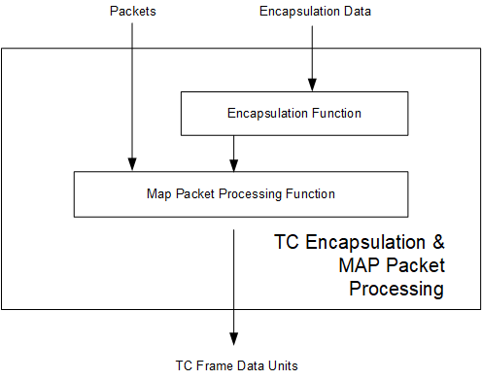

**Figure 6‑4: Internal Structure of the TC Encapsulation and MAP Packet Processing Functional Resource**

#### Service Access Points (SAPs) and Ancillary Interfaces Used by this Functional Resource

##### SAPs Accessed by this Functional Resource

The TC Encapsulation and MAP Packet Processing accesses the Transmit MAP Channel Frame Data Units SAP of a TC MAP Multiplexing FR.

##### SAPs Hosted by this Functional Resource

The TC Encapsulation and MAP Packet Processing FR has an Encapsulation SAP that can be accessed by a single Accessor.

The Encapsulation and MAP Packet Processing FR has a Transmit Space Packets SAP that can be accessed by multiple Accessors.

##### Ancillary Interfaces Required by this Functional Resource

None

##### Ancillary Interfaces Provided by this Functional Resource

None.

## AOS Space Link Protocol Transmission Functional Resource Set of the Space Link Protocol Transmission Functional Resource Stratum

The FR Types that compose the AOS Space Link Protocol Transmission Functional Resource Set of the Space Link Protocol Transmission Functional Resource stratum are:

1. AOS MC Multiplexing;
2. AOS VC Multiplexing; and
3. AOS Encapsulation, Packet Processing and VC Generation.

Figure 6‑5 illustrates the internal composition of the AOS Space Link Protocol Transmission Functional Resource Set.

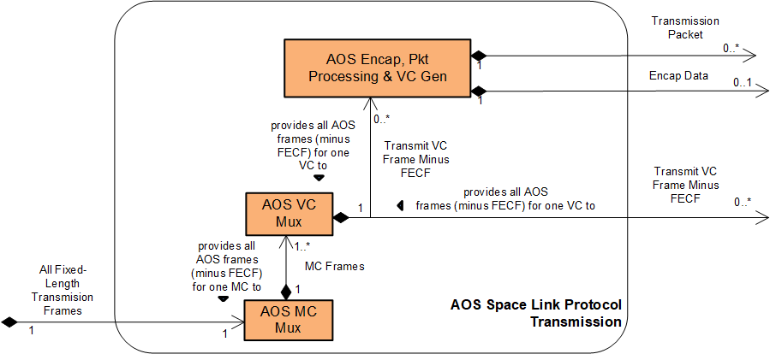

**Figure 6‑5: Members of the AOS Space Link Protocol Transmission Functional Resource Set**

### AOS MC Multiplexing

The functional resource classifier of the AOS MC Multiplexing FR Type is AosMcMux.

The parameters, events, and directives of this functional resource are registered in the SANA Candidate FR Registry.

The AOS MC Multiplexing FR corresponds to the following functions:

1. the Master Channel Multiplexing function of the AOS Space Data Link Protocol Recommended Standard (reference [18]), which multiplexes the transfer frames from one or more Master Channels into a single stream of transfer frames. The AOS MC Multiplexing FR implements the three multiplexing schemes required by the Forward Frame Cross Support Transfer Service (reference [33]): absolute priority, polling vector, and FIFO; and
2. the All Frames Generation function of the AOS Space Data Link Protocol Recommended Standard, which optionally adds a Frame Error Control Field (FECF) to the trailer of each frame.

NOTES

1. The Master Channel Multiplexing function of the AOS Space Data Link Protocol Recommended Standard is also formally assigned the OID Frame Generation subfunction. However, for reasons more fully described in 5.3.1.1, the OID generation is instead performed by the OID Generation function of the Fixed-Length-Frame Synchronization, Channel Encoding, and OID Generation FR (5.3).
2. The All Frames Generation function of the AOS Space Data Link Protocol Recommended Standard is also the insertion point for Insert service data units. If the Insert SLE transfer service (or an equivalent CSTS) were ever to be implemented, its functionality would be added to the AOS MC Multiplexing FR. However, at the time of this writing, there are no plans to implement a cross-supported Insert service.

Tables 5-1 and 5-2 of section 5 of the AOS Space Data Link Protocol Recommended Standard (reference[18]) specify a set of managed parameters for the Phyiscal Channels and Master Channels. All managed parameters from that Recommended Standard are reflected in the configuration parameters of the AOS MC Multiplexing FR as defined in the SANA FR Registry except for the managed parameters identified in Table 6‑3.

Table 6‑3 : Managed Parameters of the Master Channel Multiplexing and All Frames Generation Functions of the AOS Space Data Link Protocol Recommended Standard that are Not in the Configuration Parameters of the AOS MC Multiplexing Functional Resource

| **Excluded Recommended Standard Managed Parameter** | **Comment** |
| --- | --- |
| Physical Channel Name | The Physical Channel Name is specified in the xxxPhysChnlName parameters of the Physical Channel stratum FRs. The AOS MC Multiplexing FR inherits the value of this parameter from the Physical Channel stratum FR with which it is associated in the operational configuration. |
| Transfer Frame Length | The transfer frame length is equal to the flfSyncSlpduLength parameter of the Fixed Length Frame Synchronization, Channel Encoding, and OID Generation FR instance with which the AOS MC Mux instance is associated. |
| Transfer Frame Version Number | For AOS, this value is fixed to version 2 (‘01’ binary) and is not configurable. |
| Valid Spacecraft IDs | The spacecraft IDs of the frames are either set as part of the configuration of FRs that generate frames from user inputs, or are included in the validation parameters of FRs that receive frames from user inputs (i.e., the Forward Frame CSTS). Thus the configuration profile as a whole defines the set of valid SCIDs. |
| Presence of Insert Zone  and Insert Zone Length | As stated in NOTE 2 above, at the time of this writing, there are no plans to implement a cross-supported Insert service If the Insert SLE transfer service (or an equivalent CSTS) were ever to be implemented, its functionality would be added to the AOS MC Multiplexing FR and appropriate configuration parameter(s) added. |

NOTE – The configuration parameters of the AOS MC Multiplexing FR also include parameters that are not explicitly identified as managed parameters in the Recommended Standard.

Figure 6‑6 illustrates the sublayers of the AOS MC Multiplexing FR.

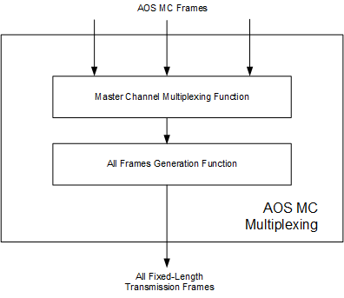

**Figure 6‑6: Internal Structure of the AOS MC Multiplexing Functional Resource**

#### Service Access Points (SAPs) and Ancillary Interfaces Used by this Functional Resource

##### SAPs Accessed by this Functional Resource

The AOS MC Multiplexing FR accesses the Transmit-Fixed-Length Frames SAP.

##### SAPs Hosted by this Functional Resource

The AOS MC Multiplexing FR has a Transmit MC Frames SAP that can be accessed by multiple sources of AOS MC frames.

##### Ancillary Interfaces Required by this Functional Resource

None.

##### Ancillary Interfaces Provided by this Functional Resource

None.

### AOS VC Multiplexing

The functional resource classifier of the AOS VC Multiplexing FR Type is AosVcMux.

The parameters, events, and directives of this functional resource are registered in the SANA Candidate FR Registry (reference [34]).

The AOS VC Multiplexing FR corresponds to the Virtual Channel Multiplexing function of the AOS Space Data Link Protocol Recommended Standard (reference [18]), which multiplexes the transfer frames from one or more Virtual Channels into a single Master Channel.

The AOS VC Multiplexing FR also implements the three multiplexing schemes required by the Forward Frame Cross Support Transfer Service (reference [33]): absolute priority, polling vector, and FIFO.

NOTE – The VC Multiplexing function defined in the AOS Space Data Link Protocol Recommended Standard also provide for generation of OID frames in the absence of user-data-bearing transfer frames from any of the input VCs and when there is only a single Master Channel on the Physical Channel. However, OID frame generation by VC Multiplexing is redundant with the OID Frame generation performed by the MC Multiplexing function and is therefore omitted by the AOS VC Multiplexing FR.

Tables 5-2 and 5-3 of section 5 of the AOS Space Data Link Protocol Recommended Standard (reference [18]) specify a set of managed parameters for Master Channels and Virtual Channels. All managed parameters from that Recommended Standard are reflected in the configuration parameters of the AOS VC Multiplexing FR as defined in the SANA FR Registry except for the managed parameters identified in Table 6‑4.

Table 6‑4 : Managed Parameters of the Virtual Channel Multiplexing Function of the AOS Space Data Link Protocol Recommended Standard that are Not in the Configuration Parameters of the AOS VC Multiplexing Functional Resource

| **Excluded Recommended Standard Managed Parameter** | **Comment** |
| --- | --- |
| Spacecraft ID | The spacecraft IDs of the frames are either set as part of the configuration of FRs that generate frames from user inputs, or are included in the validation parameters of FRs that receive frames from user inputs (i.e., the Forward Frame CSTS). Thus the configuration profile as a whole defines the set of valid SCIDs. |
| Valid VCIDs (per Master Channel) | The VC IDs of the frames are either set as part of the configuration of FRs that generate frames from user inputs or are included in the validation parameters of FRs that receive frames from user inputs (i.e., the Forward Frame CSTS). Thus the configuration profile as a whole defines the set of valid VCIDs. |
| VCID (per Virtual Channel) | The VC IDs of the frames are either set as part of the configuration of FRs that generate frames from user inputs, or are included in the validation parameters of FRs that receive frames from user inputs (i.e., the Forward Frame CSTS). |
| Data Field Content | This parameter is not applicable to the VC Multiplexing function. It applies to functions performed by the AOS Encapsulation, Packet Processing and VC Generation FR. |
| Presence of VC_OCF | This parameter is not applicable to the VC Multiplexing function as performed by the ESLT. For the version 1 AOS VC Multiplexing FR this has a fixed value of Absent. |

NOTE – The configuration parameters of the AOS VC Multiplexing FR also include parameters that are not explicitly identified as managed parameters in the Recommended Standard.

#### Service Access Points (SAPs) and Ancillary Interfaces Used by this Functional Resource

##### SAPs Accessed by this Functional Resource

The AOS VC Multiplexing FR accesses the Transmit MC Frames SAP of the AOS MC Multiplexing FR.

##### SAPs Hosted by this Functional Resource

The AOS VC Multiplexing FR has a Transmit VC Frames Minus FECF SAP that can be accessed by multiple Accessors. The SAP uses the GVCID of the frame to determine the VC into which the frame is to be multiplexed.

##### Ancillary Interfaces Required by this Functional Resource

None.

##### Ancillary Interfaces Provided by this Functional Resource

None.

### AOS Encapsulation, Packet Processing and VC Generation

NOTE - This FR will not be included in the draft Red-0.4 version of this book that will be made available for subject matter expert review.

The functional resource classifier of the AOS Encapsulation, Packet Processing and VC Generation FR Type is AosEncapPktProcVcGen.

The AOS Encapsulation, Packet Processing and VC Generation FR corresponds to the following functions:

1. the Encapsulation function of the Encapsulation Packet Protocol Recommended Standard (reference [22]), which encapsulates data into Encapsulation Packets destined for the same virtual channel. There is one instance of the Encapsulation function for each Encapsulation Protocol used on the virtual channel;GOT TO HERE
2. The Packet Transfer function of the Space Packet Protocol Recommended Standard (reference [20]), which multiplexes space packets from different sources destined for the same virtual channel;
3. the Packet Processing function of the AOS Space Data Link Protocol Recommended Standard (reference [18]), which multiplexes Space Packets, Encapsulation Packets and (optionally, Idle Packets) into Multiplexing Protocol Data Units (M_PDUs) for a single virtual channel;
4. the Virtual Channel Generation function of the AOS Space Data Link Protocol Recommended Standard, which generates VC frames from the M_PDUs.

Section 5 of the Encapsulation Service Recommended Standard (reference [22]) specifies a set of managed parameters for the Encapsulation Packet Protocol. Section 5 of the Space Packet Protocol Recommended Standard (reference [20]) specifies a set of managed parameters for the Space Packet Service. Tables 5-3 and 5-4 of section 5 of the AOS Space Data Link Protocol Recommended Standard (reference [18) specify a set of managed parameters for Virtual Channels and Packet Transfer.. All managed parameters from those subsections of those Recommended Standards are reflected in the configuration parameters of the AOS VC Multiplexing FR as defined in the SANA FR Registry except for the managed parameters identified in Table 6‑4.

Table 6‑5 : Managed Parameters of the Encapsulation Service, Space Packet Protocol, and AOS Space Data Link Protocol Recommended Standards that are Not in the Configuration Parameters of the AOS Encapsulation, Packet Processing and VC Generation Functional Resource

| **Excluded Recommended Standard Managed Parameter** | **Comment** |
| --- | --- |
| Minimum Data Unit Length (octets) (Encap) | The spacecraft IDs of the frames are either set as part of the configuration of FRs that generate frames from user inputs, or are included in the validation parameters of FRs that receive frames from user inputs (i.e., the Forward Frame CSTS). Thus the configuration profile as a whole defines the set of valid SCIDs. |
| Maximum Data Unit Length (octets) (Encap) |  |
| Valid Encapsulation Protocol Identifiers (Encap) |  |
| Valid Extended Encapsulation Protocol Identifiers (Encap) |  |
| Maximum Packet Length (octets) (SPP) |  |
| Packet Multiplexing Scheme (SPP sending systems) |  |
| Service Type (SPP ) | NOT USED because the FR supports only the Packet Service |
| Packet Secondary Header Contents (SPP) | NOT USED??? |
| Valid VCIDs (per Master Channel) | The VC IDs of the frames are either set as part of the configuration of FRs that generate frames from user inputs or are included in the validation parameters of FRs that receive frames from user inputs (i.e., the Forward Frame CSTS). Thus the configuration profile as a whole defines the set of valid VCIDs. |
| VCID (per Virtual Channel) | The VC IDs of the frames are either set as part of the configuration of FRs that generate frames from user inputs, or are included in the validation parameters of FRs that receive frames from user inputs (i.e., the Forward Frame CSTS). |
| Data Field Content | This parameter is not applicable to the VC Multiplexing function. It applies to functions performed by the AOS Encapsulation, Packet Processing and VC Generation FR. |
| Presence of VC_OCF | This parameter is not applicable to the VC Multiplexing function as performed by the ESLT. For the version 1 AOS VC Multiplexing FR this has a fixed value of Absent. |
| Valid Packet Version Numbers (set of integers) |  |
| Maximum Packet Length |  |
| Whether incomplete Packets are required to be delivered (receiving end) |  |

NOTE – The configuration parameters of the AOS VC Multiplexing FR also include parameters that are not explicitly identified as managed parameters in the Recommended Standard.

Figure 6‑7 illustrates the sublayers of the Forward AOS Encapsulation, Packet Processing and VC Generation FR.

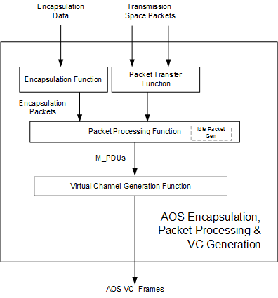

**Figure 6‑7: Internal Structure of the AOS Encapsulation, Packet Processing and VC Generation Functional Resource**

#### Relationships with external Functional Resource Sets

The AOS Encapsulation, Packet Processing and VC Generation FR accesses the AOS VC Mux SAP.

The AOS Encapsulation, Packet Processing and VC Generation FR has an Encapsulation SAP that can be accessed by a single Accessor.

The AOS Encapsulation, Packet Processing and VC Generation FR has a Transmission Space Packet SAP that can be accessed by multiple Accessors.

## Variable Length Frame Unified Space Data Link Protocol Transmission Functional Resource Set of the Space Link Protocol Functional Resource Stratum

NOTE - This FR Set will not be included in the draft Red-0.4 version of this book that will be made available for subject matter expert review.

NOTE – This FR set corresponds to the sending end functionality specified in CCSDS 732.1 (reference [35]) that is applicable to variable length frames.

The Unified SDLP is capable of using both variable-length and fixed-length transfer frames, where for any given space link physical channel USLP must use either fixed-length or variable length frames. This FR Set represents the variable-length frame (VLF) functionality of USLP on the transmitted link.

The FR types that comprise the VLF Unified Space Link Protocol Transmission Functional Resource Set of the Space Link Protocol Functional Resource stratum are:

1. VLF USLP Master Channel (MC) Multiplexing;
2. VLF USLP Virtual Channel (VC) Multiplexing;
3. VLF USLP VC Generation;
4. USLP Multiplexer Access Point (MAP) Multiplexing; and
5. USLP Encapsulation and MAP Packet Processing.

Figure 6‑8 illustrates the functional resource types that constitute the VLF Unified Space Link Protocol Transmission Functional Resource Set.

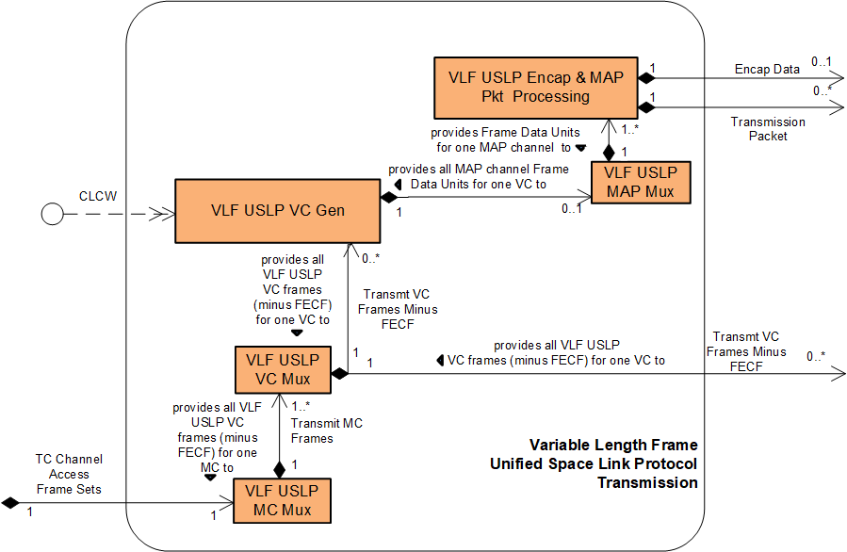

**Figure 6‑8: Member Functional Resources of the VLF Unified Space Link Protocol** **Transmission** **Functional Resource Set**

### VLF USLP Master Channel (MC) Multiplexing FR

NOTE - This FR will not be included in the draft Red-0.4 version of this book that will be made available for subject matter expert review.

The functional resource classifier of the VLF USLP MC Multiplexing FR Type is VlfUslpMcMux.

The VLF USLP MC Multiplexing FR corresponds to the following functions:

1. the variable-length frame processing of the Master Channel Multiplexing function of the Unified Space Data Link Protocol Recommended Standard (reference [35]), which multiplexes the variable-length transfer frames from one or more Master Channels into a single stream of transfer frames. The VLF USLP MC Multiplexing FR also implements the three multiplexing schemes required by the Forward Frame Cross Support Transfer Service (reference [33]): absolute priority, polling vector, and FIFO; and
2. the variable-length frame processing of the All Frames Generation function of the Unified Space Data Link Protocol Recommended Standard, which optionally adds a Frame Error Control Field (FECF) to the trailer of each frame, and submits each transfer frame to the underlying variable-length-frame Synchronization and Channel Coding functional resource (e.g., a TC PLOP, Synchronization and Channel Encoding FR instance).

NOTE – Unlike the TC SDLP, the USLP (when using variable-length transfer frames) does not support multiple transfer frames per CLTU. Therefore, each TC Channel Access Frame Set is constrained to contain only one transfer frame.

Tables 5-1 and 5-2 of section 5 of the Unified Space Data Link Protocol Recommended Standard (reference [35]) specify a set of managed parameters for the Physical Channels and Master Channels. How the managed parameters of that Recommended Standard are represented in the configuration parameters of the VLF USLP MC Multiplexing FR is To Be Specified.

Figure 6‑9 illustrates the sublayers of the VLF USLP MC Multiplexing FR.

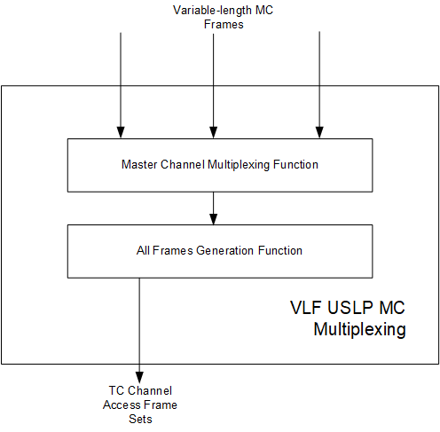

**Figure 6‑9: Internal Structure of the VLF USLP MC Multiplexing Functional Resource**

#### Support for Systematic Retransmission

When operating with variable-length frames, the Master Channel Multiplexing and All Frames Generation functions of the Unified Space Data Link Protocol Recommended Standard (reference [35]) use the Synchronizationa Channel Coding sublayer functions of the TC Synchronization and Channel Coding Recommended Standard (reference [5]). The TC Sync and Channel Coding Recommended Standard specifies a mechanism for the systematic retransmission of CLTUs. As formally specified in reference [5], the TC Synchronization and Channel Coding sublayer provides a Channel Access service interface through which the space data link protocol above it submts a set of frames, optionally accompanied by a Repetitions parameter. The set of frames – referred to as a *TC channel access frame set* in this Recommended Practice – constitutes the set of frames from which the TC Sync and Channel Coding sublayer forms the CLTU. If the Repetitions parameter has a value greater than one, then the TC Sync and Channel Coding sublayer transmits that CLTU Repetitions number of times. As formally specified in the Unified Space Data Link Protocol Recommended Standard, the TC space data link protocol generates the TC channel access frame sets (which is constrained by USLP to contain only one frame) and the accompanying Repetitions parameter values to form the ServiceAcess.Request primitives.

As described in 5.2.1.1, the Forward CLTU and Forward Space Packet services and the TC PLOP, Synchronization and Channel Encoding FR do not support the Repetitions parameter. Any repetitions of CLTUs must be accomplished by having the space data link protocol layer submit the same TC channel access frame set multiple times. The number of times that the same TC channel access frame set is submitted to the underlying TC Sync and Channel Coding sublayer is determined by the virtual channel and type (AD or BC) of the frames contained within that TC channel access frame set. Each VLF USLP VC Multiplexer FR (see 6.4.2) instance has vlfUslpVcMuxAdFrameRepetitions and vlfUslpVcMuxBcFrameRepetitions managed tables that specify the repetitions that are to be applied for the VCs that are handled by that multiplexer instance.

The net effect “on the space link” is the same as if the Repetitions parameter were used, and so interoperability across the space link is preserved.

#### Service Access Points (SAPs) and Ancillary Interfaces Used by this Functional Resource

##### SAPs Accessed by this Functional Resource

The VLF USLP MC Multiplexing FR accesses the TC Channel Access Frame Sets SAP.

##### SAPs Hosted by this Functional Resource

The VLF USLP MC Multiplexing FR has a Transmit MC Frames SAP that can be accessed by multiple instances of the VLF USLP VC Multiplexing FR.

##### Ancillary Interfaces Required by this Functional Resource

None

##### Ancillary Interfaces Provided by this Functional Resource

None.

### VLF USLP Virtual Channel (VC) Multiplexing FR

NOTE - This FR will not be included in the draft Red-0.4 version of this book that will be made available for subject matter expert review.

The functional resource classifier of the VLF USLP VC Multiplexing FR Type is VlfUslpVcMux.

The VLF USLP VC Multiplexing FR corresponds to the variable-length-frame processing of the Virtual Channel Multiplexing function of the USLP Space Data Link Protocol Recommended Standard (reference [35]), which multiplexes the transfer frames from one or more Virtual Channels into a single stream of transfer frames.

The VLF USLP VC Multiplexing FR also implements the three multiplexing schemes required by the Forward Frame Cross Support Transfer Service (reference [33]): absolute priority, polling vector, and FIFO.

Tables 5-2 and 5-3 of section 5 of the Unified Space Data Link Protocol Recommended Standard (reference [35]) specify a set of managed parameters for Master Channels and Virtual Channels. How the managed parameters of that Recommended Standard are represented in the configuration parameters of the VLF USLP VC Multiplexing FR is To Be Specified.

#### Service Access Points (SAPs) and Ancillary Interfaces Used by this Functional Resource

##### SAPs Accessed by this Functional Resource

The VLF USLP VC Multiplexing FR accesses the Transmit MC Frames SAP of a VLF USLP MC Multiplexing FR.

##### SAPs Hosted by this Functional Resource

The VLF USLP VC Multiplexing FR has a VC Frames Minus FECF SAP that can be accessed by multiple Accessors. The SAP uses the GVCID of the frame to determine the VC into which the frame is to be multiplexed.

##### Ancillary Interfaces Required by this Functional Resource

None

##### Ancillary Interfaces Provided by this Functional Resource

None.

### VLF USLP VC Generation FR

NOTE - This FR will not be included in the draft Red-0.4 version of this book that will be made available for subject matter expert review.

The functional resource classifier of the VLF USLP VC Generation FR Type is VlfUslpVcGen.

**The remainder of this section is TBS.**

### VLF USLP Multiplexer Access Point (MAP) Multiplexing FR

NOTE - This FR will not be included in the draft Red-0.4 version of this book that will be made available for subject matter expert review.

The functional resource classifier of the VLF USLP MAP Multiplexing FR Type is VlfUslpMapMux.

**The remainder of this section is TBS.**

### VLF USLP Encapsulation and MAP Packet Processing FR

NOTE - This FR will not be included in the draft Red-0.4 version of this book that will be made available for subject matter expert review.

The functional resource classifier of the VLF USLP Encapsulation and MAP Packet Processing FR Type is VlfUslpEncapMapPktProcessing.

**The remainder of this section is TBS.**

## Fixed Length Frame Unified Space Data Link Protocol Transmission Functional Resource Set of the Space Link Protocol Functional Resource Stratum

The Unified SDLP (CCSDS 732.1, reference [35]) is capable of using both variable-length and fixed-length transfer frames, where for any given space link physical channel USLP must use either fixed-length or variable- length frames. This FR Set represents the fixed-length frame (FLF) functionality of USLP on the transmitting end.

The FR types that comprise the FLF Unified Space Link Protocol Transmission Functional Resource Set of the Space Link Protocol Functional Resource stratum are:

1. FLF USLP Master Channel (MC) Multiplexing;
2. FLF USLP Virtual Channel (VC) Multiplexing;
3. FLF USLP VC Generation;
4. FLF USLP Multiplexer Access Point (MAP) Multiplexing; and
5. FLF USLP Encapsulation and MAP Packet Processing.

Figure 6‑10 illustrates the functional resource types that constitute the FLF Unified Space Link Protocol Transmission Functional Resource Set.

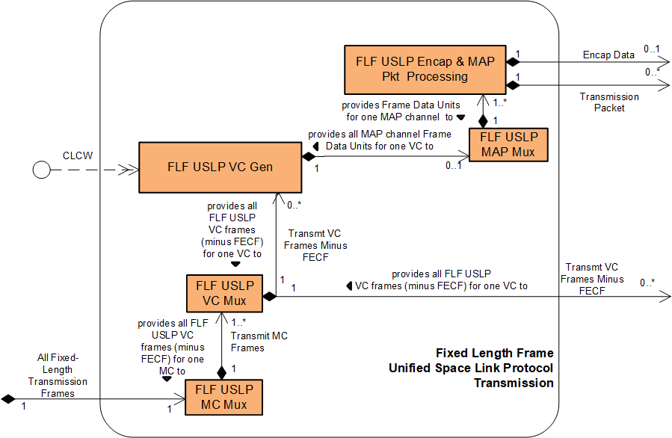

**Figure 6‑10: Member Functional Resources of the FLF Unified Space Link Protocol** **Transmission** **Functional Resource Set**

### FLF USLP Master Channel (MC) Multiplexing FR

The functional resource classifier of the FLF USLP MC Multiplexing FR Type is FlfUslpMcMux.

The parameters, events, and directives of this functional resource are registered in the SANA Candidate FR Registry (reference [34]).

The FLF USLP MC Multiplexing FR corresponds to the following functions:

1. the fixed-length frame processing of the Master Channel Multiplexing function of the Unified Space Data Link Protocol Recommended Standard (reference [35]), which multiplexes the fixed-length transfer frames from one or more Master Channels into a single stream of transfer frames. The FLF USLP MC Multiplexing FR also implements the three multiplexing schemes required by the Forward Frame Cross Support Transfer Service (reference [33]): absolute priority, polling vector, and FIFO; and
2. the fixed-length frame processing of the All Frames Generation function of the Unified Space Data Link Protocol Recommended Standard, which optionally adds a Frame Error Control Field (FECF) to the trailer of each frame, and submits each transfer frame to the underlying fixed-length frame-handling Synchronization and Channel Coding functional resource (e.g., a Fixed Length Frame Synchronization, Channel Encoding, and OID Generation FR instance).

NOTES

1 When operating on fixed-length frames, the Master Channel Multiplexing function of the Unified Space Data Link Protocol Recommended Standard is also formally assigned the OID Frame subfunction. However, for reasons more fully described in 5.3.1.1, OID generation is instead performed by the OID Generation function of the Fixed-Length-Frame Synchronization, Channel Encoding and OID Generation FR (5.3).

2 The USLP All Frames Generation function defined in reference [35] also provides for the insertion of Insert Service Data Units. If the Insert SLE transfer service (or an equivalent CSTS) were ever to be implemented, its functionality would be added to the USLP MC Multiplexing FR. However, at the time of this writing, there are no plans to implement a cross-supported Insert service.

3 The USLP Recommended Standard specifies the Master Channel Generation function, the purpose of which is to optionally commutate four-octet data units into the Operational Control Field (OCF) of the transfer frames of designated virtual channels. When implemented in an ESLT, USLP does not support the commutation of OCFs into transfer frames, and so that functionality is excluded from version 1 USLP functional resources. If and when the scope of the USLP functional resources is expanded to include OCF commutation, that ecuritylity will be added to the FLF USLP MC Multiplexng FR.

Tables 5-1 and 5-2 of section 5 of the Unified Space Data Link Protocol Recommended Standard (reference [35]) specify a set of managed parameters for the Physical Channels and Master Channels. All managed parameters from that Recommended Standard are reflected in the configuration parameters of the FLF USLP MC Multiplexing FR as defined in the SANA FR Registry except for the managed parameters identified in Table 6‑6.

Table 6‑6 : Managed Parameters of the Master Channel Multiplexing and All Frames Generation Functions of the Unified Space Data Link Protocol Recommended Standard that are Not in the Configuration Parameters of the FLF USLP MC Multiplexing Functional Resource

| **Excluded Recommended Standard Managed Parameter** | **Comment** |
| --- | --- |
| Physical Channel Name | The Physical Channel Name is specified in the xxxPhysChnlName parameters of the Physical Channel stratum FRs. The FLF USLP MC Multiplexing FR inherits the value of this parameter from the Physical Channel stratum FR with which it is associated in the operational configuration. |
| Transfer Frame Type | For the FLF USLP MC Multiplexing FR the Transfer Frame Type is always “Fixed Length” and is not configurable. |
| Transfer Frame Length | The transfer frame length is equal to the flfSyncSlpduLength parameter of the Fixed Length Frame Synchronization, Channel Encoding, and OID Generation FR instance with which the FLF USLP MC Mux instance is associated. |
| Transfer Frame Version Number | For USLP, this value is fixed to ‘1100’ binary and is not configurable. |
| Presence of Insert Zone  and Insert Zone Length | As stated in Note 2 above, at the time of this writing, there are no plans to implement a cross-supported Insert service. If the Insert SLE transfer service (or an equivalent CSTS) were ever to be implemented, its functionality would be added to the USLP MC Multiplexing FR and appropriate configuration parameter(s) added. |
| Generate OID Frame | As described in6.5.1 Note 1, the OID Frame function is not performed by the FLF USLP MC Multiplexing FR but is instead performed by the Fixed-Length-Frame Synchronization, Channel Encoding and OID Generation, and so this is not a configuration parameter of this FR. |
| Maximum Number of Transfer Frames Given to the Coding and Synchronization Sublayer as a Single Data Unit | This value is always 1 for fixed-length frames and is not configurable. |
| Maximum Value of the Repetitions Parameter to the Coding and Synchronization Sublayer | Repetition of frames to the C&S sublayer is not applicable to fixed-length frames. |

NOTE – The configuration parameters of the FLF USLP MC Multiplexing FR also include parameters that are not explicitly identified as managed parameters in the Recommended Standard.

Figure 6‑11 illustrates the sublayers of the FLF USLP MC Multiplexing FR.

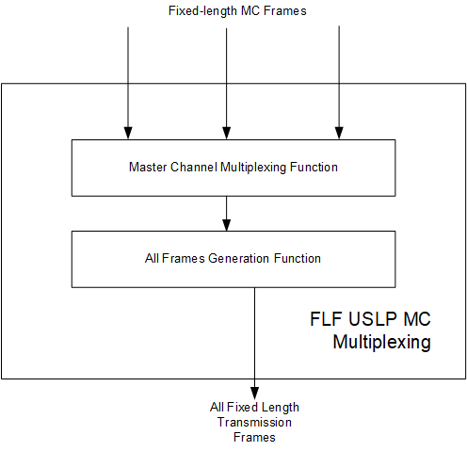

**Figure 6‑11: Internal Structure of the FLF USLP MC Multiplexing Functional Resource**

#### Service Access Points (SAPs) and Ancillary Interfaces Used by this Functional Resource

##### SAPs Accessed by this Functional Resource

The FLF USLP MC Multiplexing FR accesses the Transmit Fixed Length Frames SAP.

##### SAPs Hosted by this Functional Resource

The FLF USLP MC Multiplexing FR has a Transmit MC Frames SAP that can be accessed by multiple sources of FLF USLP VC frames.

##### Ancillary Interfaces Required by this Functional Resource

None

##### Ancillary Interfaces Provided by this Functional Resource

None.

### FLF USLP VC Multiplexing

The functional resource classifier of the FLF USLP VC Multiplexing FR Type is FlfUslpVcMux.

The parameters, events, and directives of this functional resource are registered in the SANA Candidate FR Registry (reference [34]).

The FLF USLP VC Multiplexing FR corresponds to the fixed-length-frame processing of the Virtual Channel Multiplexing function of the Unified Space Data Link Protocol Recommended Standard (reference [35]), which multiplexes the transfer frames from one or more Virtual Channels into a single stream of transfer frames.

The FLF USLP VC Multiplexing FR also implements the three multiplexing schemes required by the Forward Frame Cross Support Transfer Service (reference [33]): absolute priority, polling vector, and FIFO.

Tables 5-2 and 5-3 of section 5 of the Unified Space Data Link Protocol Recommended Standard (reference [35]) specify a set of managed parameters for Master Channels and Virtual Channels. All managed parameters from that Recommended Standard are reflected in the configuration parameters of the FLF USLP VC Multiplexing FR as defined in the SANA FR Registry except for the managed parameters identified in Table 6‑7.

Table 6‑7 : Managed Parameters of the Virtual Channel Multiplexing Function of the USLP Space Data Link Protocol Recommended Standard that are Not in the Configuration Parameters of the FLF USLP VC Multiplexing Functional Resource

| **Excluded Recommended Standard Managed Parameter** | **Comment** |
| --- | --- |
| VCIDs (per Master Channel) | The VC IDs of the frames are either set as part of the configuration of FRs that generate frames from user inputs or are included in the validation parameters of FRs that receive frames from user inputs (i.e., the Forward Frame CSTS). Thus the configuration profile as a whole defines the set of VCIDs. |
| Transfer Frame Type | For the FLF USLP VC Multiplexing FR this is always Fixed Length and not configurable. |
| VCID (per Virtual Channel) | The VC IDs of the frames are either set as part of the configuration of FRs that generate frames from user inputs or are included in the validation parameters of FRs that receive frames from user inputs (i.e., the Forward Frame CSTS). |
| VC Count Length for Sequence Control QoS | This parameter is not applicable to the VC Multiplexing function. It applies to functions performed by the FLF USLP VC Generation FR. |
| VC Count Length for Expedited QoS | This parameter is not applicable to the VC Multiplexing function. It applies to functions performed by the FLF USLP VC Generation FR. |
| COP in Effect | This parameter is not applicable to the VC Multiplexing function. It applies to functions performed by the FLF USLP VC Generation FR |
| CLCW Version Number | ??? |
| CLCW Reporting Rate |  |
| MAP IDs |  |
| MAP Multiplexing Scheme |  |
| Truncated Transfer Frame Length |  |
| Inclusion of OCF Allowed | N/A for FLF |
| Inclusion of OCF Required | OCF commutation not supported by V1 FR. |
| Value for the Repetitions Parameter to the Coding Sublayer when transferring USLP Frames carrying service data on the Sequence-Controlled Service | N/A for fisxed length frames. |
| Value for the Repetitions Parameter to the Coding Sublayer when transferring USLP Frames carrying COP Control Commands | N/A for fisxed length frames. |
| Maximum delay in milliseconds for a Transfer Frame Data Field to be completed, once started, before it must be relesased | This parameter is not applicable to the VC Multiplexing function. It applies to functions performed by the FLF USLP VC Generation FR |
| Maximum delay in milliseconds between relesases of USLP Frames on the same VC | This parameter is not applicable to the VC Multiplexing function. It applies to functions performed by the FLF USLP VC Generation FR |

NOTE – The configuration parameters of the FLF USLP VC Multiplexing FR also include parameters that are not explicitly identified as managed parameters in the Recommended Standard.

#### Service Access Points (SAPs) and Ancillary Interfaces Used by this Functional Resource

##### SAPs Accessed by this Functional Resource

The FLF USLP VC Multiplexing FR accesses the Transmit MC Frames SAP of the FLF USLP MC Multiplexing FR.

##### SAPs Hosted by this Functional Resource

The FLF USLP VC Multiplexing FR has a Transmit VC Frames Minus FECF SAP that can be accessed by multiple Accessors. The SAP uses the GVCID of the frame to determine the VC into which the frame is to be multiplexed.

##### Ancillary Interfaces Required by this Functional Resource

None

##### Ancillary Interfaces Provided by this Functional Resource

None.

### FLF USLP VC Generation FR

NOTE - This FR will not be included in the draft Red-0.4 version of this book that will be made available for subject matter expert review.

The functional resource classifier of the FLF USLP VC Generation FR Type is FlfUslpVcGen.

**The remainder of this section is TBS.**

### FLF USLP Multiplexer Access Point (MAP) Multiplexing FR

NOTE - This FR will not be included in the draft Red-0.4 version of this book that will be made available for subject matter expert review.

The functional resource classifier of the FLF USLP MAP Multiplexing FR Type is FlfUslpMapMux.

**The remainder of this section is TBS.**

### FLF USLP Encapsulation and MAP Packet Processing FR

NOTE - This FR will not be included in the draft Red-0.4 version of this book that will be made available for subject matter expert review.

The functional resource classifier of the FLF USLP Encapsulation and MAP Packet Processing FR Type is FlfUslpEncapMapPktProcessing.

**The remainder of this section is TBS.**

## TM/AOS Space Link Protocol Reception Functional Resource Set of the Space Link Protocol Functional Resource Stratum

The FR types that comprise the TM/AOS Space Link Protocol Reception Functional Resource Set of the Space Link Protocol Reception Functional Resource stratum are:

1. TM/AOS MC Demultiplexing;
2. TM/AOS VC Demultiplexing; and
3. TM/AOS Packet Extraction and De-encapsulation.

NOTE – The All Frames Reception function is formally defined as part of the TM and AOS space data link protocol. For TM, the All Frames Reception function consists of error detection on the Frame Error Control Field (FECF). For AOS, the All Frames Reception function consists of error detection on the FECF and extraction of Insert SDUs. With respect to error detection on the FECF, this functionality is included in the TM Synchronization and Channel Decoding FR (5.4.1) so that the resultant annotated transfer frames reflect all error detection and/or correction performed on those frames. With respect to extraction of AOS Insert SDUs, there are currently no cross-support dervices defined for processing or delivering Insert SDUs.

Figure 6‑12 illustrates the internal composition of the TM/AOS Space Link Protocol Reception Functional Resource Set.

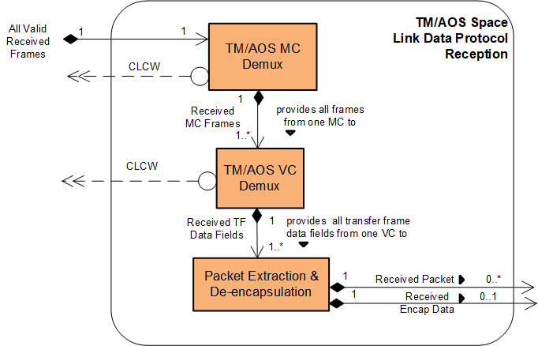

**Figure 6‑12: Member Functional Resources of the TM/AOS Space Link Protocol Reception Functional Resource Set**

### TM/AOS MC Demultiplexing

The functional resource classifier of the TM/AOS MC Demultiplexing FR Type is TmAosMcDemux.

The parameters, events, and directives of this functional resource are registered in the SANA Candidate FR Registry (reference [34]).

The TM/AOS MC Demultiplexing FR corresponds to:

1. the MC Demultiplexing function of the TM Space Data Link Protocol Recommended Standard;
2. the MC Demultiplexing function of the AOS Space Data Link Protocol Recommended Standard; and
3. the MC Frames and MC Operational Control Field (MC_OCF) Decommutation subfunctions of the MC Reception function of the TM Space Data Link Protocol Recommended Standard.

NOTES

1. There is no MC Reception function in the AOS Space Data Link Protocol Recommended Standard.
2. The MC Reception function of the TM Space Data Link Protocol Recommended Standard also includes an MC Frame Secondary Header (MC-FSH) Decommutation subfunction, but there is no standard CCSDS service that uses this field independently so it is excluded from the TM/AOS MC Demultiplexing FR.

Sections 5 of the TM Space Data Link Protocol Recommended Standard (reference [19] and the AOS Space Data Link Protocol Recommended Standard (reference [18]) specify sets of managed parameters, some of which are pertinent to the TM/AOS MC Demultiplexing FR. How the managed parameters of those Recommended Standards are represented in the configuration parameters of the TM/AOS MC Demultiplexing FR is To Be Specified.

**Figure 6‑13** illstrates the sublayers of the TM/AOS MC Demultiplexing FR.

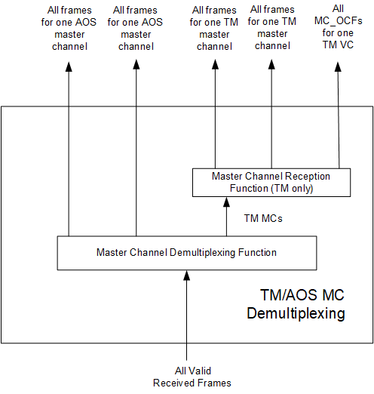

**Figure 6‑13: Internal Structure of the** **TM/AOS MC Demultiplexing FR**

#### Service Access Points (SAPs) and Ancillary Interfaces Used by this Functional Resource

##### SAPs Accessed by this Functional Resource

The TM/AOS MC Demultiplexing FR accesses an All Valid Received Frames SAP.

##### SAPs Hosted by this Functional Resource

The TM/AOS MC Demultiplexing FR has a Received MC Frames SAP that can be accessed by multiple instances of the TM/AOS VC Demultiplexing FR.

##### Ancillary Interfaces Required by this Functional Resource

None.

##### Ancillary Interfaces Provided by this Functional Resource

The TM/AOS MC Demultiplexing FR provides a CLCW ancillary interface.

### TM/AOS VC Demultiplexing

The functional resource classifier of the TM/AOS VC Demultiplexing and Reception FR Type is TmAosVcDemux.

The parameters, events, and directives of this functional resource are registered in the SANA Candidate FR Registry (reference [34]).

The TM VC Demultiplexing FR corresponds to:

1. the VC Demultiplexing functions of the TM Space Data Link Protocol Recommended Standard;
2. the VC Demultiplexing functions of the AOS Space Data Link Protocol Recommended Standard;
3. the Transfer Frame Data Field and VC-OCF Decommutation subfunctions of the VC Reception function of the TM Space Data Link Protocol Recommended Standard; and
4. the Multiplexing Protocol Data Unit (M-PDU) and VC-OCF Decommutation subfunctions of the VC Demultiplexing functions of the AOS Space Data Link Protocol Recommended Standard.

NOTES

1. The VC Reception function of the TM Space Data Link Protocol Recommended Standard also includes Virtual Channel Access Protocol Data Unit (VCA_PDU) and VC Frame Secondary Header (VC-FSH) Decommutation subfunctions, but there is no standard CCSDS service that uses either of these fields independently so their decommutation is excluded from the TM/AOS VC Demultiplexing FR.
2. The VC Reception function of the AOS Space Data Link Protocol Recommended Standard also includes VCA_PDU and Bitstream_PDU Decommutation subfunctions, but there is no standard CCSDS service that uses either of these fields independently so their decommutation is excluded from the TM/AOS VC Demultiplexing FR.

Sections 5 of the TM Space Data Link Protocol Recommended Standard (reference [19] and the AOS Space Data Link Protocol Recommended Standard (reference [19] specify sets of managed parameters, some of which are pertinent to the TM VC Demultiplexing FR. How the managed parameters of those Recommended Standards are represented in the configuration parameters of the TM/AOS VC Demultiplexing FR is To Be Specified.

**Figure 6‑13** illstrates the sublayers of the TM/AOS VC Demultiplexing FR.

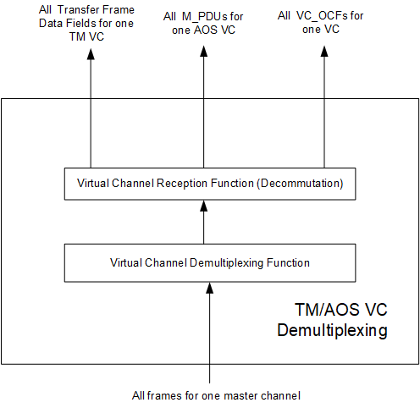

**Figure 6‑14: Internal Structure of the** **TM/AOS VC Demultiplexing FR**

#### Service Access Points (SAPs) and Ancillary Interfaces Used by this Functional Resource

##### SAPs Accessed by this Functional Resource

The TM/AOS VC Demultiplexing FR accesses a Received MC Frames SAP.

##### SAPs Hosted by this Functional Resource

The TM/AOS VC Demultiplexing FR has a Received Transfer Frame Data Field SAP that can be accessed by multiple instances of the TM/AOS VC Demultiplexing FR.

##### Ancillary Interfaces Required by this Functional Resource

None.

##### Ancillary Interfaces Provided by this Functional Resource

The TM/AOS VC Demultiplexing FR provides a CLCW ancillary interface.

### TM/AOS Packet Extraction and De-encapsulation

NOTE - This FR will not be included in the draft Red-0.4 version of this book that will be made available for subject matter expert review.

The functional resource classifier of the TM/AOS Packet Extraction and De-encapsulation FR Type is TmAosPktExtractDeencap.

The TM/AOS Packet Extraction and De-encapsulation FR corresponds to the Packet Extraction function of the TM Space Data Link Protocol and AOS Space Data Link Protocol Recommended Standards and the De-encapsulationfunction of the Encapsulation Service Recommended Standard.

##### Service Access Points (SAPs) and Ancillary Interfaces Used by this Functional Resource

To Be Specified.

## VAriable Length Frame Unified Space Data Link Protocol Reception Functional Resource Set of the Space Link Protocol Functional Resource Stratum

NOTE - This FR Set will not be included in the draft Red-0.4 version of this book that will be made available for subject matter expert review.

NOTE – This FR set corresponds to the variable-length-frame receiving end functionality specified in CCSDS 732.1 (reference [35]).

The composition of the Return Variable Length Frame (VLF) Unified Space Data Link Protocol Functional Resource Set of the Space Data Link stratum is To Be Specified.

The remaindfer of this section is TBD.

## Return Fixed Length Frame Unified Space Data Link Protocol Reception Functional Resource Set of the Space Link Protocol Functional Resource Stratum

NOTE – This FR set corresponds to the fixed-length-frame receiving end functionality specified in CCSDS 732.1 (reference [35]).

NOTE - This FR Set will not be included in the draft Red-0.4 version of this book that will be made available for subject matter expert review.

The composition of the Return Fixed Length Frame (FLF) Unified Space Data Link Protocol Functional Resource Set of the Space Data Link stratum is To Be Specified.

The remainder of this section is TBD.

# SLS Data Delivery Production Functional Resource StratUM

## General

The SLS Data Delivery Production Functional Resource stratum is the Functional Resource Stratum for FR representing production functions that are (a) associated with Data Delivery Transfer Services and (b) performed during a Space Link Session (i.e., during the execution of an SLS Service Package).

The SLS Data Delivery Production Functional Resource stratum has two candidate and two future Functional Resource Sets:

* Frame Data Sink Functional Resource Set (candidate);
* CFDP File Data Production Functional Resource Set (candidate);
* Packets File Data Transmission Production Functional Resource Set (future); and
* Packets File Data Reception Production Functional Resource Set (future).

## Frame Data Sink Functional Resource Set of the SLS Data Delivery Production Functional Resource Stratum

The Frame Data Sink Functional Resource Set of the SLS Data Delivery Production Functional Resource stratum consists of the Frame Data Sink FR. **Figure 7‑1** illustrates the member of the Frame Data Sink Functional Resource Set.

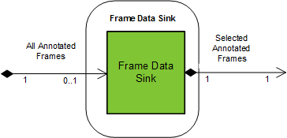

**Figure 7‑1: Member Functional Resource of the Frame Data Sink** **Member Functional Resource Set**

### Frame Data Sink

The functional resource classifier of the Frame Data Sink FR Type is FrameDataSink.

The parameters, events, and directives of this functional resource are registered in the SANA Candidate FR Registry (reference [34]).

The Frame Data Sink FR filters the stream of received annotated transfer frames from a physical channel for subsequent recording in an instance of the Offline Frame Buffer (see 9.2.1). The purpose of this FR is to accommodate data capture policies of Agencies that pre-determine which subset of all received frames are recorded for subsequent off-line retrieval. Each instance of the Frame Data Sink is tied to (and scheduled as part of) a specific SLS Service Package, whereas the Offline Frame Buffer persists across the execution of multiple SLS Service Packages.

#### Service Access Points (SAPs) and Ancillary Interfaces Used by this Functional Resource

##### SAPs Accessed by this Functional Resource

The Frame Data Sink FR accesses the All Annotated Frames SAP.

##### SAPs Hosted by this Functional Resource

The Frame Data Sink FR has a Selected Annotated Frames SAP that can be accessed by a single Accessor.

##### Ancillary Interfaces Required by this Functional Resource

None.

##### Ancillary Interfaces Provided by this Functional Resource

None.

## CFDP File Data Production Functional Resource Set of the SLS Data Delivery Production Functional Resource Stratum

The FR types that comprise the CFDP File Data Production Functional Resource Set of the SLS Data Delivery Production Functional Resource stratum are:

1. the CFDP Entity;
2. the CFDP File Transmission Processing; and.
3. the CFDP File Reception Processing.

The CFDP File Data Production Functional Resource Set is used in the production of both the IOAG Forward File Service/Forward CFDP File Service type and IOAG Return File Service/Return CFDP File Service type (reference [9]).

Figure 7‑2 illustrates the members of the CFDP File Data Production Functional Resource Set.

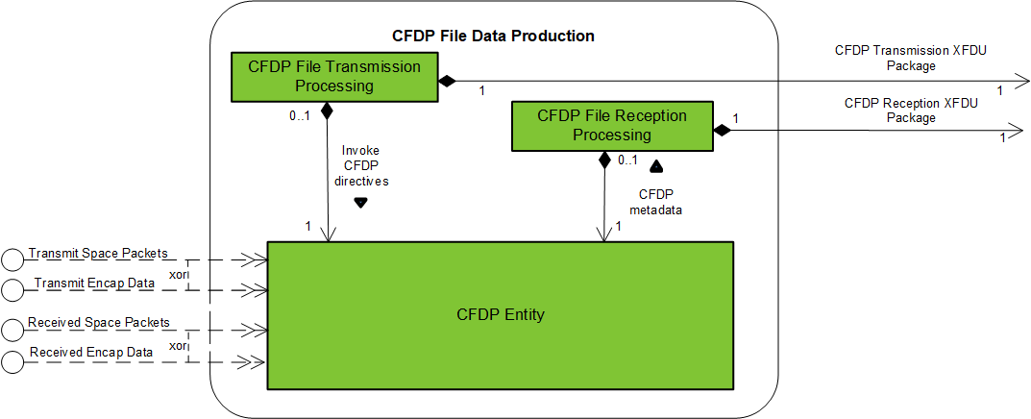

**Figure 7‑2: Member Functional Resources of the CFDP File Data** **Production** **Functional Resource Set**

### CFDP Entity

The functional resource classifier of the CFDP Entity FR Type is CfdpEntity.

The parameters, events, and directives of this functional resource are registered in the SANA Candidate FR Registry (reference [34]).

The CFDP Entity FR corresponds to the Core procedures of the CFDP Recommended Standard (reference [26]).

The CFDP Entity FR corresponds to the Core procedures of the CFDP Recommended Standard (reference [26]).

#### Service Access Points (SAPs) and Ancillary Interfaces Used by this Functional Resource

##### SAPs Accessed by this Functional Resource

The CFDP Entity FR does not access any SAPs. All relationships with other FRs are expressed by required ancillary interfaces.

##### SAPs Hosted by this Functional Resource

The CFDP Entity FR has a File Transmission SAP that can be optionally accessed by a single CFDP File Transmission Processing Accessor.

The CFDP Entity FR has a File Reception SAP that can be optionally accessed by a single CFDP File Reception Processing Accessor.

##### Ancillary Interfaces Required by this Functional Resource

The The CFDP Entity FR optionally requires either a Transmit Space Packets or a Transmit Encap Data ancillary interface.

The The CFDP Entity FR optionally requires either a Received Space Packets or a Received Encap Data ancillary interface.

##### Ancillary Interfaces Provided by this Functional Resource

None.

### CFDP File Transmission Processing

NOTE - This FR will not be included in the draft Red-0.4 version of this book that will be made available for subject matter expert review.

The functional resource classifier of the CFDP File Transmission Processing FR Type is CfdpFileXmitProcessing.

The CFDP File Transmission Processing FR corresponds to what the IOAG Forward File Data Delivery Service description calls the Forward CFDP-File Service (see reference [9]). The CFDP File Transmission Processing FR processes CFDP Transmission eXtensible Markup Language (XML)-Formatted Data Unit (XFDU) Packages that conform to the TGFT XFDU Package format defined in reference [37]. Each CFDP Transmission XFDU Package is a compressed folder/subdirectory that contains (a) a paylad data file that is to be transmitted using CFDP, (b) a metadata file containing TBD instructions for using CFDP to transmit the file, and (c) an XFDU Manifest file that describes the contents of the XFDU Package.

The CFDP File Transmission Processing FR performs the following functions:

1. retrieve the CFDP Transmission XFDU Package file from the Space Data File Store;
2. extract the CFDP Transmission XFDU Package folder/subdirectory from the CFDP Transmission XFDU Package ; and
3. invoke directives on the CFDP Entity to transmit the payload file within the CFDP Transmission XFDU Package folder, based on the instructions contained in the metadata file contained within the CFDP Transmission XFDU Package folder.

#### Service Access Points (SAPs) and Ancillary Interfaces Used by this Functional Resource

To Be Specified.

### CFDP File Reception Processing

NOTE - This FR will not be included in the draft Red-0.4 version of this book that will be made available for subject matter expert review.

The functional resource classifier of the CFDP File Reception Processing FR Type is CfdpFileRcptProcessing.

The CFDP File Reception Processing FR corresponds to what the IOAG Return File Data Delivery Service description calls the Return CFDP-File Service (see reference [9]). The CFDP File Reception Processing FR generates CFDP Transmission XFDU Packages that conform to the TGFT XFDU Package format defined in reference [37]. Each CFDP Reception XFDU Package is a compressed folder/subdirectory that contains (a) a paylad data file that was received using CFDP, (b) a metadata file containing TBD information about the payload data file, and (c) an XFDU Manifest file that describes the contents of the XFDU Package.

The CFDP File Reception Processing FR performs the following functions upon completion of file reception by CFDP:

1. generate the CFDP Reception XFDU Package folder containing: the received payload data file, the metadata file, and the XFDU Manifest file;
2. compress the CFDP Reception XFDU Package folder into a CFDP Reception XFDU Package file; and
3. initiate the transmission of the CFDP Reception XFDU Package file to the designated recipient through the Terrestrial Generic File Transfer Host.

NOTE – As currently defined, TGFT supports only a file-push mode. This requires the CFDP File Reception Processing FR to initiate the terrestrial file transfer.

#### Service Access Points (SAPs) and Ancillary Interfaces Used by this Functional Resource

To Be Specified.

## Packets File Data Transmission Production Functional Resource Set of the SLS Data Delivery Production Functional Resource Stratum

NOTE - This FR Set will not be included in the draft Red-0.4 version of this book that will be made available for subject matter expert review.

The FR type that comprises the Packets File Data Transmission Production Functional Resource Set of the SLS Data Delivery Production Functional Resource stratum is the Packets File Transmission Processing FR.

Figure 7‑3 illustrates the members of the Packets File Data Transmission Production Functional Resource Set.

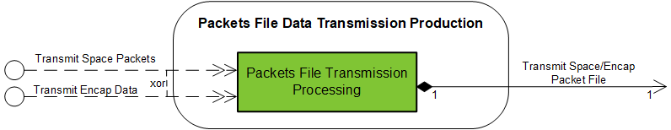

Approach 1

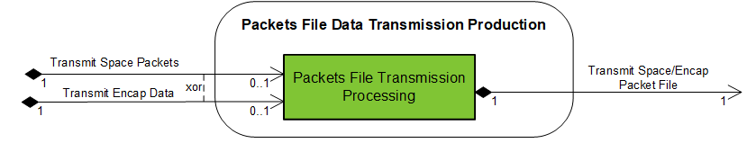

Approach 2

**Figure 7‑3: Member Functional Resources of the Packets File Data** **Delivery Transmission** **Functional Resource Set**

### Packets File Transmission Processing

NOTE - This FR will not be included in the draft Red-0.4 version of this book that will be made available for subject matter expert review.

The functional resource classifier of the Packets File Transmission Processing FR Type is PktsFileXmitProcessing.

The Packets File Transmission Processing FR corresponds to what the IOAG Forward File Data Delivery Service calls the Forward Packets File Service (see reference [9]). Because this service is not yet defined, these production functions have not yet been formally identified, but conceptually they deal with

1. extracting the space packets or encapsulation packets from a file of packets in the Forward File Data Store at the time that they are to be transmitted across the forward space link; and
2. sending the packets using the protocols that have been specified for that file transmission (i.e., as Space Packets or Encapsulation Packets).

#### Relationships with external Functional Resource Sets

To Be Specified.

## Packets File Data Reception Production Functional Resource Set of the SLS Data Delivery Production Functional Resource Stratum

NOTE - This FR Set will not be included in the draft Red-0.4 version of this book that will be made available for subject matter expert review.

The FR type that comprises the Packets File Data Reception Production Functional Resource Set of the SLS Data Delivery Production Functional Resource stratum is the Packets File Reception Processing FR.

Figure 7‑4 illustrates the member functional resources of the Packets File Data Reception Production Functional Resource Set.

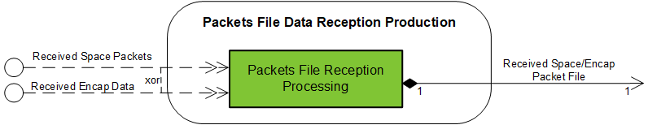

Approach 1

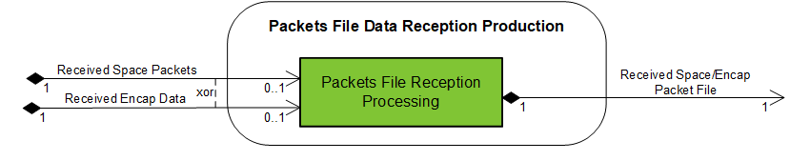

Approach 2

**Figure 7‑4: Member Functional Resources of the Packets File Data** **Reception Production** **Functional Resource Set**

### Packets File Reception Processing

NOTE - This FR will not be included in the draft Red-0.4 version of this book that will be made available for subject matter expert review.

The functional resource classifier of the Packets File Reception Processing FR Type is PktsFileRcptProcessing.

There is currently no schedule for registering the parameters, events, and directives of this functional resource in the SANA FR Registry.

The Packets File Reception Processing FR corresponds to what the IOAG Return File Data Delivery Service calls the Forward Packets File Service (see reference [9]). Because this service is not yet defined, these production functions have not yet been formally identified, but conceptually they deal with

1. accumulating Space Packets/ Encapsulation Packets into a file in the Return File Data Store; and
2. initiating the transmission of the file to the designated recipient through the Terrestrial Generic File Transfer Host.

NOTE – As currently defined, TGFT supports only a file-push mode. This requires the Packet File Reception Processing FR to initiate the transfer.

#### Relationships with external Functional Resource Sets

To Be Specified.

# SLS Radiometric Data Production Functional Resource Stratum

## General

The SLS Radiometric Data Production Functional Resource stratum has one candidate and three future Functional Resource Sets:

* Real-Time Radiometric Data Collection Functional Resource Set (candidate);
* Non-Validated Radiometric Data Collection Functional Resource Set (future);
* Delta-DOR Raw Data Collection Functional Resource Set (future); and
* Open Loop Receiver/Formatter Functional Resource Set (future).

## Real-Time Radiometric Data Collection Functional Resource Set of the SLS Radiometric Data Production Functional Resource Stratum

The Real-Time Radiometric Data Collection Functional Resource Set of the SLS Radiometric Data Production Functional Resource stratum consists of the TDM Segment Generation FR.

Figure 8‑1 illustrates the member of the Real-Time Radiometric Data Collection Functional Resource Set.

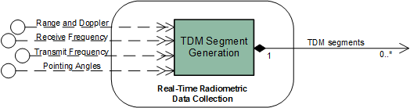

**Figure 8‑1: Member Functional Resources of the Real-Time Radiometric Data Collection** **Functional Resource Set**

### TDM Segment Generation

The functional resource classifier of the TDM Segment Generation FR Type is TdmSegmentGen.

The parameters, events, and directives of this functional resource are registered in the SANA Candidate FR Registry (reference [34]).

TDM Segment Generation constitutes the production functions associated with collecting: angle measurements from the antenna; receive frequency, carrier power, carrier power to noise spectral density, and Doppler measurements from the return space link; range and ranging power to noise spectral density measurements from the received space link; and transmit frequency and transmit frequency rate from the transmitted space link in order to generate Tracking Data Message (TDM) segments containing those measurements.

The TDM Segment Generation FR corresponds to the TDM Segment Generationproduction function specified in annex F2 of the Tracking Data CSTS Draft Recommended Standard (reference [8]). There are no CCSDS Recommended Standards for the TDM Segment Generation function. The following description serves as the definition of the function.

#### TDM Segment Generation Function

The purpose of the TDM Segment Generation function is to collect tracking data from the various resources that produce it and create TDM Atomic Segments, as defined in reference [8]. The TDM Generation function can generate ten kinds of TDM Atomic Segments:

* carrier power;
* carrier power to noise spectral density ratio;
* ranging power to noise spectral density ratio;
* Doppler (instantaneous);
* Doppler (integrated);
* range;
* receive frequency;
* transmit frequency;
* transmit frequency rate; and
* antenna angle pairs.

[applicability depends on modulation scheme used] (See the *Tracking Data Message* Recommended Standard (reference [36]) for definitions of these terms).

In forming each TDM Atomic Segment, the TDM Segment Generation function creates a TDM Metadata Section (see 3.3 of reference [36]) that is appropriate to the data type being reported, followed by a TDM Data Section (see 3.4 of reference [36]) that contains the data being reported. A single TDM Generation function instance can process radiometric data from multiple sources within the ESLT (e.g., multiple transmitters, receivers, and antennas).

Configuration of an instance of the TDM Segment Generation function essentially involves, for each instance of radiometric data to be reported:

1. identifying the source FR instance (e.g., the Forward 401 Space Link Carrier Transmission instance that supplies transmit frequency measurements; and
2. associating that source FR instance with the TDM-specific metadata used to identify tracking data measurement types.

The following subsections describe the processing performed for each of the ten supported radiometric data types.

##### Carrier Power Atomic Segments

The carrier power (3.5.2.1 of reference [36]) “conveys the strength of the radio signal transmitted by the Space User Node as received at the ESLT.”[2]

Carrier power is reported by a return space link functional resource within the Physical Channel functional resource stratum. The information necessary to configure a Carrier Power path is as follows:

1. the name of the ESLT aperture that is used by the receiving functional resource instance. This name appears in the PARTICIPANT_1 metadata keyword of the Metadata sections of the TDM Atomic Segments generated for a Carrier Power path. The name shall be the name assigned to the aperture in the SANA Service Sites and Apertures registry (reference [39]);
2. the name of the Space User Node that transmits the signal being measured. This name appears in the PARTICIPANT_2 metadata keyword of the Metadata sections of the TDM Atomic Segments generated for a Carrier Power path. If the Space User Node has a single transponder or transmitter that can be used in the generation of radiometric measurements, then the Space User Node name shall be the abbreviated name specified in the SANA Spacecraft registry ([reference](http://www.sanaregistry.org/r/spacecraft) [40]). If the Space User Node has multiple transponders or transmitters, the Space User Node name is that of the transponder/transmitter that is the source of the carrier signal. The name of the transponder/transmitter shall be formed by the concatenation of the SANA Spacecraft registry abbreviated name and the frequency band in which the transponder/transmitter operates: <Space User Node Name>-<frequency band>, where <frequency band> is the SANA Frequency Band Designator specified in table 2-1 of reference [42];

NOTE – For example, if the Space User Node with the SANA Spacecraft registry abbreviated name “EXOSAT” has a single transponder or transmitter that can be used in the generation of radiometric measurements, then the User Space Node name is ”EXOSAT”. However, if EXOSAT has multiple transponders /transmitters in different frequency bands that can be used simultaneously (one of which is near-Earth X-band), then the User Space Node name for the X-band transponder/transmitter is “EXOSAT-X-NE”, where the “X-NE” is the SANA Frequency Band Designator for near-Earth X-band.

1. the reporting period at which the Carrier Power Atomic Segments are to be generated, in seconds;

NOTE – An ESLT implementation may have this value fixed by the implementation. In such a case, the value of this parameter is constrained to be the value that is supported by the implementation. Also, an ESLT implementation may generate Carrier Power measurements on a non-periodic basis. In such a case, the reporting period configuration parameter of the TDM Segment Generation instance is set to zero.

1. the frequency band of the carrier signal received from the Space User Node, using the SANA Frequency Band Designator specified in table 2-1 of reference [42];
2. the FR Name of the Physical Channel FR that receives the carrier (and therefore has the Receive Frequency provided interface for that carrier power data).

Figure 8‑2 specifies the contents of the Carrier Power Atomic Segment generated by the TDM Segment Generation function.

META_START

TIME_SYSTEM = UTC

START_TIME = <time that the carrier power is sampled>

STOP_TIME = <time that the carrier power is sampled>

PARTICIPANT_1 = <name of the ESLT aperture>

PARTICIPANT_2 = <name of the Space User Node[-<frequency band>]>

MODE = SEQUENTIAL

PATH = 2,1

RECEIVE_BAND = <frequency band>

META_STOP

DATA_START

CARRIER_POWER = <received carrier power in dBW>

DATA_STOP

**Figure 8‑2: Contents of the Carrier Power Atomic Segment**

##### Carrier Power to Noise Spectral Density Ratio (Pc/No) Atomic Segments

Carrier power to noise spectral density ratio (Pc/No) (3.5.2.5 of reference [36]) is reported by a return space link functional resource within the Physical Channel functional resource stratum.

When the carrier being reported upon uses a suppressed carrier modulation scheme, the value reported as Pc/No shall be the *reconstructed* carrier power to noise density ratio.

The information necessary to configure a Pc/No path is as follows:

1. The name of the ESLT aperture that is used by the receiving functional resource instance. This name appears in the PARTICIPANT_1 metadata keyword of the Metadata sections of the TDM Atomic Segments generated for a Pc/No path. The name shall be the name assigned to the aperture in the SANA Service Sites and Apertures registry (reference [39]).
2. The name of the Space User Node that transmits the signal being measured. This name appears in the PARTICIPANT_2 metadata keyword of the Metadata sections of the TDM Atomic Segments generated for a Pc/No path. If the Space User Node has a single transponder or transmitter that can be used in the generation of radiometric measurements, then the Space User Node name shall be the abbreviated name specified in the SANA Spacecraft registry ([reference](http://www.sanaregistry.org/r/spacecraft) [40]). If the Space User Node has multiple transponders or transmitters, the Space User Node name is that of the transponder/transmitter that is the source of the carrier signal. The name of the transponder/transmitter shall be formed by the concatenation of the SANA Spacecraft registry abbreviated name and the frequency band in which the transponder/transmitter operates: <Space User Node Name>-<frequency band>, where <frequency band> is the SANA Frequency Band Designator specified in table 2-1 of reference [42].

NOTE – See the NOTE under 8.2.1.1.1 b).

1. The reporting period at which the Pc/No Atomic Segments are to be generated, in seconds.

NOTE – An ESLT implementation may have this value fixed by the implementation. In such a case, the value of this parameter is constrained to be the value that is supported by the implementation. Also, an ESLT implementation may generate Pc/No measurements on a non-periodic basis. In such a case, the reporting period configuration parameter of the TDM Segment Generation instance is set to zero.

1. The frequency band of the carrier signal received from the Space User Node, using the SANA Frequency Band Designator specified in table 2-1 of reference [42].
2. The FR Name of the Physical Channel FR that receives the carrier (and therefore has the Receive Frequency provided interface for that Pc/No data).

Figure 8‑3 specifies the contents of the Pc/No Atomic Segment generated by the TDM Segment Generation function.

META_START

TIME_SYSTEM = UTC

START_TIME = <time that the Pc/No is sampled>

STOP_TIME = <time that the Pc/No is sampled>

PARTICIPANT_1 = <name of the ESLT aperture>

PARTICIPANT_2 = <name of the Space User Node[-<frequency band>]>

MODE = SEQUENTIAL

PATH = 2,1

RECEIVE_BAND = <frequency band>

META_STOP

DATA_START

PC_N0 = <Pc/No in dBHz>

DATA_STOP

**Figure 8‑3: Contents of the Pc/No Atomic Segment**

##### Ranging Power to Noise Spectral Density Ratio (Pr/No) Atomic Segments

Ranging power to noise spectral density ratio (Pr/No) (3.5.2.6 of reference [36]) is reported by a return space link functional resource within the Physical Channel functional resource stratum.

When the carrier being reported upon uses a Gaussian Minimum Shift Keying (GMSK) modulation scheme, the value reported as Pc/No shall be the ranging *tone* power to noise spectral density ratio.

The information necessary to configure a Pr/No path is as follows:

1. the name of the ESLT aperture that is used by the receiving functional resource instance. This name appears in the PARTICIPANT_1 metadata keyword of the Metadata sections of the TDM Atomic Segments generated for a Pr/No path. The name shall be the name assigned to the ESLT in the SANA Service Sites and Apertures registry (reference [39]);
2. the name of the Space User Node that transmits the signal being measured. This name appears in the PARTICIPANT_2 metadata keyword of the Metadata sections of the TDM Atomic Segments generated for a Pr/No path. If the Space User Node has a single transponder or transmitter that can be used in the generation of radiometric measurements, then the Space User Node name shall be the abbreviated name specified in the SANA Spacecraft registry ([reference](http://www.sanaregistry.org/r/spacecraft) [40]). If the Space User Node has multiple transponders or transmitters, the Space User Node name is that of the transponder/transmitter that is the source of the carrier signal. The name of the transponder/transmitter is formed by the concatenation of the SANA Spacecraft registry abbreviated name and the frequency band in which the transponder/transmitter operates: <Space User Node Name>-<frequency band>, where <frequency band> is the SANA Frequency Band Designator specified in table 2-1 of reference [42];

NOTE – See the NOTE under 8.2.1.1.1 b).

1. the reporting period at which the Pr/No Atomic Segments are to be generated, in seconds;

NOTE – An ESLT implementation may have this value fixed by the implementation. In such a case, the value of this parameter is constrained to be the value that is supported by the implementation. Also, an ESLT implementation may generate Pr/No measurements on a non-periodic basis. In such a case, the reporting period configuration parameter of the TDM Segment Generation instance is set to zero.

1. the frequency band of the carrier signal received from the Space User Node, using the SANA Frequency Band Designator specified in table 2-1 of reference [42];
2. the FR Name of the Physical Channel FR that generates the Pr/No measurements (and therefore has the Range and Doppler provided interface for that Pr/No data).

Figure 8‑4 specifies the contents of the Pr/No Atomic Segment generated by the TDM Segment Generation function.

META_START

TIME_SYSTEM = UTC

START_TIME = <time that the Pr/No is sampled>

STOP_TIME = <time that the Pr/No is sampled>

PARTICIPANT_1 = <name of the ESLT aperture>

PARTICIPANT_2 = <name of the Space User Node[-<frequency band>]>

MODE = SEQUENTIAL

PATH = 2,1

RECEIVE_BAND = <frequency band>

META_STOP

DATA_START

PR_N0 = <Pr/No in dBHz>

DATA_STOP

**Figure 8‑4: Contents of the Pr/No Atomic Segment**

##### Doppler (Instantaneous) Atomic Segments

Doppler (instantaneous) “represents the instantaneous range rate of the spacecraft” (3.5.2.2 of reference [36]). Doppler measurements are reported by a functional resource within the Physical Channel functional resource stratum that provides Doppler-measurements.

The TDM Segment Generation function is limited to generating TDM Atomic Segments that contain data measurements that are available locally within the ESLT. With respect to Doppler measurements, this means that only the following Doppler measurements are reported by the TD-CSTS: one-way, two-way, and three-way when both apertures are associated with the same ESLT.

NOTE – TDMs containing three-way Doppler measurements involving multiple ESLTs may be generated by a facility that has access to the information from all of the participating ESLTs. Some of the contributing information may be reported by an ESLT via the TD-CSTS. For example, if ESLT X has the aperture that transmits the forward leg of the three-way link, that ESLT can provide Transmit Frequency Atomic Segments (see 8.2.1.1.8) to a facility that integrates the source data into the three-way TDMs. If ESLT Y receives the last leg of the three-way link, it can provide Receive Frequency Atomic Segments (see 8.2.1.1.7) and (one-way) Doppler Atomic Segments to the facility that integrates the source data into the three-way TDMs.

The information necessary to configure a Doppler (instantaneous) path is as follows:

1. the name of the ESLT aperture that (1) receives the signal for one-way Doppler measurements), (2) transmits and receives the signal (for two-way Doppler measurements), or (3) transmits the signal (for three-way Doppler measurements when the receiving aperture is part of the same ESLT). This name appears in the PARTICIPANT_1 metadata keyword of the Metadata sections of the TDM Atomic Segments generated for a Doppler (instantaneous) path. The name shall be the name assigned to the aperture in the SANA Service Sites and Apertures registry (reference [39]);
2. the name of the Space User Node that transmits the signal being received by the ESLT. This name appears in the PARTICIPANT_2 metadata keyword of the Metadata sections of the TDM Atomic Segments generated for a Doppler (instantaneous) path. If the Space User Node has a single transponder or transmitter that can be used in the generation of radiometric measurements, then the Space User Node name shall be the abbreviated name specified in the SANA Spacecraft registry ([reference](http://www.sanaregistry.org/r/spacecraft) [40]). If the Space User Node has multiple transponders or transmitters, the Space User Node name is that of the transponder/transmitter that is the source of the carrier signal. The name of the transponder/transmitter shall be formed by the concatenation of the SANA Spacecraft registry abbreviated name and the frequency band in which the transponder/transmitter operates: <Space User Node Name>-<frequency band>, where <frequency band> is the SANA Frequency Band Designator specified in table 2-1 of reference [42];

NOTE – See the NOTE under 8.2.1.1.1 b).

1. if three-way Doppler measurements are taken with both transmitting and receiving apertures associated with the ESLT, the name of the ESLT aperture that receives the signal. This name appears in the PARTICIPANT_3 metadata keyword of the Metadata sections of the TDM Atomic Segments generated for a Doppler (instantaneous) path. The name shall be the name assigned to the aperture in the SANA Service Sites and Apertures registry (reference [39]);
2. the reporting period at which the Doppler (instantaneous) Atomic Segments are to be generated, in seconds;

NOTE – An ESLT implementation may have this value fixed by the implementation. In such a case, the value of this parameter is constrained to be the value that is supported by the implementation.

1. the frequency band of the carrier signal transmitted to the Space User Node, using the SANA Frequency Band Designator specified in table 2-1 of reference [42]. For one-way Doppler measurements this value is not used;

NOTE – Whether the Doppler measurements are one-way, two-way, or three-way is determined by the configuration of the Doppler-measuring functional resource that provides the Doppler measurements.

1. the frequency band of the carrier signal received from the Space User Node, using the SANA Frequency Band Designator specified in table 2-1 of reference [42];
2. the FR Name of the Physical Channel FR that generates the Doppler measurements (and therefore has the Range and Doppler provided interface for that Doppler data).

Figure 8‑5 specifies the contents of the one-way Doppler (instantaneous) Atomic Segment generated by the TDM Segment Generation function.

META_START

TIME_SYSTEM = UTC

START_TIME = <time that the Doppler is sampled>

STOP_TIME = <time that the Doppler is sampled>

PARTICIPANT_1 = <name of the ESLT aperture>

PARTICIPANT_2 = <name of the Space User Node[-<frequency band>]>

MODE = SEQUENTIAL

PATH = 2,1

RECEIVE_BAND = <receive frequency band>

META_STOP

DATA_START

DOPPLER_INSTANTANEOUS = <Doppler in km/sec>

RECEIVE_FREQ = <receive frequency in Hz>

DATA_STOP

**Figure 8‑5: Contents of the One-Way Doppler (instantaneous) Atomic Segment**

Figure 8‑6 specifies the contents of the two-way Doppler (instantaneous) Atomic Segment generated by the TDM Segment Generation function.

META_START

TIME_SYSTEM = UTC

START_TIME = <time that the Doppler is sampled>

STOP_TIME = <time that the Doppler is sampled>

PARTICIPANT_1 = <name of the ESLT aperture>

PARTICIPANT_2 = <name of the Space User Node[-<frequency band>]>

MODE = SEQUENTIAL

PATH = 1,2,1

TRANSMIT_BAND = <transmit frequency band>

RECEIVE_BAND = <receive frequency band>

TURNAROUND_NUMERATOR = <turnaround numerator>*

TURNAROUND_DENOMINATOR = <turnaround denominator>*

META_STOP

DATA_START

DOPPLER_INSTANTANEOUS = <Doppler in km/sec>

TRANSMIT_FREQ_1 = <transmit frequency in Hz>

RECEIVE_FREQ = <receive frequency in Hz>

DATA_STOP

* The turnaround numerator and denominator (see TURNAROUND_NUMERATOR and TURNAROUND_DENOMINATOR in Table 3-3 of reference [36]) are determined by the frequency band of the transmitted carrier to which the received carrier is coherently related. For CCSDS 401-conformant carriers, the turnaround ratios are specified in reference [23]. For CCSDS 415-conformant carriers, the turnaround ratio is specified in reference [25]. The TDM Segment Generation FR obtains this information through the relationship identified by the Range and Doppler interface with a functional resource of the receiving carrier’s FR Set.

**Figure 8‑6: Contents of the Two-Way Doppler (instantaneous) Atomic Segment**

Figure 8‑7 specifies the contents of the three-way Doppler (instantaneous) Atomic Segment generated by the TDM Segment Generation function, when both the transmitting and receiving apertures are associated with the ESLT.

META_START

TIME_SYSTEM = UTC

START_TIME = <time that the Doppler is sampled>

STOP_TIME = <time that the Doppler is sampled>

PARTICIPANT_1 = <name of the transmitting aperture at the ESLT>

PARTICIPANT_2 = <name of the Space User Node[-<frequency band>]>

PARTICIPANT_3 = <name of the receiving aperture at the ESLT>

MODE = SEQUENTIAL

PATH = 1,2,3

TRANSMIT_BAND = <transmit frequency band>

RECEIVE_BAND = <receive frequency band>

TURNAROUND_NUMERATOR = <turnaround numerator>*

TURNAROUND_DENOMINATOR = <turnaround denominator>*

META_STOP

DATA_START

DOPPLER_INSTANTANEOUS = <Doppler in km/sec>

TRANSMIT_FREQ_1 = <transmit frequency in Hz>

RECEIVE_FREQ = <receive frequency in Hz>

DATA_STOP

* The turnaround numerator and denominator (see TURNAROUND_NUMERATOR and TURNAROUND_DENOMINATOR in Table 3-3 of reference [36]) are determined by the frequency band of the transmitted carrier to which the received carrier is coherently related. For CCSDS 401-conformant carriers, the turnaround ratios are specified in reference [23]. For CCSDS 415-conformant carriers, the turnaround ratio is specified in reference [25]. The TDM Segment Generation FR obtains this information through the relationship identified by the Range and Doppler interface with a functional resource of the receiving carrier’s FR Set.

**Figure 8‑7: Contents of the Three-Way Doppler (instantaneous) Atomic Segment**

##### Doppler (Integrated) Atomic Segments

Doppler (integrated) “represents the mean range rate of the spacecraft over the INTEGRATION_INTERVAL specified in the Metadata Section.” (3.5.2.3 of reference [36]) Doppler measurements are reported by a functional resource within the Physical Channel functional resource stratum that provides Doppler-measurements.

The TDM Segment Generation function is limited to ecurityng TDM Atomic Segments that contain data measurements that are available locally within the ESLT. With respect to Doppler measurements, this means that only the following Doppler measurements are reported by the TD-CSTS: one-way, two-way, and three-way when both apertures are associated with the same ESLT.

NOTE – TDMs containing three-way Doppler measurements involving multiple ESLTs may be generated by a facility that has access to the information from all of the participating ESLTs. Some of the contributing information may be reported by an ESLT via the TD-CSTS. For example, if ESLT X has the aperture that transmits the forward leg of the three-way link, that ESLT can provide Transmit Frequency Atomic Segments (see 8.2.1.1.8) to a facility that integrates the source data into the three-way TDMs. If ESLT Y receives the last leg of the three-way link, it can provide Receive Frequency Atomic Segments (see 8.2.1.1.7) and (one-way) Doppler Atomic Segments to the facility that integrates the source data into the three-way TDMs.

The information necessary to configure a Doppler (integrated) path is as follows:

1. the name of the ESLT aperture that (1) receives the signal for one-way Doppler measurements), (2) transmits and receives the signal (for two-way Doppler measurements), or (3) transmits the signal (for three-way Doppler measurements when the receiving aperture is part of the same ESLT). This name appears in the PARTICIPANT_1 metadata keyword of the Metadata sections of the TDM Atomic Segments generated for a Doppler (integrated) path. The name shall be the name assigned to the aperture in the SANA Service Sites and Apertures registry (reference [39]);
2. the name of the Space User Node that transmits the signal being received by the ESLT. This name appears in the PARTICIPANT_2 metadata keyword of the Metadata sections of the TDM Atomic Segments generated for a Doppler (integrated) path. If the Space User Node has a single transponder or transmitter that can be used in the generation of radiometric measurements, then the Space User Node name shall be the abbreviated name specified in the SANA Spacecraft registry ([reference](http://www.sanaregistry.org/r/spacecraft) [40]). If the Space User Node has multiple transponders or transmitters, the Space User Node name is that of the transponder/transmitter that is the source of the carrier signal. The name of the transponder/transmitter shall be formed by the concatenation of the SANA Spacecraft registry abbreviated name and the frequency band in which the transponder/transmitter operates: <Space User Node Name>-<frequency band>, where <frequency band> is the SANA Frequency Band Designator specified in table 2-1 of reference [42];

NOTE – See the NOTE under 8.2.1.1.1 b).

1. if three-way Doppler measurements are taken with both transmitting and receiving apertures associated with the ESLT, the name of the ESLT aperture that receives the signal. This name appears in the PARTICIPANTS_3 metadata keyword of the Metadata sections of the TDM Atomic Segments generated for a Doppler (instantaneous) path. The name shall be the name assigned to the aperture in the SANA Service Sites and Apertures registry (reference [39]);
2. the integration interval over which the Doppler measurements are to be integrated, in seconds (see INTEGRATION_INTERVAL in Table 3-3 of reference [36]);

NOTE – An ESLT implementation may have this value fixed by the implementation. In such a case, the value of this parameter is constrained to be the value that is supported by the implementation.

1. the integration reference, which specifies “the relationship between the INTEGRATION_INTERVAL and the timetag of the data, i.e., whether the timetag represents the start, middle, or end of the integration period” (see INTEGRATION_REF in Table 3-3 of reference [36]);
2. the reporting period at which the Doppler (integrated) Atomic Segments are to be generated, in seconds;

NOTE – An ESLT implementation may have this value fixed by the implementation. In such a case, the value of this parameter is constrained to be the value that is supported by the implementation.

1. the frequency band of the carrier signal transmitted to the Space User Node, using the SANA Frequency Band Designator specified in table 2-1 of reference [42]. For one-way Doppler measurements this value is not used;

NOTE – Whether the Doppler measurements are one-way, two-way, or three-way is determined by the configuration of the Doppler-measuring functional resource that provides the Doppler measurements.

1. the frequency band of the carrier signal received from the Space User Node, using the SANA Frequency Band Designator specified in table 2-1 of reference [42];
2. the FR Name of the Physical Channel FR that generates the Doppler measurements (and therefore has the Range and Doppler provided interface for that Doppler data).

Figure 8‑8 specifies the contents of the one-way Doppler (integrated) Atomic Segment generated by the TDM Segment Generation function.

META_START

TIME_SYSTEM = UTC

START_TIME = <time of the Doppler (integrated) measurement>

STOPTIME = <time of the Doppler (integrated) measurement>

PARTICIPANT_1 = <name of the ESLT aperture>

PARTICIPANT_2 = <name of the Space User Node[-<frequency band>]>

MODE = SEQUENTIAL

PATH = 2,1

RECEIVE_BAND = <receive frequency band>

INTEGRATION_INTERVAL = <integration interval in sec>

INTEGRATION_REF = ‘START’, ‘MIDDLE’, or ‘END’

META_STOP

DATA_START

DOPPLER_INTEGRATED = <Doppler in km/sec>

RECEIVE_FREQ = <receive frequency in Hz>

DATA_STOP

**Figure 8‑8: Contents of the One-Way Doppler (integrated) Atomic Segment**

Figure 8‑9 specifies the contents of the two-way Doppler (integrated) Atomic Segment generated by the TDM Segment Generation function.

META_START

TIME_SYSTEM = UTC

START_TIME = <time of the Doppler (integrated) measurement>

STOPTIME = <time of the Doppler (integrated) measurement>

PARTICIPANT_1 = <name of the ESLT aperture>

PARTICIPANT_2 = <name of the Space User Node[-<frequency band>]>

MODE = SEQUENTIAL

PATH = 1,2,1

TRANSMIT_BAND = <transmit frequency band>

RECEIVE_BAND = <receive frequency band>

TURNAROUND_NUMERATOR = <turnaround numerator>*

TURNAROUND_DENOMINATOR = <turnaround denominator>*

INTEGRATION_INTERVAL = <integration interval in sec>

INTEGRATION_REF = <‘START’, ‘MIDDLE’, or ‘END’>

META_STOP

DATA_START

DOPPLER_ INTEGRATED = <Doppler in km/sec>

TRANSMIT_FREQ_1 = <transmit frequency in Hz>

RECEIVE_FREQ = <receive frequency in Hz>

DATA_STOP

*The turnaround numerator and denominator (see TURNAROUND_NUMERATOR and TURNAROUND_DENOMINATOR in Table 3-3 of reference [36]) are determined by the frequency band of the transmitted carrier to which the received carrier is coherently related. For CCSDS 401-conformant carriers, the turnaround ratios are specified in reference [23]. For CCSDS 415-conformant carriers, the turnaround ratio is specified in reference [25]. The TDM Segment Generation FR obtains this information through the relationship identified by the Range and Doppler interface with a functional resource of the receiving carrier’s FR Set

**Figure 8‑9: Contents of the Two-Way Doppler (integrated) Atomic Segment**

Figure 8‑10 specifies the contents of the three-way Doppler (integrated) Atomic Segment generated by the TDM Segment Generation function, when both the transmitting and receiving apertures are associated with the ESLT.

META_START

TIME_SYSTEM = UTC

START_TIME = <time of the Doppler (integrated) measurement>

STOPTIME = <time of the Doppler (integrated) measurement>

PARTICIPANT_1 = <name of the transmitting aperture at the ESLT>

PARTICIPANT_2 = <name of the Space User Node[-<frequency band>]>

PARTICIPANT_3 = <name of the receiving aperture at the ESLT>

MODE = SEQUENTIAL

PATH = 1,2,3

TRANSMIT_BAND = <transmit frequency band>

RECEIVE_BAND = <receive frequency band>

TURNAROUND_NUMERATOR = <turnaround numerator>*

TURNAROUND_DENOMINATOR = <turnaround denominator>*

INTEGRATION_INTERVAL = <integration interval in sec>

INTEGRATION_REF = <‘START’, ‘MIDDLE’, or ‘END’>

META_STOP

DATA_START

DOPPLER_ INTEGRATED = <Doppler in km/sec>

TRANSMIT_FREQ_1 = <transmit frequency in Hz>

RECEIVE_FREQ = <receive frequency in Hz>

DATA_STOP

*The turnaround numerator and denominator (see TURNAROUND_NUMERATOR and TURNAROUND_DENOMINATOR in Table 3-3 of reference [36]) are determined by the frequency band of the transmitted carrier to which the received carrier is coherently related. For CCSDS 401-conformant carriers, the turnaround ratios are specified in reference [23]. For CCSDS 415-conformant carriers, the turnaround ratio is specified in reference [25]. The TDM Segment Generation FR obtains this information through the relationship identified by the Range and Doppler interface with a functional resource of the receiving carrier’s FR Set.

**Figure 8‑10: Contents of the Three-Way Doppler (integrated) Atomic Segment**

##### Range Atomic Segments

Range measurements are reported by a functional resource within the Physical Channel functional resource stratum that provides range-measurements.

The information necessary to configure a range path is as follows:

1. the name of the ESLT aperture that transmits and receives the ranging signal (for two-way Doppler measurements) or transmits the signal (for three-way Doppler measurements when the receiving aperture is part of the same ESLT). This name appears in the PARTICIPANT_1 metadata keyword of the Metadata sections of the TDM Atomic Segments generated for a range path. The name shall be the name assigned to the ESLT in the SANA Service Sites and Apertures registry (reference [39]);
2. the name of the Space User Node that transmits the signal being measured. This name appears in the PARTICIPANT_2 metadata keyword of the Metadata sections of the TDM Atomic Segments generated for a range path. If the Space User Node has multiple transponders or transmitters, the Space User Node name is that of the transponder/transmitter that is the source of the carrier signal. The name of the transponder/transmitter shall be formed by the concatenation of the SANA Spacecraft registry abbreviated name and the frequency band in which the transponder/transmitter operates: <Space User Node Name>-<frequency band>, where <frequency band> is the SANA Frequency Band Designator specified in table 2-1 of reference [42];

NOTE – See the NOTE under 8.2.1.1.1 b).

1. if three-way Doppler measurements are taken with both transmitting and receiving apertures associated with the ESLT, the name of the ESLT aperture that receives the signal. This name appears in the PARTICIPANT_3 metadata keyword of the Metadata sections of the TDM Atomic Segments generated for a Doppler (instantaneous) path. The name shall be the name assigned to the aperture in the SANA Service Sites and Apertures registry (reference [39]);
2. the range units (see RANGE_UNITS in Table 3-3 of reference [36]). The values are ‘km’ or ‘s’;

NOTE – An ESLT implementation may have this value fixed by the implementation. In such a case, the value of this parameter is constrained to be the value that is supported by the implementation.

1. the integration interval over which the Range measurements are to be integrated, in seconds;

NOTE – The INTEGRATION_INTERVAL is not mandatory (but is optional) for range data, but no explanation is provided in reference [36]) of when it is or is not used.

1. the integration reference, which specifies “the relationship between the INTEGRATION_INTERVAL and the timetag of the data, i.e., whether the timetag represents the start, middle, or end of the integration period” (see INTEGRATION_REF in Table 3-3 of reference [36]);
2. the frequency band of the carrier signal transmitted to the Space User Node, using the SANA Frequency Band Designator specified in table 2-1 of reference [42];
3. the frequency band of the carrier signal received from the Space User Node, using the SANA Frequency Band Designator specified in table 2-1 of reference [42];
4. the FR Name of the Physical Channel FR that generates the range measurements (and therefore has the Range and Doppler provided interface for that range data).

Figure 8‑11 specifies the contents of the two-way Range Atomic Segment generated by the TDM Segment Generation function.

META_START

TIME_SYSTEM = UTC

START_TIME = <time of the range measurement>

STOP_TIME = <time of the range measurement>

PARTICIPANT_1 = <name of the ESLT aperture>

PARTICIPANT_2 = <name of the Space User Node[-<frequency band>]>

MODE = SEQUENTIAL

PATH = 1,2,1

RANGE_MODE = ‘COHERENT’ or ‘CONSTANT’ *

RANGE_MODULUS = <modulus of the range observable>**

RANGE_UNITS = ‘km’ or ‘s’

TRANSMIT_BAND = <transmit frequency band>

RECEIVE_BAND = <receive frequency band>

TURNAROUND_NUMERATOR = <turnaround numerator>***

TURNAROUND_DENOMINATOR = <turnaround denominator>***

INTEGRATION_REF = ‘START’, ‘MIDDLE’, or ‘END’

META_STOP

DATA_START

RANGE = <range in RANGE_UNITS>

DATA_STOP

* The range mode (see RANGE_MODE in Table 3-3 of reference [36]) is a characteristic of the type of ranging performed by of the functional resource that generates the range measurements. The TDM Segment Generation FR obtains this information through the relationship established by the Range and Doppler interface with that functional resource.

**The determination of the range modulus (see RANGE_MODULUS in Table 3-3 of reference [36]) depends on a priori knowledge of the spacecraft trajectory. The TDM Segment Generation FR obtains this information through the relationship established by the Range and Doppler interface with that functional resource.

*** The turnaround numerator and denominator (see TURNAROUND_NUMERATOR and TURNAROUND_DENOMINATOR in Table 3-3 of reference [36]) are determined by the frequency band of the transmitted carrier to which the received carrier is coherently related. For CCSDS 401-conformant carriers, the turnaround ratios are specified in reference [23]. For CCSDS 415-conformant carriers, the turnaround ratio is specified in reference [25]. The TDM Segment Generation FR obtains this information through the relationship identified by the Range and Doppler interface with a functional resource of the receiving carrier’s FR Set.

**Figure 8‑11: Contents of the Two-Way Range Atomic Segment**

Figure 8‑11 specifies the contents of the three-way Range Atomic Segment generated by the TDM Segment Generation function, when both the transmitting and receiving apertures are associated with the ESLT.

META_START

TIME_SYSTEM = UTC

START_TIME = <time of the range measurement>

STOP_TIME = <time of the range measurement>

PARTICIPANT_1 = <name of the transmitting aperture at the ESLT>

PARTICIPANT_2 = <name of the Space User Node[-<frequency band>]>

PARTICIPANT_3 = <name of the receiving aperture at the ESLT>

MODE = SEQUENTIAL

PATH = 1,2,3

RANGE_MODE = ‘COHERENT’ or ‘CONSTANT’ *

RANGE_MODULUS = <modulus of the range observable>**

RANGE_UNITS = ‘km’ or ‘s’

TRANSMIT_BAND = <transmit frequency band>

RECEIVE_BAND = <receive frequency band>

TURNAROUND_NUMERATOR = <turnaround numerator>***

TURNAROUND_DENOMINATOR = <turnaround denominator>***

INTEGRATION_REF = ‘START’, ‘MIDDLE’, or ‘END’

META_STOP

DATA_START

RANGE = <range in RANGE_UNITS>

DATA_STOP

* The range mode (see RANGE_MODE in Table 3-3 of reference [36]) is a characteristic of type of ranging performed by the functional resource that generates the range measurements. The TDM Segment Generation FR obtains this information through the relationship established by the Range and Doppler interface with that functional resource.

**The determination of the range modulus (see RANGE_MODULUS in Table 3-3 of reference [36]) depends on a priori knowledge of the spacecraft trajectory. The TDM Segment Generation FR obtains this information through the relationship established by the Range and Doppler interface with that functional resource.

*** The turnaround numerator and denominator (see TURNAROUND_NUMERATOR and TURNAROUND_DENOMINATOR in Table 3-3 of reference [36]) are determined by the frequency band of the transmitted carrier to which the received carrier is coherently related. For CCSDS 401-conformant carriers, the turnaround ratios are specified in reference [23]. For CCSDS 415-conformant carriers, the turnaround ratio is specified in reference [25]. The TDM Segment Generation FR obtains this information through the relationship identified by the Range and Doppler interface with a functional resource of the receiving carrier’s FR Set.

**Figure 8‑12: Contents of the Three-Way Range Atomic Segment**

##### Receive Frequency Atomic Segments

The receive frequency (3.5.2.8 of reference [36]) is reported by a return space link functional resource within the Physical Channel functional resource stratum. The information necessary to configure a Receive Frequency path is as follows:

1. the name of the ESLT aperture that is used by the receiving functional resource instance. This name appears in the PARTICIPANT_1 metadata keyword of the Metadata sections of the TDM Atomic Segments generated for a Receive Frequency path. The name shall be the name assigned to the ESLT aperture in the SANA Service Sites and Apertures registry (reference [39]);
2. the name of the Space User Node that transmits the signal being measured. This name appears in the PARTICIPANT_2 metadata keyword of the Metadata sections of the TDM Atomic Segments generated for a Receive Frequency path. If the Space User Node has a single transponder or transmitter that can be used in the generation of radiometric measurements, then the Space User Node name shall be the abbreviated name specified in the SANA Spacecraft registry ([reference](http://www.sanaregistry.org/r/spacecraft) [40]). If the Space User Node has multiple transponders or transmitters, the Space User Node name is that of the transponder/transmitter that is the source of the carrier signal. The name of the transponder/transmitter shall be formed by the concatenation of the SANA Spacecraft registry abbreviated name and the frequency band in which the transponder/transmitter operates: <Space User Node Name>-<frequency band>, where <frequency band> is the SANA Frequency Band Designator specified in table 2-1 of reference [42];

NOTE – See the NOTE under 8.2.1.1.1 b).

1. the reporting period at which the Receive Frequency Atomic Segments are to be generated, in seconds;

NOTE – An ESLT implementation may have this value fixed by the implementation. In such a case, the value of this parameter is constrained to be the value that is supported by the implementation. Also, an ESLT implementation may generate Receive Frequency measurements on a non-periodic basis. In such a case, the reporting period configuration parameter of the TDM Segment Generation instance is set to zero.

1. the frequency band of the received carrier signal, using the SANA Frequency Band Designator specified in table 2-1 of reference [42];
2. the FR Name of the Physical Channel FR that receives the carrier (and therefore has the Receive Frequency provided interface for that Receive Frequency data).

Figure 8‑13 specifies the contents of the Receive Frequency Atomic Segment generated by the TDM Segment Generation function.

META_START

TIME_SYSTEM = UTC

START_TIME = <time that the carrier frequency is sampled>

STOP_TIME = <time that the carrier frequency is sampled>

PARTICIPANT_1 = <name of the ESLT aperture>

PARTICIPANT_2 = <name of the Space User Node[-<frequency band>]>

MODE = SEQUENTIAL

PATH = 2,1

RECEIVE_BAND = <receive frequency band>

META_STOP

DATA_START

RECEIVE_FREQ = <receive frequency in Hz>

DATA_STOP

**Figure 8‑13: Contents of the Receive Frequency Atomic Segment**

##### Transmit Frequency Atomic Segments

The transmit frequency (3.5.2.9 of reference [36]) is reported by a forward space link functional resource within the Physical Channel functional resource stratum. The information necessary to configure a Transmit Frequency path is as follows:

1. the name of the ESLT aperture that is used by the transmitting functional resource instance. This name appears in the PARTICIPANT_1 metadata keyword of the Metadata sections of the TDM Atomic Segments generated for a Transmit Frequency path. The name shall be the name assigned to the ESLT aperture in the SANA Service Sites and Apertures registry (reference [39];
2. the name of the Space User Node that receives the signal being measured. This name appears in the PARTICIPANT_2 metadata keyword of the Metadata sections of the TDM Atomic Segments generated for a Transmit Frequency path. If the Space User Node has a single transponder or transmitter that can be used in the generation of radiometric measurements, then the Space User Node name shall be the abbreviated name specified in the SANA Spacecraft registry ([reference](http://www.sanaregistry.org/r/spacecraft) [40]). If the Space User Node has multiple transponders or transmitters, the Space User Node name is that of the transponder/transmitter that is the source of the carrier signal. The name of the transponder/transmitter shall be formed by the concatenation of the SANA Spacecraft registry abbreviated name and the frequency band in which the transponder/transmitter operates: <Space User Node Name>-<frequency band>, where <frequency band> is the SANA Frequency Band Designator specified in table 2-1 of reference [42];

NOTE – See the NOTE under 8.2.1.1.1 b).

1. the reporting period at which the Transmit Frequency Atomic Segments are to be generated, in seconds;

NOTE – An ESLT implementation may have this value fixed by the implementation. In such a case, the value of this parameter is constrained to be the value that is supported by the implementation. Also, an ESLT implementation may generate Transmit Frequency measurements on a non-periodic basis. In such a case, the reporting period configuration parameter of the TDM Segment Generation instance is set to zero.

1. the frequency band of the transmitted carrier signal, using the SANA Frequency Band Designator specified in table 2-1 of reference [42];
2. the FR Name of the Physical Channel FR that transmits the carrier (and therefore has the Transmit Frequency provided interface for that Transmit Frequency data).

Figure 8‑14 specifies the contents of the Transmit Frequency Atomic Segment generated by the TDM Segment Generation function.

META_START

TIME_SYSTEM = UTC

START_TIME = <time that the carrier frequency is sampled>

STOP_TIME = <time that the carrier frequency is sampled>

PARTICIPANT_1 = <name of the ESLT aperture>

PARTICIPANT_2 = <name of the Space User Node[-<frequency band>]>

MODE = SEQUENTIAL

PATH = 1,2

TRANSMIT_BAND = <transmit frequency band>

META_STOP

DATA_START

TRANSMIT_FREQ_1 = <transmit frequency in Hz>

DATA_STOP

**Figure 8‑14: Contents of the Transmit Frequency Atomic Segment**

##### Transmit Frequency Rate Atomic Segments

The transmit frequency rate (3.5.2.10 of reference [36]) is reported by a forward space link functional resource within the Physical Channel functional resource stratum. The information necessary to configure a Receive Frequency Rate path is as follows:

1. the name of the ESLT aperture that is used by the transmitting functional resource instance. This name appears in the PARTICIPANT_1 metadata keyword of the Metadata sections of the TDM Atomic Segments generated for a Transmit Frequency Rate path. The name shall be the name assigned to the ESLT aperture in the SANA Service Sites and Apertures registry (reference [39];
2. the name of the Space User Node that receives the signal being measured. This name appears in the PARTICIPANT_2 metadata keyword of the Metadata sections of the TDM Atomic Segments generated for a Transmit Frequency Rate path. If the Space User Node has a single transponder or transmitter that can be used in the generation of radiometric measurements, then the Space User Node name shall be the abbreviated name specified in the SANA Spacecraft registry ([reference](http://www.sanaregistry.org/r/spacecraft) [40]). If the Space User Node has multiple transponders or transmitters, the Space User Node name is that of the transponder/transmitter that is the source of the carrier signal. The name of the transponder/transmitter shall be formed by the concatenation of the SANA Spacecraft registry abbreviated name and the frequency band in which the transponder/transmitter operates: <Space User Node Name>-<frequency band>, where <frequency band> is the SANA Frequency Band Designator specified in table 2-1 of reference [42];

NOTE – See the NOTE under 8.2.1.1.1 b).

1. the reporting period at which the Transmit Frequency Rate Atomic Segments are to be generated, in seconds;

NOTE – An ESLT implementation may have this value fixed by the implementation. In such a case, the value of this parameter is constrained to be the value that is supported by the implementation. Also, an ESLT implementation may generate Transmit Frequency Rate measurements on a non-periodic basis. In such a case, the reporting period configuration parameter of the TDM Segment Generation instance is set to zero.

1. the frequency band of the transmitted carrier signal, using the SANA Frequency Band Designator specified in table 2-1 of reference [42];
2. the FR Name of the Physical Channel FR that transmits the carrier (and therefore has the Transmit Frequency provided interface for that Transmit Frequency Rate data).

Figure 8‑15 specifies the contents of the Transmit Frequency Rate Atomic Segment generated by the TDM Segment Generation function.

META_START

TIME_SYSTEM = UTC

START_TIME = <time that the carrier frequency is sampled>

STOP_TIME = <time that the carrier frequency is sampled>

PARTICIPANT_1 = <name of the ESLT aperture>

PARTICIPANT_2 = <name of the Space User Node[-<frequency band>]>

MODE = SEQUENTIAL

PATH = 1,2

TRANSMIT_BAND = <transmit frequency band>

META_STOP

DATA_START

TRANSMIT_FREQ_RATE_1 = <transmit frequency in Hz/s>

DATA_STOP

**Figure 8‑15: Contents of the Transmit Frequency Rate Atomic Segment**

##### Antenna Angles Atomic Segments

The antenna angle data (3.5.4.2 and 3.5.4.3 of reference [36]) is reported by a return space link functional resource within the Aperture functional resource stratum. The information necessary to configure an Antenna Angles path is as follows:

1. the name of the antenna (aperture). This name appears in the PARTICIPANT_1 metadata keyword of the Metadata sections of the TDM Atomic Segments generated for an Antenna Angles path. The name shall be the name assigned to the antenna in the SANA Service Sites and Apertures registry (reference [39];
2. the name of the Space User Node to which the antenna points. This name appears in the PARTICIPANTS_2 metadata keyword of the Metadata sections of the TDM Atomic Segments generated for an Antenna Angles path. The Space User Node name shall be the abbreviated name specified in the SANA Spacecraft registry ([reference](http://www.sanaregistry.org/r/spacecraft) [40]);
3. the reporting period at which the Antenna Angles Atomic Segments are to be generated, in seconds;

NOTE – An ESLT implementation may have this value fixed by the implementation. In such a case, the value of this parameter is constrained to be the value that is supported by the implementation. Also, an ESLT implementation may generate Antenna Angles measurements on a non-periodic basis. In such a case, the reporting period configuration parameter of the TDM Segment Generation instance is set to zero.

1. The FR Name of the Aperture FR that represents the antenna (and therefore has the Pointing Angles provided interface for that Antenna Angles data).

Figure 8‑16 specifies the contents of the Antenna Angles Atomic Segment generated by the TDM Segment Generation function.

META_START

TIME_SYSTEM = UTC

START_TIME = <time that the antenna angles are sampled>

STOP_TIME = <time that the antenna angles are sampled>

PARTICIPANT_1 = <name of the antenna>

PARTICIPANT_2 = <name of the Space User Node[-<frequency band>]>

MODE = SEQUENTIAL

PATH = 1,2

ANGLE_TYPE = ‘AZEL’, ‘RADEC’, ‘XEYN’, or ‘XSYE’*

META_STOP

DATA_START

ANGLE_1 = <angle, right ascension, or “X” angle measurement,   
 depending on ANGLE_TYPE>

ANGLE_2 = <elevation, declination, or “Y” angle measurement,   
 depending on ANGLE_TYPE>

DATA_STOP

* The angle type is a characteristic of the aperture. The TDM Segment Generation FR obtains this information through the relationship established by the Pointing Angles interface with the Aperture-stratum functional resource. The valid values for ANGLE_TYPE are specified in Table 3-3 of reference [36]).

**Figure 8‑16: Contents of the Antenna Angles Atomic Segment**

#### Service Access Points (SAPs) and Ancillary Interfaces Used by this Functional Resource

##### SAPs Accessed by this Functional Resource

The TDM Segment Generation FR does not perform in the Accessor role because there is no single FR instance of another type that can contain it.

##### SAPs Hosted by this Functional Resource

The TDM Segment Generation FR has a TDM Segments SAP that can be accessed by multiple TD-CSTS Provider FR instances and/or one instance of the TDM Recording Buffer FR.

##### Ancillary Interfaces Required by this Functional Resource

The TDM Segment Generation FR requires zero or more Range and Doppler interfaces. Each Range and Doppler interface links to a source of range, Doppler, and ranging-power-to-spectral-density data (as available).

The TDM Segment Generation FR requires zero or more Receive Frequency interfaces. Each Receive Frequency interface links to a source of receive frequency, carrier power, and carrier-power-to-noise-spectral-density data (as available).

The TDM Segment Generation FR requires zero or more Transmit Frequency interfaces. Each Transmit Frequency interface links to a source of transmit frequency and transmit frequency rate data (as available).

##### Ancillary Interfaces Provided by this Functional Resource

None.

#### Configuration parameter structure in the SANA Functional Resource Registry

The configuration parameters of the TDM Segment Generation FR are specified in the SANA Functional Resource Registry (reference [34]) and registered under the parameters subtree ({TdmSegmentGen 1}), where for the configuration parameters the configured attribute = “true”.

The TDM Segment Generation FR configuration information is organized as a set of tables, where each table contains the configuration information for all of the tracking data paths for one of the ten tracking data types reported by the TD service (carrier power, carrier power to noise spectral density ratio, ranging power to noise spectral density ratio, Doppler (instantaneous), Doppler (integrated), range, receive frequency, transmit frequency, transmit frequency rate, or antenna angle pairs). The presence of a table for each tracking data type permits a Service Package to include multiple tracking data paths (e.g., ranging on both S-band and X-band for a Mission spacecraft that can communicate on both links simultaneously). For a given Service Package, the TDM Segment Generation function configuration information may have various combinations of tracking data path tables with no entries, tables with only one path per table, and tables with multiple paths per table.

Each table is represented by a complex-valued configuration parameter consisting of zero or more lists of records, where each record contains the configuration parameters for one path for the tracking data type of that table. Because each such configuration parameter represents a whole table, the lowest level of granularity at which configuration information is initially set, retrieved, and (possibly) subsequently modified is at the whole-table level.

In each table, each record has a trackingDataPathId parameter that is unique across all records in all tables for an instance of the TDM Segment Generation FR. The primary purpose of the trackingDataPathId is to serve as an index by which a Tracking Data CSTS instance (see 10.8) can be configured to receive the tracking data paths that are of interest to the user of that TD service instance.

NOTE – In Service Management configuration profiles, the uniqueness of the trackingDataPathId parameters is enforced by casting these parameters as XML Schema type xsd:ID.

## Non-Validated Radiometric Data Functional Resource Set of the SLS Radiometric Data Production Functional Resource Stratum

NOTE - This FR Set will not be included in the draft Red-0.4 version of this book that will be made available for subject matter expert review.

The Non-validated Radiometric Data Collection Functional Resource Set of the SLS Radiometric Data Production Functional Resource stratum consists of the Non-validated Radiometric Data Collection FR. Figure 8‑17 illustrates the member of the Non-validated Radiometric Data Collection Functional Resource Set.

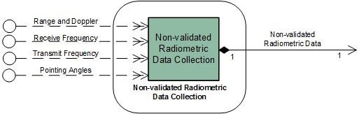

**Figure 8‑17: Member Functional Resource of the Non-validated Radiometric Data Collection** **Functional Resource Stratum**

### Non-validated Radio Metric Data Collection

NOTE - This FR will not be included in the draft Red-0.4 version of this book that will be made available for subject matter expert review.

The functional resource classifier of the Non-validated Radiometric Data Collection FR Type is NonValRmDataCollection.

Non-validated Radiometric Data Collection constitutes the production functions associated with the collection of raw radiometric data during a space link session.

NOTE – The radiometric validation process involves analyst interaction and is therefore not performed during the space link session. The performance of radiometric data validation is outside the scope of SCCS-SM.

#### Relationships with external Functional Resource Sets

To Be Specified.

## Delta-DOR Receiver/Formatter Functional Resource Set of the SLS Radiometric Data Production Functional Resource Stratum

NOTE - This FR Set will not be included in the draft Red-0.4 version of this book that will be made available for subject matter expert review.

The Delta-DOR Receiver/Formatter Functional Resource Set of the SLS Radiometric Data Production Functional Resource stratum consists of the Delta-DOR Raw Data Collection FR. Figure 8‑18 illustrates the member of the Delta-DOR Raw Data Collection Functional Resource Set.

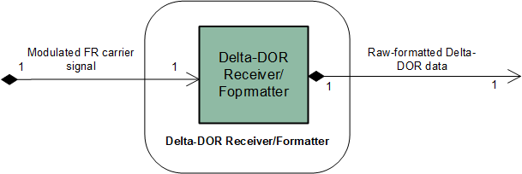

**Figure 8‑18: Member Functional Resource of the Delta-DOR Raw Data Collection** **Functional Resource Set**

### D-DOR Receiver/Formatter

NOTE - This FR will not be included in the draft Red-0.4 version of this book that will be made available for subject matter expert review.

The functional resource classifier of the D-DOR Receiver/Formatter FR Type is DdorRxFormatter.

D-DOR Receiver/Formatter consists of (a) the reception and demodulation of the RF signal carrying the DDOR tones and (b) the production functions associated with collecting the D-DOR raw data samples and organizing them in the standard D-DOR Raw Data file format (reference [32]) for storage.

#### Relationships with external Functional Resource Sets

To Be Specified.

## Open Loop Receiver/Formatter Functional Resource Set of the SLS Radio Metric Data Production Functional Resource Stratum

NOTE - This FR Set will not be included in the draft Red-0.4 version of this book that will be made available for subject matter expert review.

The Open Loop Receiver/Formatter Functional Resource Set of the SLS Radiometric Data Production Functional Resource stratum consists of the Open Loop Receiver/Formatter FR. Figure 8‑19 illustrates the member of the Open Loop Receiver/Formatter Functional Resource Set.

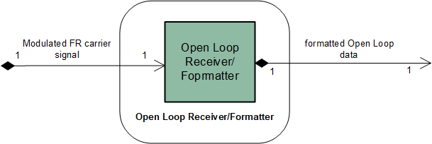

**Figure 8‑19: Member Functional Resources of the Open Loop Receiver/Formatter** **Functional Resource Set**

### Open Loop Receiver/Formatter

NOTE - This FR will not be included in the draft Red-0.4 version of this book that will be made available for subject matter expert review.

The functional resource classifier of the Open Loop Receiver/Formatter FR Type is OpenLoopRxFormatter.

The Open Loop Receiver/Formatterconstitutes the functions performed during the Space Link Session to receive and demodulate the open loop signal of the return link, digitize the signal, and route the resulting data to a specific instance of the Open Loop Data Storetype.

The Open Loop Receiver/FormatterFR corresponds to the Open Loop Receiver/Formattermanaged object to be defined in the *Space Communication Cross Support Service Management – Service Agreement and Configuration Profile Data Formats* Recommended Standard Recommended Standard.

#### Relationships with external Functional Resource Sets

To Be Specified.

# Offline Data Storage Functional Resource Stratum

## General

The Offline Data Storage Functional Resource stratum is the stratum for FR types representing data storage functions that (a) store telemetry received during a Space Link Session for subsequent retrieval via offline or complete data delivery transfer services, and (b) store forward link data for subsequent transmission during a Space Link Session.

The Offline Data Storage Functional Resource stratum has two candidate and six future Functional Resource Sets:

* Offline Frame Buffer (candidate);
* TDM Recording Buffer (candidate);
* Non-validated Radiometric Data Store (future);
* D-DOR Raw Data Store (future);
* Open Loop Data Store (future);
* Validated Radiometric Data Store (future);
* Return File Data Store (future); and
* Forward File Data Store (future).

The Offline Data Storage functional resources are persistent in that they exist outside the lifetimes of the space link services that are executed as part of Space Link Sessions. The individual operational configuration profiles – which are instantiated only for the duration of the time that they are “scheduled” – may include offline data storage FR instances but they cannot control the configuration of such FR instances.

As a practical matter, in most cases the physical resources that realize Offline Data Storage FR instances will reside at individual ESLTs. Each Offline Data Storage FR instance must be mappable to real storage resources in each ESLT that may instantiate that Offline Data Storage FR.

## Offline Frame Buffer Functional Resource Set of the Offline Data Delivery Production Functional Resource Stratum

The Offline Frame Buffer Functional Resource Set of the Offline Data Storage Functional Resource stratum consists of the Offline Frame Buffer FR. Figure 9‑1 illustrates the member of the Offline Frame Buffer Functional Resource Set.

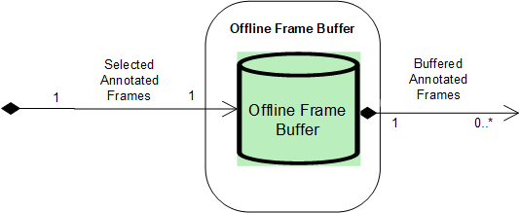

**Figure 9‑1: Member Functional Resource of the Offline Frame Buffer Functional Resource Set**

### Offline Frame Buffer

The functional resource classifier of the Offline Frame Buffer FR Type is OfflineFrameBuffer.

The parameters, events, and directives of this functional resource are registered in the SANA Candidate FR Registry (reference [34]).

The Offline Frame Buffer is a repository of return transfer frames that are subsequently retrieved by offline return SLE transfer service instances that carry transfer frames or space link data units that have been transferred across the space link within those transfer frames.

The Offline Frame Buffer FR corresponds to the Offline Frame Buffer production entity defined in the SLE RAF and RCF Service Specification Recommended Standards.

NOTE – The Offline Frame Buffer for a given physical channel symbol stream may be shared by multiple offline RAF TS and/or Return Channel Frame TS service instances.

#### Service Access Points (SAPs) and Ancillary Interfaces Used by this Functional Resource

##### SAPs Accessed by this Functional Resource

The Offline Frame Buffer FR accesses the Selected Annotated Frames SAP.

##### SAPs Hosted by this Functional Resource

The Frame Data Sink FR has a Buffered Annotated Frames SAP that can be accessed by multiple Accessors.

##### Ancillary Interfaces Required by this Functional Resource

None

##### Ancillary Interfaces Provided by this Functional Resource

None.

## Tracking Data Message (TDM) Recording Buffer Functional Resource Set of the Offline Data Storage Functional Resource Stratum

The TDM Recording Buffer Functional Resource Set of the Offline Data Storage Functional Resource stratum consists of the TDM Recording Buffer FR. Figure 9‑2 illustrates the member of the TDM Recording Buffer Functional Resource Set.

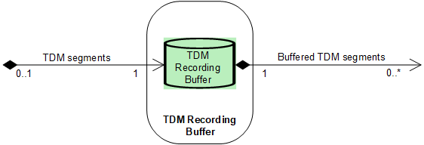

**Figure 9‑2: Internal Composition of the TDM Recording Functional Resource Set**

### TDM Recording Buffer

The functional resource classifier of the TDM Recording Buffer FR Type is TdmRcrdBuffer.

The parameters, events, and directives of this functional resource are registered in the SANA Candidate FR Registry (reference [34]).

The TDM Recording Buffer is a repository of tracking data segments that are subsequently retrieved by Tracking Data CSTS Provider instances operating in the complete data transfer mode (see 10.8).

The TDM Recording Buffer FR corresponds to the Recording Buffer production entity defined in annex F3 of the Tracking Data CSTS Draft Recommended Standard ((reference [8]).

An instance of the TDM Recording Buffer records all TDM Atomic Segments generated by the TDM Segment Generation FR instance (see 8.2.1) with which it is associated. A TDM Recording Buffer instance makes available all TDM Atomic Segments that it retains to any Tracking Data Cross Support Transfer Service (TD-CSTS) Provider FR instance (10.8.1) with which it is associated. Each TD-CSTS Provider FR instance is configured to receive a selection of TDM Atomic Segments for one or more tracking data types. The selection is configured in terms of *tracking data paths* that are created by the TDM Segment Generation FR instance (see 8.2.1) that is the source of TDM Segments for the TDM Recording Buffer.

NOTE – The TDM Recording Buffer retains the tracking data path information associated with the TDM Atomic Segments so that the associated TD-CSTS Provider instances can be configured to retrieve and transfer the desired TDM Atomic Segments.

Each instance of the TDM Recording Buffer has an allocated maximum storage capacity, in megabytes. Each TDM Recording Buffer instance retains all recorded TDM Segments until the maximum storage capacity is reached, at which time Segments are discarded in first-in-first-out (FIFO) order.

#### Service Access Points (SAPs) and Ancillary Interfaces Used by this Functional Resource

##### SAPs Accessed by this Functional Resource

When configured as part of a Space Link Session (SLS) configuration, the TDM Recording Buffer accesses a TDM Segment Generation FR instance (see 8.2.1) via a TDM Segments SAP.

When configured as part of a retrieval configuration, the TDM Recording Buffer can be accessed by multiple Accessors.

##### SAPs Hosted by this Functional Resource

The TDM Recording Buffer FR has a Buffered TDM Segments SAP that can be accessed by multiple TD-CSTS Provider FR instances.

##### Ancillary Interfaces Required by this Functional Resource

None.

##### Ancillary Interfaces Provided by this Functional Resource

None.

## Non-validated radiometric Data Store Functional Resource Set of the Offline Data Storage Functional Resource Stratum

NOTE - This FR Set will not be included in the draft Red-0.4 version of this book that will be made available for subject matter expert review.

The Non-validated Radiometric Data Store Functional Resource Set of the Offline Data Storage Functional Resource stratum consists of the Non-validated Radiometric Data Store FR. Figure 9‑3 illustrates the member of the Non-validated Radiometric Data Store Functional Resource Set.

NOTE – The Non-validated Radiometric Data Store has no SAP, because there is no Functional Resource Set or functional resource that connects to it in any automated way for the purposes of acquiring the contents of the data store. The radiometric data validation process is a manual process that culminates in the creation of a validated radiometric dataset in a validated radiometric data store (see 9.5.19.5).

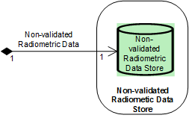

**Figure 9‑3: Member Functional Resource of the Non-validated Radiometric Data Store Functional Resource Set**

### Non-validated Radiometric Data Store

NOTE - This FR will not be included in the draft Red-0.4 version of this book that will be made available for subject matter expert review.

The functional resource classifier of the Non-validated Radiometric Data Store FR Type is NonValRmDataStore.

The Non-validated Radiometric Data Store constitutes a repository of raw radiometric data that is awaiting validation processing.

#### Relationships with external Functional Resource Sets

To Be Specified.

## Validated radiometric Data Store Functional Resource Set of the Offline Data Storage Functional Resource Stratum

NOTE - This FR Set will not be included in the draft Red-0.4 version of this book that will be made available for subject matter expert review.

The Validated Radiometric Data Store Functional Resource Set of the Offline Data Storage Functional Resource stratum consists of the Validated Radiometric Data Store FR. Figure 9‑4 illustrates the member of the Validated Radiometric Data Store Functional Resource Set.

NOTE – The Validated Radiometric Data Store is not an Accessor of any other FR because there is no Functional Resource Set or functional resource that connects to it in any automated way to be the source of the data. The radiometric data validation process is a manual process that transforms non-validated radiometric data (see 9.4) into a validated radiometric dataset.



**Figure 9‑4: Member Functional Resource of the Validated Radiometric Data Store Functional Resource Set**

### Validated Radiometric Data Store

NOTE - This FR will not be included in the draft Red-0.4 version of this book that will be made available for subject matter expert review.

The functional resource classifier of the Validated Radiometric Data Store FR Type is ValRmDataStore.

The Validated Radiometric Data Store constitutes a repository of radiometric data that has undergone validation processing and is awaiting transmission to the file recipient through the Return File interface with the designated Terrestrial File Transfer Service Provider.

#### Relationships with external Functional Resource Sets

To Be Specified.

## D-DOR Raw Data Store Functional Resource Set of the Offline Data Storage Functional Resource Stratum

NOTE - This FR Set will not be included in the draft Red-0.4 version of this book that will be made available for subject matter expert review.

The D-DOR Raw Data Store Functional Resource Set of the Offline Data Storage Functional Resource stratum consists of the D-DOR Raw Data Store FR. Figure 9‑5 illustrates the member of the D-DOR Raw Data Store Functional Resource Set.



**Figure 9‑5: Member Functional Resource of the D-DOR Raw Data Store** **Functional Resource Set**

### D-DOR Raw Data Store

NOTE - This FR will not be included in the draft Red-0.4 version of this book that will be made available for subject matter expert review.

The functional resource classifier of the D-DOR Raw Data Store FR Type is DdorRawDataStore.

The D-DOR Raw Data Store constitutes the repository of D-DOR raw data samples that have been organized in the standard D-DOR Raw Data format. D-DOR raw data is temporarily stored in the D-DOR Raw Data Store until a full file is complete, at which point the file is pushed to the file recipient through the Return File interface with the designated Terrestrial File Transfer Service Provider.

#### Relationships with external Functional Resource Sets

To Be Specified.

## OpeN Loop Data Store Functional Resource Set of the Offline Data Storage Functional Resource Stratum

NOTE - This FR Set will not be included in the draft Red-0.4 version of this book that will be made available for subject matter expert review.

The Open Loop Data Store Functional Resource Set of the Offline Data Storage Functional Resource stratum consists of the Open Loop Data Store FR. Figure 9‑6 illustrates the member of the Open Loop Data Store Functional Resource Set.



**Figure 9‑6: Member Functional Resource of the Open Loop Data Store** **Functional Resource Set**

### Open Loop Data Store

NOTE - This FR will not be included in the draft Red-0.4 version of this book that will be made available for subject matter expert review.

The functional resource classifier of the Open Loop Data Store FR Type is OpenLoopDataStore.

The Open Loop Data Store is a repository of open loop data acquired by an Open Loop Receiver. The format of the open loop data is proprietary to the service provider. Open Loop data is temporarily stored in the Open Loop Data Store until a full file is complete, at which point the file is pushed to the file recipient through the Return File interface with the designated Terrestrial File Transfer Service Provider.

#### Relationships with external Functional Resource Sets

To Be Specified.

## Return File Data Store Functional Resource Set of the Offline Data Storage Functional Resource Stratum

NOTE - This FR Set will not be included in the draft Red-0.4 version of this book that will be made available for subject matter expert review.

The Return File Data Store Functional Resource Set of the Offline Data Storage Functional Resource stratum consists of the Return File Data Store FR. Figure 9‑7 illustrates the member of the Return File Data Store Functional Resource Set.



**Figure 9‑7: Member Functional Resource of the Return File Data Store** **Functional Resource Set**

### Return File Data Store

NOTE - This FR will not be included in the draft Red-0.4 version of this book that will be made available for subject matter expert review.

The functional resource classifier of the Return File Data Store FR Type is RtnFileDataStore.

The Return File Data Store FR corresponds to the functions to be specified in a future Return File Service Specification Recommended Standard.

A Return File is temporarily stored in the Return File Data Store until a full file is complete, at which point the file is pushed to the file recipient through the Return File interface with the designated Terrestrial File Transfer Service Provider.

#### Relationships with external Functional Resource Sets

To Be Specified.

## Forward File Data Store Functional Resource Set of the Offline Data Storage Functional Resource Stratum

NOTE - This FR Set will not be included in the draft Red-0.4 version of this book that will be made available for subject matter expert review.

The Forward File Data Store Functional Resource Set of the Offline Data Storage Functional Resource stratum consists of the Forward File Data Store FR. Figure 9‑8 illustrates the internal composition of the Forward File Data Store Functional Resource Set.



**Figure 9‑8: Member Functional Resource of the Forward File Data Store** **Functional Resource Set**

### Forward File Data Store

NOTE - This FR will not be included in the draft Red-0.4 version of this book that will be made available for subject matter expert review.

The functional resource classifier of the Forward File Data Store FR Type is FwdFileDataStore.

The Forward File Data Store is the repository of space data files that are transmitted across the space link as part for the Forward File Service.

#### Relationships with external Functional Resource Sets

To Be Specified.

# Data Transfer ServiceS Functional Resources Stratum

## General

Data Transfer Services FR stratum has six candidate and two future Functional Resource Sets:

* SLE Forward Space Packet Functional Resource Set (future);
* SLE Forward CLTU Functional Resource Set (candidate);
* Forward Frame CSTS Functional Resource Set (candidate);
* SLE Return All Frames Functional Resource Set (candidate);
* SLE Return Channel Frames Functional Resource Set (candidate);
* SLE Return Operational Control Fields Functional Resource Set (candidate);
* Tracking Data CSTS Functional Resource Set (candidate); and
* Terrestrial Generic File Transfer Host Functional Resource Set (future).

## SLE Forward Space Packet Functional Resource Set of the Data transfer ServiceS Stratum

NOTE - This FR Set will not be included in the draft Red-0.4 version of this book that will be made available for subject matter expert review.

The SLE Forward Space Packet (FSP) Functional Resource Set of the Data Transfer Service Functional Resource stratum consists of the FSP Transfer Service Provider FR. Figure 10‑1 illustrates the member of the SLE Forward Space Packet Functional Resource Set.



**Figure 10‑1: Member Functional Resource of the SLE Forward Space Packet** **Functional Resource Set**

### FSP Transfer Service Provider

NOTE - This FR will not be included in the draft Red-0.4 version of this book that will be made available for subject matter expert review.

The functional resource classifier of the FSP TS Provider FR Type is FspTsProvider.

The FSP TS Provider FR corresponds to the functions specified in the SLE Forward Space Packet Service Specification Recommended Standard (reference [28]).

#### Relationships with external Functional Resource Sets

To Be Specified.

##### Configuration parameters

The configuration parameters of the FSP TS Provider FR are specified in the SANA Functional Resource Registry (reference [34]) under the parameters subtree ({FspTsProvider 1}), where for the configuration parameters the configured attribute = “true”.

##### Read-only parameters

The read-only parameters of the FSP TS Provider FR are specified in the SANA Functional Resource Registry (reference [34]) under the parameters subtree ({FspTsProvider 1}), where for the read-only parameters the configured attribute = “false”.

##### Notification events

The notification events for the FSP TS Provider FR are specified in the SANA Functional Resource Registry (reference [34]) under the events subtree ({FspTsProvider 2}).

##### Directives

The directives for the FSP TS Provider FR are specified in the SANA Functional Resource Registry (reference [34]) under the directives subtree ({FspTsProvider 3})..

## SLE Forward CLTU Functional Resource Set of the Data Transfer ServiceS Stratum

The SLE Forward CLTU Functional Resource Set of the Data Transfer Services Functional Resource stratum consists of the F-CLTU Transfer Service Provider FR. Figure 10‑2 illustrates the member of the SLE Forward CLTU Functional Resource Set.

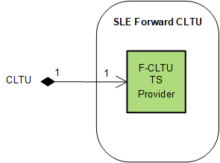

**Figure 10‑2: Member Functional Resource of the SLE Forward CLTU** **Functional Resource Set**

### F-CLTU Transfer Service Provider

The functional resource classifier of the FCLTU TS Provider FR Type is FcltuTsProvider.

The parameters, events, and directives of this functional resource are registered in the SANA Candidate FR Registry (reference [34]).

The FCLTU TS Provider FR corresponds to the functions specified in the SLE Forward CLTU Service Specification Recommended Standard (reference [27]).

#### Service Access Points (SAPs) and Ancillary Interfaces Used by this Functional Resource

##### SAPs Accessed by this Functional Resource

The FCLTU TS Provider FR accesses the CLTU SAP.

##### SAPs Hosted by this Functional Resource

None.

##### Ancillary Interfaces Required by this Functional Resource

None

##### Ancillary Interfaces Provided by this Functional Resource

None.

## Forward Frame CSTS Functional resource Set of the Data Transfer ServiceS Spectrum

The Forward Frame CSTS SC Functional Resource Set of the Data Transfer Services Stratum consists of the Forward Frame CSTS Provider FR. Figure 10‑3 illustrates the functional resource type that constitutes the Forward Frame CSTS Functional Resource Set.

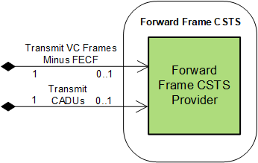

**Figure 10‑3: Member of the Forward Frame CSTS** **Functional Resource Set**

### Forward Frame CSTS Provider

The functional resource classifier of the Forward Frame CSTS Provider FR Type is FwdFrameCstsProvider.

The parameters, events, and directives of this functional resource are registered in the SANA Candidate FR Registry (reference [34]).

The Forward Frame CSTS Provider FR corresponds to the functions specified in the Forward Frame CSTS Specification Recommended Standard (reference [33]).

#### Service Access Points (SAPs) and Ancillary Interfaces Used by this Functional Resource

##### SAPs Accessed by this Functional Resource

In any given operational procedure, the Forward Frame CSTS Provider FR is configured to access one and only one of two SAPs:

1. Transmit VC Frames Minus FECF SAP, when the FR is configured to carry transfer frames; or
2. Transmit CADUs SAP, when the FR is configured to transfer CADUs.

##### SAPs Hosted by this Functional Resource

None.

##### Ancillary Interfaces Required by this Functional Resource

None.

##### Ancillary Interfaces Provided by this Functional Resource

None.

## SLE Return All Frames Functional Resource Set of the Data Transfer ServiceS Functional Resource Stratum

The Return All Frames (RAF) Functional Resource Set of the Data Transfer Service Functional Resource stratum consists of the RAF TS Provider FR. Figure 10‑4 illustrates the member of the Return All Frames Functional Resource Set.

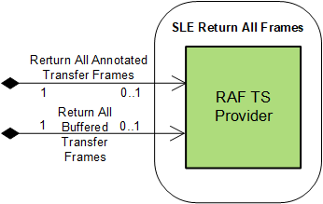

**Figure 10‑4: Member Functional Resource of the Return All Frames Functional Resource Set**

### RAF TS Provider

The functional resource classifier of the RAF TS Provider FR Type is RafTsProvider.

The parameters, events, and directives of this functional resource are registered in the SANA Candidate FR Registry (reference [34]).

The RAF TS Provider FR corresponds to the functions specified in the SLE Return All Frames Service Specification Recommended Standard.

#### Service Access Points (SAPs) and Ancillary Interfaces Used by this Functional Resource

##### SAPs Accessed by this Functional Resource

In any given operational procedure, the RAF TS Provider FR is configured to access one and only one of two SAPs:

1. Return All Annotated Transfer Frames SAP, when the FR is configured to operate in online mode; or
2. Return All Buffered Transfer Frames SAP, when the FR is configured to operate in offline mode.

##### SAPs Hosted by this Functional Resource

None.

##### Ancillary Interfaces Required by this Functional Resource

None.

##### Ancillary Interfaces Provided by this Functional Resource

None.

## SLE Return Channel Frames Functional Resource Set of the Data Transfer ServiceS Functional Resource Stratum

The Return Channel Frames (RCF) Functional Resource Set of the Data Transfer Service Functional Resource stratum consists of the RCF TS Provider FR. Figure 10‑4 illustrates the member of the Return Channel Frames Functional Resource Set.

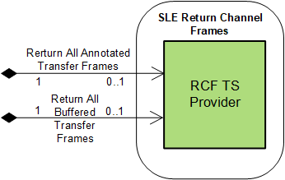

**Figure 10‑5: Member Functional Resource of the Return Channel Frames Functional Resource Set**

### RCF TS Provider

The functional resource classifier of the RCF TS Provider FR Type is RcfTsProvider.

The parameters, events, and directives of this functional resource are registered in the SANA Candidate FR Registry (reference [34]) by 1 January 2020.

The RCF TS Provider FR corresponds to the functions specified in the SLE Return Channel Frames Service Specification Recommended Standard.

#### Service Access Points (SAPs) and Ancillary Interfaces Used by this Functional Resource

##### SAPs Accessed by this Functional Resource

In any given operational procedure, the RCF TS Provider FR is configured to access one and only one of two SAPs:

1. Return All Annotated Transfer Frames SAP, when the FR is configured to operate in online mode; or
2. Return All Buffered Transfer Frames SAP, when the FR is configured to operate in offline mode.

##### SAPs Hosted by this Functional Resource

None.

##### Ancillary Interfaces Required by this Functional Resource

None.

##### Ancillary Interfaces Provided by this Functional Resource

None.

## SLE Return Operational Control Fields Functional Resource Set of the Data Transfer Services Functional Resource Stratum

The Return Operational Control Fields (ROCF) Functional Resource Set of the Data Transfer Services Functional Resource stratum consists of the ROCF Transfer Service Provider FR. Figure 10‑6 illustrates the member of the Return Operational Control Fields

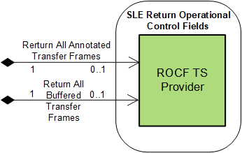

**Figure 10‑6: Member Functional Resource of the Return Operational Control Fields Functional Resource Set**

### ROCF Transfer Service Provider

The functional resource classifier of the ROCF TS Provider FR Type is RocfTsProvider.

The parameters, events, and directives of this functional resource are registered in the SANA CandidateFR Registry (reference [34]).

The ROCF TS Provider FR corresponds to the functions specified in the SLE Return Operational Control Fields Service Specification Recommended Standard (reference [29]), with one exception. Reference [29] models the production process that supports the offline delivery mode of the ROCF service as comprising an *OCF Buffer* that contains OCFs that have been extracted and stored from transfer frames. In contrast, the ROCF TS Provider FR assumes that the data retrieved by the service instance are transfer frames from the Offline Frame Buffer (9.2.1). This approach is consistent with the known current implementations of the offline mode of the ROCF service, and has advantages over an OCF-only buffering schem in that it allows the ROCF service to share the sameframe buffer as that being used by RAF (**Error! Reference source not found.**) and RCF (10.6.1) service instances.

#### Service Access Points (SAPs) and Ancillary Interfaces Used by this Functional Resource

##### SAPs Accessed by this Functional Resource

In any given operational procedure, the RCF TS Provider FR is configured to access one and only one of two SAPs:

1. Return All Annotated Transfer Frames SAP, when the FR is configured to operate in online mode; or
2. Return All Buffered Transfer Frames SAP, when the FR is configured to operate in offline mode.

##### SAPs Hosted by this Functional Resource

None.

##### Ancillary Interfaces Required by this Functional Resource

None.

##### Ancillary Interfaces Provided by this Functional Resource

None.

## Tracking Data CSTS Functional Resource Set of the Data Transfer Services Functional Resource Stratum

The Tracking Data CSTS Functional Resource Set of the Data Transfer Services Functional Resource stratum consists of the Tracking Data CSTS Provider FR. Figure 10‑7 illustrates the member of the Tracking Data CSTS Functional Resource Set.

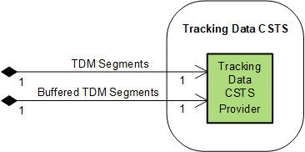

**Figure 10‑7: Member Functional Resource of the Tracking Data CSTS Functional Resource Set**

### Tracking Data CSTS Provider

The functional resource classifier of the Tracking Data CSTS Provider FR Type is TdCstsProvider.

The parameters, events, and directives of this functional resource are registered in the SANA CandidateFR Registry (reference [34]).

The Tracking Data CSTS Provider FR corresponds to the functions specified in the Tracking Data CSTS Draft Recommended Standard (reference [8]).

NOTE – The TD-CSTS provides the IOAG Real-Time Data Radiometric service. In addition to delivering radiometric data in “real time” (that is, during the execution of the SLS), the TD-CSTS may also be used to deliver tracking data after the conclusion of the SLS. However, the tracking data measurements will have been sampled at a defined rate.

#### Service Access Points (SAPs) and Ancillary Interfaces Used by this Functional Resource

##### SAPs Accessed by this Functional Resource

When configured to operate in real-time data delivery mode (see reference [8]) the Tracking Data CSTS Provider accesses the TDM Segments SAP of a TDM Segment Generation FR instance (see 8.2.1).

When configured to operate in complete data delivery mode (see reference [8]) the Tracking Data CSTS Provider accesses the Buffered TDM Segments SAP of a TDM Recording Buffer FR instance (see 9.3).

##### SAPs Hosted by this Functional Resource

None.

##### Ancillary Interfaces Required by this Functional Resource

None.

##### Ancillary Interfaces Provided by this Functional Resource

None.

## Terrestrial Generic File Transfer (TGFT) Host Functional Resource Set of the Data Transfer ServiceS Functional Resource Stratum

NOTE - This FR Set will not be included in the draft Red-0.4 version of this book that will be made available for subject matter expert review.

The Terrestrial Generic File Transfer (TGFT) Host Functional Resource Set of the Data Transfer Services Functional Resource stratum consists of the TGFT Host FR. Figure 10‑8 illustrates the member of the TGFT Host Functional Resource Set.

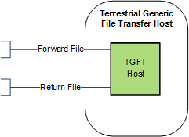

**Figure 10‑8: Member Functional Resource of the TGFT Host Functional Resource Set**

### TGFT Host

NOTE - This FR will not be included in the draft Red-0.4 version of this book that will be made available for subject matter expert review.

The functional resource classifier of the Terrestrial Generic File Transfer Host FR Type is TgftHost.

The TGFT Host FR corresponds to the functions to be specified in the *Terrestrial Generic File Transfer* draft Recommended Standard (reference [37]).

#### Relationships with external Functional Resource Sets

To Be Specified.

# Service Management Functions Functional Resource Stratum

## General

The Service Management Functions Functional Resource stratum has one candidate and one future Functional Resource Sets:

* Monitored Data (candidate); and
* Service Control (future).

## Monitored Data Functional Resource Set of the Service Management Funcitons Functional Resource Stratum

The FR that comprises the Monitored Data Functional Resource Set of the Service Management Functions Functional Resource stratum is the Monitored Data CSTS Provider FR.

Figure 11‑1 illustrates the member of the Monitored Data Functional Resource Set.

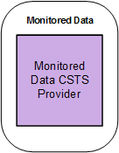

**Figure 11‑1: Member Functional Resource of the Monitored Data Functional Resource Set**

### Monitored Data CSTS Provider

The functional resource classifier of the Monitored Data CSTS Provider FR Type is MdCstsProvider.

The parameters, events, and directives of this functional resource are registered in the SANA Candidate FR Registry (reference [34]).

The Monitored Data CSTS Provider FR corresponds to the functions specified in the Monitored CSTS Recommended Standard (reference [10]).

#### Relationships with external Functional Resource Sets

The Monitored Data CSTS Provider FR has read-access to all available parameter values and notification events of all FR instances that execute in the same Service Package as that which contains the instance(s) of the Monitored Data CSTS Provider FR (where by “available” is meant the subset of parameters and events that are published in the Service Agreement under which the Service Package is defined). As such, the Monitored Data CSTS Provider FR does not access any specific SAP.

NOTE – There is some consideration being given to establishing an FR type to represent the Service Package itself. If such an FR is created, it could have a Monitored Data SAP that is accessed by one or more instances of the Monitored Data CSTS Provider FR.

## Service Control Functional Resource Set of the Service Management Functions Functional Resource Stratum

NOTE - This FR Set will not be included in the draft Red-0.4 version of this book that will be made available for subject matter expert review.

The FRs that comprise the Service Control Functional Resource Set of the Service Management Functions Functional Resource stratum are:

1. Service Control CSTS Provider FR; and
2. Service Control Production.

Figure 11‑2 illustrates the internal composition of the Service Control Functional Resource Set.



**Figure 11‑2: Member Functional Resources of the Service Control Functional Resource Set**

### Service Control CSTS Provider

NOTE - This FR will not be included in the draft Red-0.4 version of this book that will be made available for subject matter expert review.

The functional resource classifier of the Service Control CSTS Provider FR Type is scCstsProvider.

The Service Control CSTS Provider FR corresponds to the service provision functions to be specified in a future Service Control CSTS Specification Recommended Standard.

##### Relationships with external Functional Resource Sets

To Be Specified.

### Service Control Production

NOTE - This FR will not be included in the draft Red-0.4 version of this book that will be made available for subject matter expert review.

The functional resource classifier of the Service Control Production FR Type is serviceControlProduction.

The Service Control Production FR corresponds to the service production functions to be specified in a future Service Control CSTS Specification Recommended Standard.

#### Relationships with external Functional Resource Sets

To Be Specified.

# Space Internetworking Functional Resource Stratum

## General

There are currently no candidate or approved CCSDS-standard Functional Resource Sets (or Functional Resource types) defined for the Space Internetworking Functional Resource stratum.

A future Functional Resource Set for this stratum is the Delay Tolerant Networking (DTN) Functional Resource Set.

### Delay Tolerant Networking Functional Resource Set Of the Space Internetworking Functional Resource Stratum (Candidate)

NOTE - This FR Set will not be included in the draft Red-0.4 version of this book that will be made available for subject matter expert review.

The DTN Functional Resource Set of the Space Internetworking Functional Resource startum consists of the following (candidate) functional resources:

* Licklider Transfer Protocol; and
* Bundle Protocol Agent.

The DTN Functional Resource Set will be explored and (as appropriate) developed in future versions of this Functional Resource Model.

NOTE – This candidate Functional Resource Set is not included in Figure 2‑3.

1. Object Identifier Offsets for the Functional Resource Strata and Functional Resource Sets

The OIDs of the Functional Resources are organized according to a scheme in which the OIDs are assigned based on the Functional Resource strata of the FRs. In this scheme, the strata are assigned” OID offsets” beginning with 10000 for the Aperture stratum and incrementing by 10000 for every stratum. Wtihin a given stratum, each FR Set is given an OID offset beginning with 100 and incrementing by 100 for each FR Set within the stratum. The OID Offset for a given FR Set is allocated to the root FR of that FR Set, and if there is more than one FR in the FR Set, each subsequent FR in the FR Set is allocated the next OID value, incrementing by 1. The FR Model Editor allows the offset to be entered for the FR Set, and the Editor automatically assigns the OIDs to the member FRs.

This allocation scheme allows for up to 99 FR Sets within each stratum, and 100 FRs within each FR Set. The OID Offset allocation is as follows:

**10000 – Aperture FR stratum**

10100 – RF Aperture

10200 – [next Aperture FR Set]

**20000 – Physical Channel FR stratum**

20100 – CCSDS 401 Physical Channel Transmission

20200 – CCSDS 415 Physical Channel Transmission

20300 – CCSDS 401 Physical Channel Reception

20400 – CCSDS 415 Physical Channel Reception

20500 – [next Physical Channel FR Set]

**30000 – Sync and Channel Coding FR stratum**

30100 – TC Sync and Channel Coding

30200 – FLF Sync, Channel Encoding, and OID Generation

30300 – FLF Syn and Channel Decoding

30400 – [next Sync and Channel Coding FR Set]

**40000 – Space Link Protocol FR stratum**

40100 – TC Space link Protocol Transmission

40200 – AOS Space link Protocol Transmission

40300 – VLF Unified Space link Protocol Transmission

40400 – FLF Unified Space link Protocol Transmission

40500 – TM/AOS Space link Protocol Reception

40600 – VLF Unified Space link Protocol Reception

40700 – FLF Unified Space link Protocol Reception

40800 – [next Space Link Protocol FR Set]

**50000 – SLS Data Delivery Production FR stratum**

50100 – Frame Data Sink

50200 – CFDP File Data Production

50300 – Packets File Data Transmission Production

50400 – Packets File Data Reception Production

50500 – [next SLS Data Delivery Production FR Set]

**60000 – SLS Radiometric Data Production FR stratum**

60100 – TDM Segment Generation

60200 – Non-validated RM Data Collection

60300 – Delta-DOR Raw Data Collection

60400 – Open Loop Receiver/Formatter

60500 – [next TDM Segment Generation FR Set]

**70000 – Offline Data Storage FR stratum**

70100 – Offline Frame Buffer

70200 – TDM Recording Buffer

70300 – Non-validated RM Data Store

70400 – Validated RM Data Store

70500 – Delta-DOR Raw Dara Store

70600 – Open Loop Data Store

70700 – Return File Data Store

70800 – Forward File Data Store

70900 – [next Offline Data Storage FR Set]

**80000 – Data Transfer Services FR stratum**

80100 – SLE FSP

80200 – SLE Forward CLTU

80300 – FF-CSTS

80400 – SLE RAF

80500 – SLE RCF

80600 – SLE ROCF

80700 – TD-CSTS

80800 – TGFT Host

80900 – [next Data Transfer Services FR Set]

**90000 – Service Management Functions FR stratum**

90100 – MD-CSTS

90200 – SC-CSTS

90300 – [next Service Management Functions FR Set]

**100000 – Space Internetworking FR stratum**

100100 – DTN

100200 – [next Space Internetworking FR Set]

1. Security, SANA, and Patent Considerations  
     
   (informative)
   * 1. Security Considerations With respect to this Recommended Practice

This Recommended Practice does not directly address security considerations. Instead, ecurity considerations, if any, are addressed by (a) the CCSDS Recommended Standards and other standards that specify the functionality represented by the Functional Resources defined in this Functional Resource Model Recommended Practice, and/or (b) the CCSDS Recommended Standards that make use of the Functional Resources defined in this Functional Resource Model.

* + 1. SANA Considerations With respect to this Recommended Practice

This Recommended Practice identifies the CCSDS Functional Resources, defines them at the top level, and defines their interactions. The detailed definitions of the paramters, event, and directives for each of these Functional Resources is defined in the SANA Approved Functional Recource registry at <https://sanaregistry.org/r/functional_resources> (reference [34]).

* + 1. Patent Considerations With respect to this Recommended Practice

This Recommended Practice does not in itself have any patent considerations. However, there may be patent considerations with respect to the individual CCSDS Recommended Standards and other standards that specify the functionality represented by the Functional Resources defined in this Functional Resource Model. When considering implementing any of the Functional Resources defined in this Recommended Practice, the reader is referred to the Patent Consideration annex of the respective source Recommended Standard(s).

1. Acronyms

|  |  |
| --- | --- |
| AD | Acceptance check and Data [frames, see reference [21]] |
| AOS | Advanced Orbiting System |
| ASM | attached synchronization marker |
| ASN.1 | Abstract Syntax Notation One |
| AZEL | azimuth/elevation |
| BC | Bypass of acceptance check and Control [frames, see reference [21]] |
| BCH | Bose–Chaudhuri–Hocquenghem |
| CADU | channel access data unit |
| CCSDS | Consultative Committee for Space Data Systems |
| CDMA | code division multiple access |
| CFDP | CCSDS File Delivery Protocol |
| CLCW | communications link control word |
| CLTU | communication link transmission unit |
| CM | configuration management |
| COP | Communications Operation Procedure |
| CSSS | Cross Support Service System |
| CSTS | Cross Support Transfer Service |
| DOR | Differential One-way Ranging |
| DSN | Deep Space Network |
| DTN | Delay-Tolerant Network |
| DVB-S2 | Digital Video Broadcasting - Satellite - Second Generation |
| ECSS | European Cooperation for Space Standardization |
| EM | element management |
| ESLT | earth space link terminal |
| ETSI | European Telecommunications Standards Institute |
| FCLTU | forward communication link transmission unit |
| FECF | frame error control field |
| FF | Forward Frame [CSTS] |
| FIFO | first-in-first-out |
| FLF | fixed length frame |
| FOP | Frame Operation Procedure |
| FR | functional resource |
| FSH | Frame Secondary Header |
| FSP | Forward Space Packet |
| GMSK | Gaussian Minimum Shift Keying |
| GVCID | global virtual channel identifier |
| ID | identifier |
| IF | intermediate frequency |
| IOAG | Interagency Operations Advisory Group |
| IP | Internet Protocol |
| ISO | International Organization for Standardization |
| LDPC | low density parity check |
| MAP | Multiplexer Access Point |
| MC | master channel |
| MCID | master channel identifier |
| MD | Monitored Data [CSTS] |
| MIB | management information base |
| MODCOD | modulation and coding [DVB-S2] |
| MUE | mission user entity |
| NE | near earth |
| NGU | Next Generation Uplink |
| OCF | Operational Control Field |
| OID | only idle data |
| OPT | optical |
| OSI | Open System Interconnection |
| PDU | protocol data unit |
| PED | parameter, event, directive |
| PLOP | physical layer operations procedure |
| PM | provision management |
| PN | pseudo-noise |
| QPSK | Quadrature Phase Shift Keying |
| RADEC | Right Ascension and Declination |
| RAF | Return All Frames [SLE transfer service] |
| RCF | Return Channel Frames [SLE transfer service] |
| RF | radio frequency |
| RM | radiometric |
| ROCF | Return Operational Control Field [SLE transfer service] |
| SANA | Space Assigned Numbers Authority |
| SAP | service access point |
| SC[-CSTS] | service control [CSTS] |
| SCCC | Serially Concatenated Convolutional turbo Coding |
| SCCS | Space Communication[s] Cross Support |
| SCID | spacecraft identifier |
| SDLP | space data link protocol |
| SDLS | space data link security |
| SDU | service data unit |
| SFW | [CSTS] Specification Framework |
| SLE | Space Link Extension |
| SL-PDU | Space link protocol data unit |
| SLS | Space Link Session |
| SM | Service management |
| SMTF | Sync-Marked Transfer Frame |
| SNMP | Simple Network Management Protocol |
| TC | telecommand |
| TCP | transmission control protocol |
| TD[-CSTS] | Tracking Data [CSTS] |
| TDM | Traccking Data Message |
| TFVN | Transfer Frame Version Number |
| TGFT | Terttestrial Generic File Transfer |
| TM | telemetry |
| UM | utilization management |
| UML | Unified Modeling Language |
| USLP | Unified Space Data Link Protocol |
| VC | virtual channel |
| VCA | Virtual Channel Access |
| VCID | virtual channel identifier |
| VLF | variable length frame |
| XFDU | XML-Formatted Data Unit |
| XML | eXtensible Markup Language |

1. Identified Future Functional Resource Sets  
     
   [Informative]

This section lists future candidate Functional Resource Sets that have been identied as of this time, with emphasis on relevance to IOAG Service Catalog #1 and ESLTs. FR Sets associated with Space Internetworking and other services in IOAG Service Catalogs #2 and #3 will be addressed in more detail in future issues of this Recommended Practice.

* + 1. Future Candidate FR Sets by FR Strata
    2. Aperture FR Stratum
* Antenna Array (no CCSDS Recommended Standard);
* Optical Aperture (no CCSDS Recommended Standard)?.
  + 1. Physical Channel FR Stratum
* CCSDS 415 Physical Channel Transmission Functional Resource Set;
* CCSDS 415 Physical Channel Reception Functional Resource Set;
* CCSDS 131.2 SCCC Functional Resource Set(s);
* CCSDS 131.3 DVB-S2 Functional Resource Set(s);
* CCSDS 141.0 Optical Communications Physical Channel Transmission Functional Resource Set;
* CCSDS 141.0 Optical Communications Physical Channel Reception Functional Resource Set.
  + 1. Synchronization and Channel Coding FR Stratum
* CCSDS 131.2 (SCCC) Functional Resource Set(s)?;
* CCSDS 131.3 (DVB-S2 Functional Resource Set(s)?;
* CCSDS 142.0 Optical Communications Encoding and Synchronization Functional Resource Set;
* CCSDS 142.0 Optical Communications Decoding and Synchronization Functional Resource Set.
  + 1. Space Link Protocol FR Stratum
* TC Space Link Protocol Transmission Functional Resource Set (complete the remaining FRs);
* TC Space Link Protocol Transmission Functional Resource Set (complete the remaining FRs);
* Variable Length Frame (VLF) Unified Space Data Link Protocol Transmission Functional Resource Set;
* Fixed Length Frame (FLF) Unified Space Data Link Protocol Transmission Functional Resource Set (complete the remaining FRs);
* TM/AOS Space Link Protocol Reception Functional Resource Set (complete the reemaioning FRs);
* VLF Unified Space Data Link Protocol Reception Functional Resource Set;
* FLF Unified Space Data Link Protocol Reception Functional Resource Set.
  + 1. SLS Data Delivery Production FR Stratum
* CFDP File Data Production Functional Resource Set (complete the remaining FRs);
* Packets File Data Transmission Production Functional Resource Set;
* Packets File Data Reception Production Functional Resource Set.
  + 1. SLS Radiometric Data Production FR Stratum
* Non-Validated Radiometric Data Collection Functional Resource Set;
* Delta-DOR Raw Data Collection Functional Resource Set;
* Open Loop Receiver/Formatter Functional Resource Set.
  + 1. Offline Data Storage FR Stratum
* Non-validated Radiometric Data Store Functional Resource Set;
* Delta-DOR Raw Data Store Functional Resource Set;
* Open Loop Data Store Functional Resource Set Functional Resource Set;
* Validated Radiometric Data Store Functional Resource Set;
* Return File Data Store Functional Resource Set;
* Forward File Data Store Functional Resource Set.
  + 1. Service Management Functions FR Stratum
* Service Control Functional Resource Set.
  + 1. Space Internetworking Functions FR Stratum
* Delay Tolerant Networking Functional Resource Set(s);
* Internet Protocol Suite Functional Resource Set(s).
  + 1. Existing Recommendations
    2. 131.2-B-1 Flexible Advanced Coding and Modulation Scheme for High Rate Telemetry Applications

Defines both physical channel and synch & coding layers, return only. Compatible with TM, AOS transfer frames.

* + 1. 131.3-B-1 Space Link Protocols over ETSI DVB-S2 Standard

Defines both physical channel and synch & coding layers as a profile of DVB-S2, return only. Compatible with TM, AOS transfer frames. Minimal managed parameters since many of the details are covered by the single “MODCOD” parameter which selects a modulation and coding combination.

Both 131.2 and 131.3 seem most likely to be combined with a 401 forward physical channel. They both seem unlikely to carry return ranging symbols (tbc by SLS experts?) but presumably could still be used to obtain antenna angles and one-way Doppler.

* + 1. Recommendations in Progress
    2. Optical Communication (SLS-OPT)

Expects to define both physical and synch and coding layers, in separate BBs (currently listed for 2017). Two “regimes” are foreseen (low and high photon flux). Not clear to me how different they may look in terms of managed parameters. Both forward and return seem to be expected; forward 401 RF and return optical also seems a plausible combination. Expected to be compatible with AOS and TM data link protocols.

There may also be a Blue or Magenta Book(s) for Real-Time Weather and Atmospheric Characterization Data – not clear whether this represents a candidate for Service Management or not, nor what it would look like if it is.

* + 1. Next Generation Uplink NGU (SLS-NGU)

Green Book 230.2-G Next Generation Uplink is apparently awaiting publication. BB currently slated for 2017.

This seems to be largely concerned with sync and coding and selection of bandwidth-efficient modulation schemes, to be compatible with TC, forward AOS, or both. Not clear whether a single spec like ACM (what is this?), or additions to 401 and a synch & coding book, are anticipated.

* + 1. Updates to currently covered recommendations
* SLS-CS WG selecting new codes for TC uplink to upgrade 231.0-B (TC Coding).
* SLS-CS WG will start draft pink sheets to 131.0-B (TM Coding) for Fall 2014 to introduce slicing
* Will SDLS have impact on TM/TC/AOS SDLP management – BBs will be updated?
  + 1. Non-CCSDS/De Facto standards
    2. Antenna array
    3. Summary

The table shows which new FR Set we might reasonably expect to appear from each of the current and potential future recommendations.

| **FR** | **Aperture** | **Forward** | | | **Return** | | |
| --- | --- | --- | --- | --- | --- | --- | --- |
| **Recom.** | **Physical** | **Code&Sync** | **SDLP** | **Physical** | **Code&Sync** | **SDLP** |
| **131.2** |  |  |  |  | Y | Y |  |
| **131.3** |  |  |  |  | Y | Y |  |
| **Optical** | Y | Y | Y |  | Y | Y |  |
| **NGU** |  | ? | Y |  |  |  |  |

* + 1. Figures containing all FR Sets addressed in this White Book

**NOTE - This section will not be included in the Red or Pink Book versions of this document.**

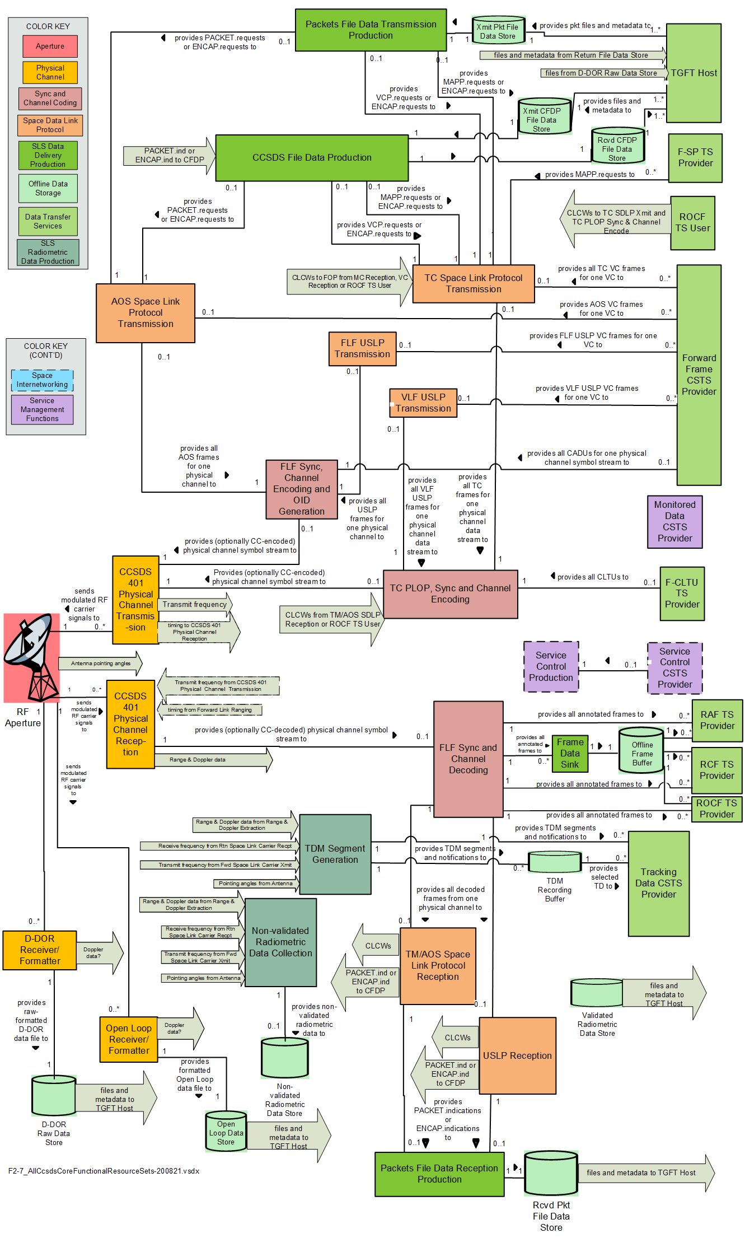

Figure D‑ : Functional Resource Set Connectivity



Figure ‑ : Functional Resources Sets within the Strata

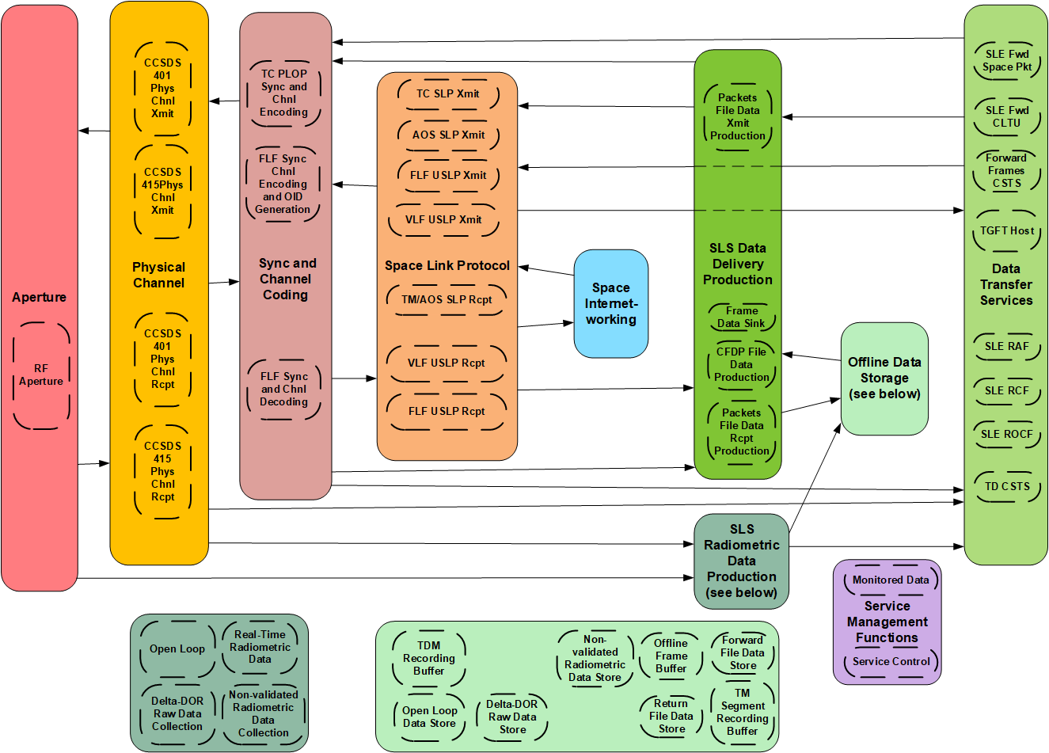

Figure ‑ : Functional Resource Strata Used in SLS Configurations

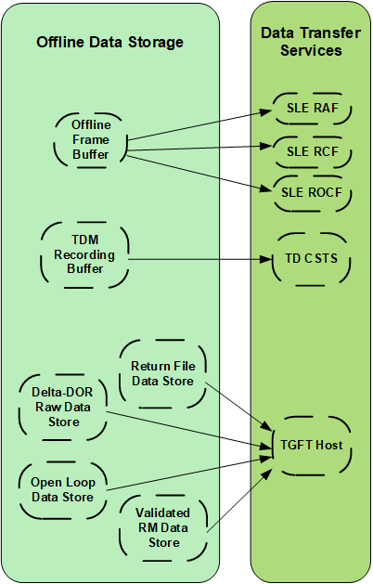

Figure ‑ : Functional Resource Strata Used in Retrieval Configurations



Figure ‑ : Functional Resource Strata Used in Forward Offline Data Delivery Configurations

1. Color Key for Functional Resource Strata (TO BE DELETED FROM RED, PINK, AND BLUE BOOKS)

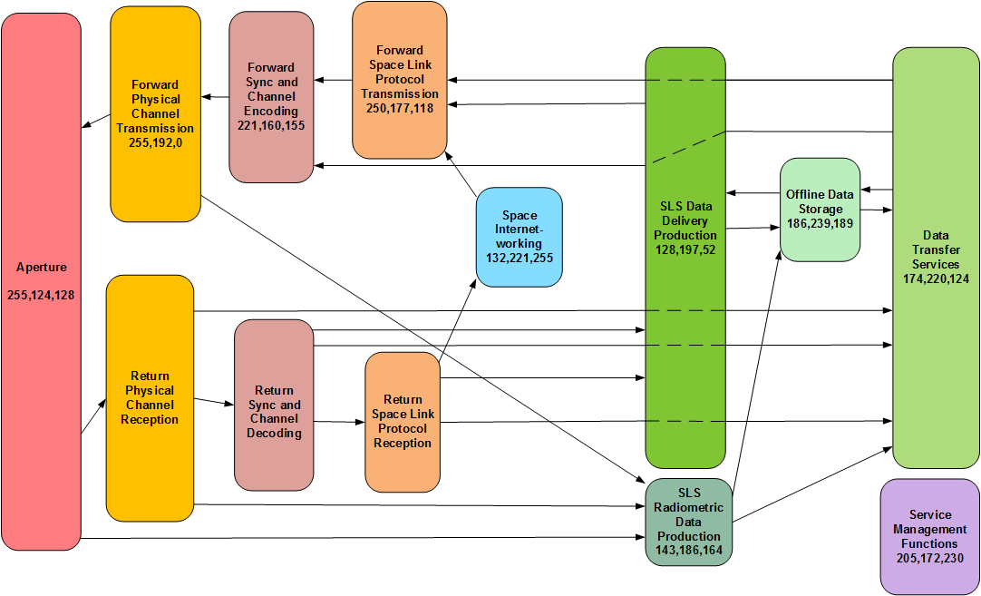

1. Reference Bookmarks (to be deleted FROM RED, PINK, AND BLUE BOOKS)

[1] nRef_910x4_CSRM

[2] nRef_911x1RAF

[3] nRef_911x2_RCF

[4] nRef_921x1CstsSFW

[5] nRef_231x0_TC_SCC

[6] nRef_131x0_TmSync

[7] nRef_905x5_SimpleConfigProfiles

[8] nRef_922x2_TD_CSTS

[9] nRef_IOAG1

[10] nRef_922x1_MD_CSTS

[11] nRef_DoatTN

[12] nRef_902x0_ESCCS_SM

[13] nRef_901x0_SCCS_ADD

[14] nRef_910x11_SCCS_SM

[15] nRef_902x_SCCS_SM_SA_CP

[16] nRef_IOAG_SC2

[17] nRef_232x0_TC_SDLP

[18] nRef_732x0_AOS_SDLP

[19] nRef_132x0_TM_SDLP

[20] nRef_133x0_SPP

[21] nRef_232x1_COP_1

[22] nRef_133x1_Encap

[23] nRef_401_RF_Mod

[24] nRef_414x1_PN_ranging

[25] nRef_415x1_CDMA

[26] nRef_727x0_CFDP

[27] nRef_912x1_CLTU

[28] nRef_912x3_FSP

[29] nRef_911x5_ROCF

[30] nRef_734x0_DTN

[31] nRef_702x1_IP_Over_CCSDS

[32] nRef_506x1_DDOR_Fmt

[33] nRef_922x3_FF_CSTS

[34] R_SANA_FR_Registry

[35] nRef_732x1_USLDP

[36] nRef503x0_TDM

[37] nRef927x1_TGFT

[38] nRef902x4_SPDF

1. One aspect of the semantics of UML composition that does not fit our service management usage is that, strictly speaking, a functional resource class is not actually composed of the FR classes “below” it. For our purposes we conveniently ignore this aspect.
2. This definition is a paraphrase of the TDM (reference [36]) definition of carrier power, adjusted for the context of the ESLT and cross support services terminology.