

|  |
| --- |
| Shared Space Link Protocol Functional Resources for Forward AOS and Fixed-Length USLP |

White Paper

CONTENTS

Section Page

CONTENTS i

1 Introduction 1-1

1.1 Purpose OF THIS REPORT 1-1

1.2 Document Organization 1-1

1.3 References 1-1

2 AOS and USLP Sending End procedures 2-1

2.1 AOS Sending End as it applies to the ESLT 2-1

2.2 USLP Sending End as it applies to the ESLT 2-2

2.3 cOMPARISON OF THE AOS and USLP eslt Sending End procedures 2-5

3 ManAged Parameters of AOS and USLP SPace Data Link Protocols 3-1

4 proposed Definitions of Fixed-length-frame functional resources 4-1

Figure Page

**Figure 2‑1: Internal Organization of the AOS SDLP Protocol Entity (Sending End)** 2-1

**Figure 2‑2: Internal Organization of the AOS SDLP Protocol Entity (ESLT Sending End)** 2-2

**Figure 2‑3: Internal Organization of the USLP Protocol Entity (Sending End)** 2-3

**Figure 2‑4: Internal Organization of the USLP Protocol Entity (ESLT Sending End)** 2-4

**Figure 2‑5: SDLP FR Groups Supporting Forward AOS, TC, and USLP** 2-6

**Figure 2‑6: Alternative SDLP FR Groups Supporting Forward AOS, TC, and USLP** 2-7

Table Page

3-1 Modified/Additional/ Configuration Parameters of the Forward TC PLOP, Synchronization and Channel Encoding Functional Resource 3-1

# Introduction

## Purpose OF THIS REPORT

This White Paper documents the analysis of the feasibility and desirability of creating common space data link protocol Functional Resources that can support both AOS and fixed-length-frame USLP transfer frames.

## Scope

Although USLP has a “fixed-length frame” capability, the aggregate functionality resembles TC quite a bit more than it does AOS. Indeed, simply trying to cleanly separate USLP into “fixed-length frame” and “variable-length frame” capabilities is overly simplistic and misleading. A more-precise distinction is whether the frames are to be transmitted *contiguously* (back-to-back) or *discontiguously*. Contiguously-transmitted frames must also be fixed-length to allow for the insertion of OID frames. Discontiguously-transmitted frames are considered to be variable-length but there is actually nothing to stop them from all being the same length on the same physical channel. The discriminating factor is whether the SDLP sits on what this White Paper calls a *contiguous sync and channel coding sublayer* (currently one of the TM (reference [6]), SCCC, or DVB-S2 coding sublayer) or a *discontiguous sync and channel coding sublayer* (currently only the TC coding sublayer (reference ([5]).

The USLP Blue Book (reference [35]) effectively defines “fixed length frame” to be “fixed length frame over a contiguous sync and channel coding sublayer”: 4.2.9.4 of reference [35] states

“When the MC Managed Parameter ‘Transfer Frame Type’ equals ‘Fixed Length’, the MC Multiplexing Function shall create an OID Transfer Frame to preserve the continuity of the transmitted stream in the event that there are no valid Transfer Frames available for transmission at a release time.”

Since the OID Transfer Frames are used **only** on contiguous links, USLP in effect defined the “Fixed Length” frame type to use a contiguous coding layer. This white paper is consistent with that interpretation: the only aspects of USLP that are considered herein for combination with AOS SDLP functionality are those that are relevant when the underlying coding layer is contiguous**.**

## Background

The current version of the Functional Resource Reference Model (<https://cwe.ccsds.org/css/docs/CSS%20Area/CWE%20Private/Functional%20Resource%20Reference%20Model%20Tech%20Note/FunctionalResourcesRefModel_TechNote-TN-0.15.docx?Web=1>) has placeholders for forward link USLP functions resources (FRs) in addition to already-developed sets of FRs for forward AOS and TC space data link protocols (SDLPs). USLP is intended to provide the functionality of AOS and TC and provide additional functionality, supporting but fixed-length frames (similar to AOS) and variable-length frames (similar to TC). As an alternative to developing the third, USLP-only set of FRs, It might be possible to support USLP by essentially expanding the functionality of the existing Forward AOS FR Set to support fixed-length USLP frames, and the existing (forward TC FR Set to support variable-length USLP frames. The two resulting FR Sets could be named something like “Forward Fixed Length Frame (FLF) SDLP” and “Forward Variable Length Frame (VLF) SDLP”, respectively. This white paper explores the fixed-length frame aspects of this inquiry. A similar effort is underway regarding the variable length frame aspects.

## Document Organization

Section 2 summarizes the procedures of the AOS and USLP sending end, and tailors those functions for applicability for use on the forward link. A preliminary allocation to FRs is identified, along with an alternative allocation.

Section 3 lists the managed parameters of the AOS and Unified space data link protocol layers, and provides a side-by-side comparison of the two sets of parameters.

Section 4 provides a more-detailed, layer-by layer comparison and contrast between AOS and USLP on the ESLT Sending End.

Section 5 documents proposed definitions of a set of fixed-length-frame functional resources and allocates managed parameters to them. This section is still TBD.

## References

This section contains the documents that are referenced in this White Paper. Note that there are also documents listed below that are not referenced by the White Paper, but they have not been removed to expedite the production of this White Paper.

[1] *Cross Support Reference Model—Part 1: Space Link Extension Services*. Recommendation for Space Data System Standards, CCSDS 910.4-B-2. Blue Book. Issue 2. Washington, D.C.: CCSDS, October 2005.

[2] *Space Link Extension—Return All Frames Service Specification*. Recommendation for Space Data System Standards, CCSDS 911.1-B-4. Blue Book. Issue 4. Washington, D.C.: CCSDS, August 2016.

[3] *Space Link Extension—Return Channel Frames Service Specification*. Recommendation for Space Data System Standards, CCSDS 911.2-B-3. Blue Book. Issue 3. Washington, D.C.: CCSDS, August 2016.

[4] *Cross Support Transfer Service - Specification Framework*, Recommendation for Space Data System Standards, CCSDS 921.1-B-1. Blue Book. Issue 1. Washington, D.C.: CCSDS, April 2017.

[5] *TC Synchronization and Channel Coding*. Recommendation for Space Data System Standards, CCSDS 231.0-B-3. Blue Book. Issue 3. Washington, D.C.: CCSDS, September 2017.

[6] *TM Synchronization and Channel Coding*. Recommendation for Space Data System Standards, CCSDS 131.0-B-3. Blue Book. Issue 3. Washington, D.C.: CCSDS, September 2017.

[7] *Requirements for Simple Configuration Profiles and Service Agreements*. Cross Support Services Area Draft Technical Note. CSSA 905.5-TN-1.1. February 2018.

[8] *Cross Support Transfer Services - Tracking Data Service*. Draft Recommendation for Space Data System Standards, CCSDS 922.2-R-1. August 2017.

[9] *IOAG Service Catalog #1*. Issue 2, Revision 1. Interagency Operations Advisory Group. February 2017.

[10] *Cross Support Transfer Services- Monitored Data Service*. Recommendation for Space Data System Standards, CCSDS 922.1-B-1. Issue 3. Washington, D.C.: CCSDS, April 2017.

[11] Doat, Yves, “Operational Scenario Implementation”, CSTSWG technical note. 20 May 2012.

[12] *Extensible Space Communication Cross Support Service Management Concept*. Informational Report. CCSDS-902.0-G-1. Green Book. Issue 1. Washington, D.C.: CCSDS, November 2013.

[13] *Space Communications Cross Support Architecture Description Document*. Report Concerning Space Data System Standards, CCSDS 901.0-G-1. Green Book. Issue 1. Washington, D.C.: CCSDS, November 2013.

[14] *Space Communication Cross Support - Service Management – Service Specification*. Recommendation for Space Data System Standards, CCSDS 910.11-B-1. Blue Book. Issue 1. Washington, D.C.: CCSDS, September 2009.

[15] *Space Communication Cross Support Service Management – Service Agreement and Configuration Profile Data Formats*. Future Recommended Standard.

[16] *IOAG Service Catalog #2*. Issue 1, Revision 2. Interagency Operations Advisory Group. January 2018.

[17] *TC Space Data Link Protocol*. Recommendation for Space Data System Standards, CCSDS 232.0-B-3. Blue Book. Issue 3. Washington, D.C.: CCSDS, September 2015.

[18] *AOS Space Data Link Protocol*. Recommendation for Space Data System Standards, CCSDS 732.0-B-2. Blue Book. Issue 3. Washington, D.C.: CCSDS, September 2015.

[19] *TM Space Data Link Protocol*. Recommendation for Space Data System Standards, CCSDS 132.0-B-2. Blue Book. Issue 2. Washington, D.C.: CCSDS, September 2015.

[20] *Space Packet Protocol*. Recommendation for Space Data System Standards, CCSDS 133.0-B-1. Blue Book. Issue 1. Washington, D.C.: CCSDS, September 2003 (includes updates through Technical Corrigendum 2, dated September 2012).

[21]*Communications Operation Procedure-1*. Recommendation for Space Data System Standards, CCSDS 232.1-B-2. Blue Book. Issue 2. Washington, D.C.: CCSDS, September 2010.

[22] *Encapsulation Service*. Recommendation for Space Data System Standards, CCSDS 133.1-B-2. Blue Book. Issue 2. Washington, D.C.: CCSDS, October 2009 (Cor. 2 April 2014).

[23] *Radio Frequency and Modulation Systems—Part 1: Earth Stations and Spacecraft*. Recommendation for Space Data System Standards, CCSDS 401.0-B-28. Blue Book. Issue 28. Washington, D.C.: CCSDS, February 2018.

[24] *Pseudo-Noise (PN) Ranging Systems*. Recommendation for Space Data System Standards, CCSDS 414.1-B-2. Blue Book. Issue 2. Washington, D.C.: CCSDS, February 2014.

[25] *Data Transmission and PN Ranging for 2 GHz CDMA Link via Data Relay Satellite*. Recommendation for Space Data System Standards, CCSDS 415.1-B-1. Blue Book. Issue 1. Washington, D.C.: CCSDS, September 2011.

[26] *CCSDS File Delivery Protocol (CFDP)*. Recommendation for Space Data System Standards, CCSDS 727.0-B-4. Blue Book. Issue 4. Washington, D.C.: CCSDS, January 2007.

[27] *Space Link Extension—Forward CLTU Service Specification*. Recommendation for Space Data System Standards, CCSDS 912.1-B-4. Blue Book. Issue 4. Washington, D.C.: CCSDS, August 2016.

[28] *Space Link Extension—Forward Space Packet Service Specification* Recommendation for Space Data System Standards, CCSDS 912.3-B-3. Blue Book. Issue 3. Washington, D.C.: CCSDS, August 2016.

[29] *Space Link Extension—Return Operational Control Fields Service Specification*. Recommendation for Space Data System Standards, CCSDS 911.5-B-3. Blue Book. Issue 3. Washington, D.C.: CCSDS, Augsut 2016.

[30] *Rationale, Scenarios, and Requirements for DTN in Space*. Report Concerning Space Data System Standards, CCSDS 734.0-G-1. Green Book. Issue 1. Washington, D.C.: CCSDS, August 2010.

[31] *IP Over CCSDS Space Links*. Recommendation for Space Data System Standards, CCSDS 702.1-B-1. Blue Book. Issue 1. Washington, D.C.: CCSDS, September 2012.

[32] *Delta-DOR Raw Data Exchange Format*. Recommendation for Space Data System Standards, CCSDS 506.1-B-1. Blue Book. Issue 1. Washington, D.C.: CCSDS, June 2013.

[33] *Cross Support Transfer Services – Forward Frame Service*. Draft Recommendation for Space Data System Standards, CCSDS 922.3-W-0.7. White Book. Issue 0.9. Washington, D.C.: CCSDS, March 2018.

[34] “Functional Resources.” Space Assigned Number Authority. <https://sanaregistry.org/r/functional_resources>.

[35] *Unified Space Data Link Protocol*. Draft Recommendation for Space Data System Standards, CCSDS 732.1-B-1. Blue Book. Issue 1. Washington, D.C.: CCSDS, October 2018.

[36] *Tracking Data Message*. Recommendation for Space Data System Standards, CCSDS 503.0-P-1.1. Pink Book. Issue 1. Washington, D.C.: CCSDS, May 2018.

# AOS and USLP Sending End procedures

## AOS Sending End as it applies to the ESLT

Figure 2‑1 is a copy of figure 4-7, Internal Organization of the Protocol Entity (Sending End), from the AOS SDLP Recommended Standard (reference [18]).

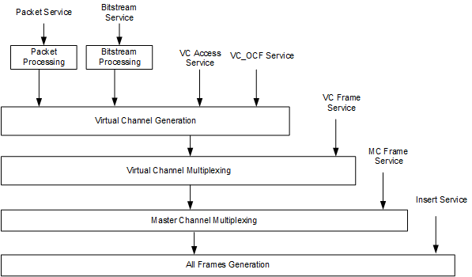

**Figure 2‑1: Internal Organization of the AOS SDLP Protocol Entity (Sending End)**

This diagram shows the protocol sending end procedures that apply to both the ESLT (i.e., on the forward link) and the Space User Node (i.e., on the return link). When we confine our interests to the forward link, several of the advertised services drop out:

1. The Bitstream and VC Access services are not used in the current FR Reference Model by higher-layer entities within the ESLT, nor are they accessible by external users via SLE or CSTS services.
2. The VC_OCF service is intended for use only on the return link.
3. The MC Frame service are not used in the current FR Reference Model by any entity within the ESLT other than the VC Multiplexing procedure, nor is it accessible by external users via SLE or CSTS services.
4. The Insert Service is not used by any of the FRs in the FR Reference Model, nor is it accessible by external users via SLE or CSTS services. Note that the 20190415 XML FRM does contain an insertZoneLength parameter even there is currently no way for Insert Zones to appear in the model other than to be already embedded within CADUs that are received via the FF-CSTS and passed directly to the Forward Fixed Length Frame Sync, Channel Encoding, and OID Generation FR that underlies the SDLP FRs. For this iteration of this Working Paper, it is assumed that the Insert service is not supported by CCSDS-standard ESLTs.

Figure 2‑2 is the simplified AOS Protocol Entity diagram when the sending end is the ESLT.

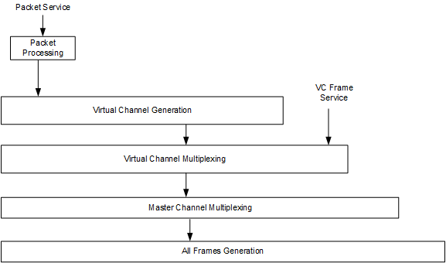

**Figure 2‑2: Internal Organization of the AOS SDLP Protocol Entity (ESLT Sending End)**

The mapping of these procedures to FRs in the current FR reference model are as follows:

* The Forward AOS Encap, Pkt Processing & VC Generation FR performs the functionality of the Packet Processing and VC Generation functions of the AOS SDLP Recommended Standard. (It also includes the functionality of the Encapsulation function of the Encapsulation Recommended Standard (reference [22]) and the Packet Transfer function of the Space Packet Protocol Recommended Standard (reference [20]).
* The Forward AOS VC Mux FR performs the functionality of the VC Multiplexing function of the AOS SDLP Recommended Standard.
* The Forward AOS MC Mux FR performs the functionality of the MC Multiplexing and All Frames Generation functions of the AOS SDLP Recommended Standard.

## USLP Sending End as it applies to the ESLT

Figure 2‑3 is a copy of figure 4-6, Internal Organization of the Protocol Entity (Sending End), from the USLP Recommended Standard (reference [35]).

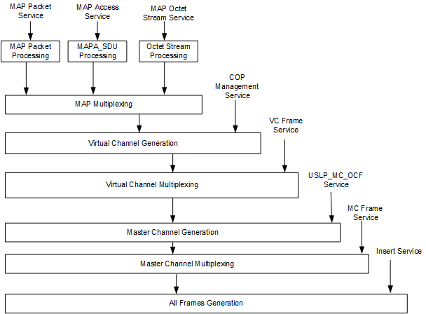

**Figure 2‑3: Internal Organization of the USLP Protocol Entity (Sending End)**

As with the AOS SDLP, this diagram shows the protocol sending end procedures that apply to both the ESLT (i.e., on the forward link) and the Space User Node (i.e., on the return link). When we confine our interests to the forward link, several of the advertised services are also affected:

1. There is currently no cross support transfer service by which Packets can be transferred into the ESLT for transfer over USLP links. The SLE Forward Space Packet Service is currently confined to operate over the TC SDLP. However, the USLP “interface” for packets is quite similar to that of TC SDLP protocol so the SLE FSP standard could probably be updated to work with USLP with minimal problems. Also, the MAP Packet service can also be expected to carry CFDP_PDUs.
2. The MAP Access and MAP Octet Stream services are not used in the current FR Reference Model by higher-layer entities within the ESLT, nor are they accessible by external users via SLE or CSTS services.
3. The USLP_MC_OCF service would be used if the COP is executed on the return link – that is, if the FOP is executed by the Space User Node. If so, then an appropriate return SDLP would have to perform the FARM – that is, extract the CLCWs and supply them to this “service” of the forward link. Alternatively, the FARM could be performed by the Earth User Node, in which case a new Forward OCF CSTS would have to be created. Such a Forward OCF CSTS could also be used for non-CLCW purposes. However, recent correspondence with the CCSDS Space Link Services (SLS) Area indicates that there are no known use cases for using COP on the return link. Therefore the current working assumption is that ESLTs will not need to provide the MC_OCF service on USLP forward links.
4. The MC Frame service are not used in the current FR Reference Model by any entity within the ESLT other than the VC Multiplexing procedure, nor is it accessible by external users via SLE or CSTS services.
5. The Insert Service is not used by any of the FRs in the FR Reference Model, nor is it accessible by external users via SLE or CSTS services. Note that the 20190415 XML FRM does contain an insertZoneLength parameter even there is currently no way for Insert Zones to appear in the model other than to be already embedded within CADUs that are received via the FF-CSTS and passed directly to the Forward Fixed Length Frame Sync, Channel Encoding, and OID Generation FR that underlies the SDLP FRs. For this iteration of this Working Paper, it is assumed that the Insert service is not supported by CCSDS-standard ESLTs.

Figure 2‑4 is the simplified USLP Protocol Entity diagram when the sending end is the ESLT. The USLP_MC_OCF service is indicated by a dashed line because whether it needs to be supported in the first release of the FR Reference Model and XML FRM is TBD.

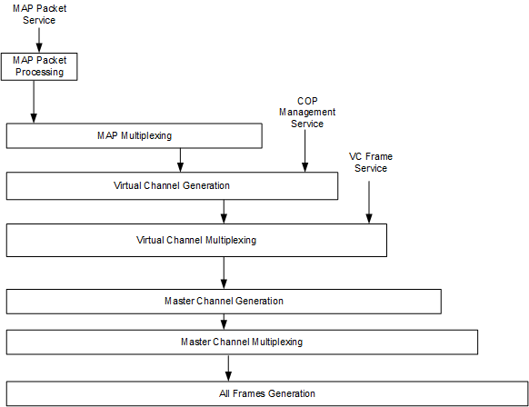

**Figure 2‑4: Internal Organization of the USLP Protocol Entity (ESLT Sending End)**

The preliminary mappings of these procedures to FRs in the current FR reference model are as follows:

* There is no mapping of the MAP Packet Processing, MAP Multiplexing, and VC Generation functions of the USLP Recommended Standard.
* The Forward USLP VC Mux FR performs the functionality of the VC Multiplexing function of the USLP Recommended Standard.
* The Forward USLP MC Mux FR performs the functionality of the MC Multiplexing and All Frames Generation functions of the USLP Recommended Standard.
* There is no FR that explicitly performs the functionality of the MC Generation function of the USLP Recommended Standard. The purpose of the USLP MC Generation function is to insert OCFs from the USLP_MC_OCF service into the frames. In the AOS protocol stack, the VC_OCF insertion function is performed by the VC Multiplexing function and by the Forward AOS VC Mux FR. If the USLP_MC_OCF service needs to be supported, it could be performed by the Forward USLP MC Mux FR

Of course, the purpose of this analysis is to determine whether this preliminary mapping to USLP-specific FRs is desirable, or if the fixed-length-frame USLP functions could/should be performed by FRs that are shared with AOS.

## Top-level cOMPARISON OF THE AOS and USLP eslt Sending End procedures

At the top-level of comparison between Figure 2‑2 and Figure 2‑4, several things stand out:

1. Packets in AOS are multiplexed directly into transfer Frames, whereas in USLP they are first organized by MAP;
2. The USLP VC Generation function has the added responsibility for (optionally) executing the FOP using COP directives acquired through the COP Management Service; and
3. USLP provides the USLP_MC_OCF service on the sending end that is not present (nor needed) in AOS.

Although it is not directly evident from the diagrams, it also seems that there is a difference between to the top and bottom portions of the USLP stack. The top of the stack (VC Generation and up) of the USLP stack appear to be almost identical to that of the TC stack, whereas (at least upon initial impression) the bottom parts of both the USLP and AOS stacks (VC Multiplexing and below) appear to be very similar for fixed length frames.

Therefore, the focus of this White Paper will be on the feasibility and desirability of using common FRs to perform the fixed-length-frame VC Multiplexing, MC Generation, MC Multiplexing, and All Frames Generation functions of both the AOS and USLP protocol stacks.

Different sets of FRs will be used for the AOS and USLP VC Generation functions and above.

Ideally, it will be possible to combine the upper USLP and TC functions in a way that allows those functions to be used to generate both fixed and variable-length frames.

Figure 2‑5 is an initial allocation of AOS, TC, and USLP SDLP functionality to the four groups of FRs that would result: AOS-only (light blue), the MAP/”Controlled” VC FRs (rose – shared by TC and USLP), the fixed-length frame (FLF) FRs (green – shared by AOS and FLF USLP) and the variable-length FRs (yellow – shared by TC and VLF USLP).

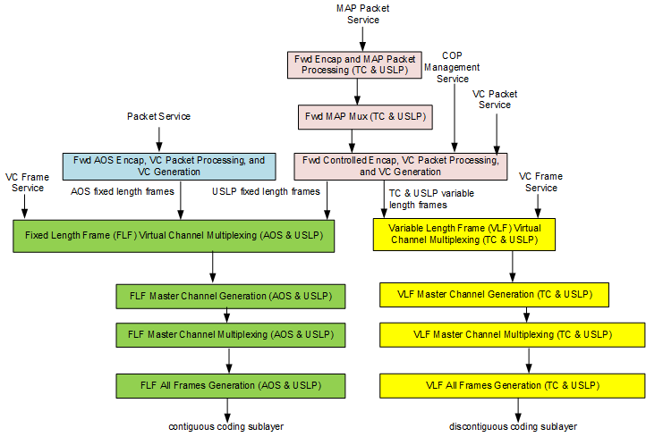

**Figure 2‑5: SDLP FR Groups Supporting Forward AOS, TC, and USLP**

Alternatively, it might be possible/desirable to make a more-complicated Fwd Encap, VC Packet Processing, and VC Generation that could support all 3 SLDPs. The result would look something like AA, where the color code would now be that the blue FR is shared by all packets destined for any of the SDLPs – AOS, TC, and USLP.

NOTE - Adopting either of these re-allocations of FRs may result in a tuning of the concept of FR Sets, which currently aligns an FR Set with a full FR Stratum. In this case, we have multiple FR “Subsets” that within the Space Link Protocol stratum that can be mixed and matched. It shouldn’t be too hard to extend the FR Ref Model to include this notion of FR Subsets, but it hasn’t been done yet.

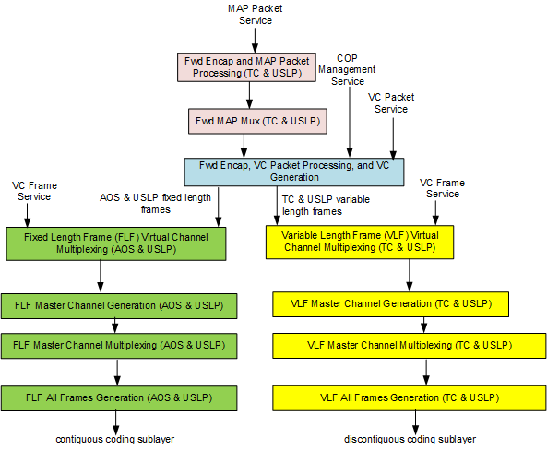

**Figure 2‑6: Alternative SDLP FR Groups Supporting Forward AOS, TC, and USLP**

# ManAged Parameters of AOS and USLP SPace Data Link Protocols

Table 3‑1 contains the managed parameters of the AOS and Unified space data link protocols. The parameters are arranged side-by-side to facilitate comparison and contrast. Notes are included.

Some parameters may be Not Applicable (N/A) to an SDLP for one of several reasons: it is N/A to the SDLP in all cases because it only applies to the “other” SDLP; it is N/A to the SDLP on the forward link; or it is N/A to the SDLP on a forward link radiated by an ESLT. The table identifies these different flavors of non-applicability.

Table 3‑1 : Managed Parameters of the AOS and Unified Space Data Link Protocols

| **Parameter Category** | **Managed Parameter** | **AOS Allowed Values** | **USLP Allowed Values** | **Notes** |
| --- | --- | --- | --- | --- |
| Physical Channel | Physical Channel Name | Character String | Character String |  |
| Physical Channel | Transfer Frame Type | Fixed only | set to Fixed |  |
| Physical Channel | Transfer Frame Length (octets) | Integer (range?) | Integer (range?) |  |
| Physical Channel | TFVN | '01' binary | '1100' binary |  |
| Physical Channel | Valid Spacecraft IDs | Set of Integers | N/A |  |
| Physical Channel | MC Multiplexing Scheme | Mission Specific | Mission Specific | Both can use our 3 schemes (priority, polling, fifo) |
| Physical Channel | Presence of Frame Header Error Control | Present, Absent | N/A |  |
| Physical Channel | Presencs of Insert Zone | Present, Absent | Present, Absent |  |
| Physical Channel | Inserr Zone Length (octets) | Integer (range?) | Integer (range?) |  |
| Physical Channel | Presence of Frame Error Control | Present, Absent | Present, Absent |  |
| Physical Channel | Frame Error Control Length (octets) | NA (only 2 is valid) | 2 or 4 |  |
| Physical Channel | Generate OID Frames | N/A | T, F | AOS BB always assumes this to be true, but when AOS is operating over Forward FLF Sync, Channel Encoding and OID Generation it will effectively be false |
| Physical Channel | Max # of TFs Given to the Coding and Sync Sublayer as a Single Data Unit | N/A | N/A for fixed frames |  |
| Physical Channel | Max Value of the Repetitions Parameter | N/A | N/A for fixed frames |  |
|  |  |  |  |  |
| Master Channel | Transfer Frame Type | Fixed only | set to fixed |  |
| Master Channel | Spacecraft ID | Integer (range?) | 16-bit Integer |  |
| Master Channel | Valid VCIDs | Set of Integers 0-62 with 63 reserved | Set of Integers 0-62 with 63 reserved |  |
| Master Channel | VC Multiplexing Scheme | Mission Specific | Mission Specific | Both can use our 3 schemes (priority, polling, fifo) |
|  |  |  |  |  |
| Virtual Channel | Transfer Frame Type | Fixed only | set to Fixed |  |
| Virtual Channel | Spacecraft ID | Integer | Not specified in list of managed parameters for VC |  |
| Virtual Channel | VCID | One of 0-62 | One of 0-62 | Stating that 63 is reserved is meaningless in this definition |
| Virtual Channel | Data Field Content | M_PDU, B-PDU, VCA-SDU, Idle Data (for ESLT limited to M_PDU) | N/A | For USLP the multiplexing is done at the MAP Channel (see MAP Channel: SDU Type below) |
| Virtual Channel | Presence of VC_OCF | N/A for forward link | N/A (USLP doesn’t have VC_OCF service) |  |
| Virtual Channel | VC Count Length for Sequence Control QoS | N/A | Integer (max 56-bit) |  |
| Virtual Channel | VC Count Length for Expedited QoS | N/A | Integer (max 56-bit) |  |
|  |  |  |  |  |
| Virtual Channel | COP in Effect | N/A | COP-1, None | COP-P N/A for ESLT |
| Virtual Channel | CLCW Version Number | N/A | N/A for ESLT forward link | ULSP specifies "1", but it is not a managed parameter if there is only one value |
| Virtual Channel | CLCW Reporting Rate | N/A | N/A for ESLT forward link |  |
| Virtual Channel | MAP IDs | N/A | Integer [0..15] |  |
| Virtual Channel | MAP Mux Scheme | N/A | “Mission Specific” | Propose that our 3 schemes (priority, polling, fifo) be used |
| Virtual Channel | Truncated TF Frame Length | N/A | Integer | Not clear what this parameter value should be if the USLP non-truncated TF is used |
| Virtual Channel | Inclusion of OCF Allowed (var length frames only) | N/A | N/A for fixed length frames |  |
| Virtual Channel | Inclusion of OCF Required (fixed length frames only) | N/A | N/A for ESLT forward link |  |
| Virtual Channel | Value of Repetitions Parameter for Frames Carrying data on the Sequence-Controlled Service | N/A | N/A for fixed frames |  |
| Virtual Channel | Value of Repetitions Parameter for Frames Carrying COP Control Commands | N/A | N/A for fixed frames |  |
| Virtual Channel | Maximum delay in milliseconds for a TFDF to be completed, once started, before it must be released | Not specified | Integer (note 4 - "used within the MAPP, MAPA, and MAP Octet Stream Services" | Should this (or some form of it) apply to AOS to release fill packets? |
| Virtual Channel | Maximum delay in milliseconds between releases of Frames of the same VC | Not specified | Integer |  |
|  |  |  |  |  |
| MAP Channel | MAP ID | N/A | One of [0..15] |  |
| MAP Channel | SDU Type | N/A | CCSDS Packet, MAPA_SDU, Octet Stream Data (for ESLT, limited to CCSDS Packet) | For AOS the multiplexing is done at the VC (see Virtual Channel: Data Field Content above) |
| MAP Channel | UPID Supported (see CCSDS | N/A | Integer (range?) |  |
|  |  |  |  |  |
| Packet Transfer | Valid Packet Version Numbers | Set of Integers (range?) | Set of Integers (range?) |  |
| Packet Transfer | Max Packet Length (octets) | Integer (range?) | Integer (range?) |  |
| Packet Transfer | Incomplete packet delivery required | N/A for forward link | N/A for forward link |  |

# Detailed Comparison of AOS and USLP VC Generation, VC Multiplexing, MC Generation, MC Multiplexing, and All Frames Generation ESLT Sending End functions

The following comparisons are made between the nominally-common sending-end functions of the AOS and Unified SDLPs, as they apply to the ESLT. As described in 2.2 and 2.3 and illustrated by figures 2-2 and 2-4, these functions are modified subsets of the full functions defined in the AOS and Unified SDLP specifications.

The USLP MAP Packet Processing and MAP Multiplexing functions of SLP are not addressed in this section, because that are assumed to be performed by FRs that are common to USLP and TC, as described in 2.4.

## Virtual Channel Generation function

The functional similarities shared by the AOS and USLP VC Generation functions are:

1. Executes the (Transfer) Frame Generation procedures, which generates fixed-length transfer frames carrying the specified payload (M_PDUs for AOS, TFDFs for USLP) with the Transfer Frame Header information for the designated VCs. Up to 32 VCs are available per Spacecraft ID.

The functional differences between the AOS and USLP VC Generation functions are:

1. The AOS TF Primary Header supports up to 256 SCIDs; USLP supports up to 65,536 SCIDs.
2. The USLP TF Primary Header carries the Source or Destination ID (flag) to identify whether the SCID refers to the source or destination of the transfer frames; AOS assumes that there is only one SC involved (the other end of the link being an ESLT).
3. The USLP TF Primary Header carries the MAP ID; AOS does not support MAP and has no such header field.
4. The AOS TF Primary Header optionally contains a Frame Header Error Control field; USLP provides no such option.
5. The AOS TF Primary Header supports VC Frame Counts up to 28 bits in length; USLP supports VC Frame Counts up to 56 bits in length.
6. The USLP VC Generation function also executes the Frame Operation Procedure (FOP), which accepts COP Directives, sets the Bypass/Sequence Control Flag in the TF Primary Header, and retransmits frames as in response to information contained in CLCWs. The AOS VC Generation function has no equivalent functionality (i.e., all VCs are essentially in Bypass mode).
7. Although they do not apply to ESLTs for reasons discussed in 2.1 and 2.2, in general the AOS VC Generation function alternatively multiplexes Bitstream PDUs or VCA_SDUs, and optionally multiplexes OCF_SDUs into M_PDUs, B_PDUs, or VCA_SDUs; and in general the USLP VC Generation function alternatively multiplexes Bitstream PDUs or VCA_SDUs, and optionally multiplexes OCF_SDUs into M_PDUs, B_PDUs, or VCA_SDUs. The rough USLP equivalent of the B_PDU is the Octet Stream and the equivalent of the VCA_SDU is the MAPA_SDU, both of which are created by the USLP MAP Multiplexing function.

NOTES

1. The AOS TF Primary Header contains a Replay Flag that is only applicable to return link frames and is therefore always set to ‘0’ (Realtime transfer frame ) on the forward link.
2. The USLP TF Primary Header may be truncated for fixed-length frames that have no OCF of FECF fields. **Note that the truncated header also has neither the Bypass/Sequence Control Flag nor the Protocol Control Command Flag. Presumably this means that the truncated header can only be used for frames that are to be treated as Expedited, but the USLP specification does not explicitly state that.**

Comment: Given that the USLP VC Generation functionality more closely represents that of TC VC Generation than AOS VC Generation, it might be better to combine the TC and USLP VC Generation functionality into the same FR even for fixed-length USLP frames, and leave the simpler AOS VC Generation functionality as a stand-alone FR.

## Virtual Channel Multiplexing function

The functional similarities shared by the AOS and USLP VC Multiplexing functions are:

1. Both AOS and USLP VC Multiplexing functions multiplex transfer frames from different VCs into their common MC.
2. The sources of the VCs can be a combination of the corresponding VC Generation function and one or more instances of a “VC Frame Service” [Note that the FF -CSTS accesses both SDLPs through their respective VC Frame Services.]
3. The definition of multiplexing schemes is deferred to “project organizations” in both SDLP specifications.

NOTE - Although the Blue Books defer definition, for cross-support purposes three standard multiplexing schemes have been defined for VCs that are used by the FSP SLE TS and Forward Frame CSTS: absolute priority, polling vector, and FIFO. The expectation is that these same schemes will be available for cross support of USLP.

The functional differences between the AOS and USLP VC Generation functions are:

1. As formally defined in the Blue Book, “if there is only one Master Channel on the Physical Channel”, the AOS VC Multiplexing function creates Only Idle Data (OID) Frames “to preserve the continuity of the transmitted stream in the even that there are no valid Transfer Frames available for transmission at release time.” However, this capability is redundant with the OID Frame creation capability of the AOS MC Multiplexing function and is therefore unnecessary.

NOTE - This redundancy was identified in an earlier review of a USLP Red Book does and was removed from USLP: OID Frame creation is now strictly the purview of the USLP MC Multiplexing function. OID Frame creation should be removed from the AOS VC Multiplexing function in the next update of that Blue Book.

## Master Channel Generation function (USLP only)

The MC Master Channel function exists only in USLP. Its sole purpose is to insert MC_OCF_SDUs into transfer frames on the MC. For fixed-length frames, if any frames on the MC contain OCFs then all frames (for all VCs) must contain OCFs. (For variable-length frames OCFs may be allowed but not required. The author of this White Paper has not (yet) investigated exactly what this means).

For AOS this would be a “null” layer.

## Master Channel Multiplexing function

The functional similarities shared by the AOS and USLP MC Multiplexing functions are:

1. Multiplex the Master Channel Frames from multiple MCs into a single Physical Channel. For AOS, the MCs are supplied by one or more instances of the VC Multiplexing function. For USLP, the MCs are supplied by one or more instances of the MC Generation function. Although neither the AOS nor USLP MC Frame service is supported by ESLTs, in general the AOS and Unified SDLP MC Multiplexing functions also support multiplexing of the frames from MCs via instances of the respective MC Frame services.
2. For AOS and fixed-length USLP frames, the MC Multiplexing Function creates an OID Transfer Frame to preserve the continuity of the transmitted stream in the event that there are no valid Transfer Frames available for transmission at a release time.

There are no functional differences between AOS and USLP MC Multiplexing functions in the processing of fixed-length frames.

## All Frames Generation function

The functional similarities shared by the AOS and USLP All Frames Generation functions are:

1. If optional Frame Error Control is present, check bits are generated and inserted into the Trailer of every transfer frame on the Physical Channel.
2. Although not used in ESLTs, if the optional Insert Service is used, IN_SDUs into all frames on the Physical Channel.

The functional differences between the AOS and USLP All Frames Generation functions are:

1. If optional Frame Error Control is present, for AOS it is always a 2-octet field, but for USLP it is either a 2-octet or 4-octet field (as configured by Service Management).
2. If the AOS frames have the optional Frame Header Error Control field, the AOS All Frames Generation function generates these values. USLP frames have. no Frame Header Error Control field

# proposed Definitions of Fixed-length-frame functional resources

To Be Written