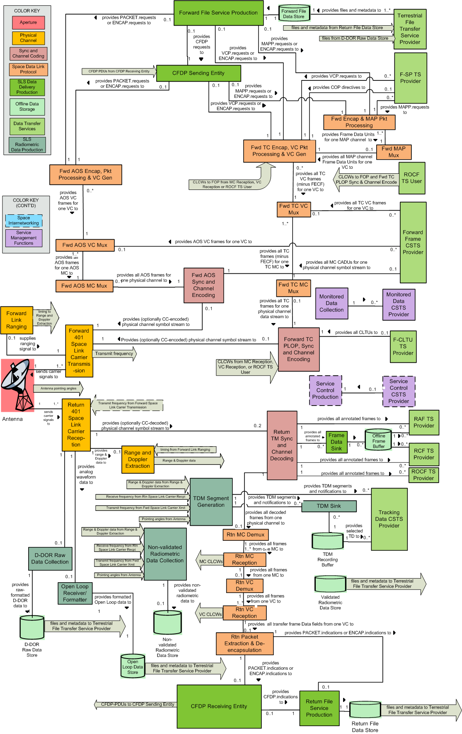
All CCSDS Core Functional Resource Types - 8 November 2017

