meeting date | 07-09 November 2017 | ref./réf. | CSTS-WG-091117 |  |  | page/page | 1
date de la réunion |  |  |  |  |  |  | 8
meetingplace | Den Hague / Netherlands |  |  | chairman | M. di Giulio (ESA, margherita.di.giulio@esa.int)
lieu de la réunion |  |  |  | président

minute’s date dates de minute | 09 November 2017 | participants participants | W. Hell (ESA, wo_._he@t-online.de)  S. Gully (DLR, Part-time, via webex) (sylvain.gully@dlr.de)  F. Lassere (CNES),  J. Pietras (NASA / GTS),  R. Neutze (NASA-MFSC robert.l.neutze@nasa.gov)  T. Pham (JPL/NASA, timothy.t.pham@jpl.nasa.gov)  J. Liao (JPL/NASA, Part-time, via webex) (jliao@jpl.nasa.gov)  H. Dreihahn (ESA, Holger.Dreihahn@esa.int)

subject/objet | CSTS Working Group-  2017 Fall Meeting | copy/copie | CCSDS CSTS Working Group Members

Description/description | action/action | Due date/date limite
NOTE:
All actions are recorded with an “A” in the MoM.
The “Workplan” (Chapter 11) identifies the responsible WG member for each product/activity.
Table Of Contents

1 Fall Meetings Agenda 3
2 Review of Workplan from Spring Meeting 2017 4
3 Forward Frame CSTS 4
4 Functional Resources Technical Note and FR Model. 5
5 FR/P/D/E OIDs and their Registration at SANA 5
6 CSTS Specification Framework CCSDS 921.1 6
7 Concept Book 6
8 Guidelines 6
9 Monitored Data CSTS 6
10 Tracking Data CSTS – CCSDS-922.2 6
11 Workplan 7
12 Schedule of Teleconferences 7

Fall Meetings Agenda

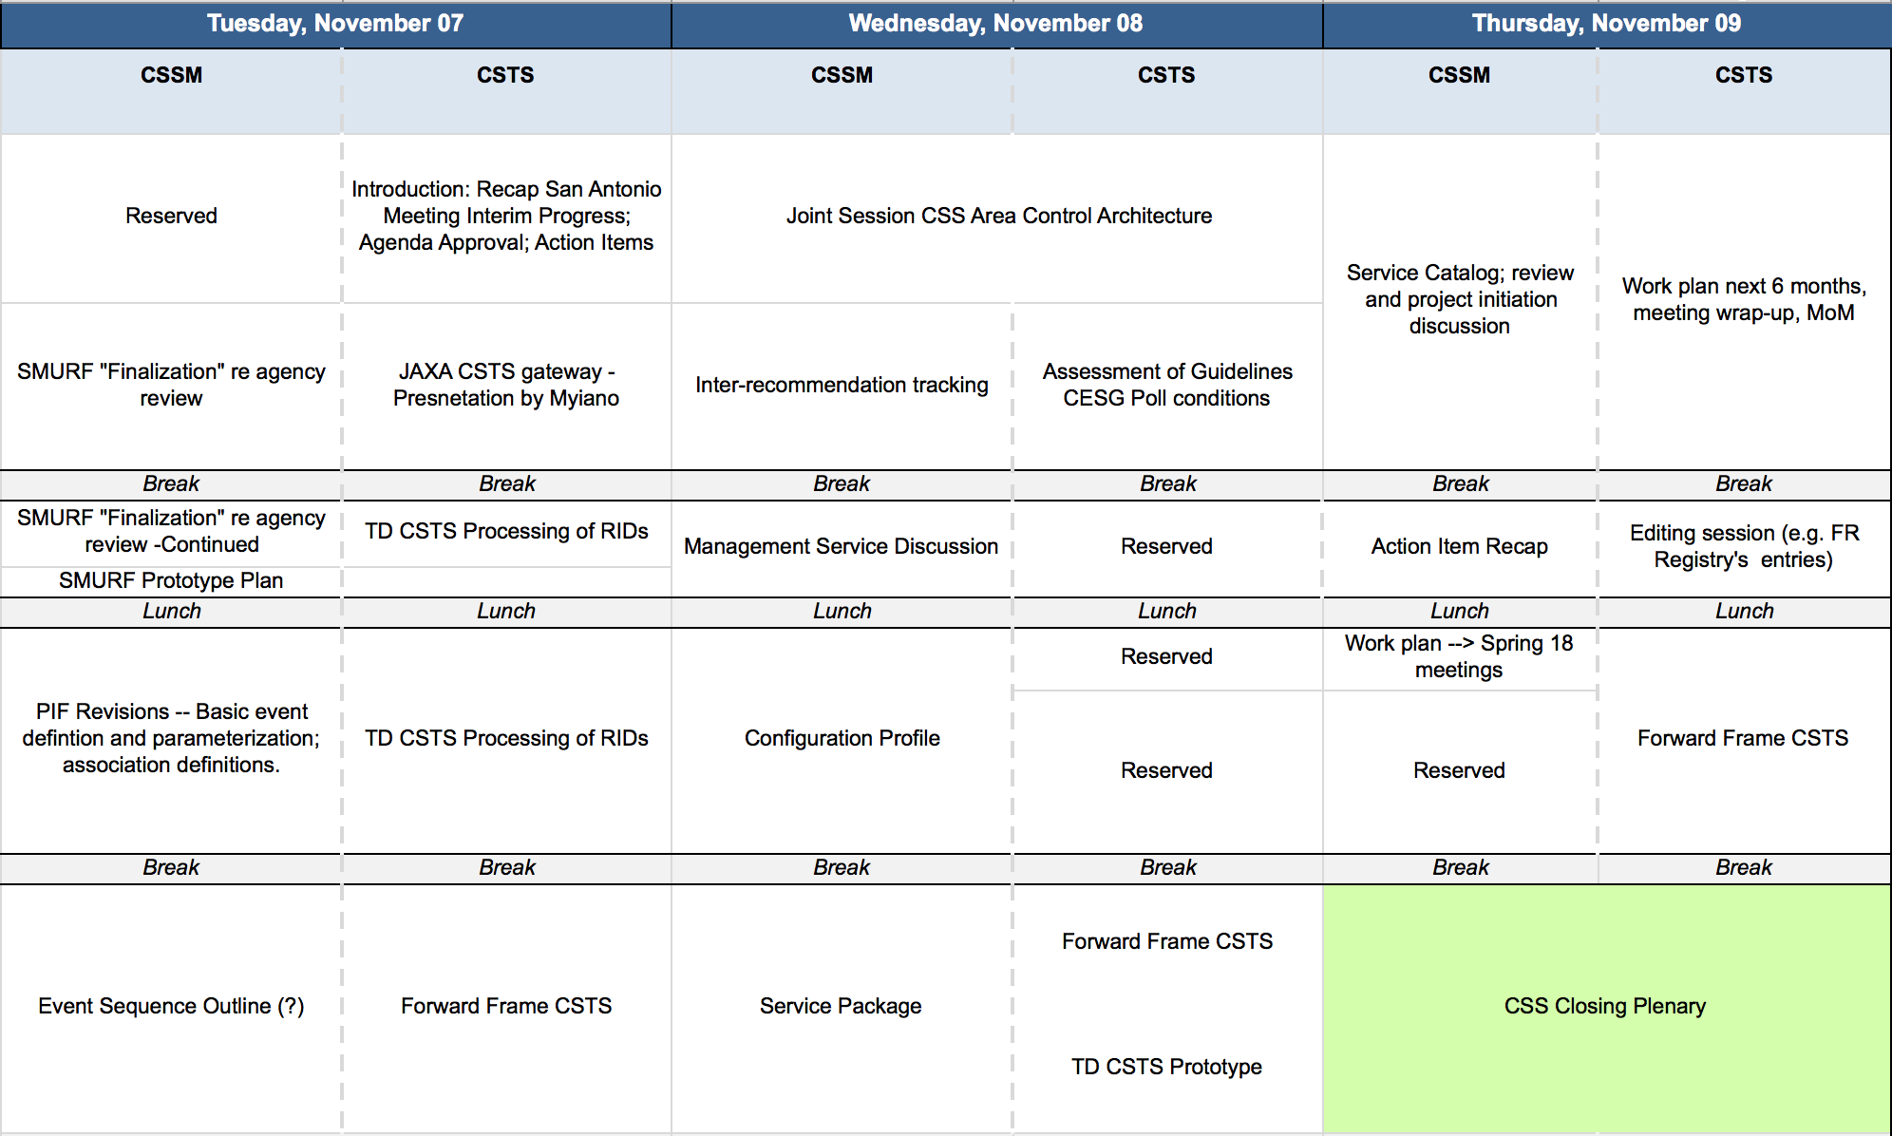
S Statement
D Decision
A Action

Review of Workplan from Spring Meeting 2017
Work Item | Progress
Update/ finalize CSTS Concept: W. Hell, (ESA), WG to review. | Finalized, available on CWE, some minor updates are pending.
Update/ finalize TD CSTS: W. Hell (ESA) | Done. Agency Review has been done, RID is processing pending.
Update/ produce FF CSTS specification: T. Pham (JPL/NASA) | White book version 0.2 is on CWE.
Completion of data preparation for SANA Registry: W. Hell / H. Dreihahn / H. Ernst / T. Pham | Has to be taken up with SANA for a hierarchical presentation.  The definition of some functional resources is not done.
Yellow Book for TD CSTS Prototype: S. Gully (DLR) test plan and report. | Jason has provided additional test cases.

Forward Frame CSTS
S | Forward Frame White Book V0.2 on CWE:  https://cwe.ccsds.org/css/docs/CSS-CSTS/CWE Private/Future Services using Toolkit/Forward Frame CSTS/FF-CSTS-922x3-w-0_2-review.doc  John provided an overview.
D | First draft April 2018.
S | Decide how to deal with AOS uplink in terms of coding and modulation standards.  CESG Action Item to all agencies, which are the relevant coding and modulation schemes. Only NASA expressed interest; SLS will come up with presumably a magenta book identifying the subset of possibilities for AOS uplinks
A | MDG: Question to SLS: What are the milestones for that AOS forward magenta book? Most likely the CSTS FF needs to rely on it.
D | The FF-CSTS shall be written verbose mode.
D | Frame identification and validation shall be done based on GVCID and bitmasks.
D | Frame Length Validation: The min / max frame length approach shall be used.
D | Invalid frame handling: For the buffered forward frame the service shall issue a notification for each frame, which cannot be accepted. The frame shall be discarded and not radiated.
D | There shall be two multiplexing stages, VC multiplexing and MC multiplexing.
S | All resources required for the Project phases have been entered in CWE to be submitted to CMC approval.
S | TP will call for progress meetings.
A | WH: Check if there is a way to handle the latest processing start time in ‘better way’ than FSP.
S | JP will continue to define the CSTS FF production engine.
D | The capability to dynamically change the buffer size of the BDP procedure shall be restricted to change buffer size only when it is BOUND but not ACTIVE. Rationale is to avoid complexity to handle situations where the buffer size is shrinked shrank, but the buffer fill level is greater than the new buffer size. Buffer size changes will be achieved by BDP procedure extension adding a ‘execute directive’ operation.

Functional Resources Technical Note and FR Model.

S | The discussion on the FR registry update shall be discussed and followed up in a dedicated telecom after the meeting.
S | Meeting with SANA engineer has been held to discuss the FR presentation at SANA.
A | SANA to fix the "1.3.112.4.4.2.1" (Functional Resources) sub-tree not loading in the OID tree  browser.  The issue might be caused because there are gaps between the FR's OIDs and their children's.  Potential fixes discussed:  - Display the full tree by skipping missing OIDs;  - As there is semantic embedded in the OID for these entries, generate specific records (during XML  -> SANA conversion) that will represent this meaning in the FR registry.
A | HD to update SANA FR ICD with description of the OID bits until 15/11/2017.
A | SANA will provide a hierarchical organization of the FR table / tree
A | SANA will provide a link to the input XML file of the FR and the stylesheet to produce the internal HTML format (if possible).
A | SANA will change the order of the columns (OID first) according to the SANA FR ICD table 2-1.
S | Suggested to maintain at CWE a spreadsheet with all identified FRs, state and assigned author – discuss with WG.
A | Add a functional resource to cover CCSDS 415.1-B-1.

FR/P/D/E OIDs and their Registration at SANA
D | OID update for MD-CSTS:  - Annex B of the MD-CSTS Blue Book assigns the OID {crossSupportFunctionalities 17} to mdCstsProvider  - Annex C of the TD-CSTS Red Book assigns the OID {crossSupportFunctionalities 19} to tdCstsProvider  SANA Registry assigns these FR Types OIDs ending in 46 (MonitoredDataCSTSProvider) and 38 (RealTimeTrackingDataCSTSProvider)  Align the SANA registry for MD-CSTS and TD-CSTS.
S | Check the representation at SANA:  The beta: https://beta.sanaregistry.org/r/functional_resources/functional_resources.html  The official registry: https://sanaregistry.org/r/functional_resources  - All items, FR and P/E/D are on the same level. That makes navigation very difficult. The organization must be hierarchical, i.e. FR on top-level and P/E/D below.  - The XML of the FR was downloadable, now it isn’t. Can we put it back?  Has been discussed and agreed with SANA.

CSTS Specification Framework CCSDS 921.1
TODO | Technical Corrigendum needed? See discussion of Wolfgang and John about:  - Peer Abort diagnostic codes  - Procedure PDUs ASN.1 irregularities (see below)Other?
A | Discussion of ‘Procedure PDUs ASN.1 irregularities’ email thread between JP and WH. Update for Procedure PDUs ASN.1 irregularities to clean the ASN.1  See email WH 27/10/2017
A | Invalid PDU handling: State machine presentation shall be consistent

Concept Book
D | The concept book is done and uploaded to CWE. After completion of AI (see the row below) it shall be given to the Area Director for publication as a Green Book.
A | WH: Align to the guideline change that the guidelines are a recommended practice and should be followed unless there is a compelling reason that they can’t be followed.

Guidelines
D | Guidelines will stay a Magenta Book and will go to Agency Review. WG decision in reply to a CESG PID.
A | WH: Add a statement that eventually refined procedure PDUs have to be exported from the ASN.1 module. Will be a RID in Agency Review.
S | The CESG poll has resulted in some conditions, which have been resolved. The CMC poll is ongoing. Agency review will start after.
S | The SANA consideration section PID has been discussed with P. Shames. No action is required.
A | WH: The normativity of the Guidelines will be clarified in the book.
A | WH: Check if the Guidelines explain how to add behavior to procedures (extension).

Monitored Data CSTS
A | MDG: Check why the Yellow book of MD-CSTS is not on CCSDS publications Yellow Book.

Tracking Data CSTS – CCSDS-922.2

S | The author of the ESA RIDs has accepted all of WHs responses. The editorials will be taken on board.
D | Meeting with P. Shames took place to discuss the SANA considerations. WH asked for the desired changes of the TD-CSTS section ‘SANA Considerations’. P. Shames has agreed that the CSTS SFW references explain how the SANA reference is used correctly. Therefore TD-CSTS and the Guidelines are fine by referencing the CSTS SFW.
A | WH: All RIDs have been discussed and answered. WH has all dispositions and will prepare formal RID responses.
S | Prototype: DLR can run the first test cases of the test plan locally. S. Gully gave a walk through the test case.
S | The DLR prototype implementation is not fully completed.
S | JPL provided a presentation about the prototype implementation state.
S | Connectivity between DLR and JPL is being established for the interoperability tests. A direct VPN connection is under discussion.
S | A draft schedule has been presented by T. Pham. Confirmation from DLR (SG) has been received. The delay in the Prototype development will cause a delay in the publication of the TD CSTS Blue Book.
A | TP: JPL (JL / TP) consider to take over the authoring of the Yellow Book from DLR.

Workplan

Update / finalize CSTS Concept: W. Hell (ESA)
Update / finalize Guidelines W. Hell (ESA)
Update / finalize TD CSTS: W. Hell (ESA) as per RID disposition from Agency Review
Update / produce FF CSTS first draft specification: T. Pham (JPL / NASA) / J. Pietras (GST)
Completion of data preparation for SANA Registry: W. Hell / H. Dreihahn / H. Ernst / T. Pham
Yellow Book for TD CSTS Prototype: T. Pham, J. Liao (JPL / NASA)
Prepare Technical Corrigendum for CSTS SFW by collecting items. W. Hell (ESA) / J. Pietras (GST)

Development of TD CSTS Prototype:
- User: Jason Liao (NASA/JPL)
- Provider: S. Gully (DLR)
- Validation, interoperability tests: S. Gully (DLR) / J. Liao (NASA)

Schedule of Teleconferences

Telecon 1: 18 January 2018 at 16:00 CET
Telecon 2: 15 March 2018 at 16:00 CET
Telecon about FR 14 December at 16:00 CET

All Presentations given at the 2017 Fall Meeting can be found at:
https://cwe.ccsds.org/css/docs/Forms/AllItems.aspx?RootFolder=%2Fcss%2Fdocs%2FCSS-CSTS%2FMeeting Materials%2F2017 Fall Meeting The Hague&FolderCTID=0x012000A2CFA608DF169C4EB988261660CEFAEB&View=%7BD853EDDB-F007-4BF6-8C31-BA03A9D0F4A4%7D

