REPORT & CONCEPT – CSSA CLOUD BOF
Report and Concept from the Cross Support Services Area, cloud computing data delivery BOF.

Executive summary
in May 2022, the CSS Area Director initiated a CCSDS “Birds-Of-a-Feather” (BOF) to determine if CCSDS standards for cross support with regards to data delivery via cloud computing should be developed, and if so, what should the scope of such standard(s) be. This was in response to a growing awareness that mission ground data systems are making increasing use of cloud computing services and that multiple CCSDS member agencies have been approached about providing mission data directly into the cloud from their ground stations. The BOF has concluded that some relatively simple data format standards, leveraging existing CCSDS standards, coupled with considerations specific to a cloud computing environment can and should be developed. A new Working Group in the CSS Area can and should be chartered to produce one concept book (a green book) and one normative recommendation (a blue book).

Historical Overview: CCSDS SLE, CSTS, and The Emergency of Cloud Computing
The CCSDS Cross Support Services (CSS) Area has produced standards for transferring data to and from ground stations serving mission spacecraft and mission operations centers (MOCs). The Space Link Extension standards (CCSDS xxx) standardize delivery of command and telemetry data between a mission operation center and a ground station. MD-CSTS (CCSDS 922.1-B-1) and TD CSTS (CCSDS 922.2-B-1) were developed for transfer of monitor data and tracking data respectively from a ground station to a mission operations center. Both SLE and CSTS are intended to operate during the execution of a tracking pass providing data from the tracking station to the mission operations center in (near-)real time while also providing the ability to record and store data for delivery after the tracking pass.
The CSS Area data transfer standards were designed starting circa 1990. At the time that these standards were being created the internet as global communications infrastructure was emerging and the SLE Recommendations utilized capabilities based on TCP/IP as the means for transporting the data.
Since ~2003 there have been tremendous developments in terrestrial computing infrastructure including the emergence of infrastructure and services on demand. By the early to mid 2000’s data centers had emerged, and internet connectivity and bandwidth was increasing rapidly. These two developments afforded an opportunity for the emergence of a computing infrastructure that is always on, can scale quickly and can provide continuous computing services and is now known as “cloud computing” for just “the cloud”.

Examples of Cloud Computing and Space Missions
Cloud computing is becoming pervasive for supporting and running space missions. Following are just a few examples of the application of cloud computing for space missions:
- Data processing: Spacecraft generate large volumes of data, including images, sensor readings, and telemetry data. Cloud computing allows space agencies to process this data quickly and efficiently using high-performance computing resources. For example, NASA's Earth Observing System Data and Information System (EOSDIS) uses cloud computing to process and distribute data from its fleet of Earth-observing satellites.
- Data storage: Space missions produce enormous amounts of data that must be stored securely and efficiently. Cloud storage services like Amazon S3 and Microsoft Azure provide space agencies with scalable, low-cost storage options that can handle petabytes of data. For example, the Roman Space Telescope mission, planning to be tracked by NASA, ESA, and JAXA, will be making use of cloud computing for storage of it’s anticipated vast amounts of data returned.
- Public outreach: To support timely access to significant events of general interest, NASA/JPL’s Perseverance rover makes use of cloud computing to provide public on-demand outreach services.
- Machine learning: Space agencies are also using machine learning algorithms to analyze the large volumes of data generated by space missions. Cloud computing platforms like Google Cloud and Amazon Web Services (AWS) provide tools and services for building and training machine learning models. For example, NASA is using machine learning to analyze data from its Kepler mission, which is searching for exoplanets.

SLE Limitations, Issues (and by extension, CSTS)
Although truly a CCSDS success story, when compared against today’s cloud computing environment and considering implementation issues seen over the last 20+ years, there are some limitations and issues with the SLE approach. Some of these are:
- Point-to-point data delivery: SLE is a point-to-point only data delivery solution. If a Mission Operations Center (MOC) desires to have selected telemetry frames routed to different destinations, it means separate SLE instances are required. This does not scale very well. To address this limitation, alternative data delivery solutions could be explored that allow for more efficient and flexible data transfer, such as cloud-based data storage and processing.
- Troubleshooting: The SLE bind operation tends to consume time during early mission test and check out to resolve agency firewall issues and/or neophyte mission implementation issues. This is something of a “hidden” expense for on boarding a mission at a given TT&C provider. Making use of an omni-present context afforded by cloud computing should help eliminate these types of issue.
- ASN.1 compiler: SLE requires the mission to purchase or license an ASN.1 compiler. This can be a significant cost for some missions, especially those with limited budgets. There are modern day encoding techniques that work well in a cloud computing environment that can eliminate the need for purchasing a specialized compiler.
- Outdated model: The SLE model is outdated and does not attract the attention of today's graduates. This can make it difficult for agencies to find qualified personnel to maintain SLE-based systems. Today’s graduates tend to know a fair amount about cloud computing and university courses and degree programs in cloud computing have emerged.
- Cost, Scalability: SLE can be costly for TT&C providers to increase processing and storage capacity to offer SLE services for emerging missions that plan to downlink terabits daily. For CCSDS member agencies it is not typically cost effective to purchase ever increasing amounts of hardware for data storage and/or faster processors to drive SLE at higher data rates.

Use Cases To Be Addressed
The BOF concluded, based on discussions with regard to agency inputs that the following are the key use case to address;
- Delivery of files of telemetry frames in the cloud such that a mission can retrieve the telemetry frame files directly in the cloud
- Delivery of files of tracking data in the cloud such that a mission can retrieve the tracking data files directly in the cloud
- Delivery of files of telemetry frames from the cloud such that a mission can download the telemetry frame files to a location outside the cloud
- Delivery of files of tracking data in the cloud such that a mission can download the tracking data files to location outside the cloud
- Streaming, in near-real time, of telemetry frames via the cloud to an end point in the cloud such that a mission can receive the data stream directly in the cloud
- Streaming, in near-real time, of tracking data via the cloud to an end point in the cloud such that a mission can receive the data stream directly in the cloud
- streaming, in near real time, of ground station monitor data via the cloud to an end point in the cloud such that the mission can receive the data stream directly in the cloud
- streaming, in near real time, of telemetry frames via the cloud to an end point such that a mission can receive it outside of the cloud
- streaming in near real time of tracking data via cloud to an end point such that mission can receive it outside of the cloud
- streaming in near real time of ground station monitor data to an end point such that a mission can receive it outside of the cloud

BOF Conceptual Approach
The BOF considered three different approaches:
- Selecting and recommending the micro-services generally offered by cloud providers: the BOF concluded that delving into all the micro-services offered by cloud-computing providers to generalize architectural patterns would in fact be counter-productive, requiring a rather vast amount of time and energy to arrive at any useful, agreed-upon standards
- Making use of messaging publication/subscription that can run independently of any cloud provider: the BOF concluded that this approach would be too heavy and risked being too prescriptive relative to use cases to be addresses
- Identification of the file and streaming formats needed along with the ancillary supporting information such as proper meta-data definitions, operational notifications that make sense given the omni-present context afforded by a cloud environment, considerations regarding making use of cloud computing services including, but not limited to cybersecurity.
Approach c) was chosen as it is the approach most likely to produce effective, needed standards in a relatively short time, while at the same time allowing agencies the necessary freedoms in selecting cloud providers and implementation approach re utilizing cloud provider services.

Recommended Standards to Be Developed
The Proposed cloud data delivery standards aim to provide inter-operability between TT&C providers and Mission Operations Centers independently of any cloud provider. The following are the key aspects that are expected to be addressed by these proposed standards:
1. Delivery of telemetry, tracking and monitor data: The proposed cloud data delivery standards are expected to cover the delivery of telemetry, tracking, and monitor data from ground stations to mission operation centers.
2. Data format specifications: The standards are expected to provide data format specifications for streaming of telemetry, tracking, and monitor data. Additionally, file formats for telemetry and tracking data will be specified to ensure compatibility and consistency across different systems.
3. Notifications: The standards will specify the notifications that are required to be provided, for example, telemetry files being available or that a telemetry data stream is available. This will allow for efficient and timely data delivery, as well as provide transparency in data availability.
4. Cybersecurity considerations and recommendations: Cybersecurity considerations and recommendations will be provided to ensure that the data transmitted over the cloud is secure and protected from potential cyber threats. This will include recommendations for encryption, access controls, and vulnerability management.
5. Ground station and mission operation center cloud utilization considerations: The standards will address the considerations for ground station and mission operation center cloud utilization, such as bandwidth limitations, data transfer rates, and storage capacity.
6. Considerations regarding selection of cloud providers: The standards will provide guidance on the selection of cloud providers, including considerations for cost, performance, reliability, and security.

Recommendation for WG Formation
It is recommended that a new WG be created for producing the standards to be developed as outline above. This is predicated on the rationale that the standards to be developed are sufficiently distinct from the others being produced by working groups in the CSS Area but yet are very typically within the remit of cross support services created by the CSS Area.
The suggested name for the new working group is Cloud Data Deliver Standards, with a suggested identifier in the CCSDS CWE Management Framework of CSS-CDDS.
It is recommended that the formation of the CDDS WG include a formal CCSDS Announcement of Opportunity circulated to industry partners. As a result of the BOF meetings, industry interest in helping with creation of the standards has been noted.
Figure below summarizes the recommended approach regarding working group and standards to be produced
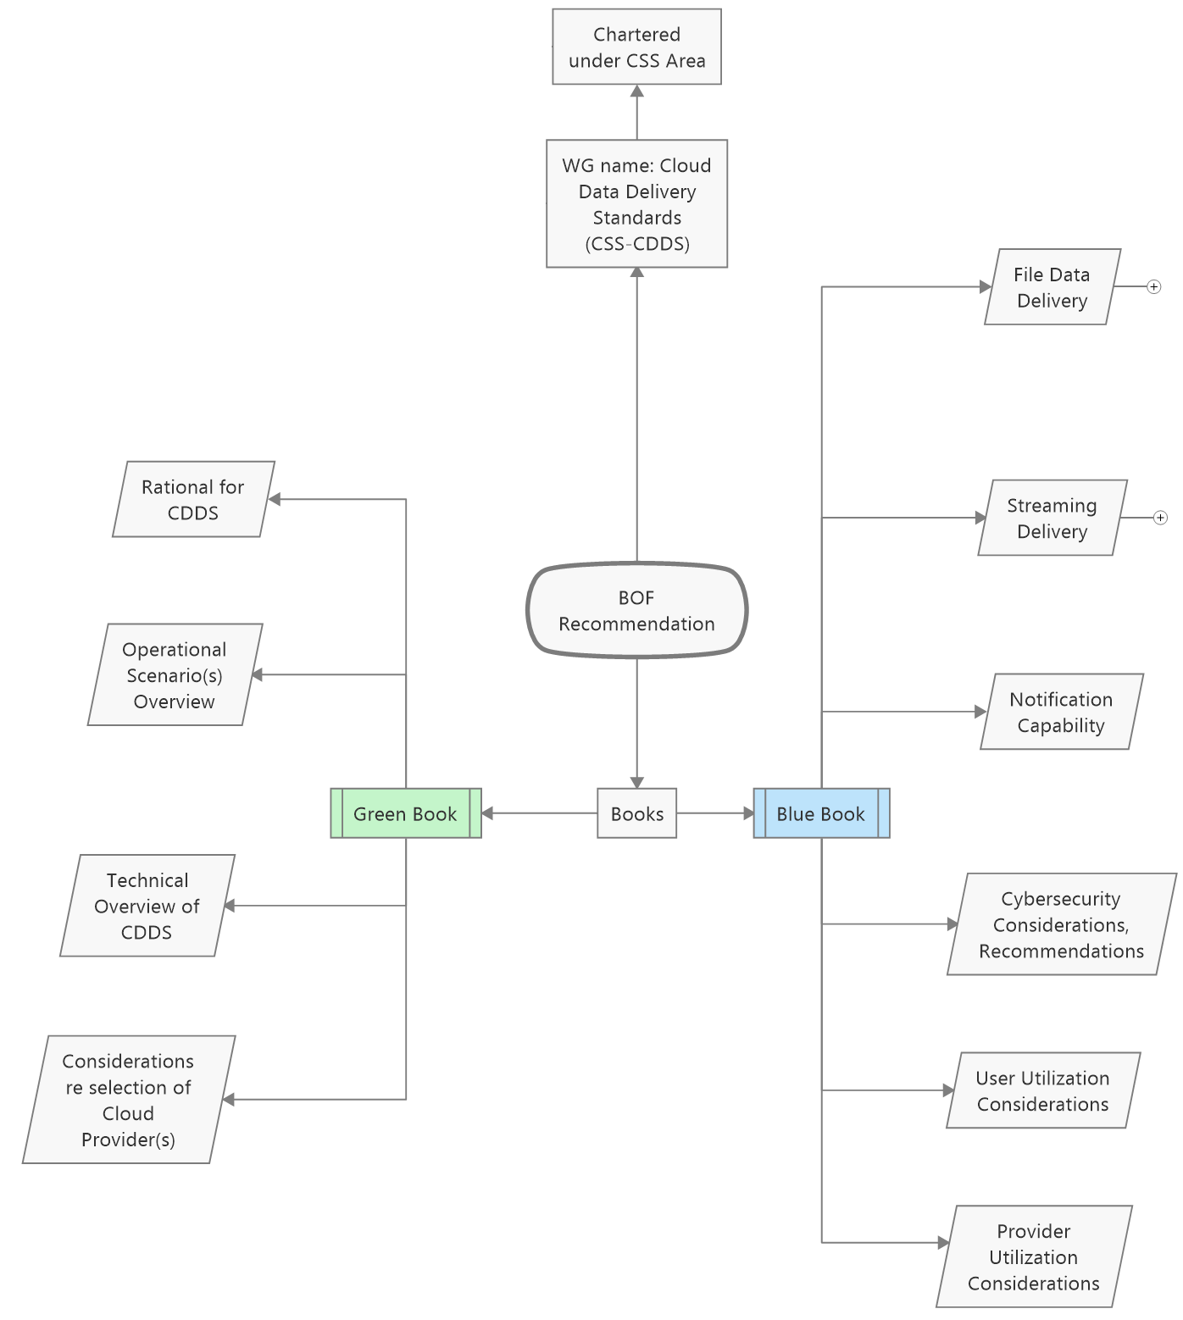

Figure 1 -- Summary of WG and Standards Proposed for Cloud Data Delivery Standards

https://www.earthdata.nasa.gov/eosdis/cloud-evolution
https://www.nasa.gov/feature/goddard/2021/ground-system-for-nasa-s-roman-space-telescope-moves-into-development
https://www.geekwire.com/2021/nasa-releases-jaw-dropping-video-audio-mars-assist-aws/
https://mast-labs.stsci.io/2019/10/kepler-data-available-on-aws
For example, George Washington University offer a masters program: https://www.programs.gwu.edu/cloud-computing-management
Airbus Industries, Amazon AWS Aerospace & Satellite, and MAXAR have either participated in a BOF meetings and/or enquired as to providing resources for standards development.

