CSS Cloud BOF Meeting Notes
16 February 2023

Attendees
E. Barkley, A. Crowson, H. Dreihahn, J. Liao, C. Radulescu

General Announcements
- CESG will take up consideration of an announcement of opportunity re cloud computing industry representatives with regard to cloud computing data delivery standards at the CESG meeting next week

Action item check
- 3 action items closed
- No action items added
- Four action items added
- One action item opened
- One open action item
- See spreadsheet for details (https://cwe.ccsds.org/css/docs/CSS-CLOUD/CWE%20Private/Action%20Items CWE log in required)

Considerations/lessons learned re use of cloud computing
- J. Liao provided a presentation on lessons learned doing CSTS prototyping making use of cloud computing
  - For FF-CSTS prototyping cloud computing easy to set up
    - Did not have to deal with lengthy delay in re access permission as compared to on-premises prototyping for TD-CSTS
    - Did not have to worry about setting up hardware
    - Easy to reconfigure resources as needed
  - Some additional steps required re identity/cybersecurity as prototyping partners did not have a common/federated authentication scheme
  - noted that there can be more complex dependencies/difficulty in troubleshooting for some issues
  - additional steps likely when using multiple cloud providers
- _H. Dreihahn confirmed that for ESA any mission that is EU funded is required to make use of EU based cloud providers (if cloud computing is involved)

Encoding discussion
- Reviewed spreadsheet of CCSDS recommendations that are candidates for leveraging re cloud data delivery and the encoding schemes already defined the recommendations
  - See CWE folder for this telecon for spreadsheet
- Noted that for easing transition, “native” (i.e. those already specified in the leveraged recommendations) can be indicated in a future standard
- Agreed that the eventual cloud computing standard(s) should offer at least one alternative encoding that would fit better with the modern cloud computing environment
  - Alternate encoding to be considered on a case by case basis
    - E.g., telemetry data delivery might have a simple binary encoding vs tracking data which might have a json encoding;
  - This does imply prototyping requirements for the eventual standard(s)
    - Not seen as needing a significant investment as the encodings defined are likely to be small in terms of normative statements
    - Noted that cloud computing can of course leveraged for this prototyping
      - (Ed. note: this can also help inform TTC Provider and TTC Client considerations)

Standards to be produced discussion
- E. Barkley presented a diagram outlining potential WG name, and deliverables for 1 Green (Concept) Book and 1 Blue (Normative) Book
  - See Figure 1 Overview of Books to Be Produced
  - Preliminary consensus is that this looks good re eventual WG deliverables
  - BOF participants requested to review and comment

AOB (none)

Next telecon
The next teleconference is on March 16, 2023

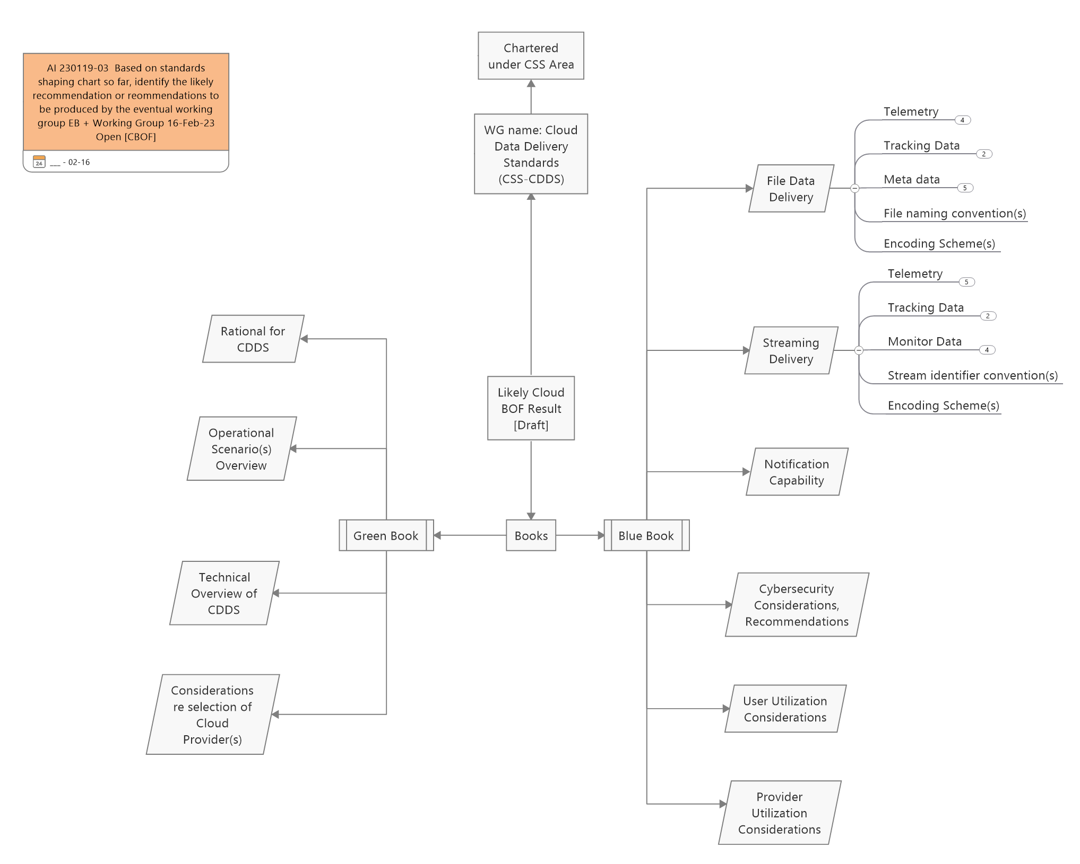
Figure 1 Overview of Books to Be Produced

