COVID-19 situation on 1st August 2020

Travel Conditions :

- It is mandatory to wear a surgical mask in the airports and on board – Masks are not provided by companies
- The checking of passengers' body temperature is gradually implemented at the departure of some flights to international destinations. The temperature will be taken using a non-contact infrared thermometer.
- Before making any travel plans, please contact the relevant national authorities to check entry and stay requirements in your final destination (France) and possibly transit countries. You are advised to make backup plans for both your travel and accommodation.
- To learn about the travel requirements currently in place in France, please consult before departure, the website of your Embassy and refer to the official information websites below:
  - Coming to France - France Diplomatie
  - View current travel requirements (TravelDoc)
- For travel in Metropolitan France, special travel certificates and/or other health documentation may also be required for your trip. Please consult the list of required documents using the link below.
All these travel documents must be presented before boarding and kept with you until arrival at your final destination.
  - Download certificates

Border Restrictions:

- Individuals arriving from the European area (EU Member States, Andorra, Iceland, Liechtenstein, Monaco, Norway, United Kingdom, San Marino, the Vatican City State and Switzerland) or one of the following countries: Australia, Canada, China, Georgia, Japan, Morocco, New Zealand, Rwanda, South Korea, Thailand, Tunisia and Uruguay will no longer be subject to restrictions on the grounds of preventing risks linked to the COVID-19 epidemic when entering Metropolitan France. This list will be regularly updated, at least every two weeks, in liaison with our European partners, taking account of the recommendations of the Council of the European Union, developments in the health situation and the principle of reciprocity.

- Entry into the national territory from countries outside the European area or not included in the above list is only authorised in specific derogatory situations, which include foreign nationals residing in France or French nationals. Information should be obtained from the Ministry of the Interior.

Countries | Entry permited | Travel certificate | Statement of honour | Quarantine | Test
Germany | YES | NO | NO | NO | NO
Italy | YES | NO | NO | NO | NO
United-Kingdom | YES | NO | NO | NO | NO
Netherlands | YES | NO | NO | NO | NO
USA | NO
Canada | YES | NO | NO | NO | NO
Brazil | NO
South Africa | NO
United Arab Emirates | NO
India | NO
South Korea | YES | NO | NO | NO | NO
Japan | YES | NO | NO | NO | NO
China | YES | NO | NO | ? | ?
Autralia | YES | NO | NO | NO | NO
Russia | NO

Living conditions in France :

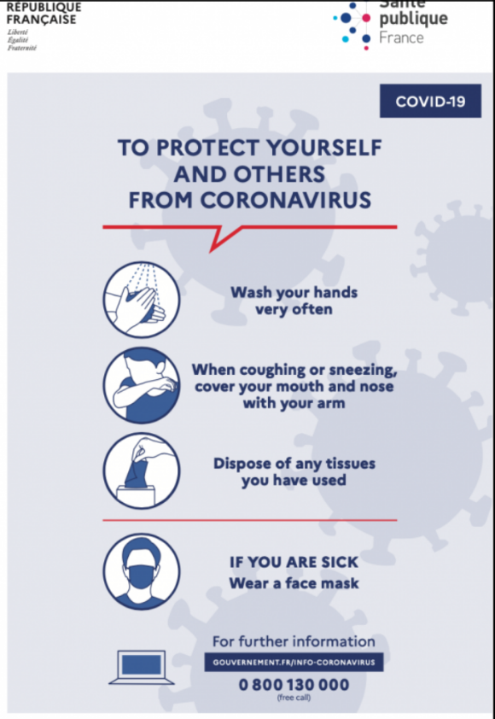

- Respect of social distancing and of transmission precaution: wash your hands very regularly, when coughing or sneezing cover your mouth and nose with your arm or into a tissue, use « single use tissue » and throw it away, greet without shaking hands and avoid hugs, wear a face mask if you are or if you feel sick.

- Wearing of the mask recommended in all public places, mandatory on all enclosed public areas: public transport, shops, restaurants…

- The restaurants and bars reopen gradually with a distance of 1 meter between the tables => so their capacity is greatly reduced

- There is no restriction for hotels but you are invited to consult your hotel web site for details

CNES : Access and meeting rules

- On your arrival at CNES, you will be asked to fill in a form about your previous trips and your state of health.

- Wearing a mask is mandatory in any place when you are on a CNES site.

- The meeting rooms can be used according to their capacity, without limitation of the number of participants provided that 1,5 meter of distance between each person can be respected. Wearing a mask is mandatory if the physical distance rule of 1.5 meters cannot be respected or if any participant requests that everyone wears the mask.

- The meeting rooms will be cleaned twice a day, before 9am and at lunchtime (midday – 2 pm). It is therefore compulsory that they are vacated in these time frames.

