CCSDS CMC Draft Agenda
13 – 16 June 2017
Hosted by ROSCOSMOS, St. Petersburg, Russia

Here we provide a few essential tips you should know when arriving to the airport Pulkovo of Saint Petersburg, Russia. Additionally, if you have any questions, please, contact the following Russian CCSDS Secretary Representatives:
- Dmitry Barannikov: +7 (915) 125-25-44
- Anna Vasilenko: +7 (916) 964-00-28

Park Inn by Radisson Pribaltiyskay Hotel
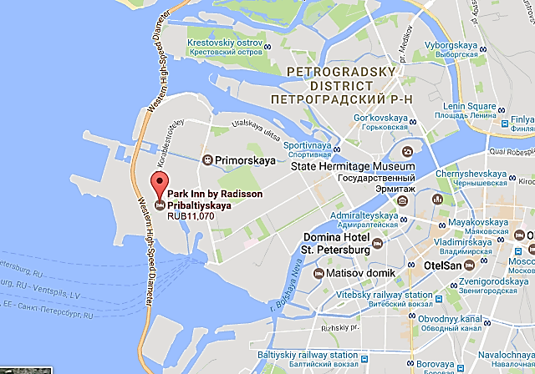
Island,
LOCATION: 14 Korablestroiteley Street, Vasilyevsky
St Petersburg
METRO STATION: Primorskaya Vasileostrovskaya
Sportivnaya

TEL.: +7 812 329-26-26 SITE: www.parkinn.ru/hotelpribaltiyskaya-stpetersburg

How do you get to the hotel from Pulkovo Airport?

The Park Inn Pribaltiyskaya is approximately 20km from Pulkovo Airport. Guests are strongly recommended to take a taxi. The drive will take 40-60 minutes.

Approx. 20km
(40-60 min)
Park Inn Hotel
Pulkovo Airport

You can choose a variety of taxi services, but we recommend you to deal with TAXI PULKOVO service. Please, be advised, the prices here are indicative.

TAXI PULKOVO

Tel.: + 7 (812) 677-86-35
Approx.price: 1050 – 1150 RUB (18 – 20 EURO; 20 – 22 USD)

To take a taxi, you should ask taxi service front desk. Payment has to be made at the counter at once before getting taxi and departure from the airport. Cards are acceptable. In the case of any questions raised, you may always ask assistant at front desk in English.
Taxi Pulkovo counters are located at Arrivals hall on the first floor of the Terminal. This is how the front desk looks like:

! NOTE: Do not accept offers from private taxi drivers the way out of the airport for safety purposes.

Peterhof Guided Tour Schedule (15 June)

We’re suggesting you plunging into charming historic atmosphere of the old places nearby Saint Petersburg.
09.30 | Departure from Senatskaya Pier
11.00 | Peterhof Fountain Park visiting
11.15 | Peterhof Lower Park tour including the Grand Palace visiting
14.30 | Lunch in Peterhof
16.30 | Departure from Peterhof to St Petersburg
17.30 | Arrival to Dvortsovaya Pier
19.30 | Social Event

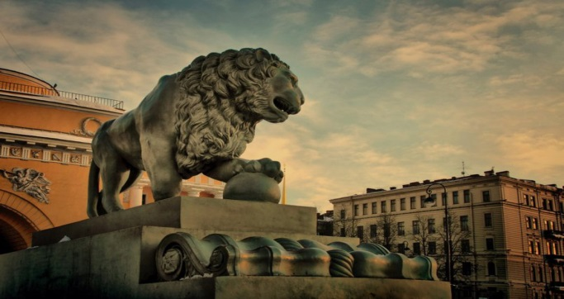

Bridge Openings Schedule in St. Petersburg
In St Petersburg there are 13 bridges that cross the river Neva and at night they open for at least four hours to let large ships pass. In order to have an idea till what time you should managed to cross the necessary bridge to get successfully to your hotel, see the special ‘opening bridges schedule’ below.

Special for our guests we’ve marked the bridges that directly lead to Vasileostrovsky Island, so pay attention on opening timeline while crossing the Blagoveschensky, Palace, Birzhevoy and Tuchkov bridges.
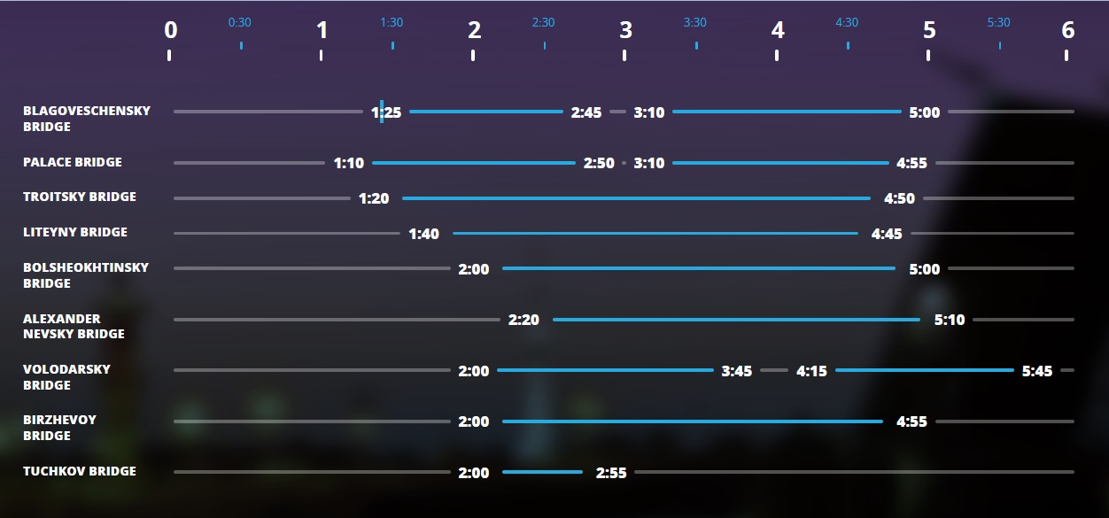

!
!

!
!

! NOTE: Sampsonievsky, Grenadersky and Kantemirovsky bridges are raised from 1:30 a.m. to 4:30 a.m. by prior 2-day request.
For more actual information about Bridge Openings Schedule, please, see https://en.mostotrest-spb.ru

