2015 Spring CCSDS Management Council (CMC) Meeting
Date: 18-21 (Mon-Thu) May, 2015
Venue: Mielparque-Nagano, Nagano, Japan
(April 14, 2015 updated)

Logistic Information

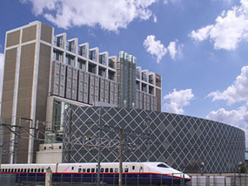
- General
            - Location: Nagano City, Nagano Pref., Japan
            - Dates: May 18-21 (Mon-Thu), 2015
            - Meeting Venue & Recommended Hotel:
Mielparque-Nagano
Access: 5 minute walk from the East Exit of JR Nagano Station
Address: 752-8, Tsuruga-takahata, Nagano-City, Nagano 380-8584 Japan
Tel: +81-26-225-7800
Fax: +81-26-225-7801

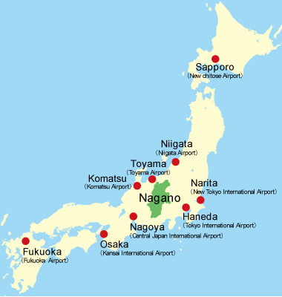
- How to Get to Nagano from Airport
It generally takes about 3 hours and 20 minutes from Narita International Airport to JR Nagano Station. From Haneda Airport, it takes about 2 hours and 40 minutes.
Here!
Either route you take, you would change at Tokyo Station to Bullet Train (Hokuriku Shinkansen*).
*Hokuriku Shinkansen:
http://www.nippon.com/en/features/h10015/

The venue and recommended hotel Mielparque-Nagano is within 5 minute walk from the east exit of JR Nagano Station.
2.1 Airport --> JR Tokyo Station
2.1.1 Narita Airport --> JR Tokyo Station
There are various ways to get to Tokyo Station from Narita Airport. Recommended is the following route which is the fastest and direct.
Narita Express Train “N’EX”
Limited Express train by Japan Railways (JR) called “N’EX” runs form Narita Airport Terminals 1 and 2 to Tokyo Station every 30 minutes between 7:30-21:44 for 3,020JPY. It efficiently takes you to major train terminals in Tokyo. JR Narita Airport Stations are located on the B1F of both Terminals 1 & 2, just one floor below the arrival lobby. All seats are reserved.
Just visit JR EAST Travel Service Centers located in Narita Airport Terminal 1 and 2 for more information, if you are interested.

For N’EX details, please visit: http://www.jreast.co.jp/e/nex/index.html
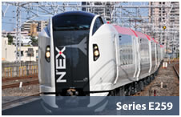

Cost: 3,020 JPY/one way/person
Travel time: 62 minutes
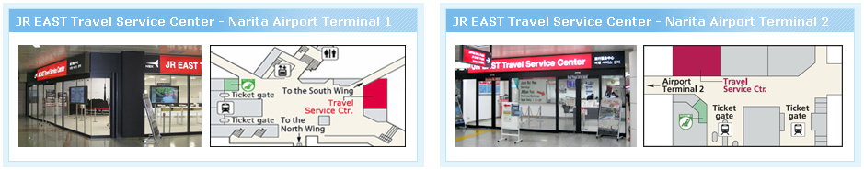
Open Hours: 8:15-19:00
Open Hours: 9:30-20:00

JR EAST Travel Service Counter: http://www.jreast.co.jp/e/customer_support/service_center.html
Narita Airport: http://www.narita-airport.jp/en/access/train/index.html
East Japan Railway Company HP: http://www.jreast.co.jp/e/
*Note : At JR EAST Travel Service Centers, you can also buy bullet train tickets to and from Nagano with reserved seats so that you do not have to buy tickets at busy Tokyo Station. English-speaking attendant helps you buy the most convenient ticket at ticket office. Receipt is issued upon request. Credit cards accepted.
2.1.2 Haneda Airport --> JR Tokyo Station
Either of Tokyo Monorail and Keikyu Line provides smooth access to the heart of Tokyo from Haneda Airport. More recommendable is Tokyo Monorail since you can receive English assistance for the Monorail, Yamanote Line, and Bullet Train to/from Nagano inclusively at JR EAST Travel Service Center, located in Haneda Airport International Terminal.
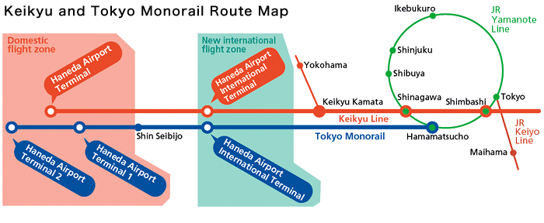
By Tokyo Monorail to Hamamatsucho Station:
When taking “Haneda Express” (an express service) of Tokyo Monorail, it takes 13 minutes from Haneda Airport International Terminal Station to JR Hamamatsucho Station.
For Tokyo Monorail details, please visit:
http://www.tokyo-monorail.co.jp/english/guidance/kokusaisen/index.html
Cost: 490 JPY(+160 JPY for Yamanote Line to Tokyo Station)/one way
Travel time: 14 min (+6 min for Yamanote Line to Tokyo Station)/one way
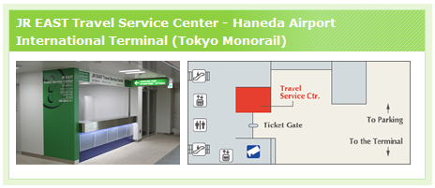
Open Hours: 7:45-18:30
*Note : At JR EAST Travel Service Center, you can also buy bullet train tickets to/from Nagano with reserved seats so that you do not have to buy tickets at busy Tokyo Station. English-speaking attendant helps you buy the most convenient ticket at ticket office. Receipt is issued upon request. Credit cards accepted.

From Shinagawa/Hamamatsucho Station to JR Tokyo Station:
Whichever station you get off, please get out of Tokyo Monorail/Keikyu Line ticket gate and enter JR Hamamatsucho Station/JR Shinagawa Station to take Yamanote Line (green line on silver body) and get to Tokyo Station. To Tokyo Station, it is 5 stations from Shinagawa Sta. while it is 3 stations from Hamamatsucho Sta.
From Shinagawa Sta.: at JR Shinagawa Station, Yamanote Line, Platform #1
From Hamamatsucho Sta.: at JR Hamamatsucho Sta., Yamanote Line, Platform #2

2.2 JR Tokyo Station --> JR Nagano Station
When you are coming from Narita by N’EX, you will arrive at B5 of JR Tokyo Station. Please go up to the ground floor by escalators and (if you are still without it) buy a ticket for Hokuriku Shinkansen* (Bullet Train).
When you are coming from Haneda by changing to Yamanote Line, you will arrive at the second floor of JR Tokyo Station. Please go down to the ground floor by escalators and (if you are still without it) buy a ticket for Hokuriku Shinkansen* (Bullet Train).
* For details, please see Hokuriku Shinkansen Guide below:
http://www.nippon.com/en/features/h10015/

Tickets are available at JR Reservation Ticket Office “Midori-no- Madoguchi”.
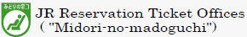
Tokyo Station is a huge station, so please secure around 30-40 minutes for changing to and getting a ticket for the Hokuriku Shinkansen (Bullet Train “Asama”, “Hakutaka”, and “Kagayaki”).
Note: Nagano station is not the last stop now. The line has been extended to Kanazawa station (Ishikawa Pref.) since March 2015. Please be careful not to oversleep in the train.
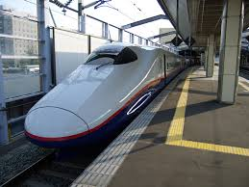
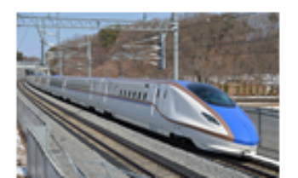
If you wish to get off at Sakudaira Station to join the technical tour in the morning on Monday, May 18, please make sure to get on an Asama or Hakutaka, which stop at Sakudaira. (* Not every Asama/Hakutaka stops at Sakudaira.) If you are not sure, please consult at JR EAST Travel Service Counter. Tickets are available at 6,340JPY for Sakudaira.
Asama E2 car
Asama E7 car

Ticket: Hokuriku Shinkansen
Cost for reserved seat: 8,200 JPY/one way
Travel time: 85-95 minutes
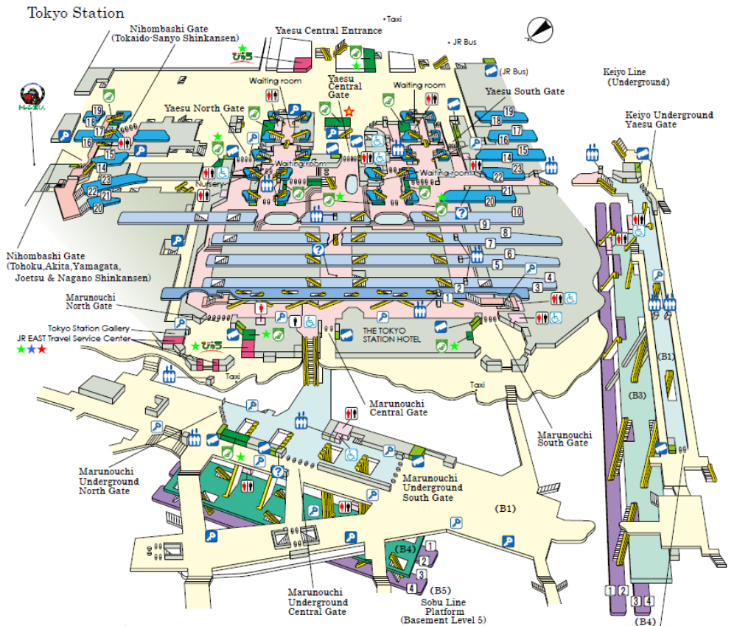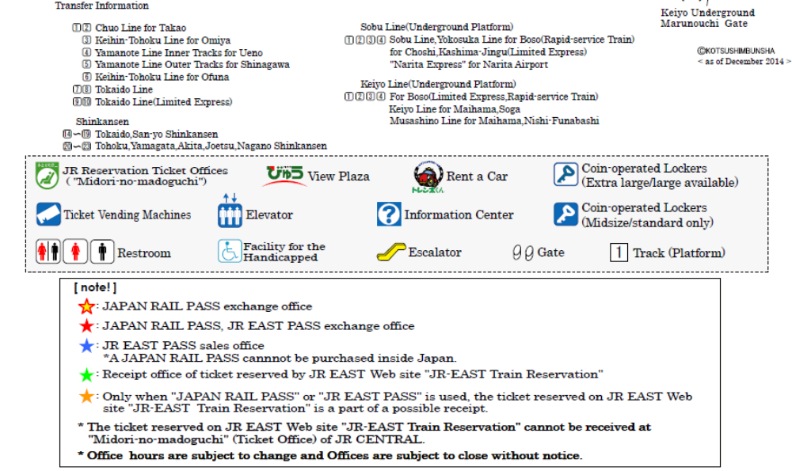
Map of Tokyo Station
Arriving Platform from Narita Airport when using N’EX
Arriving Platform (#4) from Haneda Airport when coming on Yamanote Line
Shinkansen Platform for Nagano
Shinkansen Tickets are available at any JR Reservation Ticket Office with
this sign :


2.3 Useful Websites for Train Options
HyperDia
http://www.hyperdia.com/en/

Japan Rail Pass
http://www.jrpass.com/

- Venue
Mielparque-Nagano
Access: 5 minute walk from the east exit of JR Nagano Station.
Address: 752-8, Tsuruga-takahata, Nagano-City, Nagano 380-858, Japan
TEL: +81-26-225-7800
FAX: +81-26-225-7801
Mielparque-Nagano
Web: http://www.mielparque.jp/ngn/eng.html
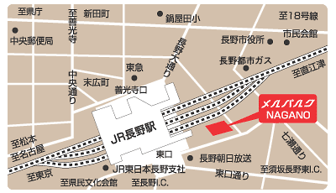
East Exit
Venue & Hotel: Mielparque-Nagano
JR Nagano
station
Meeting Room Information:
- Meeting room “Hikari” on the 4th floor (see the floor maps below)
- Capacity: 20 persons
- Booked Hours:
9:00 a.m.-17:00 p.m. (May 19-20),
9:00 a.m.-16:00 p.m. (May 21).
- High speed Internet access (wireless)
- Coffee, tea, and water available (self-serve)
- No snack is allowed in the meeting room as per the venue rental policy.
- The meeting room may be locked by a hotel staff during lunch break when no one is using the room.
- Note: Please make sure that every attendee leaves the room by 17:30 at the latest for its subsequent use by others.

Zenkoji Exit

Venue & Hotel: Mielparque-Nagano

Access from JR Nagano Station
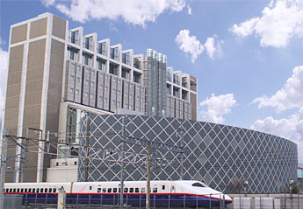

Mielparque-Nagano

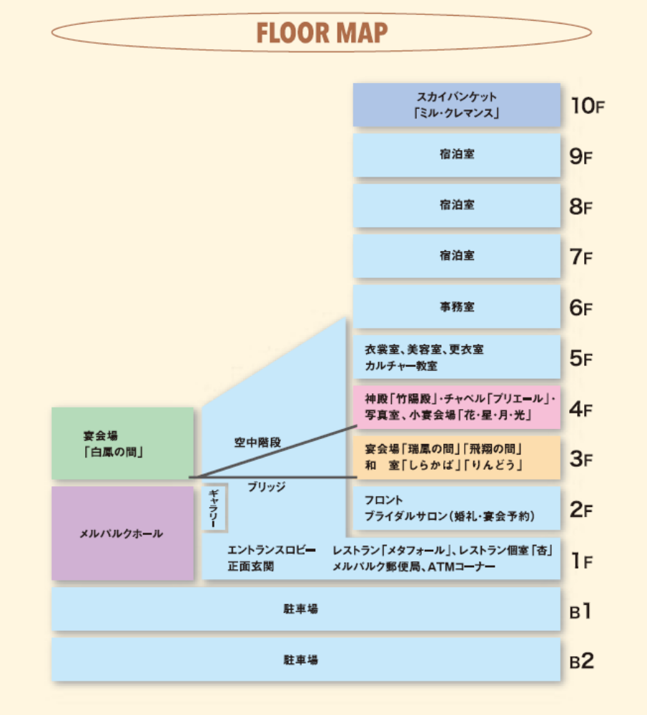
Banquet Hall
Banquet Hall
Parking
Parking
Office
Guest Rooms
Guest Rooms
Guest Rooms
Banquet Hall
Front Desk
Lobby, Restaurants, Post Office, Cash Dispenser
Powder room, etc.
Small Banquet Halls
Small Meeting Rooms
Mielparque-Nagano

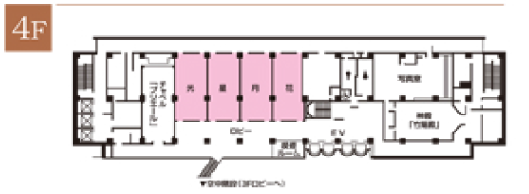
CMC Meeting Room “Hikari”
Elevators
Bathroom
光

- Others
Visa Requirements
Local Secretariat below will support your application to visa to enter Japan. Please contact the Local Secretariat for support.

Link: The Ministry of Foreign Affairs of Japan: http://www.mofa.go.jp/index.html)

Local Secretariat*
Contact person: Naoko TOBARI
Space Tracking and Communications Center, JAXA
Address: 2-1-1 Sengen, Tsukuba-shi, Ibaraki 305-8505, Japan
Phone: +81-50-3362-4038, Fax: +81-29-868-2990
E-mail: tobari.naoko@jaxa.jp
* Effective on the 1st of April, the Local Secretariat will be replaced. Please pay attention to further notice. We are sorry for the inconvenience this may cause you.

Climate
Mid-Spring (May)
May is spring season in Japan with the average temperature of around 16 degrees Celsius. In May, the weather is mild and only a long-sleeved shirt would be enough during the day, but in the evening, a light jacket might be your help to keep you feel comfortable. Although Nagano is slightly colder than Tokyo, most days are generally warm and comfortable.

