Technical corrigendum for 211.2-B-3

FROM
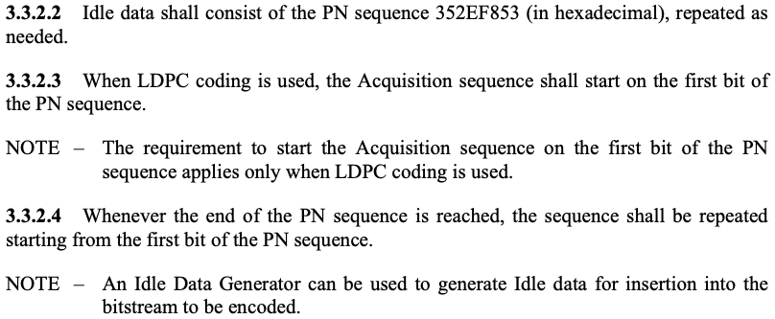
TO

3.3.2.3 When LDPC coding is used, octet synchronization shall be maintained between the PLTUs and LDPC codewords as follows.
- The first LDPC message block shall start with the first bit of the Acquisition Sequence, and this shall be the first bit of the PN sequence defined in 3.3.2.2.
- The Acquisition Sequence shall be an integer number of octets in length.
- Idle data inserted between PLTUs shall start with the first bit of the PN sequence defined in 3.3.2.2, and shall be an integer number of octets in length.
NOTE – These synchronization requirements apply only when LDPC coding is used.

