

Report Concerning Space Data System Standards

|  |
| --- |
| Video Quality for space applications |

Draft Informational Report

CCSDS 000.0-G-0

Draft Green Book

November 2010

AUTHORITY

|  |  |  |  |
| --- | --- | --- | --- |
|  | | | |
|  | Issue: | Draft Green Book, Issue 0 |  |
|  | Date: | November 2010 |  |
|  | Location: | Not Applicable |  |
|  | | | |

**(WHEN THIS INFORMATIONAL REPORT IS FINALIZED, IT WILL CONTAIN THE FOLLOWING STATEMENT OF AUTHORITY:)**

This document has been approved for publication by the Management Council of the Consultative Committee for Space Data Systems (CCSDS) and reflects the consensus of technical panel experts from CCSDS Member Agencies. The procedure for review and authorization of CCSDS Reports is detailed in the *Procedures Manual for the Consultative Committee for Space Data Systems*.

This document is published and maintained by:

CCSDS Secretariat

Space Communications and Navigation Office, 7L70

Space Operations Mission Directorate

NASA Headquarters

Washington, DC 20546-0001, USA

FOREWORD

Through the process of normal evolution, it is expected that expansion, deletion, or modification of this document may occur. This Report is therefore subject to CCSDS document management and change control procedures, which are defined in the *Procedures Manual for the Consultative Committee for Space Data Systems*. Current versions of CCSDS documents are maintained at the CCSDS Web site:

http://www.ccsds.org/

Questions relating to the contents or status of this document should be addressed to the CCSDS Secretariat at the address indicated on page i.

At time of publication, the active Member and Observer Agencies of the CCSDS were:

Member Agencies

* Agenzia Spaziale Italiana (ASI)/Italy.
* Canadian Space Agency (CSA)/Canada.
* Centre National d’Etudes Spatiales (CNES)/France.
* China National Space Administration (CNSA)/People’s Republic of China.
* Deutsches Zentrum für Luft- und Raumfahrt e.V. (DLR)/Germany.
* European Space Agency (ESA)/Europe.
* Instituto Nacional de Pesquisas Espaciais (INPE)/Brazil.
* Japan Aerospace Exploration Agency (JAXA)/Japan.
* National Aeronautics and Space Administration (NASA)/USA.
* Federal Space Agency (FSA)/Russian Federation.
* UK Space Agency/United Kingdom.

Observer Agencies

* Austrian Space Agency (ASA)/Austria.
* Belgian Federal Science Policy Office (BFSPO)/Belgium.
* Central Research Institute of Machine Building (TsNIIMash)/Russian Federation.
* China Satellite Launch and Tracking Control General, Beijing Institute of Tracking and Telecommunications Technology (CLTC/BITTT)/China.
* Chinese Academy of Sciences (CAS)/China.
* Chinese Academy of Space Technology (CAST)/China.
* Commonwealth Scientific and Industrial Research Organization (CSIRO)/Australia.
* CSIR Satellite Applications Centre (CSIR)/Republic of South Africa.
* Danish National Space Center (DNSC)/Denmark.
* Departamento de Ciência e Tecnologia Aeroespacial (DCTA)/Brazil.
* European Organization for the Exploitation of Meteorological Satellites (EUMETSAT)/Europe.
* European Telecommunications Satellite Organization (EUTELSAT)/Europe.
* Geo-Informatics and Space Technology Development Agency (GISTDA)/Thailand.
* Hellenic National Space Committee (HNSC)/Greece.
* Indian Space Research Organization (ISRO)/India.
* Institute of Space Research (IKI)/Russian Federation.
* KFKI Research Institute for Particle & Nuclear Physics (KFKI)/Hungary.
* Korea Aerospace Research Institute (KARI)/Korea.
* Ministry of Communications (MOC)/Israel.
* National Institute of Information and Communications Technology (NICT)/Japan.
* National Oceanic and Atmospheric Administration (NOAA)/USA.
* National Space Agency of the Republic of Kazakhstan (NSARK)/Kazakhstan.
* National Space Organization (NSPO)/Chinese Taipei.
* Naval Center for Space Technology (NCST)/USA.
* Scientific and Technological Research Council of Turkey (TUBITAK)/Turkey.
* Space and Upper Atmosphere Research Commission (SUPARCO)/Pakistan.
* Swedish Space Corporation (SSC)/Sweden.
* United States Geological Survey (USGS)/USA.

DOCUMENT CONTROL

|  |  |  |  |
| --- | --- | --- | --- |
| **Document** | **Title and Issue** | **Date** | **Status** |
| CCSDS 000.0-G-0 | [Document Title], Draft Informational Report, Issue 0 | November 2010 | Current draft |
|  |  |  |  |
|  |  |  |  |

CONTENTS

Section Page

1 Introduction 1-1

1.1 Rational AND PURPOSE OF THIS Document 1-1

1.2 Scope 1-1

1.3 References 1-2

2 Use Cases 2-1

2.1 Temporal and Spatial Impacts to Video Quality 2-1

2.2 Reference File characteristics 2-1

3 Video Quality and Assessment Tools 3-3

3.1 Definitions 3-3

3.2 Instrumental quality estimation 3-5

3.2.1 Video Quality Estimation 3-5

4 Methods for measuring quality 4-8

5 Example 5-10

5.1 Artemis SLS Reference Files Example 5-10

5.2 “Head-and-Shoulder” Video Test Example 5-14

5 aNNEX A A-17

# Introduction

## Rational AND PURPOSE OF THIS Document

An understanding of imagery quality for space applications and a method for standardizing motion imagery quality testing for space applications is needed to meet mission objectives and provide imagery suitable for public consumption and technical analysis. Motion imagery is usually compressed for storage and may be further compressed when transmitted. Each time imagery is compressed, quality is degraded. Requirements for motion imagery quality are generally nonspecific except for specialized space imagery systems, such as scientific cameras and guidance, navigation, and controls cameras. The lack of specific requirements can lead to unfulfilled end user expectations. A method for determining the quality of compressed video in an objective manner is needed to maximize imagery quality while minimizing downlink bandwidth.   
The purpose of this document is to identify a set of common motion imagery quality measurement methods and an example. A set of reference files composed of the same imagery at different compression and quality settings is also described. These reference files can be used to test imagery systems and assess image quality.

## Scope

This document describes quality measures for recorded motion imagery transmitted from space to ground, ground to space, and space to space.

The scope does not include video source specification.

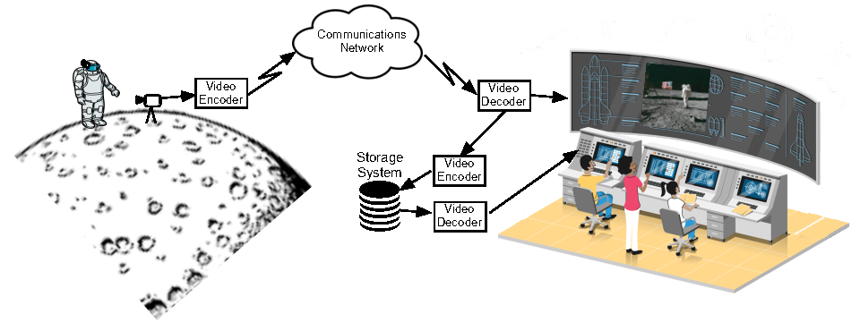

**Figure 1-1: Representative video transmission path.**

## References

The following documents were referenced in the development of this report. All documents are subject to revision. Users of this report are encouraged to investigate the possibility of applying the most recent editions of the documents indicated below.

[1] Digital Motion Imagery, Recommended Standard CCSDS 766.1-B-3. Washington, D.C.: CCSDS, April 2021.

[2] ITU-R Rec. BT.500-15, “BT Series: Broadcasting service (television) Methodologies for the subjective assessment of the quality of television images”, May 2023.

[3] Jekosch, U., ”Voice and Speech Quality Perception: Assessment and Evaluation”. Springer, GER-Berlin, 2005.

[4] Möller, S. and Raake, A. Eds., ”Quality of Experience: Advanced Concepts, Applications and Methods”, 1st ed. Springer, GER-Heidelberg, 2014.

[5] ITU-T Rec. E.800, ”Definitions of Terms related to Quality of Service”, International Telecommunication Union, CH-Geneva, 09/2008.

[6] ITU-T Rec. P.10/G.100, ”Vocabulary for Performance, Quality of Service and Quality of Experience”, International Telecommunication Union, CH-Geneva, 11/2017.

[7] ETSI TS 103 294, ”Speech and Multimedia Transmission Quality (STQ); Quality of Experience; A Monitoring Architecture”, European Telecommunications Standards Institute, FRA-Sophia Antipolis, 12/2014.

[8] Raake, A., “Speech Quality of VoIP: Assessment and Prediction.” John Wiley and Sons, UK-Chichester, 2006.

[9] Wältermann, M., “Dimension-based Quality Modeling of Transmitted Speech.” SpringerVerlag, GER-Berlin, 2013.

[10] Winkler, S., “Digital Video Quality - Vision, Models and Metrics.” John Wiley and Sons, UK-Chichester, 2005

[11] Wang, Z. and Bovik, A., “A Universal Image Quality Index”. IEEE, 2002.

[12] Brunet, D. and Vrscay, E. and Wang. Z., “On the Mathematical Properties of the Structural Similarity Index.” IEEE Transaction on Image Processing, Vol 21, No.2,2012

[13] Zhi li, et al., Netflix TechBlog, “VMAF: The Journey Continues,” URL: https://netflixtechblog.com/vmaf-the-journey-continues-44b51ee9ed12, Oct. 2018, last visit: 09/2024

[14] Tektronix, “Understanding PQR, DMOS, and PSNR Measurements – Application Note”, 2008.

[15] ITU-T Rec. P.1204, ”Video quality assessment of streaming services over reliable transport for resolutions up to 4K”, CH-Geneva, 2023.

[16] ITU-T Rec. P.800.1, “Mean opinion score (MOS) terminology”, CH-Geneva: ISO/IEC, 2016.

[17] Schiffner, F., “Dimension-Based Quality Analysis and Prediction for Videotelephony (T-Labs Series in Telecommunication Services)”, Springer-Verlag, CH-Geneva, 2020.

# Use Cases

Video transmission is dependent on many parameters. It is not sufficient to specify a resolution, frame rate, encoding method, and data rate to cover all use cases. What is acceptable for a relatively static scene may not be acceptable for a scene with fast or unpredictable motion. A set of reference files will be established to aid the user in selecting components for their motion imagery system. These scenes may be used to evaluate acceptability of the video system.

One key goal of this document is to describe a set of reference files that can be ingested into encoding systems and/or downlink paths to ensure encoding and transmission errors do not impair image quality. Use cases are described based on temporal and spatial complexity of scenes. Reference files are chosen based on scenarios an imagery system is used for. In the domain of space flight, these scenarios are defined in CCSDS Recommendation [1]:

* Personal Conferencing
* Medical conferencing
* Proximity operations / situational awareness
* Public affairs
* High resolution imaging
* Crew training and instructions

## Temporal and Spatial Impacts to Video Quality

Compression algorithms are challenged by a scene’s spatial and temporal complexity. Therefore, reference files are chosen based on the spatial and temporal characteristics of the expected use case. The calculation of the temporal and spatial activity indices can help to identify unexpected performance. Further, a deviation from expected values can be an indicator of specific video degradation.

For example, an abrupt drop in spatial information could be indicating that a bit rate was lowered, resulting in a more blurred image. At this point, the quality rating will drop. Another example is, when the temporal information rises, it could mean that more noise is introduced to the video, leading to a degrading video quality score. Therefore, the Spatial Activity Index and the Temporal Activity Index are linked to video quality and especially helpful to find indicators where a quality impairment occurred [2]. This holds true, when monitoring longer sequences and the video quality model only returns an average score for the whole sequence. As shown in Table 2-1 the spatial and temporal information of the video sequence can help to categorize the sequences and choose the right corresponding values (test files, setups etc.).

## Reference File characteristics

The following table describes imagery characteristics for reference files which will be used to assess quality based on representative use cases.

**Table 2-1: Overview and description of spatial and   
temporal characteristics of video imagery.**

|  |  |  |  |
| --- | --- | --- | --- |
| **Spatial** | **Temporal** | **Description** | **Example Use Case** |
| Complicated | Complicated | * Non-predicable motion * Dynamic lighting | 1. Polar regions of the lunar surface 2. Launch environment |
| Complicated | Simple | * High detail content * Minimal scene motion | 1. Moon rock selection 2. Talking head with a complex background |
| Simple | Complicated | * Low detail content * Dynamic lighting * Rapid scene motion | 1. Events in the void of space - Onboard camera looking at engine nozzle against the void of space (when the engine ignites there’s movement) |
| Simple | Simple | * Low detail content * Stationary subject and background * No dynamic lighting * Minimal scene motion | 1. Talking head with a simple background |

# Video Quality and Assessment Tools

## Definitions

It is necessary to determine what is considered “good quality” and measure the products and services accordingly. The following is a list of important definitions to understand quality.

Quality is broadly defined as:

“Quality is a result of a comparison between the perceived composition of an entity and the desired composition. [3]”

Quality measurements or models are based on human perception and judgment as illustrated in Figure 3-1 and 3-2. Accordingly, human factors such as expectations, experience, mood, and knowledge all play a role. The entity does not necessarily have to be a physical object. It can also be a service (such as a telephone service), which has features for which the quality may be quantified. Regarding the descriptions in literature, the terminology often varies. The term Quality of Experience (QoE) is often used although Quality of Service (QoS) is more appropriate. The terms are not clearly separated, and QoE [4] is often used due to marketing reasons. Nevertheless, it is important to distinguish them.

The term QoS as defined in ITU Rec. E.800 [5]:

“The totality of characteristics of a telecommunications service that bear on its ability to satisfy stated and implied needs of the user of the service.”

The IETF has a stronger network-centric definition on QoS, where the user is not mentioned at all:

“A set of service requirements to be met by the network while transporting a flow.”

On the other hand, the term QoE as defined in ITU-T Rec. P.10 [6]:

“The overall acceptability of an application or service, as perceived subjectively by the end-user.”

Another similar QoE definition comes from ETSI (TS 103 294) [7]:

“Degree of delight or annoyance of the user of an application or service.”

QoS is often used in practice when describing concepts and measures for network performance (like jitter or delay). In some instances, it is also used regarding forms of network traffic engineering, such as rate policing. QoE, as a term, is often used in ways which no longer fit the original definition. In the literature, one can read about “improving the QoE,” where, for example, a technology for reducing the delay is described. This could indeed lead to a better QoE but is still more related to QoS because it does not take the user, the context, etc., into account. If the relationship between QoS and QoE is understood correctly, network performance can be enhanced.

Summarizing, both QoS and QoE reflect different viewpoints on the quantification of quality, although intersections exist between both. As a rule of thumb, QoE is referencing the user’s point of view, whereas QoS reflects the network/service provider’s point of view. This should be kept in mind when talking about quality.

**3.1.2 Subjective Quality Judgment**

In general, quality is a result of a highly complex judgment process, as shown in Figure 3-1. Because quality judgment is purely subjective, quality cannot be objective. It always needs, directly or indirectly, a subjective rating as baseline.

As an example: if the object is a visual signal, e.g. a video sequence, the perceived features (color, brightness, etc.) will be detected. The composition of these features will define what the video look like ("is the swan black or white"). In order to obtain statements about the video quality, primarily the human evaluates. The process can be deconstructed in several steps (comp. Raake [8] and Jekosch [3]):

1. Optical event: Is a physical process and is determined through its physical properties (e. g. wavelength). An optical event is objective and exists independently from subjective perception. In this example, it would be the transmitted video on a screen.

2. Perception: The optical event is received by the human visual system (eyes, nerves, visual cortex, etc.). At this moment, the optical event becomes a perceptual event ("visual event"). It contains an amount of possible information (e. g. brightness, frequency content). In addition, all information, emotional state, situation, experience, etc. plays a role in the perception. All of these factors continually adapt to the perception of what has been seen.

3. Consideration: The receiver considers all factors of what has been seen. In the process of forming the quality judgment, only the quality-relevant features are considered subconsciously.

4. Comparison: The perceived features are now internally compared with the expected constitution of the features. There can be different values for different features (e. g. the brightness was as expected, but the color was dull). The distance between these values forms the basis for the subsequent step.

5. Judgment: The receiver now takes the distances from all features into account. The distances are weighted differently depending on their size and importance, and finally, the overall rating is formed. In the example (transmitted video), the color was not as expected leading to a low overall quality. The receiver can describe the video (e.g. "The video had a very dull color (description of features), but the overall quality was “fair” (description of quality)").

It should be noted that, the quality judgment of "something" is not static but constantly changing, especially with improvement in technology, and therefore shifting the expectations of the viewer.

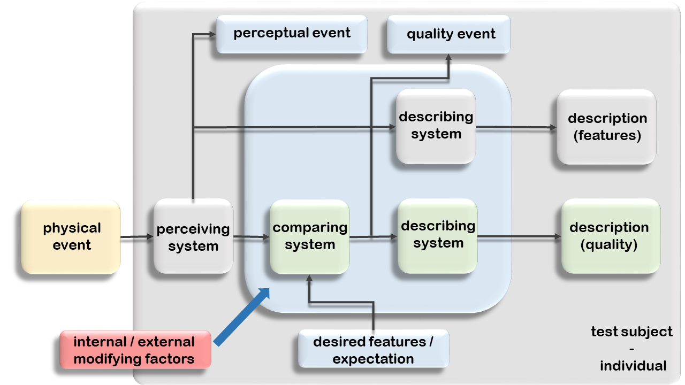

**Figure 3-1: Schematic representation of a person forming a quality rating (based [8], [9])**

## Instrumental quality estimation

Quality models may be used to estimate the perceived quality of encoded and transmitted video. These models are often referred to as objective models or instrumental estimation. They use signal measurement and estimation to predict the quality as rated by a person. There are several different approaches to do so, depending on the targeted use case. The following section provides an overview of the central concepts of instrumental quality estimation.

### Video Quality Estimation

Video quality can be estimated using two different modeling approaches: Full-Reference (used when a reference signal can be obtained) or No-Reference (used when no reference signal can be obtained).

* **Full-Reference:** In this method, the reference signal is required as well as the transmitted signal. Here the two signals are compared, and with the help of quality metrics, the differences are quantified. If the difference is significant due to impairments, the resulting estimation of the quality rating will be low.
* **No-Reference:** As the name suggests, the reference signal is not available to estimate the quality. In other terms, no comparison between a reference and the transmitted signal is performed. The quality ratings are purely done by analyzing the transmitted signal. A potential risk is actual content can be interpreted as an impairment and can reduce the quality score (e. g. a chessboard is interpreted as block artifact).

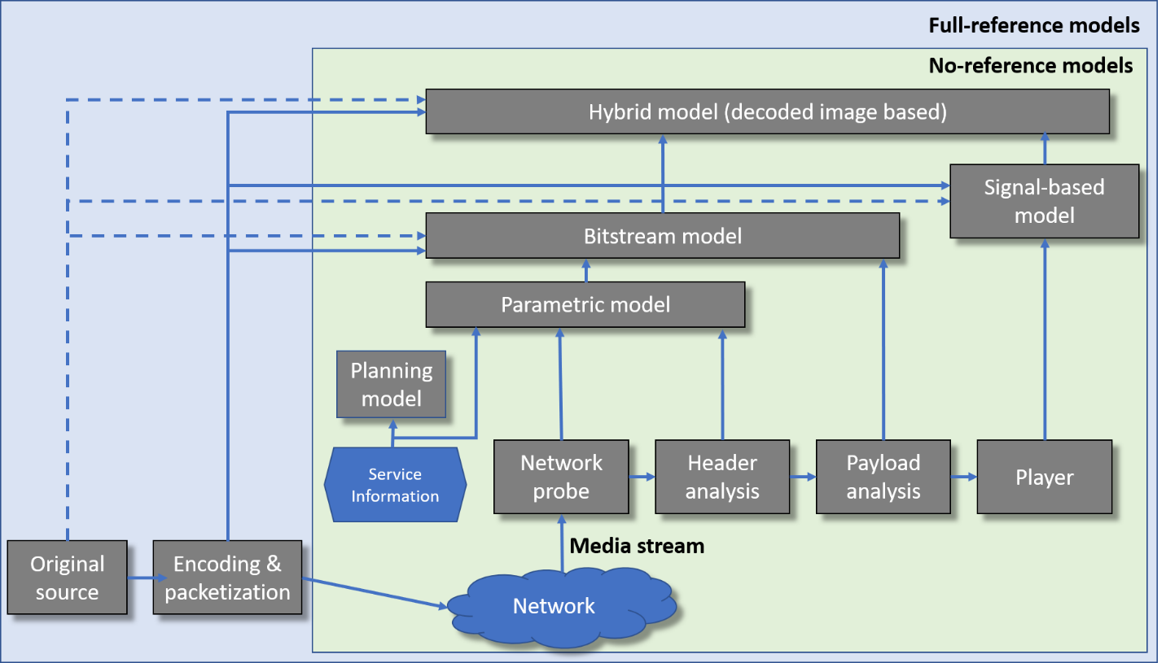

**Figure 3-2: Depiction and categorization of video quality assessment algorithms and approaches, adapted from [4].**

#### Reference Cases

Use of a reference scene gives the measurement system a basis for measuring transmission system degradation. It is not always practical to obtain imagery that is an exact match of what is anticipated for a mission. Mission analogs can be helpful for obtaining similar imagery. Reference files which represent picture elements that are equivalent to anticipated mission imagery can be sent through the transmission system to provide users with useful quality data. This serves mainly to document the relative image quality from a mission and can indicate operational modes that provide better imagery from a deployed system.

#### No Reference Cases

As described, measurement systems and their applied quality model are available to provide metrics of video quality. Non-Reference models are undesirable as there is nothing to base the measurement against. If the source video is poor, the measurement system will grade it poorly, even if the transmission system worked flawlessly.

*Video Quality Metrics*

It is widely accepted that the assessment of video quality is a complex problem. Therefore, a multitude of different approaches and metric were developed. This section will give a tiny glimpse of different measures and approaches on video quality.

Some of the most often used metrics in image and video processing that do not account for human perception models are the Mean Squared Error (MSE) and the Peak Signal-to-Noise Ratio (PSNR) [10]. The MSE is the mean of the squared differences between the gray-level values of pixels in two frames. The Root Mean Square Error (RMSE) is simply the square root of the MSE. The PSNR is a measure given in decibels and is a relative value in comparison to the maximum value a pixel can take. The main advantage of these metrics is that they are easy to compute. Nevertheless, the main drawback is that they have only an approximate relationship to different kinds of degradations and quality ratings.

Another metric is the Structural Similarity (SSIM) index [11], [12]. It was designed as a full-reference metric to improve previously mentioned methods (MSE, PSNR). SSIM is a perception-based model that considers image degradation as a perceived change in structural information. Further, it includes information about luminance and contrast, in addition to their masking effects.

VMAF (Video Multimethod Assessment Fusion) is a perceptual video quality assessment algorithm developed by Netflix [13]. As the name suggests, the algorithm combines different approaches for image and video quality. The resulting value provides an approximation about the quality rating a human viewer would give. The algorithm is indented to use as a full reference model. It is free accessible, and this leads to a fast popularization. Further, it also provides a set of tools that allows a user to train and test a custom VMAF model.

Furthermore, the DMOS (Difference Mean Opinion Score) as a metric often used in image and video quality assessment. Here, a reference file and the test file (e.g. transmitted video sequence) are rated separately on a 5-point scale ranging from (bad - 1 to excellent – 5). To obtain the DMOS, the score of the reference file is subtracted from the score of the test file. The calculate DMOS value for a particular test video sequence represents the subjective quality of the test video relative to the reference video used in the evaluation [14].

Besides, the aforementioned metrics and approaches to obtain meaningful results from video quality, there a many more models and metrics used in image and video quality assessment e.g. the model series standardized within the ITU-T (e.g. Rec. 1204 Series) [15]. Depending on the use case, the instrumental availability or time and cost constrains, it could beneficial to familiarize with different approaches.

# Methods for measuring quality

Compression, transmission, and decompression of video typically affects the quality of final video output. It is ideal to determine final video quality through end to end testing.  However, it is not always possible for a developer to test the entire system. In that case, only segments of the entire transmission path can be characterized. Therefore, a method of measuring quality of various segments of the data path should be pursued.

A quantitative measurement of video quality can be made by comparing a raw uncompressed video file with the resulting video file after it has been compressed and decompressed. Video quality testing (instrumental or subjective) can be very time and cost consuming. So, commercial off the shelf (COTS) products are available to perform a comparison of original video to final video. Many of these COTS products have developed their own measurement schemes along with using standard processes as described in Section 3.2.1.

One tool used for video file comparison is ClearView software created by Video Clarity which provides a Just Noticeable Differences (JND) value.  ClearView compares every pixel in every frame of a source video file with the processed file. While the software provides a variety of measurement parameters, Peak Signal to Noise Ratio (PSNR) [14] and Just Noticeable Difference (JND) are commonly used to assess video quality.

PSNR is the ratio between maximum signal power and the power of corrupting noise. In the case of video quality estimation, PSNR is the comparison between the source video file and the error introduced by compression/decompression. However, this measurement can breakdown with blurred images, artifact blocking, and even some noise not showing up in the measurement.  Therefore, additional tools beyond PSNR should be used.  In Table 4-1 below, PSNR values are described.

**Table 4-1: PSNR, description and associated values.**

|  |  |
| --- | --- |
| **Description** | **PSNR** |
| Very poor quality | -20 |
| Annoying to watch | 20-25 |
| Slight annoyance | 25-31 |
| Slight perceptible difference | 31-37 |
| Imperceptible difference | 37+ |

JND is a video quality metric based on the Sarnoff JND vision model.  The goal of this metric is to quantitatively and systematically assess what had previously been viewed as human perception. In Table 4-1 below, JND values are described.

**Table 4-2: JND, description and associated values.**

|  |  |
| --- | --- |
| **Description** | **JND** |
| Video probably not aligned | 13+ |
| Unwatchable | 10 – 12.99 |
| Annoying | 7.0 – 9.99 |
| Broadcast Quality | 2.0 – 6.99 |
| Production Quality | 0.01 – 1.99 |
| No Defects | 0 |

Since the space community has very specific needs in terms of imagery quality and types of imagery, as described in section 2, a set of reference files should be developed. In addition, these reference files should then be assessed for various uses such as Photogrammetry, Scientific Analysis, General Inspection, Public Affairs, and other typical mission support use cases.

Therefore, it is necessary to develop a standard process and dataset using the following steps:

1. Generation of a reference file dataset (representative scenes, reflecting the different use cases shown in Section 2).
2. Generation of a degradation dataset from the reference files (reflecting the possible video impairments for each case).
3. Gathering of Mean Opinion Scores (MOS) [16] from imagery experts in the fields used for space missions (from subjective tests to a baseline quality score)
4. Calculate values from standardized video quality methods and models.
5. Correlate results from steps 3 and 4.
6. Publish dataset and data sheet with quality scores for each case.

Once the above is completed, an end user will be able to levy an exact requirement on various portions of their system and allow the program to obtain the desired imagery quality.

# Example

Below is an example data set previously developed for the Artemis Space Launch System (SLS) program. This data set was developed for vehicle-based camera systems. It provides representative video types showing expected complexity and scene changes.

This data set is categorized as Analysis Quality, High Quality, and Low Quality.  Analysis quality is used for high precision analysis. High quality is required for mission critical events with no pre-defined analysis. Low quality is acceptable for situational awareness.

## Artemis SLS Reference Files Example

Artemis SLS reference files, mentioned in this section, were used to assess video quality. The output of the videos from the encoder was assessed to determine the video products’ PQR and PSNR values for a instrumental quality assessment.

**Static Booster Firing Video Test Sample:** This scene sample allows for the video system’s compression performance to be tested to the video motion challenges that are expected to be seen during the ascent stage of the flight.

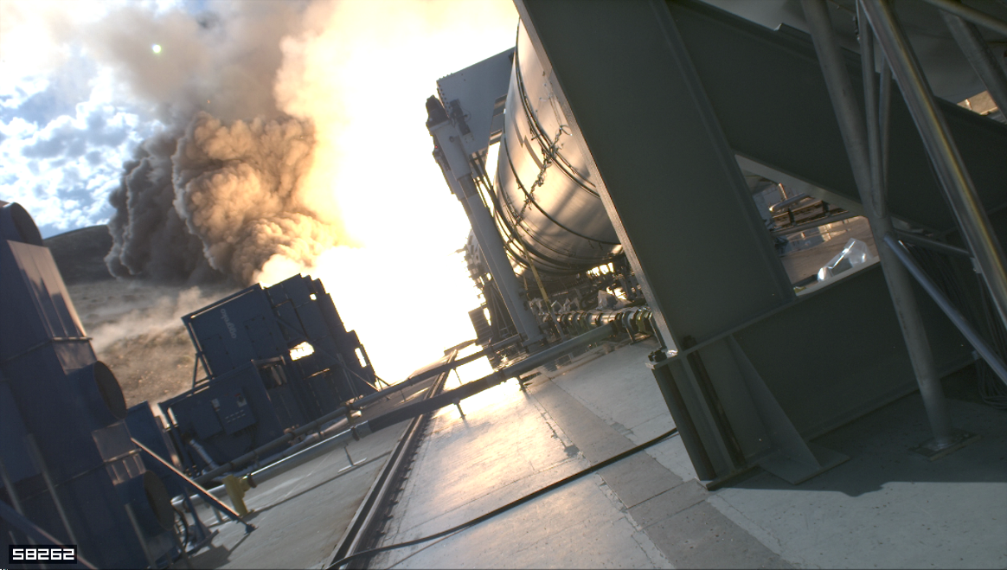

**Figure 5- 1: Static booster firing, video image capture.**

**Shadow Movement Video Test Sample:** This scene sample allows for the video system’s compression performance to be tested to the video motion challenges that are expected to be seen when shadows move through the video field of view during maneuvers such as vehicle rolls during ascent, thermal rolls or attitude changes while in orbit.

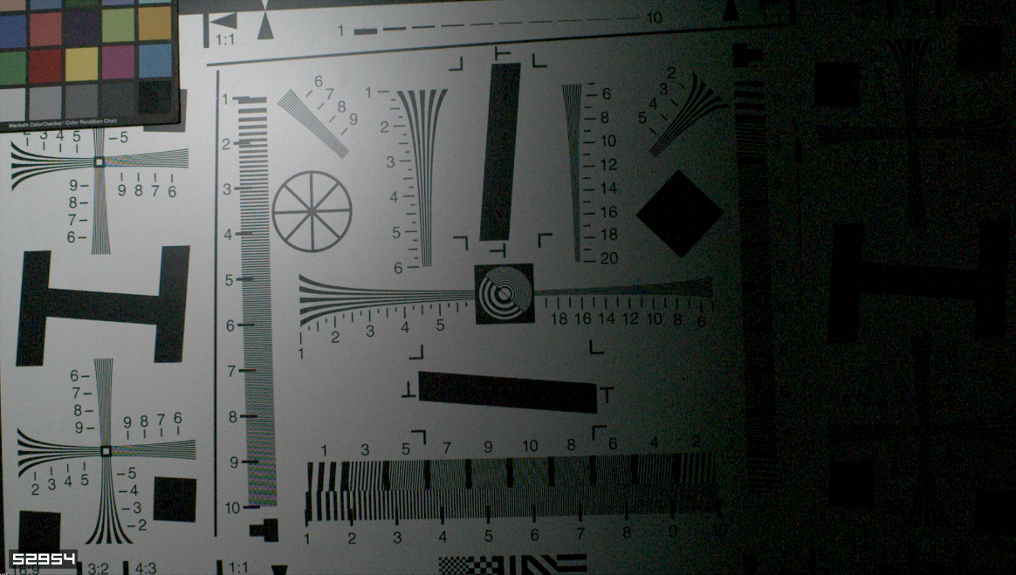

Figure 5-2. Shadow movement, video image capture.

* **Debris Complex Scene Video Test Sample:** This scene sample allows for the video system’s compression performance to be tested to the video motion challenges that are expected to be seen during off-nominal events and during complex scenes such as clearing the launch pad.

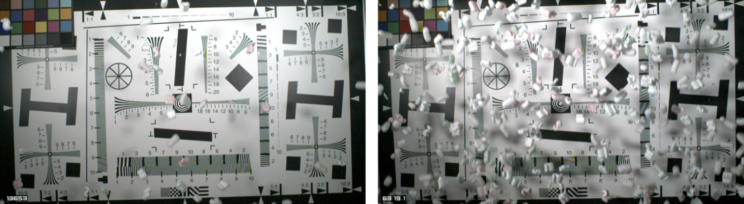

Figure 5-3. Video material representing debris, video image capture.

* **Artemis SLS Image Quality for HEVC Video**

The compressed image quality performance characteristics (PQR and PSNR) for the Artemis SLS subsystem will meet the following criteria as shown in Table 5-1 (Low Quality Compressed Imagery), Table 5-2 (High Quality Compressed Imagery) and Table 5-3 (Photogrammetry Quality Compressed Imagery).

Table 5-1: Low quality compressed imagery (2.0 Mbps - 3.0 Mbps) quality parameters

| **Low Quality Video (HEVC)**  **(Compression Encoding 2.0 Mbps - 3.0 Mbps)** | | | |
| --- | --- | --- | --- |
| **Scene** | **JND Less than** | **PQR**  **Less than** | **PSNR**  **Greater than** |
| Static Booster Firing Video Test Sample | 3.0 | 2.5 | 38 |
| Shadow Movement Video Test Sample | 5.0 | 3.0 | 31 |
| Debris Video Test Sample | 6.0 | 8.0 | 25 |

Table 5-2. High quality compressed imagery (4.0 Mbps - 5.0 Mbps) quality parameters

| **High Quality Video (HEVC)**  **(Compression Encoding 4.0 Mbps - 5.0 Mbps)** | | | |
| --- | --- | --- | --- |
| **Scene** | **JND Less than** | **PQR**  **Less than** | **PSNR**  **Greater than** |
| Static Booster Firing Video Test Sample | 2.5 | 1.75 | 42 |
| Shadow Movement Video Test Sample | 4.5 | 2.75 | 32 |
| Debris Video Test Sample | 5.5 | 6.0 | 28 |

Table 5-3. Photogrammetry quality compressed imagery   
(7.0 Mbps - 8.0 Mbps) quality parameters

| **Analysis Quality Video (HEVC)**  **(Compression Encoding 7.0 Mbps - 8.0 Mbps)** | | | |
| --- | --- | --- | --- |
| **Scene** | **JND Less than** | **PQR**  **Less than** | **PSNR**  **Greater than** |
| Static Booster Firing Video Test Sample | 2.0 | 1.5 | 43 |
| Shadow Movement Video Test Sample | 4.0 | 2.5 | 33 |
| Debris Video Test Sample | 4.5 | 4.0 | 30 |

## “Head-and-Shoulder” Video Test Example

These scenes simulate a typical video-speech-telephony situation. This can be representative for an astronaut talking to a mission control center. The example below shows different video degradations. The following tables show their impact on the quality score, as rated by human viewers. This example is intended to highlight completely different appearing video degradations can have the same impact on the perceived quality and vice versa (taken from [17]). Therefore, video quality estimation and assessment should always be conducted with the understanding that different root causes for video impairments can result in different quality impacts.

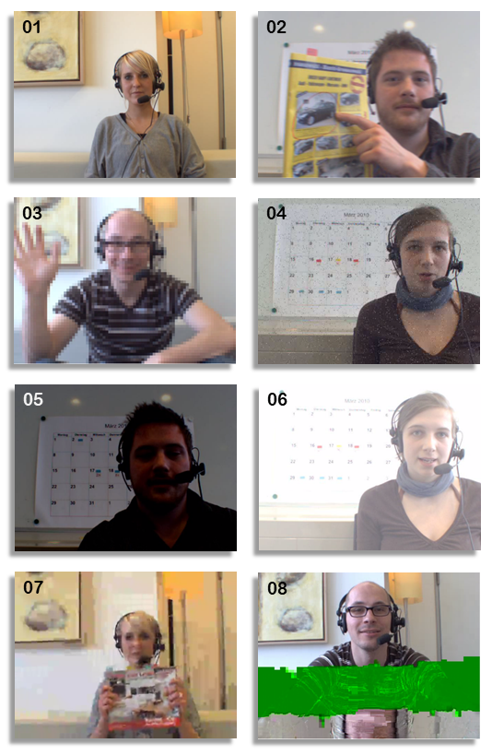Table 5-4-: Video quality (VQ) rating from the subjective experiment, 95% confidence interval (CI95%) – corresponding examples shown left.

|  |  |  |
| --- | --- | --- |
| **Condition** | **VQ** | **CI95%** |
| Reference (01) | 4.07 | 0.41 |
| Blockiness 5x5 (03) | 2.09 | 0.40 |
| Blockiness 8x8 | 1.52 | 0.40 |
| Blurring F1 (02) | 2.67 | 0.40 |
| Blurring F7 | 1.93 | 0.40 |
| Jerkiness 6 | 2.94 | 0.40 |
| Jerkiness 11 | 2.56 | 0.40 |
| NoiseQ 3% (04) | 2.42 | 0.40 |
| NoiseQ 15% | 1.95 | 0.40 |
| H.264 Bitrate 28kbps (07) | 1.45 | 0.39 |
| H.264 Bitrate 56kbps | 2.01 | 0.40 |
| Packet Loss 0.5% | 2.82 | 0.40 |
| Packet Loss 1.5% (08) | 1.74 | 0.39 |
| Lum. Impair. I (darker) (05) | 3.05 | 0.40 |
| Lum. Impair. II (brighter) (06) | 3.08 | 0.40 |

Figure 5-4-: Video degradations common in video-telephony and -conferencing.

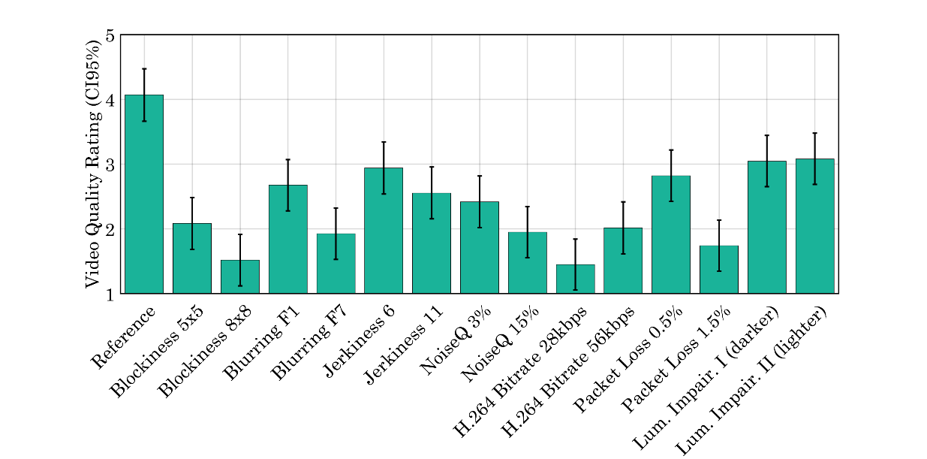

Figure 5-5. Video quality (VQ) rating, 95% Confidence interval (CI95%).

Figure

1-1 Representative video transmission path 1-1

3-1 Schematic representation of a person forming a quality rating 3-5

3-2 Depiction and categorization of video quality assessment algorithms and approaches 3-6

5-1 Static booster firing, video image capture 5-10

5-2 Shadow movement, video image capture 5-11

5-3 Video material representing debris, video impage capture 5-11

5-4 Video degradations common in video-telephony and -confrencing 5-14

Table

3-1 Dummy Table 3-2

1. INFOrmative REferences

(INFROMATIVE)

These references are listed with the intention, to guide the reader of this Green Book, to further information on the topic of quality assessment, and estimation.

[A1] Series H: AUDIOVISUAL AND MULTIMEDIA SYSTEMS Infrastructure of audiovisual services – Coding of Moving Video High efficiency video coding. Recommendation ITU-T H.265. Geneva: ITU, 2021.

[A2] AUDIOVISUAL AND MULTIMEDIA SYSTEMS Infrastructure of audiovisual services – Coding of Moving Video Advanced video coding for generic audiovisual services. Recommendation ITU-T H.264. Geneva: ITU, 2021.

[A3] (MPEG Transport Stream) Generic coding of moving pictures and associated audio information – Part 1: Systems. ISO/IEC 13818-1:2022. Geneva: ISO/IEC, 2022

[A4] Subjective audiovisual quality assessment methods for multimedia applications, ITU-T Recommendation P.911. Geneva: ISO/IEC 1998

[A5] Methods for the subjective assessment of video quality, audio quality and audiovisual quality of Internet video and distribution quality television in any environment. ITU-T Recommendation P.913, Geneva: ISO/IEC 1998

[A6] Dimension-based subjective quality evaluation for video content. ITU-T Recommendation P.918, Geneva: ISO/IEC 2020

[A7] Multimedia communications delay, synchronization and frame rate measurement. ITU-T Recommendation P.931 Geneva: ISO/IEC 1998

[A8] Parametric non-intrusive assessment of audiovisual media streaming quality – _Lower resolution application area. ITU-T Recommendation P.1201.1 Geneva: ISO/IEC 2012

[A9] Parametric non-intrusive assessment of audiovisual media streaming quality – _Higher resolution application area. ITU-T Recommendation P.1201.2 Geneva: ISO/IEC 2012

[A10] Parametric non-intrusive bitstream assessment of video media streaming quality. ITU-T Recommendation P.1202 Geneva: ISO/IEC 2012

[A11] Parametric bitstream-based quality. ITU-T Recommendation P.1203 Geneva: ISO/IEC 2017

[A12] Video quality assessment of streaming services over reliable transport for resolutions up to 4K with access to full bitstream information. ITU-T Recommendation P.1204.3 Geneva: ISO/IEC 2020

[A13] Video quality assessment of streaming services over reliable transport for resolutions up to 4K with access to full and reduced reference pixel information. ITU-T Recommendation P.1204.4 Geneva: ISO/IEC 2022

[A14] Video quality assessment of streaming services over reliable transport for resolutions up to 4K with access to transport and received pixel information. ITU-T Recommendation P.1204.5 Geneva: ISO/IEC 2023

[A15] Network model for evaluating multimedia transmission performance over Internet Protocol. ITU-T Recommendation G.1050 Geneva: ISO/IEC 2016

[A16] Opinion model for video-telephony applications. ITU-T Recommendation G.1070 Geneva: ISO/IEC 2018

[A17] Opinion model for network planning of video and audio streaming applications. ITU-T Recommendation G.1071 Geneva: ISO/IEC 2016

[A18] User Group; End-to-end QoS management at the Network Interfaces; Part 3: QoS informational structure. European Telecommunications Standards Institute (ETSI) TR 102 805-3 V1.1.1 Sophia Antipolis France: 2010

[A19] Speech and multimedia Transmission Quality (STQ); Quality of Experience. A Monitoring Architecture. ETSI TS 103 294 v1.1.1 Sophia Antipolis France: 2014

[A20] Speech and multimedia Transmission Quality (STQ); Best practices for robust network QoS benchmark testing and scoring. ETSI TR 103 559 V1.1.1 Sophia Antipolis France: 2023

[A21] Satellite Earth Stations and Systems (SES); Broadband Satellite Multimedia (BSM); Interworking with DiffServ QoS. ETSI TS 102 464 V1.2.1 Sophia Antipolis France: 2015

[A22] User Group; The assessment of the overall Quality of Services (QoS) as perceived by the users; Definition of QoS indexes for all the customer relationship stages ETSI EG 202 934 V1.1.2, Sophia Antipolis France: 2012