

|  |
| --- |
| **NAVIGATION DATA MESSAGES XML SPECIFICATION V3.0 TEST PLAN/REPORT** |

FOREWORD

This document describes the plan for testing prototype implementations of the CCSDS Navigation Data Messages XML Specification Version 3, and presents the results of that testing.

Through the process of normal evolution, it is expected that expansion, deletion, or modification of this document may occur. This document is therefore subject to CCSDS document management and change control procedures, which are defined in the *Procedures Manual for the Consultative Committee for Space Data Systems*. Current versions of CCSDS documents are maintained at the CCSDS Web site:

http://www.ccsds.org/

Questions relating to the contents or status of this document should be addressed to the CCSDS Secretariat at the address indicated on page i.

DOCUMENT CONTROL

|  |  |  |
| --- | --- | --- |
| **Document** | **Title and Issue** | **Date** |
| CCSDS 505.0-Y-1 | NDM/XML Prototyping Test Plan/Report Issue 1 | October 2010 |
| CCSDS  505.0-Y-2 | Navigation Data Messages XML Specification Prototyping Test Plan/Report Issue 2 | February 2021 |
|  | Navigation Data Messages XML Specification V3.0 TEST PLAN/REPORT |  |

CONTENTS

Section Page

DOCUMENT CONTROL ii

CONTENTS iii

1 INTRODUCTION 1

1.1 PURPOSE 1

1.2 SCOPE 1

1.3 APPLICABILITY 1

1.4 RATIONALE 1

1.5 DOCUMENT STRUCTURE 1

1.6 DEFINITIONS 2

1.7 REFERENCES 2

2 BLUE BOOK PROMOTION CRITERIA 4

3 SUMMARY CONCLUSIONs and RECOMMENDATION 6

4 NAVIGATION DATA MESSAGES XML OVERVIEW 7

5 NDM/XML PROTOTYPE TEST PHILOSOPHY 8

5.1 BASIC TEST PLAN 8

5.2 TEST REPORTS 8

6 TEST PLAN DETAILS 9

6.1 TEST Plan FOR The NDM/XML schemas 9

6.2 TEST Plan FOR the Attitude Data MESSAGES (APM, AEM) 9

6.3 TEST PLAN FOR the Conjunction data MESSAGE (CDM) 10

6.4 TEST PLAN FOR THE Orbit data MESSAGES V.1 (OPM, OEM) 10

6.5 TEST PLAN FOR the Orbit data MESSAGES V.2 (OPM, OMM, OEM) 11

6.6 TEST PLAN FOR the Orbit data MESSAGES V.3 (OMM, OCM) 11

6.7 TEST PLAN FOR THE Re-entry data MESSAGE (RDM) 12

6.8 TEST PLAN FOR THE tracking data MESSAGE (TDM) 13

6.9 TEST PLAN FOR the COMBINED INSTANTIATION feature 14

6.10 TEST PLAN for the NDM/XML Document figures 16

7 PROTOTYPE TEST report 17

7.1 NDM/XML schema validation TEST results ("unqualified") 17

7.2 NDM/XML schema validation TEST results ("qualified") 17

7.3 ATTITUDE DATA MESSAGES TEST RESULTS 18

7.4 CONJUNCTION DATA MESSAGE TEST RESULTS 18

7.5 ORBIT DATA MESSAGES TEST results 19

7.6 RE-ENTRY DATA MESSAGE TEST RESULTS 19

7.7 TRACKING DATA MESSAGE TEST RESULTS 20

7.8 Combined instantiation TEST RESULTS 20

7.9 NDM/XML Document figure TEST RESULTS 21

# INTRODUCTION

## PURPOSE

This document presents the Test Plan and Test Report for prototype testing conducted in support of advancing the *CCSDS Navigation Data Messages XML Specification Pink Book*  (NDM/XML, reference [2]) to Blue Book. The report will be submitted to the MOIMS Area Director for review and subsequent submission to the CCSDS Secretariat, CCSDS Engineering Steering Group (CESG), and CCSDS Management Council (CMC), along with results of the Agency Review of the NDM/XML document. Together these artifacts constitute a formal request to the CESG/CMC for progression of the NDM/XML Pink Book to CCSDS Blue Book status.

## SCOPE

The scope of this document is test plans and test results for the updated schemas of the NDM/XML Version 3. The NDM/XML is part of the technical program of the CCSDS Navigation Working Group. The NDM/XML Pink Book 2.1 updated draft completed the CCSDS Agency Review on 08 February 2023; the Agency Review process is described in reference [1].

Note that in general the prototyping of a CCSDS standard could include results based on modifications to the document provided via the Review Item Discrepancy (RID) process of the Agency Review. However, in the case of the NDM/XML Version 3 [2], there were no RIDs from the Agency Review that required altering the Pink Book or the prototype tests.

## APPLICABILITY

This document applies only to the prototype testing conducted for the third edition of the NDM/XML standard.

## RATIONALE

A test plan and test report are required by the CCSDS standardization process documented in reference [1].

## DOCUMENT STRUCTURE

The first sections of this document describe the Test Plan for the prototyping activity; the last sections of the document provide a Test Report of the realized plan.

* Section 1 (this section) presents introductory material.
* Section 2 presents the CCSDS prototyping requirements for promotion from Pink Book to Blue Book, describes the testing waiver received by the Navigation WG for the NDM/XML Version 2, explains why one prototype implementation was seen as desirable and sufficient even though not required by the waiver, and why the waiver continues to be applicable for the NDM/XML Version 3.
* Section 3 presents conclusions derived from the prototype testing and the recommendation of the Navigation WG based on that testing.
* Section 4 presents a brief introduction to the Navigation Data Messages for which schemas are provided.
* Section 5 provides the overall NDM/XML testing philosophy.
* Section 6 describes the test plan detail for the ADM, CDM, ODM, RDM, TDM, combined instantiations, and document figures (i.e., examples from applicable Blue Books).
* Section 7 shows the results of the testing, i.e., validation of the schemas and the test messages using XML Spy.
* Annex A contains a listing of acronyms used in this document.

## DEFINITIONS

None.

## REFERENCES

The following publications are referenced in this document. At the time of publication, the editions indicated were valid. The CCSDS Secretariat maintains a register of currently valid CCSDS publications.

[1] *Organization and Processes for the Consultative Committee for Space Data Systems*, CCSDS A02.1-Y-4. Yellow Book - CCSDS Normative Procedures. Issue 4. April 2014, https://public.ccsds.org/Pubs/A02x1y4c2.pdf .

[2] *Navigation Data Messages / XML Specification*, CCSDS 505.0-P-2.1. Pink Book. Issue 2.1. Washington, D.C.: CCSDS, November 2022, https://cwe.ccsds.org/moims/docs/MOIMS-NAV/Draft%20Documents/Navigation%20Data%20Messages-XML%20Specification%20(NDM-XML)/Agency-Review-3/505x0p2.1-agency-review-copy.pdf . (This is the Agency Reviewed Pink Book; there were no revisions necessary based upon submitted RIDs.)

[3] *Attitude Data Messages*, CCSDS 504.0-B-1, Blue Book. Issue 1. Washington, D.C.: CCSDS, May 2008, https://public.ccsds.org/Pubs/504x0b1c1.pdf .

[4] Attitude Data Messages V.1 Test Plan/Report:

https://cwe.ccsds.org/moims/docs/MOIMS-NAV/Draft%20Documents/Attitude%20Data%20Messages%20(ADM)/Agency-Review-1/ADM-Prototyping-Plan+Report-final.pdf , April 1, 2008.

[5] *Conjunction Data Message*, CCSDS 508.0-B-1, Blue Book. Issue 1. Washington, D.C.: CCSDS, June 2013, https://public.ccsds.org/Pubs/508x0b1e2c2.pdf .

[6] Conjunction Data Message V.1 Test Plan/Report:

https://cwe.ccsds.org/moims/docs/MOIMS-NAV/Draft%20Documents/Conjunction%20Data%20Message%20(CDM)/CDM%20Archive/CDM-TestReport-508.1-Y-1.pdf , April 2013.

[7] *Orbit Data Messages*, CCSDS 502.0-P-2.1, Pink Book. Issue 2.1. Washington, D.C.: CCSDS,October 2021. https://cwe.ccsds.org/moims/docs/MOIMS-NAV/Draft%20Documents/Orbit%20Data%20Messages%20(ODM)/ODM%20V.3%20Agency%20Review/502x0p21.pdf.

[8] Orbit Data Messages V2.0 Test Plan/Report. Yellow Book. 26-Aug-2009. https://cwe.ccsds.org/moims/docs/MOIMS-NAV/Draft%20Documents/Orbit%20Data%20Messages%20(ODM)/ODM%20V.2%20Agency%20Review/ODM-V2-Prototyping-Plan+Report-final.pdf

[9] Orbit Data Messages V3.0 Test Plan/Report. Yellow Book, 502.3, Feb 2023. https://cwe.ccsds.org/moims/docs/MOIMS-NAV/Draft%20Documents/Orbit%20Data%20Messages%20(ODM)/ODM%20V.3%20Agency%20Review/OCM_Test_Plan+Report_V.13.pdf

[10] *Re-Entry Data Message*, CCSDS 508.1-B-1, Blue Book. Issue 1. Washington, D.C.: CCSDS, October 2019, https://public.ccsds.org/Pubs/508x1b1c1.pdf .

[11] Re-Entry Data Message Test Plan/Report:

https://cwe.ccsds.org/moims/docs/MOIMS-NAV/Draft%20Documents/Re-Entry%20Data%20Message%20(RDM)/RDM%20Archive/RDM_YellowBook_v1.5_prototypingTestPlanReport.pdf , April 2019.

[12] *Tracking Data Message*, CCSDS 503.0-B-2, Blue Book. Issue 2. Washington, D.C.: CCSDS, June 2020. https://public.ccsds.org/Pubs/503x0b2c1.pdf .

[13] Tracking Data Message Version 1 Prototyping Test Plan/Report,

https://cwe.ccsds.org/moims/docs/MOIMS-NAV/Draft%20Documents/Tracking%20Data%20Message%20(TDM)/TDM%20Archive/TDM-Prototyping-Plan+Report-final-changesaccepted.pdf , 05-October-2007.

[14] TDM Version 2 Test Plan/Report:

https://cwe.ccsds.org/moims/docs/MOIMS-NAV/Draft%20Documents/Tracking%20Data%20Message%20(TDM)/TDM%20Archive/TDM-V2-prototyping-plan+report-final-changesaccepted.pdf , March 2020.

[15] SANA Registry (beta) for elementFormDefault="unqualified" schemas,

https://beta.sanaregistry.org/r/ndmxml_unqualified/

[16] SANA Registry (beta) for elementFormDefault="qualified" schemas,

https://beta.sanaregistry.org/r/ndmxml_qualified/

[17] *Procedures for Sana Registry Specification*, CCSDS 313.2-Y-2, Yellow Book. Issue 2.

https://beta.sanaregistry.org/r/ndmxml_qualified/, Washington, D.C.: CCSDS, October 2020, https://public.ccsds.org/Pubs/313x2y2.pdf .

# BLUE BOOK PROMOTION CRITERIA

The CCSDS procedures manual [1] states that for a Recommendation to become a Blue Book:

“At least two independent and interoperable prototypes or implementations must have been developed and demonstrated in an operationally relevant environment, either real or simulated, unless a waiver of the interoperability testing requirement has been approved”.

This document will outline the Navigation Working Group’s approach to meeting this requirement for the NDM/XML Version 3, along with the results of applying said approach.

In the case of the NDM/XML Version 2 (predecessor of the Version 3), a waiver of the interoperability testing requirement was suggested by the MOIMS Area Director, and the waiver was approved at the time the Resolution approving the project was filed; no substantive objections were raised and the project was approved. The Resolution is shown immediately below:

**From:** "Mario.Merri@esa.int" <Mario.Merri@esa.int>  
**Date:** Tuesday, June 21, 2016 at 10:45 AM  
**To:** "Nestor.Peccia@esa.int" <Nestor.Peccia@esa.int>, "cesg@mailman.ccsds.org" <cesg@mailman.ccsds.org>  
**Cc:** "brigitte.behal@cnes.fr" <brigitte.behal@cnes.fr>, David Berry <david.s.berry@jpl.nasa.gov>, "frank.dreger@esa.int" <frank.dreger@esa.int>, "techsupport@mailman.ccsds.org" <techsupport@mailman.ccsds.org>, "Tai, Wallace S (9000)" <wallace.s.tai@jpl.nasa.gov>, CCSDS Management Framework <ccsds_techsupport@aiaa.org>  
**Subject:** Re: Approval of CCSDS Document Project - All Recipients Please Review

Dear CESG chair and CESG colleagues,   
  
Brigitte and I fully support the proposal by the MOIMS/NAV WG to approve the new project for the 5 year revision of the XML Specifications for Navigation Data Messages (CCSDS 505.0-B-1) and kindly ask the CCSDS Secretariat to establish the required CMC poll. However, before doing this we would like to submit a request to the CESG (see below) for approval.   
  
For the 2 prototypes (originally done by NASA and ESA), we would like to propose that in this case no prototype is required based on the following argumentations:

* The revised book will be the result of removing material from the current version. In fact, the XML representations of the ADM, ODM and TDM, currently in the published blue book, will be migrated to the message specific books in the context of their on-going 5-year reviews (e.g. the ADM XML will be included in the ADM book revision).
* What will be left in the to be approved revised book is the a "Combined Instantiation" of navigation data messages (see Section 4.14) along with basic sections on XML in general. The Combined Instantiation allows merging ODM and/or ADM and/or TDM in a single file. This material will be technically unchanged with respect to the currently published book and already went through prototyping (see attached NDM/XML PROTOTYPING TEST PLAN & REPORT, yellow book)
* The above approached is proposed in agreement with the NAV WG chair and deputy chair.
* There are in general scarce resources in CCSDS, therefore avoiding unnecessary work should be welcomed by everyone.

NASA has agreed to take over the book editorship task.   
  
We would appreciate to receive your endorsement for this approach by 28Jun16.   
  
Best regards,   
Brigitte & Mario

At the time the project was commenced, the NDM/XML Version 1 document contained XML formatting instructions for three of the Navigation WG Blue Books: the Orbit Data Messages (ODM), Attitude Data Messages (ADM), and Tracking Data Messages (TDM). These documents were all in the process of being revised based on the required CCSDS 5 Year Review requirement. At the time the NDM/XML update was approved, the plan was to complete the revisions of these three CCSDS Recommendations including the XML formatting instructions therein, and then remove the XML instructions for ODM, ADM, and TDM from the NDM/XML, leaving only general information and the "combined instantiation" feature of the NDM/XML. As it happened, the document revisions have proceeded at different rates. The TDM Version 2 was the first revision completed, and by a significant period (around 2.5 years). Consequently, the NDM/XML Version 2 only removed material from the TDM; the previous material for the ODM and ADM was still included in the NDM/XML Version 2. This fact, by itself, does not alter the approved waiver of prototype testing for the NDM/XML Version 2. The NDM/XML 3 reflects the migration of material discussing ODM/XML formatting into the ODM document (reference [7]); the revision of the ADM continues and will be reflected in a subsequent version of the NDM/XML document (Version 4), probably later in 2023. The Navigation WG believes that this phased migration is consistent with the waiver granted for the planning of NDM/XML Version 2 because that waiver specifically mentioned the overall plan to migrate XML formatting instructions for the ADM, ODM, and TDM from the NDM/XML to the message specific standards, and thus no new waiver is required for the NDM/XML Version 3 or Version 4.

Although a prototyping waiver was established at the time the NDM/XML update project was approved, the Navigation WG proposes to perform the set of prototype tests described in this Test Plan because a new message was added to the Orbit Data Messages standard. Because there is only one schema set on the SANA Registry that will be available to users, it seems reasonable and justifiable to provide only a single prototype as part of the Test Plan. Further justification of this approach from a flight dynamics standpoint is provided in Sections 3 and 5 of this document.

# SUMMARY CONCLUSIONs and RECOMMENDATION

**Conclusion #1**

Prototype testing conducted by several CCSDS Agencies in conjunction with the publication of references [3], [5], [7], [10], and [12] has previously established that the ADM, CDM, ODM, RDM, and TDM can be used to support common flight dynamics functions associated with the representation of an attitude, a conjunction of two spacecraft, a trajectory, a re-entry event, and the exchange of tracking data (see references [4], [6], [8], [9], [11], [13], [14]).

**Conclusion #2**

The prototype testing performed by NASA/JPL using the same technical content as was described both in earlier testing and that described in this document has established that the flight dynamics content of the ADM, CDM, ODM, RDM, and TDM standards can be rendered in an XML format.

**Recommendation**

It is recommended that the NDM/XML Version 3 document [2] and its associated schemas [15, 16] be promoted to Blue Book status.

# NAVIGATION DATA MESSAGES XML OVERVIEW

The NDM/XML Recommended Standard is part of the technical program of the CCSDS Navigation Working Group (WG). XML representations of the Navigation WG Recommendations were prepared in response to a directive from the CMC that Navigation WG standards must have an XML representation[1]. Document 505.0-P-2.1 (reference [2]) discusses an integrated XML schema set that corresponds to the full set of standard formats prepared by the CCSDS Navigation WG. There are 9 distinct individual message schemas that make up the NDM/XML; for background information on the respective messages the reader is referred to references [3], [5], [7], [10], and [12]). These messages are:

* Attitude Parameter Message (APM)
* Attitude Ephemeris Message (AEM)
* Conjunction Data Message (CDM)
* Orbit Parameter Message (OPM)
* Orbit Mean Elements Message (OMM)
* Orbit Ephemeris Message (OEM)
* Orbit Comprehensive Message (OCM) ← (new in the ODM V.3)
* Re-Entry Data Message (RDM)
* Tracking Data Message (TDM)

In support of the individual message schemas, there are also several auxiliary schemas that are nested (they either include the message schemas or are included by the message schemas). This strategy increases modularity and re-use of common XML structures in the NDM/XML.

A CCSDS Agency Review of the NDM/XML Version 3 document was completed 08-Feb-2023. One RID was received during the Agency Review, and it was rejected as being not applicable. The CCSDS Agency Review process is described in reference [1].

# NDM/XML PROTOTYPE TEST PHILOSOPHY

## BASIC TEST PLAN

The prototype testing of the NDM/XML will exercise each of the message types that together constitute the Navigation Data Messages.

In order to validate the XML format messages, it is necessary to check both (1) the flight dynamics content of the messages and (2) the XML structure of the messages. In order to meet both of these criteria, the basic test philosophy will be:

1. Validate the schemas for the ADM, CDM, ODM, RDM, TDM, and auxiliary schemas (master schema, common schema, namespace schema, combined instantiation schema) using a commercial off-the-shelf XML validator (XML Spy).
2. Transform the KVN messages used in the prototype testing of the ADM, CDM, ODM, RDM, and TDM into the XML formats. (Many of these messages were previously transformed as part of the NDM/XML Version 1 and Version 2 testing.)
3. Validate the resultant XML formatted messages against the NDM/XML schemas using a commercial off-the-shelf XML validator (XML Spy).

The logic behind this process is that the KVN messages used in prior testing have already established the valid flight dynamics content of the underlying standards. By transforming those messages into the XML format and validating the results against the schema set, we check both the structure of the message and the fact that the flight dynamics content can be accurately rendered in an XML format. By redoing the individual KVN test messages in XML format, the test coverage is the same as that of the underlying standards that are already part of the CCSDS catalog.

In addition to the above testing, the following test will be performed:

1. The combined instantiation feature of the NDM/XML will be tested by combining selected messages described above and validating against the schema. These messages contain no new flight dynamics information; they constitute repackaging of messages already used in step #3 above.

## TEST REPORTS

The test report will consist of the messages produced by XML Spy during the schema validation process and XML message validation process for each test case.

# TEST PLAN DETAILS

The schemas for the NDM/XML 3 are available on the beta SANA Registry (references [15] and [16]), in accordance with the CCSDS Procedures for Sana Registry Specification [17].

For this test, the schemas will be downloaded from the SANA Registry to a local disk, and then the schemas will be validated with XML Spy.

The test messages will then be validated directly against the schemas in the SANA Registry. They could also be validated against the schemas that were downloaded; this is thought to be most likely operations scenario for the schemas rather than using the SANA Registry directly in operations.

The XML and related KVN messages associated with these test cases may be found in the Navigation Working Group CWE folder entitled “Test-Messages”:

**XML:** https://cwe.ccsds.org/moims/docs/MOIMS-NAV/Test-Messages/XML

**KVN****:** https://cwe.ccsds.org/moims/docs/MOIMS-NAV/Test-Messages/KVN

Note that all of the KVN test messages have an XML counterpart, however, there are a number of additional XML messages in the test set.

## TEST Plan FOR The NDM/XML schemas

After downloading the schemas from the SANA Registry as described above, the schemas for elementFormDefault="unqualified" and elementFormDefault="qualified" will be validated using the XML Spy validator. This ensures that the schemas themselves are valid from an XML schema standpoint. This test doesn't establish anything from an astrodynamics standpoint; the XML message validation tests, described in the remainder of the plan, comprise the bulk of the test plan and link the schemas to the astrodynamics content.

## TEST Plan FOR the Attitude Data MESSAGES (APM, AEM)

The tests in this section correspond to the tests described in reference [4], as summarized in the table below.

| **Test #** | **Msg Type** | **Data Types** | **NDM/XML Test Case** | **Corresponding**  **KVN Test Case** |
| --- | --- | --- | --- | --- |
| 1 | APM | Quaternions  Euler rates (repeat axis)  Reference frames | adm-testcase01.xml | adm-testcase01.kvn |
| 2 | APM | Quaternions  Euler rates (repeat axis)  Reference frames  Maneuver | adm-testcase02.xml | adm-testcase02.kvn |
| 3 | AEM | Quaternions  Euler rates  Reference frames | adm-testcase03a.xml  adm-testcase03b.xml | adm-testcase03a.kvn  adm-testcase03b.kvn |
| 4 | AEM | Euler angles  Euler rates  Reference frames | adm-testcase04a.xml  adm-testcase04b.xml | adm-testcase04a.kvn  adm-testcase04b.kvn |

## TEST PLAN FOR the Conjunction data MESSAGE (CDM)

The tests in this section are representative of the tests described in reference [6], as summarized in the table below.

|  |  |  |  |  |
| --- | --- | --- | --- | --- |
| **Test #** | **Msg Type** | **Data Types** | **NDM/XML Test Case** | **Corresponding**  **KVN Test Case** |
| 1 | CDM | Standard JSpOC CDM | cdm-testcase01.xml | cdm-testcase01.kvn |
| 2 | CDM | Standard JSpOC CDM | cdm-testcase02.xml | cdm-testcase02.kvn |
| 3 | CDM | Standard JSpOC CDM | cdm-testcase03.xml | cdm-testcase03.kvn |
| 4 | CDM | All CDM keywords | cdm-testcase04.xml | N/A. Used to check a message using every CDM keyword against the schema. |

## TEST PLAN FOR THE Orbit data MESSAGES V.1 (OPM, OEM)

This test case is a "designed fail" test case. In the NDM/XML Version 1, schemas were provided for the Orbit Data Messages Version 1 (CCSDS 502.0-B-1). However, as noted in Annex F of the NDM/XML Version 2, support for the ODM Version 1, which was replaced by the ODM Version 2 in 2009, was phased out in that version. These tests should fail in the XML Spy test, indicating that the support is no longer provided. KVN tests are not applicable; the basic idea here is that the schema cannot be found because it was not created for NDM/XML Version 2 or Version 3. (Note: the older schemas remain available for interested users on the Navigation WG CWE space in the "NDM-XML-Schema-Archive".)

|  |  |  |  |  |
| --- | --- | --- | --- | --- |
| **Test #** | **Msg Type** | **Element Form Default** | **NDM/XML Test Case** | **Corresponding**  **KVN Test Case** |
| 1q | OPM V1 | Qualified | odmv1-testcase1q.xml | N/A |
| 1u | OPM V1 | Unqualified | odmv1-testcase1u.xml | N/A |
| 2 | OPM V1 | Unqualified | N/A. An additional OPM test is not necessary. Tests 1Q and 1U establish that the OPM schema cannot be found. | N/A |
| 3 | OEM V1 | Unqualified | odmv1-testcase3.xml | N/A |

## TEST PLAN FOR the Orbit data MESSAGES V.2 (OPM, OMM, OEM)

The tests in this section correspond to the tests described in reference [8], as summarized in the table below.

| **Test #** | **Msg Type** | **Data Types** | **NDM/XML Test Case** | **Corresponding**  **KVN Test Case** |
| --- | --- | --- | --- | --- |
| 1 | OPM | Simple OPM | odmv2-testcase1.xml | odmv2-testcase1.kvn |
| 2 | OPM | OPM with Finite Maneuver | odmv2-testcase2.xml | odmv2-testcase2.kvn |
| 3 | OPM | OPM with Impulsive Maneuver and Covariance Matrix; the "U" case includes unit attributes. | odmv2-testcase3.xml  odmv2-testcase3U.xml | odmv2-testcase3.kvn |
| 4 | OMM | OMM without Covariance Matrix | odmv2-testcase4.xml | odmv2-testcase4.kvn |
| 5 | OMM | OMM with Synthetic Covariance Matrix; "U" case includes unit attributes. | odmv2-testcase5.xml  odmv2-testcase5U.xml | odmv2-testcase5.kvn |
| 6 | OEM | OEM with Multiple Covariances, No Accelerations; "U" case includes unit attributes. | odmv2-testcase6.xml  odmv2-testcase6U.xml | odmv2-testcase6.kvn |
| 7 | OEM | OEM with Optional Accelerations | odmv2-testcase7a.xml  odmv2-testcase7b.xml | odmv2-testcase7a.kvn  odmv2-testcase7b.kvn |
| 8 | OPM | OPM with User Defined Parameters | odmv2-testcase8.xml | odmv2-testcase8.kvn |
| 9 | OMM | OMM with User Defined Parameters | odmv2-testcase9.xml | odmv2-testcase9.kvn |

## TEST PLAN FOR the Orbit data MESSAGES V.3 (OMM, OCM)

The tests in this section correspond to the tests described in reference [9], as summarized in the table below.

| **Test #** | **Msg Type** | **Data Types** | **NDM/XML Test Case** | **Corresponding**  **KVN Test Case** |
| --- | --- | --- | --- | --- |
| 1 | OCM | OCM Orbit Data Unit Test | odmv3-OCM_Test_01_output.xml | OCM_Test_01.kvn |
| 2 | OCM | OCM Physical Characteristics Unit Test | odmv3-OCM_Test_02_output.xml | OCM_Test_02.kvn |
| 3 | OCM | OCM Covariance Unit Test | odmv3-OCM_Test_03_output.xml | OCM_Test_03.kvn |
| 4 | OCM | OCM Maneuver Unit Test | odmv3-OCM_Test_04_output.xml | OCM_Test_04.kvn |
| 5 | OCM | OCM Perturbations Unit Test | odmv3-OCM_Test_05_output.xml | OCM_Test_05.kvn |
| 6 | OCM | OCM Orbit Determination Unit Test | odmv3-OCM_Test_06_output.xml | OCM_Test_06.kvn |
| 7 | OCM | OCM User Parameters Unit Test | odmv3-OCM_Test_07_output.xml | OCM_Test_07.kvn |
| 8 | OCM | OCM Full Message | odmv3-OCM_Test_08_output.xml | OCM_Test_08.kvn |
| 9 | OCM | OCM Message Requiring SANA Registry Interpretation and Enforcement, and Astrodynamics Conversions | odmv3-OCM_Test_09_output.xml | OCM_Test_09.kvn |
| 10 | OCM | OCM Maneuver and Deployment Scenario | odmv3-OCM_Test_10_output.xml | OCM_Test_10.kvn |
| 11 | OMM | OMM w/BSTAR, MEAN_MOTION_DDOT | odmv3-OMM_Test_01.xml | N/A |
| 12 | OMM | OMM w/BTERM, AGOM | odmv3-OMM_Test_02.xml | N/A |

## TEST PLAN FOR THE Re-entry data MESSAGE (RDM)

The tests in this section correspond to the tests described in reference [11], as summarized in the table below.

| **Test #** | **Msg Type** | **Data Types** | **NDM/XML Test Case** | **Corresponding**  **KVN Test Case** |
| --- | --- | --- | --- | --- |
| 1 | N/A | N/A | N/A. | N/A. RDM Test 1 was an internal ESOC test that validated the KVN to XML conversion. |
| 2 | AVUM R/B (2012-006K) | Long-term prediction | rdm-testcase02.xml | rdm-testcase02.kvn |
| 3 | AVUM R/B (2012-006K) | Short-term prediction | rdm-testcase03.xml | rdm-testcase03.kvn |
| 4 | AVUM R/B (2012-006K) | Ground impact location (no uncertainty) | rdm-testcase04.xml | rdm-testcase04.kvn |
| 5 | AVUM R/B (2012-006K) | Ground impact location (with impact location uncertainty) | rdm-testcase05.xml | rdm-testcase05.kvn |

## TEST PLAN FOR THE tracking data MESSAGE (TDM)

The tests in this section correspond to the tests described in references [13] and [14], as summarized in the table below. Because the TDM Version 2 testing only involved new TDM data types, the XML messages for the TDM encompass those used in TDM Version 1 testing and TDM Version 2 testing.

| **Test**  **#** | **Msg Type** | **Data Types** | **NDM/XML Test Case** | **Corresponding**  **KVN Test Case** |
| --- | --- | --- | --- | --- |
| 1 | TDM | 2-way Doppler Range  Delta-DOR | tdm-testcase01a.xml tdm-testcase01b.xml  tdm-testcase01c.xml | tdm-testcase01a.kvn tdm-testcase01b.kvn  tdm-testcase01c.kvn |
| 2 | TDM | 2-way Doppler  Range  Delta-DOR | tdm-testcase02a.xml  tdm-testcase02b.xml  tdm-testcase02c.xml | tdm-testcase02a.kvn  tdm-testcase02b.kvn  tdm-testcase02c.kvn |
| 3 | TDM | Angles | tdm-testcase03.xml | tdm-testcase03.kvn |
| 4 | TDM | Angles | tdm-testcase04.xml | tdm-testcase04.kvn |
| 5 | N/A | N/A | N/A. | N/A. Test case was removed from TDM V.1 test plan due to launch delay. |
| 6 | TDM | Angles | tdm-testcase06.xml | tdm-testcase06.kvn |
| 7 | TDM | Ancillary Data Types: (Ionosphere) | tdm-testcase07.xml | tdm-testcase07.kvn |
| 8 | TDM | Ancillary Data Types: (Troposphere) | tdm-testcase08.xml | tdm-testcase08.kvn |
| 9 | TDM | 1-way Doppler  3-way Doppler | tdm-testcase09.xml | tdm-testcase09.kvn |
| 10 | TDM | Meteorological | tdm-testcase10.xml | tdm-testcase10.kvn |
| 11 | TDM | Optical Magnitude | tdm-testcase11.xml | tdm-testcase11.kvn |
| 12 | TDM | Radar Cross Section | tdm-testcase12.xml | tdm-testcase12.kvn |
| 13 | TDM | Doppler Counts | tdm-testcase13.xml | N/A. This test case went straight to XML, so no KVN test case was used. |
| 14 | TDM | Optical Magnitude, Angle | tdm-testcase14.xml | tdm-testcase14.kvn |
| 15 | TDM | Phase Counts | tdm-testcase15.xml | tdm-testcase15.kvn |
| 16 | TDM | Phase Counts | tdm-testcase16.xml | tdm-testcase16.kvn |
| 17 | TDM | Optical Magnitude, Angle | tdm-testcase17.xml | tdm-testcase17.kvn |
| 18 | TDM | Radar Cross Section, Angle | tdm-testcase18.xml | tdm-testcase18.kvn |
| 19 | TDM | Phase Counts | tdm-testcase19a.xml  tdm-testcase19b.xml  tdm-testcase19c.xml | tdm-testcase19a.kvn  tdm-testcase19b.kvn  tdm-testcase19c.kvn |

## TEST PLAN FOR the COMBINED INSTANTIATION feature

Combined instantiations will be created from the XML messages used in previous test cases for the ADM, CDM, ODM, RDM, and TDM. At this time there are no combined instantiations for the KVN messages because the KVN messages do not lend themselves to the "packaging" that typifies an NDM/XML combined instantiation. Scenarios where combined instantiations might potentially be used in operations will be tested. Assuming the messages validate successfully against the NDM/XML schema, the tests will be complete given that the underlying messages will have already been tested in the prior testing of the ADM, CDM, ODM, RDM, or TDM. The combined instantiation XML messages are posted on the CWE along with the other XML messages.

Note that for the purposes of these combined instantiation tests, it is not necessary that the data in the NDM type files be associated or even different. For example, the same APM may be used repeatedly, or actual APMs for two or more different “non-formation flyer” spacecraft may be used. Validation of the actual association is beyond the scope of these tests. The tests consists of ensuring that these potential combinations of NDMs are syntactically valid against the schema.

| **Test#** | **Msg Types** | **Scenario** | **Test Case** |
| --- | --- | --- | --- |
| 1 | MultipleAPMs | Multiple APMs may be combined in the same NDM/XML message to describe the attitude states of a formation of satellites (e.g., Starlink) at a given epoch. | ndm-testcase01.xml |
| 2 | MultipleAEMs | Multiple AEMs may be combined in the same NDM/XML message to describe the attitude states of a formation of satellites (e.g., Starlink) over a period of time. | ndm-testcase02.xml |
| 3 | MultipleCDMs | Multiple CDMs may be combined in the same NDM/XML message to describe conjunctions of a single spacecraft with multiple different debris objects, or multiple different spacecraft. | ndm-testcase03.xml |
| 4 | MultipleOPMs | Multiple OPMs may be combined in the same NDM/XML message to describe the orbit states of a formation of satellites (e.g., Starlink) at a given epoch. | ndm-testcase04.xml |
| 5 | Multiple OMMs | Multiple OMMs may be combined in the same NDM/XML message to describe the orbit states of a formation of satellites (e.g., Starlink) at a given epoch. | ndm-testcase05.xml |
| 6 | Multiple OEMs | Multiple OEMs may be combined in the same NDM/XML message to describe the orbits of a formation of satellites (e.g., Starlink) over a period of time. | ndm-testcase06.xml |
| 7 | Multiple RDMs | Multiple RDMs may be combined in the same NDM/XML message to describe a re-entry scenario that is based on different assumptions, different models, different analyses, etc. | ndm-testcase07.xml |
| 8 | Multiple TDMs | Multiple TDMs may be combined in the same NDM/XML message to transfer a set of tracking data from a formation of satellites (e.g., Starlink) or multiple sets of tracking data for the same spacecraft. | ndm-testcase08.xml |
| 9 | An OPM and an Associated APM | An OPM and an associated APM may be combined in the same NDM/XML message to describe a single orbit and attitude state of a spacecraft, e.g., at separation during launch. | ndm-testcase09.xml |
| 10 | An OMM and an Associated APM | An OMM and an associated APM may be combined in the same NDM/XML message to describe a single orbit and attitude state of a spacecraft, e.g., at separation during launch. | ndm-testcase10.xml |
| 11 | An OEM and an Associated AEM | An OEM and an associated AEM may be combined in the same NDM/XML message to describe a series of orbit and attitude states of a spacecraft, e.g., before, during, after a maneuver. | ndm-testcase11.xml |
| 12 | A CDM and 2 OEMs | A CDM and two OEMs may be combined in the same NDM/XML message in order to transfer a conjunction warning and the associated OEMs for the two objects in the analysis. | ndm-testcase12.xml |
| 13 | An RDM and an associated OEM | An RDM and OEM may be combined in the same NDM/XML message in order to transfer a re-entry prediction and an associated spacecraft trajectory that led to the re-entry prediction. | ndm-testcase13.xml |
| 14 | An OEM and multiple associated TDMs | An OEM and multiple TDMs may be combined in the same NDM/XML message in order to transfer a spacecraft trajectory and the set of tracking data files used in the orbit determination process and residual analysis. | ndm-testcase14.xml |
| 15 | One of Each NDM | This test is not necessarily a real use case, but the schema set needs to be able to handle it if a user decides to create such a message. If this test message validates, the schema set can handle any combination. | ndm-testcase15u.xml  ndm-testcase15q.xml |

## TEST PLAN for the NDM/XML Document figures

In addition to the test cases documented above, the examples shown in Annex G of the NDM/XML document are tested. The only figures in this version of the Blue Book will be those for the ADM messages since the XML related information for the CDM, ODM, RDM, and TDM are already in the respective Blue Books.

|  |  |  |  |
| --- | --- | --- | --- |
| **Test #** | **Msg Type** | **NDM/XML Test Case** | **Corresponding**  **KVN Test Case** |
| 1 | AEM | NDMXML-figure-G-1.xml | N/A |
| 2 | AEM | NDMXML-figure-G-2.xml | N/A |
| 3 | APM | NDMXML-figure-G-3.xml | N/A |

# PROTOTYPE TEST report

The following screen prints were made from XML Spy after submitting all of the XML schemas and instantiations for the ADM, CDM, ODM, RDM, TDM, and combined instantiations for validation checking against the schemas from the SANA Registry.

## NDM/XML schema validation TEST results ("unqualified")

There are 13 schemas in the schema set, one for each of the 9 messages and 4 auxiliary schemas (master, namespace, common, and the "ndm" schema for combined instantiations). The schemas were downloaded from https://beta.sanaregistry.org and loaded into XML Spy. All schemas were valid as evaluated by XML Spy.

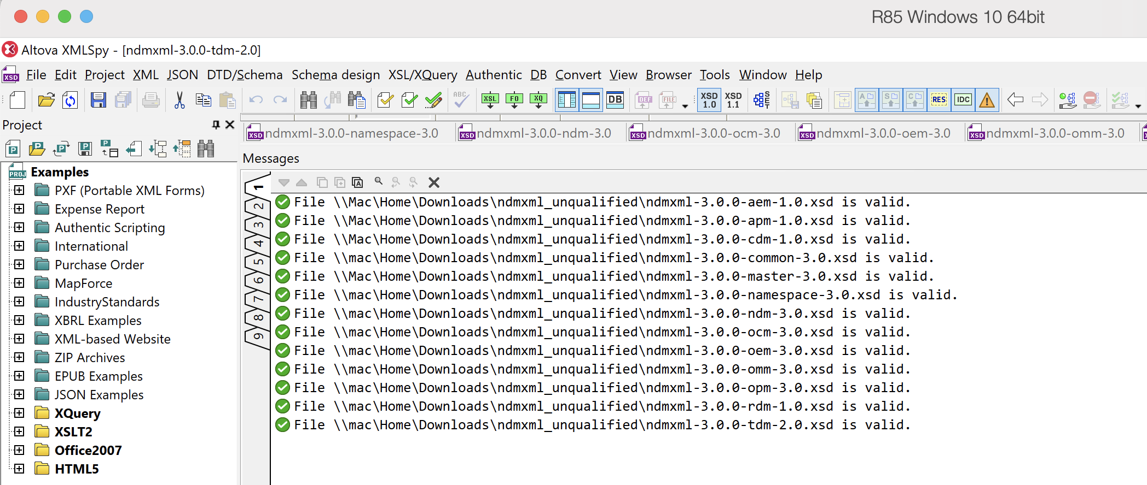

## NDM/XML schema validation TEST results ("qualified")

There are 13 schemas in the schema set, one for each of the 9 messages and 4 auxiliary schemas (master, namespace, common, and the "ndm" schema for combined instantiations). The schemas were downloaded from https://beta.sanaregistry.org and loaded into XML Spy. All schemas were valid as evaluated by XML Spy. Note that the qualified schemas differ from the unqualified schemas in a single line in the header (the "elementFormDefault" parameter).

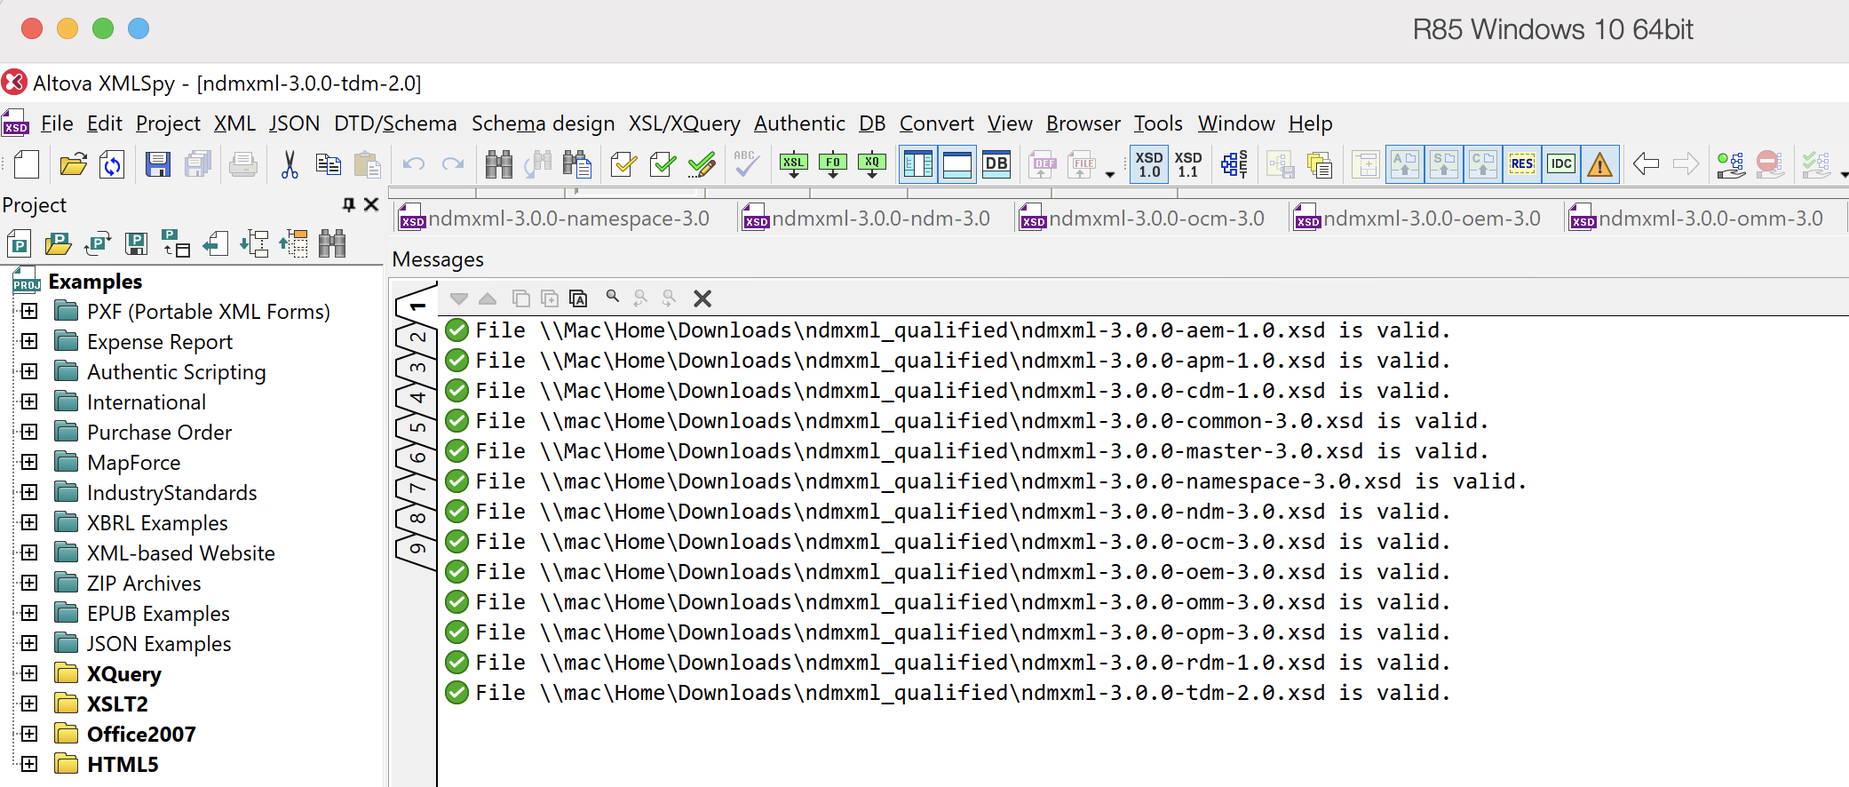

## ATTITUDE DATA MESSAGES TEST RESULTS

All ADM XML test instantiations are valid.

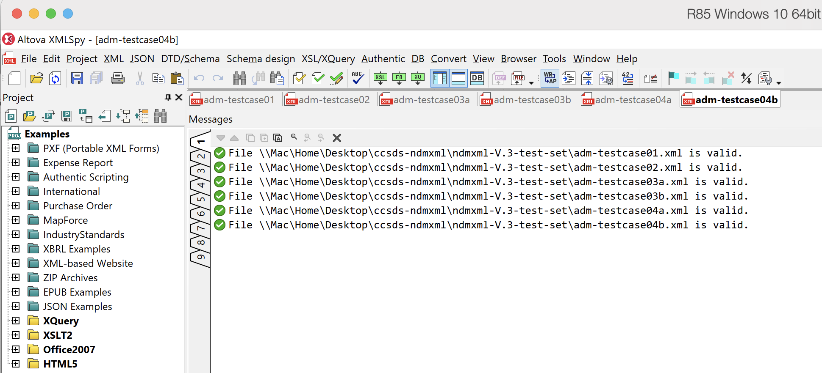

## CONJUNCTION DATA MESSAGE TEST RESULTS

All CDM XML test instantiations are valid.

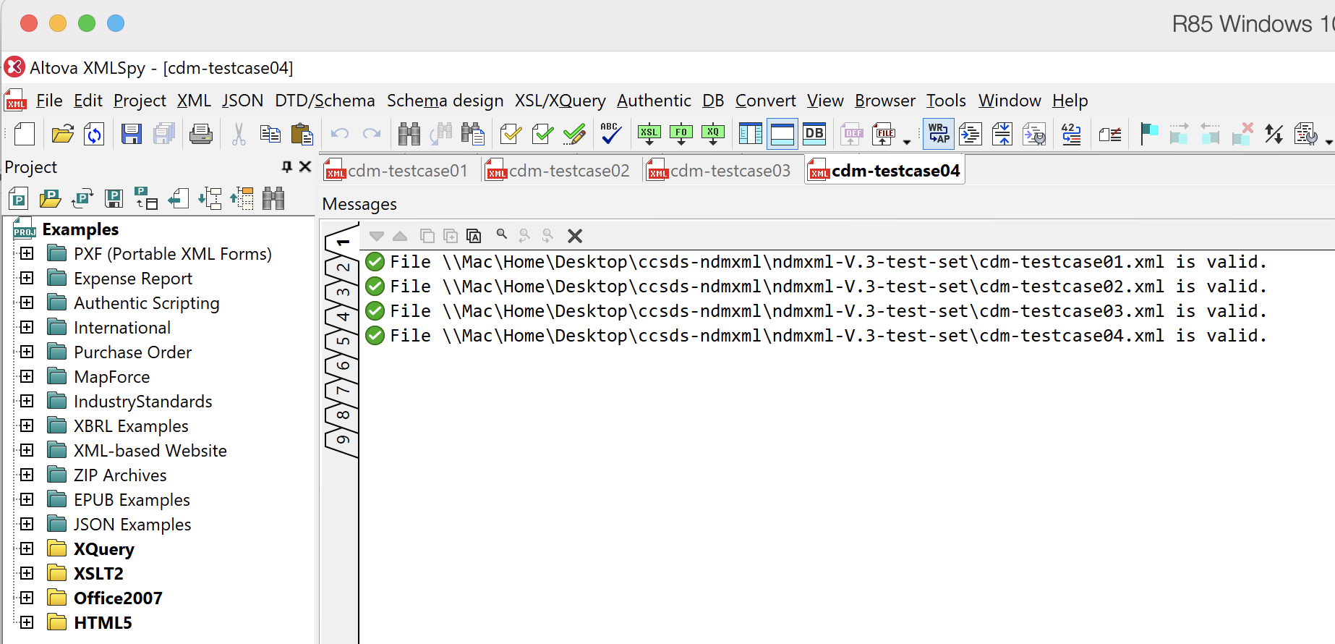

## ORBIT DATA MESSAGES TEST results

The ODM Version 1 XML instantiations failed, as expected, because the required schema is obsolete and therefore not included by design in NDM/XML Version 3. All ODM Version 2 and ODM Version 3 XML instantiations are valid.

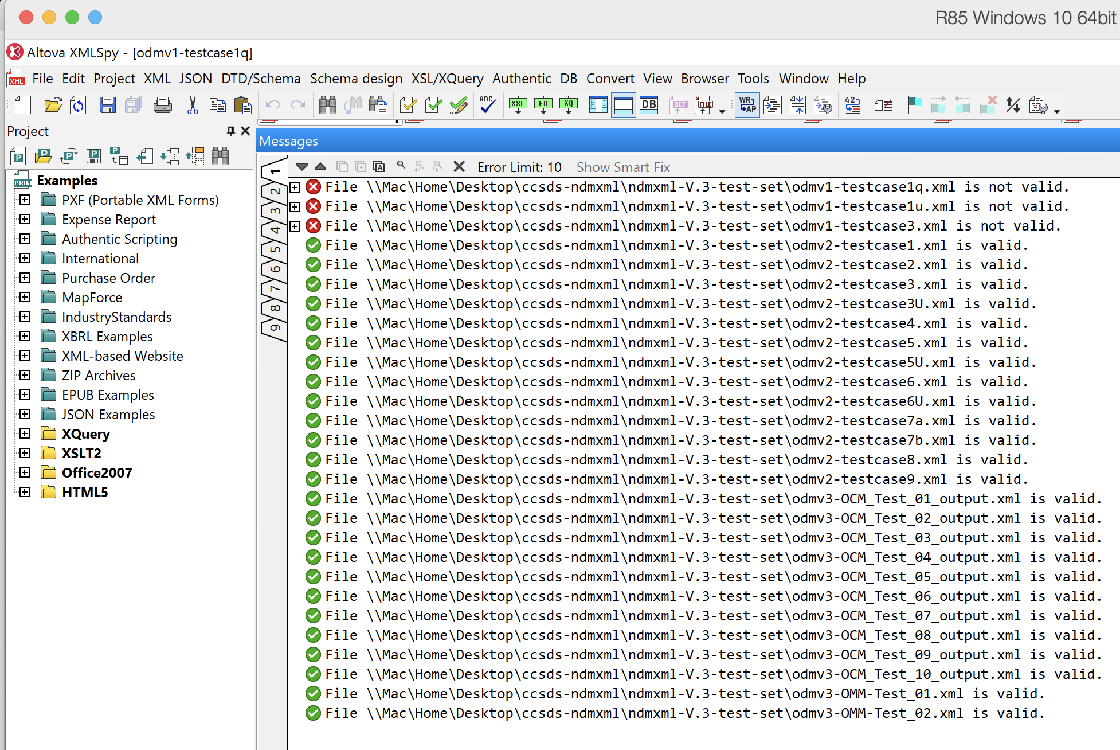

## RE-ENTRY DATA MESSAGE TEST RESULTS

All RDM XML test instantiations are valid.

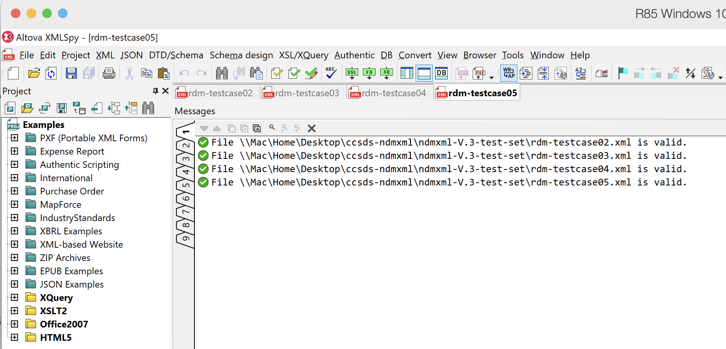

## TRACKING DATA MESSAGE TEST RESULTS

All TDM XML test instantiations are valid.

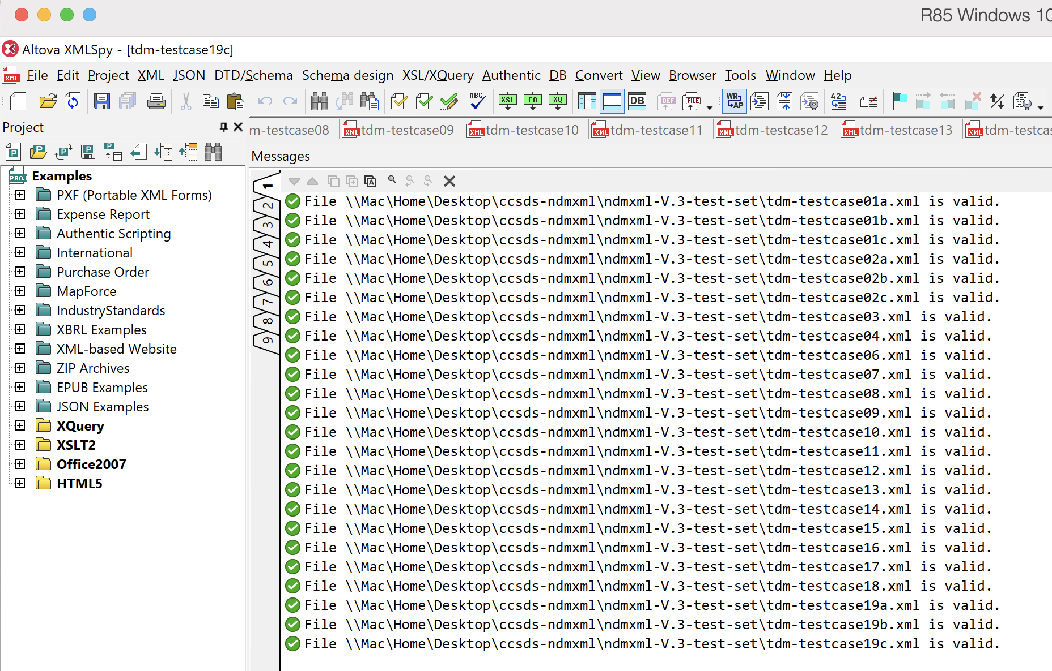

## Combined instantiation TEST RESULTS

All NDM/XML combined instantiation tests are valid.

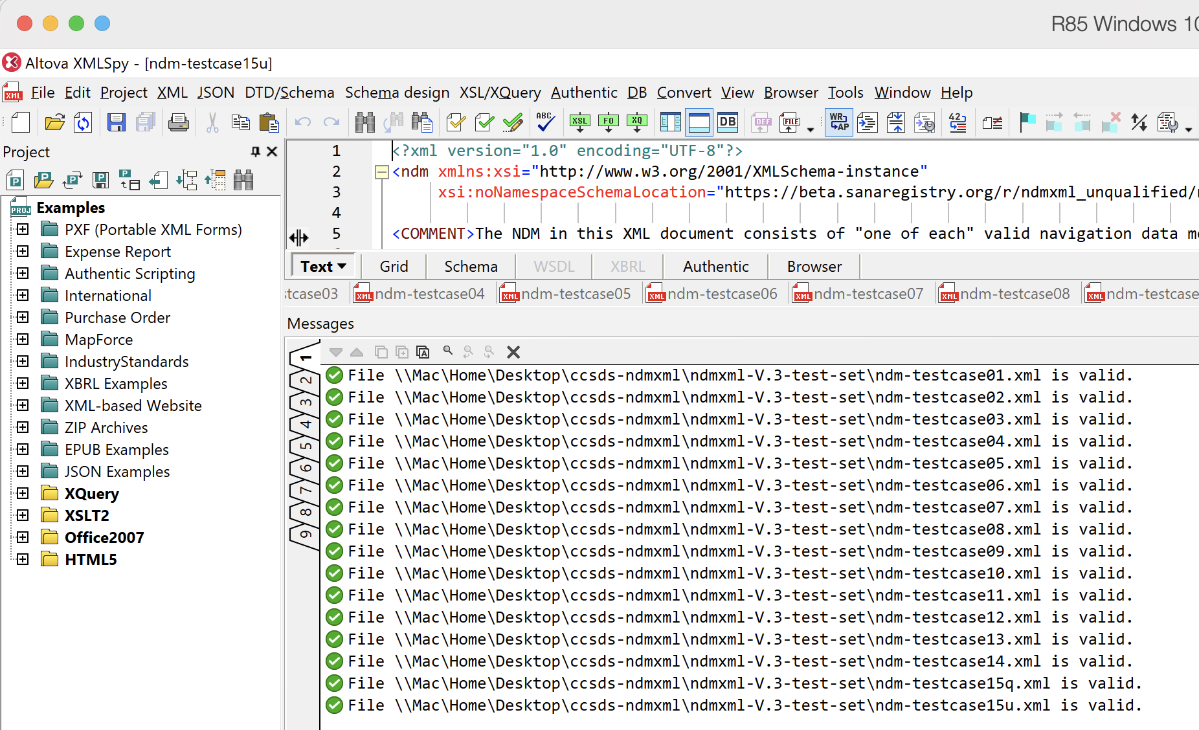

## NDM/XML Document figure TEST RESULTS

All document figure test instantiations are valid.

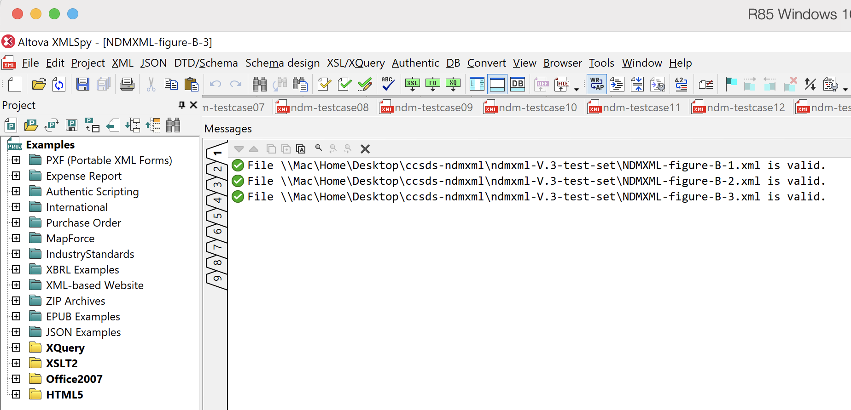

1. ACRONYMS

|  |  |
| --- | --- |
| ADM | The CCSDS Attitude Data Messages Recommended Standard (504.0) |
| AEM | Attitude Ephemeris Message |
| APM | Attitude Parameter Message |
| CCSDS | Consultative Committee for Space Data Systems |
| CDM | The CCSDS Conjunction Data Message Recommended Standard (508.0) |
| CESG | CCSDS Engineering Steering Group | |
| CMC | CCSDS Management Council |
| CWE | CCSDS Collaborative Work Environment | |
| ESA | European Space Agency | |
| ESOC | European Space Operations Center | |
| JPL | Jet Propulsion Laboratory | |
| JSpOC | Joint Space Operations Center (United States Air Force) | |
| KVN | Keyword Value Notation | |
| MOIMS | Mission Operations and Information Management Services | |
| N/A | Not Applicable |
| NASA | National Aeronautics and Space Administration (United States) |
| NAV | Navigation |
| NDM | Navigation Data Message (a generic reference to one of the messages in the ADM, CDM, ODM, RDM, or TDM); also a combined instantiation |
| NDM/XML | The CCSDS Navigation Data Messages XML Specification (505.0) |
| ODM | The CCSDS Orbit Data Messages Recommended Standard (502.0) |
| OCM | Orbit Comprehensive Message |
| OEM | Orbit Ephemeris Message |
| OMM | Orbit Mean Elements Message |
| OPM | Orbit Parameter Message |
| RDM | The CCSDS Re-Entry Data Message Recommended Standard (508.1) |
| RID | Review Item Discrepancy |
| SANA | Space Assigned Numbers Authority | |
| TBD | To Be Determined | |
| TDM | The CCSDS Tracking Data Message Recommended Standard (503.0) |
| WG | Working Group | |
| XML | eXtensible Markup Language | |

1. CCSDS Management Council Resolution MC-F02-09 directed Subpanel P1J (precursor to Navigation

   Working Group) to utilize PVL, or preferably XML schema language, in the CCSDS 502.0-R-2 Orbit DataMessages.