Short Bio:
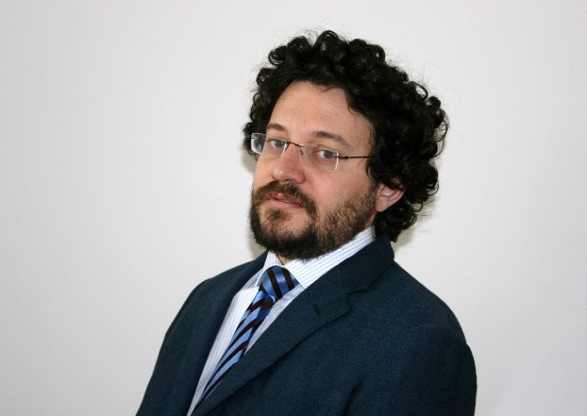
Tomaso de Cola. He received the master degree and PhD title from University of Genoa (Italy) in 2001 and 2010 respectively. He worked from 2002 to 2007 with the Italian Consortium of Telecommunications (CNIT), University of Genoa Research Unit, as scientist researcher. Since 2008, he has been with the German Aerospace Center (DLR), where he has been involved in several projects funded by EU and ESA programs, focusing on different aspects of DVB standards, CCSDS protocols, emergency communications, and testbed design. He is currently leading the integrated satellite systems group at the satellite networks departments, as part of the DLR institute of communications and navigation (DLR-KN).
He has been taking part in different standardization activities within ETSI, IETF, DVB, and CCSDS, where he currently serves as deputy area director of the Space Internetworking Services (SIS) since 2015. He has been involved in many projects (co-)funded by European and Italian Space agencies and European Commission, where he served as project leader, project coordinator, or technical contributor. Finally, he is co-author of more than 100 papers, including international conferences and journals. His main research activity concerns: TCP/IP protocols, satellite networks, delay tolerant networks, and protocol architectures for space systems.
Dr. de Cola has served on the Technical Program Committee at many IEEE International Conferences and as TPC chair for the satellite track in many ICC and Globecom editions. He has also been guest editor for many IEEE journals and magazines. He is an IEEE ComSoc member, where he served as chair of the Satellite and Space Communications (SSC) technical Committee (TC) from 2017 to 2020. He is also recipient of the 2020 Satellite Communications Distinguished Service award from the aforementioned SSC technical committee.
Main CCSDS Activities:
- Actively following CCSDS activities since 2001, with focus initially on CFDP specification and performance analysis and then since 2008 about DTN activities with respect to BP and LTP adoption in CCSDS and related evolution
- Participation to CCSDS meetings since Fall 2008 as part of SLS C&S, SLS-OPT, SLS-SLP, SIS-DTN, SIS-CFDP, and SIS-MIA working groups
- Leader contributor and rapporteur for CCSDS 131.5-O-1 “Erasure Correcting Codes for Use in Near-Earth and Deep-Space Communications”
- Support to the adoption of DTN standards in DLR with initial iterations with NASA (A. Hook) for joint testing.
- SIS DAD responsibility since 2015 with involvement in the regular CESG telco, official CESG and CESG+CMC meetings, review of CCSDS draft books, and general support to the SIS AD as to overall area decision, administrative support, and check of the relevant sections on the CWE dealing with the processes and management.

Selected publications (in the context of space communications):
- T. de Cola, "Achieving Ordered Data Block Delivery in CCSDS-DTN Space Networks: a Case Study," GLOBECOM 2020 - 2020 IEEE Global Communications Conference, Taipei, Taiwan, 2020, pp. 1-6.
- N. Alessi, C. Caini, T. de Cola, S. Martin and J. P. Mayer, "DTN Performance in Complex Deep-Space Networks," 2018 9th Advanced Satellite Multimedia Systems Conference and the 15th Signal Processing for Space Communications Workshop (ASMS/SPSC), Berlin, Germany, 2018, pp. 1-7.
- N. Alessi, S. Burleigh, C. Caini and T. De Cola, "LTP robustness enhancements to cope with high losses on space channels," 2016 8th Advanced Satellite Multimedia Systems Conference and the 14th Signal Processing for Space Communications Workshop (ASMS/SPSC), Palma de Mallorca, Spain, 2016, pp. 1-6.
- T. de Cola, E. Paolini, G. Liva and G. P. Calzolari, "Reliability Options for Data Communications in the Future Deep-Space Missions," in Proceedings of the IEEE, vol. 99, no. 11, pp. 2056-2074, Nov. 2011.
- T. de Cola and M. Marchese, "Joint Use of Custody Transfer and Erasure Codes in DTN Space Networks: Benefits and Shortcomings," 2010 IEEE Global Telecommunications Conference GLOBECOM 2010, Miami, FL, USA, 2010, pp. 1-5.
- T. De Cola and M. Marchese, "Reliable data delivery over deep space networks: Benefits of long erasure codes over ARQ strategies," in IEEE Wireless Communications, vol. 17, no. 2, pp. 57-65, April 2010.
- Bisio, M. Cello, T. de Cola and M. Marchese, "Combined Congestion Control and Link Selection Strategies for Delay Tolerant Interplanetary Networks," GLOBECOM 2009 - 2009 IEEE Global Telecommunications Conference, Honolulu, HI, USA, 2009, pp. 1-6.
- Bisio, M. Marchese and T. de Cola, "Congestion Aware Routing Strategies for DTN-Based Interplanetary Networks," IEEE GLOBECOM 2008 - 2008 IEEE Global Telecommunications Conference, New Orleans, LA, USA, 2008, pp. 1-5.
- T. de Cola and M. Marchese, "High Performance Communication and Navigation Systems for Interplanetary Networks," in IEEE Systems Journal, vol. 2, no. 1, pp. 104-113, March 2008.
- T. De Cola and M. Marchese, "Performance analysis of data transfer protocols over space communications," in IEEE Transactions on Aerospace and Electronic Systems, vol. 41, no. 4, pp. 1200-1223, Oct. 2005.
- Alessi, N, Caini, C, de Cola, T, Martin, S, Mayer, JP. DTN performance analysis of multi‐asset Mars‐Earth communications. Int J Satell Commun Network. 2019; 1– 16.
- Caini, C., Firrincieli, R., de Cola, T., Bisio, I., Cello, M. and Acar, G. (2014), Mars to Earth communications through orbiters: Delay‐Tolerant/Disruption‐Tolerant Networking performance analysis. Int. J. Satell. Commun. Network., 32: 127-140.
- Alessi, N, Burleigh, S, Caini, C, de Cola, T. Design and performance evaluation of LTP enhancements for lossy space channels. Int J Satell Commun Network. 2019; 37: 3– 14.

