
Recommendation for Space Data System Standards
Spacecraft Onboard Interface Services—XML Specification for Electronic Data Sheets
Recommended Standard
CCSDS 876.0-B-1
Blue Book
April 2019

AUTHORITY

 | Issue: | Recommended Standard, Issue 1
 | Date: | April 2019
 | Location: | Washington, DC, USA
This document has been approved for publication by the Management Council of the Consultative Committee for Space Data Systems (CCSDS) and represents the consensus technical agreement of the participating CCSDS Member Agencies. The procedure for review and authorization of CCSDS documents is detailed in Organization and Processes for the Consultative Committee for Space Data Systems (CCSDS A02.1-Y-4), and the record of Agency participation in the authorization of this document can be obtained from the CCSDS Secretariat at the e-mail address below.

This document is published and maintained by:

CCSDS Secretariat
National Aeronautics and Space Administration
Washington, DC, USA
E-mail: secretariat@mailman.ccsds.org
STATEMENT OF INTENT
The Consultative Committee for Space Data Systems (CCSDS) is an organization officially established by the management of its members. The Committee meets periodically to address data systems problems that are common to all participants, and to formulate sound technical solutions to these problems. Inasmuch as participation in the CCSDS is completely voluntary, the results of Committee actions are termed Recommended Standards and are not considered binding on any Agency.
This Recommended Standard is issued by, and represents the consensus of, the CCSDS members. Endorsement of this Recommendation is entirely voluntary. Endorsement, however, indicates the following understandings:
o Whenever a member establishes a CCSDS-related standard, this standard will be in accord with the relevant Recommended Standard. Establishing such a standard does not preclude other provisions which a member may develop.
o Whenever a member establishes a CCSDS-related standard, that member will provide other CCSDS members with the following information:
-- The standard itself.
-- The anticipated date of initial operational capability.
-- The anticipated duration of operational service.
o Specific service arrangements shall be made via memoranda of agreement. Neither this Recommended Standard nor any ensuing standard is a substitute for a memorandum of agreement.
No later than five years from its date of issuance, this Recommended Standard will be reviewed by the CCSDS to determine whether it should: (1) remain in effect without change; (2) be changed to reflect the impact of new technologies, new requirements, or new directions; or (3) be retired or canceled.
In those instances when a new version of a Recommended Standard is issued, existing CCSDS-related member standards and implementations are not negated or deemed to be non-CCSDS compatible. It is the responsibility of each member to determine when such standards or implementations are to be modified. Each member is, however, strongly encouraged to direct planning for its new standards and implementations towards the later version of the Recommended Standard.
FOREWORD
This document is a technical Recommended Standard for the XML Specification for Electronic Data Sheets for Onboard Devices and has been prepared by the Consultative Committee for Space Data Systems (CCSDS). The XML Specification for Electronic Data Sheets for Onboard Devices described herein is intended for missions that are cross-supported between Agencies of the CCSDS, in the framework of the Spacecraft Onboard Interface Services (SOIS) CCSDS area.
This Recommended Standard specifies the XML schema, and associated constraints, to be used by space missions to describe the data interface of an onboard device accessed over a spacecraft subnetwork. The XML Specification for Electronic Data Sheets for Onboard Devices may be used for an onboard device regardless of the particular type of data link or protocol being used for communication with that device.
Attention is drawn to the possibility that some of the elements of this document may be the subject of patent rights. CCSDS has processes for identifying patent issues and for securing from the patent holder agreement that all licensing policies are reasonable and non-discriminatory. However, CCSDS does not have a patent law staff, and CCSDS shall not be held responsible for identifying any or all such patent rights.
Through the process of normal evolution, it is expected that expansion, deletion, or modification of this document may occur. This Recommended Standard is therefore subject to CCSDS document management and change control procedures, which are defined in Organization and Processes for the Consultative Committee for Space Data Systems (CCSDS A02.1-Y-4). Current versions of CCSDS documents are maintained at the CCSDS Web site:
http://www.ccsds.org/
Questions relating to the contents or status of this document should be sent to the CCSDS Secretariat at the e-mail address indicated on page i.
At time of publication, the active Member and Observer Agencies of the CCSDS were:
Member Agencies
- Agenzia Spaziale Italiana (ASI)/Italy.
- Canadian Space Agency (CSA)/Canada.
- Centre National d’Etudes Spatiales (CNES)/France.
- China National Space Administration (CNSA)/People’s Republic of China.
- Deutsches Zentrum für Luft- und Raumfahrt (DLR)/Germany.
- European Space Agency (ESA)/Europe.
- Federal Space Agency (FSA)/Russian Federation.
- Instituto Nacional de Pesquisas Espaciais (INPE)/Brazil.
- Japan Aerospace Exploration Agency (JAXA)/Japan.
- National Aeronautics and Space Administration (NASA)/USA.
- UK Space Agency/United Kingdom.
Observer Agencies
- Austrian Space Agency (ASA)/Austria.
- Belgian Federal Science Policy Office (BFSPO)/Belgium.
- Central Research Institute of Machine Building (TsNIIMash)/Russian Federation.
- China Satellite Launch and Tracking Control General, Beijing Institute of Tracking and Telecommunications Technology (CLTC/BITTT)/China.
- Chinese Academy of Sciences (CAS)/China.
- China Academy of Space Technology (CAST)/China.
- Commonwealth Scientific and Industrial Research Organization (CSIRO)/Australia.
- Danish National Space Center (DNSC)/Denmark.
- Departamento de Ciência e Tecnologia Aeroespacial (DCTA)/Brazil.
- Electronics and Telecommunications Research Institute (ETRI)/Korea.
- European Organization for the Exploitation of Meteorological Satellites (EUMETSAT)/Europe.
- European Telecommunications Satellite Organization (EUTELSAT)/Europe.
- Geo-Informatics and Space Technology Development Agency (GISTDA)/Thailand.
- Hellenic National Space Committee (HNSC)/Greece.
- Hellenic Space Agency (HSA)/Greece.
- Indian Space Research Organization (ISRO)/India.
- Institute of Space Research (IKI)/Russian Federation.
- Korea Aerospace Research Institute (KARI)/Korea.
- Ministry of Communications (MOC)/Israel.
- Mohammed Bin Rashid Space Centre (MBRSC)/United Arab Emirates.
- National Institute of Information and Communications Technology (NICT)/Japan.
- National Oceanic and Atmospheric Administration (NOAA)/USA.
- National Space Agency of the Republic of Kazakhstan (NSARK)/Kazakhstan.
- National Space Organization (NSPO)/Chinese Taipei.
- Naval Center for Space Technology (NCST)/USA.
- Research Institute for Particle & Nuclear Physics (KFKI)/Hungary.
- Scientific and Technological Research Council of Turkey (TUBITAK)/Turkey.
- South African National Space Agency (SANSA)/Republic of South Africa.
- Space and Upper Atmosphere Research Commission (SUPARCO)/Pakistan.
- Swedish Space Corporation (SSC)/Sweden.
- Swiss Space Office (SSO)/Switzerland.
- United States Geological Survey (USGS)/USA.

DOCUMENT CONTROL

Document | Title | Date | Status
CCSDS 876.0-B-1 | Spacecraft Onboard Interface Services—XML Specification for Electronic Data Sheets, Recommended Standard, Issue 1 | April 2019 | Original issue

CONTENTS
Section Page
1 introduction 1-1

1.1 Purpose and scope of this Document 1-1
1.2 Applicability 1-1
1.3 Rationale 1-1
1.4 Document Structure 1-1
1.5 Conventions and Definitions 1-2
1.6 NOMENCLATURE 1-4
1.7 References 1-4

2 OvervieW 2-1

2.1 General 2-1
2.2 The Subject Matter of Electronic Data Sheets 2-2
2.3 Purpose and Operation of SOIS Electronic Data SheetS 2-3
2.4 Use of W3C Recommendations 2-4

3 Basic Structure of the SEDS/XML SCHEMA 3-1

3.1 Overview 3-1
3.2 Electronic Data Sheets and the Associated Schema 3-3
3.3 SEDS/XML Basic Structure 3-4
3.4 MetaData 3-6
3.5 Packages 3-8
3.6 Data Types 3-9
3.7 Scalar Data Types 3-10
3.8 Ranges 3-14
3.9 Arrays 3-15
3.10 Containers 3-16
3.11 Fields 3-20
3.12 Interfaces 3-22
3.13 Components 3-27
3.14 Component Implementations 3-30
3.15 Activities 3-34
3.16 State Machines 3-43

4 Constructing a SEDS/XML Instance 4-1

4.1 Overview 4-1
4.2 XML Version 4-1
4.3 Type Referencing and Matching 4-1

CONTENTS (continued)
Section Page
4.4 External References 4-4
4.5 Primitive Associations 4-5
4.6 State Machine Operation 4-9
4.7 Encoding and Decoding 4-11
4.8 Extensible Enumerations 4-14

ANNEX A Electronic Data Sheet for Onboard Devices Implementation Conformance Statement
Proforma (Normative) A-1
ANNEX B Security, SANA, and Patent CONSIDERATIONS (Informative) B-1
ANNEX C Abbreviations and Acronyms (informative) C-1
ANNEX D Informative References (informative) D-1
ANNEX E Example SEDS/XML Schema Instantiations (Informative) E-1
Figure
2-1 SEDS Concept Map 2-1
2-2 SOIS Electronic Data Sheets Describe Data Interfaces in a Spacecraft 2-2
3-1 Overview of Selected Key Elements and Abstract Types of a Datasheet 3-1
3-2 Key Inheritance Relationships between Elements and Abstract Schema Types 3-2
3-3 Device Datasheets and Package Files 3-3
3-4 Datasheets and Package Files 3-4
3-5 Metadata Element 3-6
3-6 Package Element 3-8
3-7 Data Types within a DataTypeSet Element 3-9
3-8 Scalar Data Types 3-10
3-9 Ranges within a SubRangeDataType Element 3-14
3-10 ArrayDataType and Dimension Elements 3-15
3-11 Constraints and Entries of a ContainerDataType Element 3-16
3-12 Field Schema Type 3-20
3-13 External Field Schema Type 3-21
3-14 Interfaces within an InterfaceDeclarationSet Element 3-22
3-15 Parameters in a ParameterSet Element 3-24
3-16 Commands in a CommandSet Element 3-25
3-17 Components in a ComponentSet Element 3-27
3-18 Generic Type Mapping 3-28
3-19 Implementation Element of a Component 3-30
3-20 Variable Element of a VariableSet 3-31

CONTENTS (continued)
Figure Page
3-21 ParameterMap Element of a ParameterMapSet 3-31
3-22 ParameterActivityMap Element of a ParameterActivityMapSet 3-32
3-23 Activities within an ActivitySet Element 3-34
3-24 SendParameterPrimitive Element 3-35
3-25 SendCommandPrimitive Element 3-36
3-26 Assignment Element 3-37
3-27 Polynomial and Spline Calibrators within a Calibration Element 3-37
3-28 MathOperation Element 3-38
3-29 Conditional Element 3-41
3-30 Conditional Execution of an Activity or State Machine Transition Guard 3-41
3-31 State Machines within a StateMachineSet Element 3-43
3-32 State Machine Transition Element 3-44
4-1 Elements and Abstract Types Relevant to Type and Interface Referencing 4-1
4-2 Parameter Definitions and Primitives 4-5
4-3 Command Definitions and Primitives 4-6
4-4 Primitives That Trigger State Transition 4-7
4-5 Primitives Sent During Activity Execution 4-7
4-6 State Machine Concepts 4-9
Table
3-1 Data Types, Encodings, Ranges, and Literals 3-11
3-2 MinMaxRange Options 3-14
3-3 Error Control Types 3-19
3-4 Interface Levels 3-23
3-5 Interface Syntax, Primitives, and Transactions 3-26
3-6 Legal Parameter Mappings 3-32
3-7 Arguments to a Primitive 3-36
3-8 Mathematical Operators 3-40
4-1 SOIS Subnetwork SAP Models 4-12
B-1 SANA Registry Content B-2

introduction

Purpose and scope of this Document
This document is one of a family of documents specifying the Spacecraft Onboard Interface Services (SOIS)-compliant services to be provided in support of applications.
This document defines the XML Specification for SOIS Electronic Data Sheet (SEDS) for Onboard Devices. The SEDS is for use in electronically describing the data interfaces offered by flight hardware such as sensors and actuators.
Once the description is in machine-readable format, a toolchain can be used to facilitate the various phases in the life of a space vehicle.
The definition encompasses the XML representation of the functional interfaces offered by any protocols used to access the data interfaces.

Applicability
This document applies to any mission or equipment claiming to provide SEDS for Onboard Devices.

Rationale
SOIS provides an XML schema specification in order to enable toolchain compatibility amongst systems implementing interfaces defined by SEDS.

Document Structure
This document has four major sections:
- Section 1 contains administrative information, definitions, and references.
- Section 2 provides a brief overview of Electronic Data Sheets for onboard devices.
- Section 3 provides a normative description of the structure of the SEDS XML schema and compliant SEDS XML instances.
- Section 4 provides normative instructions on how to construct valid instantiations of SEDS for onboard devices, describing requirements and constraints beyond those imposed by the schema.
In addition, the following annexes are provided:
- Annex ANNEX A comprises a Protocol Implementation Conformance Statement (PICS) proforma.
- Annex ANNEX B discusses security, Space Assigned Numbers Authority (SANA), and patent considerations relating to the specifications of this document.
- Annex ANNEX C contains a list of acronyms.
- Annex ANNEX D contains a list of informative references.
- Annex ANNEX E provides an example instantiation of the SEDS XML schema, for illustrative purposes.

Conventions and Definitions

Definitions

Definitions from the Open Systems Interconnection Reference Model
The document is defined using the style established by the Open Systems Interconnection (OSI) Basic Reference Model (reference [D19]). This model provides a common framework for the development of standards in the field of systems interconnection.
The following terms used in this Recommended Standard are adapted from definitions given in (reference [D19]):
layer: A subdivision of the architecture, constituted by subsystems of the same rank.
service: A capability of a layer, and the layers beneath it (service providers), provided to the service users at the boundary between the service providers and the service users.

Terms Defined in this Recommended Standard
For the purposes of this Recommended Standard, the following definitions apply:
application: An algorithm that applies SOIS services to accomplish the goals of a mission.
component: A logical element of a system accessed through defined interfaces. A component may be purely conceptual or realized in software or hardware (e.g., as a field-programmable gate array).
device: A physical element of a system accessed through subnetwork-layer interfaces. (See reference [D20].)
dictionary of terms, DoT: Ontology of terms used to describe data in interfaces in Electronic Data Sheets. (See reference [1].)
Electronic Data Sheet, EDS: Electronic description of some details of a device, software component, or standard. Unless qualified with the acronym ‘SOIS’, this term is general, referring to any machine-readable data sheet. (See SOIS Electronic Data Sheet, SEDS.)
engineering profile: A collection of attributes used to define the meaning of an item of data used in operations and parameters. (See reference [D20].)
glossary: A collection of terms with brief informal explanations of their usage in a particular document.
interface: A facility provided or supplied by a component that allows exchange of data.
portability: The capability of a component to be integrated into an assembly without change either to the component or to the assembly interfaces. Portability requires that the definitions of interfaces be consistent across all systems to which they may be ported. Consistency requires that the terms used to define an interface be defined in the DoT. (See ‘toolchain compatibility.)
semantic attribute: A property of an engineering profile, such as reference frame or unit of measure.
SOIS Electronic Data Sheet, SEDS: Electronic description of a device’s metadata, device-specific functional and access interfaces, device-specific access protocol, and, optionally, device abstraction control procedure (see reference [D20]), compliant with SOIS standards. (See Electronic Data Sheet, EDS.)
syntactic type: A type of data that is defined by attributes for encoding the data for storage (transmission through time) or communication (transmission through space). An example of an attribute for a syntactic type is the choice of interpretation of bits as an integer, as a floating-point number, or other choices. (See reference [D20].)
term: A word or phrase that has a formally defined interpretation in a particular context of usage. The terms in the SOIS dictionary of terms are defined in the context of describing spacecraft components in Electronic Data Sheets.
toolchain compatibility: Capability to function in a sequence of computer-assisted engineering steps, optionally with locally defined ontology extensions. Toolchain compatibility is a weaker form of interface consistency than portability. The locally defined ontology extensions make it possible for SOIS Electronic Data Sheets to function in a toolchain early in the life of a project without waiting for terms to be defined in the SANA DoT ontology. For complete portability, all terms in an Electronic Data Sheet must be defined in the SANA DoT ontology.
type: A conceptual class that is defined in an EDS as a class. The instances of a type share those properties that define the type. The properties are defined in the dictionary of terms.
value: A formatted instance of data that is acquired from or used as a command to a component.

NOMENCLATURE

Normative Text
The following conventions apply for the normative specifications in this Recommended Standard:
- the words ‘shall’ and ‘must’ imply a binding and verifiable specification;
- the word ‘should’ implies an optional, but desirable, specification;
- the word ‘may’ implies an optional specification;
- the words ‘is’, ‘are’, and ‘will’ imply statements of fact.
NOTE – These conventions do not imply constraints on diction in text that is clearly informative in nature.

Informative Text
In the normative sections of this document, informative text is set off from the normative specifications either in notes or under one of the following subsection headings:
- Overview;
- Background;
- Rationale;
- Discussion.

References
The following publications contain provisions which, through reference in this text, constitute provisions of this document. At the time of publication, the editions indicated were valid. All publications are subject to revision, and users of this document are encouraged to investigate the possibility of applying the most recent editions of the publications indicated below. The CCSDS Secretariat maintains a register of currently valid CCSDS publications.
[1] Spacecraft Onboard Interface Services—Specification for Dictionary of Terms for Electronic Data Sheets for Onboard Components. Recommendation for Space Data System Practices (Magenta Book), 876.1-M-1. Forthcoming.
[2] Tim Bray, et al., eds. “Extensible Markup Language (XML) 1.0.” W3C Recommendation. 5th ed., 26 November 2008. http://www.w3.org/TR/2008/REC-xml-20081126/.
[3] Shudi (Sandy) Gao, C. M. Sperberg-McQueen, and Henry S. Thompson, eds. “W3C XML Schema Definition Language (XSD) 1.1 Part 1: Structures.” W3C Recommendation. Version 1.1, 5 April 2012. http://www.w3.org/TR/xmlschema11-1/.
[4] David Peterson, et al., eds. “W3C XML Schema Definition Language (XSD) 1.1 Part 2: Datatypes.” W3C Recommendation. Version 1.1, 5 April 2012. http://www.w3.org/TR/xmlschema11-2/.
[5] Jonathan Marsh, David Orchard, and Daniel Veillard, eds. “XML Inclusions (XInclude) Version 1.0.” W3C Recommendation. 2nd ed., 15 November 2006. http://www.w3.org/TR/xinclude/.
[6] Information Technology—Microprocessor Systems—Floating-Point Arithmetic. International Standard, ISO/IEC/IEEE 60559:2011. Geneva: ISO, 2011.
[7] Sixteen-Bit Computer Instruction Set Architecture. Military Standard, MIL-STD-1750A. Washington, DC: USAF, 2 July 1980.
[8] Julie D. Allen, et al., eds. The Unicode Standard. Version 7.0. Mountain View, CA: The Unicode Consortium, October 2014.
[9] Information Technology—8-Bit Single-Byte Coded Graphic Character Sets—Part 1: Latin Alphabet No. 1. International Standard, ISO/IEC 8859-1:1998. Geneva: ISO, 1998.
[10] TC Space Data Link Protocol. Issue 3. Recommendation for Space Data System Standards (Blue Book), CCSDS 232.0-B-3. Washington, D.C.: CCSDS, September 2015.
[11] Space Engineering—SpaceWire—Remote Memory Access Protocol. ECSS-E-ST-50-52C. Noordwijk, The Netherlands: ECSS Secretariat, 5 February 2010.
[12] CCSDS File Delivery Protocol (CFDP). Issue 4. Recommendation for Space Data System Standards (Blue Book), CCSDS 727.0-B-4. Washington, D.C.: CCSDS, January 2007.
[13] Information Processing—Use of Longitudinal Parity to Detect Errors in Information Messages. 2nd ed. International Standard, ISO 1155:1978. Geneva: ISO, 1978.
[14] “Spacecraft Onboard Interface Services Electronic Data Sheets and Dictionary of Terms.” Space Assigned Numbers Authority. http://sanaregistry.org/r/sois/.
[15] Spacecraft Onboard Interface Services—Subnetwork Packet Service. Issue 1. Recommendation for Space Data System Practices (Magenta Book), CCSDS 851.0-M-1. Washington, D.C.: CCSDS, December 2009.
[16] Spacecraft Onboard Interface Services—Subnetwork Memory Access Service. Issue 1. Recommendation for Space Data System Practices (Magenta Book), CCSDS 852.0-M-1. Washington, D.C.: CCSDS, December 2009.
[17] Spacecraft Onboard Interface Services—Subnetwork Synchronisation Service. Issue 1. Recommendation for Space Data System Practices (Magenta Book), CCSDS 853.0-M-1. Washington, D.C.: CCSDS, December 2009.
[18] Concise Binary Object Representation RFC 7049. Internet Engineering Task Force. https://tools.ietf.org/html/rfc7049.
NOTE – Informative references are contained in annex ANNEX D.

OvervieW

General
The diagram below is a map of the major concepts involved in SEDS, and the relationships among them. The topics this document focuses on are highlighted in blue.
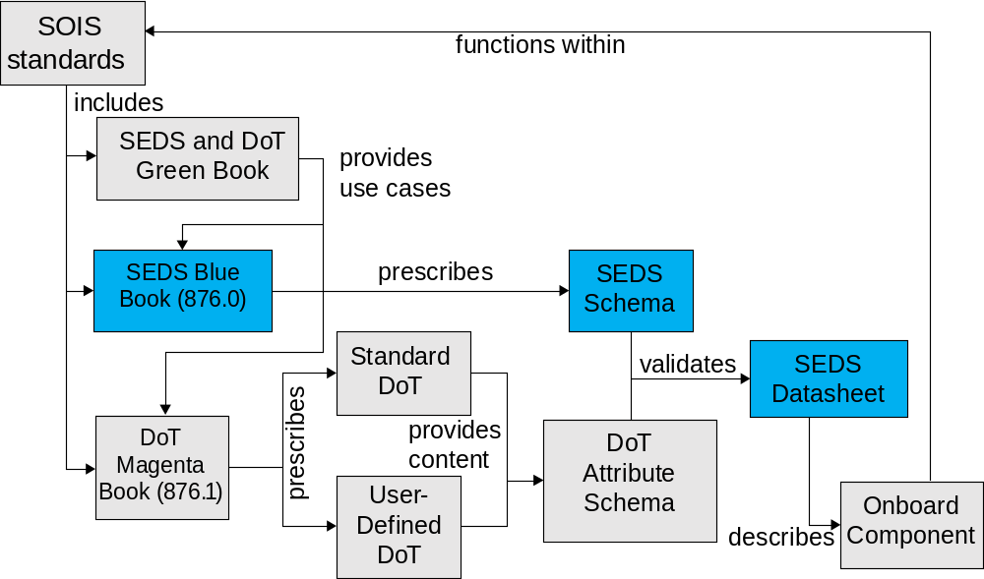
Figure 2-11: SEDS Concept Map
A SOIS Electronic Data Sheet (SEDS) specifies the usage of SOIS standards by an Onboard Component. The XML schema used to validate such a datasheet is defined in two parts:
- The SEDS Schema is defined and described in this document.
- The DoT Attribute schema is extensible and comes from combining the standard and, optionally, a user-defined Dictionary of Terms (DoT), as described in reference [1].

The Subject Matter of Electronic Data Sheets
The SOIS Electronic Datasheets are defined within the context of the overall SOIS architecture (see reference [D20]). Figure 2-2 illustrates how SOIS Electronic Data Sheets can describe data interfaces at various points in a spacecraft data system. Devices appear on the left side, with increasing degrees of aggregation of data interfaces in moving to the right side of the diagram.
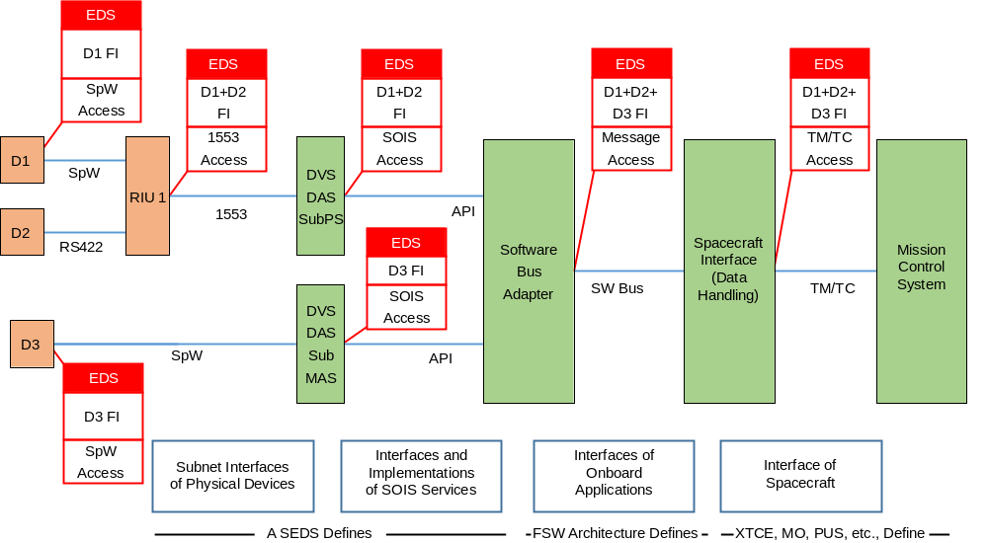
Figure 2-22: SOIS Electronic Data Sheets Describe Data Interfaces in a Spacecraft
A SEDS is intended to be used to describe the format of information in any data interface for any onboard device. (A collection of SEDS instances may be needed to describe the data interfaces of applications in an onboard computer.) A SEDS can also define a simple structural or behavioural mapping between such interfaces, such as that required to map the binary message format used by a device to the set of commands and parameters it supports.
Some aspects of a device data interface may correspond to standardized protocols directly usable at the Application Layer. The remainder is specified by the SOIS Electronic Datasheet for that device, which captures all device-specific aspects. This includes those specified at some other level of commonality (e.g., agency, company, product line).
The interfaces defined in a datasheet may then be used in the specification or implementation of applications and Application Layer services.

Purpose and Operation of SOIS Electronic Data SheetS
A SEDS is intended to be a machine-understandable mechanism for describing onboard components, as more fully described in the SOIS Green Book (reference [D20]).
The SEDS is intended to replace the traditional interface control documents and proprietary data sheets which accompany a device and are necessary to determine the operation of the device and how to communicate with it. The SEDS could then be used for a wide variety of purposes, whilst ensuring consistency and completeness of information:
- generating human-readable documentation;
- specifying interfaces to the device;
- automatically generating software implementing the relevant parts of the onboard software for the device;
- automatically generating device-interface-simulation software for use in test or device-simulation software;
- transforming the device functional interface into telecommands and telemetry suitable for processing by a command and data handling system onboard and on the ground;
- capturing interface information for the spacecraft database;
- providing a common definition to human-friendly authoring mechanisms for SEDS instances;
- providing the common exchange medium between organizations for the above use cases.

Further information on the potential uses of SEDS can be found in the SOIS Green Book (reference [D20]).
In order to be able to relate the elements of the data sheet to physical (and nonphysical) concepts, and to promote standardization and interoperability, a SANA DoT (reference [1]) provides a core ontology for data sheet authors and users. These core semantic terms effectively form part of the language that is used to write SEDS. Whenever the semantics provided by the SANA DoT are insufficient, a data sheet author may utilize an additional user-defined DoT, which must then be supplied with the data sheet itself. This provides a standard, flexible, and extensible mechanism for capturing the semantics of device operation in a machine-understandable form.
The SEDS schema enumerates some external standards and conventions so that these standards and conventions may be associated with data in a SEDS instance. Examples are error control check words, math operations, and encoding schemes. These enumerations will never cover the variety of such standards and conventions, so the SEDS schema allows for extension of these enumerations. The extensions needed within a project to support a local toolchain can be written into an auxiliary schema, which the SEDS schema includes. The extensions that have been identified by manufacturers for use in products that are interoperable across agencies, but have not been incorporated into the SEDS schema, are written into another auxiliary schema, which is generated from the DoT, and which the SEDS schema includes. (See 4.9 for details.)
Finally, a SEDS may contain device metadata that allows recording arbitrary values such as physical device characteristics, author, version, and status. No predefined meaning is attached to any of the information in this area, but it may have semantic terms attached as above.
The combination of these mechanisms allows datasheets to be both
- defined in a fixed and published standard, allowing interoperability between tools that support that standard; and
- customizable to support additional features or requirements of any particular tool or system, without compromising the above.

Use of W3C Recommendations
The specification and use of SEDS makes use of a number of World-Wide Web Consortium (W3C) standards:
- XML—The Extensible Markup Language (reference [2]) is used to mark up data sheet documents in a machine-readable manner.
- XSD—The XML Schema Definition language (references [3] and [4]) is used to specify valid construction rules for data sheet documents. It should be noted that version 1.1 of the XSD recommendation is used.
- XInclude—To permit the construction of data sheet documents from multiple files, some of which may represent standardized data sheet elements, support for the XML Inclusions recommendation (reference [5]) is expected of applications processing SEDS documents.

Basic Structure of the SEDS/XML SCHEMA

Overview
This section describes the structure of an Electronic Data Sheet.
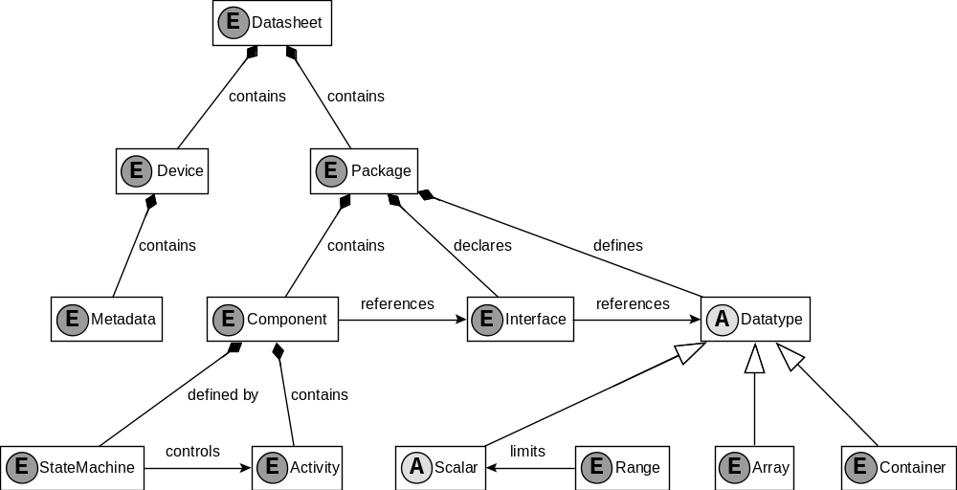
Figure 3-33: Overview of Selected Key Elements and Abstract Types of a Datasheet
Following this overview, subsection 3.2 covers the nature and relation of the various XML and XSD files that make up a datasheet. Within those files, a DataSheet (3.3) contains device Metadata (3.4) plus multiple Packages (3.5), which
- define a variety of Data Types (3.6);
- declare Interfaces (3.12) referencing those types; and
- contain Components (3.13) that specify a behavioural mapping (3.14) between those interfaces.
In turn, components
- are defined by a set of State Machines (3.16);
- which control the execution of a set of Activities (3.15).
The data types supported are
- single-valued Scalar Data Types (3.7), which can be limited by Ranges (3.8);
- Arrays (3.9), which contain repeated similar elements; and
- Containers (3.10), which contain a sequence of named Fields (3.10.25).
In addition to the rules laid out by the schema, further patterns shall be followed in constructing a data sheet document (a schema instance) to ensure that the data sheet is logically and functionally consistent. These additional rules are described in section 4.
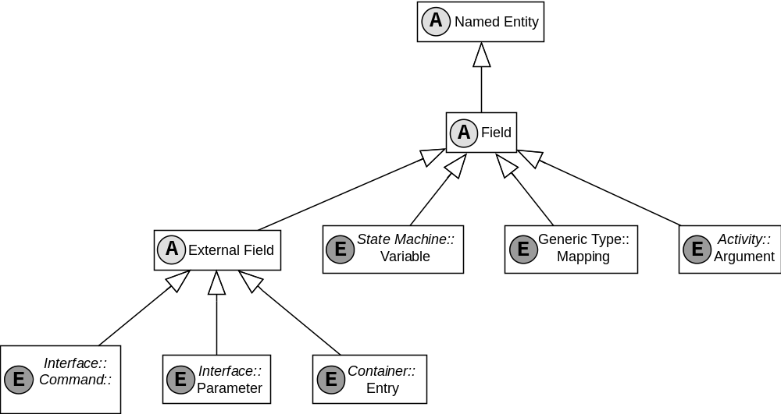
Figure 3-44: Key Inheritance Relationships between Elements and Abstract Schema Types
The above diagram shows that:
- A Field (3.10.25) is a Named Entity (3.3).
- The following are all Fields:
- Variables of a State Machine (3.16);
- Mappings of a Generic Type (3.13);
- Arguments of an Activity (3.15).
- An External Field (3.10.25) is also a Field.
- The following are all External Fields:
- Parameters on an Interface (3.12);
- Arguments to a Command on an Interface (3.12);
- Entries within a Container (3.10).

Electronic Data Sheets and the Associated Schema
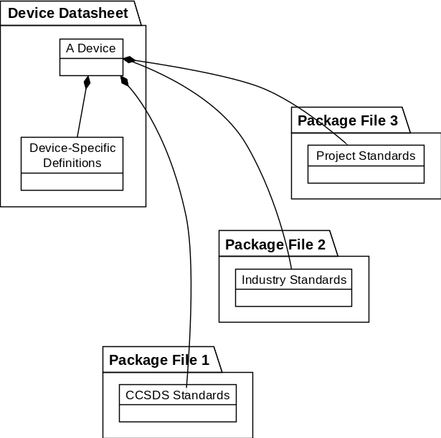
Figure 3-55: Device Datasheets and Package Files
Figure 3-5 shows the relationship among SEDS files. (It is not a syntax diagram.) A Device Datasheet contains all known information about a particular device or class of devices. It may reference one or more Package Files that capture an independently managed subset of that data, such as
- a standard or specification it supports;
- a product line it belongs to;
- a compatibility mode it is capable of; or
- a replaceable hardware or software part it contains or manages.
A Package File may describe a composable unit of software or hardware, in the manner of a Device Datasheet, but without the Device element, and without XInclude (reference [5]). A Package File may contain only metadata or data types for a platform, for a project, or for universal reference.
    - The basic unit of data exchange of SOIS device information is an XML document known as a device datasheet.
    - A device datasheet shall be de defined by a single top-level XML file.
    - Any files referenced by a device datasheet shall be XML package files compliant to the PackageFile element of the SEDS schema.
    - When a package file is used by a datasheet, XInclude (reference [5]) may be used to incorporate the Package element of that file into a single logical document compliant to the DataSheet element of the SEDS schema.
    - A package file shall be a single standalone XML file without any use of XInclude.
NOTES
- The additional constraints listed in section 4 apply only to complete documents.
- The SEDS schema is available on the Internet-accessible CCSDS SANA registry (reference [14]).
- Schemas that are referenced by the SEDS schema, and thus form part of the SEDS schema, will also be publicly available on the same CCSDS resource, such that they may be located using the reference information in the SEDS schema. This includes the schema which corresponds to the standard DoT (reference [1]).
    - A SEDS document can make reference to one or more user-defined DoTs. In this case, the actual schema reference from the datasheet will be to a schema which is an extension of the SEDS schema.
NOTE – The process of generating such an extended schema is defined in reference [1].

SEDS/XML Basic Structure
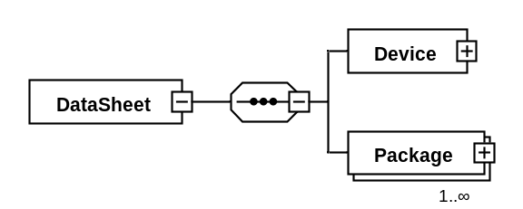
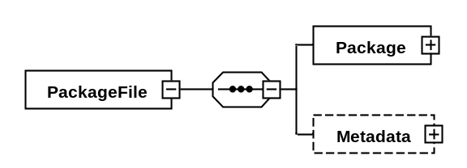
Figure 3-66: Datasheets and Package Files
NOTE – The purpose of the basic structure of a SEDS instance is to indicate whether a given file represents a complete device datasheet, or is only a part of such a definition, intended to be referenced by XInclude.
    - The root element of a SEDS document shall be one of the DataSheet and PackageFile elements.
    - The DataSheet element shall contain exactly one Device element.
NOTE – This element represents the device which is being described by the SEDS document. In the diagram notation above, this is shown by the DataSheet element having a child element Device.
    - The DataSheet element shall contain one or more Package elements.
    - The PackageFile element shall contain exactly one Package element.
    - The Device and PackageFile elements shall contain zero or one MetaData elements (see 3.4).
    - If any SEDS element is based on the NamedEntityType, the element shall have a name attribute and may have the optional shortDescription attribute and LongDescription child element. Optionally, such an element may carry attributes specified by the standard DoT (reference [1]).
NOTES
- The attribute name is restricted by this regular expression [a-zA-Z][a-zA-Z0-9_]* in NameType.
- All named elements of a data sheet use this mechanism to allow summaries and full descriptions to be provided at any level.
- Attributes provided by the standard DoT include units, coordinate reference frames, etc.
- To keep the diagrams simple, attributes are not shown, only elements.
    - The Device element shall be based on the NamedEntityType.

MetaData
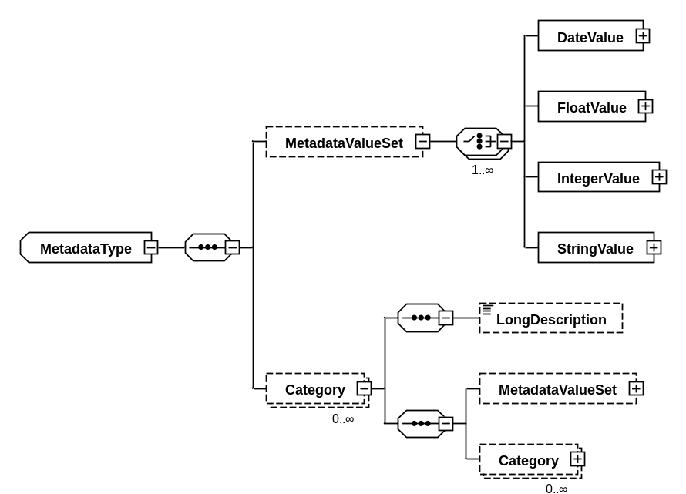
Figure 3-77: Metadata Element
NOTE – Metadata is used for purposes that include the following:
- configuration management information for the SEDS instance in which it appears;
- manufacturers information, including manufacturer name, device model, and serial number;
- model of operation of device to enable semantic reference to subjects of data;
- parameters of mission and platform that are configurable at design time.
- In the above diagram, the box style of the MetadataType indicates that this is not an XML element in itself, but an XML schema-type definition that can apply to one or more elements. These XML schema types use inheritance to share attribute and element definitions. Therefore ‘an element based on the MetadataType’ means ‘any element with an XML schema type derived from MetadataType’.
    - A Metadata element shall specify a hierarchical set of categories of constant data values, each of which can be associated with machine-understandable semantics.
    - A Category element shall specify a categorization or grouping of metadata.
    - The Category element is based on NamedEntityType (see 3.3.6).
    - The Category element shall contain one or more child elements, each of which is either a Category element or MetadataValueSet element.
    - A MetadataValueSet element shall contain one or more child elements, each of which is either a DateValue element, a FloatValue element, an IntegerValue element, or a StringValue element.
    - The DateValue, FloatValue, IntegerValue, and StringValue elements are all based on FieldType.
    - DateValue and StringValue elements shall contain a value attribute specifying the value of the metadata as a literal, per table 3-1.
    - FloatValue and IntegerValue elements may contain a value attribute specifying the value of the metadata as a literal, per table 3-1.

  - Packages
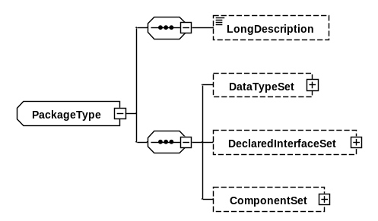
Figure 3-88: Package Element
NOTE – Packages describe a related set of components, data types, and interfaces.
    - The name of each Package element declared shall be unique within the datasheet.
    - A Package name may be hierarchical, in which case it shall consist of multiple name segments separated by the slash character (‘/’).
NOTES
- This permits the declaration of hierarchical packages.
- A hierarchical name is separated by the slash character, which is enforced by a pattern. Hierarchical names are used to avoid accidental name conflicts between the names of packages; there is no special relationship between packages implied by their position in the hierarchy, and no special syntax for accessing the elements defined with package A from a package A/B.
- Subsection 4.3 provides details of referencing types or interfaces within a package from other elements.
    - A package may have an optional shortDescription attribute and an optional LongDescription child element.
    - A Package element may contain the following optional elements, in the following order:
- DataTypeSet;
- DeclaredInterfaceSet;
- ComponentSet.

Data Types
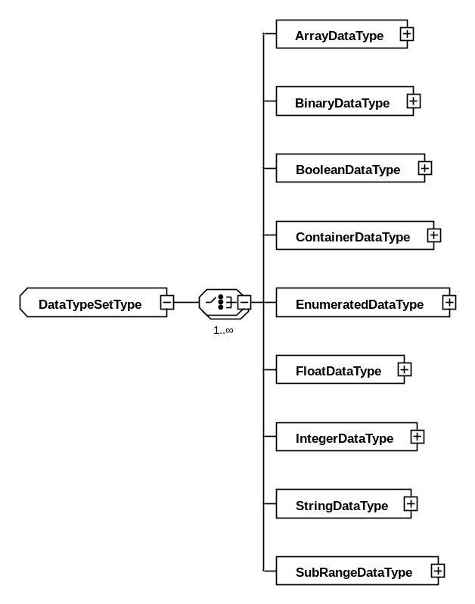
Figure 3-99: Data Types within a DataTypeSet Element
NOTE – Data types describe the syntax and semantics of units of data that flow through interfaces.
    - The DataTypeSet element contained in a package or component shall contain one or more of the following elements: ArrayDataType, BinaryDataType, BooleanDataType, ContainerDataType, EnumeratedDataType, FloatDataType, IntegerDataType, StringDataType, and SubRangeDataType.
    - Each child element of a DataTypeSet element is based on the NamedEntityType (see 3.3.6).
    - The name of each child element of a DataTypeSet element shall be unique within the containing package.
NOTE – This forbids the definition of types with duplicate names inside components within the same package.

Scalar Data Types
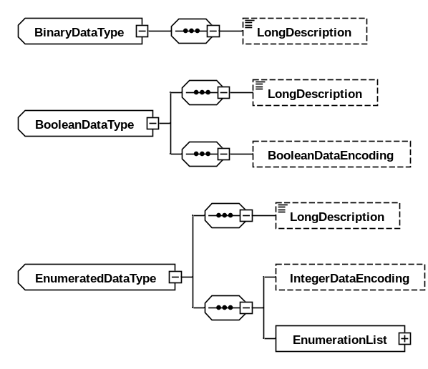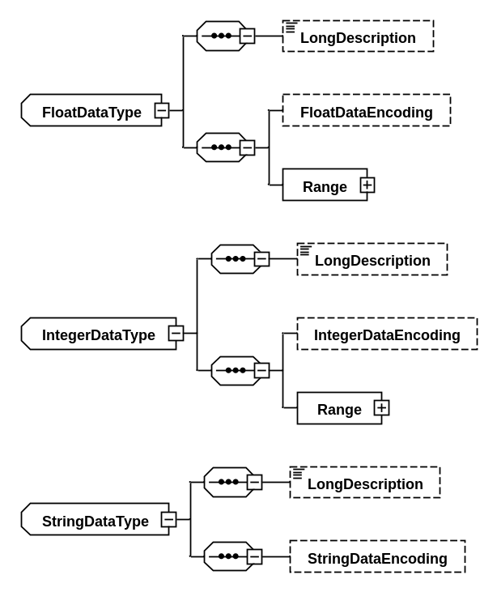
Figure 3-1010: Scalar Data Types
NOTES
- A ‘scalar’ data type is a single-valued data type, as opposed to structured types such as arrays or containers.
- A ‘numeric’ data type is an IntegerDataType or a FloatDataType.
- Scalar types can specify how they are to be encoded. This information is used when they are transmitted over a subnetwork. (See this section, below, and section 4.7.)
- All encoding specifications should be considered as complete and standalone, with no inheritance mechanism.
- Numeric scalar data types can specify a range of representable values, which form a constraint on the possible encodings. (See 3.8 for details.)
- Scalar types can have values specified in a datasheet as literals (see table 3-1).
    - Each BooleanDataType, EnumeratedDataType, FloatDataType, IntegerDataType, StringDataType, or SubRangeDataType element may contain an optional encoding element of a type corresponding to table 3-1.
Table 3-11: Data Types, Encodings, Ranges, and Literals
Data Type | Encoding Type | Range Types | Literal Syntax
BinaryDataType |  |  | xs:hexBinary
BooleanDataType | BooleanDataEncoding |  | xs:boolean
EnumeratedDataType | IntegerDataEncoding | EnumeratedRange | xs:string, matching enumeration label.
FloatDataType | FloatDataEncoding | PrecisionRange  MinMaxRange | xs:float
IntegerDataType | IntegerDataEncoding | MinMaxRange | xs:integer
StringDataType | StringDataEncoding | EnumeratedRange | xs:string
SubRangeDataType |  | as base type | as base type, within range
    - A FloatDataEncoding or IntegerDataEncoding element may carry a byteOrder attribute specifying a value of
- bigEndian, the default, for values which are to be encoded most significant byte first; or
- littleEndian for values which are to be encoded least significant byte first.
NOTE – The littleEndian specification applies only to data types whose size is a multiple of 8 bits.
    - A BooleanDataEncoding element shall carry a sizeInBits attribute which specifies the size, in bits, of the encoded data as a positive integer.
    - A BooleanDataEncoding element may carry a falseValue attribute which specifies the value that corresponds to logical falsehood, with options
- zeroIsFalse (the default); and
- nonZeroIsFalse.
    - An IntegerDataEncoding element shall carry an encoding attribute which has a value of
- unsigned, for an unsigned value;
- signMagnitude, for an encoding with a separate sign bit (the most significant bit is the sign bit, with 1 indicating negative);
- twosComplement, for twos complement;
- onesComplement, for ones complement;
- BCD, for a natural unsigned binary coded decimal, where each byte is a decimal digit encoded as binary; or
- packedBCD, where each byte contains two decimal digits encoded as binary, followed by an optional sign nibble. A negative sign is 1011 or 1101; a positive sign is 1010, 1100, 1110, 1111, or omitted.
    - An IntegerDataEncoding element shall carry a sizeInBits attribute which specifies the size, in bits, of the encoded data as a positive integer.
    - The size in bits of a BCD encoding shall be a multiple of 8. The size in bits of a packedBCD shall be a multiple of 4. The size in bits of both forms of binary coded decimals is a fixed value, so all high-order digits that are zero shall be present to fill the fixed size in bits.
    - A FloatDataEncoding element shall carry an encodingAndPrecision attribute which has a value of either
- IEEE754_2008_single;
- IEEE754_2008_double;
- IEEE754_2008_quad;
- MILSTD_1750A_simple; or
- MILSTD_1750A_extended.
NOTE – These represent the supported sizes of IEEE (reference [6]) and MIL-STD-1750A (reference [7]).
    - A FloatDataEncoding element shall carry a sizeInBits attribute which specifies the size, in bits, of the encoded data as a positive integer.
    - A StringDataType shall carry a length attribute which defines the maximum possible length of the string, in bytes.
    - A StringDataType may carry a fixedLength attribute which, if ‘false’, indicates that the string can be shorter than the value specified by the length attribute.
NOTE – Specification of fixedLength="false" indicates a data type that occupies a variable amount of memory. When such a data type is an entry in a container, then the container is of variable length. (See 4.9 for details about string lengths.)
    - A StringDataEncoding element may carry an encoding attribute which has a value of either
- UTF-8, specifying Unicode UTF-8 encoding (reference [8]); or
- ASCII, the default, specifying US ASCII encoding (reference [9]).
    - The optional terminationByte attribute of a StringDataEncoding element shall specify the termination byte for the string.
NOTES
- For example, a termination character of zero (null) is used by C-language strings.
- Bytes used by a termination character are not included in the count of bytes that constitute the length of the string.
- UTF-8 characters use variable-length encoding that can contain as much as 4 bytes per character. Consequently, not all UTF-8 strings of a given character length are representable by a data type with that byte length.
    - An EnumeratedDataType shall contain an EnumerationList element, consisting of a list of one or more Enumeration elements.
    - Each Enumeration element shall have required label and value attributes, indicating the integer value corresponding to a given label string.
    - An Enumeration element may carry attributes provided by the standard DoT (reference [1]).
    - A BinaryDataType shall have a required sizeInBits attribute.
    - A BinaryDataType may have an optional fixedSize attribute. If this attribute is true, then the sizeInBits indicates the actual size of data. If this attribute is false, then the sizeInBits is the maximum size of data. The default value is false.
    - A SplineCalibrator or PolynomialCalibrator child element may be placed in a numeric data type element to specify any calibration that would be required to take the raw value represented by the data type and convert it into the units and other semantic terms associated with the data type (see 3.15).

Ranges
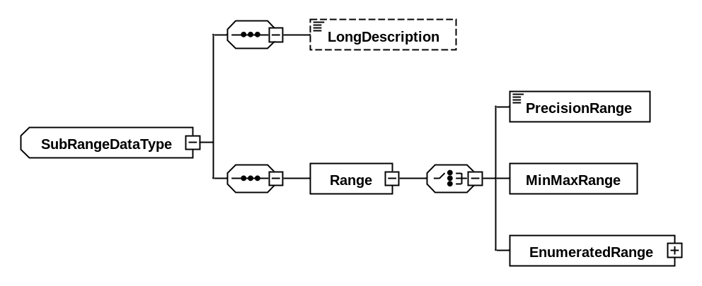
Figure 3-1111: Ranges within a SubRangeDataType Element
NOTE – A range constrains the values of a data type for the purposes of validation and recognition.
NOTE – When a range and a calibrator apply to the same data type, the range shall constrain the raw values (before calibration) of the data type.
    - Each FloatDataType, IntegerDataType, and SubRangeDataType element shall contain a single Range element of a type corresponding to table 3-1.
    - A SubRangeDataType element shall contain a baseType attribute, referring to the numeric or enumerated scalar type which defines all properties other than range.
NOTE – The baseType attribute of a SubRangeDataType should not refer to another SubRangeDataType.
    - A PrecisionRange element shall be either single, double, or quad, representing the full supported representation range of the corresponding IEEE754 floating point data encodings.
    - A MinMaxRange element shall have an attribute rangeType, one of the options listed in table 3-2.
Table 3-22: MinMaxRange Options
Interval Notation | Relational Notation | XML Notation
Interval Notation | Relational Notation | rangeType | min | max
(a..b) | {x | a < x < b} | exclusiveMinExclusiveMax | yes | yes
[a..b] | {x | a <= x <= b} | inclusiveMinInclusiveMax | yes | yes
[a..b) | {x | a <= x < b} | inclusiveMinExclusiveMax | yes | yes
(a..b] | {x | a < x <= b} | exclusiveMinInclusiveMax | yes | yes
(a..+∞) | {x | a < x} | greaterThan | yes
[a..+∞) | {x | a <= x} | atLeast | yes
(-∞..b) | {x | x < b} | lessThan |  | yes
(-∞..b] | {x | x <= b} | atMost |  | yes
    - A MinMaxRange element may have attributes min and max, whose presence and values shall be consistent with table 3-2.
    - An EnumeratedRange element shall have a list of Label child elements, with values that shall be enumeration labels of the corresponding EnumeratedDataType.
    - Each StringDataType element may contain a single Range element of a type corresponding to table 3-1.

Arrays
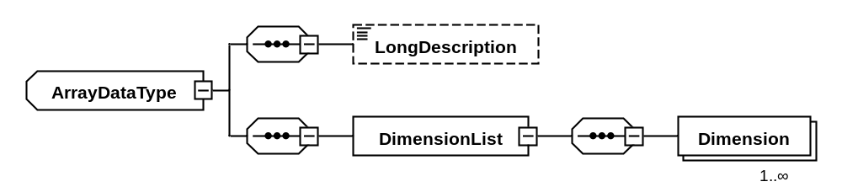
Figure 3-1212: ArrayDataType and Dimension Elements
NOTE – Arrays provide the means to specify adjacent repetitions of the same type of data, the elements of which can be accessed by index.
    - An ArrayDataType element shall contain a dataTypeRef attribute, referring to the type of the elements within the array.
NOTE – Subsection 4.3 provides further details.
    - An ArrayDataType element shall contain a DimensionList element with one or more Dimension child elements.
    - A Dimension element determines the length of the array dimension, in elements, and shall either have attribute size, directly indicating the maximum length, or attribute indexTypeRef, indicating the integer or enumerated data type to be used to index the array. The type referenced by an indexTypeRef attribute has maximum and minimum legal values, from which the size of the array can be inferred. When the size attribute is used, the index is zero-based; when the indexTypeRef is used, the index of the first element of the array is the minimum legal value of the index type.
    - An array having multiple Dimension elements is equivalent to an array with only the first Dimension element and a dataTypeRef naming an array type with the original dataTypeRef and all remaining Dimension elements.
NOTES
- The maximum length of an array with a specified index type can be found by looking at the maximum value of the index range (e.g., an array with index type ‘8 bit unsigned’ has a maximum size of 255).
- Arrays are always encoded serially with no implicit padding. Multi-dimensional arrays use the order implied by paragraph 3.9.4.
- Variable-length arrays, that is, lists, are only supported within the context of a container. (For details, see 3.10.)

Containers
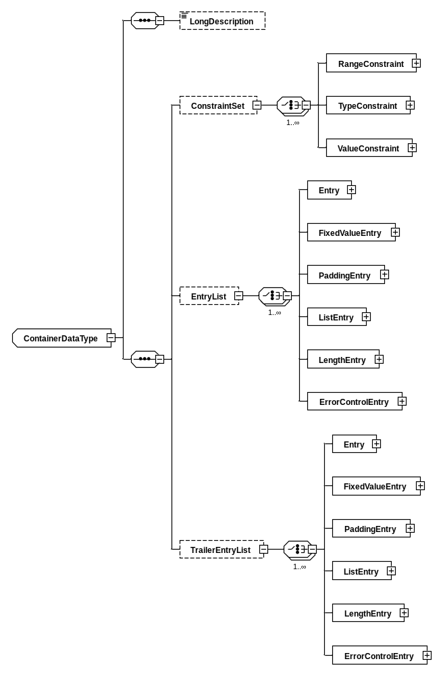
Figure 3-1313: Constraints and Entries of a ContainerDataType Element
NOTES
- Containers are aggregate data types with named entries; each can be of any type.
- There is a concept of a ‘container encoding’, explained in 4.7. For a container that describes a protocol data unit, the encoding determines the arrangement and content of the entries of the container in the protocol data unit. Any container can specify encoding information; a toolchain should ignore this when not applicable. The following information specifies the encoding of a container:
- padding entries;
- bit-width of entries;
- encoding of entries.
- When used for multi-level self-identifying structured data (e.g., CCSDS space packets) containers are organized in a hierarchy in which the concrete container representing a specific packet has a base type of the container representing the packet header and trailer.
- Constraints on header fields represent an implicit algorithm for classifying raw packet data step by step until the final concrete container is selected. (See 4.7 for details.)
- The constraints in a constraint set are combined by conjunction (AND).
    - A ContainerDataType element may carry an optional abstract attribute which, if set to ‘true’, indicates that the container is not to be used directly, only referenced as the base type of other containers.
    - A ContainerDataType element may carry an optional baseType attribute which indicates that the container is a constrained extension of another.
    - A ContainerDataType element shall include zero or one ConstraintSet element and zero or one EntryList element.
    - An abstract ContainerDataType element may include zero or one TrailerEntryList element.
    - The ConstraintSet element of a ContainerDataType element shall specify the criteria that apply to the entries of the container type that is the base type of this container, in order for the type to be valid.
    - The ConstraintSet element of a ContainerDataType element shall contain one or more child elements, which can be one of a RangeConstraint, a TypeConstraint, or a ValueConstraint.
    - Each child entry of a ConstraintSet shall have an attribute entry, which names the entry that the constraint applies to. This entry shall exist within a base container reachable by a recursive chain of base container references from the current container.
    - A RangeConstraint element shall carry a child element of any type of range legal for the type of the constrained entry (see table 3-1).
    - A TypeConstraint element shall have an attribute type, which shall reference a numeric type which has a range included in the type of the constrained entry.
    - A ValueConstraint element shall have an attribute value, which shall contain a literal value of a type corresponding to the type of the constrained entry.
    - The EntryList and TrailerEntryList elements of a ContainerDataType element shall contain one or more Entry, FixedValueEntry, PaddingEntry, ListEntry, LengthEntry, and ErrorControlEntry child elements.
    - The first entry in an EntryList is located at a bit offset immediately following the last entry of the EntryList of any base container, or offset 0 if no such container exists.
    - For an abstract packet, the first entry in a TrailerEntryList is located at a bit offset immediately following all entries of the derived container.
    - Each other entry in an EntryList or TrailerEntryList is located at a bit offset immediately following the previous entry.
    - Each Entry, FixedValueEntry, ListEntry, LengthEntry, and ErrorControlEntry element shall have the attributes and child elements associated with an external field (see 3.10.25).
    - Each Entry, FixedValueEntry, ListEntry, LengthEntry, and ErrorControlEntry element within a container shall have a name that is unique within that container, plus all containers recursively referenced by its baseType attribute.
    - A FixedValueEntry entry shall have a fixedValue attribute which specifies the value to which the container entry should be fixed.
NOTE – The container entry therefore has a constant value and is effectively read-only. This is used for report IDs, command codes, etc.
    - If the fixedValue attribute is used to specify the value for an entry; the value shall be a literal whose type matches the type of the entry according to table 3-1.
    - A PaddingEntry element within a container shall have an attribute sizeInBits, which is used to specify the position of successive fields.
    - A ListEntry element within a container shall specify an attribute listLengthField which contains the name of another element of the same container whose value will be used to determine the number of times this entry should be repeated.
    - A LengthEntry element within a container shall specify an entry whose value is constrained, or derived, based on the length of the container in which it is present.
    - If a LengthEntry element has a calibration (see 3.11.7), that calibration shall be used to map between the length in bytes of the container and the value of the entry, according to the formula:
container length in bytes = calibration(entry raw value).
NOTE – A constraint that refers to a LengthEntry compares to the entry raw value.
    - Any calibration specified for a LengthEntry shall be reversible, that is, a linear polynomial, or spline, with all points of degree 1.
    - An ErrorControlEntry element within a container shall specify an entry whose value is constrained, or derived, based on the contents of the container in which it is present. In addition to a subset of the attributes and elements supported for a regular container entry, it has the mandatory attribute type, which is one of the values specified in the DoT for errorControlType as illustrated in table 3-3.
Table 3-33: Error Control Types
Value | Description | Reference
CRC16_CCITT | G(X) = X^16 + X^12 + X^5 + 1 | [10], subsection 4.1.4.2
CRC8 | G(x) = x^8 + x^2 + x^1 + x^0 | [11], clause 5.2
CHECKSUM | modulo 2^32 addition of all 4-byte | [12], subsection 4.1.2
CHECKSUM_LONGITUDINAL | Longitudinal redundancy check, bitwise XOR of all bytes | [13]
    - A ContainerDataType element may carry an optional encodingRules attribute which indicates that the container should be encoded according to CBOR or CBORindefinite encoding.
NOTE – Concise Binary Object Representation (CBOR) is defined in IETF RFC 7049 [18].
    - A ContainerDataType element may carry an optional encodedAs attribute which indicates that the container should be encoded as if the totality of its contents were treated as a single instance of the data type referenced by the attribute.
NOTE – For example, a container encoded as an integer data type and used as an entry in a container with CBOR encoding would be packed in an integer and then encoded as the appropriate CBOR type.
    - Each Entry, FixedValueEntry, ListEntry, LengthEntry, ErrorControlEntry, and PaddingEntry element within a container may contain a PresentWhen element which contains constraints to specify when that entry is present in an instance of that container type. The types of constraints in a PresentWhen element shall be the same types that may appear in a ConstraintSet element of a container.
    - Each RangeConstraint, TypeConstraint, and ValueConstraint element within a ConstraintSet or PresentWhen element may have an optional negate attribute, which defaults to “false”, and which indicates when “true” that the negation of the constraint applies.

Fields
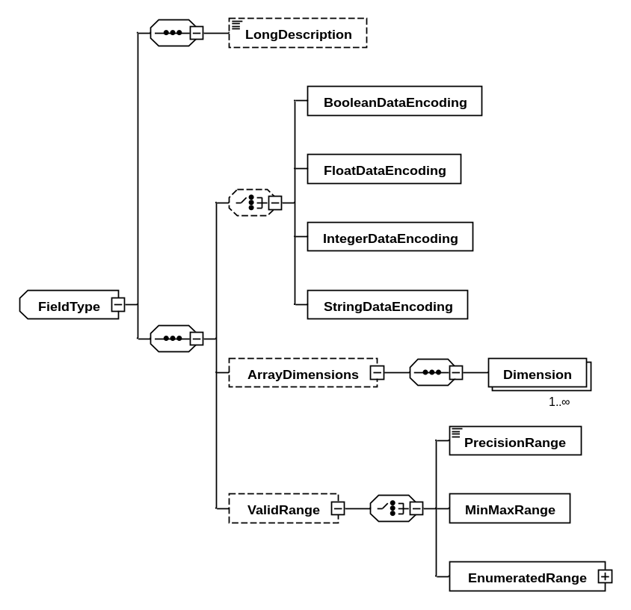
Figure 3-1414: Field Schema Type
NOTES
- Data types are instantiated in many different circumstances; however, whenever a data type is instantiated there is a set of common valid attributes and elements. This is referred to as a ‘field’. This subsection describes these attributes and elements such that they may be referenced whenever a data type instantiation is described elsewhere in this document.
- The concept of ‘field’ permits the definition of parameter, arguments, or container entries that are a subrange, encoding, or array of the referenced type; this definition of an anonymous type avoids the need to define artificial explicit named types.
- An extension of the field concept is the External Field schema type, which is used in cases in which the value of the field may appear on an interface (i.e., parameters, command arguments, and container entries).
    - A field is based on the NamedEntityType (see 3.3.7).
    - A field shall carry a type attribute identifying the name of the data type it is based on.
NOTE – Subsection 4.3 provides further details.
    - A field shall have zero or one ValidRange element, zero or one ArrayDimensions element, and zero or one encoding element.
    - Any ValidRange and encoding child elements of a field shall match the type attribute according to table 3-1.
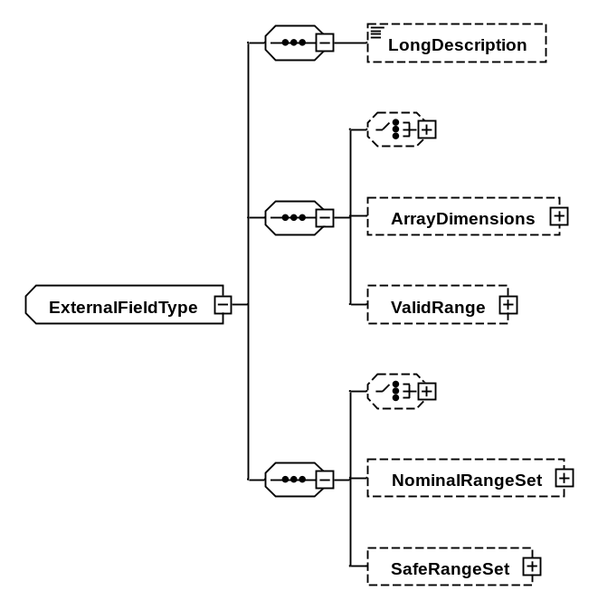
Figure 3-1515: External Field Schema Type
    - A NominalRangeSet child element of an external field specifies the nominal operating limits of the field. It has the same child elements and attributes as other Range elements (see 3.8).
    - A SafeRangeSet child element of an external field specifies the safe operating limits of the field. It has the same child elements and attributes as other Range elements (see 3.8).
    - A SplineCalibrator or PolynomialCalibrator child element of an external field specifies any calibration that would be required to take the raw value represented by the data type and convert it into the units and other semantic terms associated with the field (see 3.15).

Interfaces
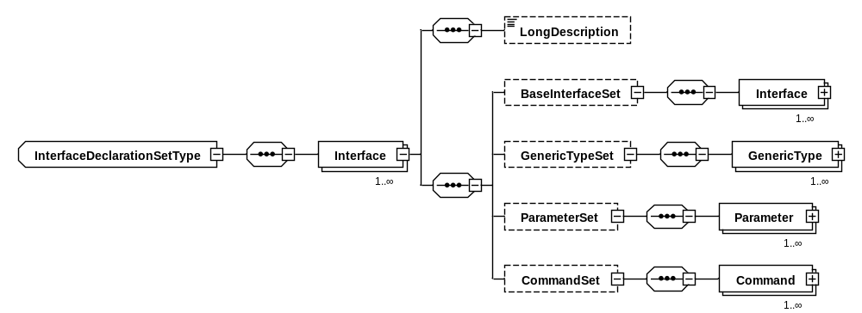
Figure 3-1616: Interfaces within a DeclaredInterface Set Element
NOTES
- Standardized interfaces, including those to the subnetwork, are defined with this interface construct to allow them to be treated symmetrically with user-defined interfaces.
- Any interface declared within a data sheet is implicitly scoped to the target device, bypassing any complexities associated with having multiple devices.
- An interface definition can be split into multiple parts, and therefore placed in multiple package files, which can be joined together by specifying the members of the BaseInterfaceSet. This allows separation of aspects of an interface which address different concerns or have different authors.
- No guarantee of run-time compatibility is implied by two different interfaces sharing a common base interface.
- All commands and parameters in such a set of aggregated interfaces must have unique names, so no rules are needed to resolve conflicts between them.
- An interface can be defined in terms of generic types to avoid placing undue restrictions on its implementation or use. Such interfaces need to have those generic types mapped to fully specified types before use (see 3.12.7).
    - A DeclaredInterface Set element shall contain one or more Interface elements.
    - Each Interface child element of a DeclaredInterface Set is based on the NamedEntityType (see 3.3.7).
    - The name of each Interface child element of a DeclaredInterface Set element shall be unique.
    - An Interface element of a DeclaredInterfaceSet element shall contain zero or one BaseInterfaceSet element referencing one or more Interface elements, zero or one GenericTypeSet element containing one or more GenericType elements, zero or one ParameterSet element containing one or more Parameter elements, and zero or one CommandSet element containing one or more Command elements. The total number of commands and parameters in a declared interface shall be greater than zero, summing over inheritance through BaseInterfaceSet and over declaration in ParameterSet and CommandSet.
    - An Interface element of a DeclaredInterfaceSet element may have an optional attribute abstract, which, if true, indicates the interface may not be used directly by a component.
    - An Interface element of a DeclaredInterfaceSet element may have an optional attribute level, with value taken from table 3-4, which indicates the system level at which it operates. The default value is “application”.
NOTE – The level of an interface corresponds mostly to the layers in a protocol stack for onboard communications but includes two special layers, application and environment, which would not be considered to be part of a protocol stack. The application level represents interfaces between applications that serve a purpose other than communication protocol. The environment level represents the interfaces provided by the real world for functions of physical hardware sensors and actuators. The environment level may describe interfaces for simulation, for hardware-in-the-loop, and for specification of environmental constraints on hardware. Hardware constraints in the environmental level may express manufacturer’s recommended thermal operating ranges, maximum radio frequency energy, maximum photon count, for example.
Table 3-44: Interface Levels
Name | Description
application | Not directly related to device data.
functional | Higher-level virtual abstraction of device data.
access | Lower-level specification of device data.
subnetwork | Raw uninterpreted communication channel to a device.
physical | OSI layer 1, pins, voltages, etc.
environment | For simulation or hardware-in-the-loop, between component and environment.
    - Each Interface child element of a BaseInterfaceSet element shall identify one existing interface definition whose commands, parameters, and generic types shall be treated as part of this interface definition.
NOTE – This interface will therefore aggregate all of the parameters and commands of each identified parent interface type (including any parameters and commands inherited from their parents, and so on). Circular aggregation (‘A has base B which has base A’) is not permitted. (See notes attached to 3.12.12 and 3.12.16.)
    - Each GenericType child element of a GenericTypeSet element specifies a generic type to be used by the interface, and is based on the NamedEntityType (see 3.3.6).
    - The name of each GenericType child element of a GenericTypeSet element shall be unique.
    - Each GenericType element may carry a baseType attribute which specifies an existing type. The existing type shall be a base (ancestor) type of any concrete type, which is mapped to the generic type when the interface is instantiated.
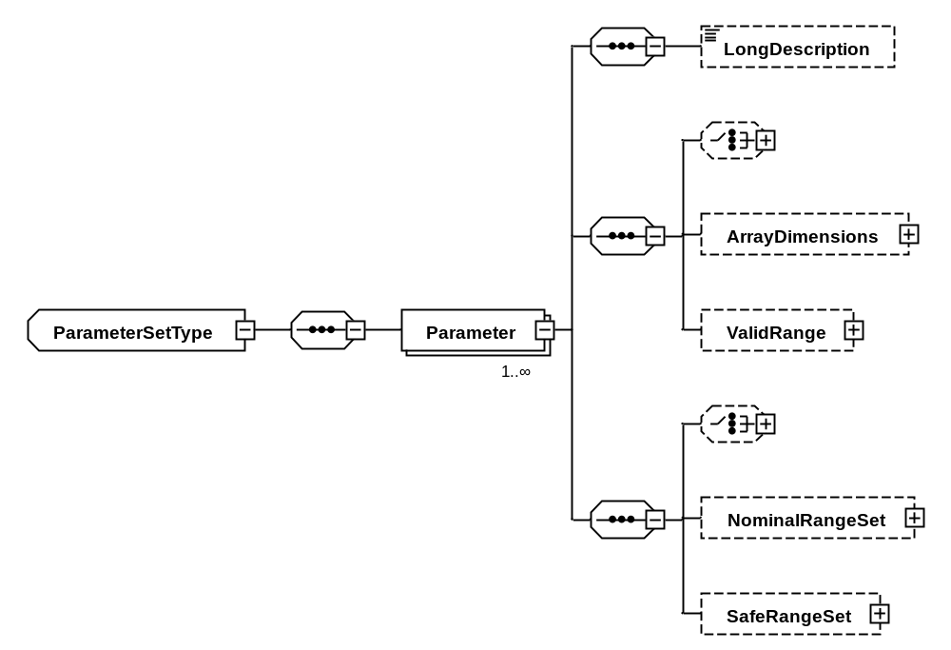
Figure 3-1717: Parameters in a ParameterSet Element
    - Each Parameter child element of a ParameterSet element shall have the attributes and child elements associated with an external field (see 3.10.25) with the addition of an optional mode attribute indicating how the parameter data is transmitted across the interface, and an optional readOnly attribute identifying if the parameter is read-only.
    - The name of each Parameter child element of a ParameterSet element shall be unique within the set of interfaces reachable by BaseType references from the containing interface.
    - Valid values for the mode attribute of a Parameter element shall be ‘sync’ (the default, indicating a two-way message exchange) or ‘async’.
NOTE – Subsection 4.5 provides further details.
    - Valid values for the readOnly attribute shall be ‘false’ (the default) or ‘true’.
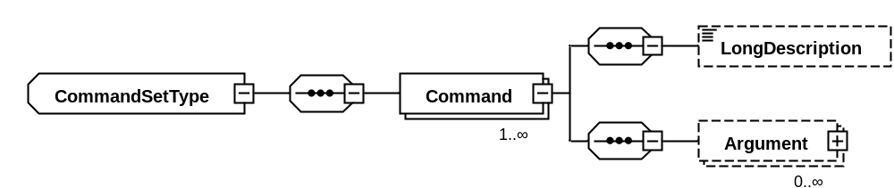
Figure 3-1818: Commands in a CommandSet Element
    - Each Command child element of a CommandSet element is based on the NamedEntityType (see 3.3.6), plus optional mode and pattern attributes, identifying the command message pattern.
NOTE – The command message pattern is explained in section 4.5.
    - The name of each Command child element of a CommandSet element shall be unique within the set of interfaces reachable by BaseType references from the containing interface.
NOTE – The reason for this restriction is to eliminate the possibility of a derived interface overriding a command of a base interface. Instead, the commands of each base type interface are included unchanged in the derived interface. This is a form of aggregation of interface commands.
    - Each Command child element of a CommandSet element identifies a command on an interface and shall contain zero or more Argument elements, each of which identifies an argument to the command.
    - Each Argument child element of a Command element shall have the attributes and child elements associated with an external field (see 3.10.25) with the addition of an optional mode attribute, identifying the argument mode.
    - The name of each Argument child element of a Command element shall be unique within the command.
    - A command argument may have an attribute defaultValue, indicating the value to be used for a call to this command when not otherwise specified.
    - A command argument may have an attribute dataUnit, indicating it is a service data unit, and therefore should be passed to/from the device without further interpretation or encoding.
NOTE – Subsection 4.7 provides further details.
Table 3-55: Interface Syntax, Primitives, and Transactions
Interface Element | Parameter/Command Modes | Argument Modes | Primitive | Transaction
Parameter | sync |  | request  indication | yes
Parameter | async |  | indication | no
Command | sync | No notify arguments. | request  indication | yes
Command | sync | At least one notify argument | request  notify  indication | yes
Command | async | No notify arguments, no out or inout arguments | request | no
Command | async | At least one notify argument, no out or inout arguments | request  notify | no
Command | async | inout, or both in and out | illegal | no
Command | async | No notify arguments, no in or inout arguments | indication | no
    - Valid values for the mode attribute of a command argument shall be as listed in table 3-5.
NOTE – Subsection 4.5 provides further details.

Components
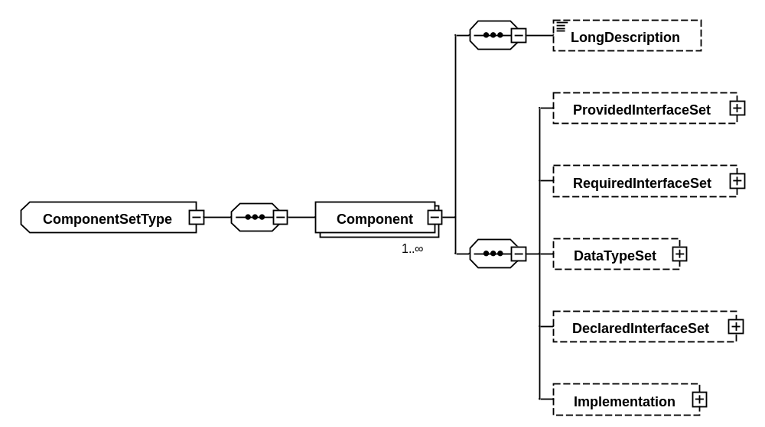
Figure 3-1919: Components in a ComponentSet Element
NOTE – Components describe entities that have interfaces and computational behaviour.
    - The ComponentSet element contained in a package shall contain one or more Component elements.
    - Each Component child element of a ComponentSet element is based on the NamedEntityType (see 3.3.6).
    - The name of each Component child element of a ComponentSet element shall be unique within the containing package.
    - A Component element shall contain, in order,
- zero or one ProvidedInterfaceSet element;
- zero or one RequiredInterfaceSet element;
- zero or one DataTypeSet element;
- zero or one DeclaredInterfaceSet element; and
- zero or one Implementation element.
    - The ProvidedInterfaceSet and RequiredInterfaceSet element, if present, shall each contain one or more Interface elements, each of which identifies a provided or required interface, respectively.
    - Each Interface child element of a ProvidedInterfaceSet or RequiredInterfaceSet element is based on the NamedEntityType (see 3.3.6).
    - The name of each Interface child element of a ProvidedInterfaceSet or RequiredInterfaceSet element shall be unique within the containing component.
    - Each Interface element of a ProvidedInterfaceSet or RequiredInterfaceSet element shall carry a type attribute which identifies the type of the interface by referencing an element of the DeclaredInterfaceSet entry of a Package or Component.
NOTE – Subsection 4.3 provides further details.
    - Each Interface element may have a GenericTypeMapSet element which maps the generic types used to define the interface to the concrete types used in the current component.
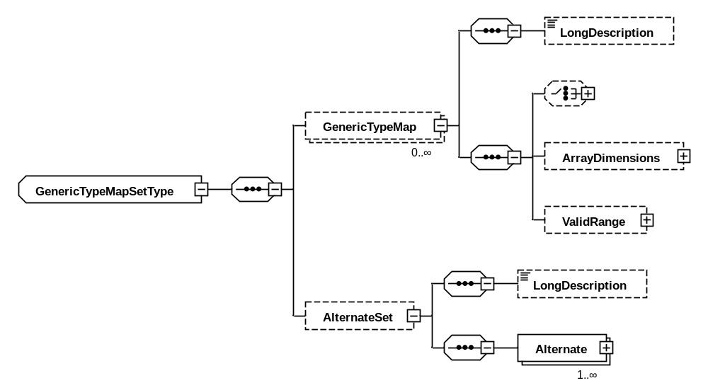
Figure 3-2020: Generic Type Mapping
    - A GenericTypeMap element specifies a mapping of a generic type to a concrete type and shall have the attributes and child elements associated with a field (see 3.10.25), with the optional addition of a fixedValue attribute.
    - The optional fixedValue attribute of a GenericTypeMap element shall specify a fixed value for the generic type.
NOTE – This is equivalent to specifying a data type with a valid range which contains only the value specified by the fixedValue attribute.
    - An AlternateSet child element of a GenericTypeMapSet element, if present, specifies a set of alternative mappings of generic types to a concrete type and shall contain one or more Alternate elements, each of which shall contain one or more GenericTypeMap elements.
NOTE – This construct exists to deal with scenarios like ‘if you read a value from address x, the result will be of type A, whereas if you read from address y, the result will be of type B’. (See 4.3 for further details.)
    - The optional DataTypeSet child element of a Component shall define types local to the component and cannot be referenced outside it.
    - The optional DeclaredInterfaceSet child element of a Component shall define interface declaration local to the component and cannot be referenced outside it.
NOTE – Such local interfaces are normally constrained versions of a more generic interface, such as a subnetwork service.
    - Types and interfaces declared within the DataTypeSet and DeclaredInterfaceSet child elements of a Component element shall only be visible to descendent elements of the Component element.
NOTE – Types declared as part of a component type can only be used within the component type and its associated implementation. This makes these types ‘private’ to the component type declaration.

Component Implementations
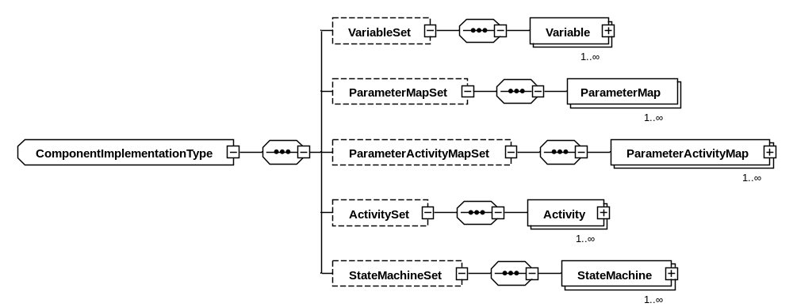
Figure 3-2121: Implementation Element of a Component
NOTES
- The implementation of a component specifies its behaviour, that is, the way in which the component offers data services through provided interfaces, and the way in which the component uses data services through required interfaces.
- A set of variables organizes working memory for computation of behaviour.
- The parameter map set and parameter activity map set provide a terse specification of the transfer of data between required and provided interfaces.
- For cases in which this is insufficient, the state machine set contains UML state machine graphs which express time-driven and event-driven behaviour.
- The activity set contains snippets of procedures in a form that is consistent with many structured procedural programming languages. These can be referenced from state machines and parameter activity maps.
    - The Implementation child element of a Component element shall contain zero or one of each of the following elements, in order:
- VariableSet;
- ParameterMapSet;
- ParameterActivityMapSet;
- ActivitySet;
- StateMachineSet.
    - A VariableSet element shall contain one or more Variable elements. (See figure 3-22.)
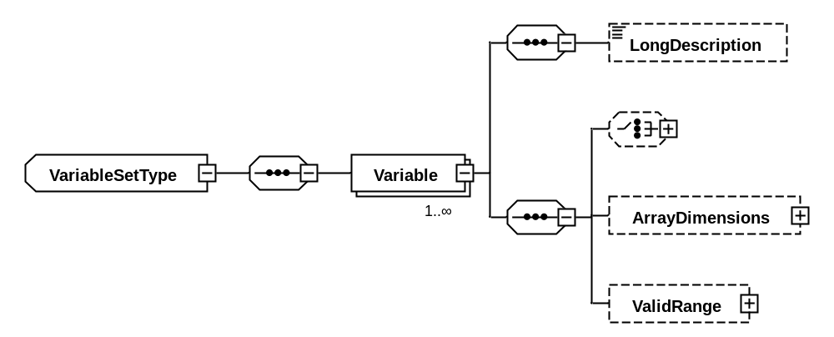
Figure 3-2222: Variable Element of a VariableSet
    - Each Variable element shall have the attributes and child elements associated with a field (see 3.10.25), with the addition of an optional initialValue attribute identifying the initial value of the variable and an optional readOnly attribute.
    - The name of each Variable child element of a VariableSet element shall be unique.
    - If the initialValue attribute is used to specify an initial value for a variable, the value shall be a literal whose type matches the type of the variable, as specified in table 3-1.
    - The optional Boolean readOnly attribute of a variable shall, if true, indicate that the variable shall have an initial value, and may not be subsequently assigned to.
    - A ParameterMapSet element shall contain one or more ParameterMap elements.
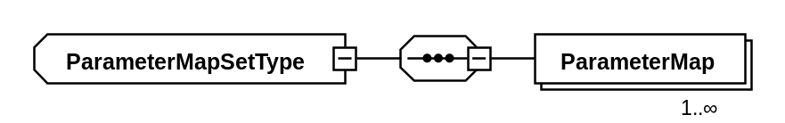
Figure 3-2323: ParameterMap Element of a ParameterMapSet
    - A ParameterMap element shall carry one parameterRef attribute and one variableRef attribute.
    - The parameterRef attribute of a ParameterMap element shall refer to a parameter on an interface provided or required by the component type.
    - The variableRef attribute of a ParameterMap element shall refer to a variable declared by the component type.
    - The types of the elements referred to by the parameterRef and variableRef attributes shall match. (See 4.3.12 in the SEDS Green Book, reference [D22], for an explanation.)
Table 3-66: Legal Parameter Mappings
Interface Parameter |  |  | Component Variable | Description
Interface | Mode | Read-only | Read-only | Description
provided | sync | true | true | Externally-readable constant
provided | sync | true | false | Externally-readable variable
provided | sync | false | false | Externally-updateable variable
required | async | true | false | Externally-supplied variable
    - The set of properties of the interface parameter and component variable involved in a mapping shall correspond to one of the rows in table 3-6. (See 4.3.12 in the SEDS Green Book, reference [D22], for an explanation.)
    - A ParameterActivityMapSet element shall contain one or more ParameterActivityMap elements.
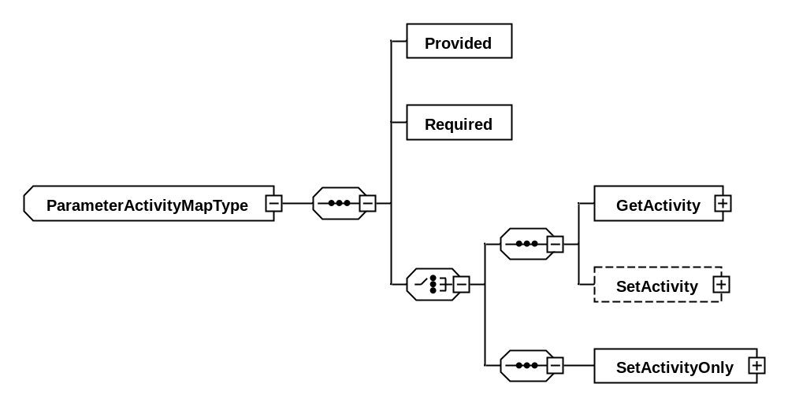
Figure 3-2424: ParameterActivityMap Element of a ParameterActivityMapSet
    - Each ParameterActivityMap element maps a parameter on a provided interface to a parameter on a required interface using an activity.
    - A ParameterActivityMap element shall contain a Provided element and a Required element, each of which carry a name attribute and an interfaceParameterRef attribute. These elements make the specified interface parameter available within the scope of the activity as a local variable with the specified name.
    - The interface parameters referenced by the Provided and Required elements of a ParameterActivityMap shall have the same values for the attribute mode.
    - If the interface parameter referenced by the Required element of a ParameterActivityMap has the readOnly attribute set to true, the same shall be true of the interface parameter referenced by the Provided element.
    - Additionally, each ParameterActivityMap element shall have either
- one GetActivity child element; or
- one GetActivity child element and one SetActivity child element.
    - The GetActivity and SetActivity elements shall specify a sequence of actions to be used for the parameter mapping during a get or set operation on the provided parameter, respectively. The valid child elements for these elements shall be the same as those for the Body child element of an Activity element (see 3.15.7).
    - If the interface parameter referenced by the Required element of a ParameterActivityMap has the readOnly attribute set to true, the SetActivity child element shall not be present.
    - The same interface parameter may not be referenced more than once across all ParameterMap and ParameterActivityMap elements of a component.
NOTE – There is no restriction on using the same variable, or fields thereof, for multiple mappings.

Activities
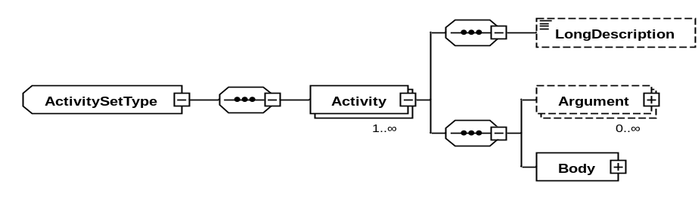
Figure 3-2525: Activities within an ActivitySet Element
NOTE – An activity is a block of executable statements whose invocation is controlled by one or more state machines.
    - The ActivitySet element shall contain one or more Activity elements.
    - Each Activity element is based on the NamedEntityType (see 3.3.6).
    - The name of each Activity child element of an ActivitySet element shall be unique.
    - Each Activity element shall contain zero or more Argument elements and one Body element.
NOTE – Argument elements permit the operation of the activity, specified by the Body element, to be parameterized. Parameterization means that invocation of the activity must be accompanied by arguments that provide data values to be used by the activity, and the body of the activity contains statements that refer to those arguments. In this document, references to arguments are indicated by the term “activity argument”.
    - Each Argument child element of an Activity element shall have the attributes and child elements associated with a field (see 3.10.25).
    - The name of each Argument child element of an Activity element shall be unique.
    - The Body child element of an Activity element shall contain one or more of the following elements: SendParameterPrimitive, SendCommandPrimitive, Calibration, MathOperation, Assignment, Conditional, Iteration, or Call.
    - The sequence of elements specified in the Body element shall define the sequence of operations of the activity.
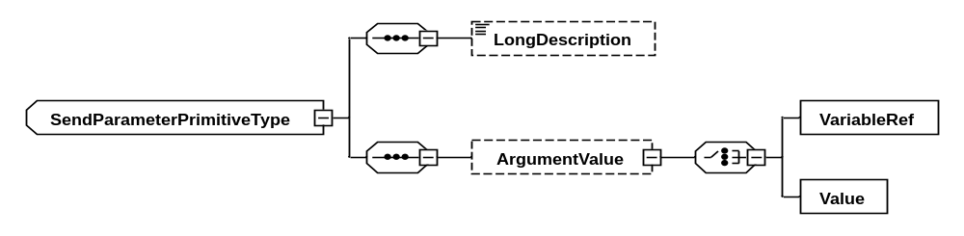
Figure 3-2626: SendParameterPrimitive Element
    - A SendParameterPrimitive element shall specify the transmission of a parameter request or indication primitive to an interface provided or required by the component type.
    - A SendParameterPrimitive element shall carry
- an interface attribute, identifying the component interface to which the primitive relates;
- a parameter attribute, identifying the interface parameter to which the primitive relates;
- an operation attribute, identifying whether the primitive is for a get or set operation;
- an optional transaction attribute which permits this primitive to be related to the opposing primitive of the request/indication pair; and
- an optional failed attribute, defaulting to false, used in an indication to explicitly report failure of the corresponding request.
    - The transaction attribute of the SendParameterPrimitive element shall be present or absent, depending on the conditions given in table 3-5.
    - A SendParameterPrimitive element may include an ArgumentValue element according to the conditions described in table 3-7.
    - An ArgumentValue element shall include either a Value element, specifying a literal value to be associated with the primitive, or a VariableRef element, specifying a component variable or activity argument be associated with the primitive (see table 3-7).
Table 3-77: Arguments to a Primitive
Element | Interface Direction | Parameter Operation | Number of Arguments
SendCommandPrimitive | any |  | 0 or more
OnCommandPrimitive | any |  | 0 or more
SendParameterPrimitive | required | Get | 0
SendParameterPrimitive | provided | Get | 1
SendParameterPrimitive | required | Set | 1
SendParameterPrimitive | provided | Set | 1
OnParameterPrimitive | required | Get | 1
OnParameterPrimitive | provided | Get | 0
OnParameterPrimitive | required | Set | 1
OnParameterPrimitive | provided | Set | 0
    - The type of the value specified by either the VariableRef or Value child element of an ArgumentValue element shall match the type of the parameter or command argument to which the primitive relates.
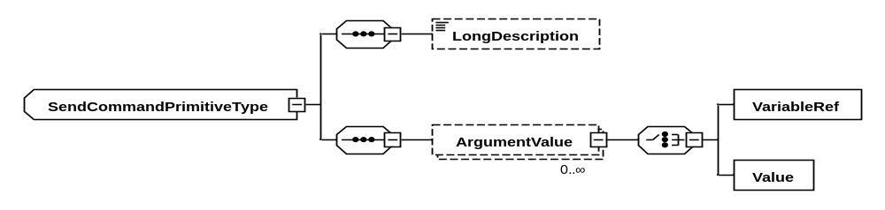
Figure 3-2727: SendCommandPrimitive Element
    - A SendCommandPrimitive element shall specify the transmission of a command request or indication primitive to an interface provided or required by the component type.
    - A SendCommandPrimitive element shall carry
- an interface attribute, identifying the component interface to which the primitive relates;
- a command attribute, identifying the interface command to which the primitive relates;
- an optional transaction attribute which permits this primitive to be related to the opposing primitive of the request/indication pair; and
- an optional failed attribute, defaulting to false, used in an indication to explicitly report failure of the corresponding request.
    - The transaction attribute of the SendCommandPrimitive element shall be present or absent according to the conditions expressed in table 3-5.
    - A SendCommandPrimitive element may include a number of ArgumentValue elements according to the conditions described in table 3-7.
    - Each ArgumentValue child element of a SendCommandPrimitive element shall carry a name attribute identifying the command argument with which this value is associated.
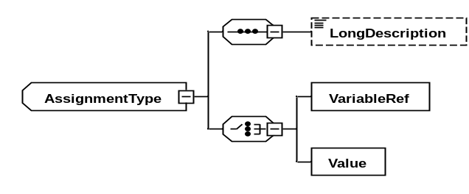
Figure 3-2828: Assignment Element
    - An Assignment element shall specify the assignment of a value, either by specifying as a literal or by referencing a component variable or activity argument, to a component variable.
    - An Assignment element shall carry an outputVariableRef attribute identifying the component variable to which the value should be assigned.
    - An Assignment element shall include either a Value element, specifying a literal value to be assigned to the output parameter, or a VariableRef element which specifies a component variable or activity argument to use as the source of the value to assign to the output parameter.
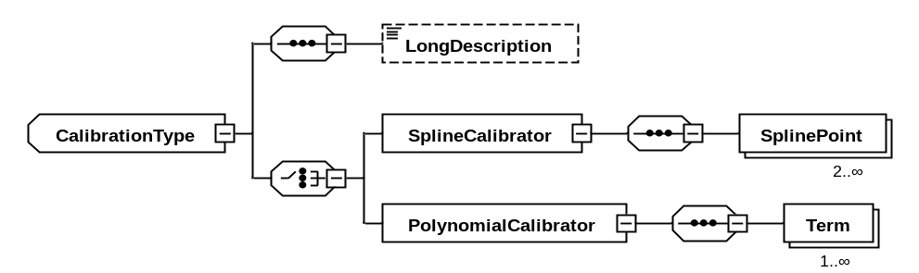
Figure 3-2929: Polynomial and Spline Calibrators within a Calibration Element
    - A Calibration element shall specify the assignment of a value, either by specifying as a literal or by referencing a component variable or activity argument, to a component variable, translating the value according to a specified calibration operation.
    - A Calibration element shall carry an outputVariableRef attribute identifying the component variable to which the calibrated value should be assigned.
    - A Calibration element shall include an inputVariableRef element, specifying a component variable or activity argument to use as the source of the value to calibrate before assignment to the output parameter.
    - A Calibration element shall include either a SplineCalibrator or PolynomialCalibrator element.
    - A SplineCalibrator element shall have an attribute extrapolate, indicating whether to extrapolate values outside the range of points.
    - A SplineCalibrator element shall have two or more SplinePoint child elements.
    - A SplinePoint child element of a SplineCalibrator shall have attributes raw and calibrated, which together represent a point on the spline curve used to convert from raw to calibrated values, and order, which represents the maximum degree of the polynomial segment between that point and the point with the next higher raw value. The order attribute value shall be in {1, 2, 3}. Specification of a value n for order shall also imply that the zeroth through (n-1)th derivatives of the polynomial segments ending and beginning at the spline point shall be the same. The value of the polynomial segments at a spline point shall equal the calibrated value of the spline point. If order is not specified, it shall be assumed to be 1. The second derivatives of the polynomial segments at the spline points with greatest and least raw values shall be implicitly zero.
NOTE – A spline of order 1 is linear (i.e., a traditional point calibration), a spline of order 2 is quadratic, and a spline of order 3 is cubic. There must be the mathematically necessary number of consecutive points of a given order to support higher-order spline curves.
NOTE -- The zeroth derivative of a function is the value of the function.
NOTE -- The continuity constraints above force equality of polynomial segments at each interior spline point. The spline function passes through each spline point.
    - A PolynomialCalibrator element shall have one or more Term child elements.
    - A Term child element of a PolynomialCalibrator shall have attributes coefficient and exponent, which together define one term of the polynomial expression used to convert from raw to calibrated values.
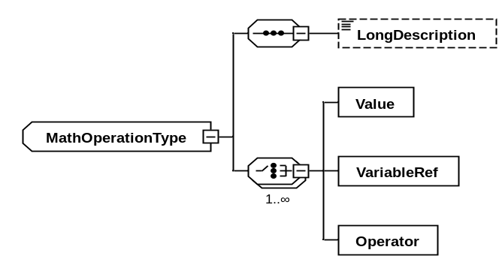
Figure 3-3030: MathOperation Element
    - A MathOperation element shall specify a mathematical operation in postfix (Reverse Polish) notation.
NOTE – This means that the sequence of values and operators must be valid when taking into account the ‘arity’ column of table 3-8.
    - A MathOperation element shall carry an outputVariableRef attribute identifying the component variable to which the calculated value should be assigned.
NOTE – The encoding and size of the variable referenced by the outputVariableRef attribute determines the precision of the math operation.
NOTE -- The implementation of math operations should operate internally on floating point numbers. When the output variable reference specifies an integer type, and the math operation computes a non-integer result, the implementation should throw an error condition.
    - A MathOperation element shall include a sequence of the following child elements:
- Value;
- VariableRef;
- Operator.
    - The Value and VariableRef child elements of a MathOperation element shall have the same contents and meanings as the elements of the same name of an Assignment element.
NOTE -- Math operations apply to integer and floating point values and variables.
    - An Operator child element of a MathOperation element shall have a single attribute operator, which shall be one of the values from table 3-8.
Table 3-88: Mathematical Operators
Value | Description | Arity
add | Addition | binary
subtract | Subtraction | binary
multiply | Multiplication | binary
divide | Division | binary
modulus | Remainder | binary
pow | x raised to the power y | binary
ln | Natural (base e) logarithm of x | unary
log | Base 10 logarithm | unary
exp | e raised to a power x | unary
inverse | 1/x | unary
tan | Trigonometric function | unary
cos | Trigonometric function | unary
sin | Trigonometric function | unary
atan | Inverse trigonometric function | unary
atan2 | Inverse trigonometric function | binary
acos | Inverse trigonometric function | unary
asin | Inverse trigonometric function | unary
tanh | Hyperbolic trigonometric function | unary
cosh | Hyperbolic trigonometric function | unary
sinh | Hyperbolic trigonometric function | unary
atanh | Inverse hyperbolic trigonometric function | unary
acosh | Inverse hyperbolic trigonometric function | unary
asinh | Inverse hyperbolic trigonometric function | unary
swap | Exchange x and y | binary
abs | Absolute value | unary
ceil | Round to integer towards positive infinity | unary
floor | Round to integer towards negative infinity | unary
round | Round to nearest integer, ties as ceil | unary
min | Minimum | binary
max | Maximum | binary
sqrt | Square root | unary
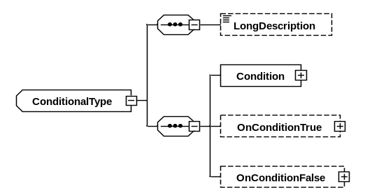
Figure 3-3131: Conditional Element
    - A Conditional element shall specify the conditional execution of elements of the activity.
    - A Conditional element shall include one Condition element, zero or one OnConditionTrue element, and zero or one OnConditionFalse element.
    - A Condition element shall specify a Boolean expression as shown in figure 3-32.
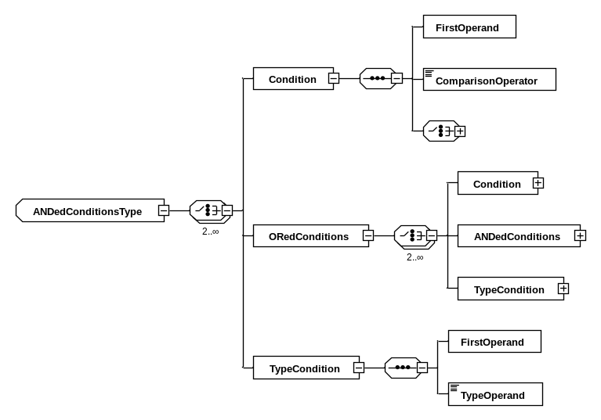
Figure 3-3232: Conditional Execution of an Activity or State Machine Transition Guard
      - An ANDedConditions element shall specify the conjunction of two or more Boolean expressions, as shown in figure 3-32. Each Boolean expression may be a Condition element, a TypeCondition element, or an ORedConditions element.
      - An ORedConditions element shall specify the disjunction of two or more Boolean expressions. Each Boolean expression may be a Condition element, a TypeCondition element, or an ANDedConditions element.
    - A TypeCondition element shall be true if the FirstOperand value is an instance of the type specified by the TypeOperand, or an instance of a derivative of that type.
    - An OnConditionTrue element shall contain one or more of the elements allowed in an activity body specifying the operations to perform if the outcome of the condition expression is ‘true’.
    - An OnConditionFalse element shall contain one or more of the elements allowed in an activity body specifying the operations to perform if the outcome of the condition expression is ‘false’.
    - An Iteration element shall specify the repeated execution of elements of the activity.
    - An Iteration element shall carry an iteratorVariableRef attribute identifying the component variable to use to hold the iteration value.
    - An Iteration element shall either contain either an OverArray element or a StartAt element, a Step element, and an EndAt element, in that order.
    - An Iteration element shall contain a Do element after all other elements.
    - The OverArray element of an Iteration element shall specify an array over which to iterate, assigning the value of each array element, in turn, to the iteration parameter.
    - The StartAt element shall include either a Value element, specifying a literal value to be assigned as the initial value of the iteration parameter, or a VariableRef element, specifying a component variable or activity argument to use as the source of the value to use as an initial value of the iteration parameter.
    - The EndAt element shall include either a Value element, specifying a literal value to be used as the final value of the iteration parameter (inclusive), or a VariableRef element, specifying a component variable or activity argument to use as the source of the value to use as the final value of the iteration parameter (inclusive).
    - A Step element shall include either a Value element, specifying a literal value to be used as the difference in value of the iteration parameter between iterations, or a VariableRef element, specifying a component variable or activity argument to use as the source of the value to be used as the difference in value of the iteration parameter between iterations.
    - The Do element shall contain one or more of any of the elements allowed in an activity body.
    - A Call element shall identify a nested activity to be called at this point in the activity execution.
    - A Call element shall include zero or more ArgumentValue elements, each of which, in turn, shall carry a name attribute, identifying the name of an activity argument and including either a Value element, specifying a literal value to be associated with the named activity argument, or a variableRef element, specifying a component variable or activity argument to associate with the named activity argument.

State Machines
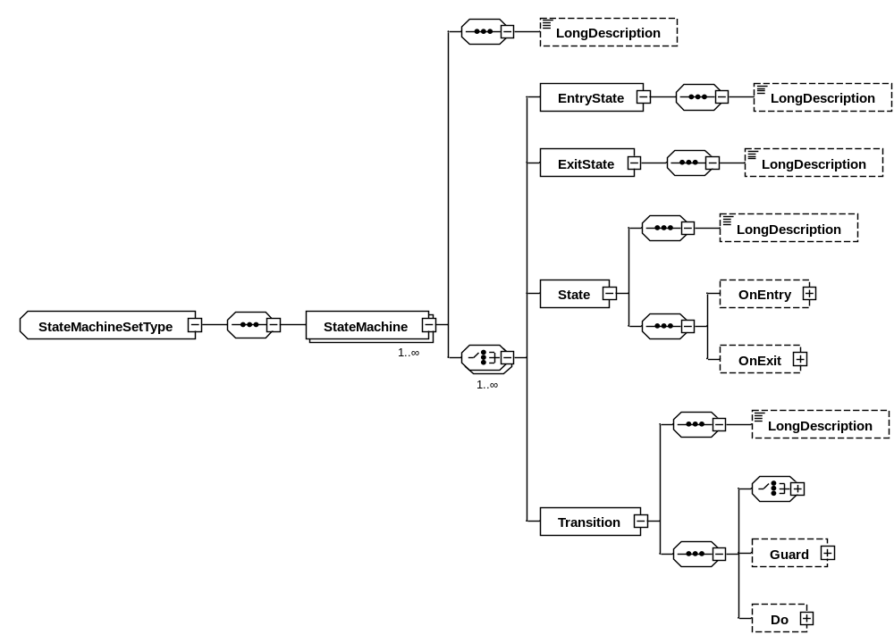
Figure 3-3333: State Machines within a StateMachineSet Element
NOTE – A state machine responds to events and schedules the execution of activities.

    - Each StateMachine element shall include one or more of the following elements: EntryState, ExitState, State, and Transition.
    - Each child element of a StateMachine element shall carry a name attribute identifying the name of that element.
    - The name of each child element of a StateMachine element shall be unique within the state machine.
    - Each State element shall include zero or one of the following elements: OnEntry, OnExit.
    - The OnEntry, OnExit, and Do elements shall each specify the name of an activity, using the activity attribute, to be invoked on entry to the state, immediately before exit from the state, and when performing a transition between states, respectively.
    - The OnEntry, OnExit, and Do elements shall each include zero or more ArgumentValue elements, each of which, in turn, carries a name attribute, identifying the name of an activity argument, and includes either a Value element, specifying a literal value to be associated with the named activity argument, or a VariableRef element, specifying a component variable to associate with the named activity argument.
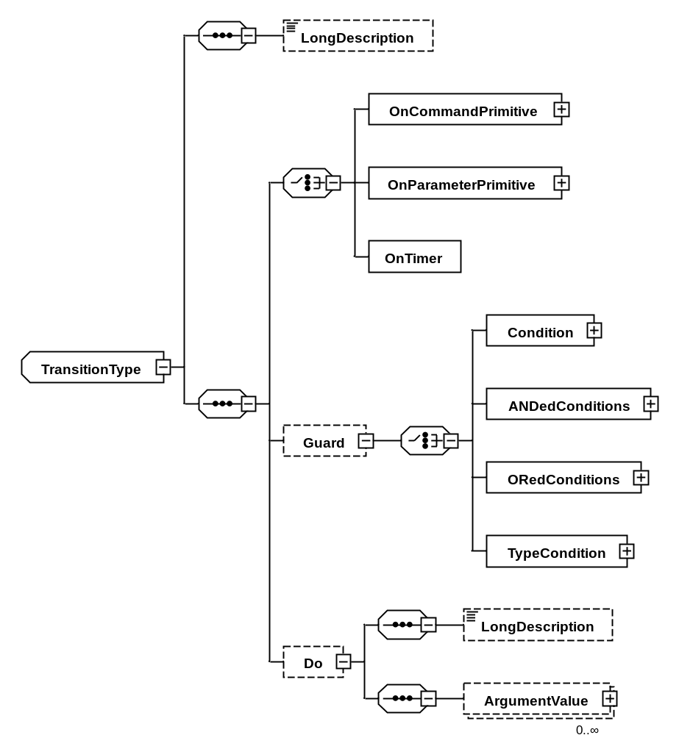
Figure 3-3434: State Machine Transition Element
    - Each Transition element shall carry
- a fromState attribute, identifying the name of the state that this transition starts from; and
- a toState attribute, identifying the name of the state that this transition ends at.
    - A transition shall not start from an exit state nor end at an entry state.
    - Each Transition element shall include one of the following elements:
- OnCommandPrimitive;
- OnParameterPrimitive;
- OnTimer.
    - Each Transition element shall include zero or one of each of the following elements:
- Guard;
- Do.
    - An OnTimer element shall contain a nanosecondsAfterEntry attribute which indicates the number of nanoseconds that shall elapse between state entry and triggering the transition, providing that the guard condition is met.
    - An OnCommandPrimitive or OnParameterPrimitive element shall identify the primitive that shall be received to trigger the transition, providing that the guard condition is met.
    - An OnParameterPrimitive element shall carry
- an interface attribute, identifying the component interface to which the primitive relates;
- a parameter attribute, identifying the parameter to which the primitive relates;
- an operation attribute, identifying whether the primitive is for a get or set operation;
- an optional transaction attribute, permitting the primitive reception to be matched to the corresponding primitive transmission using a string identifier; and
- an optional failed attribute, defaulting to false, identifying whether the transition should be triggered on successful or failed indications.
    - The transaction attribute of an OnCommandPrimitive or OnParameterPrimitive element shall be present according to the conditions defined in table 3-5.
    - An OnParameterPrimitive element may, according to the conditions defined in table 3-7, include a VariableRef element specifying a component variable to receive the value associated with the primitive.
    - An OnCommandPrimitive element shall carry
- an interface attribute, identifying the component interface to which the primitive relates;
- a command attribute, identifying the command to which the primitive relates;
- an optional transaction attribute, permitting the primitive reception to be matched to the corresponding primitive transmission using a string identifier; and
- an optional failed attribute, defaulting to false, identifying whether the transition should be triggered on successful or failed indications.
    - An OnCommandPrimitive element shall include zero or more ArgumentValue elements, each of which, in turn, includes a VariableRef element which specifies a component variable to associate with a command argument to the primitive.
    - A Guard child element of a transition shall identify the guard condition that shall be met to trigger the transition, providing that the trigger event has been received.
NOTE – If no Guard element is present, no condition need be met to trigger the transition.
    - A Guard element shall specify a Boolean expression as shown in figure 3-32.

Constructing a SEDS/XML Instance

Overview
The section describes the rules which shall be followed in order to construct a valid Electronic Data Sheet over and above those laid out by the Electronic Data Sheet schema described in section 3.
The phrase ‘to have left the scope of nominal behaviour’ indicates that the device or service described by a SEDS instance has failed. Treatment of the failure shall be determined by the designers of the mission in which the device or service is used.

XML Version
The first line of each XML file used as part of a SEDS document shall specify the XML version, exactly as follows:
<?xml version="1.0" encoding="UTF-8"?>

Type Referencing and Matching

Overview
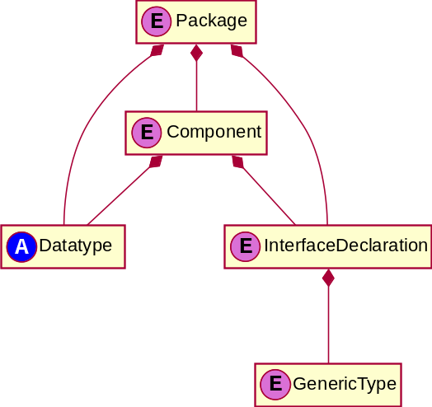
Figure 4-3535: Elements and Abstract Types Relevant to Type and Interface Referencing
Datasheets both define and use types and interfaces. This subsection covers how those definitions and their usages can be connected. In short,
- types and interfaces can be referenced by their names, which are unique within a package; and
- it is possible to reference type and interface definitions defined at the top level of another package, but not those from component or interfaces within that package.

Specification
      - If a data type or interface declaration is referenced from within the same Package element, the referencing name shall match the type name exactly.
      - If a data type or interface declaration is referenced from within the same Component element, declarations from the respective DataTypeSet and DeclaredInterfaceSet elements of that component shall be possible matches.
      - If a data type or interface declaration is referenced across packages, the referencing name shall use the following syntax:
{package name} / {name}
      - If a data type is expected by a type attribute on an element, the type referenced shall be a data type.
      - If an interface type is expected by a type attribute on an element, the type referenced shall be an interface type.
      - If a data type is referenced from within an interface declaration, the type referenced may be a generic type defined on that interface or any of its base interfaces (as recursively identified by the BaseType child element).
      - If a generic type mapping is specified for a generic type with a base type, the concrete type being specified shall be the same as that specified as the base type or a descendant of the base type.
      - If a mapping for a generic type is necessary, as that generic type is used as the type for an interface parameter or command argument which is in turn used within the data sheet, that generic type shall have a valid mapping.
NOTE – It is permissible to leave generic types unbound if they are not used within the data sheet.
      - If alternate generic type mappings are provided, as alternate sets, the correct set shall be determined using the types and values associated with the relevant primitive.
      - Should multiple alternate generic type sets match a primitive, the most restrictive set shall be chosen.
NOTE – More restrictive means that any valid ranges associated with the type are smaller, and/or the type is a closer relation.
      - If a component variable, interface parameter, or argument is used in relation to a destination component variable, interface parameter, or argument, then type conversion occurs. See Section 4.8.
      - If a source literal is used in relation to a destination component variable, interface parameter, or argument, the value of the literal shall be valid according to table 3-1.
      - Activity or state machine operations which reference nonliteral values shall reference component variables and activity arguments only, not interface parameters.
NOTE – Interface parameters can only be accessed using the dedicated operations described in 4.5.
      - Activity or state machine operations which reference a parameter, variable, or argument which is an instance of a container parameter type may select a single entry from the container using the following syntax:
{parameter name}.{entry name}
      - Activity or state machine operations which reference a parameter, variable, or argument which is an array may select a single element from the array using the following syntax:
{parameter name}[{0-based element index}]
NOTE – The element index may be specified as an enumeration literal, or the current value of a variable or argument of integer or enumerated type. When an enumerated type indexes an array, the enumeration shall have consecutive values, the lowest of which is zero.
NOTE -- Array indexing with out of range (including negative) values is a Failure Detection, Isolation, and Recovery (FDIR) trigger, i.e. ‘an indication that the device has left the scope of the nominal behaviour documented by the datasheet’. Some cases may be detected statically by datasheet tooling; ideally this would include as a warning the use of an index type that allowed negative values, and as an error in the datasheet the use of an index type with a completely negative range.
      - The above two rules may be chained together to access nested array and container entries. Interpretation shall be left-associative with equal precedence.
NOTE -- For chained access, the "." and "[]" syntax would be used as appropriate for the type of the object on their left. For example, suppose "name" refers to an instance whose type is an array of quaternions. The array type would be defined with elements that are quaternion type. The quaternion type could be defined as a container with elements "x", "y", "z", and "r". To refer to the real part of the first quaternion in the array, the syntax is "name[0].r". The "[0]" applies to the array type, and yields a quaternion type, to which the ".r" applies.
      - References to data types, by means of baseType attributes or by means of BaseType elements, collectively form a graph of references. That graph shall contain no circuits.
NOTE – The schema does not enforce this statement. A tool chain should enforce this statement, in order to protect itself from endless referential loops, by not supporting forward references.
      - The same activity argument name may be used in more than one activity. No activity argument name shall be the same as a component variable name.
      - State machine transition guard expressions may reference arguments of the primitive that triggers the transition.

External References

Overview
To support applications in which an Electronic Data Sheet is used to describe the interfaces of a software component or smart device, it may be necessary to reference externally stored values from any part of the EDS.
For example, a reusable software component may be designed to support an arbitrary number of instances of a particular piece of logic. The specific number of instances chosen may have an impact on the EDS; for instance, it may affect the Dimension element on an ArrayType used for describing telemetry messages produced by that software component.
The specific value for this deployment characteristic is driven by the requirements of the project or mission deploying the software, but the EDS file describing the interface(s) of the software component would be authored by the software component vendor. Therefore, the software vendor cannot dictate a specific value in the EDS, but must include a placeholder such that the user can supply the value.
To solve this issue, the EDS may reference external values in place of absolute values in any other EDS element or attribute.

Specification
      - External references in EDS definitions shall use the following syntax to indicate a placeholder where the actual value is to be supplied:
${name}
      - The names of external references may contain alphanumeric characters and the ‘_’ and ‘.’ symbols.
      - Validation of EDS files utilizing external references shall be performed after the substitution of absolute values has taken place.
NOTE – This may be performed by a dedicated preprocessing tool, or as an intermediate output of the toolchain.

Primitive Associations

Overview
The state machines making up a component are driven by messages arriving on the interfaces to and from that component. These messages, called primitives, are defined by the set of parameters and commands present on the interface definitions.
Interfaces are two-way and asymmetric; the component requiring the interface is referred to as the consumer, and the component providing it as the provider.
If the parameter mode is sync, then messages in both directions must be present even if they have no content. For a command, the pattern describes the set of messages that are present; see Figure 4-37. If not specified, the pattern of a command is calculated according to Table 4-9. In either case, a message that exists but has no content is a pulse; it carries no information, but can still trigger a state transitiod.
Parameters that are read-only may not be set by a client of that interface.
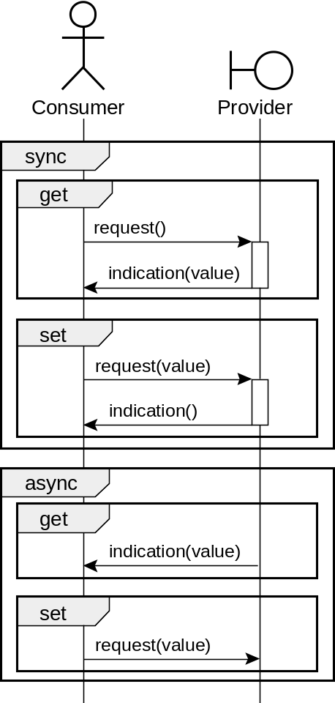
Figure 4-3636: Parameter Definitions and Primitives
There are four distinct interaction patterns for parameter primitives, based on whether the parameter definition is sync, async, and/or readOnly.

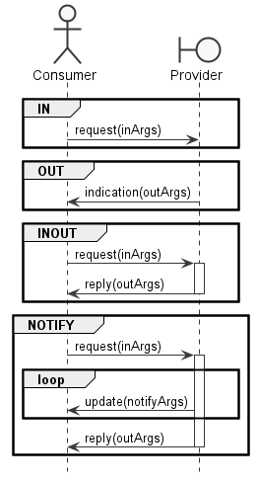

Figure 4-3737: Command Definitions and Primitives
EDS has four distinct interaction patterns for commands. If pattern is specified, then it is one of the patterns in Figure 4-37; that is in, out, inout, or notify. If pattern is not specified, then the pattern is inferred as in Table 4-9, based on whether the command mode is async or sync, and on the set of input, output, and notify arguments it has.
Table 4-9: Command Message Pattern Inference
Command Argument Modes Present | Command mode=”async” | Command mode=”sync”
in | in | in
out | out | out
notify | error | notify
in and out, or inout | error | inout
in and notify | error | notify
out and notify | error | notify
(in and out, or inout) and notify | error | notify

Specification
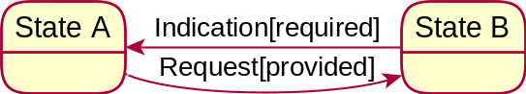
Figure 4-3838: Primitives That Trigger State Transition
      - If a parameter primitive is to be received (to trigger a state machine transition), the primitive shall be
- a get operation primitive from an interface provided by the component identifying a parameter value read request;
- a set operation primitive from an interface provided by the component identifying a parameter value write request;
- a get operation primitive from an interface required by the component identifying a parameter value read indication; or
- a set operation primitive from an interface required by the component identifying a parameter value write indication.
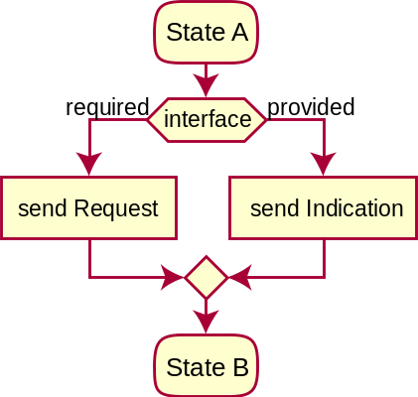
Figure 4-3939: Primitives Sent During Activity Execution
      - If a parameter primitive is to be transmitted (by an activity), the primitive shall be
- a get operation primitive to an interface provided by the component identifying a parameter value read indication;
- a set operation primitive to an interface provided by the component identifying a parameter value write indication;
- a get operation primitive to an interface required by the component identifying a parameter value read request; or
- a set operation primitive to an interface required by the component identifying a parameter value write request.
      - The reception of a get operation parameter indication primitive or a set operation parameter request primitive shall specify a component variable into which the parameter value can be received.
      - The transmission of a set operation parameter request primitive or a get operation parameter indication primitive shall specify a value for the parameter.
      - In the case of interface parameters marked as synchronous (having their mode attribute set to ‘sync’), primitives shall
- always be transferred in pairs: one transmitted primitive and one received primitive (in the appropriate order); and
- be associated using an identical string specified as the transaction attribute.
      - In the case of interface parameters marked as asynchronous (having their mode attribute set to ‘async’), primitives shall always be a single get operation indication primitive
- transmitted to a component provided interface; or
- received from a component required interface.
      - An attempt to transmit a get operation request primitive to an asynchronous interface parameter on a required interface of the component shall be invalid.
      - An attempt to receive a get operation request primitive from an asynchronous interface parameter on a provided interface of the component shall be invalid.
      - If a command primitive is to be received (to trigger a state machine transition), the primitive shall be
- from an interface provided by the component identifying a command execution request; or
- from an interface required by the component identifying a command execution indication.
      - If a command primitive is to be transmitted (by an activity), the primitive shall be
- to an interface provided by the component identifying a command execution indication; or
- to an interface required by the component identifying a command execution request.
      - The reception of a command request primitive may specify the component variable into which the value of any arguments of modes in or inout can be stored.
      - The reception of a command indication primitive may specify the component variable into which the value of any arguments of modes out or inout can be stored.
      - The reception of a command update primitive may specify the component variable into which the value of any arguments of modes notify can be stored.
      - The transmission of a command request primitive shall specify a value for all arguments of modes in or inout.
      - The transmission of a command indication primitive shall specify a value for all arguments of modes out or inout.
      - The transmission of a command update primitive shall specify a value for all arguments of modes notify.
      - A contradiction between specified pattern and pattern inferred from mode shall be invalid.

State Machine Operation

Overview
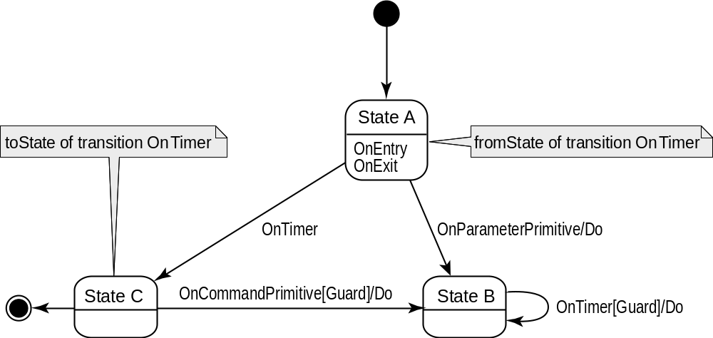
Figure 4-4040: State Machine Concepts
Component behaviour is defined by a set of state machines which transition from one state to another, triggered by either timers or the reception of primitives on the interface required and provided by that component.
Transitions may have guards, which are Boolean conditions that can prevent the transition firing, and actions which take place once the transition fires.
States may have actions which take place on entry or exit from the state. These are not executed for transitions that do not change state.
Each state machine has a single entry state, in which execution starts, and may have an exit state. The exit state corresponds to the actual behaviour of the target device leaving the scope of the nominal behaviour documented by the datasheet. This would be used in the case of a failure to respond within a reasonable time, an explicit error report, etc. This would normally be an indication that higher-level, mission-specific, or operator-driven fault recovery mechanisms should be initiated.
Similar considerations would apply if a device were to behave in a way not documented in the data sheet, for example, sending a message not anticipated by the current set of active states.
A state machine can include logic to explicitly detect and respond to failures in lower layers. In the absence of such specification, error events will not be handled, and therefore the state machine will transition to the error event as above.

Specification
      - A state machine transition shall trigger only if the state machine is in the state identified as the fromState of the transition.
      - A state machine transition with an OnXPrimitive element shall trigger only when the corresponding primitive is received.
      - A state machine transition with an OnTimer element shall trigger only when the corresponding time after state entry is reached.
      - If a state machine transition guard is present, the transition shall trigger only if the guard condition is met.
      - If multiple transitions from a state have identical conditions, then a transition without a guard shall trigger only if the guard conditions of all other transitions are false.
NOTE – Such a transition effectively represents an ‘ELSE’ condition.
      - An external transition is a transition in which the fromState of the transition is not equal to its toState.
      - When a transition is triggered, the following actions shall be performed in order:
- for an external transition, the state machine shall exit the state identified as the fromState of the transition;
- for all transitions, any activity specified in the Do child element of the transition shall be executed;
- for an external transition, the state machine shall enter the state identified as the toState of the transition.
      - When a state is exited, this shall result in execution of the state onExit activity, if such an activity is specified.
      - When a state is entered, this shall result in execution of the state onEntry activity, if such an activity is specified.
      - In order to determine the required logic of a state machine specified in a data sheet, activities shall be assumed to complete instantaneously.
NOTE – Timing considerations should be modelled by states with OnTimer elements.
      - Any possible incoming primitive shall meet the trigger conditions of only a single transition.
NOTE – Otherwise, the data sheet is invalid, although this cannot necessarily be statically detected. When developing a SEDS for a device, a mapping from primitives to state machine transitions is implied by the guard conditions. The mapping could contain complex expressions that depend upon data appearing in the interface, so testing all combinations could be impractical.
      - Only one EntryState element shall be present in a given state machine.
      - If an explicit EntryState element is present, it shall be used as the starting state.
NOTE – This allows explicit specification of initialization actions.

      - If a state machine transitions to an exit state, the device should be considered to have left the scope of the nominal behaviour documented by the datasheet.
      - If an error occurs in an activity, such as an arithmetic error, or such as violating the range of a range-constrained type, the device should be considered to have left the scope of the nominal behavior documented by the datasheet. Detection of arithmetic errors is typically done by computer hardware. Detection of violation of a range constraint should be done by software generated by tool chain and should not necessarily be explicit in activity body.
      - If an activity contains an assignment, calibration, or math operation in which the semantic tags of the result of computation are incompatible with the semantic tags of the output variable reference, the tool chain may report an error in the SEDS instance.

Encoding and Decoding

Overview
Any interface definition with level set to subnetwork corresponds to a subnetwork Service Access Point (SAP). When a component uses one of these SAPs as a required interface and refers to that required interface in a primitive association, the tool chain should interpret the reference as an interaction through a subnetwork SAP.
When primitives are sent on such an interface, they must be translated into Protocol Data Units (PDUs) by a process known as encoding. Parts of this encoding (such adding spacewire routing headers) are specified by the definition of the subnetwork protocol in use, and therefore do not need to be specified in the datasheet using such an interface.
Of the actual arguments required by the underlying subnetwork implementation,
- some will be fixed to values implied by the fact that communication is happening with the device the datasheet represents;
- some will be specified as normal arguments to the subnetwork interface; and
- the remainder will be encoded in a way specified by the encoding specification of the applicable data.
The reverse process, when PDUs are received and must be translated into primitives, is known as decoding. The encoding specification in the datasheet is used for this in the corresponding way.
A tool chain may support any subnetwork. For SOIS subnetworks, the tool chain should implement the interaction according to the abstract interface Request and Indication definitions in the corresponding subnetwork Magenta Book, identified in table 4-10. (See annex ANNEX E for an example of coding.)
Table 4-109: SOIS Subnetwork SAP Models
Interface Name | Subnet Book
PSInterfaceType | CCSDS 851.0-M-1 SOIS Packet Service (reference [15])
MASInterfaceType | CCSDS 852.0-M-1 SOIS Memory Access Service (reference [16])
SYNCInterfaceType | CCSDS 853.0-M-1 SOIS Synchronization Service (reference [17])

Specification
      - A value is encoded when
- a value of a nonbinary data type is used for an outgoing argument of a command on an interface, and that argument has the dataUnit attribute set to true;
- a value of a nonbinary data type is used to set the value of a parameter on an interface.
NOTE – A toolchain shall use encoding specifications of a data type to encode an item of data for sending outbound through an interface. This encoding ensures that a PDU will have the expected format at the receiving endpoint.
      - A value is decoded when
- a variable of a nonbinary data type is used as the destination for an incoming argument of a command on an interface, and that argument has the dataUnit attribute set to true;
- a value is decoded when a variable of a non-binary data type is used as the destination for an incoming parameter on an interface.
NOTE – A toolchain may use encoding specifications to decode an item of data received through an interface. This decoding allows for variation in memory words and for variation in alignment of entries of structures across different platforms and compilers.
      - If a scalar value is encoded or decoded, it shall have an encoding specification set.
      - If a scalar value with a valid range is encoded, the encoding specification shall provide for the full extent of the range.
NOTE – This means, for example, that a value with a valid range that includes negative numbers cannot use an unsigned integer encoding.
      - If a scalar value with a valid range is decoded, and the decoded value is outside the valid range, the device should be considered to have left the scope of the nominal behaviour documented by the datasheet.
      - If an enumerated value is decoded, and the decoded value does not correspond to any of the values of the enumeration, the device should be considered to have left the scope of the nominal behaviour documented by the datasheet.
      - The constraints applicable to a container are those contained within its ConstraintSet child element, plus all those specified on containers referenced as a direct or indirect base type.
      - If a container is decoded, and the incoming data does not match all applicable constraints, the device should be considered to have left the scope of the nominal behaviour documented by the datasheet.
      - When an abstract container is encoded or decoded, the concrete container type to use shall be selected from the set of all non-abstract containers that have that container as a direct or indirect base type.
      - If an abstract container is decoded, and the incoming data does not match any of the candidate concrete container types, the device should be considered to have left the scope of the nominal behaviour documented by the datasheet.
      - If the sizeInBits attribute of FloatDataEncoding element disagrees with the standard identified in the encodingAndPrecision attribute in the same element, the condition shall be treated as an error.

Type Conversion

Overview
In SEDS, a type defines two things:
- an abstract, implementation-independent set of possible values, optionally with usage constrained by semantic attributes
- optionally, a mechanism to translate a value from that set to and from a binary representation.
The latter is known as encoding and decoding. See section 4.7 for details
Type conversion is the process for taking an abstract value belonging to one type and finding the equivalent abstract value of another type.
This process can fail if there are values in the source value set that are not in that of the target type, for example when the target type has a smaller numeric range.
If a device behaves in such a way that this failure actually occurs, the device should be considered to have left the scope of the nominal behavior documented by the datasheet.
Conversion is always used in assignment between, and operations on, component variables, and activity arguments. It is also used for interface command arguments that are not data units.
In contrast to encoding and decoding, type conversion may never change the value converted. A concrete implementation that did so, for a device that had not itself exhibited a prior error, would itself be in error.
Conversion to and from the same type, or identical types, is a null operation that can never fail.

Specification
      - A value is converted when:
- It is assigned to a component variable via the outputVariableRef attribute of an Assignment, Calibration, or MathOperation.
- It is passed as an argument of an activity.
- It is passed or received as a non-data-unit argument of a command.
      - The type to be converted to shall be that of the target field.
NOTE -- the named type referenced by the field may be modified by inline type descriptors such as ValidRange or ArrayDimensions (see section 3.11).
      - With respect to conversion, there are four fundamental categories of types:
- Set-based values (BooleanDataType, EnumeratedDataType, enumerated SubRangeDataType, enumerated StringDataType, and corresponding fields)
- Range-based values (IntegerDataType, FloatDataType, numeric SubRangeDataType, and corresponding fields)
- Sequences (non-enumerated StringDataType, BinaryDataType, ArrayDataType, and corresponding fields)
- Structured values (ContainerDataType)
      - Conversion always fails between types of different categories.
      - Conversion fails for set-based values outside the enumerated set of the target type.
      - Conversion fails for range-based values outside the valid range of the target type.
      - Conversion fails for sequences with a length outside the valid length of the target sequence.
      - Conversion fails for sequences if it fails for any value within the source sequence.
      - Conversion fails for structured values if the target type has a field not present in the source value.
      - Conversion fails for structured values if it fails for any value within the structure.
      - For numeric data types that include a calibrator, the range constraints refer to the uncalibrated value, and the unit attribute refers to the calibrated value. If both the source and the target have calibrators, then both calibrators must be identical, or conversion fails.
      - If a conversion in a data sheet will always fail, that data sheet is invalid
NOTE -- For example, a conversion between different EnumeratedDataTypes, or from a literal value outside the target range will always fail.
      - If any conversion fails, the device shall be considered to have left the scope of the nominal behavior documented by the datasheet.
NOTE -- If a conversion in a datasheet will possibly fail, datasheet tooling may issue a diagnostic warning. For example, an assignment between numeric values with overlapping ranges will fail if the assigned value is not within the intersection of the ranges. This will be the case when assigning between types representing signed and unsigned integers of the same size. Another example: If the usage constraints of explicit semantic tags of the source differ from those of the target, a diagnostic warning may be issued.

Extensible Enumerations
The following attributes can be extended by means of auxiliary schemas, which the SEDS schema includes:
- errorControlType attribute of an ErrorControlEntry element;
- encodingAndPrecision attribute of FloatDataEncoding element;
- encoding attribute of IntegerDataEncoding element;
- encoding attribute of StringDataEncoding element;
- operator attribute of Operator element.
The SEDS schema includes the following auxiliary schemas:
- seds-core-semantics.xsd is generated from the SOIS DoT. This auxiliary schema contains extensions that have been normalized by the curators of the DoT and published in SANA. Normalization identifies external conventions and standards that are of general use in describing interoperable systems across space agencies.
- seds-extension-semantics.xsd is provided for use within single projects to identify conventions for use by the project toolchain. This auxiliary schema is maintained by the project personnel.
SEDS instances that use the auxiliary schema seds-extension-semantics.xsd cannot be interoperable across agencies, because that auxiliary schema is not managed by a standards organization.

Electronic Data Sheet for Onboard Devices Implementation Conformance Statement Proforma
(Normative)
  - Introduction
This annex provides the Implementation Conformance Statement (ICS) Requirements List (RL) for implementation of the SEDS, CCSDS 876.0-B-1, April 2019. The ICS for an implementation is generated by completing the RL in accordance with the instructions below. An implementation shall satisfy the mandatory conformance requirements of the base standards referenced in the RL.
The RL in this annex is blank. An implementation’s complete RL is called an ICS. The ICS states which capabilities and options of the services have been implemented. The following can use the ICS:
- The service implementer, as a checklist to reduce the risk of failure to conform to the standard through oversight;
- The supplier and acquirer or potential acquirer of the implementation, as a detailed indication of the capabilities of the implementation, stated relative to the common basis for understanding provided by the standard ICS proforma;
- The user or potential user of the implementation, as a basis for initially checking the possibility of interoperability with another implementation;
- A service tester, as a basis for selecting appropriate tests against which to assess the claim for conformance of the implementation.
  - Notation
The following are used in the RL to indicate the status of features:
Status Symbols
M | mandatory
O | optional
Support Column Symbols
The support of every item as claimed by the implementer is stated by entering the appropriate answer (Y, N, or N/A) in the Support column:
Y | Yes, supported by the implementation
N | No, not supported by the implementation
N/A | Not applicable
  - Referenced Base Standards
The base standards references in the RL are
- Spacecraft Onboard Interface Services—XML Specification for Electronic Data Sheets (this document).
  - Generation Information
    - Identification of ICS
Ref | Question | Response
1 | Date of Statement (DD/MM/YYYY)
2 | ICS serial number
3 | System Conformance statement cross-reference
    - Identification of Implementation Under Test (IUT)
Ref | Question | Response
1 | Implementation name
2 | Implementation version
3 | Special configuration
4 | Other information
    - Identification
Ref | Question | Response
1 | Supplier
2 | Contact Point for Queries
3 | Implementation name(s) and Versions
4 | Other information necessary for full identification, for example, name(s) and version(s) for machines and/or operating systems:  System Name(s)
    - Service Summary
Ref | Question | Response
1 | Service Version
2 | Addenda implemented
3 | Amendments implemented
4 | Have any exceptions been required?  NOTE – A YES answer means that the implementation does not conform to the service. Non-supported mandatory capabilities are to be identified in the ICS, with an explanation of why the implementation is nonconforming. | Yes No
    - Instructions for Completing the RL
An implementer shows the extent of compliance to the specification by completing the RL; that is, compliance to all mandatory requirements and the options that are not supported are shown. The resulting completed RL is called an ICS. In the Support column, each response shall be selected either from the indicated set of responses, or it shall comprise one or more parameter values, as requested. If a conditional requirement is inappropriate, N/A shall be used. If a mandatory requirement is not satisfied, exception information must be supplied by entering a reference Xi, where i is a unique identifier, to an accompanying rationale for the noncompliance.
The implementers affected by this RL are writers of software that reads and interprets Electronic Data Sheets for use in computer-assisted engineering.
  - General/Major Capabilities
Service Feature | Reference | Status | Support
SEDS Core | 3.2, 3.3, 4.2 | M
Device Metadata | 3.4 | O
Packages | 3.5 | M
Data Types | 3.6 | M
Scalar Data Types | 3.7 | M
Ranges | 3.8 | M
Arrays | 3.9 | M
Containers | 3.10 | M
Fields | 3.10.25 | M
Interface Types | 3.12 | M
Component Types | 3.13 | M
Component Implementations | 3.14 | O
Activities | 3.15 | O
State Machines | 3.16 | O
Type Referencing and Matching | 4.3 | M
Primitive Associations | 4.4 | O
State Machine Operation | 4.5 | O
Encoding and Decoding | 4.6 | O
  - Underlying Layers providing Services to Implementation
This subsection provides identification of the underlying layers providing services to the implementation.
Service Feature | Reference | Status | Support
XInclude | 3.2.2–3.2.4 | M
User-defined Ontology | 3.2.6 | O

Security, SANA, and Patent CONSIDERATIONS
(Informative)
  - Security Considerations
    - Security Background
The SOIS services are intended for use with protocols that operate solely within the confines of an onboard subnet. It is therefore assumed that SOIS services operate in an isolated environment which is protected from external threats. Any external communication is assumed to be protected by services associated with the relevant space-link protocols. The specification of such security services is outside the scope of this document.
    - Security concerns
At the time of writing there are no identified security concerns. If confidentiality of data is required within a spacecraft, it is assumed it is applied at the Application Layer. More information regarding the choice of service and where it can be implemented can be found in reference [D21].
    - Potential threats and attack scenarios
Potential threats and attack scenarios typically derive from external communication and are therefore not the direct concern of the SOIS services, which make the assumption that the services operate within a safe and secure environment. It is assumed that all applications executing within the spacecraft have been thoroughly tested and cleared for use by the mission implementer. Confidentiality of applications can be provided by Application Layer mechanisms or by specific implementation methods such as time and space partitioning. Such methods are outside the scope of SOIS.
    - Consequences of not applying security
The security services are outside the scope of this document and are expected to be applied at layers above or below those specified in this document. If confidentiality is not implemented, science data or other parameters transmitted within the spacecraft might be visible to other applications resident within the spacecraft, resulting in disclosure of sensitive or private information.
    - Reliability
While it is assumed that the underlying mechanisms used to implement the devices operate correctly, the SEDS make no assumptions as to their reliability.
  - SANA Considerations
The recommendations in this document have created the following SANA registry, named ‘Spacecraft Onboard Interface Services Electronic Data Sheets and Dictionary of Terms’ and located at http://sanaregistry.org/r/sois/. The registry consists of a set of files that constitute an XML schema, an ontology, and related files.
The registration rule for change to this registry requires an engineering review by a designated managing authority. The managing authority shall be assigned by the SOIS-APP working group Chair, or in absence, Area Director. The managing authority may request assistance from subject matter experts provided or recommended by participating agencies.
At time of publication, the registry contains the items in table B-11:
Table B-1110: SANA Registry Content (Normative Unless Noted Otherwise)
File | Description
seds.xsd | The schema for SOIS Electronic Data Sheets.
seds-core-semantics.xsd | The SOIS Dictionary of Terms in the form of a schema to be included by seds.xsd.
seds-extension-semantics.xsd | A non-normative schema to be included by seds.xsd for non-interoperable terms that are needed by a project sooner than the terms can be incorporated in the DoT.
ccsds.sois.modops.xml | A non-normative collection of definitions that may be referenced by SEDS instances for models of operations.
ccsds.sois.seds.xml | A non-normative collection of definitions that can reduce the number of definitions in an electronic data sheet.
ccsds.sois.subnetwork.xml | A non-normative collection of definitions that can facilitate integration with SOIS subnetwork services.
dod.milbus.milstd1553.xml | A non-normative collection of definitions that can facilitate integration with DOD Milbus 1553 subnetworks.
esa.ecss.milstd1553.xml | A non-normative collection of definitions that can facilitate integration with ESA ECSS 1553 subnetworks.
sois.0.owl | The ontology for SOIS Dictionary of Terms. This ontology imports sysml-qudv-si-sois.owl.
sysml-qudv.owl | The original proof-of-concept definition of quantities, units, dimensions, and values.
sysml-qudv-si.owl | The original proof-of-concept extension of QUDV to the International System of Units. This ontology imports SysML-QUDV.owl.
sysml-qudv-si-sois.owl | An extension of the original QUDV ontologies to support units used in SOIS EDS. This ontology imports SysML-QUDV-SI.owl.
soisOwlTools.zip | A non-normative compressed project that contains open-source utilities that are intended to perform the following functions:  - Converts a conformant ontology into a seds-core-semantics.xsd  - Extracts an HTML file for human-readable listing of Dictionary of Terms.  - Extracts an XML file of units and quantity kinds for use by tool chain functions for analysis of units.
seds.xsd | The schema for SOIS Electronic Data Sheets.
  - Patent Considerations
The technology used in managing SEDS (XML and XSD) is in the public domain.

Abbreviations and Acronyms
(informative)

CBOR | Concise Binary Object Representation [18]
CCSDS | Consultative Committee for Space Data Standards
DoT | Dictionary of Terms
FDIR | Failure Detection, Isolation, and Recovery
OSI | Open Systems Interconnection
OWL  PDU  PICS | Web Ontology Language  Protocol Data Unit  Protocol Implementation Conformance Statement
QUDV | Quantities, Units, Dimensions, Values
SANA | Space Assigned Numbers Authority
SAP  SEDS | Service Access Point  SOIS Electronic Data Sheet
SOIS | Spacecraft Onboard Interface Services
XML | eXtensible Markup Language
XSD | XML Schema Definition

Informative References (informative)
[D19] Information Technology—Open Systems Interconnection—Basic Reference Model: The Basic Model. 2nd ed. International Standard, ISO/IEC 7498-1:1994. Geneva: ISO, 1994.
[D20] Spacecraft Onboard Interface Services. Issue 2. Report Concerning Space Data System Standards (Green Book), CCSDS 850.0-G-2. Washington, D.C.: CCSDS, December 2013.
[D21] The Application of Security to CCSDS Protocols. Issue 3. Report Concerning Space Data System Standards (Green Book), CCSDS 350.0-G-3. Washington, D.C.: CCSDS, March 2019.
[D22] Electronic Data Sheets and Dictionary of Terms for Onboard Devices and Components. Report Concerning Space Data System Standards. Forthcoming.

Example SEDS/XML Schema Instantiations
(Informative)
<?xml version="1.0" encoding="UTF-8"?>
<DataSheet
xmlns="http://www.ccsds.org/schema/sois/seds"
xmlns:xi="http://www.w3.org/2001/XInclude"
xmlns:xsi="http://www.w3.org/2001/XMLSchema-instance"
xsi:schemaLocation="http://www.ccsds.org/schema/sois/seds seds.xsd">
<Device name="SimpleDevice" shortDescription="Simple arbitrary example of SEDS XML usage">
</Device>
<xi:include href="ccsds.sois.subnetwork.xml" xpointer="element(/1/1)"/>
<Package name="SimpleDemo">
<DataTypeSet>
<IntegerDataType name="MyInteger">
<Range>
<MinMaxRange min="0" max="4294967296" rangeType="inclusiveMinInclusiveMax" />
</Range>
</IntegerDataType>
</DataTypeSet>
<DeclaredInterfaceSet>
<Interface name="DeviceAccessInterface">
<ParameterSet>
<Parameter name="DeviceMode" type="MyInteger"/>
</ParameterSet>
<CommandSet>
<Command name="DoSomething">
<Argument name="WithANumber" type="MyInteger" mode="in"/>
</Command>
</CommandSet>
</Interface>
</DeclaredInterfaceSet>
<ComponentSet>
<Component name="DeviceDACP">
<ProvidedInterfaceSet>
<Interface name="VendorSpecificInterface" type="DeviceAccessInterface"/>
</ProvidedInterfaceSet>
<RequiredInterfaceSet>
<Interface name="Subnetwork" type="CCSDS/SOIS/Subnetwork/MASInterfaceType"/>
</RequiredInterfaceSet>
</Component>
</ComponentSet>
</ Package >
</DataSheet>

The above example shows a datasheet defining a device SimpleDevice with a single component DeviceDACP that in turn provides a single interface, VendorSpecificInterface. The interface type DeviceAccessInterface has one command DoSomething and one parameter DeviceMode. Both of those definitions share a single data type, MyInteger.
The definition of the subnetwork interface used (MASInterfaceType) is provided in an external file. It should be noted that in this example, no implementation of the component is defined; a fully specified device datasheet would include the logical transformations needed to map between the required and provided interfaces as state machines.

See the note attached to 3.12.16; a similar explanation applies to parameters.
The file “ccsds.sois.subnetwork.xml” provides definitions of abstract subnetwork SAPs, defined as interfaces in a declared interface set.

