MPZ-01
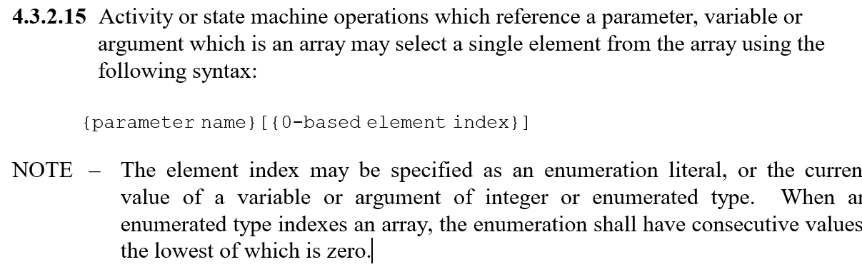

MPZ-02
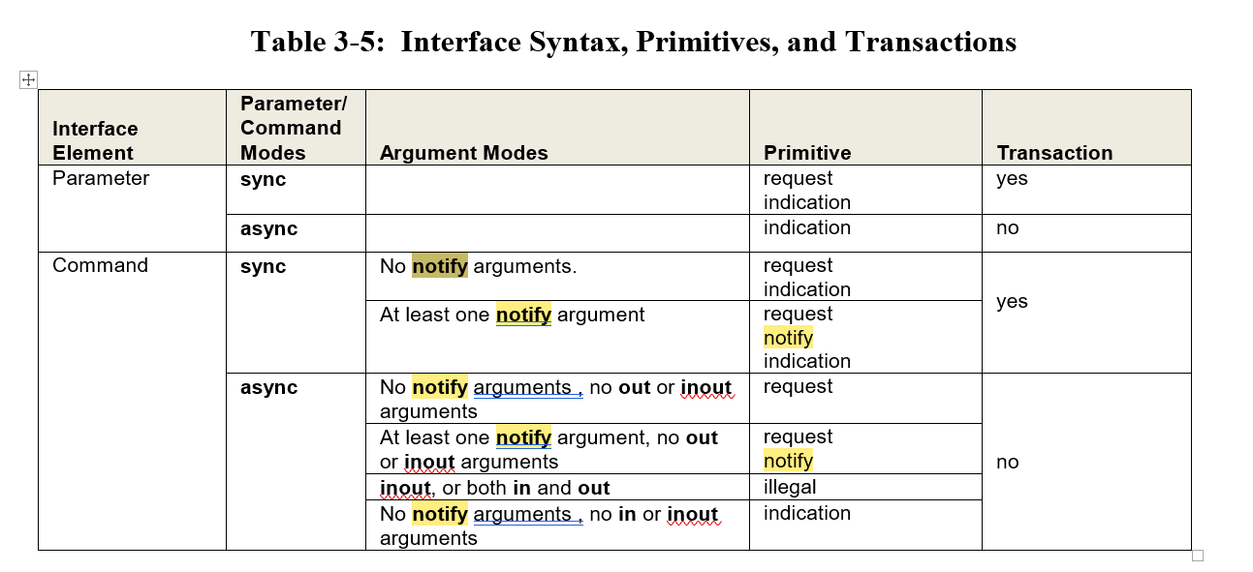

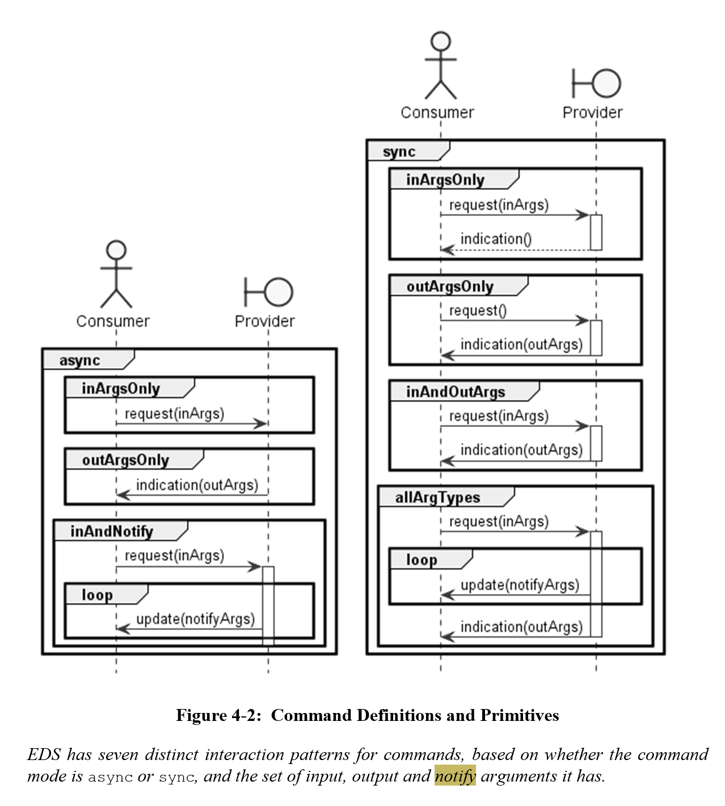

MPZ-03
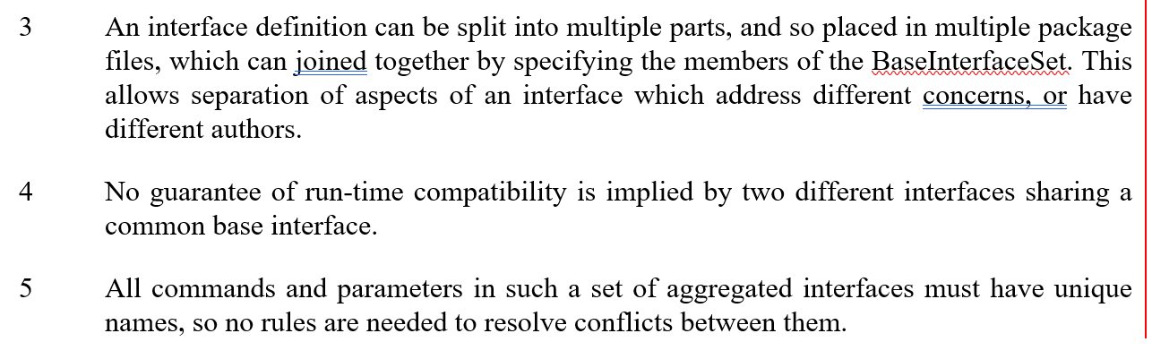

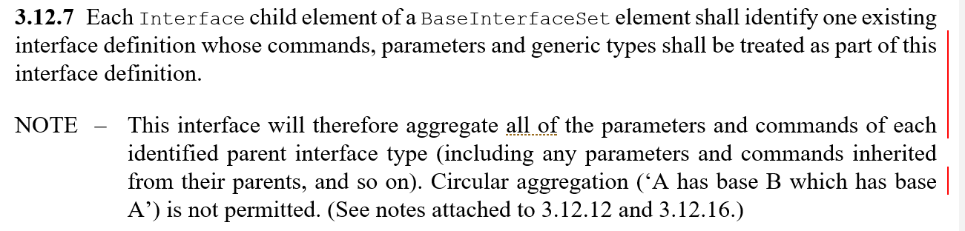

MPZ-04
(green book)
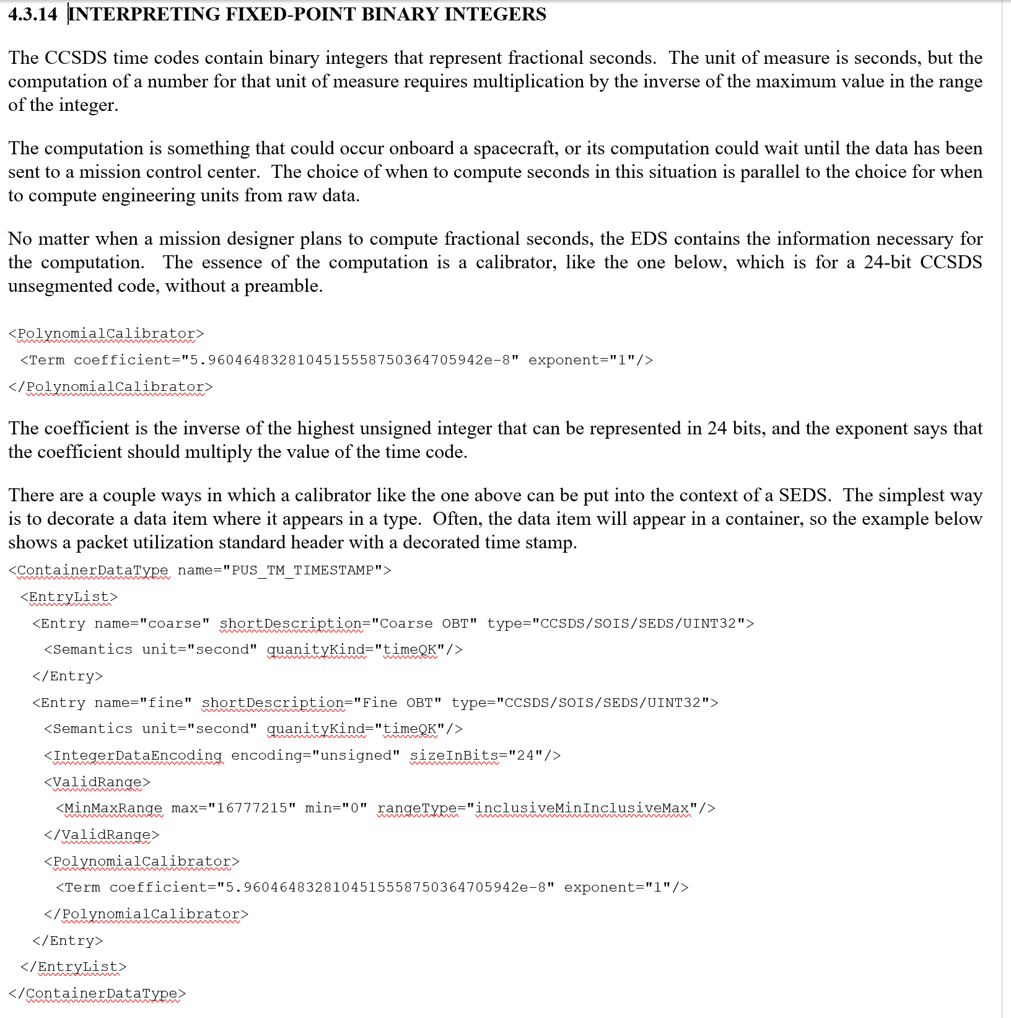
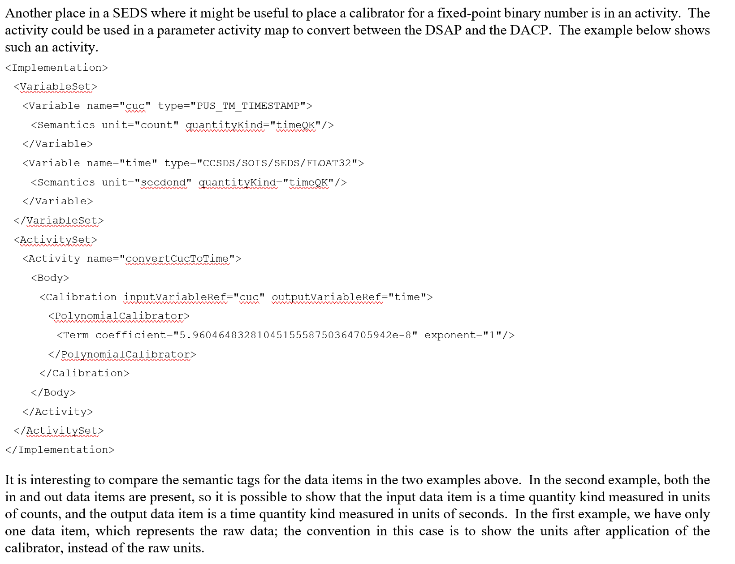

MPZ-05
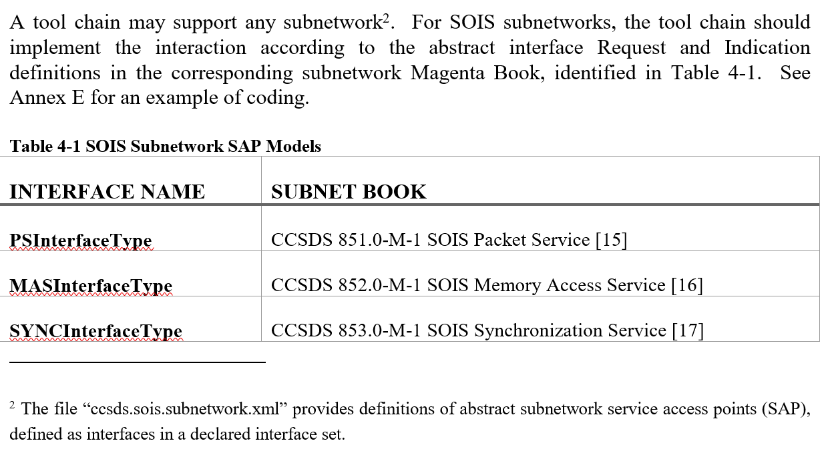

MPZ-06
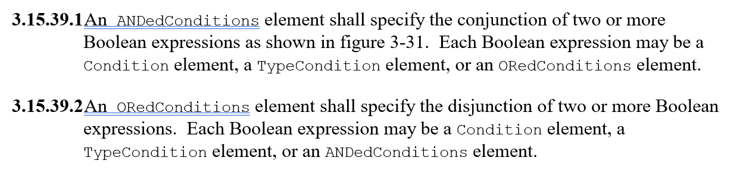

MPZ-07
Rejected: The size in bits is available on integer data encoding, so the problem described here could be handled with an unsigned integer with size in bits = 1.

MPZ-08
Rejected: This can be done in a container that contains the array to be padded.

MPZ-09
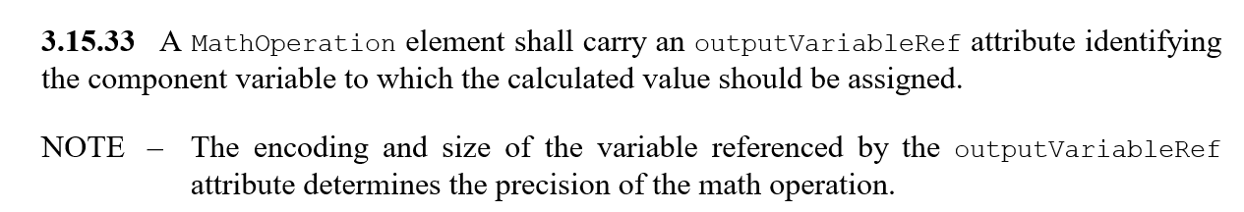

MPR-01
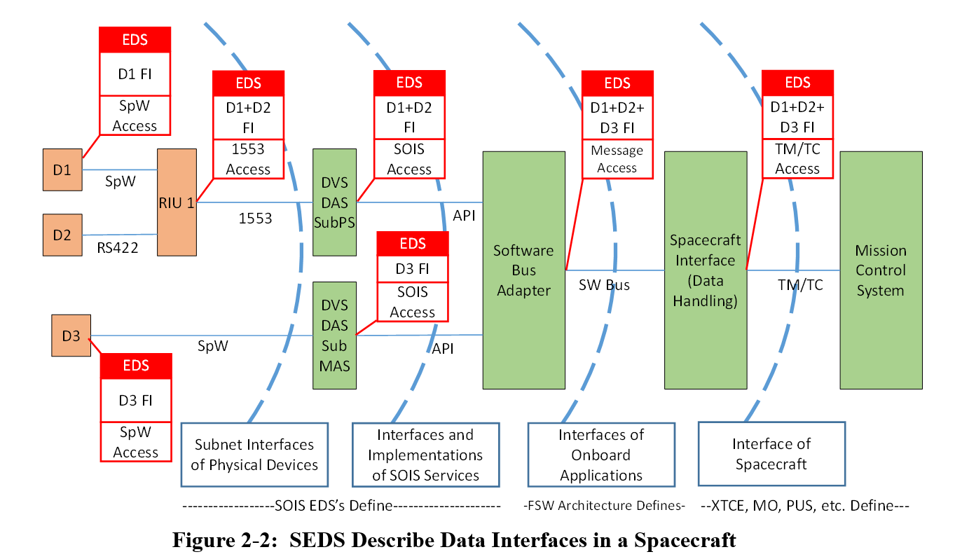

MPR-02
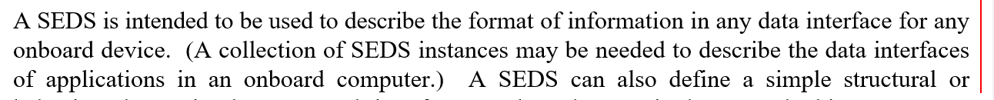

MPR-03
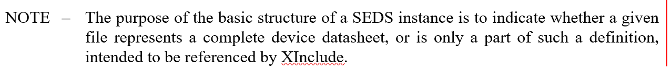
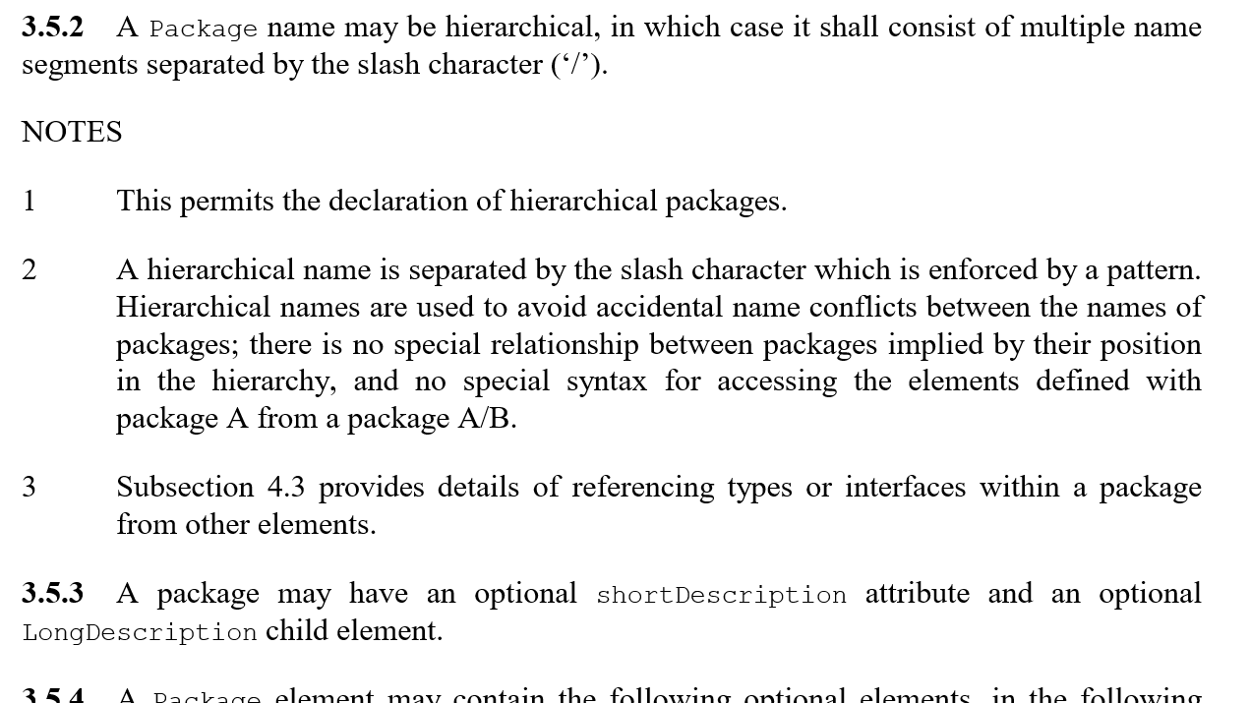

MPR-04
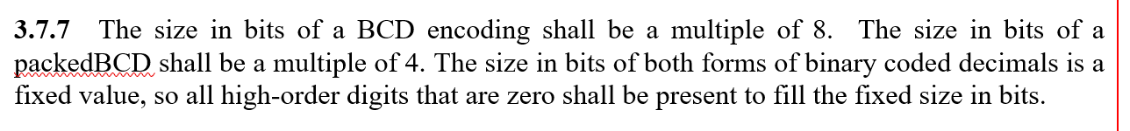

MPR-05
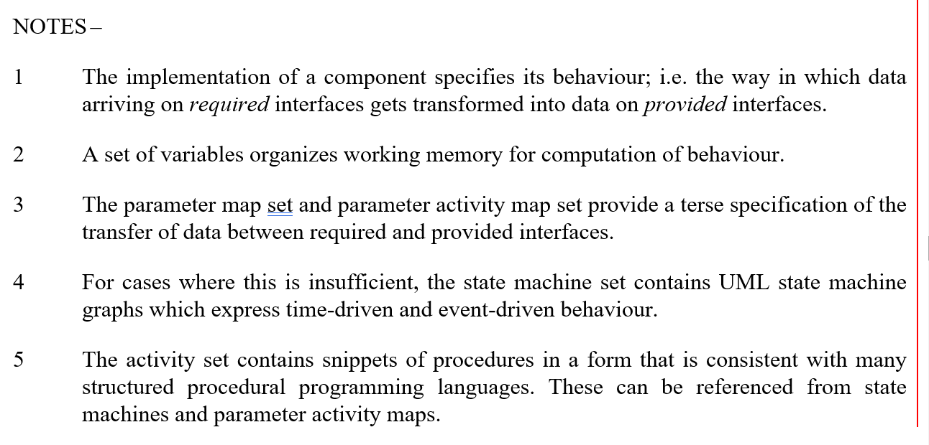

MPR-05a
(green book)
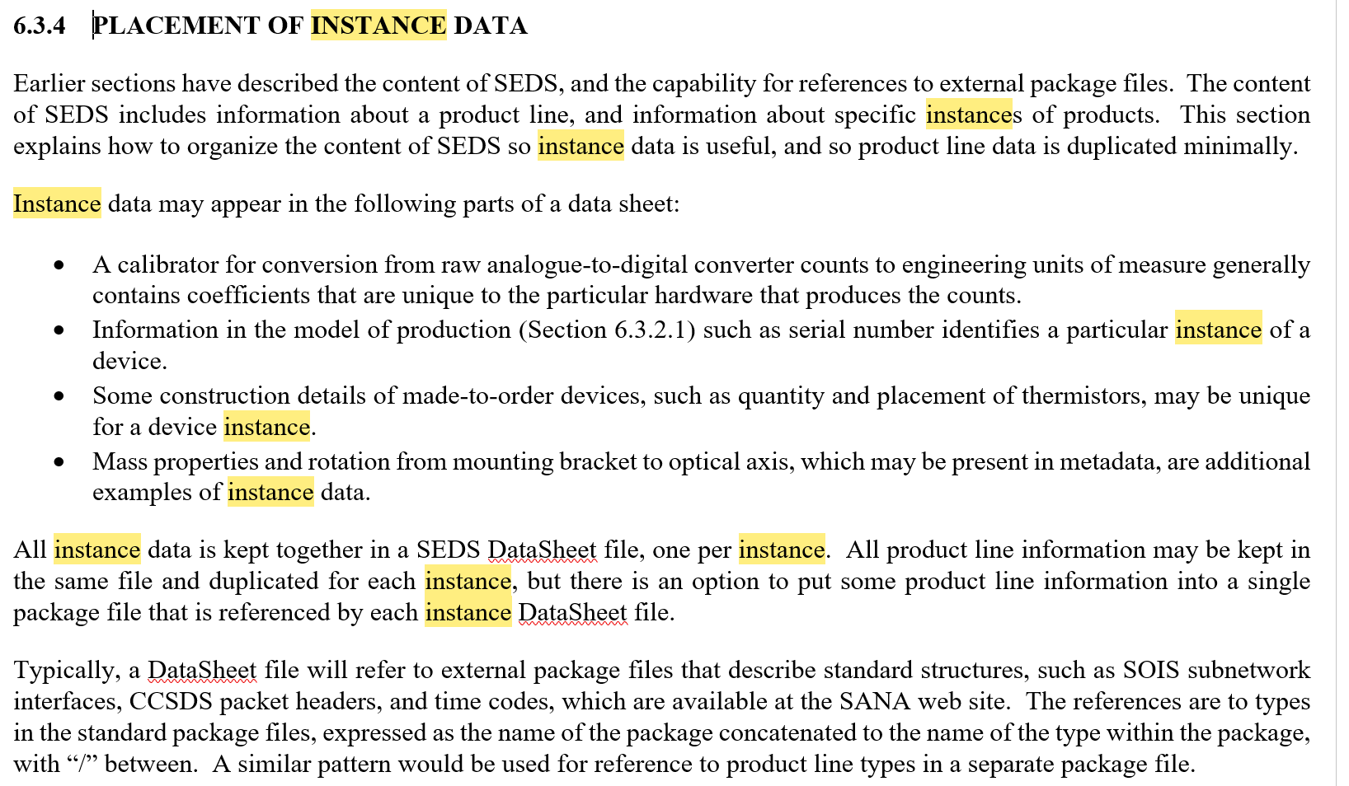

MPR-06
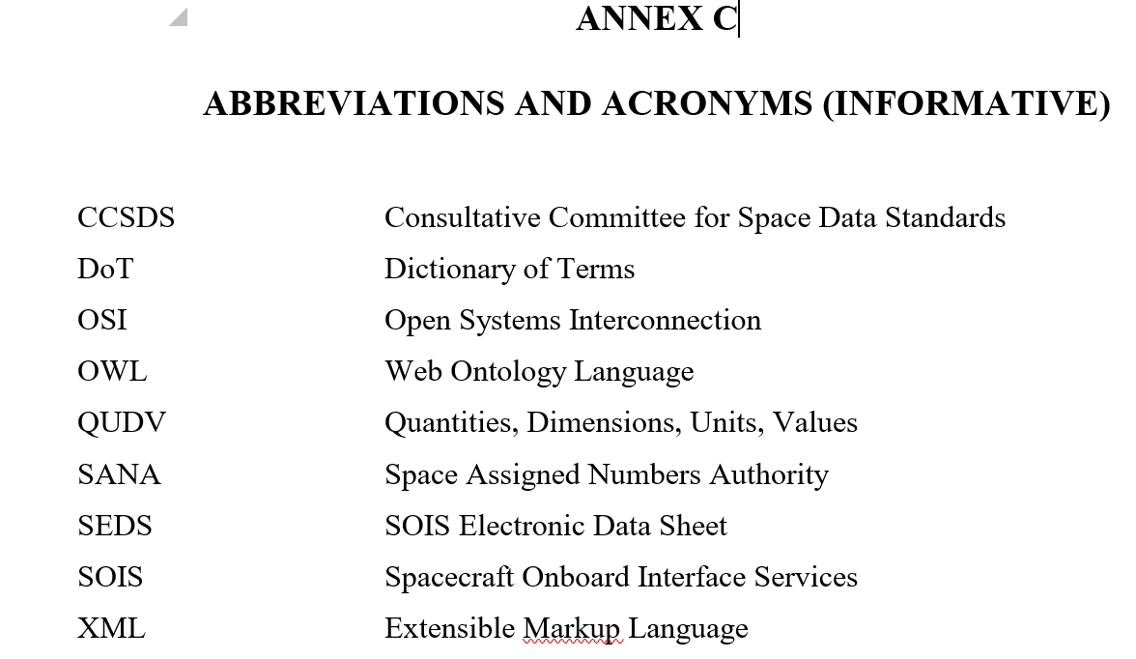

JL-01

JL-02
Agreed that the value of the annex is small; however, it is called out for an example in paragraph 4.7.1.

DP-01
See Section 15 MPR-05a above.

DP-02
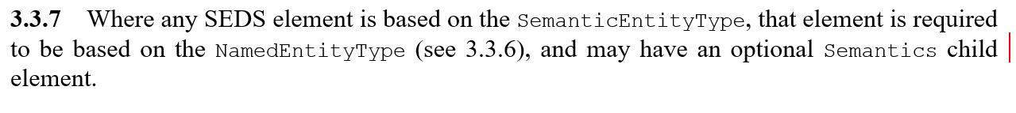

DP-03

DP-04
Rejected: The only references to long description are the generic statement in 3.3.6, and the variant statement in 3.5.3. The former provides a general statement for all elements that can have a long description. Each metadata category can include a metadata value set.

DP-05

DP-06

DP-07
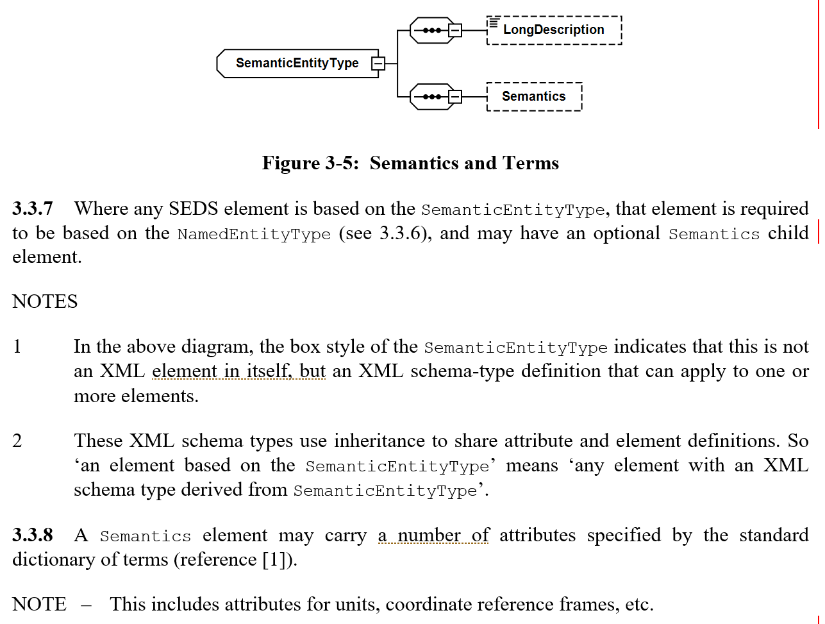

PSk-01
See Section 5 MPZ-05.

GPC-01
We reviewed the list, and found that the references are all standards referenced by SEDS. Please notify us if there are particular items that we should have excluded.

GPC-02

