CCSDS Polling System – Pre-Requirements

Overview:
The following Requirements below should be qualified as “Pre-Requirements” or “Wish List Requirements” that have been complied by numerous CCSDS suggestions over the past several years. It is assumed that both the CESG and CMC will formalize which requirements are necessary in order to develop a new CCSDS Polling System.

Product Selection:
The new CCSDS Polling System will be developed using the SharePoint 2013 Platform.

PRE-REQ-001: Permissions
Both the CMC and CESG Polls and their results will be visible to all CMC and CESG members. EX: CESG can view CMC Polls & CMC can view CESG Polls

PRE-REQ-002: Dashboard Enhancements
The following fields (see picture below) will be presented on the Dashboard of both the CESG and CMC polling systems. Automation should be maximized to calculate such fields, so that the Secretariat can minimize support efforts.
- Title
- Poll Close Date
- Poll Closed?
- Provisions Resolved?
- Results

Title | Poll Close date | Poll Closed? | Provisions Resolved? | Results
CMC-P-2010-06-001 Authorization to publish CCSDS 520.1-M-1, Mission Operations Reference Model (Magenta Book, Issue 1) | 7/9/2010 | No | No | Pending
CMC-P-2010-05-003 Authorization to publish CCSDS 644.0-B-3, The Data Description Language EAST Specification (CCSD0010) (Blue Book, Issue 3) | 6/16/2010 | Yes | No | Pending
CMC-P-2010-05-004 Reconfirmation of Producer-Archive Interface Methodology Abstract Standard | 6/16/2010 | Yes | No | Pending
CMC-P-2010-05-002 Authorization to approve the Beijing Institute of Tracking and Telecommunications Technology (BITTT) as a CCSDS Observer Agency | 6/4/2010 | Yes | Yes | Adopted
CMC-P-2010-05-001 Authorization to publish new issue of Navigation Data--Definitions and Conventions Green Book | 5/28/2010 | Yes | Yes | Adopted
CMC-P-2010-04-001 Authorization to publish 502.1-Y-1, Orbit Data Messages V2.0 Test Plan/Report (Yellow Book, Issue 1) | 5/12/2010 | Yes | Yes | Rejected
CMC-P-2010-03-001 Authorization to publish CCSDS 414.0-G-1, Pseudo-Noise (PN) Ranging Systems (Green Book, Issue 1) | 3/30/2010 | Yes | Yes | Adopted
CMC-P-2010-01-002 Authorization to release CCSDS 231.0-P-1.1, TC Synchronization and Channel Coding Pink Sheets for CCSDS Agency review | 2/23/2010 | Yes | Yes | Adopted

PRE-REQ-003: Not Yet Voted
Add a column, “Not Yet Voted,” to the Open Polls screen that tells users at a glance what users haven’t yet voted on (and who else hasn’t yet voted).

Title | Opens | Closes | Vote | Results | Not Yet Voted
CMC-P-2010-06-001 Authorization to publish CCSDS 520.1-M-1, Mission Operations Reference Model (Magenta Book, Issue 1) | 6/19/2010 | 7/9/2010 | Click Here to Vote | Click Here for Current Results | CNSA  ASI  NASA  RFSA

PRE-REQ-004: Colors on Dashboard
Indicate on the Dashboard whether the poll is:
- Open (that default light yellow color)
- Pending with conditions (orange – poll closed but provisions not yet met),
- If Passed, or when all conditions have been met (green)
- If Failed (red)

PRE-REQ-005: Voting Screen Enhancements
a) Move the “Select agency” and “Save” functions down to the very bottom of the screen, so voters don’t have to bounce around to the bottom and top of the page. Make it sequential from the top to the bottom (see below).

b) Change “ADOPT PROVISIONALLY (i.e., if stated condition is satisfied)” to:

- ADOPT WITH PROVISIONS
Indicate provisions that must be met in order to ADOPT. Whenever possible include specific language for required changes (“from/to” language)

c) Change “State Conditions” to “State Provisions or Comments”

d) Move “* indicates a required field” to top of screen.

e) Delete the “Attach Review (RIDS)“ box from the page.

f) Add to the voting screen a section that tells the voter how the others have already voted. See example below:
CURRENT RESULTS:
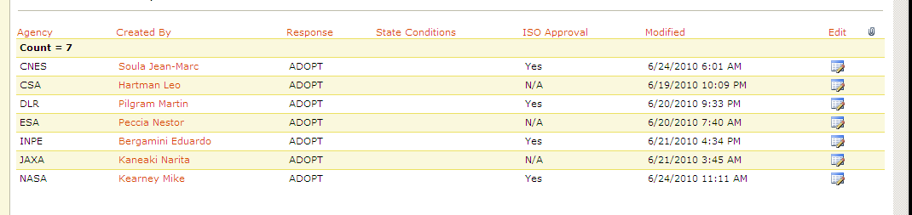

PRE-REQ-006: Self-Service Creation
Create an Area where Secretariat Staff can create both CESG and CMC polls as an Automated Process. The system will require / prompt for basic information of the Poll, and then the Poll will be created without post-process changes.

PRE-REQ-006: CESG Self-Service Resolution Creation
Create an Area where the CESG (ADs and DADs) can create Resolutions using an Automated Process. The system will require / prompt for basic information of the Resolution, and then the Resolution will be created without post-process changes.

The back end will be a repository that 1) allows creation of resolutions by Area directors or their deputies (or Secretariat personnel) and 2) automatically notifies the CESG and Secretariat whenever a new resolution is created. That repository will consist of four fields: resolution number, date of receipt, resolution title, and resolution text.

