

CCSDS SANA Registry Management Policy
Draft Yellow Book
CCSDS 313.1-Y-0.1
Draft Record
November 2015

AUTHORITY

 | Issue: | Draft Yellow Book, Issue 0.1
 | Date: | November 2015
 | Location: | Washington, DC, USA
(WHEN THIS CCSDS RECORD IS FINALIZED, IT WILL CONTAIN THE FOLLOWING STATEMENT OF AUTHORITY:)
This document has been approved for publication by the Management Council of the Consultative Committee for Space Data Systems (CCSDS). The procedure for review and authorization of CCSDS documents is detailed in Organization and Processes for the Consultative Committee for Space Data Systems (CCSDS A02.1-Y-4).

This document is published and maintained by:

CCSDS Secretariat
National Aeronautics and Space Administration
Washington, DC, USA
E-mail: secretariat@mailman.ccsds.org
FOREWORD
Through the process of normal evolution, it is expected that expansion, deletion, or modification of this document may occur. This Record is therefore subject to CCSDS document management and change control procedures, which are defined in Organization and Processes for the Consultative Committee for Space Data Systems (CCSDS A02.1-Y-4). Current versions of CCSDS documents are maintained at the CCSDS Web site:
http://www.ccsds.org/
Questions relating to the contents or status of this document should be sent to the CCSDS Secretariat at the e-mail address indicated on page i.
At time of publication, the active Member and Observer Agencies of the CCSDS were:
Member Agencies
- Agenzia Spaziale Italiana (ASI)/Italy.
- Canadian Space Agency (CSA)/Canada.
- Centre National d’Etudes Spatiales (CNES)/France.
- China National Space Administration (CNSA)/People’s Republic of China.
- Deutsches Zentrum für Luft- und Raumfahrt (DLR)/Germany.
- European Space Agency (ESA)/Europe.
- Federal Space Agency (FSA)/Russian Federation.
- Instituto Nacional de Pesquisas Espaciais (INPE)/Brazil.
- Japan Aerospace Exploration Agency (JAXA)/Japan.
- National Aeronautics and Space Administration (NASA)/USA.
- UK Space Agency/United Kingdom.
Observer Agencies
- Austrian Space Agency (ASA)/Austria.
- Belgian Federal Science Policy Office (BFSPO)/Belgium.
- Central Research Institute of Machine Building (TsNIIMash)/Russian Federation.
- China Satellite Launch and Tracking Control General, Beijing Institute of Tracking and Telecommunications Technology (CLTC/BITTT)/China.
- Chinese Academy of Sciences (CAS)/China.
- Chinese Academy of Space Technology (CAST)/China.
- Commonwealth Scientific and Industrial Research Organization (CSIRO)/Australia.
- Danish National Space Center (DNSC)/Denmark.
- Departamento de Ciência e Tecnologia Aeroespacial (DCTA)/Brazil.
- Electronics and Telecommunications Research Institute (ETRI)/Korea.
- European Organization for the Exploitation of Meteorological Satellites (EUMETSAT)/Europe.
- European Telecommunications Satellite Organization (EUTELSAT)/Europe.
- Geo-Informatics and Space Technology Development Agency (GISTDA)/Thailand.
- Hellenic National Space Committee (HNSC)/Greece.
- Indian Space Research Organization (ISRO)/India.
- Institute of Space Research (IKI)/Russian Federation.
- KFKI Research Institute for Particle & Nuclear Physics (KFKI)/Hungary.
- Korea Aerospace Research Institute (KARI)/Korea.
- Ministry of Communications (MOC)/Israel.
- National Institute of Information and Communications Technology (NICT)/Japan.
- National Oceanic and Atmospheric Administration (NOAA)/USA.
- National Space Agency of the Republic of Kazakhstan (NSARK)/Kazakhstan.
- National Space Organization (NSPO)/Chinese Taipei.
- Naval Center for Space Technology (NCST)/USA.
- Scientific and Technological Research Council of Turkey (TUBITAK)/Turkey.
- South African National Space Agency (SANSA)/Republic of South Africa.
- Space and Upper Atmosphere Research Commission (SUPARCO)/Pakistan.
- Swedish Space Corporation (SSC)/Sweden.
- Swiss Space Office (SSO)/Switzerland.
- United States Geological Survey (USGS)/USA.

DOCUMENT CONTROL

Document | Title | Date | Status
CCSDS 313.1-Y-0 | CCSDS SANA Registry Management Policy, Draft Yellow Book, Issue 0.1 | October 2015 | Original draft, superseded
CCSDS 313.1-Y-0.1 | CCSDS SANA Registry Management Policy, Draft Yellow Book, Issue 0.1 | November 2015 | Current draft

CONTENTS
Section Page
1 Introduction 1-1

1.1 PURPOSE 1-1
1.2 APPLICABILITY 1-2
1.3 NOMENCLATURE 1-2
1.4 DEFINITIONS 1-3
1.5 References 1-8

2 CCSDS Registry Management DESCRIPTION 2-1

2.1 Space Assigned Numbers Authority OVERVIEW 2-1
2.2 SANA USE CASES 2-1
2.3 SANA REGISTRY OVERVIEW 2-2
2.4 CCSDS Enterprise REGISTRIES 2-3
2.5 CCSDS GLOBAL REGISTRIES 2-6
2.6 CCSDS LOCAL (PROTOCOL Identifier) REGISTRIES 2-7
2.7 SANA Registry MANAGEMENT Model 2-7
2.8 CCSDS AREA AND WORKING GROUP Registry CONSIDERATIONS 2-9

3 REGISTRY MANAGEMENT POLICIES 3-1

3.1 REGISTRY MANAGEMENT OVERVIEW 3-1
3.2 CCSDS AREA AND WORKING GROUP Registry DEFINITION PROCESSES 3-1
3.3 CCSDS ENTERPRISE REGISTRIES 3-2
3.4 CCSDS GLOBAL REGISTRIES 3-14
3.5 CCSDS WG / Local IDENTIFIER REGISTRIES 3-22
3.6 LIMITATIONS 3-25

4 Expert Group 4-1

4.1 Overview 4-1
4.2 INITIAL SET OF CCSDS EXPERT GROUPS 4-1

ANNEX A CCSDS OID Tree (Normative) A-1
ANNEX B Information Models (Informative) B-1
ANNEX C Informative References (Informative) C-1

CONTENTS (continued)
Figure Page
2-1 Agency/Representative and Registry Model 2-4
2-2 Overall SANA Registry Management Model 2-8
A-1 CCSDS OID Tree A-5
B-1 Organization and Relationship Info Model B-1
B-2 Contacts Info Model B-4
B-3 Spacecraft Info Relationship Model B-6
B-4 Spacecraft Info Model B-7
B-5 Service Site and Aperture Info Relationship Model B-9
B-6 Service Site and Aperture Info Model B-10
B-7 IOAG Antenna Registry B-11

Table
B-1 Organization Database Elements B-2
B-2 Contact Database Elements B-5
B-3 Spacecraft Database Elements B-8

Introduction

PURPOSE
This document describes the CCSDS Space Assigned Numbers Authority (SANA) Registry Management Policy and related procedures. This document is a product of the CCSDS Engineering Steering Group (CESG), developed by the System Engineering Area and the SANA Steering Group (SSG). The purpose of this document is to provide an overview of the key SANA and other CCSDS registries and their relationships, and to define a consistent set of policies and procedures that can be applied to the creation, control, and management of the CCSDS-wide enterprise registries, and the global and local registries in the SANA (reference [19]).
A number of different CCSDS Recommended Standards make reference to organization or system elements, such as CCSDS Agencies, members of those agencies who have particular roles regarding standards or their deployment and use, or common terminology. A primary purpose of this document is to clearly define a set of common registries for such elements that may be re-used and extended as needed to provide a central and accessible location for such information.
Three different categories of registries are identified:
- enterprise: Registries containing CCSDS Agency, other Affiliate Organization, contact, and asset information that are managed by these organizations and their representatives;
- global: Registries containing information that is global or cross-cuts more than one CCSDS area and that are managed at the CCSDS Engineering Steering Group (CESG) level; and
- local: Registries that are created and managed at Area level that are managed at an Area level or delegated to a Working Group.
This document specifies normative policies and procedures for each of these three categories of registries that are applicable to:
- the SANA, the SANA Operator, and the SANA Steering group;
- the CCSDS Secretariat;
- CCSDS Agencies and Affiliate Organizations controlling data in the SANA;
- the CESG; and
- the CCSDS Areas and Working Groups defining or using registries.
CCSDS Areas and Working Groups are required to use the enterprise and global registries in preference to creating new local versions. They may extend these common registries, following the defined procedures, where that is needed.
CCSDS Working Groups or Areas that define new registries, or use or adapt existing registries, are encouraged to become familiar with the policies in this document and to coordinate their work, at the earliest opportunity, with the SANA and the SSG.

APPLICABILITY
This CCSDS Registry Management Policy is normative on CCSDS, and it specifically applies to the SANA, which has responsibility for managing and providing access to all the registries. This policy also applies to the CCSDS Secretariat, the CCSDS working organizations, and to all requests to SANA made in any CCSDS documents to create, update, and control registries. It shall be binding on the work of CCSDS as a whole and on all CCSDS Member Agency, Affiliate, and service provider organizations that supply and update information for these registries.
The information models and data structures that are provided in this document are for guidance to the implementers and are informative. The normative information models and registry design is intended to be somewhat dynamic and extensible. The normative information models and registry design shall be explicitly documented in the SANA.

NOMENCLATURE

Normative Text
The following conventions apply for the normative specifications in this CCSDS Policy:
- the words ‘shall’ and ‘must’ imply a binding and verifiable specification;
- the word ‘should’ implies an optional, but desirable, specification;
- the word ‘may’ implies an optional specification;
- the words ‘is’, ‘are’, and ‘will’ imply statements of fact.
NOTE – These conventions do not imply constraints on diction in text that is clearly informative in nature.

Informative Text
In the normative sections of this document, informative text is set off from the normative specifications either in notes or under one of the following subsection headings:
- Overview;
- Background;
- Rationale;
- Discussion.

DEFINITIONS

Definitions Adopted from Reference [5]
delegation: The act of assigning responsibility for a registry to an organization.
registration rules: The specified rules used to manage the creation and update of a registry.
registry: Information system that securely manages any content type and the standardized metadata that describes it. The registry manages the registration of the content. The associated repository is a store for the content.
SANA: On-line registry of CCSDS protocol numbers and other CCSDS information that must be publically accessible in an on-line, easily located form.
SANA Operator: Organization that manages and operates the SANA.
SANA Steering Group, SSG: Group that provides operational oversight of SANA, validation and confirmation SANA activities, and the first level of appeal for issues.

Definitions Adopted or Adapted from Reference [4]
CCSDS Associates: Scientific and industrial entities who create a formal tie with the CCSDS, which allows them to more closely monitor and possibly influence the technical document development process.
Associates may participate in CCSDS with the explicit approval of a sponsoring CCSDS Member or Observer Agency.
CCSDS Liaison Organizations: Governmental or private enterprises with developmental programs in the areas of space-related data and information systems.
Liaison Organization participation in CCSDS is subject to approval by the CMC (see subsection 4.1.1 in reference ).
CCSDS Member Agency
, Member Agency: A governmental or quasi-governmental organization that fully participates in all CCSDS activities and provides a commensurate level of support. Only one agency representing a given country or multinational organization may participate as a Member Agency of the CCSDS.
Only Member Agencies have CCSDS voting rights, which are exercised through Member Agency Heads of Delegation. Member Agency Heads of Delegation make up the CCSDS Management Council (CMC), which meets twice a year to decide on the business and direction of the CCSDS.
CCSDS Observer Agency, Observer Agency: A governmental or quasi-governmental organization that participates in CCSDS activities at a reduced level of support.
Observer Agencies may participate in CCSDS with the explicit approval of a sponsoring CCSDS Member Agency or the CCSDS Secretariat.
CCSDS Secretariat: Organization that acts on behalf of the CMC to manage and maintain the CCSDS web site and to operate the CCSDS standards processes.
The Secretariat maintains lists of Member Agencies, Observer Agencies, Liaison organizations, and Associate organizations. These lists are maintained on the CCSDS Web site.

Definitions Adopted or Adapted from Reference [7]

Agency Representative, AR: An individual designated by a CCSDS Agency Head of Delegation or Affiliate Organization Point of Contact as the person authorized to request registry additions, changes, or deletions on behalf of the respective agency.
Each CCSDS Agency or Affiliate Organization may have more than one AR and each AR may have more than one role relative to different registries.
CCSDS Agency: A CCSDS Member or Observer Agency.
CCSDS Agency Head of Delegation, HoD: The individual who serves as principal representative of a CCSDS Agency in dealings with the CCSDS.
Global Spacecraft Identifier, GSCID: The concatenation of the 2-bit Version Number (VN) and the SCID. Thus GSCID = VN • SCID, where ‘•’ refers to the concatenation operator.
Spacecraft Identifier, SCID: A value used in specified fields of CCSDS-defined space data link data structures.
space link: A communications link between a spacecraft and its associated ground system, or between two spacecraft.
space link protocol: A communications protocol designed to be used over a space link (see above).
version number, VN: A field value used to differentiate CCSDS-defined transfer frames. The valid range of the currently defined VN field is shown in table 1-1 of reference [7].

Definitions Adopted or Adapted from Reference [8]
Control Authority Identifier, CAID: A four-character restricted-domain ASCII string, which identifies an individual Control Authority (CA) office or the Standard Formatted Data Units (SFDU) Control Authority (SCA) Agent.
Member Agency Control Authority Office, MACAO: An individual CCSDS-participating Agency organization that has accepted the operational responsibilities and constraints specified within CCSDS Recommendations on SCA operations.
Primary MACAO: The entity in the SCA organization that has overall responsibility for ensuring SCA services for its Agency and any of its Descendant MACAOs.
SFDU Control Authority, CA: An organization under the auspices of CCSDS which supports the transfer and usage of SFDUs by providing operational services of registration, archiving, and dissemination of data descriptions. It comprises:
- The SANA, acting for the CCSDS as the CA Agent;
- Member Agency Control Authority Offices (MACAOs).
SFDU Control Authority Agent, CA Agent: An organizational entity that has agreed to discharge the CA Agent responsibilities of the CCSDS Secretariat. The SANA acts as this agent. Overall CA Agent responsibility rests with the SANA.
Standard Formatted Data Unit, SFDU: Data that conform to CCSDS SFDU Recommended Standard for structure, construction rules, and field specification definition.

Definitions Adopted or Adapted from the SLE Reference Model [9]
service provider, provider: An entity that offers a service to another by means of one or more of its ports is called a service provider (provider). The other entity is called a service user (user). An entity may be a provider of some services and a user of others.
service user, user: An entity that uses a service offered by a service provider. An entity may be a provider of some services and a user of others.

Definitions Adopted or Adapted from References [11] and [12]
ASN.1: Abstract Syntax Notation One.
administrative role: (Of a Registration Authority) Assigning and making available unambiguous names according to the ITU-T Recommendation and/or this SANA Registry Management Policy defining the procedures for the Registration Authority.
international object identifier tree: A tree whose root corresponds to ISO X.660 and whose nodes correspond to Registration Authorities responsible for allocating arcs from a parent node.
object of interest, object: Anything in some world, generally the world of telecommunications and information processing or some part thereof,
- which is identifiable (can be named); and
- which may be registered.
object identifier, OID: An ordered list of primary integer values from the root of the international object identifier tree to a node, which unambiguously identifies that node.
registration: The assignment of an unambiguous name to an object in a way which makes the assignment available to interested parties.
Registration Authority: An entity such as an organization, a standard, or an automated facility that performs registration of one or more types of objects.
NOTE – For this CCSDS SANA Registry Management Policy, the above definition of Registration Authority covers the SANA and other CCSDS organizations that perform registration, such as a MACAO.
registration procedures: The specified procedures for performing registration and amending (or deleting) existing registrations.

Definitions Adopted or Adapted from Reference [13]
BER: Basic Encoding Rules of ASN.1
encoding: (Of a data value) The complete sequence of octets used to represent the data value.

Definitions Specified in this Document:
Affiliate Organization, Affiliate, AO: A CCSDS Associate or Liaison organization.
Affiliate Organization Point of Contact, PoC: The individual who serves as principal representative of a CCSDS Affiliate Organization in dealings with the CCSDS.
Affiliate Organization Registry: The registry of CCSDS Associates and Liaison Organizations; part of the CCSDS Organization Registry
Agency Registry: The registry of CCSDS Member and Observer Agencies; part of the CCSDS Organization Registry.
Assigned by CCSDS: Having identifier values requested by CCSDS Agencies or Affiliates.
Contacts Registry: The registry of individuals with active roles in CCSDS and SANA management and operations; one of the SANA enterprise registries.
Defined by CCSDS: Having design and identifier values specified by CCSDS.

Member Agency Registry: The registry of CCSDS Member Agencies that is part of the CCSDS Organization Registry.
Observer Agency Registry: The registry of CCSDS Observer Agencies that is part of the CCSDS Organization Registry.
OID Registry: The registry of ISO compliant Object Identifiers (OIDs) that are used for unambiguous identification of CCSDS protocol elements, data types, organizations, contacts, resources, and spacecraft.
Organization Registry: The registry of all organizations that participate in CCSDS activities. It includes the Agency and Affiliate Organization Registries.
Owned by Agencies: Having content controlled by the CCSDS Agency or Affiliate.
Owned by CCSDS Area: Having content controlled by the CCSDS Area. Areas may delegate the registry design and update responsibility to a Working Group (WG) while that WG is in operation.
Owned by CESG: Having content controlled by the CESG. The CESG may delegate the registry design and update responsibility to a CCSDS Expert Group.
Owned by projects: Having content controlled by the projects.
Review Authority: The organization that is assigned a role in performing engineering review of a SANA registry that requires it.
Roles Registry: The registry of organization and contact role types used in the SANA enterprise registries.
Service Provider Registry: The registry of organizations that provide services communications, data, or operations services; part of the SANA Organization Registry.
Service Site and Aperture Registry: The registry of sites that provide services such as communications, data, or relay services, including the specifications of the apertures used for communications; one of the SANA enterprise registries.
NOTE – Registered sites may offer services, or have communications apertures, or both. Sites may be in fixed locations, or may be mobile, and they may be in space. A spacecraft that offers relay or network services may be registered as a site. This registry points to the IOAG RF Asset registry entries, and to Spacecraft Registry entries as needed, using OIDs to provide unambiguous references.
Spacecraft Registry: The registry of spacecraft, spacecraft identifiers, names, and aliases; one of the SANA enterprise registries.
Terminology Registry: The registry of terms, glossary entries, and abbreviations; one of the SANA global registries.
XML Schema Registry: Any of the registries of XML schema that are stored in the SANA.

References
The following publications are referenced in this document. At the time of publication, the editions indicated were valid. All publications are subject to revision, and users of this document are encouraged to investigate the possibility of applying the most recent editions of the publications indicated below. The CCSDS Secretariat maintains a register of currently valid CCSDS publications.
[1] “Uniform Resource Names (URN) Namespaces.” Internet Assigned Numbers Authority. http://www.iana.org/assignments/urn-namespaces/urn-namespaces.xhtml.
[2] “CCSDS URN Namespace.” Space Assigned Numbers Authority. http://sanaregistry.org/r/urn/urn.html.
[3] CCSDS Publications Manual. Issue 4. CCSDS Record (Yellow Book), CCSDS A20.0-Y-4. Washington, D.C.: CCSDS, April 2014.
[4] Organization and Processes for the Consultative Committee for Space Data Systems. Issue 4. CCSDS Record (Yellow Book), CCSDS A02.1-Y-4. Washington, D.C.: CCSDS, April 2014.
[5] Space Assigned Numbers Authority (SANA)—Role, Responsibilities, Policies, and Procedures. Issue 1. CCSDS Record (Yellow Book), CCSDS 313.0-Y-1. Washington, D.C.: CCSDS, July 2011.
[6] CCSDS URN Namespace Policy. Issue 0. Draft CCSDS Record (Draft Yellow Book), CCSDS 315.1-Y-0. Forthcoming. [To be revised.]
[7] CCSDS Global Spacecraft Identification Field Code Assignment Control Procedures. Issue 6. Recommendation for Space Data System Standards (Blue Book), CCSDS 320.0-B-6. Washington, D.C.: CCSDS, October 2013. [To be revised.]
[8] Standard Formatted Data Units — Control Authority Procedures. Issue 1. Recommendation for Space Data System Standards (Blue Book), CCSDS 630.0-B-1. Washington, D.C.: CCSDS, June 1993. [To be revised.]
[9] Cross Support Reference Model—Part 1: Space Link Extension Services. Issue 2. Recommendation for Space Data System Standards (Blue Book), CCSDS 910.4-B-2. Washington, D.C.: CCSDS, October 2005.
[10] Cross Support Transfer Service—Specification Framework. Issue 2. Draft Recommendation for Space Data System Standards (Red Book), CCSDS 921.1-R-2. Washington, D.C.: CCSDS, May 2014.
[11] Information Technology—Procedures for the Operation of Object Identifier Registration Authorities: General Procedures and Top Arcs of the International Object Identifier Tree. ITU-T Recommendation X.660. Geneva: ITU, 2011.
[12] Information Technology—Abstract Syntax Notation One (ASN.1): Specification of Basic Notation. ITU-T Recommendation X.680. Geneva: ITU, 2015.
[13] Information technology—ASN.1 Encoding Rules: Specification of Basic Encoding Rules (BER), Canonical Encoding Rules (CER) and Distinguished Encoding Rules (DER). ITU-T Recommendation X.690. Geneva: ITU, 2015.
[14] R. Moats. URN Syntax. RFC 2141. Reston, Virginia: ISOC, May 1997.
[15] K. Sollins. Architectural Principles of Uniform Resource Name Resolution. RFC 2276. Reston, Virginia: ISOC, January 1998.
[16] M. Mealling. A URN Namespace of Object Identifiers. RFC 3061. Reston, Virginia: ISOC, February 2001.
[17] M. Mealling. Dynamic Delegation Discovery System (DDDS)—Part One: The Comprehensive DDDS. RFC 3401. Reston, Virginia: ISOC, October 2002.
[18] L. Daigle, et al. Uniform Resource Names (URN) Namespace Definition Mechanisms. RFC 3406. Reston, Virginia: ISOC, October 2002.
[19] Space Assigned Numbers Authority (SANA). http://sanaregistry.org/.

CCSDS Registry Management DESCRIPTION

Space Assigned Numbers Authority OVERVIEW
The CCSDS has defined the SANA as the core registrar for CCSDS activities. The SANA is the official CCSDS registrar, the clerk and enforcer of alignment and assignment, and curator of information provided by others. Many space-mission protocols require that someone keep track of key protocol numbering assignments that were added after the protocol came out. Typical examples of the kinds of registries needed are for spacecraft IDs, protocol version numbers, reserved APIDs, and SFDU control authorities. The CCSDS also registers other standards-related information, such as agencies, service and data providers, XML schema, a Glossary of terms, and other information that is used across CCSDS.
The SANA provides these key configuration management services for CCSDS in an on-line, web browser accessible form at http://www.sanaregistry.org. These registries may also be accessed via programmatic interfaces using HTTP/REST. The SANA Yellow Book (reference [5]) defines the roles of the SANA and the SANA Operator.
In addition to the registries maintained by the SANA, the Secretariat maintains the official lists of Member Agencies, Observer Agencies, Liaison organizations, and Associate organizations. These lists are maintained on the CCSDS Web site. Periodic updates to these specific lists will be provided to the SANA, and will be merged with the more extensive lists of Affiliate Organizations and contacts maintained in an on-line searchable and sortable form, in the SANA registries.

SANA USE CASES
The SANA may be used in either static or dynamic modes. It can be used by missions, operations, or CCSDS staff to look up information using a web browser. Because it is hosted in an on-line service with a protocol interface, it may also be queried dynamically by programs as an interactive service. The list below includes several possible use cases for the SANA. The list makes no pretense at being either exhaustive or complete. Possible use cases are:
- look up agency, service provider, or other organization point of contact;
- identify potential service providers;
- request new SCID, OID, or assigned protocol number by authorized persons;
- determine existing protocol identifiers;
- register new XML schema, validate XML documents against existing schema validators;
- lookup existing SCID or OID to determine spacecraft identifiers or owner;
- translate URN or OID name into an on-line reference URL;
- lookup CCSDS terms to identify meaning, relationships, and sources;
- support CCSDS WGs with single point, on-line, access to terminology and other registries;
- locate links to service providers, their service catalogs, and service commitment organizations;
- update organization and contact information to keep it up to date.

SANA REGISTRY OVERVIEW
The SANA Operator creates new registries based on a CCSDS-approved Recommended Standard where the instructions to create the registry and the registration rules to add new registry entries are documented. The SANA Operator is to review any requests for new registries and notify the CESG of any issues such as similar registries or objects being registered more than once. Any WG creating a new registry, or extending an existing registry, must contact the SANA Operator, prior to initial document distribution for agency review, to review and vet the registry design, and create a draft, or ‘candidate’ registry. WGs are strongly encouraged to initiate these discussions with the SANA, and the SANA Steering Group, at the earliest opportunity.
A CCSDS document requesting the creation of a new registry must define which one of the following registration rules is to be used for adding new entries or for making changes to the registry:
- Change requires a CCSDS approved document.
- Change requires an engineering review by a designated expert or group. The expert for that registry is assigned by the CESG based on the WG recommendation.
- Change requires no engineering review, but the request must come from the official representative of a space agency that is a member of the CCSDS. The official representative of an agency may differ for each registry.
- Change requires no review; assignments are done on a first-come, first-served basis.
In the CCSDS document that defines the creation of a registry, the registration rule must be defined either within the above set of rules or by some other rule. These rules provide guidance to the SANA Operator on how to make assignments of new parameters for that registry. The CCSDS document that defines the registry must clearly define the rules to be followed for update, modification, or removal of entries. In addition to any stated registration rule every registry has a Registration Authority who ‘owns’ the registry.
This document provides specific guidance for the creation, management, and use of cross-cutting registries containing agency, organization, contact, spacecraft, communication asset, or other enterprise or global information. These registries are usually of type b) change requires an engineering review, or type c) change requires a request from an official representative of a space agency (cf. reference [5]). It also defines a registry management approach that will support re-use and extension of existing registries of information instead of creating new ones at a WG level, which has been the practice to date.
The rationale for this policy is to encourage management and re-use of common types of registry information that cross-cut CCSDS Recommended Standards and that may be referenced by more than one Area, WG, or group of related standards. It is intended to provide a level of consistency across all of the SANA registries.
To organize the set of SANA registries this document defines three categories of registries:
- enterprise: Registries for CCSDS Agencies, Affiliate Organizations, their contacts, assets, and information owned and provided by these organizations;
- global: Registries that hold global or cross-cutting information that, for consistency, must be managed at the top engineering level in CCSDS, the CESG;
- local: Registries that hold information local to an Area or WG and that may be managed locally.
The next subsections describe these different registry categories in more detail.

CCSDS Enterprise REGISTRIES

General
The following subsections describe a registry structure for managing the information related to the CCSDS enterprise, including the CCSDS Member and Observer Agencies, Affiliate Organizations such as CCSDS Associates and Liaisons, and the persons who are points of contact or who otherwise have roles in CCSDS and in SANA.
Figure 2-1 graphically shows the relationships among these elements and the registry information for which they are responsible.
The following subsections describe each of these registries and their relationships. These reflect CCSDS policies for organizations and sponsorship, as documented in the CCSDS Organization and Processes document (reference [4]). The official registries of CCSDSsAgencies andsAffiliates are created by the Secretariat and stored on the CCSDSeWeb site. Each of these entities now has a unique object identifier assigned by the SANA.
For convenient, centralized, programmatic access, copies of these registries are managed in the SANA, by the SANA Operator. The SANA manages the operational versions of these registries that also include extensions to cover services, assets, and spacecraft registries. The SANA and the Secretariat are responsible for managing any needed updates and coordination. To simplify the discussion in the rest of this document the focus will be upon the SANA as the central, accessible, operational, source of all these data.
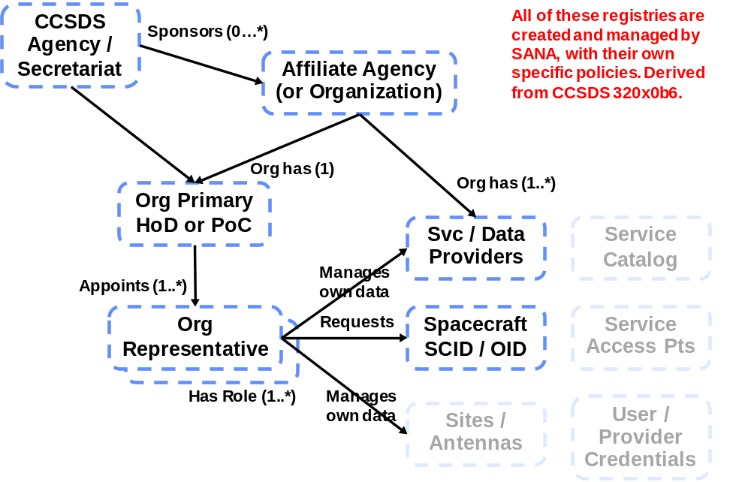
Figure 2-11: Agency/Representative and Registry Model
There is a set of inter-relationships among these enterprise entities and these are described in detail in the following subsections, but introduced here. For example:
- The CCSDS Secretariat is the ‘root’ organization for CCSDS.
- The Secretariat is responsible for updates to these Organization Registries, based on requests from the agencies.
- Every agency or other organization that participates in CCSDS has some primary place of business, address, and a primary point of contact.
- Each point of contact has a name, address, email, phone number, and organizational role.
- Member Agencies have roles in sustaining CCSDS and also are allowed to sponsor other organizations and Affiliates.
- Some organizations offer space communications or data services, either terrestrial or in space (such as relay services).
- Some organizations build and operate spacecraft.
- Each contact involved in CCSDS has a name, address, email, phone number and organizational role.
- Some contacts have specific roles in CCSDS, such as WG chair, CESG member, or appointed representative to make registry updates for an agency.
In some cases there are specific rules about organization roles or the roles that persons may play. These are described in the following subsections.
The grayed out items in figure ,, service catalog, service access points, and credentials, are potential future registries that reflect work that is in development in CCSDS at the time of publication of this version of the document. There is an RF Asset registry that has been developed by the IOAG and is hosted by the SANA. The Service Site and ApertureyRegistry references these data and contains additional information on sites and services that is intended to be referenced in CCSDSsRecommended Standards such as service management and cross support.

CCSDS ENTERPRISE REGISTRY TYPES
CCSDS maintains registries for all of the CCSDS Agencies and CCSDS Affiliates. The registries include the organization information, country, affiliations, and sponsorship where appropriate. For each CCSDS Agency there is a HoD who is the primary point of contact for that agency. For CCSDS Member Agencies the HoD is usually also the CCSDS Management Council (CMC) representative. For each CCSDS Affiliate there is a PoC. There is only one HoD or PoC for each organization and the entries include name, address, phone and email information.
It is the responsibility of each HoD and each PoC to assign one or more AR. Each AR may have one or more roles and may be assigned responsibility for controlling updates to the contents of a registry that contains CCSDS Agency or Affiliate data.
In addition to the registries for organizations, CCSDS provides registries that hold information that is requested or provided by an CCSDS Agency or Affiliate. Examples of such registries are the SCIDs, service sites and apertures, SFDU control authorities, and service provider information (including sites and pointers to service catalogs and commitment offices). These registry types may be extended as needed and new roles or service types may be added as needed.

Organization REGISTRY OVERVIEW
All CCSDS assignments in the Organization Registry are managed by the SANA (see reference [5]). This registry is the normative reference for all CCSDS organizations. Information about other organizations may also kept in registries managed by the SANA. Each registry type may have its own registration rules, but changes to these organization registries require requests and approvals from an AR who has been delegated responsibility for the agency entries in a registry, or from the appropriate HoD or PoC. Organizations may have one or more assigned roles. The set ofnorganization roles may be extended as needed.

CONTACTs REGISTRY OVERVIEW
All of the persons who have roles in the operation of CCSDS, or the SANA and its registries, are managed in a Contacts Registry that is also part of the SANA. This registry is the normative reference for all CCSDS persons and points of contact. Changes to the Contacts Registry require approval from an AR who has been delegated responsibility for the Contact entries in the registry or from the appropriate HoD or PoC. Contacts may have one or more assigned roles. The set of Contact roles may be extended as needed.

Spacecraft IDENTIFIER REGISTRY OVERVIEW
CCSDS Data Link Layer protocol frame headers include a field for a unique spacecraft identification number. These numbers are requested by the organizations that develop the spacecraft and are assigned and managed by the SANA for the duration of the active mission lifetime. A unique identifier (OID) that is permanent is also assigned. The SCID registry includes space communication characteristics as well. Changes to the SCID registry requires approval from an AR who has been delegated responsibility for an organization’s entries in the registry or from the appropriate HoD or PoC.

Service Site and Aperture Registry OVERVIEW
All of the assets that are involved in spacecraft communications and cross support should have unambiguous identification numbers (OID) assigned so that they can be properly referenced for space link communication planning, scheduling, and utilization purposes. These unique identifiers (OIDs) are assigned and managed by the SANA. The registry identifies sites where communication assets are located, and the apertures themselves. These cross support assets may be owned and operated by space agencies, commercial entities, or other organizations such as universities or research labs. The Service Site and Aperture Registry may include services offered by a site and space communication aperture characteristics (frequency bands, apertures sizes, EIRP and G/T) as well. Changes to the Service Site and Aperture Registry requires approval from an AR who has been delegated responsibility for an organization’s entries in the registry or from the appropriate HoD or PoC.

CCSDS GLOBAL REGISTRIES

CCSDS GLOBAL REGISTRY TYPES
CCSDS maintains registries containing information that is global or crosses more than one CCSDS area. These registries are controlled at the CCSDS Engineering Steering Group (CESG) level. These registries may originate in an Area or WG, but they specify information that must be managed in a global forum because it is either cross cutting, affecting more than one WG, or it is global in nature, potentially affecting all WGs that reference those types of information.
Examples of registries of this type include: XML schema registries, URN namespace registry, CCSDS registry of OID, the CCSDS Terminology, Terms, and Abbreviations, and the SANA itself.
Because of their global nature these registries are controlled at the top engineering level of the CCSDS, the CESG. Responsibility for being the Review Authority (responsibility for controlling and requesting update of the contents) may be delegated by the CESG down to some working level in the organization. Typically this review authority will be the SSG or an Expert Group of some type, either assigned the responsibility or formed for the purpose. The Expert Group will have members drawn from the WGs most involved with creating the registry or otherwise affected by the registry.

GLOBAL REGISTRY CUSTODY
All CCSDS assignments in the global registries are managed by the SANA (see reference [5]). These registries are the normative references for all CCSDS global information sets. Each registry will have its own registration rules, and changes to these global registries typically require requests fromsWGs and approvals from the review authority, SSG, or Expert Group that has been delegated responsibility for controlling the entries. One group may be responsible for more than one global registry.

CCSDS LOCAL (PROTOCOL Identifier) REGISTRIES
CCSDS maintains registries containing protocol identifiers or other standard- or WG-specific information that are created and controlled at Area or WG level. These registries originate in a WG, and they specify information that typically affects only one WG or Area. Other WGs within an Area, or even other Areas, may reference these types of information, but they are essentially internal to an Area.
Examples of registries of this type include: protocol identifiers, extensions, and version numbers; data catalogs, source lists, or other locally controlled information; WG-specific data items; or any portion of the ISO OID registry that is delegated to a WG or Area.
Because of their local nature these registries are controlled at the level of an Area. Responsibility for doing active control of the contents will typically be delegated by the Area down to some WG, but the Area is responsible and must identify means to control such registries if the WG that created them has been retired. Typically the review authority for such registries will be a WG, but it may coordinate with other WGs within the Area most involved with creating or otherwise affected by the registry.

SANA Registry MANAGEMENT Model
The set of registries described above should be considered as a whole. The SANA and the SANA Operator provide the framework and the machinery for managing, registering, updating, and accessing these data. Figure 2-2 provides a view of all of the identified registry categories and their contents. The data in these different categories of registries are handled in the following ways:
enterprise: Database updates are requested and approved by Agency Representatives.
global: Database updates are requested by agencies, areas, or WGs and are approved by the assigned engineering body.
local / WG: Database updates are requested by WGs and approved by the Area.

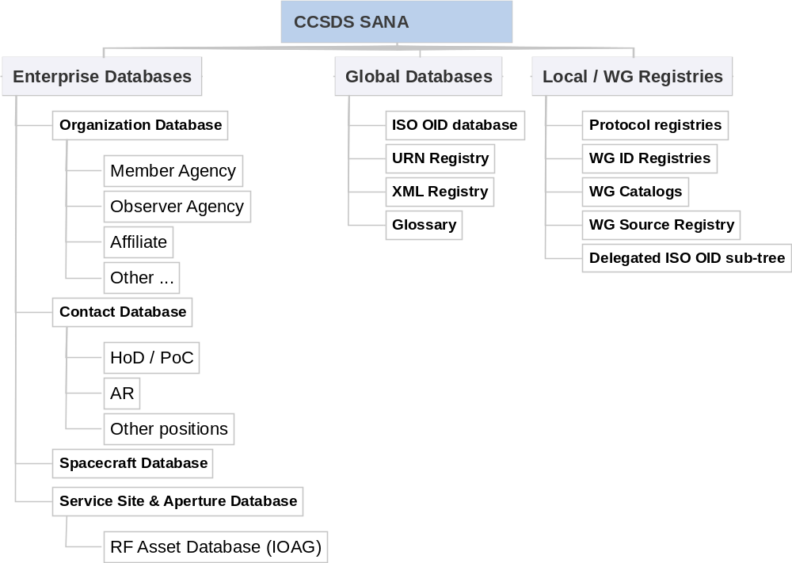
Figure 2-22: Overall SANA Registry Management Model

CCSDS AREA AND WORKING GROUP Registry CONSIDERATIONS
The overall policies and procedures for the SANA and its operation are described in the SANA Yellow Book (see reference [5]). The SANA Yellow Book also provides the SANA Considerations section required in allsRecommended Standards that define registries. This document describes the specific policies and procedures that the SANA and the CCSDS Areas,sWGs, and users are to follow for theeenterprise andlglobal registries and for the development of new registries or extensions to existing registries. Areas may delegate responsibility down to a.WG. Areas may also hold responsibility for an Area level registry at the Area executive level.
Before a new registry is proposed, or before changes to an existing registry are made, a WG must review the existing SANA registries to determine if re-use or extension of existing capabilities would be satisfactory. If extension of an existing registry, of any category, seems most appropriate then the proposer must contact the Registration Authority for the existing registry to explore the possible options. Every effort should be made to re-use, or make simple, conformant, extensions to existing capabilities wherever possible.
The existing registries, grouped by category, are to be found at http://sanaregistry.org. Each SANA registry also includes a pointer to the registration policy and the Registration Authority for the registry, as well as a pointer to any source document(s).

REGISTRY MANAGEMENT POLICIES

REGISTRY MANAGEMENT OVERVIEW
This section provides specific policies and procedures for controlling and updating the three identified categories of registries. The primary focus in this document is upon registries that are of category enterprise or global because of their cross-cutting nature and because of the value of re-use of the information that they hold. The other category of registries, the protocol identifier registries that tend to be local to an Area, may continue to be controlled under whatever registration rules that the Area or WG deems appropriate.
All of the registries managed in the SANA must have an associated registration policy. Registries of category enterprise use registration policies of type c) Change requires no engineering review, but the request must come from the official representative of a space agency that is a member of the CCSDS. Registries of category global use registration rules of type b) Change requires an engineering review by a designated expert or group (cf. reference [5]).
Any new proposed registries are subject to engineering review, initially at the SANA and potentially at the SSG or even the CESG level. During these reviews it is possible that a proposed new registry may be identified as having consequences that merit re-assigning it from the local to the global level, or that may prompt changes to the Agency registry structures, such as adding new roles. It is strongly recommended that a WG discuss any new registry with the SANA at the earliest possible opportunity.
This section defines registry policies for each of the specific types of registries within each category. It defines policies for extending the enterprise registries with new roles, as needed. It also provides guidelines to be used in considering whether any new registry should be reassigned to a different category.

CCSDS AREA AND WORKING GROUP Registry DEFINITION PROCESSES
This subsection describes the overall process for CCSDS Areas or WGs who wish to develop new registries or extend existing registries.
- Every CCSDS Area or WG that identifies a potential requirement for a new registry shall first evaluate the existing registries in the SANA.
- Any requirement for a registry referencing agencies, organizations, commercial entities, universities, or other service providers shall use or extend the existing Organization Registry.
- Any requirement for a registry referencing contacts who are members of a CCSDS Agency or other registered organizations shall use or extend the existing Contacts Registry.
- Any requirement for a registry referencing spacecraft shall use or extend the existing Spacecraft Registry.
- Any requirement for a registry referencing service providers, sites, or apertures shall use or extend the existing Service Site and Aperture Registry.
- If direct use of an Organization, Contact, Service Site, or Spacecraft Registry is possible the Recommended Standard shall point to the existing registries.
- If new roles or other attributes are required, the Recommended Standard shall define these extensions and coordinate them with the Registry Authority for the affected registries and the SANA.
- Any requirement for a registry referencing global data, SANA, Terminology/Glossary, XML, URN, or OID shall use or extend an existing global category registry.
- If direct use of a global category registry is possible the Recommended Standard shall point to the existing registries.
- If extension to a global category registry appears to be required, the Area or WG shall contact the appropriate Registration Authority for the affected registry.
- Any requirement for a local category, Area or WG, registry shall evaluate use or extension of one of the existing registries, either within the Area or in another Area.
- If extension to an existing local category registry appears to be required the Area or WG shall contact the Registration Authority for the affected registry.
- In some cases it may be appropriate to adapt, extend, or promote a local registry to a global category registry. Any such proposals shall be reviewed with the SSG and the originator of the registry.
- All new registries, or extensions to existing registries, shall be defined in a CCSDS Blue or Magenta Book, or a CCSDS normative Yellow Book such as this one.
- The registry definition shall include the registry specification and the registration rules as described in reference [5].
- Each working meeting of any CCSDS group that acts as Registration Authority shall review and disposition proposed changes, additions, or deletions to any existing registries and contact points under their purview.

CCSDS ENTERPRISE REGISTRIES
This subsection describes the policies and procedures for CCSDS registries of category enterprise. All of the organization descriptions and policies in this subsection are entirely consistent with the CCSDS Organization and Processes Yellow Book (reference [4]). Most of the registration processes described here for initial registration of member organizations orsAffiliates shall be carried out by the CCSDS Secretariat and the information shall then be transferred to the SANA. The Secretariat and the SANA are responsible for coordinating these updates, using the OIDs assigned by the SANA.

CCSDS Agency AND REPRESENTATIVE REGISTRIES

CCSDS Member Agencies
        - The SANA shall implement a CCSDS Agency Registry as part of the CCSDS Organization Registry.
        - The Registration Authority for the CCSDS Agency Registry shall be the CCSDS Secretariat.
        - The Registration Policy for the CCSDS Agency Registry shall be c) Change requires no engineering review, but the request must come from the CCSDS Secretariat, the HoD, or the appointed AR for that Agency (cf. reference [5]).
        - Each CCSDS Member Agency shall be registered in the CCSDS Agency registry.
        - Each Member Agency entry in the CCSDS Agency registry shall have the role ‘Member Agency’.
        - Each CCSDS Member Agency entry shall include agency name, abbreviation, logo, address, country, type=‘member’, HoD name, and a unique OID for the agency.
        - CCSDS Member Agency participation is subject to approval by the CMC (see subsection 4.1.1 in reference [4]).
        - Each country shall have only one CCSDS Member Agency.
        - The SANA shall provide a unique OID for each Member Agency.
        - The SANA shall update the Organization Registry by synchronizing with the CCSDS Secretariat registry.
        - The SANA shall update Member Agency entries in the CCSDS Agency registry only after approval by the CCSDS Secretariat.
        - A CCSDS Member may act as the sponsor for one or more Associate Organizations in its country.
        - The CCSDS Member Agency HoD for each Member Agency shall act as the Agency CCSDS Management Council (CMC) member.
        - Only persons from CCSDS Member Agencies may be CMC members.

CCSDS Observer Agencies
        - The SANA shall implement a CCSDS Observer Agency Registry as part of the CCSDS Organization Registry.
        - The Registration Authority for the CCSDS Observer Agency Registry shall be the CCSDS Secretariat.
        - The Registration Policy for the CCSDS Observer Agency Registry shall be c) Change requires no engineering review, but the request must come from the CCSDS Secretariat, the HoD, or the appointed AR for that Agency (cf. reference [5]).
        - CCSDS Observer Agency participation is subject to approval by the CMC (see subsection 4.1.1 in reference .).

        - Each country may have zero or more CCSDS Observer Agencies.
        - The SANA shall provide a unique OID for each Observer Agency.
        - The SANA shall update the Organization Registry by synchronizing with the CCSDS Secretariat registry.
        - The SANA shall update the Observer Agency entries in the CCSDS Agency registry only after approval by the CCSDS Secretariat.
        - Each CCSDS Observer Agency shall be registered in the CCSDS Agency registry.
        - The Observer Agency entry in the CCSDS Agency registry shall have the role ‘Observer Agency’.
        - Each CCSDS Observer Agency entry shall include agency name, abbreviation, logo, address, country, type=‘observer’, HoD name, and a unique OID for the agency.
        - A CCSDS Observer Agency may act as the sponsor for one or more CCSDS Associate Organizations in its country.

CCSDS Contacts Registry
        - The SANA shall implement a CCSDS Contacts Registry.
        - The Registration Authority for the CCSDS Contacts Registry shall be the SANA.
        - The Registration Policy for the CCSDS Contacts Registry shall be c) Change requires no engineering review, but the request must come from the Secretariat or an official representative of a CCSDS Agency or Affiliate that is a member of the CCSDS (cf. reference [5]).
        - Each CCSDS person who has a role in controlling or updating any of the SANA Registries shall be registered in the CCSDS Contacts Registry.
        - Each CCSDS contacts entry shall include organization name, an organization reference, representative name, address, phone number, email address, and a unique OID for the contact.
        - The SANA shall provide a unique OID for each Contact.
        - The SANA shall update the Contacts Registry by synchronizing with the CCSDS Secretariat registry as needed.
NOTE – Not all persons in the CCSDS Secretariat registry need to be in the SANA Contacts registry, and vice-versa
        - Each CCSDS contact may have one or more roles assigned.
        - Valid roles shall be stored in a Roles Registry.
        - The Registration Authority for the Roles Registry is the SSG.
        - In alignment with the policies stated elsewhere in this document, contact roles may be any of:
- HoD (one per CCSDS Agency);
- PoC (one per CCSDS Affiliate Organization);
- AR (one or more per CCSDS Agency or Affiliate Organization);
- GSCID requestor/relinquisher (one per CCSDS Agency; see reference [7]);
- MACAO PoC (one or more per agency; see reference [8]);
- Service Provider PoC (one per agency or provider);
- service site and aperture PoC (one per agency or provider);
- SANA PoC (one for CCSDS; see reference [5]);
- SSG PoC;
- SSG Member;
- Expert Group PoC;
- Expert Group Member;
- Area PoC (one or more per Area);
- WG PoC (one or more per WG);
- CMC Chair;
- CMC Member (usually the CCSDS Member Agency HoD);
- CESG Chair or Deputy;
- Area Director or Deputy;
- WG Chair, Deputy, or Co-chair;
- SIG or BoF chair.
        - In alignment with the policies stated elsewhere in this document, organization roles (and types) may be any of:
- CCSDS Agency (Member or Observer);
- Affiliate Organization (Associate or Liaison);
- service provider (cross support, data, operations, management, relay, internetworking, flight dynamics, and D-DOR data, );
- service user (cross support, data, operations, management, relay, internetworking);
- MACAO;
- SANA Operator;
- spacecraft developer, or spacecraft, mission, science, instrument operations center.
        - New roles for organizations or contacts may be defined, as needed, in CCSDS Blue, Magenta, or Yellow Books.
        - The Review Authority for new roles shall be the SSG.

CCSDS Agency Head of Delegation
        - The SANA shall implement a CCSDS Agency Head of Delegation Registry as part of the CCSDS Contacts Registry.
        - The Registration Authority for the CCSDS Agency Head of Delegation Registry shall be the CCSDS Secretariat.
        - The Registration Policy for the CCSDS Agency Head of Delegation Registry shall be c) Change requires no engineering review, but the request must come from the Secretariat or an official representative of a space agency that is a member of the CCSDS (cf. reference [5]).
        - Each HoD shall be registered in the CCSDS Contacts Registry.
        - The SANA shall provide a unique OID for each Agency HoD.
        - The SANA shall update the Contacts registry by synchronizing with the CCSDS Secretariat registry.
        - The HoD entry in the CCSDS Contacts Registry shall include the role ‘HoD’.
        - The HoD shall be responsible for ensuring the accuracy of his or her agency and contacts information in the CCSDS Organization Registry.
        - Only the HoD shall be permitted to request changes to the CCSDS Organization Registry information for his or her agency.
        - Each HoD may nominate one or more ARs.
        - Each AR shall be registered in the Contacts registry.
        - Each HoD may assign one or more roles to their ARs.
        - Each AR entry in the CCSDS Contacts Registry shall include the assigned role(s).

CCSDS Affiliate Organizations (AO)
        - The SANA shall implement an Affiliate Organization Registry that is part of the CCSDS Organization Registry.
        - The Registration Authority for the Affiliate Organization Registry shall be the CCSDS Secretariat or the SANA.
NOTE – Not all Affiliate Organizations require CCSDS Secretariat registration. Some Affiliate organizations (type = ‘Other’) only require SANA services and may just register directly with the SANA.
        - The Registration Policy for the Affiliate Organization Registry shall be c) Change requires no engineering review, but the request must come from the Secretariat or an official representative of a space agency that is a member of the CCSDS (cf. reference [5]).
        - A CCSDS Affiliate Organization may be a CCSDS Associate or Other.
        - Each CCSDS Affiliate Organization shall be sponsored by the CCSDS Agency (Member Agency or Observer Agency) for its country.

        - Each country may have zero or more CCSDS Affiliate Organizations.
        - Every Liaison organization shall require CMC approval.
        - The SANA shall provide a unique OID for each Affiliate Organization.
        - The SANA shall update the Affiliate Organization registry by synchronizing with the CCSDS Secretariat registries, as needed.
        - Each CCSDS Affiliate Organization shall be registered in the Affiliate Organization Registry.
        - The Affiliate entry in the CCSDS Affiliate Organization registry shall have the role ‘Associate’, ‘Liaison’, or ‘Other’ as appropriate.
        - Each CCSDS Affiliate Organization entry shall include organization name, abbreviation, address, country, type=‘liaison’ or ‘associate’, organization Point of Contact (PoC) name, and a unique OID for the organization.

CCSDS Affiliate Organization Point of Contact (PoC)
        - The SANA shall implement an Affiliate Organization PoC Registry capability as part of the CCSDS Contacts Registry.
        - The Registration Authority for the Affiliate Organization PoC Registry shall be the CCSDS Secretariat.
        - The Registration Policy for the Affiliate Organization PoC Registry shall be c) Change requires no engineering review, but the request must come from the Secretariat or an official representative of an Affiliate Organization that is a member of the CCSDS (cf. reference [5]).
        - Each CCSDS Affiliate Organization Point of Contact (PoC) shall be registered in the CCSDS Contacts Registry.
        - Each PoC entry in the CCSDS Contacts Registry shall include the role ‘PoC’.
        - The SANA shall provide a unique OID for each PoC.
        - The SANA shall update the Contacts registry by synchronizing with the CCSDS Secretariat registry, as needed.
        - The PoC shall be responsible for ensuring the accuracy of all of their organization and representative information in the Affiliate Organization Registry.
        - Only the PoC shall be permitted to request changes to the Affiliate Organization Registry information for their organization.
        - Each PoC may nominate one or more ARs.
        - Each AR shall be registered in the Contacts registry.
        - Each PoC may assign one or more roles to each AR.
        - Each AR entry in the CCSDS Contacts Registry shall include the assigned role(s).

Policy on References to CCSDS Enterprise Registries
        - All SANA registries requiring a reference to any CCSDS organization shall directly reference the CCSDS Organization Registry.
        - All SANA registries requiring a reference to a HoD shall directly reference the CCSDS Contacts Registry.
        - All SANA registries requiring reference to a CCSDS Affiliate Organization shall directly reference the CCSDS Organization Registry.
        - All SANA registries requiring a reference to a CCSDS Affiliate Organization Point of Contact (PoC) shall directly reference the CCSDS Contacts Registry.
        - All SANA registries requiring a reference to a CCSDS Agency or Affiliate Organization AR shall directly reference the CCSDS Contacts Registry.
        - Any CCSDS Recommended Standard requiring a new role in the Role Registry shall document it in a CCSDS Recommended Standard and review it with the SSG and the SANA Operator.

CCSDS PROVIDER and DATA REGISTRIES

Spacecraft Identifier Registry
        - The SANA shall implement a Spacecraft Identifier registry as specified in reference [7] (as modified).
        - The Registration Authority for the Spacecraft Identifier registry shall be the SANA.
        - The Registration Policy for the Spacecraft Identifier registry shall be c) Change requires no engineering review, but the request must come from the identified Agency Representative of a space agency or other organization that is a member of the CCSDS (cf. reference [5]).
        - Only CCSDS Agencies may request SCIDs.
NOTE – SCID request from non–CCSDS Agency organizations are handled through a CCSDS Agency Representative (see subsection 3.1.2 in reference .).
        - SCIDs shall be requested following procedures specified in reference [7] (as modified).
        - Only an Agency Representative who has the SCID PoC role shall be permitted to request SCID assignment or relinquishment.
        - The AR shall provide the unique spacecraft name, space link type(s), frequency bands, nominal launch date, and nominal end of mission (which may be extended).
        - The AR may provide other information, such as spacecraft name abbreviation (3-4 letters) and other alias names for the spacecraft.
        - Only one SCID of a given type shall be assigned per spacecraft.
        - More than one GSCID (protocol version number + SCID) may be assigned to each spacecraft, as required.

- NOTE – CCSDS GSCIDs are relinquished when active communication with the identified spacecraft ends (see reference .).
        - The request for SCID assignment shall assign and provide a permanent, unique, ISO OID for the spacecraft.
        - The OID assigned to the spacecraft may be used as the permanent unique identifier for the spacecraft.

Standard Formatted Data Unit Control Authority Registry
        - The SANA shall implement an SCA Registry as specified in reference ..
        - The Review Authority for the SCA shall be the MOIMS Area.
        - The Registration Policy for the SCA Registry shall be c) Change requires no engineering review, but the request must come from the identified Agency Representative of an organization that is a member of the CCSDS (cf. reference [5]).
        - The SANA shall act as the SCA Agent, as defined in reference ..
        - The SANA shall be the Primary SCA for CCSDS.
        - The SANA shall be assigned the Control Authority Identifier (CAID) ‘CCSD’.
        - Only an Agency Representative who has the Member Agency Control Authority Office (MACAO) PoC role shall be permitted to request a CAID or changes to the MACAO registries for that organization.
        - Each CCSDS Agency that uses CCSDS SFDUs, as defined in reference [C20], should register with the SANA.
        - Each CCSDS Agency that uses SFDUs shall identify and register in the CCSDS Organization Registry the organizational element that acts as the primary MACAO.
        - Each organization that has a MACAO shall have the MACAO role assigned.
        - Each CCSDS Agency using SFDUs shall request a unique CAID.
        - The CCSDS Agency organizational element that establishes the agency CAID shall be called the Primary MACAO.
        - The AR for a CCSDS Agency may request creation of one or more descendent MACAOs.
        - The SFDU namespace shall be hierarchical, with one or more sub-trees at each level.
        - Each MACAO shall have responsibility for the management and distribution of data descriptions in its namespace, as defined in reference ..
NOTES
- This policy requires only that the SCA and MACAO organization top level elements align with the rest of the SANA organization and contact structures. The MACAOs are free to use their own internal data storage and access mechanisms as in the past.
- TBD: As a future consideration the entire MACAO, including the data descriptions, could be brought into the SANA and made accessible on-line using the SANA mechanisms.

Service Provider Registry
        - The SANA shall implement a Service Provider Registry as part of the CCSDS Organization Registry.
        - The Review Authority for the Service Provider Registry shall be the SSG.
        - The Registration Policy for the Service Provider Registry shall be c) Change requires no engineering review, but the request must come from the Secretariat or an official representative of a space agency that is a member of the CCSDS (cf. reference [5]).
        - Only an AR with the Service Provider PoC role shall be permitted to create, update, or delete Service Provider Registry entries for that organization.
        - Each CCSDS Agency or CCSDS Affiliate Organization that provides services shall register in the CCSDS Organization Registry.
        - Each Service Provider organization will have a unique ISO OID assigned by the organization registration process.
        - Each Service Provider organization may have one or more Service provider locations.
        - Each Service Provider location shall be registered in the Service Site and Aperture Registry.
        - Each Service Provider should provide a pointer (URN) for their Service Catalog.
        - Each Service Provider should provide a reference to their organizational PoC that can provide information and commit to services.
        - The organizational PoC shall be registered in the Contacts Registry.

Service Site and Aperture Registry
        - The SANA shall implement a Service Site and Aperture Registry.
        - The Review Authority for the Service Site and Aperture Registry shall be the SSG.
        - The Registration Policy for the Service Site and Aperture Registry shall be c) Change requires no engineering review, but the request must come from the official representative of a space agency or organization that is a member of the CCSDS (cf. reference [5]).
        - Only an AR with the service site PoC role shall be permitted to create, update, or delete Service Site and Aperture Registry entries for that organization.
        - Each CCSDS Agency or CCSDS Affiliate Organization that provides space communication or cross support services shall register in the CCSDS Organization Registry.
        - Each Service Provider site will have a unique ISO OID assigned by the service site and aperture registration process.
        - Each service site and aperture database entry for a site may include either services, or apertures, or both.
        - Each CCSDS Agency or Affiliate Organization that provides space communication relay or networking services should register each service site and any aperture(s) it contains, with the SANA.
        - Each service site entry shall reference the organization that owns and operates it (using the OID).
        - Each registered service site shall provide information about the site, site name, location, PoC, and any Apertures at the site.
        - Each service site shall have a unique ISO OID assigned.
        - Service sites that are spacecraft, and registered in the SCID registry, should use the SCID OID as a reference.
        - The location for a service site may be fixed, e.g., on Earth or some other planetary body defined by coordinates, mobile, or in motion and defined by an orbit or trajectory.
        - Each Aperture entry shall provide information about the antenna name, antenna type, antenna diameter, supported frequency bands, location, performance (EIRP, G/T, pointing accuracy).
        - Each Aperture shall have a unique ISO OID assigned.
        - Each Service Provider organization shall have the appropriate Service Provider role assigned in the Organization Registry.
        - Each Service Provider organization should register the types of services that it provides.
        - Each Service providing system entity shall have a unique ISO OID assigned.
        - The initial Service Types may be one of: cross support, data, operations, management, relay, internetworking. Others may be added as needed.
        - Any CCSDS WG requiring a new Service Type shall document it in a CCSDS Recommended Standard and review it with the SSG.
        - Each Service Type shall have a unique ISO OID assigned.
        - Each service instance for the Service Provider and location shall have a unique ISO OID assigned referencing the appropriate Service Type OID defined by the CSS area.
NOTES
- The IOAG agencies have developed RF Asset and Optical Asset databases that contain data about the physical assets and their locations. This policy recommends that these registries be provided as one of the SANA registries and that access to the registry be offered to any other service providers who wish to register their services. The information in this database is similar to that recorded in reference [C21].
- It is recommended that the IOAG databases be updated to include the assigned OIDs for the sites, and the apertures, such that the relationships between those databases and the CCSDS service site and aperture database may be established and maintained.

Additional Organization and Data Registries

Discussion
CCSDS WGs may identify additional registries, or sub-registries, that are most appropriately controlled and updated at a CCSDS Agency level. Some types of registries that might meet this criteria are: public credential registry (for providers and users), pointers to provider and user PKI authorities (a current SEA Sec WG work item), service catalogs, or service access points.
Some of the existing CCSDS protocols have already defined what are essentially flat namespaces, with a first come / first served registry policy. Examples of these are BP agents, LTP Engines, SM&C services, AMS Nodes, etc. A more effective namespace policy might be to create a CCSDS-wide set of registries for such protocol entities allowing association of the protocol entities with the organizations that own and operate them. These could use the spacecraft and service site and aperture databases to provide the identification of the physical nodes, such as spacecraft, GSS/GS, relay/routing spacecraft, or operational nodes, that have well defined ownership and identities and that also operate, in many cases, as service providers.
Adoption of even a limited hierarchical namespace rooted at an agency level, and association of these protocol entities and physical nodes with organizations, would align well with present Internet practices. It could also utilize these enterprise data registries to permit CCSDS Agencies and other service provider organizations to control namespace assignments within their organizations.

Requirement
Any changes or extensions to the CCSDS enterprise data registries discussed in 3.3.2.5.1 shall be documented in a CCSDS Recommended Standard and reviewed with the SSG.

CCSDS GLOBAL REGISTRIES

Overview
This subsection describes the policies and procedures for CCSDS registries of the global category. Global registries cross-cut more than one WG or Area. Responsibility for controlling these global registries is assigned to the CCSDS Engineering Steering Group (CESG). These registries may originate in an Area or a WG, but they specify information that must be managed in a global forum because it is either cross cutting, affecting more than one Area and WG, or it is global in nature, potentially affecting all WGs that reference these types of information.
Responsibility for doing active control of the contents of these global registries will be delegated by the CESG down to some working level in the organization. Typically this will be the SSG or an Expert Group of some type, either assigned the responsibility or formed for the purpose, which will have members drawn from the WGs most involved with creating or otherwise affected by the registry. (See section 4 for a discussion of Expert Groups and related policies.)
Examples of registries of this type include: XML schema registries, URN namespace registry, CCSDS registry of OIDs, the CCSDS Terminology, Terms, and Abbreviations, and the SANA itself.

Space Assigned Numbers Authority
      - The SANA shall implement a set of Registries for the CCSDS, as documented in reference [5] and as specified in this document.
      - The SANA Operator shall take operational guidance from the SSG.
      - The SANA shall operate according to the policies specified in reference [5] and those specified in this document.
      - This document shall take precedence over all other documents relating to the SANA, its policies, and registry operations.
      - The organization that operates the SANA shall be appointed by the CMC.
      - The organization that operates the SANA shall be registered in the SANA Organization Registry.
      - The organization that operates the SANA shall have the SANA Operator role assigned.
      - The SANA shall provide an OID assignment function that may be globally accessed.
      - The SANA shall provide an OID resolver function that returns distinguished names and locations, where applicable.
      - The SANA shall provide a URN assignment function that may be globally accessed.
      - The SANA shall provide a URN resolver function that returns URL addresses, where applicable.
      - The SANA shall provide a bidirectional URN to OID mapping function.
      - All SANA Registries shall be accessible on line via web browser interfaces.
      - All SANA Registries shall be accessible programmatically on line via HTTP/REST interfaces.
      - The SSG members shall be selected from the CCSDS Areas that are most affected by SANA operations.
      - The SSG members shall be selected to ensure adequate CCSDS Area and Member Agency participation.
      - The SSG members shall be registered in the Contacts Registry.
      - The SSG members shall have the assigned role ‘SSG Member’.

SANA Point of Contact POLICIES (SANA-PoC)
      - Only a CCSDS contact with the SANA registry PoC role shall be permitted to create, update, or delete Registry entries for that organization.
      - Each CCSDS Area shall identify a SANA registry PoC.
      - A CCSDS Area may delegate the SANA registry PoC to one or more members of a WG.
      - The CCSDS Secretariat shall identify a SANA registry PoC.
      - The CCSDS Secretariat SANA registry PoC shall be the CCSDS Chief Technical Editor or someone else who is delegated that responsibility.
      - Every SANA registry PoC shall be registered in the Contacts Registry with role SANA registry PoC.
      - Any CCSDS Area or WG may request creation of a new SANA Registry using a new, or updated, and approved CCSDS Blue, Magenta, or Yellow Book document.
      - Each CCSDS Area may delegate oversight responsibility for a Registry it creates and controls to a WG or assigned Expert Group.

CCSDS Terminology (GLOSSARY, TERMS, AND ABBREVIATIONS) (TERMINOLOGY)
      - The SANA shall implement a Terminology Registry, with Glossary, Terms and Abbreviations, for the CCSDS.
      - The Review Authority for the Terminology Registry shall be the Terminology Expert Group (TEG).
      - The Registration Policy for the Terminology Registry shall be b) Change requires an engineering review by a designated expert or group (cf. reference [5]).
      - A CCSDS Area or delegated SANA registry PoC shall request update of the Terminology Registry when a document containing defined terms is published, updated, or retired.
      - A SANA registry PoC may only request changes to the parts of these registries that they are responsible for.
      - Each CCSDS WG shall review the Terminology Registry, for relevant terms and abbreviations, before defining any new ones.
      - Each CCSDS WG shall determine whether existing terms are sufficiently broad so as to cover their subject matter or if the existing terms must be specialized or generalized.
      - Terminology Registry definitions shall be clear and unambiguous.
      - Terminology Registry definitions shall include metadata documenting the source of the definition.
      - Terminology Registry definitions shall include metadata documenting the relationships among definitions, such as ‘isA’, ‘partOf’, ‘ownedBy’, ‘implementedBy’, or ‘derivedFrom’.
      - Terminology Registry definitions shall be sortable, searchable, and hyperlinked for convenient cross reference.
      - Existing terms from authoritative sources, i.e., ITU, ISO, IETF, W3C, OMG, shall be preferred over local definitions as long as they do not collide with broadly accepted and agreed CCSDS usage.
      - The TEG shall take an active role in the coordination of terminology across all CCSDS WGs.

CCSDS URN NAMESPACE REGISTRY (URN)
      - The SANA shall implement a URN Registry for the CCSDS, as documented in reference [6].
      - The Review Authority for the URN Registry shall be the XML Expert Group (XEG).
      - The Registration Policy for the URN Registry shall be b) Change requires an engineering review by a designated expert or group (cf. reference [5]).
      - The SANA Operator shall use the XEG to review requests for new URNs and to resolve any issues that arise.
      - Each CCSDS Area shall register the URNs that it provides.
      - A SANA registry PoC may only request changes to the part of the sub-tree that they are allocated.
      - The URN types shall be one of: document, schema, or registry.
      - The CCSDS Secretariat SANA registry PoC shall request update of the document URN list when a new document is published, updated, or retired.
      - Documents shall be identified under the urn:ccsds:document:<document number> sub-tree.
      - A CCSDS Area or delegated SANA registry PoC shall request update of the schema URN when a new schema is published, updated, or retired.
      - Schemas shall be identified under the urn:ccsds:schema:<keyword> sub-tree.
      - Any CCSDS Agency may request creation of a schema sub-tree for an agency.
      - Agency schema shall be identified under the urn:ccsds:schema: agency:<agencyid>:<keyword> sub-tree.
      - A CCSDS Agency shall identify a SANA registry PoC to control and update agency schema.
      - A CCSDS Area or delegated SANA registry PoC shall request update of the registry URN when a new registry is created, changed, or retired.
      - Registries shall be identified under the urn:ccsds:sana:<registry_name> sub-tree.
NOTE – A URN resolver is responsible for initiating and sequencing the queries that ultimately lead to a full resolution (translation) of a URN name or a ‘resolution request’, e.g., a request for translation of a URN name into a URL.

CCSDS XML REGISTRIES (XML)
      - The SANA shall implement a set of XML Registries for the CCSDS, as documented in reference [6].
      - The Review Authority for all the XML Registries shall be the XEG.
      - The Registration Policy for the XML Registries shall be b) Change requires an engineering review by a designated expert or group (cf. reference [5]).
      - The SANA Operator shall use the XEG to review requests for new schema registries and to resolve any issues that arise.
      - The SANA shall provide one or more CCSDS Common Schema registries that define terms that cross cut multiple CCSDS Areas.
NOTE – The MOIMS Navigation and SM&C WGs, the CSS SM WG, the SOIS APP WG, and the OMG all have existing or in work XML Schemas that are suitable for this purpose. This proposes doing the work to make these available in a global sense.
      - Each CCSDS Area shall register the XML schema that it provides.
      - A SANA registry PoC may only request changes to the schema registries that they create.
      - The CCSDS Secretariat SANA registry PoC shall request update of the XML schema registries when a new document is published, updated, or retired.
      - XML schema shall comply with the CCSDS XML Schema Guidelines (TBS).
      - All XML schema shall utilize terms that are defined in the CCSDS Terminology Registry.
      - Any new, unique, terms or abbreviations that are required for XML schema shall be added to the Terminology Registry.
      - Any Area producing XML schema shall ensure that the terms and abbreviations used are self-consistent across all the WGs in the Area.

ISO Object Identifier Registry
      - The SANA shall implement an ISO conformant OID Registry for the CCSDS, as initially described in reference [10] and extended in annex ANNEX A of this document.
      - The Review Authority for the top level CCSDS OID tree shall be the SSG.
      - The Registration Policy for the ISO OID Registry shall be b) Change requires an engineering review by a designated expert or group (cf. reference [5]).
      - The SANA Operator shall use the SSG to review requests for new OID sub-trees and to resolve any issues that arise.
      - CCSDS shall use the ISO OID Registry to assign unique identifiers to protocol elements, data types, organizations, contacts, resources, and spacecraft.
      - OIDs may be displayed in ASN.1 notation ‘{iso(1) identified-organization(3) standards-producing-organization(112) ccsds(4)}’ form (see reference [12]) or in IETF dot notation ‘1.3.112.4’ (see reference [16]).
      - The CCSDS OID tree shall be rooted at {iso(1) identified-organization(3) standards-producing-organization(112) ccsds(4)}, or 1.3.112.4.
      - The SANA shall assign new OIDs under the appropriate sub-tree.
      - OIDs may be encoded as an ASCII string or in one of the other interoperable ASN.1 encodings specified in ITU-T, X.690, ASN.1 BER encoding rules (reference [13]).
      - The recommended compact binary encoding for OIDs is the ‘relative OID’ as specified in ITU-T, X.690, Sec 8.20, left justified in an eight (8) octet field.
NOTE – The field type (X’0D), and the length (X’08) are implied and are to be left off the stored relative OID, as is the CCSDS root (1.3.112.4 or X’2B7004). For compactness only the eight octets of unique OIDs are stored.
      - Any CCSDS Recommended Standard requiring a new OID (sub-)type in the OID Registry shall document it in a CCSDS Recommended Standard and review it with the SSG.
      - Each organization registered with CCSDS shall have a unique OID assigned when the entry is created.
      - Each contact registered with CCSDS shall have a unique OID assigned when the entry is created.
      - Each spacecraft registered with CCSDS shall have a unique OID assigned when the spacecraft SCID is registered.
      - Each resource (site, antenna, service provider, service component) registered with CCSDS shall have a unique OID assigned when the entry is created.
NOTE – OIDs may designate a variety of different things, including: objects, types, instances, organizations, contacts, or concepts (see annex ANNEX A for the current CCSDS ISO OID tree assignments). Further open source information on OIDs may be found at: http://www.oid-info.com. OIDs, in either ASN.1 BER or IETF dot form tend to be opaque to humans, but they are convenient for computers.

ISO OID Sub-Tree POLICIES
      - Each CCSDS Area shall register the types of OIDs that it provides.
      - A CCSDS Area or delegated SANA registry PoC shall request update of the OID sub-trees when a new registry requiring OIDs is created, changed, or retired.
      - The OID sub-tree for CCSDS organizations (organization type) shall be rooted at 1.3.112.4.1.
      - The OID for the Secretariat shall be 1.3.112.4.1.1.
      - The OIDs for other organizations shall be assigned on a first come, first served basis.
      - Organizations may request sub-trees of their root tree for any of their organizational elements that need to be distinguished.
NOTE – For example, NASA might want to distinguish the centers (e.g., GSFC, JPL, JSC), and they might wish to distinguish some of their lower level elements (Code 450, IND, MOD). Or ESA might distinguish ESOC, ESTEC, and ESTRACK.
      - The OID sub-tree for CCSDS contacts (contacts type) shall be rooted at 1.3.112.4.2.
      - The OIDs for contacts shall be assigned on a first-come, first-served basis.
      - The OID sub-tree for Space Link Extension (space-link-extension) shall be rooted at 1.3.112.4.3.
      - The OID sub-tree for Cross Support Transfer Services (csts) shall be rooted at 1.3.112.4.4.
      - The OID sub-tree for roles shall be rooted at 1.3.112.4.5.
      - The OID sub-tree for organization role type shall be rooted at 1.3.112.4.5.1.
      - The OID sub-tree for contact role type shall be rooted at 1.3.112.4.5.2.
      - The OID sub-tree for service sites and apertures shall be rooted at 1.3.112.4.6.
      - The OID sub-tree for spacecraft (s/c) shall be rooted at 1.3.112.4.7.
      - A SANA registry PoC may request changes only to the part of the sub-tree that they are assigned.
      - A CCSDS Area or delegated SANA registry PoC shall request update of the OID tree when a new OID sub-tree is published, updated, or retired.
      - Any CCSDS organization may request creation of a OID sub-tree for the organization.
      - The OID sub-tree for organization-assigned sub-trees shall be rooted at 1.3.112.4.8.
      - A CCSDS organization must identify a SANA registry PoC to control and update organization assigned OIDs.
NOTE – There is a mapping from OIDs to URNs and reverse. It is documented in reference [16]. There is an on-line service that provides a mapping that is to be found at: http://www.oid-info.com/get/1.3.112.4. It also responds to ASN.1 and the OID-IRI notation that uses slashes (‘/’) instead of dots (‘.’).

CCSDS WG / Local IDENTIFIER REGISTRIES

Overview
This subsection describes general guidelines for the CCSDS registries containing protocol identifiers or other standard- or WG-specific information that are created and controlled at Area or WG level. These registries typically originate in a WG, and they specify information that typically affects only one WG or Area. Other WGs within an Area, or even other Areas, may reference these types of information, but they are typically internal to an Area.
These registries are controlled at the level of an Area. Responsibility for doing active update and control of the contents will typically be delegated by the Area down to some WG, but the Area is responsible and must identify means to control such registries if the WG that created them has been retired.
Examples of registries of this type include: protocol identifiers, extensions, and version numbers; data catalogs, source lists, or other locally controlled information; WG specific data items; or any portion of the ISO OID registry that is delegated to a WG or Area.

Protocol IDENTIFIER REGISTRIES
      - Any CCSDS Area may define a new registry for protocol identifiers, protocol extensions, or version numbers, as described in reference [5].
      - The Review Authority for such registries shall be the Area Director or the Area Director’s delegate.
      - Responsibility for the registry definition and updates may be delegated down to a CCSDS WG, but the Area Director retains overall responsibility for any registry.
      - The registry shall be defined in a CCSDS Blue or Magenta Book, or in a CCSDS normative Yellow Book such as this one.
      - The registry definition shall include the detailed registry specification and the registration rules.
      - The registration rules for protocol identifiers will typically be either type a) change requires a CCSDS approved document, or type d) Change requires no review (cf. reference [5]); assignments are done on a first-come, first-served basis.
      - The initial registry specification shall be defined prior to the first Agency Red Book Review, and reviewed with the SANA (and/or SSG) at the earliest possible opportunity.
      - Upon request to the SANA the initial registry may be created based on the draft Recommended Standard and placed in the Candidate Registry section of the SANA.
      - After approval of the defining document the Area Director should request that the registry be promoted to Approved Registry status.

DATA CATALOG OR SOURCE LIST REGISTRIES
      - Any CCSDS Area may define a new registry that is a catalog or source list, as described in reference [5].
      - The Registration Authority for such registries shall be the Area Director or the Area Director’s delegate.
      - Responsibility for the registry definition and updates may be delegated down to a CCSDS WG, but the Area retains overall responsibility for any registry.
      - The registry shall be defined in a CCSDS Blue or Magenta Book.
      - The registry definition shall include the detailed registry specification and the registration rules.
      - The registration rules for source catalogs will typically be type b) Change requires an engineering review by a designated expert, but may be of type c) Change requires no engineering review, but the request must come from the official representative of a space agency that is a member of the CCSDS (cf. reference [5]).
      - The initial registry specification shall be defined prior to the first Agency Red Book Review, and reviewed with the SANA (and/or SSG) at the earliest possible opportunity.
      - Upon request to the SANA, an initial registry may be created based on the draft Recommended Standard and placed in the Candidate Registry section of the SANA.
      - After approval of the defining document, the Area Director may request that the registry be promoted to Approved Registry status.

OID REGISTRIES DELEGATED TO AN AREA
      - Within the ISO conformant OID Registry, a CCSDS Area may request creation of a new OID sub-tree.
      - The Registration Authority for such registries shall be the Area Director or the Area Director’s delegate.
      - OIDs shall be identified under the appropriate sub-tree.
      - Responsibility for the registry definition and updates may be delegated down to a CCSDS WG, but the Area shall retain overall responsibility for any registry.
      - The OID sub-tree shall be defined in a CCSDS Blue or Magenta Book.
      - A SANA registry PoC may request changes only to the parts of the sub-tree that they are allocated.
      - The registry definition shall include the OID sub-tree specification and the registration rules.
      - The registration rules for OID sub-trees will typically be type b) Change requires an engineering review by a designated expert, but may be of type c) Change requires no engineering review, but the request must come from the official representative of a space agency that is a member of the CCSDS (cf. reference [5]).
      - The initial OID sub-tree specification shall be defined prior to the first Agency Red Book Review, and reviewed with the SANA (and/or SSG) at the earliest possible opportunity.
      - Upon request to the SANA, the initial OID sub-tree may be created based on the draft Recommended Standard and placed in the Candidate Registry section of the SANA.
      - After approval of the defining document, the Area Director may request that the OID sub-tree be promoted to Approved Registry status.
      - New registries, or changes to existing registries, must be specified in a CCSDS Blue Book or Magenta Book. Some registries and policies may be specified in a CCSDS policies Yellow Book, such as this one.
      - The Area responsible for establishing a registry shall also define the policy for its update and use, which is normally defined as part of the document establishing the registry. (See reference [5]) for specifics.)
      - CCSDS Orange Books may not create new registries in SANA nor modify existing registries. If a registry is required as a part of an Orange Book it shall follow the procedures documented in reference [6], subsection 3.4, Work in Progress.

LIMITATIONS
None identified (yet).

Expert Group

Overview
This document uses the term CCSDS Expert Group to define a light-weight organizational element that performs engineering review for SANA requests that are of type b) Change requires an engineering review by a designated expert (cf. reference [5]). This group is composed of experts nominated by the CESG with no pre-determined terms. The CESG may choose to change the group as it sees fit.
The policies governing expert groups are defined in the SANA Roles, Responsibilities, Policies and Procedures Manual (reference [5]).

INITIAL SET OF CCSDS EXPERT GROUPS

Overview
This document refers to three different expert groups. They are described here.

SANA STeering Group
The SANA Steering Group is defined in Space Assigned Numbers Authority (SANA)—Role, Responsibilities, Policies, and Procedures, reference [5]:
A SANA Steering Group (SSG) is appointed by the CMC to provide to the SANA Operator technical and programmatic guidance related to ongoing operational and policy matters. The SSG is delegated responsibility for oversight of SANA operations, validation and confirmation of SANA operations, and acting as the first level of appeal for issues. In the event of issues with registries, policies, or practices, the SANA Operator may ask the SSG for guidance. SANA issues to be resolved by the SSG should be sent to ssg@sanaregistry.org. The membership of the SANA Steering Group is determined and approved by the CMC.
As needed, the SSG will meet with the SANA Operator during CCSDS working meetings. Otherwise the SSG will work electronically or by teleconference as issues arise.
The membership of the SANA Steering Group consists of individuals with the following responsibilities:
- SEA AD, chair;
- SANA Operator (ex officio);
- Secretariat (ex officio);
- CMC member;
- SLS area member;
- CSS area member;
- SIS area member.
Members are also chosen to ensure agency balance.

XML Expert Group
An XML Expert Group is defined in the CCSDS URN Namespace Policy Yellow Book (reference [6]):
This document defines a CCSDS XML Expert Group to review the requests. This group is composed of XML experts nominated by the CESG with no pre-determined terms. CESG may choose to change the group as it sees fit. As with all other CCSDS processes the XML Expert Group makes decisions based on consensus, as defined in Organization and Processes for the Consultative Committee for Space Data Systems (reference [4]). Requests to the XML Expert Group may be sent to XEG@mailman.ccsds.org.
The membership of the XML Expert Group consists of individuals with the following responsibilities:
- CESG Chair and SEA AD, co-chairs;
- SANA Operator (ex officio);
- CSS SM WG member;
- MOIMS DAI WG member;
- MOIMS Navigation WG member;
- MOIMS SM&C WG member;
- SEA SA WG member;
- SOIS APP WG member.
Members are drawn from the CCSDS WGs that develop or make heavy use of XML schema. Members are also chosen to ensure agency balance. The membership of the XML Expert Group is determined and approved by the CESG and concurred by the CMC.

Terminology Expert Group
This document defines a Terminology Expert Group to review the requests for registration of new terms, definitions, terminology relationships, and abbreviations. This group is composed of terminology experts nominated by the CESG with no pre-determined terms. CESG may choose to change the group as it sees fit. As with all other CCSDS processes the Terminology Expert Group makes decisions based on consensus, as defined in Organization and Processes for the Consultative Committee for Space Data Systems (reference [4]). Requests to the Terminology Expert Group may be sent to TEG@mailman.ccsds.org.
The membership of the Terminology Expert Group consists of individuals with the following responsibilities:
- SEA SA WG, chair;
- SANA Operator (ex officio);
- CSS Area member;
- MOIMS Area member;
- SEA Area member;
- SIS Area member;
- SLS Area member;
- SOIS Area member.
Members are drawn from all of the CCSDS Areas. Members should be chosen from individuals with a broad understanding of the terminology in use in their area and in space data systems in general. Members are also chosen to ensure agency balance. The Membership of the Terminology Expert Group is determined and approved by the CESG and concurred by the CMC.

CCSDS OID Tree
(Normative)
This annex includes a high-level view of the current CCSDS ISO OID tree. The CCSDS OID tree was initially defined in the SLE Transfer Service API Core Specification (reference [C22]) and then further refined in the CSTS Specification Framework (reference [10]) and in Cross Support Transfer Services—Monitored Data Service (reference [C23]).
OIDs are used for two primary purposes in CCSDS:
- defining unique types that may be used to distinguish object types or roles, i.e. HoD, Flight Dynamics Data Provider;
- assigning unique numbers to distinguish specific instances of a kind of object, i.e. organization, site, aperture.
The OIDs defined in this section are of both types. The SANA will assign new OIDs as needed. New types (typically organization or contact roles) may be defined by a WG, as needed. New unique object OIDs will be assigned sequentially as needed, and they are permanent assignments that will never be re-used. If an organization (or person) changes its name the OID remains the same. If there is a substantial change in the organization or affiliation a new OID may be assigned. If an element, such as a ground station, changes ownership the OID persists, but the organizational affiliation and owner fields in the related database will change.
OIDs are defined in the Recommendation ITU-T X.660 | ISO/IEC 9834 series. A new release of the whole series has been published in 2008; a new release of Recommendation ITU-T X.660 | ISO/IEC 9834-1 is planned for 2014. Binary encodings of OIDs are specified in Rec. ITU-T X.690 | ISO/IEC 8825-1 for the Binary (BER) and Distinguished (DER) Encoding rules, in Rec. ITU-T X.691 | ISO/IEC 8825-2 for the Packed Encoding rules (PER). An XML encoding of OIDs is specified in Rec. ITU-T X.693 | ISO/IEC 8825-3.
The dot notation for OIDs is an IETF invention. The ASN.1 group thought it better to have a notation using the forward slash (/), or an extended notation using spaces and braces, with optional text labels, so that 1.3.6.1 would become something like {iso(1) identified-organization(3) dod(6) internet(1)} or {1 3 6 1} or variants thereof. The IETF folks thought this was somewhat inconvenient, and decided to use the dot notation. This is, among other things, spelled out in IETF RFC 1778, section 2.15, but was in use long before that time.
This document adopts the core of the CCSDS ISO OID tree for CCSDS (1.3.112.4), as specified, and defines a set of extensions to provide unambiguous identifiers for a variety of other information object types. In practice, for use within CCSDS, the ‘relative OIDs’, as defined in X.690, section 8.20 should be used in local information sets. The full CCSDS header may be appended as needed for unambiguous external reference.
Object Identifier Label
1 iso
1.3 identified-organization
1.3.112 standards-producing-organization
1.3.112.4 ccsds
1.3.112.4.1 organizations (was control-authority-registration-authority)
1.3.112.4.1.1 CCSDS Secretariat
1.3.112.4.1.2 SANA
1.3.112.4.1.3 next registered organization … (may have sub-organization structure)
1.3.112.4.2 contacts (was control-authority-authority-description)
1.3.112.4.2.1 registered contact …
1.3.112.4.2.2 next registered contact …
1.3.112.4.3 space-link-extension
1.3.112.4.3.1 sle-transfer-services
1.3.112.4.4 css
1.3.112.4.4.1 csts
1.3.112.4.4.1.1 framework (modules, attributes, operations, proceduresExtensions, fwProceduresFunctionalities, serviceGenericIdentifiers)
1.3.112.4.4.1.2 services
1.3.112.4.4.1.2.2 serviceIdentifiers
1.3.112.4.4.1.3 externallyDefinedTypeAndValueExtension
1.3.112.4.4.2 crossSupportResources
1.3.112.4.4.2.1 crossSupportFunctionalities
1.3.112.4.4.2.2 agencyFunctionalities
1.3.112.4.5 roleTypes
1.3.112.4.5.1 organizationRoleTypes (see info model for details)
1.3.112.4.5.1.1 memberAgencyRole
1.3.112.4.5.1.2 observerAgencyRole
1.3.112.4.5.1.3 affiliateOrganizationRole
1.3.112.4.5.1.3.1 associateOrganizationRole
1.3.112.4.5.1.3.2 liaisonOrganizationRole
1.3.112.4.5.1.4 ESLTServiceProviderRole
1.3.112.4.5.1.5 dataProviderRole
1.3.112.4.5.1.6 flightDynamicsDataProviderRole
1.3.112.4.5.1.7 next organizationRole ….
1.3.112.4.5.2 contactRoleTypes (see info model for details)
1.3.112.4.5.2.1 agencyHoDRole
1.3.112.4.5.2.2 organizationPoCRole
1.3.112.4.5.2.3 CMCRoles
1.3.112.4.5.2.3.1 …
1.3.112.4.5.2.4 next contactRole …
1.3.112.4.6 serviceSiteAndAperture
1.3.112.4.6.1 serviceSiteUniqueID
1.3.112.4.6.1.1 siteServiceIDs
1.3.112.4.6.1.1.1 crossSupportServices
1.3.112.4.6.1.1.2 spaceLinkServices
1.3.112.4.6.1.1.3 dataServices
1.3.112.4.6.1.1.4 networkRelayServices
1.3.112.4.6.1.1.5 serviceManagement
1.3.112.4.6.1.2 siteApertures
1.3.112.4.6.1.2.1 siteApertureID
1.3.112.4.6.1.2.1.1 siteApertureUplink
1.3.112.4.6.1.2.1.2 siteApertureDownlink
1.3.112.4.6.1.2.2 next registered siteAperture …
1.3.112.4.6.2 next registered serviceSite …
1.3.112.4.7 spacecraft
1.3.112.4.7.1 spacecraftUniqueID
1.3.112.4.7.1.1 spacecraftAperture
1.3.112.4.7.1.1.1 spacecraftApertureUplink
1.3.112.4.7.1.1.2 spacecraftApertureDownlink
1.3.112.4.7.1.2 next registered spacecraftAperture…
1.3.112.4.7.2 next registered spacecraftUniqueID …
1.3.112.4.8 organizationAssignedIDs
1.3.112.4.8.1 organizationAssignedUniqueID (assigned sequentially)
1.3.112.4.8.1.1 organizationAssignedUniqueSubID (defined by the organization)

The figure A3 shows the whole structure of the CCSDS OID Tree,twhich is based upon the CCSDS root identifier 1.3.112.4.

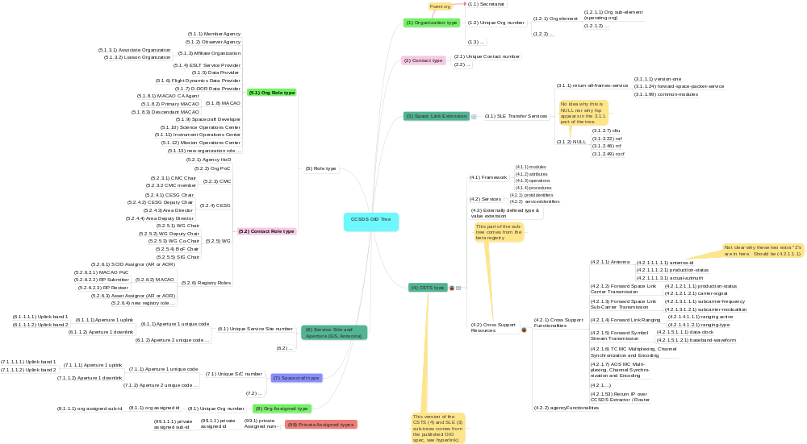

: CCSDS OID Tree

Information Models
(Informative)
  - CCSDS Organization Registry INFO MODEL
Figure B-4 shows the overall information model and relationships for the CCSDS OrganizationyRegistry. It also shows, graphically, the data structures for thenorganization database, which were derived from the organization database structure defined in referenc [8], with extensions for alignment with the rest of this policy.

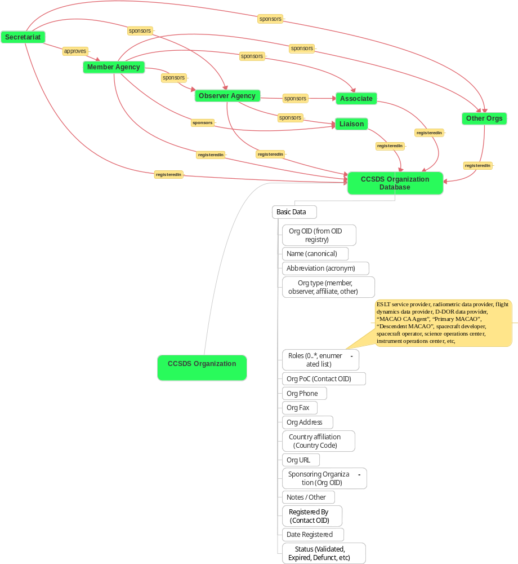
Figure B-44: Organization and Relationship Info Model
The relationships among organizations are based on the process definitions from reference [4]. SThe CCSDS Secretariat maintains lists of all CCSDS Member and Observer Agencie , Liaison organizationh, and Associate organizations (see subsection 4.2 in referencet.). The Secretariat and the SANA will coordinate updates and synchronization of these official entries.
The SANA may also register, separately, Affiliate Organizations who do not have this formal relationship but still need to utilize or access SANA databases. These ‘other’ entries will only be registered in the SANA and will not be synchronized with the Secretariat databases maintained in the CCSDS Web site.
Table 1 defines the nominal definition of thenorganization database elements, the fields, types, and constraints. The SANA (and the CCSDSeWeb site) will define the actual database tables and they will document the final database structures. These fields are to be treated as the minimal necessary content for the information set.
Table B-11: Organization Database Elements

Column Name | Data Type | Data Range | Notes
Organization Name | Character (64) | Valid organization name in English | May also want org abbreviation, logo, etc. fields.
Organization Type | One Type from Enumerated list | One of ‘Member Agency’, ‘Observer Agency’, ‘Associate’, ‘Liaison’, ‘Other’ | (See organization types in this document.)
Organization Point of Contact | Character (64) | Valid Person name | Name must be in Contacts Registry; entry may include OID.
Organization Phone | Character (32) | +country-code valid-phone-number | Must be a valid international phone number.
Organization Fax | Character (32) | +country-code valid-phone-number | Must be a valid international phone number.
Organization Address | Character (64) x 6 lines | Valid street address in English
Affiliation Country | Character (2) | Valid 2-character country code | Field must contain valid ISO 2-character country code.
Sponsoring Organization | Character (64) | Valid organization name | Name must be in Organization Registry, must be one of Secretariat, Member Agency, Observer Agency. Entry may include org OID.
Object ID | ISO OID, 8 bytes | Relative OID, digital, form of 1.3.112.4.1.1 … | Unique OID is assigned to each organization; may be sub-org.
Organization Roles | Zero or more roles, expressed as OID from extensible list | Zero or more of: Earth-Space Link Terminal (ESLT) Service Provider, Data Provider, etc. | (See organization role types in this document.)
URL | Character (64) | Valid Web site URL or N/A
Registered by | ISO OID, 8 bytes | Relative OID, digital, form of 1.3.112.4.2.1 … | Unique OID for the person who last changed the registry.
Last Request Date | Date | yyyy-mm-dd
Status | One of the Enumerated list | ‘TBC’, ‘Current’, ‘Active’, ‘Defunct’, NULL
Note | Char (64)
  - CCSDS CONTACTS Registry INFO MODEL
The following figure shows graphically the overall information model and relationships for the CCSDS Contacts Registry. It also shows the information model for the Contacts database, derived from the data structures defined in references [8] and [7], with extensions for alignment with the rest of this policy.

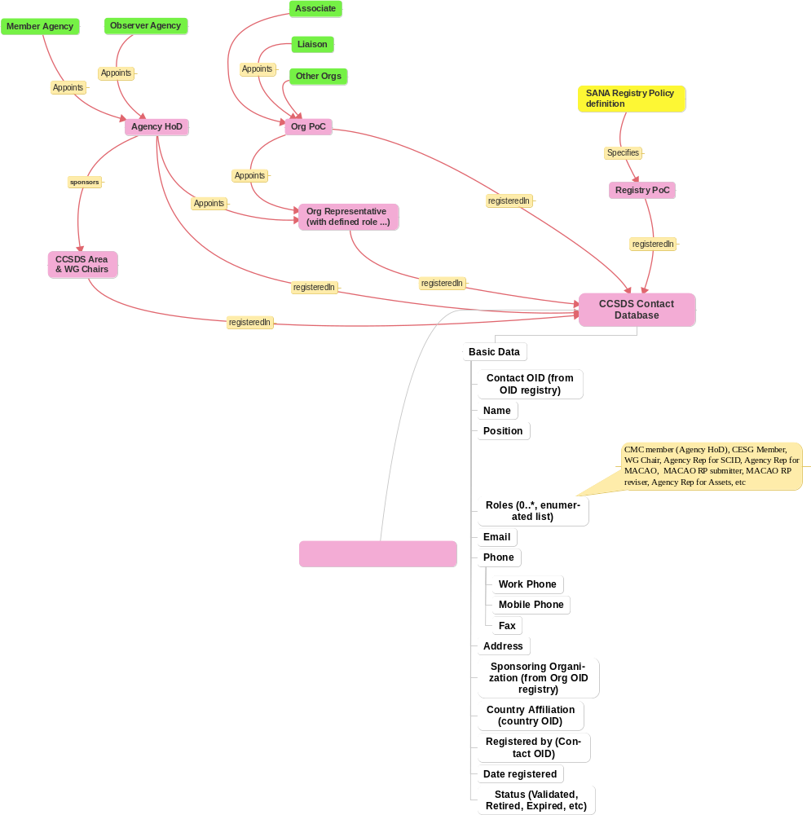
Figure B-55: Contacts Info Model
The relationships among contacts and organizations are based on the process definitions from reference [4].
Table 1 specifies the nominal definition of the Contacts database elements, the fields, types, and constraints. The SANA (and the CCSDSeWeb site) will define the actual database tables and they will document the final database structures. These fields are to be treated as the minimal necessary content for the information set.
Table B-22: Contact Database Elements

Column Name | Data Type | Data Range | Notes
Person Name | Character (64) | Valid person name in English
Position | Character (64) | Agency title
Sponsoring Organization | Character (64) | Valid organization name | Name must be in Organization Registry; entry may include OID.
Email | Character (64) | Valid email address, e.g. user@name.org | Must be a valid address.
Phone (Work) | Character (32) | +country-code valid-phone-number | Must be a valid international phone number.
Phone (Mobile) | Character (32) | +country-code valid-phone-number | Must be a valid international phone number.
Fax | Character (32) | +country-code valid-phone-number | Must be a valid international phone number.
Address | Character (64) x 6 lines | Valid street address in English
Affiliation Country | Character (2) | Valid 2-character country code | Field must contain valid ISO 2-character country code.
Object ID | ISO OID, 8 bytes | Relative, digital, form of 1.3.112.4.2.1 … | Unique OID is assigned to each person.
Contact Roles | Zero or more roles, expressed as OID from extensible list | Zero or more of: WG chair, SCID Assignor, MACAO PoC, etc. | (See contact role types in this document.)
Registered by | ISO OID, 8 bytes | Relative, digital, form of 1.3.112.4.2.1 … | Unique OID for the person who last changed the registry.
Last Request Date | Date | yyyy-mm-dd
Status | One of the Enumerated list | ‘TBC’, ‘Current’, ‘Retired’, ‘Deceased’, NULL
Note | Char (64)

  - CCSDS Spacecraft Registry INFO MODEL
The following figures show the information models for the CCSDS Spacecraft Registry. Figure 1 shows the overall information relationship model for the CCSDS SpacecraftyRegistry and its relationships to other registries, such as the Organization and ContactssRegistries.

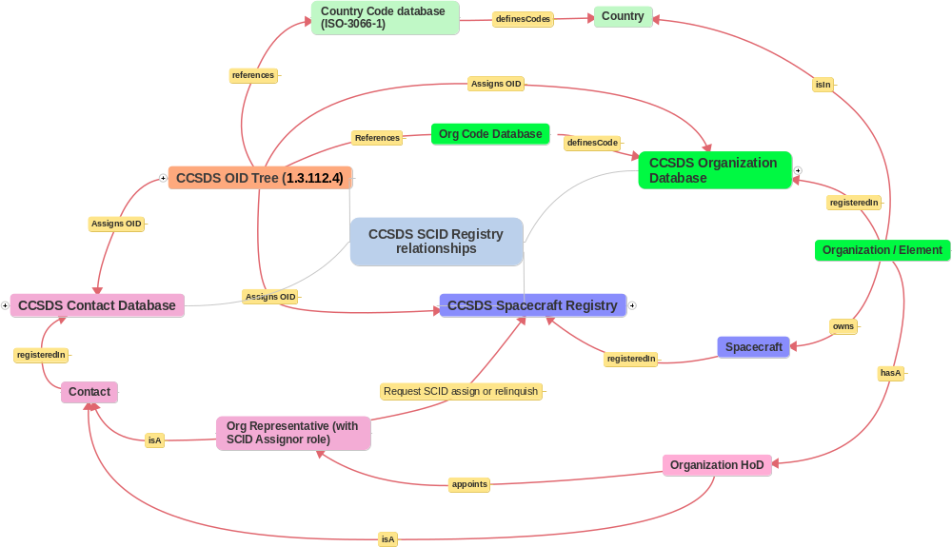
Figure B-66: Spacecraft Info Relationship Model
The relationships among the SCID Registry and other registries are based on the process definitions from reference [4] and]..
Figure 2 shows the information model for thetspacecraft database, as derived from the data structures defined in reference [7], with extensions for alignment with the rest of this policy.

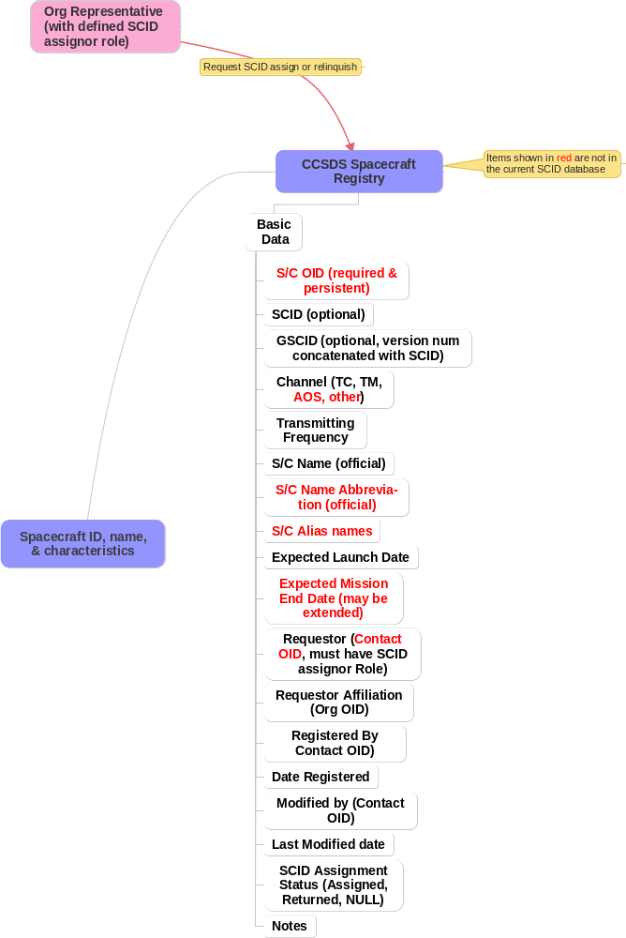
Figure B-77: Spacecraft Info Model
Table 1 specifies the nominal definition of thetspacecraft database elements, the fields, types, and constraints. The SANA will define the actual database tables and it will document the final database structures. These fields are to be treated as the minimal necessary content for the information set.
Table B-33: Spacecraft Database Elements

Column Name | Data Type | Data Range | Notes
Spacecraft Name | Character (64) | Any valid alpha-numeric | Assigned by the agency.
Protocol | Character (3) | TC, TM, AOS, Other
Version No. | Integer (short) | 1, 2, or 3 | May be extended.
SCID | Hex (3) | 001-max | Max is maximum SCID value for Version no.
GSCID | Hex (3) | 001-max | GSCID = VN + SCID.
Object ID | ISO OID, 8 bytes | Relative, digital, form of 1.3.112.4.7 … | Unique OID is assigned to each spacecraft.
Requestor Name | Character (64) | Valid Contact name in English | Contact must have SCID Assignor role; entry may include OID.
Requestor Affiliation | Character (64) | Valid organization name | Name must be in Organization Registry; entry may include OID.
Requestor Affiliation Country | Character (2) | Valid 2-character country code | Field must contain valid ISO 2-character country code.
Last Request Date | Date | yyyy-mm-dd
Registered by | ISO OID, 8 bytes | Relative, digital, form of 1.3.112.4.2.1 … | Unique OID for the person who last changed the registry.
Status | One of the Enumerated list | ‘Assigned’, ‘Returned’, OID only, NULL
Spacecraft Name Abbreviation | Character (8) | Any valid alpha-numeric | Agency assigned abbreviation or acronym.
Spacecraft Name Alias(es) | Character (128) | Comma separated list of any valid alpha-numeric | Agency assigned alias list (pre/post launch, familiar).
Transmitting Frequency | Float (32) | KHz, MHz, or GHz | Actual frequency, not just band designator.
Expected Launch Date | Date | yyyy-mm-dd | Assignment will typically be pre-launch.
Expected Mission End Date | Date | yyyy-mm-dd | May be extended upon request to SANA.
Note | Char (64)
  - CCSDS Service Site and Aperture Registry INFO MODEL
The figure B-8 shows the information relationship model for the CCSDS Service Site and ApertureyRegistry. It shows the relationships among the various data elements that may be present in an entry in this database defining a site.

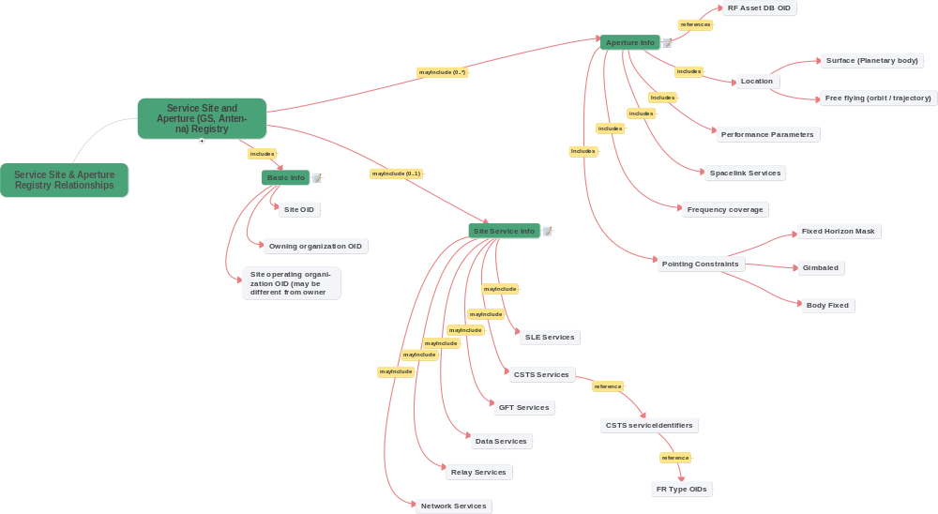
Figure B-88
: Service Site and Aperture Info Relationship Model
The service site and aperture data structures are intended to capture all of the information needed in order to support CCSDS Service Management operations. It describes the specific fields required to hold the specifications for a site, including ownership and location, the information for any services that are supported at that site, and the information for any apertures located at that site.
A site may be any of:
- a fixed facility on the Earth that has one or more cross support services;
- a fixed facility on Earth that has one or more space communication apertures, where apertures may have one or more feeds at different frequencies;
- a mobile facility on Earth that has one or more services or space communication apertures, where apertures may have one or more feeds at different frequencies;
- a fixed facility on the some other planetary body that has one or more cross support services;
- a fixed facility on some other planetary body that has one or more space communication apertures, where apertures may have one or more feeds at different frequencies;
- a mobile facility in space, either in orbit or on some well known trajectory, that has one or more services or space communication apertures, where apertures may have one or more feeds at different frequencies.
The following figure shows the overall data structure model for the CCSDS Service Site and Aperture Registry. It shows the information model for database that is intended to register sites that provide services (either static or in motion), and any apertures associated with these sites. There may be sites with just services, or sites with just apertures, or sites with both services and apertures.
This registry will point to IOAG RF Asset registry entries, and to Spacecraft Registry entries as needed, using the unique assigned OIDs to provide unambiguous cross-references.

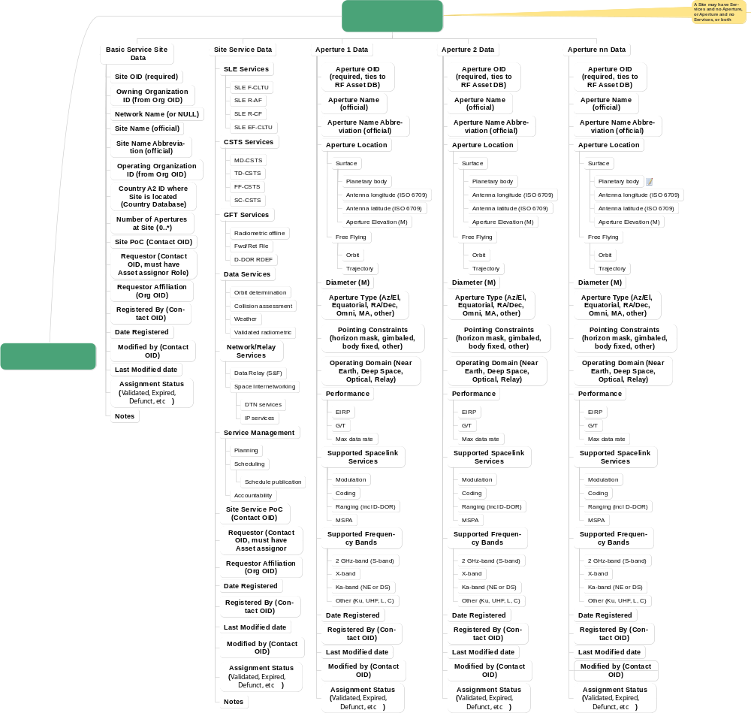
Figure B-99: Service Site and Aperture Info Model
  - IOAG RF ASSet Registry INFO MODEL
The figure B-10 shows the overall data structure model for the IOAG Antenna registry. It shows the primary data elements in the base registry. The elements shown in red are requested extensions to the base registry for alignment with the CCSDS Service Site and Aperture Registry.
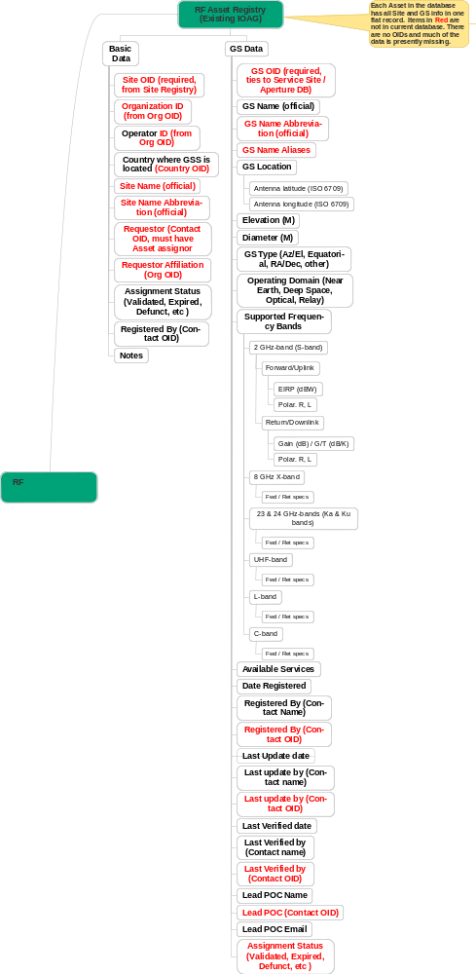
Figure B-1010
: IOAG Antenna Registry

Informative References
(Informative)

[C20] Standard Formatted Data Units—Structure and Construction Rules. Issue 2. Recommendation for Space Data System Standards (Blue Book), CCSDS 620.0-B-2. Washington, D.C.: CCSDS, May 1992.
[C21] Radio Frequency and Modulation—Part 1: Earth Stations. Issue 3-S. Report Concerning Space Data System Standards (Historical), CCSDS 411.0-G-3-S. Washington, D.C.: CCSDS, (May 1997) April 2005.
[C22] Space Link Extension—Application Program Interface for Transfer Services—Core Specification. Issue 2. Recommendation for Space Data System Practices (Magenta Book), CCSDS 914.0-M-2. Washington, D.C.: CCSDS, September 2015.
[C23] Cross Support Transfer Services—Monitored Data Service. Issue 1. Draft Recommendation for Space Data System Standards (Red Book), CCSDS 922.1-R-1. Washington, D.C.: CCSDS, Forthcoming.

A current CSS SM WG work item.
Derived from CSS CSTS work items.

