AIRPORTS NEAR CALTECH (per Google Maps)

El Monte Airport
4233 Santa Anita Ave, El Monte, CA 91731 (626) 448-6129

Bob Hope Airport
Small airport serving Southern California & offering direct rail service to Los Angeles. - Google
2627 N Hollywood Way, Burbank, CA 91505 (818) 840-8840
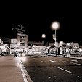

Los Angeles International Airport
Airport hub known for the colorful glass pylons & 32-foot-high "LAX" letters outside its entrance. - Google
1 World Way, Los Angeles, CA 90045 (310) 646-5252
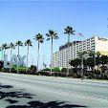

Fullerton Municipal Airport
4011 W Commonwealth Ave, Fullerton, CA 92833 (714) 738-6323
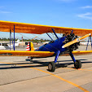

Whiteman Airport
12653 Osborne St, Los Angeles, CA 91331 (818) 896-5271
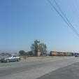

Compton/Woodley Airport
901 W Alondra Blvd, Compton, CA 90220 (310) 631-8140

Hawthorne Municipal Airport
12101 S Crenshaw Blvd, Hawthorne, CA 90250 (310) 349-1635

Van Nuys Airport
16461 Sherman Way, Van Nuys, CA 91406 (818) 442-6500
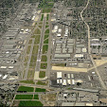

Long Beach Airport
4100 Donald Douglas Dr, Long Beach, CA 90808 (562) 570-2600

